Supplement

Comparing wildlife camera data to red fox abundance estimate
For the red fox, natural resources institute Finland (Luke) has yearly abundance estimate based on snow-track data by wildlife triangle censuses (Pellikka et al. 2005; raccoon dog and badger are usually not active during snowy season). Thus, we could evaluate how well the red fox occurrence in our camera trap data correlates with abundance estimate based on snow-track data. Snow-track censuses are done in January–March by trained volunteers. The census scheme is an equilateral triangle with fixed 4 km sides with on average five triangles monitored each year within an area of 50×50 km² (Pellikka et al. 2005). The animal abundance is reported as a snow-track index derived from the number of snow tracks observed crossing the route per 24 h of fresh snow per 10 km of census. We used the mean index of the (local) Game management association where the camera trap located. If there were less than three triangles within the district, we combined the data with 1-2 nearest districts. For two urban camera sites, we lacked the snow-track data and these were omitted from this comparison. We built a generalized linear mixed model (poisson distribution) where the number of red fox observations was explained by the snow-track index and the camera trap type. Here study area was included as random effects. The number of the red fox observations positively correlated with the snow-track index in the same area (estimate 0.09 ± 0.03, F_{1,73.9} = 8.4, p = 0.005; supplementary Fig. 1), supporting the prediction that the number of observations in our data reflected the red fox abundance in the area.

Reference
Pellikka, J., Rita, H. & Lindén, H. (2005). Monitoring wildlife richness—Finnish applications based on wildlife triangle censuses. Ann Zool Fenn 42:123–134.

Supplementary Figure 1. The model predicted number of red fox observations in camera traps versus red fox snow-track index in Finnish wildlife triangle data in the region of the camera site.

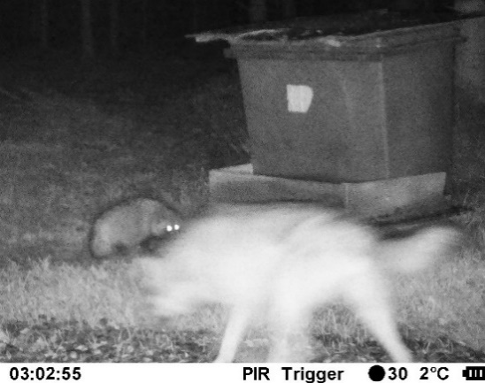

Supplementary Figure 2. A raccoon dog and a wolf at a feeding site in Kiikala (16 October 2020). Photo: Natural Resources Institute Finland Luke

Supplementary Table 1. Results of Generalized linear mixed models examining factors causing variation in the number of mesopredator observations in a camera trap. The variables dropped out from the final models, which are presented in the main text in Tables 2, 3, and 4 (n = 580 camera traps in 37 study areas).
Effect | Estimate | F_{df} | p
Table 2 (the raccoon dog model)
Wolf index * growth season interaction | -0.061 ± 0.074 | 0.70_{1,216} | 0.48
Wolf index * agricultural area interaction | -0.018 ± 0.011 | 2.58_{1,326.8} | 0.11
Lynx index * agricultural area interaction | 0.001 ± 0.008 | 0.01_{1,115.8} | 0.90
Forest area (500m buffer) | 0.016 ± 0.008 | 4.7_{1,148.7} | 0.04
Built area (500m buffer) | -0.012 ± 0.02 | 0.44_{1,482.7} | 0.51
Water area (500m buffer) | -0.017 ± 0.008 | 4.5_{1,206.8} | 0.05
Table 3 (the red fox model)
Wolf index * growth season interaction | 0.14 ± 0.13 | 1.06_{1,49.67} | 0.31
Lynx index * growth season interaction | 0.21 ± 0.11 | 4.1_{1,209} | 0.07
Lynx index * agricultural area interaction | -0.017± 0.015 | 1.28_{2,474.5} | 0.26
Forest area (500m buffer) | -0.006 ± 0.008 | 0.46_{1,436.4} | 0.50
Built area (500m buffer) | -0.1 ± 0.09 | 1.28_{1,541.1} | 0.25
Water area (500m buffer) | 0.009 ± 0.009 | 1.17_{1,424.7} | 0.28
Table 4 (the badger model)
Wolf index * growth season interaction | 0.16 ± 0.20 | 0.60_{1,54.42} | 0.44
Lynx index * growth season interaction | 0.38 ± 0.16 | 4.5_{1,86.53} | 0.06
Wolf index * forest area interaction | 0.38 ± 0.16 | 3.5_{1,86.53} | 0.09
Lynx index * forest area interaction | 0.04 ± 0.02 | 3.9_{1,492.7} | 0.08
Agricultural area (500m buffer) | -0.0063 ± 0.011 | 0.36_{1,565} | 0.55
Built area (500m buffer) | -0.02 ± 0.06 | 0.09_{1,563.8} | 0.76
Water area (500m buffer) | 0.0076 ± 0.011 | 0.50_{1,551.5} | 0.48

