Supplementary Information

Title: Density-impact functions for invasive house mouse effects on indigenous lizards and invertebrates

Journal: Biological Invasions

Authors: Grant Norbury*, Deborah J. Wilson, Dean Clarke, Ella Hayman, James Smith, Simon Howard

*Corresponding author: Manaaki Whenua – Landcare Research, P.O. Box 282, Alexandra 9340, New Zealand. norburyg@landcareresearch.co.nz

Online Resource 1

Table 1
Invertebrate (≥2 mm body length) taxonomic groups that each comprised <10% of invertebrates counted

Sampling method | Taxonomic groups
Landscape sampling (refuges) | spiders (Araneae), flies (Diptera), caterpillars (Lepidoptera), hoppers (Amphipoda), moths (Lepidoptera).
Sampling inside and outside mammal-resistant fences (refuges) | moths, centipedes (Chilopoda), earthworms (Oligochaeta), earwigs (Dermaptera), flatworms (Platyhelminthes), millipedes (Diplopoda), harvestmen (Opiliones), pseudoscorpions (Pseudoscorpiones), woodlice (Isopoda), slugs (Gastropoda), springtails (Collembola), bugs (Hemiptera), silverfish (Zygentoma), hymenopterans, orthopterans, beetles (Coleoptera), and flies.
Sampling inside and outside mammal-resistant fences (pitfall traps) | hoppers, centipedes, earthworms, flatworms, millipedes, Opiliones, springtails, cockroaches (Blattodea), moths, bugs, hymenopterans, orthopterans, and flies.

Table 2

Models fitted to each predictor-response combination. Most exponential growth models are not shown, as they either could not be fitted or had AICc more than 5 units higher than the next best model. Bold text indicates models with considerable support, i.e., with AICc within 2 units of the best-fitting model (the model with the lowest AICc). If the intercept-only model has the lowest AICc, only that model is highlighted with bold text. MNA = minimum number alive. * = data sets available from both the landscape and fence studies.

Predictor | Response | Figure | Model | AICc
Mouse print rate | Skink print rate* | 1a | intercept only | 616.04
 |  |  | linear | 608.87
 |  |  | exponential decay | 605.09
 | Gecko print rate | 1b | intercept only | 20.45
 |  |  | linear | 22.06
 |  |  | exponential decay | 21.30
 |  |  | exponential growth | 24.05
 | McCann’s skink pitfall | 1c | intercept only | 212.24
 |  |  | linear | 211.30
 |  |  | exponential decay | 210.93
 | Grass skink pitfall | 1d | intercept only | 116.61
 |  |  | linear | 112.50
 |  |  | exponential decay | 111.73
 | McCann’s skink refuge* | 1e | intercept only | 732.68
 |  |  | linear | 728.42
 |  |  | exponential decay | 725.19
 | Grass skink refuge* | 1f | intercept only | 585.49
 |  |  | linear | 584.91
 |  |  | exponential decay | 584.63
 | Gecko refuge* | 1g | intercept only | 541.09
 |  |  | linear | 541.97
 |  |  | exponential decay | 540.87
 | Wētā print rate | 2a | intercept only | 708.54
 |  |  | linear | 704.54
 |  |  | exponential decay | 704.29
 | Wētā pitfall | 2b | intercept only | 62.79
 |  |  | linear | 63.40
 |  |  | exponential decay | 63.71
 | Invertebrate pitfall | 2c | intercept only | 214.32
 |  |  | linear | 213.26
 |  |  | exponential decay | 213.09
 | Invertebrate refuge* | 2d | intercept only | 721.97
 |  |  | linear | 722.57
 |  |  | exponential decay | 722.33
Mouse track rate | Skink track rate* | 3a | intercept only | 755.92
 |  |  | linear | 733.50
 |  |  | exponential decay | 732.09
 | Gecko track rate | 3b | intercept only | 133.21
 |  |  | linear | 133.81
 |  |  | exponential decay | 132.86
 | McCann’s skink pitfall | 3c | intercept only | 212.24
 |  |  | linear | 211.26
 |  |  | exponential decay | 211.20
 | Grass skink pitfall | 3d | intercept only | 116.61
 |  |  | linear | 110.96
 |  |  | exponential decay | 110.60
 | McCann’s skink refuge* | 3e | intercept only | 732.68
 |  |  | linear | 726.82
 |  |  | exponential decay | 725.35
 | Grass skink refuge* | 3f | intercept only | 585.49
 |  |  | linear | 585.13
 |  |  | exponential decay | 585.30
 | Gecko refuge* | 3g | intercept only | 541.09
 |  |  | linear | 541.94
 |  |  | exponential decay | 541.92
 | Wētā track rate* | 4a | intercept only | 778.20
 |  |  | linear | 761.83
 |  |  | exponential decay | 763.62
 | Wētā pitfall | 4b | intercept only | 62.79
 |  |  | linear | 64.46
 |  |  | exponential decay | 64.55
 | Invertebrate pitfall | 4c | intercept only | 214.32
 |  |  | linear | 212.64
 |  |  | exponential decay | 212.55
 | Invertebrate refuge* | 4d | intercept only | 721.97
 |  |  | linear | 722.27
 |  |  | exponential decay | 721.89
Mouse MNA | Skink print rate | Fig. 2a online resource 1 | intercept only | 81.59
 |  |  | linear | 82.25
 |  |  | exponential decay | 82.16
 | McCann’s skink pitfall | Fig. 2b online resource 1 | intercept only | 103.91
 |  |  | linear | 105.91
 |  |  | exponential decay | 105.91
 | Grass skink pitfall | Fig. 2c online resource 1 | intercept only | 55.01
 |  |  | linear | 52.89
 |  |  | exponential decay | 51.64
 | McCann’s skink refuge | Fig. 2d online resource 1 | intercept only | 120.81
 |  |  | linear | 122.09
 |  |  | exponential decay | 122.11
 | Grass skink refuge | Fig. 2e online resource 1 | intercept only | 99.18
 |  |  | linear | 98.69
 |  |  | exponential decay | 97.55
 | Wētā print rate | Fig. 3a online resource 1 | intercept only | 114.16
 |  |  | linear | 114.51
 |  |  | exponential decay | 114.58
 | Wētā pitfall | Fig. 3b online resource 1 | intercept only | 31.08
 |  |  | linear | 32.52
 |  |  | exponential decay | 32.57
 | Invertebrate pitfall | Fig. 3c online resource 1 | intercept only | 103.87
 |  |  | linear | 102.36
 |  |  | exponential decay | 102.57
 | Invertebrate refuge | Fig. 3d online resource 1 | intercept only | 132.94
 |  |  | linear | 130.97
 |  |  | exponential decay | 130.64

Table 3

Models fitted to three predictor-response combinations with a habitat interaction term included (= hab). Bold text indicates the model with the lower AICc within each pair of models (with and without the habitat interaction term)

Predictor | Response | Figure in online resource 2 | Model | AICc
Mouse print rate | Skink print rate | 1a & b | linear | 608.87
 |  |  | linear_hab | 610.35
 |  |  | exponential decay | 605.09
 |  |  | exponential decay_hab | 605.63
Mouse print rate | McCann’s skink refuge | 1c & d | linear | 674.80
 |  |  | linear_hab | 678.20
 |  |  | exponential decay | 671.46
 |  |  | exponential decay_hab | 673.69
Mouse print rate | Wētā print rate | 1e & f | linear | 704.54
 |  |  | linear_hab | 707.38
 |  |  | exponential decay | 704.29
 |  |  | exponential decay_hab | 707.11

Online Resource 2

Fig. 1 Density-impact functions for mice, skinks and wētā separated into woody (left column, n = 33 for each graph) and tussock (right column, n = 49 for each graph) habitat at the Macraes Conservation Area, eastern Otago. Figs. a and b are from Fig. 2a of the article. Figs. c and d are from Fig. 2e. Figs. e and f are from Fig. 3a. Some data points are overlapping

Woody habitat Tussock habitat

Fig. 2 Density-impact functions for mice and lizards at the Macraes Conservation Area, eastern Otago. Mouse abundance based on minimum number alive (MNA) measured only on grids outside the mammal fences (MNA not measured in landscape sampling). Lizard abundance indices derived from: printing rates of skinks (a, n = 16); number of McCann’s skinks (b, n = 16) and southern grass skinks (c, n = 16) per 100 pitfall trap nights; and number of McCann’s skinks (d, n = 16) and southern grass skinks (e, n = 16) per 100 artificial refuge nights. Data not shown for geckos because they were rarely detected outside the mammal fences. Relationship shapes with considerable support are indicated (bolded in Table 2 online resource 1). Some data points are overlapping

Fig. 3 Density-impact functions for mice and invertebrates at the Macraes Conservation Area, eastern Otago. Mouse abundance based on minimum number alive (MNA) measured only on grids outside the mammal fences (MNA not measured in landscape sampling). Wētā abundance indices derived from printing rates of wētā (a, n = 16) and number of wētā per 100 pitfall trap nights (b, n = 16). Abundance indices of other invertebrates are derived from number per 100 pitfall trap nights (c, n = 16) (same pitfall traps as wētā), and number per 100 artificial refuge nights (d, n = 16). Relationship shapes with considerable support are indicated (bolded in Table 2 online resource 1). Some data points are overlapping

Online Resource 3

Model selection and error structure simulations
Where datasets were available from both the landscape and fence studies, data were combined for the analyses. Because counts are integers and abundance indices are real numbers, conventional statistical analyses of these different data types, for example using generalized linear models, assume different error term distributions. We used non-linear models to maintain a similar analytical approach to past studies (sensu Norbury et al. 2015), but this made specifying models with the correct error term distribution difficult. Using statistical models that do not adhere to these conventions risks drawing biased or incorrect inferences from parametric tests (e.g. O’Hara, Kotze 2010). Parametric tests are not used in our model selection process, and it was unclear whether this would be affected by error term distribution. We tested this using simulated count data (drawn from a Poisson distribution) following linear and exponential relationships and modelled using the correct (Poisson) and incorrect (Gaussian) error distributions. We applied our model selection steps to see if the two error distributions differed in the frequency with which the correct model was selected. The simulations below showed that model selection appeared to be independent of the error distribution when selecting between intercept-only, linear and exponential growth relationship shapes.
Continuous responses were created by pooling total counts from collection devices in a grid and dividing by the total number of collection devices to derive numbers per device.
To determine the most representative shape of density impact functions, several models were run on the same predictor and response data. The models varied in the shape of the relationship they could fit. Fitted models were intercept-only, linear, exponential growth and exponential decay models. The model selection method used small-sample-corrected Akaike Information Criterion (AICc) and applied a rule where a model with lowest AICc value and was >2 AICc clear from the next closest model, was chosen as the model best representing the shape of the density impact function.
This script is designed to test whether models with correct (Poisson) or incorrect (Gaussian) error terms select models with the same frequency when applying the model selection rules described above.
Methods
To test whether error distribution choice affects model selection frequency a simulation approach is used. Using exponential (α.e^{β.x}) and linear (α + β.x) relationships between the predictor and response we simulated data sets with varying slope terms and fit intercept-only, linear and exponential models to the data. A sequence of β values were drawn between 0.001 (effectively intercept-only) and 0.035 and replicate simulations were then run for each beta value in the sequence using the following steps:
- Randomly draw a set of set of predictor values (x) from a uniform distribution.
- Calculate response values (λ_{i}) using the “true” values of α and β and x using the exponential or linear equations above.
- Randomly draw count responses from a Poisson distribution y_{i} = Pois(λ_{i} . number of devices) and divide count by number of devices to convert to a number per device.
- Fit six models, intercept-only, linear and exponential growth model using Gaussian (i.e. using linear and non-linear regression) and Poisson (i.e. Poisson GLMs with identity and log links).
- Calculate and store AIC_{c} for each model.
- Apply model selection rules to models with Gaussian (incorrect) and Poisson (correct) error distributions and compare model selection frequencies across a large number of simulations and across all values of the slope term β.

Simulation parameters
# set number of predictors
alpha <- 0.05 # set intercept
n <- 50 # set number of data points
nreps <- 5000 # number of replicates

# Generate a sequence of slopes exponents
betaseq <- seq(0.001, 0.035, length.out = 21)

matplot(alpha * exp(outer(0:100, betaseq, "*")), type = "l", lty = 1,
col = "gray", xlab = "predictor", ylab = "response",
main = "'True' exponential relationship between predictor and response over values of
beta")
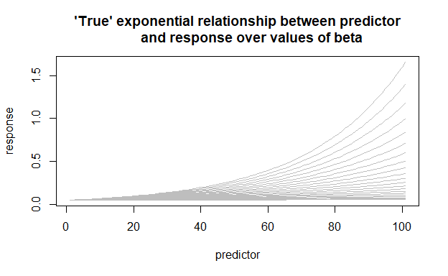
Loop through values of beta and apply simulation steps
# Store AICc values for all models across simulations and slope exponents
AIC_results <- array(NA, dim = c(6,nreps, length(betaseq)))
# loop over beta sequence
for(j in seq_along(betaseq)){{
# run models over replicates
AIC_results[,,j] <- replicate(n = nreps, expr = {{
# try() is required because a small proportion of non-linear model fits fail
try({{
beta <- betaseq[j]
# 1. Randomly draw a set of set of predictor values from a uniform distribution.
x <- sort(runif(n, 0,100))
# 2. Calculate response values using the "true" values of alpha, beta and x
lambda <- alpha * exp(beta * x)
# 3. Randomly draw count responses from a Poisson distribution and divide
# count by number of devices to convert to a number per device.
n_devices <- 16
y_counts <- rpois(n = lambda, lambda = lambda * n_devices)
y_rate <- y_counts / n_devices
# 4. Fit six models, intercept-only, linear and exponential growth model using Gaussian
(i.e., using linear and non-linear regression) and Poisson (i.e., Poisson GLMs with
identity and log links).
## INTERCEPT-ONLY
m1 <- lm(y_rate ~ 1) # fit intercept-only
## LINEAR CURVE
m2 <- lm(y_rate ~ x) # fit regression
## EXPONENTIAL GROWTH
try({
m3 <- nls(y_rate~a*exp(b*x), start = list(a = alpha, b = beta))
}}, TRUE)
if(!exists("m3")) m3 <- NULL

## INTERCEPT-ONLY
m1_poiss <-
glm(y_counts ~ 1, offset = rep(log(n_devices), length(x)),
family = poisson(link = "log"))
## LINEAR CURVE
m2_poiss <-
suppressWarnings({{
glm(y_counts ~ x, family = poisson(link = "identity"),
start = c(alpha,0.5))
})
##EXPONENTIAL GROWTH
m3_poiss <-
glm(y_counts ~ x,
offset = rep(log(n_devices), length(x)),
family = poisson(link = "log"))
# 5. Calculate and store AICc for each model
AICc <- sapply(list(m1, m2, m3, m1_poiss, m2_poiss, m3_poiss), AICcmodavg::AICc)
}}, silent = TRUE)
# fill all AICc values with NA if a model in the replicate fails
if(!exists("AICc")) AICc <- rep(NA, 6)
return(AICc)
}})
}}
Apply model selection rules and compare
If the exponential model has the lowest AICc value and is AICc difference between both the intercept-only and linear model is <=-2 then the exponential is selected.
chooseExpMod_gaussian <-
apply(AIC_results[1:3,,], 2:3,
FUN = function(x) {{ x[3] == min(x) && all(x[3] - x[-3] <= -2) }})
chooseExpMod_poisson <-
apply(AIC_results[4:6,,], 2:3,
FUN = function(x){{ x[3] == min(x) && all(x[3] - x[-3] <= -2) }})
plot(y = colMeans(chooseExpMod_gaussian, na.rm = TRUE),
x = betaseq, type = "b",
ylab = "Proportion of replicates selecting exponential model",
main = "Model selection frequency of exponential model using\n
Gaussian (black) and Poisson (red) errors")
lines(y = colMeans(chooseExpMod_poisson, na.rm = TRUE),
x = betaseq, type = "b", col = "red")
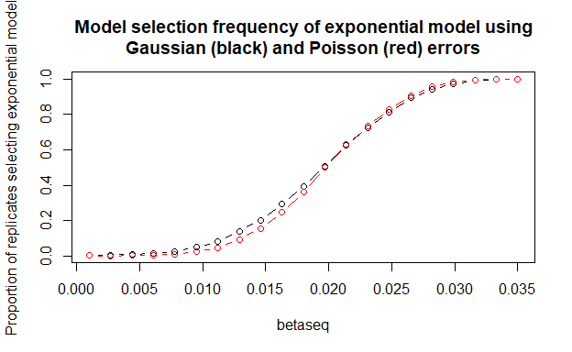
Simulation parameters
# set intercept
alpha <- 1
# Generate a sequence of slopes exponents
betaseq <- seq(0.001, 0.05, length.out = 21)
matplot(alpha + outer(0:100, betaseq, "*"), type = "l", lty = 1,
col = "gray", xlab = "predictor", ylab = "response",
main = "'True' linear relationship between predictor and response over values of beta")
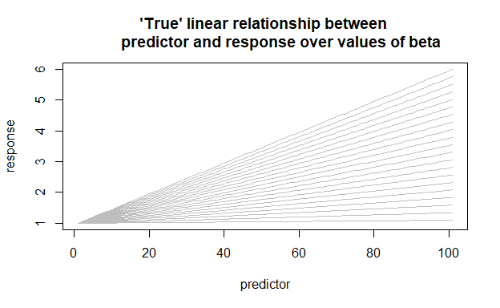
Loop through values of beta and apply simulation steps
# Store AIC values for all models across simulations and slope exponents
AIC_results <- array(NA, dim = c(6,nreps, length(betaseq)))
# loop over beta sequence
for(j in seq_along(betaseq)){{
# run models over replicates
AIC_results[,,j] <- replicate(n = nreps, expr = {{
# try() is required because a small proportion of non-linear model fits fail
try({{
beta <- betaseq[j]
# 1. Randomly draw a set of set of predictor values from a uniform
# distribution.
x <- sort(runif(n, 0,100))
# 2. Calculate response values using the "true" values of alpha, beta and x
y_true <- alpha + beta * x
# 3. Randomly draw count responses from a Poisson distribution and divide count by number of
# devices to convert to a number per device.
n_devices <- 16
y_counts <- rpois(n = y_true, lambda = y_true * n_devices)
y_rate <- y_counts / n_devices
# 4. Fit six models, intercept-only, linear and exponential growth model using Gaussian
# (i.e., using linear and non-linear regression) and Poisson (i.e., Poisson GLMs with identity and
# log links).
## INTERCEPT-ONLY
m1 <- lm(y_rate ~ 1) # fit intercept-only
## LINEAR CURVE
m2 <- lm(y_rate ~ x) # fit regression
## EXPONENTIAL DECAY
try({{
m3 <- nls(y_rate~a*exp(b*x), start = list(a = alpha, b = beta))
}}, TRUE)
if(!exists("m3")) m3 <- NULL
## INTERCEPT-ONLY
m1_poiss <-
glm(y_counts ~ 1, offset = rep(log(n_devices), length(x)),
family = poisson(link = "log"))
## LINEAR CURVE
m2_poiss <-
suppressWarnings({{
glm(y_counts ~ x, family = poisson(link = "identity"),
start = c(alpha,0.5))
}})
## EXPONENTIAL DECAY
m3_poiss <-
glm(y_counts ~ x,
offset = rep(log(n_devices), length(x)),
family = poisson(link = "log"))
# 5. Calculate and store AICc for each model
AICc <- sapply(list(m1, m2, m3, m1_poiss, m2_poiss, m3_poiss),
FUN = AICcmodavg::AICc)
}}, silent = TRUE)
# fill all AICc values with NA if a model in the replicate fails
if(!exists("AICc")) AICc <- rep(NA, 6)
return(AICc)
}, simplify = "array")
}}
Apply model selection rules to linear generating model and compare
If the linear model has the lowest AICc value and is AICc difference between both the intercept-only and linear model is <=-2 then the exponential is selected.
chooseLinearMod_gaussian <-
apply(AIC_results[1:3,,], 2:3,
FUN = function(x){{ x[2] == min(x) && all(x[2] - x[-2] <= -2) }})
chooseLinearMod_poisson <-
apply(AIC_results[4:6,,], 2:3,
FUN = function(x){{ x[2] == min(x) && all(x[2] - x[-2] <= -2) }})
plot(y = colMeans(chooseLinearMod_gaussian, na.rm = TRUE), x = betaseq,
type = "b", ylim = c(0,1),
ylab = "Proportion of replicates selecting linear model",
main = "Model selection frequency of linear model using Gaussian (black) and\n
Poisson (red) errors")
lines(y = colMeans(chooseLinearMod_poisson, na.rm = TRUE), x = betaseq, type = "b", col = "red")
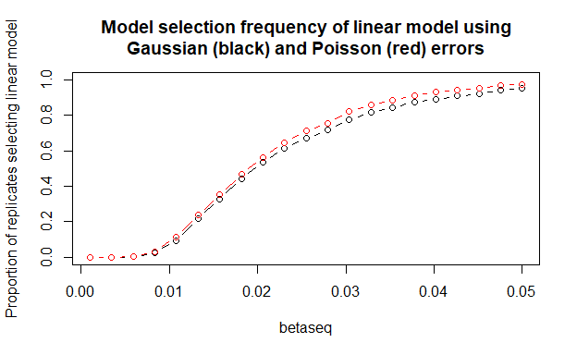

References

Norbury GL, Pech RP, Byrom AE, et al. (2015) Density-impact functions for terrestrial vertebrate pests and indigenous biota: Guidelines for conservation managers. Biological Conservation 191:409-420
O’Hara RB, Kotze DJ (2010) Do not log-transform count data. Methods in Ecology and Evolution 1:118-122

