The faunal Ponto-Caspianization of central and western European waterways

Ismael Soto^{1,*}, Ross N. Cuthbert^{2,3,*}, Anthony Ricciardi⁴, Danish A. Ahmed⁵, Florian Altermatt^{6.7}, Gaït Archambaud-Suard⁸, Núria Bonada⁹, Miguel Cañedo-Argüelles^{9,10}, Zoltan Csabai^{11,12}, Thibault Datry¹³, Jaimie T. A. Dick¹⁴, Mathieu Floury¹⁵, Marie Anne Eurie Forio¹⁶, Maxence Forcellini¹³, Jean-François Fruget¹⁷, Belinda Gallardo^{18,19}, Peter Goethals¹⁶, Peter Haase^{20,21}, Emma J. Hudgins²², J. Iwan Jones²³, Antonín Kouba¹, Patrick Leitner²⁴, Marie-Helène Lizée⁸, Anthony Maire²⁵, John F. Murphy²³, Davis Ozolins²⁶, Jes Jessen Rasmussen²⁷, Ralf B. Schäfer²⁸, Astrid Schmidt-Kloiber²⁴, Agnija Skuja²⁶, Rachel Stubbington²⁹, Gea H. Van der Lee³⁰, Rudy Vannevel¹⁶, Gábor Várbíró³¹, Ralf C. M. Verdonschot³⁰, Peter Wiberg-Larsen³², Phillip J. Haubrock^{1,21,†}, Elizabeta Briski^{2,†}

Affiliations
¹ University of South Bohemia in České Budějovice, Faculty of Fisheries and Protection of Waters, South Bohemian Research Center of Aquaculture and Biodiversity of Hydrocenoses, Zátiší 728/II, 389 25 Vodňany, Czech Republic
² GEOMAR Helmholtz-Zentrum für Ozeanforschung Kiel, 24105 Kiel, Germany
³ School of Biological Sciences, Queen’s University Belfast, Belfast, BT9 5DL, United Kingdom
⁴ Redpath Museum and Bieler School of Environment, McGill University, Montreal, Canada
⁵Center for Applied Mathematics and Bioinformatics (CAMB), Department of Mathematics and Natural Sciences,
Gulf University for Science and Technology, Hawally, Kuwait
⁶ Eawag: Swiss Federal Institute of Aquatic Science and Technology, Department of Aquatic Ecology, Überlandstr. 133, CH-8600 Dübendorf, Switzerland
⁷ Department of Evolutionary Biology and Environmental Studies, University of Zurich, Winterthurerstr. 190, CH-8057 Zürich, Switzerland.
⁸ INRAE, Aix Marseille Univ, RECOVER, Aix-en-Provence, France
⁹ Grup de Recerca Freshwater Ecology, Hydrology and Management (FEHM), Departament de Biologia Evolutiva, Ecologia i Ciències Ambientals, Facultat de Biologia, Institut de Recerca de la Biodiversitat, Universitat de Barcelona (UB), Diagonal 643, 08028, Barcelona, Catalonia, Spain
¹⁰ Institute of Environmental Assessment and Water Research C. Jordi Girona 18-26, 08034 Barcelona (IDAEA-CSIC)
¹¹ Department of Hydrobiology, University of Pécs, Pécs, Hungary
¹² Department of Botany and Zoology, Faculty of Science, Masaryk University, Brno, Czech Republic
¹³ INRAE, UR RiverLy, centre de Lyon-Villeurbanne, 5 rue de la Doua CS70077, 69626, Villeurbanne, Cedex, France
¹⁴ Institute for Global Food Security, School of Biological Sciences, Queen’s University Belfast, Belfast, BT9 5DL, United Kingdom
¹⁵ Univ Lyon, Université Claude Bernard Lyon 1, CNRS, ENTPE, UMR 5023 LEHNA, F-69622, Villeurbanne, France
¹⁶ Aquatic Ecology Research Group, Ghent University, Coupure Links 653, 9000 Gent, Belgium
¹⁷ ARALEP, Ecologie des Eaux Douces, Campus LyonTech-La Doua, 66 Bld Niels Bohr, CS52132, 69603, Villeurbanne Cedex, France
¹⁸ Instituto Pirenaico de Ecología (IPE), CSIC, Avda. Montana 1005, 50059 Zaragoza, Spain
¹⁹ Biosecurity Research Initiative at St Catharine’s (BioRISC), St Catharine’s College, CB2 1RL Cambridge, UK
²⁰ University of Duisburg-Essen, Faculty of Biology, Essen, Germany
²¹ Senckenberg Research Institute and Natural History Museum Frankfurt, Department of River Ecology and Conservation, Gelnhausen, Germany.
²²Department of Biology, Carleton University, Ottawa, Ontario, Canada, K1S 5B6
²³ School of Biological and Behavioural Sciences, Queen Mary University of London, London, UK
²⁴ University of Natural Resources and Life Sciences, Vienna. Institute of Hydrobiology and Aquatic Ecosystem Management, Austria
²⁵ EDF R&D, Laboratoire National d’Hydraulique et Environnement, LNHE, 78401 Chatou Cedex, France
²⁶ Institute of Biology, University of Latvia, Riga, Latvia
²⁷ Norwegian Institute for Water Research (NIVA Denmark), Njalsgade 76, 2300 Copenhagen S, Denmark
²⁸ Institute for Environmental Sciences, Quantitative Landscape Ecology, Rhineland Palatinate Technical University, Landau, Germany
²⁹ School of Science and Technology, Nottingham Trent University, Nottingham, UK.
³⁰ Wageningen Environmental Research, Wageningen UR,P.O. Box 47, Wageningen 6700 AA The Netherlands
³¹ Department of Tisza River Research, Centre for Ecological Research, Institute of Aquatic Ecology, Debrecen 4026 Hungary
³²Aarhus University, Department of Ecoscience, Vejlsoevej 25, 8600 Silkeborg, Denmark

* Equally contributing first authors
† Equally contributing senior authors

Supplementary Material:
Supplementary Figure 1: Length of time series according to their geographic origin
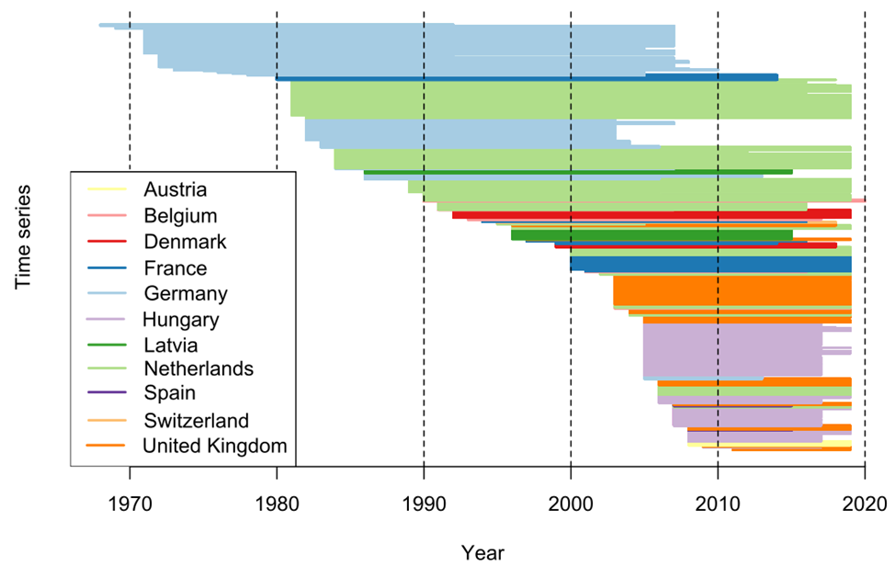
Figure S1: Length of time series according to their geographic origin.

Supplementary Figure 2: Number of Ponto-caspian invaders in time series according tot heir geographic origin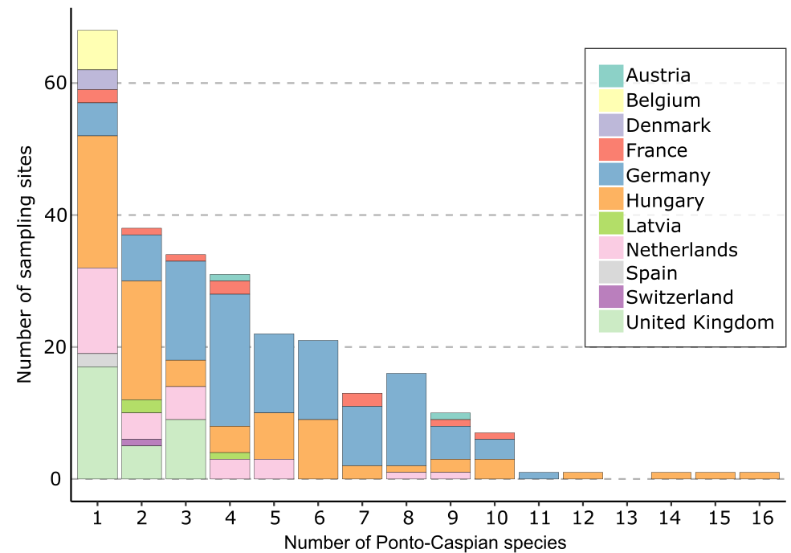
Figure S2 The number of sites at which different total numbers of Ponto-Caspian macroinvertebrate species were recorded segmented by country.

Supplementary Figure 3: Response of Generalized Linear Model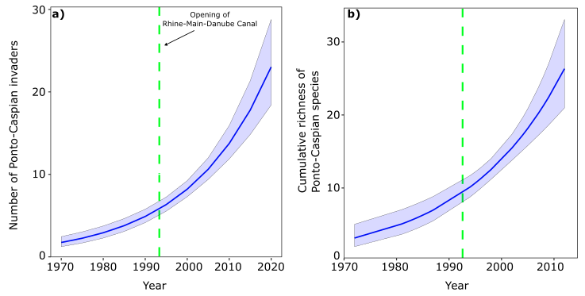
Figure S3: Response of the Generalized Linear Models for a) number of Ponto-Caspian over time and b) cumulative richness of Ponto-Caspian species. The dashed green line refers to the opening of the Rhine-Main-Danube Canal in 1992.

Supplementary Figure 4: Relationship between time series length and the number of Ponto-Caspian species.
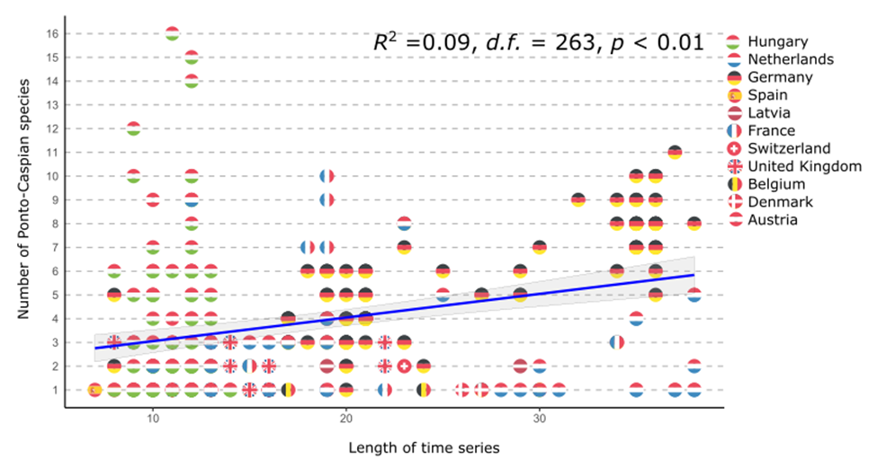
Figure S4: Relationship between the time series length and the number of Ponto-Caspian invaders. Circles represent the flag of the country of origin of the time series. The blue line and gray area represent the trend and its standard error (SD), respectively.

Supplementary Figure 5: Order of arrival of Ponto-Caspian invaders.
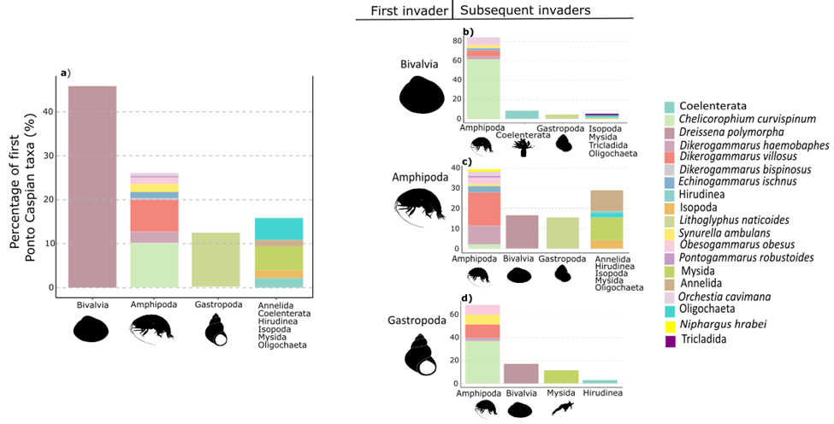
Figure S5: Percentage of Ponto-Caspian taxa to be recorded first in invaded sites and (b–d) the composition of the taxa recorded second after the top-three first-recorded major taxa (i.e. Bivalvia, Amphipoda and Gastropoda).

Supplementary Table 1: The sampling methods used on each time series.

Time series | Sampling method | Season | Rivers/Stream | Period | Country
100000001 | Multiplate artificial substratum¹ | summer | Rhone | 1980-2014 | France
100000002 | Multiplate artificial substratum | summer | Rhone | 1999-2014 | France
100000011 | Indice Biologique Global Normalisé² | summer | Ill | 1997-2016 | France
100000217 | Indice Biologique Global Normalisé | summer | Saone | 1994-2016 | France
100000308 | Multiplate artificial substratum | summer | Rhone | 2000-2019 | France
100000309 | Multiplate artificial substratum | summer | Rhone | 2000-2019 | France
100000310 | Multiplate artificial substratum | fall | Rhone | 2000-2019 | France
100000311 | Multiplate artificial substratum | fall | Rhone | 2000-2019 | France
100000312 | Multiplate artificial substratum | fall | Rhone | 2000-2019 | France
100000313 | Multiplate artificial substratum | fall | Rhone | 2001-2019 | France
103000046 | Multi-habitat Kick-sampling³ | summer | Ebro | 2008-2015 | Spain
103000213 | Multi-habitat Kick-sampling | summer | Ebro | 2007-2015 | Spain
107000201 | Kick-sampling⁴ | spring | Mølleå | 1992-2019 | Denmark
107000213 | Kick-sampling | spring | Halleby Å | 1992-2018 | Denmark
107000224 | Kick-sampling | spring | Ringsted Å | 1999-2018 | Denmark
108000010 | DIN 38410⁵ | fall | Rhein | 1971-2007 | Germany
108000011 | DIN 38410 | fall | Rhein | 1969-2007 | Germany
108000020 | DIN 38410 | summer | Buttergraben | 1986-2006 | Germany
108000022 | DIN 38410 | summer | Meierbach | 1986-2006 | Germany
108000026 | DIN 38410 | fall | Fintau | 1986-2006 | Germany
108000028 | DIN 38410 | fall | Waakhauser Polder | 1986-2001 | Germany
108000030 | DIN 38410 | spring | Osenhorster Bach | 1986-2013 | Germany
108000031 | DIN 38410 | summer | Rehbaeke | 1986-2006 | Germany
108000032 | DIN 38410 | fall | Rhein | 1971-2007 | Germany
108000033 | DIN 38410 | fall | Rhein | 1971-1998 | Germany
108000034 | DIN 38410 | summer | Rhein Herne Canal | 1972-2007 | Germany
108000035 | DIN 38410 | summer | Rhein Herne Canal | 1972-2007 | Germany
108000036 | DIN 38410 | summer | Datteln-Hamm-Canal | 1972-2007 | Germany
108000037 | DIN 38410 | summer | Datteln-Hamm-Canal | 1972-2007 | Germany
108000038 | DIN 38410 | summer | Datteln-Hamm-Canal | 1973-2010 | Germany
108000039 | DIN 38410 | summer | Wesel Datteln Canal | 1972-2007 | Germany
108000040 | DIN 38410 | summer | Wesel Datteln Canal | 1972-2007 | Germany
108000041 | DIN 38410 | summer | Wesel Datteln Canal | 1972-2007 | Germany
108000042 | DIN 38410 | summer | Dortmund Ems Canal | 1972-2007 | Germany
108000043 | DIN 38410 | summer | Dortmund Ems Canal | 1984-2007 | Germany
108000044 | DIN 38410 | summer | Dortmund Ems Canal | 1984-2007 | Germany
108000045 | DIN 38410 | summer | Dortmund Ems Canal | 1972-2008 | Germany
108000046 | DIN 38410 | summer | Dortmund Ems Canal | 1972-2008 | Germany
108000047 | DIN 38410 | summer | Dortmund Ems Canal | 1972-2008 | Germany
108000049 | DIN 38410 | summer | Mittelland Canal | 1973-2008 | Germany
108000050 | DIN 38410 | summer | Mittelland Canal | 1973-2008 | Germany
108000051 | DIN 38410 | fall | Rhein | 1971-1991 | Germany
108000053 | DIN 38410 | fall | Sieg | 1971-2005 | Germany
108000054 | DIN 38410 | fall | Rhein | 1982-2001 | Germany
108000060 | DIN 38410 | fall | Rhein | 1971-2005 | Germany
108000061 | DIN 38410 | fall | Rhein | 1971-2007 | Germany
108000062 | DIN 38410 | fall | Rhein | 1971-2005 | Germany
108000063 | DIN 38410 | fall | Rhein | 1978-2005 | Germany
108000064 | DIN 38410 | fall | Rhein | 1971-2007 | Germany
108000065 | DIN 38410 | fall | Rhein | 1973-2005 | Germany
108000066 | DIN 38410 | fall | Rhein | 1971-2007 | Germany
108000067 | DIN 38410 | fall | Rhein | 1971-2005 | Germany
108000068 | DIN 38410 | fall | Rhein | 1971-2007 | Germany
108000069 | DIN 38410 | fall | Rhein | 1976-2005 | Germany
108000070 | DIN 38410 | fall | Rhein | 1972-2007 | Germany
108000071 | DIN 38410 | fall | Rhein | 1982-2007 | Germany
108000072 | DIN 38410 | fall | Rhein | 1971-2007 | Germany
108000073 | DIN 38410 | fall | Rhein | 1972-2007 | Germany
108000074 | DIN 38410 | fall | Rhein | 1971-2007 | Germany
108000077 | DIN 38410 | fall | Lahn | 1983-2006 | Germany
108000078 | DIN 38410 | fall | Rhein | 1971-1994 | Germany
108000079 | DIN 38410 | fall | Rhein | 1977-1994 | Germany
108000080 | DIN 38410 | fall | Rhein Herne Canal | 1975-2005 | Germany
108000081 | DIN 38410 | fall | Mittelland Canal | 1972-2001 | Germany
108000082 | DIN 38410 | fall | Mittelland Canal | 1972-2001 | Germany
108000083 | DIN 38410 | fall | Rhein | 1968-1992 | Germany
108000084 | DIN 38410 | fall | Rhein | 1976-1991 | Germany
108000085 | DIN 38410 | fall | Rhein | 1969-1984 | Germany
108000086 | DIN 38410 | fall | Rhein | 1972-1991 | Germany
108000087 | DIN 38410 | fall | Rhein | 1972-1985 | Germany
108000088 | DIN 38410 | fall | Rhein | 1972-1990 | Germany
108000089 | DIN 38410 | fall | Queich | 1983-2003 | Germany
108000090 | DIN 38410 | fall | Rhein | 1983-2003 | Germany
108000091 | DIN 38410 | fall | Rhein | 1971-1991 | Germany
108000094 | DIN 38410 | fall | Rhein | 1982-2001 | Germany
108000095 | DIN 38410 | fall | Rhein | 1982-2001 | Germany
108000096 | DIN 38410 | fall | Rhein | 1982-2003 | Germany
108000104 | DIN 38410 | fall | Rhein | 1982-2001 | Germany
108000106 | DIN 38410 | fall | Rhein | 1983-2001 | Germany
108000107 | DIN 38410 | fall | Moselle | 1983-2004 | Germany
108000108 | DIN 38410 | fall | Moselle | 1983-2003 | Germany
108000109 | DIN 38410 | fall | Moselle | 1982-2003 | Germany
108000110 | DIN 38410 | fall | Moselle | 1982-2003 | Germany
108000111 | DIN 38410 | fall | Moselle | 1982-2003 | Germany
108000112 | DIN 38410 | fall | Saar | 1983-2004 | Germany
108000113 | DIN 38410 | fall | Saar | 1983-2004 | Germany
108000114 | DIN 38410 | fall | Saar | 1983-2003 | Germany
108000115 | DIN 38410 | fall | Moselle | 1982-2002 | Germany
108000116 | DIN 38410 | fall | Moselle | 1982-1995 | Germany
108000117 | DIN 38410 | fall | Moselle | 1982-2003 | Germany
108000118 | DIN 38410 | fall | Moselle | 1982-2003 | Germany
108000119 | DIN 38410 | fall | Moselle | 1982-2003 | Germany
108000120 | DIN 38410 | fall | Moselle | 1982-2003 | Germany
108000121 | DIN 38410 | fall | Moselle | 1982-2003 | Germany
108000122 | DIN 38410 | fall | Moselle | 1982-2003 | Germany
108000123 | DIN 38410 | fall | Moselle | 1982-1999 | Germany
108000124 | DIN 38410 | fall | Moselle | 1982-2003 | Germany
108000125 | DIN 38410 | fall | Moselle | 1982-1999 | Germany
108000126 | DIN 38410 | fall | Moselle | 1982-1999 | Germany
108000127 | DIN 38410 | fall | Moselle | 1982-1992 | Germany
108000128 | DIN 38410 | fall | Moselle | 1982-1996 | Germany
108000129 | DIN 38410 | fall | Moselle | 1982-2003 | Germany
108000130 | DIN 38410 | fall | Moselle | 1982-2003 | Germany
108000131 | DIN 38410 | fall | Moselle | 1982-1999 | Germany
108000132 | DIN 38410 | fall | Moselle | 1982-1999 | Germany
108000133 | DIN 38410 | fall | Moselle | 1982-1999 | Germany
108000134 | DIN 38410 | fall | Moselle | 1982-2003 | Germany
108000135 | DIN 38410 | fall | Moselle | 1982-2003 | Germany
108000136 | DIN 38410 | fall | Moselle | 1982-2003 | Germany
108000137 | DIN 38410 | fall | Moselle | 1982-2003 | Germany
108000138 | DIN 38410 | fall | Rhein | 1982-2001 | Germany
108000143 | DIN 38410 | fall | Rhein | 1972-1992 | Germany
108000144 | DIN 38410 | fall | Rhein | 1971-2007 | Germany
108000145 | DIN 38410 | fall | Rhein | 1971-2007 | Germany
108000146 | DIN 38410 | fall | Rhein | 1972-2007 | Germany
108000149 | DIN 38410 | fall | Lahn | 1983-2003 | Germany
108000162 | Multi-habitat Kick-sampling | summer | Weisse Elster | 2005-2013 | Germany
108000164 | Multi-habitat Kick-sampling | summer | Havel | 2005-2013 | Germany
109000048 | UK RIVPACS protocol⁶ | spring | Thames | 2005-2019 | United Kingdom
109000049 | UK RIVPACS protocol | fall | Thames | 2005-2016 | United Kingdom
109000050 | UK RIVPACS protocol | fall | Thames | 2005-2016 | United Kingdom
109000051 | UK RIVPACS protocol | fall | Thames | 2006-2015 | United Kingdom
109000068 | UK RIVPACS protocol | spring | Severn | 2011-2019 | United Kingdom
109000069 | UK RIVPACS protocol | spring | Severn | 2007-2019 | United Kingdom
109000125 | UK RIVPACS protocol | spring | Wyre | 2009-2019 | United Kingdom
109000169 | UK RIVPACS protocol | fall | Stour | 2005-2014 | United Kingdom
109000201 | UK RIVPACS protocol | fall | South Forty Foot Drain | 2004-2019 | United Kingdom
109000215 | UK RIVPACS protocol | spring | South Forty Foot Drain | 2003-2015 | United Kingdom
109000218 | UK RIVPACS protocol | fall | Nene | 2003-2019 | United Kingdom
109000226 | UK RIVPACS protocol | spring | Welland | 2004-2019 | United Kingdom
109000235 | UK RIVPACS protocol | spring | Welland | 2006-2019 | United Kingdom
109000242 | UK RIVPACS protocol | spring | Nene | 2003-2019 | United Kingdom
109000243 | UK RIVPACS protocol | spring | Nene | 2003-2019 | United Kingdom
109000244 | UK RIVPACS protocol | spring | Nene | 2005-2019 | United Kingdom
109000246 | UK RIVPACS protocol | spring | Nene | 2006-2019 | United Kingdom
109000247 | UK RIVPACS protocol | spring | Nene | 2003-2019 | United Kingdom
109000254 | UK RIVPACS protocol | spring | Nene | 1997-2019 | United Kingdom
109000260 | UK RIVPACS protocol | spring | Welland | 2003-2019 | United Kingdom
109000261 | UK RIVPACS protocol | spring | Welland | 2003-2019 | United Kingdom
109000262 | UK RIVPACS protocol | spring | Welland | 2003-2019 | United Kingdom
109000264 | UK RIVPACS protocol | spring | Welland | 2003-2017 | United Kingdom
109000290 | UK RIVPACS protocol | spring | Ure | 2003-2016 | United Kingdom
109000321 | UK RIVPACS protocol | fall | Trent | 1996-2018 | United Kingdom
109000330 | UK RIVPACS protocol | spring | Trent | 2006-2019 | United Kingdom
109000331 | UK RIVPACS protocol | spring | Trent | 2011-2019 | United Kingdom
109000340 | UK RIVPACS protocol | spring | Trent | 2008-2019 | United Kingdom
109000359 | UK RIVPACS protocol | spring | Trent | 2008-2019 | United Kingdom
109000364 | UK RIVPACS protocol | spring | Ancholme | 2003-2019 | United Kingdom
109000366 | UK RIVPACS protocol | fall | Ancholme | 2003-2018 | United Kingdom
114000001 | Multi-habitat Kick-sampling | spring | Nádor-Canal | 2007-2017 | Hungary
114000002 | Multi-habitat Kick-sampling | fall | Danube | 2000-2017 | Hungary
114000003 | Multi-habitat Kick-sampling | fall | Danube | 2001-2017 | Hungary
114000004 | Multi-habitat Kick-sampling | spring | Mosoni-Danube | 2001-2017 | Hungary
114000005 | Multi-habitat Kick-sampling | fall | Mosoni-Danube | 2000-2017 | Hungary
114000006 | Multi-habitat Kick-sampling | spring | Lajta | 2004-2017 | Hungary
114000007 | Multi-habitat Kick-sampling | spring | Ikva | 2001-2017 | Hungary
114000009 | Multi-habitat Kick-sampling | summer | Répce | 2007-2017 | Hungary
114000010 | Multi-habitat Kick-sampling | fall | Rába | 2007-2016 | Hungary
114000011 | Multi-habitat Kick-sampling | spring | Rába | 2001-2017 | Hungary
114000014 | Multi-habitat Kick-sampling | spring | Marcal | 2001-2017 | Hungary
114000015 | Multi-habitat Kick-sampling | fall | Concó | 2000-2016 | Hungary
114000016 | Multi-habitat Kick-sampling | spring | Által-ér | 2007-2017 | Hungary
114000017 | Multi-habitat Kick-sampling | spring | Kenyérmezei | 2001-2017 | Hungary
114000019 | Multi-habitat Kick-sampling | summer | Ipoly | 2005-2017 | Hungary
114000020 | Multi-habitat Kick-sampling | summer | Kígyós-Canal | 2008-2017 | Hungary
114000021 | Multi-habitat Kick-sampling | summer | Ferenc-Canal | 2008-2017 | Hungary
114000022 | Multi-habitat Kick-sampling | fall | Tisza | 2005-2017 | Hungary
114000023 | Multi-habitat Kick-sampling | fall | Sió | 2001-2016 | Hungary
114000024 | Multi-habitat Kick-sampling | fall | Kapos | 2001-2016 | Hungary
114000025 | Multi-habitat Kick-sampling | fall | Danube | 2008-2017 | Hungary
114000028 | Multi-habitat Kick-sampling | fall | Dráva | 2005-2017 | Hungary
114000029 | Multi-habitat Kick-sampling | fall | Pécsi-víz | 2005-2015 | Hungary
114000030 | Multi-habitat Kick-sampling | fall | Fekete-víz | 2005-2017 | Hungary
114000032 | Multi-habitat Kick-sampling | spring | Tisza | 2007-2017 | Hungary
114000033 | Multi-habitat Kick-sampling | fall | Tisza | 2005-2017 | Hungary
114000034 | Multi-habitat Kick-sampling | summer | Tisza | 2009-2017 | Hungary
114000035 | Multi-habitat Kick-sampling | fall | Tisza | 2005-2017 | Hungary
114000037 | Multi-habitat Kick-sampling | spring | Szamos | 2005-2017 | Hungary
114000038 | Multi-habitat Kick-sampling | spring | Kraszna | 2005-2017 | Hungary
114000040 | Multi-habitat Kick-sampling | fall | Keleti-Canal | 2007-2017 | Hungary
114000041 | Multi-habitat Kick-sampling | fall | Berettyó | 2007-2017 | Hungary
114000042 | Multi-habitat Kick-sampling | fall | Hortobágy-Berettyó | 2007-2017 | Hungary
114000043 | Multi-habitat Kick-sampling | fall | Fehér-Körös | 2006-2017 | Hungary
114000044 | Multi-habitat Kick-sampling | fall | Fekete-Körös | 2006-2017 | Hungary
114000045 | Multi-habitat Kick-sampling | fall | Sebes-Körös | 2007-2017 | Hungary
114000046 | Multi-habitat Kick-sampling | fall | Ketts-Körös | 2007-2017 | Hungary
114000048 | Multi-habitat Kick-sampling | spring | Cuhai-Bakony-ér | 2001-2017 | Hungary
114000049 | Multi-habitat Kick-sampling | spring | Únyi-patak | 2001-2015 | Hungary
114000050 | Multi-habitat Kick-sampling | summer | Dunavölgyi-Canal | 2008-2017 | Hungary
114000051 | Multi-habitat Kick-sampling | fall | Maros | 2005-2017 | Hungary
114000052 | Multi-habitat Kick-sampling | fall | Hármas-Körös | 2005-2017 | Hungary
114000054 | Multi-habitat Kick-sampling | fall | Tisza | 2005-2017 | Hungary
114000055 | Multi-habitat Kick-sampling | fall | Dráva | 2005-2017 | Hungary
114000056 | Multi-habitat Kick-sampling | fall | Tisza | 2005-2017 | Hungary
114000058 | Multi-habitat Kick-sampling | fall | Hármas-Körös | 2007-2017 | Hungary
114000059 | Multi-habitat Kick-sampling | fall | Danube | 2000-2017 | Hungary
114000061 | Multi-habitat Kick-sampling | fall | Rába | 2000-2016 | Hungary
114000062 | Multi-habitat Kick-sampling | spring | Rábca | 2001-2017 | Hungary
114000063 | Multi-habitat Kick-sampling | summer | Répce upper | 2008-2016 | Hungary
114000065 | Multi-habitat Kick-sampling | spring | Koppány | 2005-2017 | Hungary
114000066 | Multi-habitat Kick-sampling | summer | Kígyós-Canal | 2008-2017 | Hungary
114000067 | Multi-habitat Kick-sampling | spring | Tocó | 2007-2017 | Hungary
114000068 | Multi-habitat Kick-sampling | spring | Villongó-ér | 2007-2017 | Hungary
114000069 | Multi-habitat Kick-sampling | fall | Berettyó | 2006-2017 | Hungary
114000070 | Multi-habitat Kick-sampling | fall | Halastói-főcsatorna | 2007-2017 | Hungary
114000071 | Multi-habitat Kick-sampling | fall | Maros | 2005-2017 | Hungary
114000073 | Multi-habitat Kick-sampling | spring | Gőgő-Szenke-Canal | 2005-2015 | Hungary
114000074 | Multi-habitat Kick-sampling | fall | Hármas-Körös | 2006-2017 | Hungary
114000075 | Multi-habitat Kick-sampling | spring | Tocó | 2007-2017 | Hungary
114000076 | Multi-habitat Kick-sampling | spring | Túr-Belvíz-Canal | 2005-2015 | Hungary
114000077 | Multi-habitat Kick-sampling | spring | Ér | 2005-2017 | Hungary
114000078 | Multi-habitat Kick-sampling | fall | Duna | 2008-2017 | Hungary
114000080 | Multi-habitat Kick-sampling | fall | Bodrog | 2006-2019 | Hungary
114000081 | Multi-habitat Kick-sampling | fall | Bódva | 2006-2018 | Hungary
114000082 | Multi-habitat Kick-sampling | fall | Bódva | 2005-2019 | Hungary
114000083 | Multi-habitat Kick-sampling | spring | Hanyi-Canal | 2008-2019 | Hungary
114000084 | Multi-habitat Kick-sampling | summer | Hernád | 2005-2018 | Hungary
114000086 | Multi-habitat Kick-sampling | summer | Hortobágy-Berettyó | 2007-2019 | Hungary
114000087 | Multi-habitat Kick-sampling | spring | Mirhó-Gyolcsi-Canal | 2008-2019 | Hungary
114000089 | Multi-habitat Kick-sampling | summer | Sajó | 2005-2019 | Hungary
114000091 | Multi-habitat Kick-sampling | summer | Tisza | 2002-2018 | Hungary
114000092 | Multi-habitat Kick-sampling | fall | Tisza | 2006-2019 | Hungary
114000093 | Multi-habitat Kick-sampling | summer | Zagyva lower | 2007-2019 | Hungary
116000004 | Multi-habitat Kick-sampling | spring | Danube | 2008-2018 | Austria
116000007 | Multi-habitat Kick-sampling | summer | Pulkau | 2008-2019 | Austria
117000003 | Standard invertebrate net⁷ | spring | Dommel | 2003-2019 | Netherlands
117000005 | Standard invertebrate net | spring | Dommel | 2004-2019 | Netherlands
117000006 | Standard invertebrate net | spring | Regge | 1981-2019 | Netherlands
117000007 | Standard invertebrate net | spring | Regge | 1984-2019 | Netherlands
117000009 | Standard invertebrate net | spring | Linderbeek | 1984-2019 | Netherlands
117000010 | Standard invertebrate net | spring | Hagmolenbeek | 1984-2019 | Netherlands
117000012 | Standard invertebrate net | spring | Dinkel | 1981-2019 | Netherlands
117000014 | Standard invertebrate net | fall | Geelebeek | 1984-2012 | Netherlands
117000015 | Standard invertebrate net | fall | Dinkel | 1981-2012 | Netherlands
117000016 | Standard invertebrate net | spring | Glanerbeek | 1982-2019 | Netherlands
117000017 | Standard invertebrate net | fall | Ruenbergerbeek | 1981-2016 | Netherlands
117000019 | Standard invertebrate net | fall | Overijsselse Vecht | 1991-2016 | Netherlands
117000020 | Standard invertebrate net | spring | Aastrang | 1990-2019 | Netherlands
117000021 | Standard invertebrate net | spring | Berkel | 1989-2019 | Netherlands
117000022 | Standard invertebrate net | spring | Boven Slinge | 1989-2019 | Netherlands
117000027 | Standard invertebrate net | summer | Oude IJssel | 1990-2006 | Netherlands
117000028 | Standard invertebrate net | spring | Astense Aa | 2000-2019 | Netherlands
117000030 | Standard invertebrate net | fall | Aa | 2000-2019 | Netherlands
117000031 | Standard invertebrate net | fall | Aa | 2006-2019 | Netherlands
117000032 | Standard invertebrate net | spring | Aa | 2002-2019 | Netherlands
117000033 | Standard invertebrate net | fall | Aa | 2000-2019 | Netherlands
117000034 | Standard invertebrate net | fall | Aa | 1996-2016 | Netherlands
117000035 | Standard invertebrate net | fall | Dieze | 2007-2019 | Netherlands
117000036 | Standard invertebrate net | fall | Dieze | 1995-2005 | Netherlands
117000038 | Standard invertebrate net | fall | Goorloop | 2006-2019 | Netherlands
117000042 | Standard invertebrate net | fall | Leijgraaf | 2006-2019 | Netherlands
117000047 | Standard invertebrate net | spring | Grift | 1981-2018 | Netherlands
117000048 | Standard invertebrate net | spring | Dorpse Beek | 1981-2019 | Netherlands
117000052 | Standard invertebrate net | spring | Kleine Barneveldsebeek | 1981-2019 | Netherlands
117000053 | Standard invertebrate net | spring | Barneveldsebeek | 1981-2019 | Netherlands
118000004 | Multi-habitat Kick-sampling | spring | Glatt | 1995-2018 | Switzerland
120000001 | Multi-habitat Kick-sampling | summer | Salaca | 1986-2015 | Latvia
120000002 | Multi-habitat Kick-sampling | summer | Salaca | 1996-2015 | Latvia
120000003 | Standardized quantitative sampling | summer | Salaca | 1996-2015 | Latvia
121000183 | Artificial substrate sampling⁸ | summer | Dender I | 2003-2019 | Belgium
121000196 | Artificial substrate sampling | summer | Netekanaal | 2001-2016 | Belgium
121000251 | Artificial substrate sampling | summer | Canal dessel-kwaadmechelen, dessel-schoten bocholt-herentals | 1991-2007 | Belgium
121000252 | Artificial substrate sampling | summer | Canal dessel-kwaadmechelen, dessel-schoten bocholt-herentals | 1990-2020 | Belgium
121000253 | Artificial substrate sampling | summer | Canal dessel-kwaadmechelen, dessel-schoten bocholt-herentals | 1993-2010 | Belgium
121000254 | Artificial substrate sampling | summer | Canal dessel-kwaadmechelen, dessel-schoten bocholt-herentals | 1993-2017 | Belgium
¹ Invertebrates are sampled during two seasons, spring and autumn, using standardized artificial substrates called Verneaux (Verneaux et al., 1976), consisting of concrete slats and brushes. For each station, two substrates were submerged for four weeks, with the net lowered and deposited on the bottom of a boat and then attached to fixed structures in the river. When lifting nets to the surface, the pulled rope deployed the 250 μm mesh net in order to trap and not lose the most mobile invertebrates during the ascent. Then, the substrates are cleaned and the invertebrates are recovered and stored in a 5% formalin solution.
² Macroinvertebrate sampling was conducted following a common, normalized protocol using a 25×25 cm and 500 μm meshed hand-net (multi-habitat sampling technique; norm XP T 90-333 in AFNOR, 2009).
³ A multi-habitat type sampling was carried out, following the IBMWP protocol (sampling all the existing microhabitats), with the exception that the substrate that was sampled must have a surface of 0.5 m². All the existing microhabitats in the river section were sampled, counting the number of kicks collected in each one of them. The sample is examined in the field, capturing a specimen of each different taxon and the sampling ends when new kicks do not contribute new taxa (Alba-Tercedor et al., 2002).
⁴ Macroinvertebrates were sampled using a standard kick-sampling net (mesh size = 500 µm) following a standardised procedure for Danish stream monitoring (Skriver et al., 2001). In brief, sub-samples were collected at 25%, 50%, 75%, and 100% of the stream width along three equidistant transects positioned within the 50 m reach for each station. If riffle sequences were present within the reach, a minimum one of the transects was positioned at the riffle. All sub-samples were pooled and conserved in 96% ethanol in the field (Skriver et al., 2000).
⁵ Determination of the Saprobic Index in Running Waters in Germany (DIN 38410, 2004; Friedrich and Herbst, 2004).
⁶ A 3-minute kick sample (25 x 25 cm net opening with 1 mm mesh net) of the wetted channel bed, with effort distributed between in-stream habitats in proportion to their areal coverage, followed by a 1-minute hand search of any other habitats not effectively sampled by the kick method, e.g. large stones, woody debris. Material retained in the net was fixed in dilute formalin or high strength alcohol (>70%), returned to the laboratory where animals were sorted from mineral and plant material, identified and counted (Wright et al., 1984; Star Consortium, 2003).
⁷ In a representative river stretch (approx 50 m), 10 subsamples of 0.5 m were taken with a pond net (net opening width 30 cm x height 20 cm, mesh size 0.5mm) divided over the microhabitats present in the stretch (multi-habitat). These samples were pooled into a 5 m sample of the site, which was processed in the laboratory and identified to the lowest taxonomic level practical (Bijkerk et al., 2014).
⁸ Comprising a plastic netting/potato bag filled with medium-sized pieces of brick (4-8 cm); three replicates per sampling site; an exposure time of 3 weeks. The substrates were not placed in the open water, but along the banks of the watercourse (De Pauw et al., 1986; Gabriels et al., 2010).

References
AFNOR, 2009. NF EN ISO 10304-1, Qualité de l’eau – dosage des anions dissous par chromatographie des ions en phase liquide – partie 1: dosage du bromure, chlorure, fluorure, nitrate, nitrite, phosphate et sulfate.

Alba Tercedor, J., Jáimez-Cuéllar, P., Álvarez, M., Avilés, J., Bonada i Caparrós, N., Casas, J., ... and Zamora-Muñoz, C. (2002). Caracterización del estado ecológico de ríos mediterráneos ibéricos mediante el índice IBMWP (antes BMWP'). Limnetica, 2002, vol. 21, num. 3-4, p. 175-185.

Bijkerk, R., Beers, M., Bonhof, G., Brans, B., Buskens, R., Coops, H., ... and de Wit, M. (2014). Handboek Hydrobiologie: biologisch onderzoek voor de ecologische beoordeling van Nederlandse zoete en brakke oppervlaktewateren. STOWA.

De Pauw, N., Roels, D., and Fontoura, A. P. (1986). Use of artificial substrates for standardized sampling of macroinvertebrates in the assessment of water quality by the Belgian Biotic Index. Hydrobiologia, 133(3), 237-258.

Friedrich, G., and Herbst, V. (2004). Eine erneute Revision des Saprobiensystems‐weshalb und wozu?. Acta hydrochimica et hydrobiologica, 32(1), 61-74.

Gabriels, W., Lock, K., De Pauw, N., and Goethals, P. L. (2010). Multimetric Macroinvertebrate Index Flanders (MMIF) for biological assessment of rivers and lakes in Flanders (Belgium). Limnologica-Ecology and Management of Inland Waters, 40(3), 199-207.

DIN 38410 (2004). Deutsche Einheitsverfahren zurWasser-, Abwasser- und Schlammuntersuchung Biolo-gisch)-ökologische Gewässeruntersuchung (Gruppe M) Bestimmung des Saprobienindex in Fließgewässern(M 1).

Skriver, J., Friberg, N., and Kirkegaard, J. (2000). Biological assessment of running waters in Denmark: introduction of the Danish Stream Fauna Index (DSFI). Internationale Vereinigung für theoretische und angewandte Limnologie: Verhandlungen, 27(4), 1822-1830.

Star Consortium. (2003). The AQEM sampling method to be applied in STAR. Internet-URL: http://www. eu-star. at Link: Protocols.

Verneaux, J., Faessel, B. and Malesieux, G. (1976). Note préliminaire à la proposition de nouvelles méthodes de détermination de la qualité des eaux courantes.

Wright, J. F., Moss, D., Armitage, P. D., and Furse, M. T. (1984). A preliminary classification of running‐water sites in Great Britain based on macro‐invertebrate species and the prediction of community type using environmental data. Freshwater biology, 14(3), 221-256.
Supplementary Table 2: The taxonomic group and origin of the 29 Ponto-Caspian macroinvertebrate species considered in our study. PC: Ponto-Caspian region; eMed: East Mediterranean; GBIF: Global Biodiversity Information Facility (GBIF.org; NOBANIS; North European and Baltic Network on Invasive Alien Species (Nobanis.org)
Species (number of time series) | Taxonomic group | Origin | Source
Chelicorophium curvispinum (n= 146)  Chelicorophium robustum (n= 34)  Dikerogammarus bispinosus (n= 6)  Dikerogammarus haemobaphes (n= 63)  Dikerogammarus villosus (n= 132)  Chaetogammarus ischnus (n= 64)  Trichogammarus trichiatus (n= 8)  Obesogammarus obesus (n= 8)  Cyptorchestia garbinii (n= 25)  Pontogammarus robustoides (n= 2)  Niphargus hrabei (n= 5)  Synurella ambulans (n= 25) | Amphipoda | PC  PC  PC  PC  PC  PC  PC  PC  PC+eMed  PC  PC  PC+eMed | NOBANIS; den Hartog et al., 1992  GBIF; Gusynskaya and Zhdanova, 1978  GBIF  Bij de Vaate et al., 2002  Bij de Vaate et al., 2002  Bij de Vaate et al., 2002  Bij de Vaate et al., 2002  Bij de Vaate et al., 2002  Essl and Rabitsch 2002; Kinzelbach, 1972  Ketelaars, 2004  Bij de Vaate et al., 2002  GBIF; NOBANIS
Jaera istri (n= 87) | Isopoda | PC | Bij de Vaate et al., 2002
Hemimysis anomala (n= 5)  Katamysis warpachowskyi (n= 3)  Limnomysis benedeni (n= 53) | Mysida | PC  PC  PC | Bij de Vaate et al., 2002  Bij de Vaate et al., 2002  Bij de Vaate et al., 2002
Hypania invalida (n= 58) | Annelida | PC | Bij de Vaate et al., 2002
Dreissena bugensis (n= 6)  Dreissena polymorpha (n= 164) | Bivalvia | PC  PC | Casties et al., 2016  Bij de Vaate et al., 2002
Cordylophora caspia (n= 30) | Hydrozoa | PC | Bij de Vaate et al., 2002
Caspiobdella fadejewi (n= 10)  Piscicola haranti (n= 7) | Hirudinea | PC  PC | Bij de Vaate et al., 2002  Gollaschand and Nehring, 2006
Potamothrix bavaricus (n= 5)  Potamothrix heuscheri (n= 8)  Potamothrix moldaviensis (n= 28)  Potamothrix vejdovskyi (n= 2)  Psammoryctides moravicus (n= 5) | Oligochaeta | PC  PC  PC  PC  PC | GBIF  Bij de Vaate et al, 2002  GBIF  Bij de Vaate et al., 2002  GBIF
Lithoglyphus naticoides (n= 47) | Gastropod | PC | Bij de Vaate et al., 2002
Dendrocoelum romanodanubiale (n= 17) | Tricladida | PC | Bij de Vaate et al., 2002

References
Bij de Vaate, A., Jazdzewski, K., Ketelaars, H. A., Gollasch, S., and Van der Velde, G. (2002). Geographical patterns in range extension of Ponto-Caspian macroinvertebrate species in Europe. Canadian Journal of Fisheries and Aquatic Sciences, 1159-1174.
Casties, I., Seebens, H., and Briski, E. (2016). Importance of geographic origin for invasion success: A case study of the North and Baltic Seas versus the Great Lakes–St. Lawrence River region. Ecology and Evolution, 8318-8329.
Den Hartog, C., Van den Brink, F. W. B., and Van der Velde, G. (1992). Why was the invasion of the River Rhine by Corophium curvispinum and Corbicula species so successful?. Journal of Natural History, 26(6), 1121-1129.
Essl, F., Rabitsch, W., and Breuss, O. (2002). Neobiota in Österreich (Vol. 43). Wien: Umweltbundesamt.
Gusynskaya, S. L., and Zhdanova, G. A. (1978). Distribution of northern and estuarine-Caspian planktonic crustaceans in the Dnieper reservoirs. Gidrobiologicheskii Zhurnal, 14(6), 25-27.
Ketelaars, H. A. (2004). Range extensions of Ponto-Caspian aquatic invertebrates in continental Europe. In: H. Dumont, T.A., Shiganova, and U. Niermann (Eds.), Aquatic Invasions in the Black, Caspian, and Mediterranean Seas (pp. 209-236). Dordrecht: Springer.
Kinzelbach, R. K. (1972). Zur Verbreitung und Ökologie des Süßwasser-Strandflohs Orchestia cavimana Heller, 1865 (Crustacea, Amphpioda, Talitridae). Bonner Zoologische Beiträge, 23, 267–282
Nehring, S. G. S. (2006). National checklist for aquatic alien species in Germany. Aquatic invasions, 1(4), 245-269.

Supplementary Table 3: Number of time series across 11 European countries in which at least one Ponto-Caspian macroinvertebrate species occurred.

Country | Number of time series
Germany | 103
Hungary | 74
United Kingdom | 31
Netherlands | 30
France | 10
Belgium | 6
Denmark | 3
Latvia | 3
Austria | 2
Spain | 2
Switzerland | 1

Supplementary Table 4: Response of the meta-regression model for all Ponto-Caspian species and each key taxa (i.e. amphipods, bivalves and prosobranchia). k refers to the number of time series in each group.
Model | Estimate | Standard Error | P value | Ci. lower | Ci. upper
Overall  k= 190 | 1.16 | 1.84 | 0.62 | -2.45 | 4.76
Amphipods  k= 137 | -0.90 | 3.94 | 0.81 | -8.63 | 6.82
Bivalves  k= 118 | 0.27 | 1.29 | 0.83 | -2.27 | 2.82
Gastropods  k= 37 | 0.79 | 4.14 | 0.84 | -7.33 | 8.92
Richness
Overall  k= 169 | 12.97 | 2.54 | <0.001 | 7.97 | 17.96
Amphipods  k= 99 | 6.38 | 1.26 | <0.001 | 3.90 | 8.86

Supplementary Table 5: Response of the Generalized Linear Model for a) distance to the native range and b) years after the arrival of the next Ponto-Caspian species
a) Distance to the native region | Estimate | Standard error | P value
Intercept | 33.221 | 13.592 | 0.014
Distance to native region | -0.001 | 0.001 | 0.071
First year of time series | -0.014 | 0.006 | 0.121
a) Years after the arrival of the next Ponto-Caspian species | Estimate | Standard error | P value
Intercept | 1.354 | 0.177 | <0.001
Number of years | -0.017 | 0.006 | 0.002

Supplementary material 2: Sensitivity analysis
We conducted a sensitivity analysis, excluding (i) the two cryptogenic species (Synurella ambulans and Cyptorchestia garbinii) based on evidence that their native ranges are not limited to the Ponto-Caspian region (Table S1) and (ii) time series from Hungary (n= 74), acknowledging their spatial heterogeneity, skew towards these data and their late first sampling years (2005–2008). For this, we repeated analyses of (1) the relationship between the number of Ponto-Caspian species at a site and the distance from the site to the native region, (2) the trend of the average years between consecutively appearing Ponto-Caspian macroinvertebrate species and (3) the cumulative richness over time, each following the methods in the main text.

i) The effect of Synurella ambulans and Cyptorchestia garbinii
Distance to the native region
The removal of S. ambulans and C. garbinii led to the loss of nine time series, without which, the relationship between the number of Ponto-Caspian macroinvertebrate species and the distance to the Ponto-Caspian region found in the main text did not vary (Figure S4).
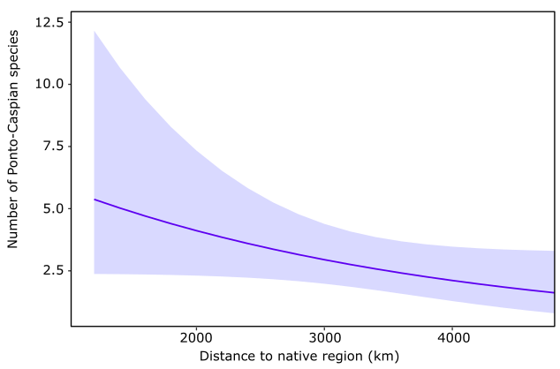
Figure S4: Relationship between the number of Ponto-Caspian species per time series and the average distance to their native Ponto-Caspian region.

Consecutive Ponto-Caspian species
The relationship between the time (in years; averaged across all time series) between sequentially occurring Ponto-Caspian macroinvertebrate species remained significantly negative with the rising number of alien species (R² = 0.86; d.f. = 13; p < 0.01; Figure S5).

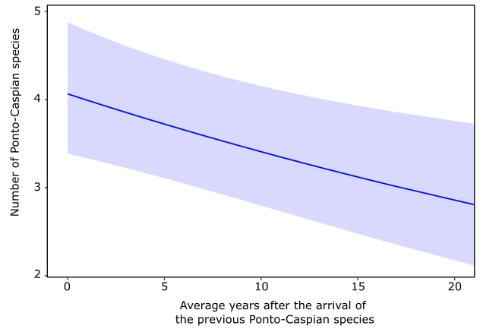.
Figure S5: Relationship between the averaged difference in years of sequentially detected Ponto-Caspian macroinvertebrate species per time series and the number of such species per time series.

Cumulative richness over time
We identified 27 Ponto-Caspian macroinvertebrate species in the 256 time series, i.e. all but S. ambulans and C. garbinii (Figure S6) We observed an increase in their cumulative richness, coinciding with the pattern presented in the main text.
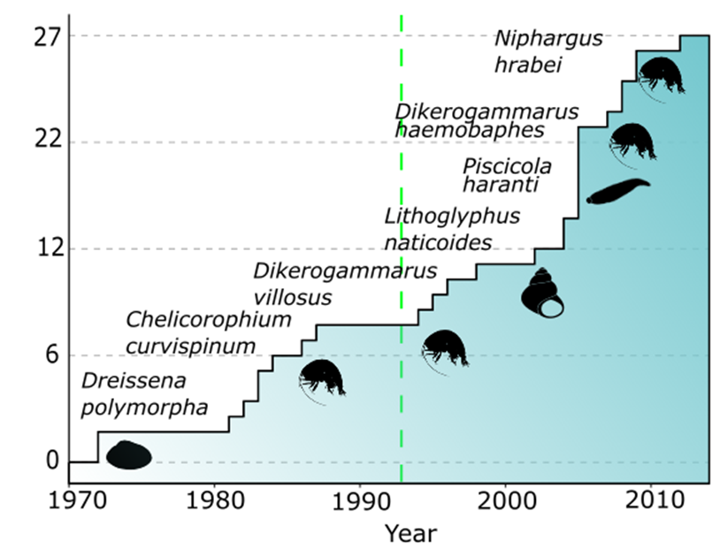
Figure S6: The cumulative richness of Ponto-Caspian macroinvertebrates detected over time. The green dashed line represents the opening of the Rhine-Main-Danube Canal in 1992.

ii) The effect of Hungarian time series

Distance to the native region
The relationship between the number of Ponto-Caspian macroinvertebrate species and the distance to their native region (Figure S7).
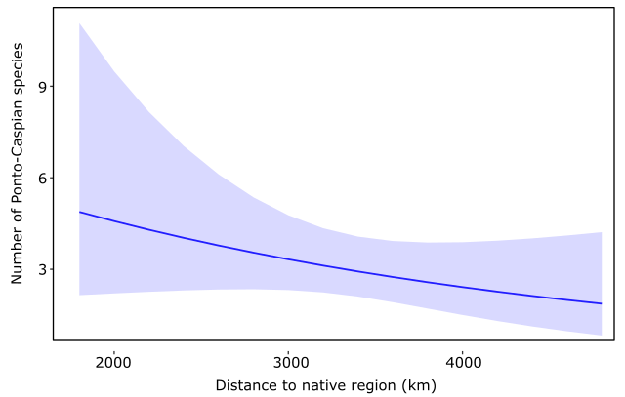
Figure S7: Relationship between the number of Ponto-Caspian species per time series and the average distance to their native Ponto-Caspian region..

Consecutive Ponto-Caspian species
There remained a significant decline in time to the next invasion with an increase in the number of alien species (R² = 0.81; d.f. = 8; p < 0.01; Figure S8).

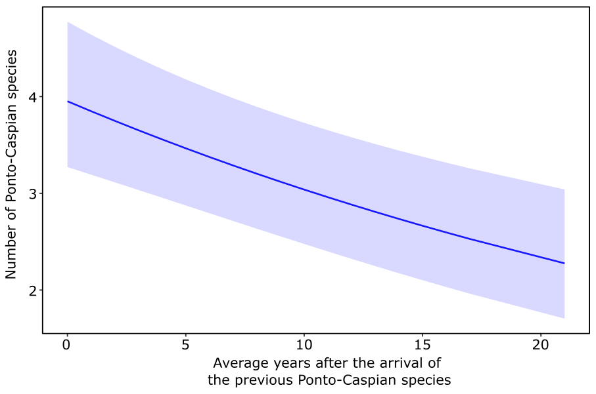
Figure S8: Relationship between averaged difference in years of consecutively appearing Ponto-Caspian macroinvertebrate species per time series and the number of Ponto-Caspian species per time series.

Cumulative richness over time
We identified 25 Ponto-Caspian macroinvertebrate species in the 191 time series remaining after excluding those collected in Hungary, reflecting the occurrence of four species (Katamysis warpachowskyi, Niphargus hrabei, Piscicola haranti and Synurella ambulans) only in Hungarian time series. We observed an increase in their cumulative richness, but the marked increase in 2005 (Figure 3)—which reflected the first year of many Hungarian time series—was replaced by a steadier increase over time.
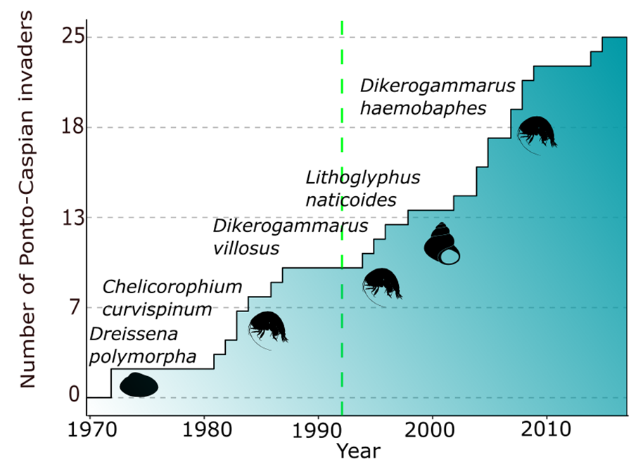
Figure S9: The cumulative richness of Ponto-Caspian macroinvertebrates detected over time. The green dashed line represents the opening of the Rhine-Main-Danube Canal in 1992.

Supplementary material Excel file: First record of Ponto-Caspian macroinvertebrates in each country
https://docs.google.com/spreadsheets/d/1ngrXMhqaU5LDA6C57mB9Ih88BTGDAevp/edit?usp=sharing&ouid=112604765661978933823&rtpof=true&sd=true

Country | C.fadejewi | C.caspia | C. curvispinum | C.robustum | D.romanodanubiale | D.bispinosus | D. haemobaphes | D.villosus | Dreissena polymorpha | D.rostriformis (bugensis) | E.ischnus | E.trichiatus | H. anomala | H. invalida | J. istri |  | K. warpachowskyi | L.benedeni | L.naticoides | N. hrabei | O.obesus | O. cavimana | P.haranti | P.robustoides | P. bavaricus | P.heuscheri | P. moldaviensis | P.vejdovskyi | P.s moravicus | S. ambulans
Austria | 2009 |  |  |  |  | 2008 |  | 2008 |  |  | 2008 | 2013 |  | 2011 | 2008 |  |  |  |  |  | 2014 |  |  |  | 2015 |  | 2011 | 2013 | 2008
Belgium |  |  |  |  |  |  |  |  |  |  |  |  |  |  | 2003
Denmark |  |  |  |  |  |  |  |  | 2000
France |  | 2018 | 2005 | 2017 |  |  | 2014 | 2000 | 1991 | 2018 |  |  | 2004 | 2004 | 2007 |  |  | 2010 | 2000
Germany |  | 1982 | 1983 | 2005 | 1986 |  | 2007 | 1994 | 1972 |  | 1972 | 2002 |  | 1995 | 1996 |  |  | 2013 | 2005 |  |  | 1983 |  | 2005 |  |  | 1993
Hungary | 2005 |  | 2005 | 2009 | 2007 | 2010 | 2005 | 2005 | 2005 | 2009 | 2005 | 2014 | 2010 | 2005 | 2005 | 2009 |  | 2005 | 2005 | 2012 | 2005 | 2012 | 2005 |  |  |  |  |  |  | 2005
Latvia |  |  |  |  |  |  |  |  | 1986 |  |  |  |  |  |  |  |  |  |  |  |  |  |  |  |  |  | 1997 | 2007 | 1987
Netherlands |  |  | 2003 | 2012 |  |  | 2012 | 2004 | 1991 | 2015 |  |  | 2007 | 2012 | 2013 |  |  | 2004 | 1998 |  |  | 2012 |  |  | 2008 | 1984 | 1981 |  | 2012
Spain |  |  |  |  |  |  |  |  | 2011
Switzerland |  |  |  |  |  |  |  | 2011 | 1995
United Kingdom |  |  | 2006 |  |  |  | 2012 |  | 2003 |  |  |  |  | 2012

