Supplementary material: Dynamic connectivity analyses to inform management of theinvasive American minkand a native species competitor, the European mink

Authors: Teresa Goicolea¹, Rebecca L. Lewison², M. Cruz Mateo-Sánchez¹, Megan K. Jennings¹
- ETSI Montes, Forestal y del Medio Natural, Universidad Politécnica de Madrid, Ciudad Universitaria s/n, 28040, Madrid, Spain
- Biology Department, San Diego State University, 5500 Campanile Drive, San Diego, CA 92182-4614, USA
APPENDIX S1. Climate variables selection

We first reduced the candidate set of bioclimatic variables according to ecological understanding of the species, response curves, correlation measures, and performance (AUC) of univariate ensemble models (i.e., combining different statistical: generalized linear models (GLM) (McCullagh and Nelder 1989), generalized additive models (GAM) (Hastie and Tibshirani 1986), generalized boosting models (GBM) (Friedman 2001), maximum entropy (MAXENT) (Phillips et al. 2006), multivariate adaptive regression splines (MARS) (Friedman 1991), and random forests (RF)). We selected a final set of predictors that were uncorrelated, meaningful, and relevant for the species. Table 1 shows the final selection of bioclimatic variables used.

We additionally checked whether current and future climatic conditions outside of the captured calibration range could be suitable for the species. This is especially important for invasive species whose distribution may not be found across the full extent of potentially suitable habitat in the invaded landscape. To assess the potential for future expansion, we compared the values of the bioclimatic variables across minks’ occurrences in Spain with those in their worldwide distribution. The minks’ Spanish and worldwide occurrences were downloaded from the Global Biodiversity Information Facility (GBIF.org). The Spanish occurrences of American mink were generally associated with the hottest and driest conditions of their global climatic range. Additionally, American minks’ occurrences in Spain were in the coldest and wettest regions of the country. This suggests that American mink has already reached all areas of suitable climate in Spain. Based on the general trend towards hotter and drier future climate conditions in Spain, we assumed that the future bioclimatic variables would not provide additional suitable habitat for American mink outside the range of the calibration range.

TABLE S2. Land-use suitability of each CORINE (European Union, Copernicus Land Monitoring Service 2018) land cover type: null suitability (0) for artificial uses, medium suitability (0.75) for agricultural uses, and the maximum suitability (1) for natural areas.

Code | Description | Land-use suitability
111 | Continuous urban fabric | 0
112 | Discontinuous urban fabric | 0
121 | Industrial or commercial units | 0
122 | Road and rail networks and associated land | 0
123 | Port areas | 0
124 | Airports | 0
131 | Mineral extraction sites | 0
132 | Dump sites | 0
133 | Construction sites | 0
141 | Green urban areas | 0
142 | Sport and leisure facilities | 0
211 | Non-irrigated arable land | 0.75
212 | Permanently irrigated land | 0.75
213 | Rice fields | 0.75
221 | Vineyards | 0.75
222 | Fruit trees and berry plantations | 0.75
223 | Olive groves | 0.75
231 | Pastures | 0.75
241 | Annual crops associated with permanent crops | 0.75
242 | Complex cultivation patterns | 0.75
243 | Land principally occupied by agriculture with significant areas of natural vegetation | 0.75
244 | Agro-forestry areas | 0.75
311 | Broad-leaved forest | 1
312 | Coniferous forest | 1
313 | Mixed forest | 1
321 | Natural grasslands | 1
322 | Moors and heathland | 1
323 | Sclerophyllous vegetation | 1
324 | Transitional woodland-shrub | 1
331 | Beaches, dunes, sands | 1
332 | Bare rocks | 1
333 | Sparsely vegetated areas | 1
334 | Burnt areas | 1
335 | Glaciers and perpetual snow | 1
411 | Inland marshes | 1
412 | Peat bogs | 1
421 | Salt marshes | 1
422 | Salines | 1
423 | Intertidal flats | 1
511 | Water courses | 1
512 | Water bodies | 1
521 | Coastal lagoons | 1
522 | Estuaries | 1
523 | Sea and ocean | 1

APPENDIX S3. Connectivity metrics.

The Equivalent Connected Area index (ECA) is defined as the area of a single habitat patch that would provide the same level of connectivity as the actual pattern of habitat patches in the whole landscape (Saura et al. 2011). The level of connectivity of the landscape was given by the Probability of Connectivity index (PC) (Saura and Pascual-Hortal 2007; Saura and Rubio 2010) which is the probability that two randomly selected points within the landscape fall into spatially connected habitat patches). PC is given by:

$$PC=\frac{\sum_{i=1}^{n}{\sum_{j=1}^{n}{a_{i}·a_{j}·p_{ij}^{*}}}}{A_{L}^{2}}$$

Where i and j are the source and destination patches, a_{i} and a_{j} their attributes (patch area in this case), n is the total number of patches, A_{L} is the maximum landscape attribute, and p_{ij}* the probability of connection between patches i and j, considering both direct dispersal and through intermediate stepping stones. The probability of connection through each link (p_{ij}) was inversely proportional to its effective distance. Probabilities of movement are considered to follow a negative exponential function of the link length, corresponding a 0.05 probability to the maximum effective dispersal distance of the focal species. Longer distances will imply lower probabilities of movement, while shorter paths are linked to a higher likelihood of connections. Although ECA and PC are equivalents we used ECA as it is in area units, and it is easier to interpret.

The adequacy and irreplaceability of patches to overall habitat availability and connectivity was calculated by the variation in PC when removing each individual path from the landscape. This variation is given by the differential of PC (dPC, Saura and Rubio, 2010):

$${dPC}_{k}=100· \frac{{PC}_{initial}-{PC}_{remove,k}}{{PC}_{initial}}$$

Where dPC_{k} is the individual contribution of patch k, PC_{initial} is the probability of connectivity, considering every landscape element (all the habitat patches and their connections), and PC_{remove,k} is the probability of connectivity after the removal of the patch or link k. A higher dPC_{k} value means a higher contribution of element k to overall connectivity. Therefore, the removal of patches or links with a high dPC will imply a great loss in terms of habitat availability and connectivity, and thus, will be priority areas and links for conservation measures.

Table S4. Mean AUC, TSS, and Kappa of the ten cross-validation runs of every individual and ensemble climatic suitability model. The individual models correspond to: generalized linear models (GLM), generalized additive models (GAM), generalized boosting models (GBM), maximum entropy (MAXENT), multivariate adaptive regression splines (MARS), and random forests (RF).

 | AUC |  | TSS |  | KAPPA
Statistical technique | American mink | European mink | American mink | European mink | American mink | European mink
GLM | 0.85 | 0.97 | 0.51 | 0.92 | 0.47 | 0.87
GAM | 0.88 | 0.98 | 0.52 | 0.91 | 0.49 | 0.86
GBM | 0.90 | 0.97 | 0.74 | 0.94 | 0.70 | 0.90
MAXENT | 0.86 | 0.92 | 0.53 | 0.87 | 0.50 | 0.83
MARS | 0.86 | 0.97 | 0.52 | 0.94 | 0.50 | 0.91
RF | 0.94 | 0.98 | 0.60 | 0.93 | 0.57 | 0.90
Ensemble model | 0.89 | 0.99 | 0.60 | 0.94 | 0.59 | 0.91

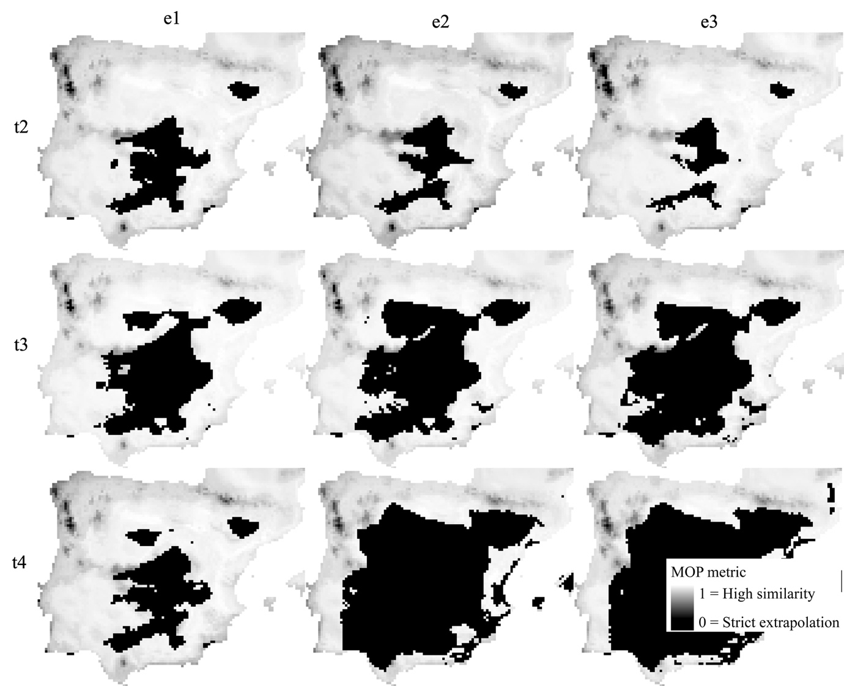

FIG S5. Mobility-oriented parity metric for each scenario combination of t2, t3, and t4 periods (2011-2040, 2041-2070, 2071-2100 respectively) with e1, e2, and e3 emission scenarios (shared socio-economic and emissions pathways 126, 375 and 585 respectively). The MOP values represent the degree of similarity between the future climatic conditions and the calibration climate conditions correspondent to the historic period (1985-2010), wherein values of zero correspond to areas of strict extrapolation.

Table S6. Number of habitat patches, total suitable area (sum of the area of all habitat patches), and mean patch area for American and European minks, each period t1, t2, t3, and t4 (1985-2010, 2011-2040, 2041-2070, 2071-2100 respectively), and each emission scenarios e1, e2, and e3 (shared socio-economic and emissions pathways 126, 375 and 585 respectively).

Species | Period | Emission scenario | Number of nodes | Total suitable area (ha) | Mean patch size (ha)
American mink | t1 | - | 1156 | 1941853.16 | 1679.80
American mink | t2 | e1 | 770 | 1463830.28 | 1901.08
American mink | t2 | e2 | 830 | 1543740.03 | 1859.93
American mink | t2 | e3 | 829 | 1610170.67 | 1942.30
American mink | t3 | e1 | 674 | 1160428.91 | 1721.70
American mink | t3 | e2 | 583 | 1038238.87 | 1780.86
American mink | t3 | e3 | 720 | 1124220.92 | 1561.42
American mink | t4 | e1 | 745 | 1667508.83 | 2238.27
American mink | t4 | e2 | 657 | 927345.56 | 1411.48
American mink | t4 | e3 | 660 | 821075.01 | 1244.05
European mink | t1 | - | 384 | 617170.46 | 1607.21
European mink | t2 | e1 | 352 | 526011.36 | 1494.35
European mink | t2 | e2 | 388 | 548289.98 | 1413.12
European mink | t2 | e3 | 393 | 464564.08 | 1182.10
European mink | t3 | e1 | 305 | 514131.73 | 1685.68
European mink | t3 | e2 | 297 | 494500.51 | 1664.98
European mink | t3 | e3 | 298 | 390377.69 | 1309.99
European mink | t4 | e1 | 206 | 231652.03 | 1124.52
European mink | t4 | e2 | 150 | 114224.64 | 761.50
European mink | t4 | e3 | 176 | 124447.08 | 707.09

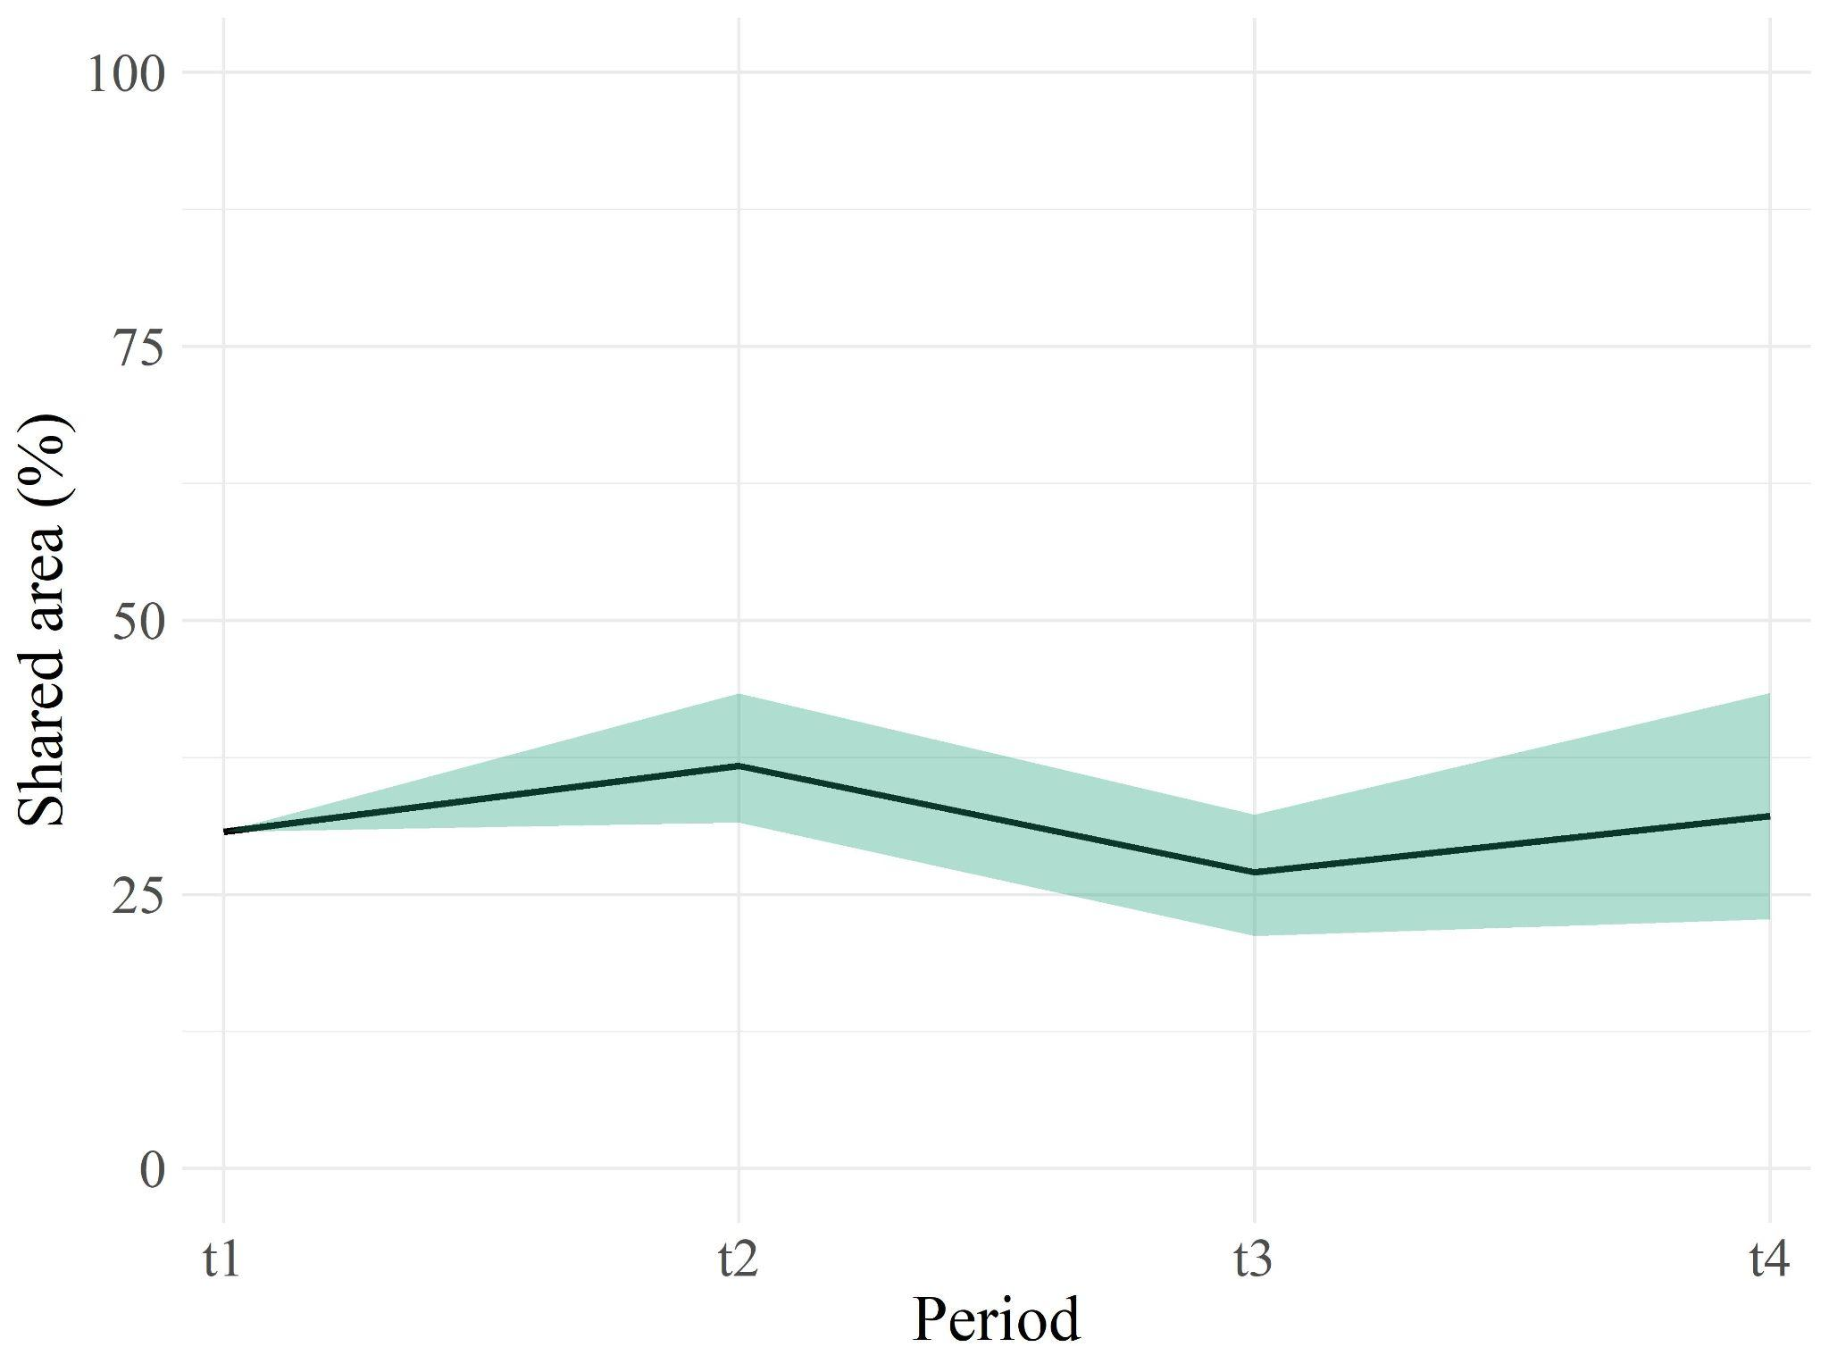
Fig. S7. The proportion of suitable habitat area for the European mink that overlaps with the suitable habitat for the American mink for the periods t1, t2, t3, and t4 (1985-2010, 2011-2040, 2041-2070, 2071-2100 respectively). The central line shows the mean across the three emission scenarios and the shaded area represents the range between the minimum and the maximum.

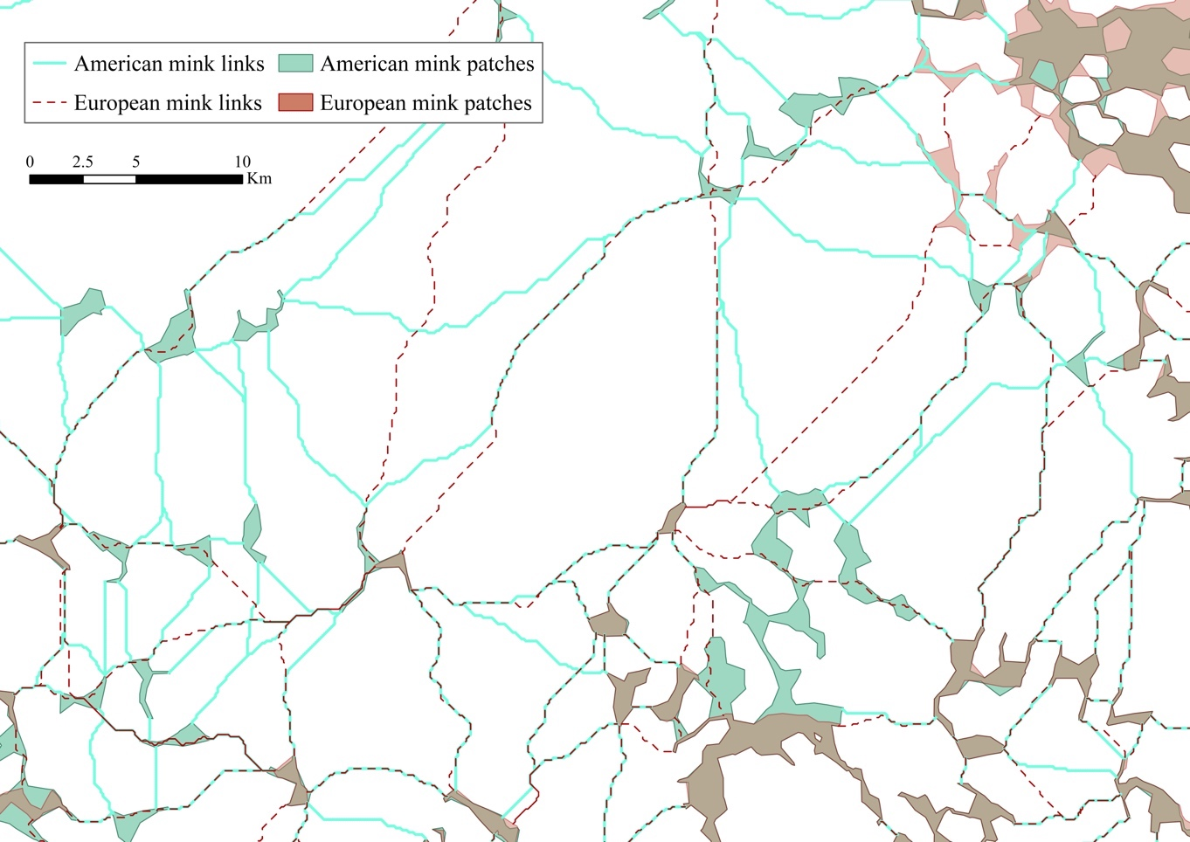

Fig. S8. Detail of American and European mink habitat patches and links in t1 (1985-2010).

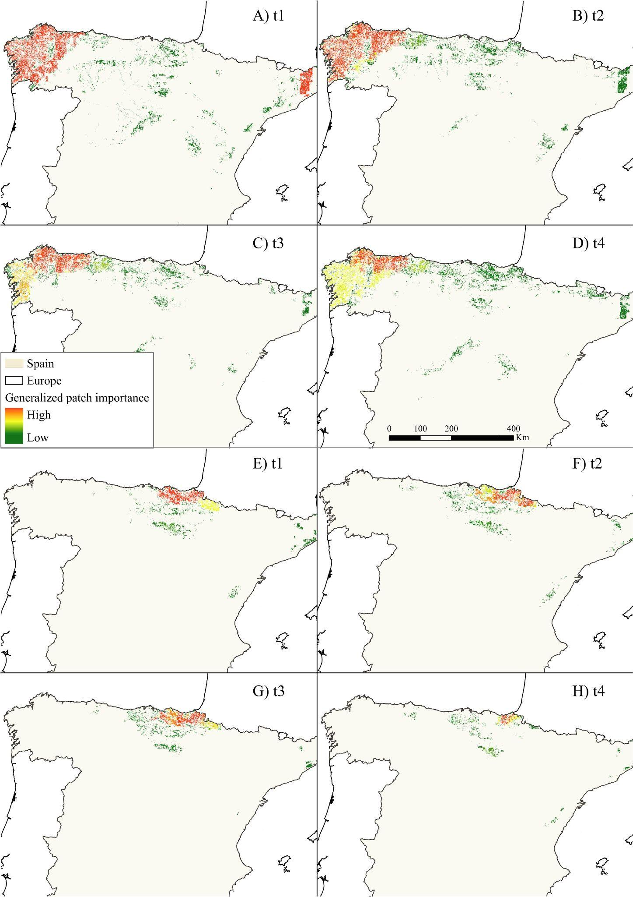
Fig. S9. Variation in the generalized patch importance of American mink (A, B, C, and D) and European mink (E, F, G, H) according to the periods t1, t2, t3, and t4 (2011-2040, 2041-2070, 2071-2100 respectively).
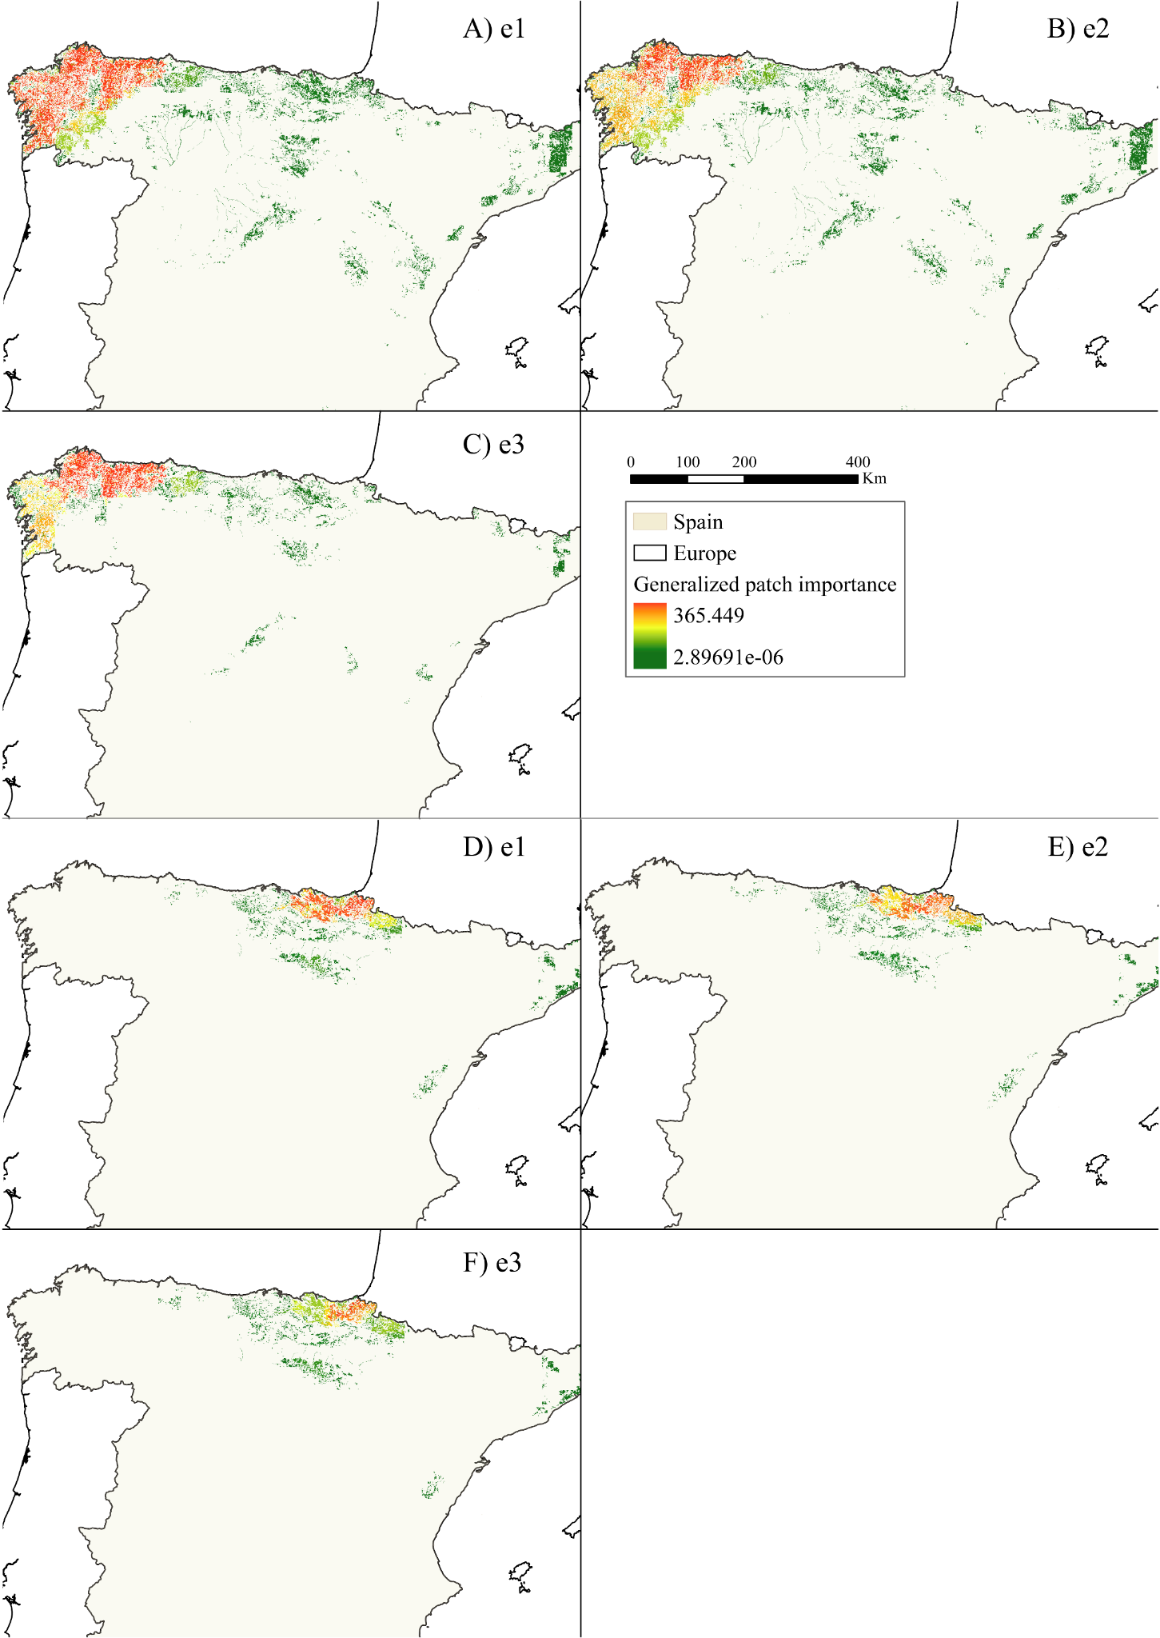
Fig. S10. Variation in the generalized patch importance of American mink (A, B, and C) and European mink (D, E, and F), according to the emission scenarios e1, e2, and e3 (shared socio-economic and emissions pathways 126, 375 and 585 respectively).

