Supplementary Material
Table S1: Hot spot map classes summarized by subregion, ranked by percent area covered by hot spots. Area approximated in hectares using tabulated pixel totals.
 | Hot Spot |  | Ephemeral |  | None
Mojave Desert Subregion | Total Area (ha) | % | Total Area (ha) | % | Total Area (ha) | %
Western Mojave Basins | 181,027,305 | 13.03 | 1,133,064,936 | 81.57 | 74,987,370 | 5.40
Eastern Mojave Mountain Woodland and Shrubland | 16,397,235 | 7.64 | 193,485,834 | 90.12 | 4,814,478 | 2.24
Western Mojave Low Ranges  and Arid Footslopes | 85,194,828 | 7.05 | 1,090,975,878 | 90.26 | 32,542,236 | 2.69
Eastern Mojave Basins | 147,146,625 | 4.96 | 2,674,961,658 | 90.19 | 143,723,403 | 4.85
Eastern Mojave Low Ranges and Arid Footslopes | 119,136,906 | 4.37 | 2,536,673,598 | 93.08 | 69,368,724 | 2.55
Arid Valleys and Canyonlands | 21,146,994 | 4.15 | 472,895,496 | 92.71 | 16,023,177 | 3.14
Lower Grand Canyon | 5,706,531 | 2.92 | 180,326,412 | 92.15 | 9,664,596 | 4.94
Mojave Lava Fields | 721,143 | 1.97 | 34,816,635 | 95.05 | 1,090,341 | 2.98
Western Mojave Mountain Woodland and Shrubland | 1,052,919 | 1.31 | 67,803,723 | 84.37 | 11,506,131 | 14.32
Eastern Mojave High Elevation Mountains | 101,493 | 0.40 | 22,206,798 | 86.46 | 3,376,890 | 13.15
Western Mojave High Elevation Mountains | 19,845 | 0.33 | 4,313,979 | 72.56 | 1,611,657 | 27.11
Mojave Playas | 95,418 | 0.07 | 87,520,176 | 60.25 | 57,653,289 | 39.69
Amargosa Desert | 200,313 | 0.04 | 483,519,375 | 85.09 | 84,520,908 | 14.87
Death Valley/Mojave Central Trough | 19,764 | 0.00 | 487,240,596 | 81.69 | 109,161,675 | 18.30
Mesquite Flat/Badwater Basin | 405 | 0.00 | 32,839,020 | 48.22 | 35,259,057 | 51.78
Mojave Sand Dunes | 0 | 0.00 | 14,970,015 | 50.60 | 14,616,045 | 49.40

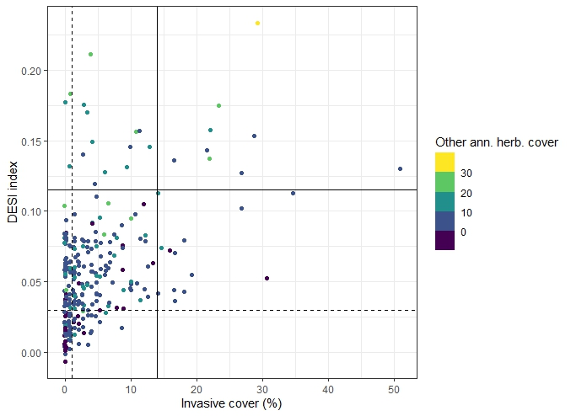
Figure S1: Graphical representation of DESI thresholding methods. Combinations of target species and spectral and spatial thresholds were experimented to maximize classification accuracy. Solid line represents a high threshold with high confidence in invasive annual presence, low risk of false positives. Dashed line represents a low threshold for higher sensitivity of pixels with low invasive annual cover, higher risk of false positives.

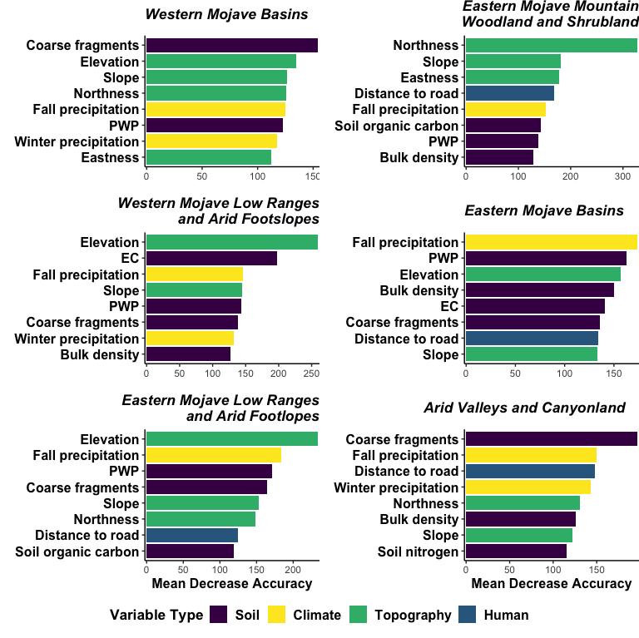
Figure S2: Subregional random forest variable importance of most persistently invaded level IV ecoregions, ranked by contribution of accuracy to the model and grouped by variable type. PWP and EC refer to percent weight at wilting point and electrical conductivity, respectively.

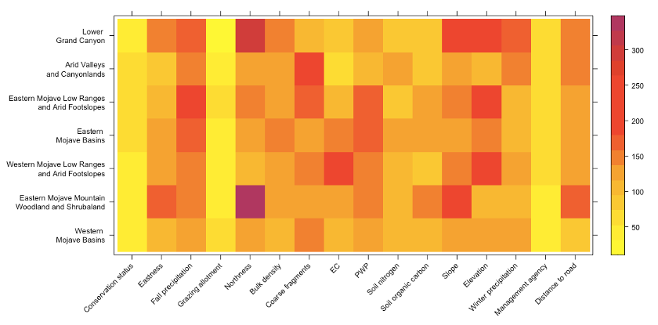
Figure S3: Heat map of subregional random forest variable importance of most persistently invaded level IV ecoregions, ranked by contribution of accuracy to the model and grouped by variable type. PWP and EC refer to percent weight at wilting point and electrical conductivity, respectively.

Subregional Kernel Density Plots
Western Mojave Basins
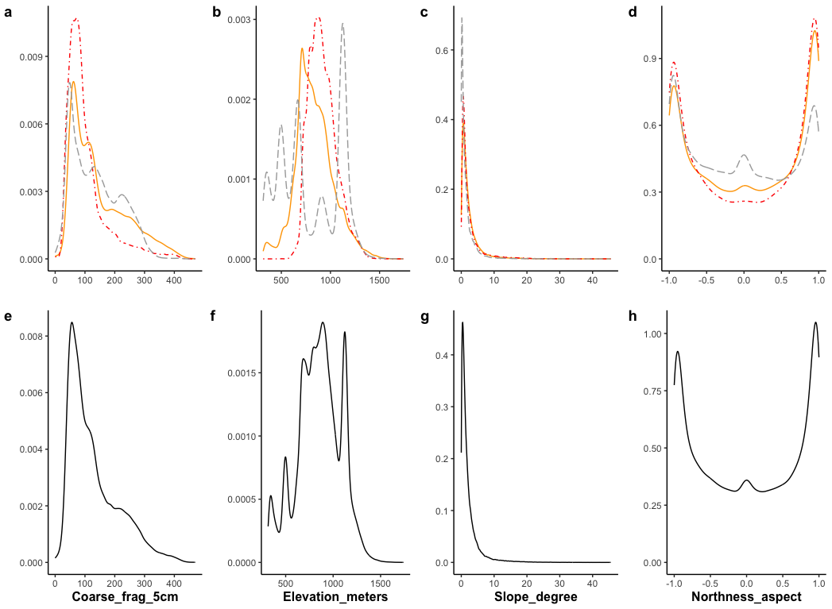
Figure S4: Kernel density plots of top-ranked variables in Western Mojave Basins. Grouped kernel density plots separated by hot spot response group (a–d), and overall distribution of top-ranked variables (e–h). Red - hot spots; yellow - ephemeral; grey - none. Variables included: coarse fragments (cm³/dm³); elevation (m); slope (degrees), northness.

Eastern Mojave Mountain Woodland and Shrubland
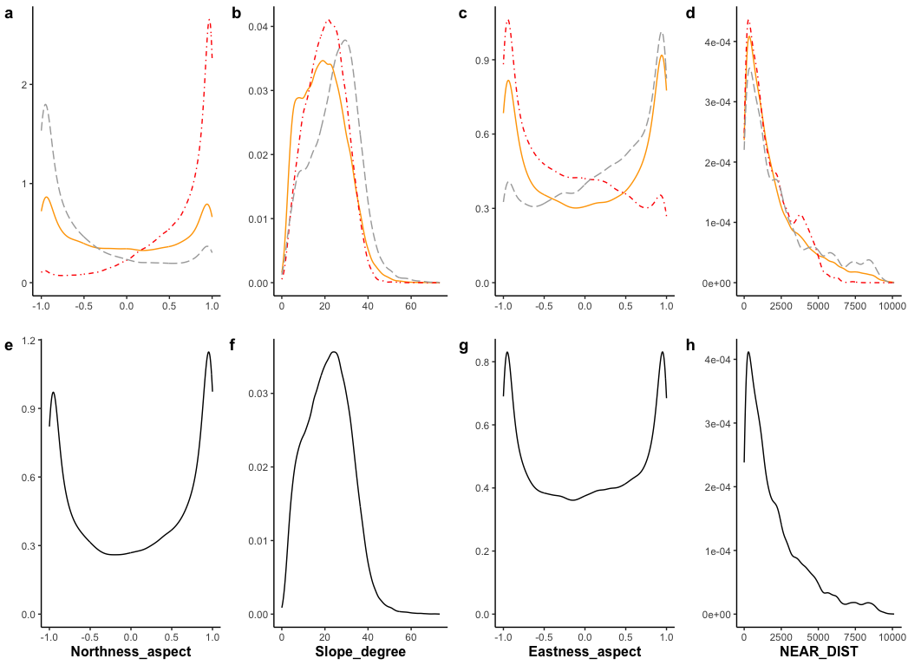
Figure S5: Kernel density plots of top-ranked variables in Eastern Mojave Mountain Woodland and Shrubland. Grouped kernel density plots separated by hot spot response group (a–d), and overall distribution of top-ranked variables (e–h). Red - hot spots; yellow - ephemeral; grey - none. Variables included: northness; slope (degrees); eastness; distance to nearest road (m).

Western Mojave Low Ranges and Arid Footslopes
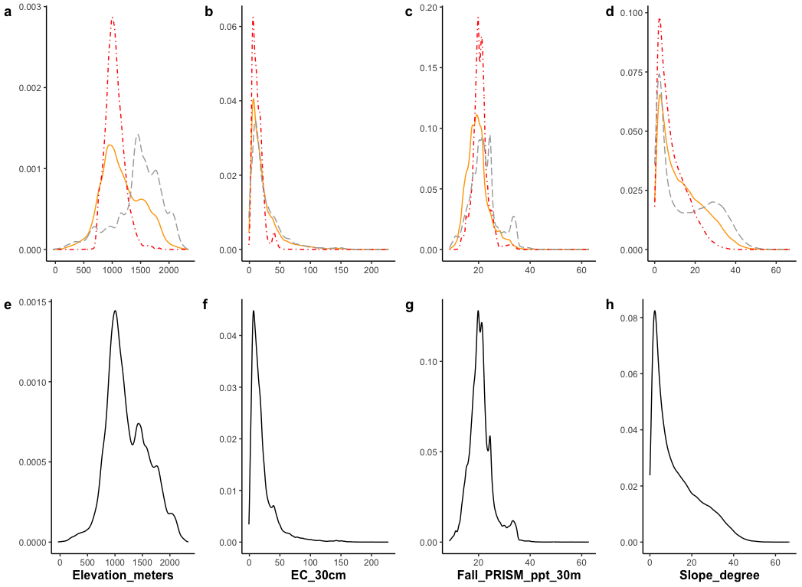
Figure S6: Kernel density plots of top-ranked variables in Western Mojave Low Ranges and Arid Footslopes. Grouped kernel density plots separated by hot spot response group (a–d), and overall distribution of top-ranked variables (e–h). Red - hot spots; yellow - ephemeral; grey - none. Variables included: elevation (m); electrical conductivity (mS/m); fall precipitation (cm); slope (degrees).

Eastern Mojave Basins
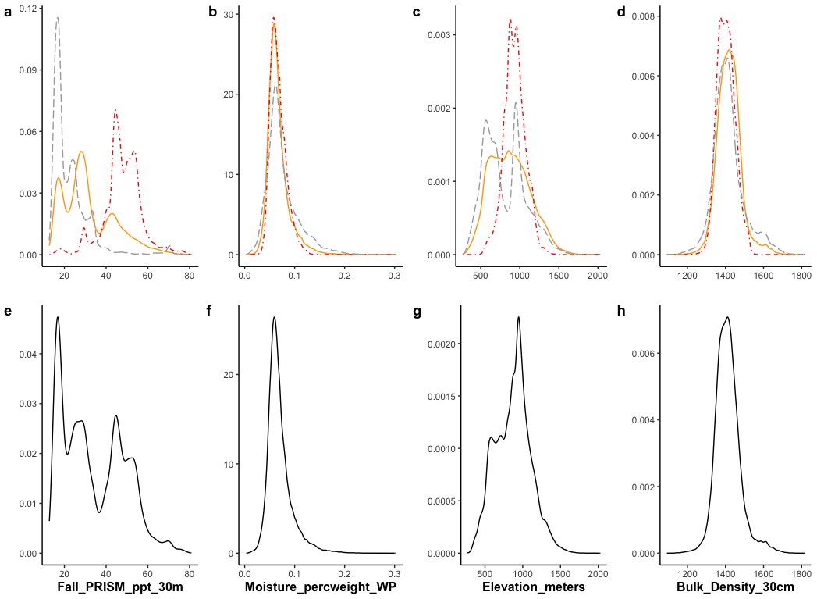
Figure S7: Kernel density plots of top-ranked variables in Eastern Mojave Basins. Grouped kernel density plots separated by hot spot response group (a–d), and overall distribution of top-ranked variables (e–h). Red - hot spots; yellow - ephemeral; grey - none. Variables included: fall precipitation (cm); PWP (%); elevation (m); bulk density (kg m⁻³).

Eastern Mojave Low Ranges and Arid Footslopes

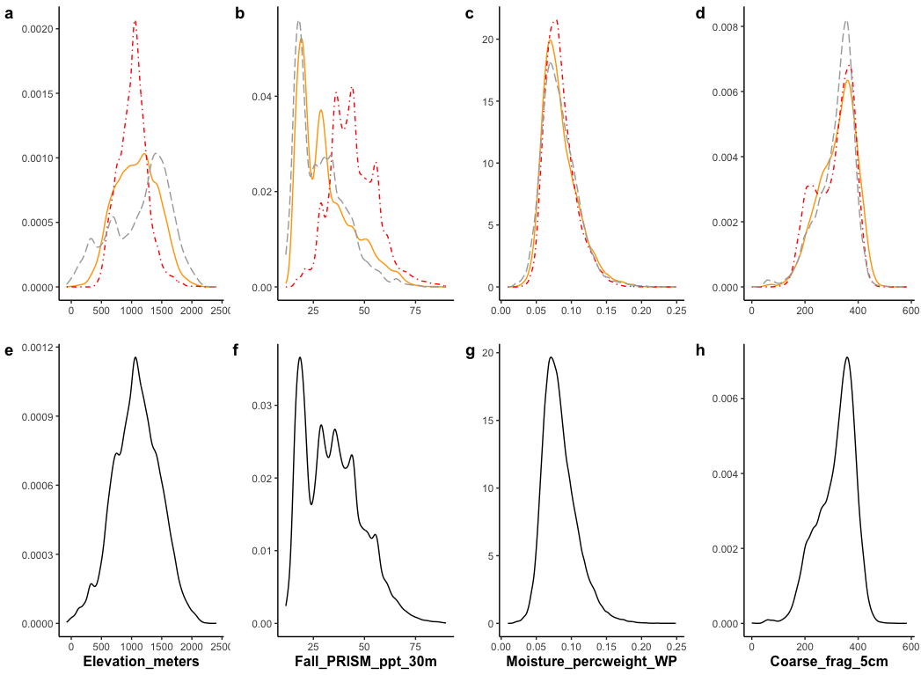
Figure S8: Kernel density plots of top-ranked variables in Eastern Mojave Low Ranges and Arid Footslopes. Grouped kernel density plots separated by hot spot response group (a–d), and overall distribution of top-ranked variables (e–h). Red - hot spots; yellow - ephemeral; grey - none. Variables included: elevation (m); fall precipitation (cm); PWP (%); coarse fragments (cm³/dm³).

Arid Valleys and Canyonlands
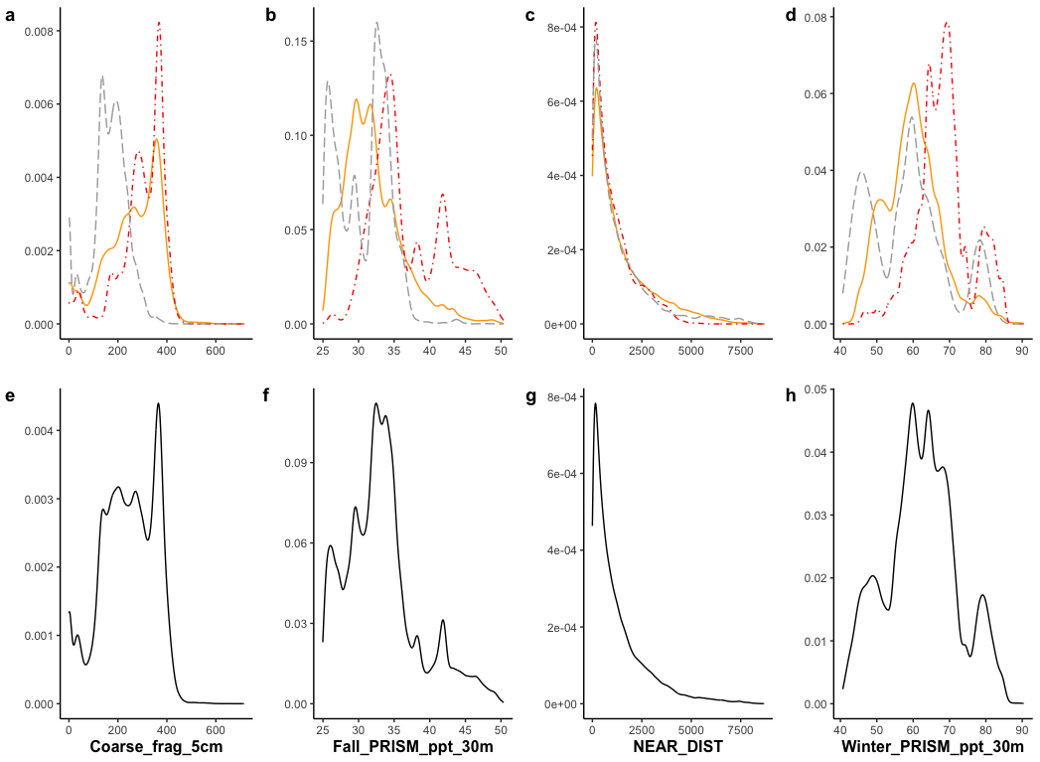
Figure S9: Kernel density plots of top-ranked variables in Arid Valleys and Canyonlands. Grouped kernel density plots separated by hot spot response group (a–d), and overall distribution of top-ranked variables (e–h). Red - hot spots; yellow - ephemeral; grey - none. Variables included: coarse fragments (cm³/dm³); fall precipitation (cm); distance to nearest road (m); winter precipitation (cm).

