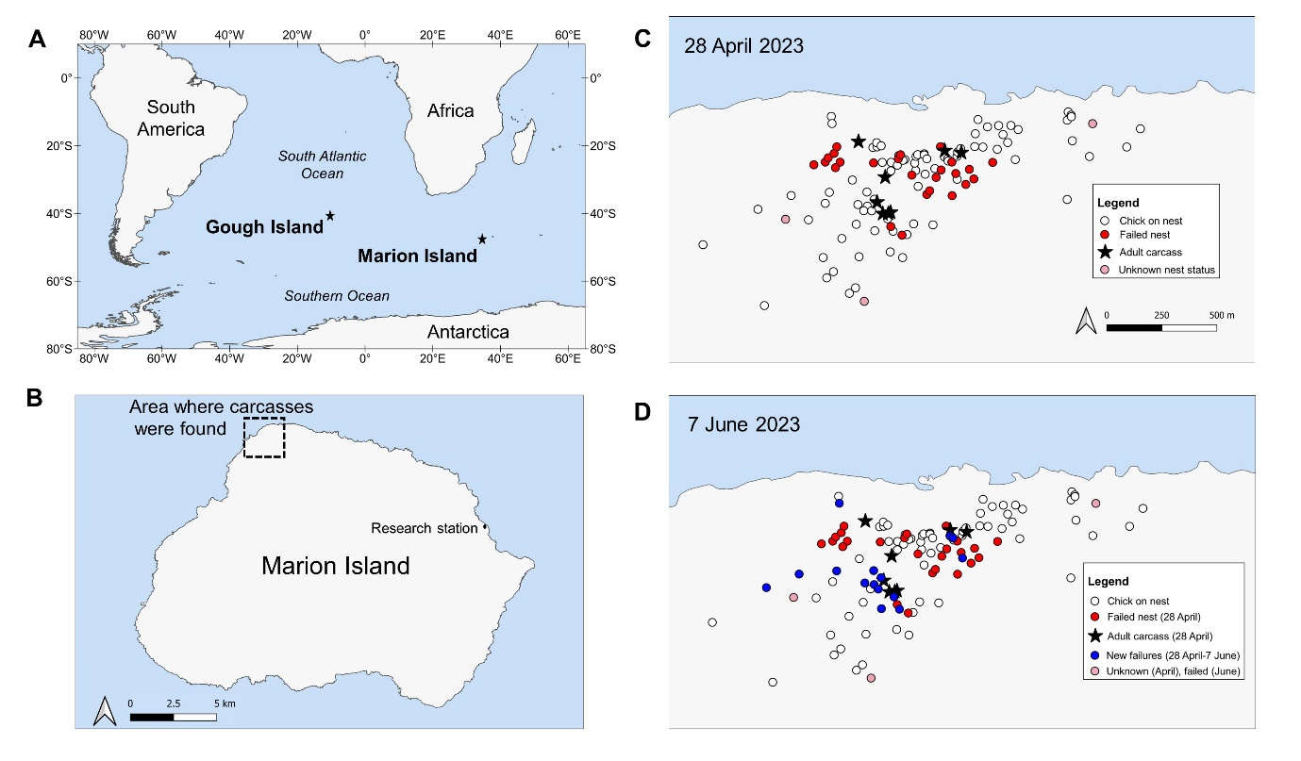
Online Resource 1: Location of Gough and Marion Islands (A), the area where carcasses were recorded on Marion Island (B), the location of nests with chicks, failed nests and adult Wandering Albatross carcasses recorded on 28 April 2023 (C) and 7 June 2023 (D). Pink circles in Figure 1C represent nests of which the status (active or failed) was uncertain.

