Supplementary Information (SI)

Factors influencing naturalisation success in woody horticultural species: A case study of planting records from the inception of a planned city
Biological Invasions
Rakhi Palit^{1, 2}, Paul O Downey¹ & Richard P Duncan^{1*}

¹Centre for Conservation Ecology and Genomics, Institute for Applied Ecology, University of Canberra, Canberra, ACT, 2617, Australia
²School of Natural Resource Sciences, North Dakota State University, Fargo, ND 58102, USA
*Email of corresponding author: rakhi.palit@ndsu.edu

SI 1.
Planting records prior to the establishment of Canberra (1830-1911)
Before the establishment of the city of Canberra, the area was farmland with numerous homesteads. There are records, dating back to the 1830s, of non-native woody plant species being planted around these homesteads and as shelterbelts (Mulvaney, 1991). The primary purpose of these non-native woody plantings was for shelter and for edible fruits and nuts, although some garden species were also planted. Although direct evidence of which species of trees and shrubs were planted in the region is scarce, information on the likely plants grown in the region were extracted from several archived and historically documented sources by Mulvaney (1991), specifically: (a) the nursery catalogues of MacArthur, who was Australia's main nurseryman during that period, and who was known to supply plants to the Canberra region, and, (b) archived newspapers, specifically, the area’s first newspaper ‘The Golden Age’ (later ‘The Queanbeyan Age’) which was first published in the 1860s. The newspaper contained gardening advertisements that listed species available for sale at that time in the region. The most frequent nursery advertisements were from four nurseries (Goulburn Seed and Nursery Company, A. Landsdowne & Sons, Seedsman, and Plant Merchants). The Goulburn Seed and Nursery Company provided the primary guide to the plants sold in the Canberra region during this period ( Mulvaney, 1991). Once Mulvaney had identified the principal and most plausible sources of non-native plant species in the region, he compiled a dataset of the woody plant species listed (i.e., in newspaper advertisements and nursery catalogues) for the Canberra region covering the period 1830 to 1911 (85 years). Despite being from a range of data sources, these early planting records are essential as they provide an extended timeframe for examining naturalisation and invasion rates.
Planting records from the establishment of Canberra – the Yarralumla nursery (1912-1990)
The establishment of Canberra as the nation’s capital, led to the creation of the Yarralumla Nursery in 1911, exclusively to grow plants for the new capital city during its development (Coltheart, 2011). Charles Weston, the founder of Yarralumla Nursery, established the nursery and an experimental site on which many plant species were tested for suitability in Canberra's climate. For this, in addition to Goulburn nursery, large numbers of plants were imported from different nurseries in Sydney, the countryside of NSW, Melbourne, and New Zealand. The Yarralumla Nursery was a government-run nursery, and detailed annual records were kept by the nursery and associated government agencies of what was grown, trialled, and planted (Coltheart, 2011). Mulvaney (1991) used these archived records to compile a detailed record of deliberate plantings in the Canberra urban region. Due to time constraints, Mulvaney sub-sampled the records by only examining records from three random years per decade (1912-1984). The years Mulvaney sampled were 1912, 1915, 1918, 1923, 1924, 1928, 1930, 1934, 1936, 1946, 1948, 1949, 1952, 1953, 1960, 1963, 1966, 1969, 1972, 1975, 1978, 1981, and 1984. For each of these years, Mulvaney examined the records and recorded the number of individuals recorded as planted by species. We assumed that the years Mulvaney chose are representative and provide a good relative measure of planting effort for each species over this period.
For the period between 1912 and 1924, detailed information including lists of the imported plant species, how successful they were, and how widely they were planted was well documented. These records were contained in nursery files of inwards and outwards correspondence for the Yarralumla Nursery, and in the personal diaries and notes of Charles Weston; these documents are held in the Australian Archives in Canberra. During this period (1912-1924), approximately forty thousand plants were distributed to landholders in the territory, in addition to the 15,000 plants that were planted around the growing city. Nursery activities increased substantially in the post-war period (i.e., after 1945). By 1950, a total of 40,000 individual trees and shrubs were established in public areas, and street trees had been planted in many suburbs using plants from the Yarralumla Nursery. Additionally, 20,000 plants were given to householders for planting in residential blocks (Mulvaney, 1991; Unpublished manuscripts A431 \ 1273 and 1274 file number in ACT archives). During the 1950s, there were approximately 4500 residential and garden plots in Canberra. Yarralumla Tree planting activities between 1940 and 1966 were summarised from the correspondence files held at the Parks and Gardens archive, the Department of Capital Territories archive, and at the Australian. Since 1966, the government nursery had considerably lower stocks of plants; those records were available from Yarralumla nursery and the Parks and Garden archive repositories.
Additional sources of planting records for the Canberra region: Willow Park Nursery and The Canberra Gardener (1932-1990)
Of the seven major private nurseries in Canberra in the late 1980s approached by Mulvaney (1991), only Willow Park allowed him to examine their ordering records. These records were used to supplement the Yarralumla Nursery data (see above). Willow Park nursery is Canberra’s oldest non-government nursery (established in 1932), which is still in business and is the source of some of the oldest horticultural plantings in Canberra. The records of Willow Park and Yarralumla nurseries provided data on the number of individuals of each species planted for each year surveyed, while information from ‘The Canberra Gardener’ and the nursery catalogues helped determine the probable period when a species was first introduced to Canberra (introduction period).
Between 1948 and 1982, the Canberra Horticultural Society published seven editions of ‘The Canberra Gardener’ (Hutton & Shakespeare, 1948; Hutton & Shakespeare, 1951), a guide to the plant species that grow in and around Canberra (including non-native plants). The list of plant species contained in ‘The Canberra Gardener’ identifies the plant species most likely sold in the private nurseries around Canberra. Although the inclusion of species listed in ‘The Canberra Gardener’ expanded the list of species planted in the Canberra region, it needed some means of indexing to get an estimate of the number of plants introduced for each species. To address this issue, Mulvaney (1991) used a multiplier for ‘The Canberra Gardner’ records to estimate the relative planting number for each species, such that mention of a species per edition was equivalent to a nursery record of fifty individuals being planted. The value of 50 was arbitrary but distinguished frequently listed plants from those not listed or irregularly listed. To confirm whether the choice of 50 is an appropriate value, we ran all my analyses with and without records from ‘The Canberra Gardener’, and we also ran my analyses assuming each record in ‘The Canberra Gardner’ was equivalent to 1, 25, 100, and 200 individuals being planted. None of these changes altered the key findings. In total, Mulvaney (1991) found planting records for 2,517,377 individual plants comprising 2,147 species.

SI 2. Palit et al Canberra naturalised plants dataset. Complete data set, listing all the species which naturalised (updated_nat_status=1) and those failed to naturalise (updated_nat_status=0), and their traits.

Table SI 1. List of plant introduction periods and number of species in each category, including missing values and number of naturalised and invasive species. There was a total of 1439 species, among them 128 were naturalised in Canberra.
Category Total number of species Number of naturalised species
1= <1851 290 57
2= 1851-1870 239 18
3= 1871- 1890 183 9

4= 1891-1910 185 14
5= 1911-1930 54 11
6= 1931-1950 96 12
7=1951-1970 93 2
8= > 1970 299 5

Table SI 2. List of hardiness zones and number of species in each category, including missing values and number of naturalised and invasive species. There were a total of 1439 species, among them 128 were naturalised in Canberra.
Category Total number of species Number of naturalised species
H1 233 34
H2 207 27
H3 230 27
H4 211 22
H5 291 14
G1 117 3
G2 66 1
Missing 84 0
Table SI 3. List of dispersal modes and number of species in each category, including missing values and number of naturalised and invasive species. There were a total of 1439 species, among them 128 were naturalised in Canberra.
Category Total number of species Number of naturalised species
External animal transport 49 10

Internal animal transport 324 66

Unassisted dispersal 69 2

Water dispersal 16 3

Wind dispersal 220 38

Missing value 761 9

Table SI 4. List of traits (continuous variables) variables and their categories, and the number of species in each category, including missing values and number of naturalised species. There were a total of 1439 species, among them 128 were naturalised.
Trait Category Total number of species Number of naturalised
Height Values 1389 128
Missing 50 0

Seed mass Values 759 107
Missing 680 21

Supplementary figures.

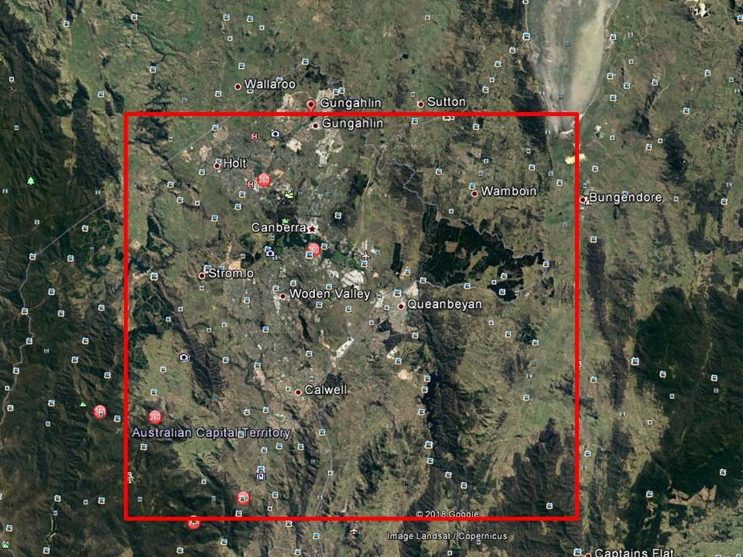
Fig. SI-1: Map showing the urban areas in Canberra, and the rectangle (in red) used to define the area in which naturalisation records from the AVH were confined to (see text for details).

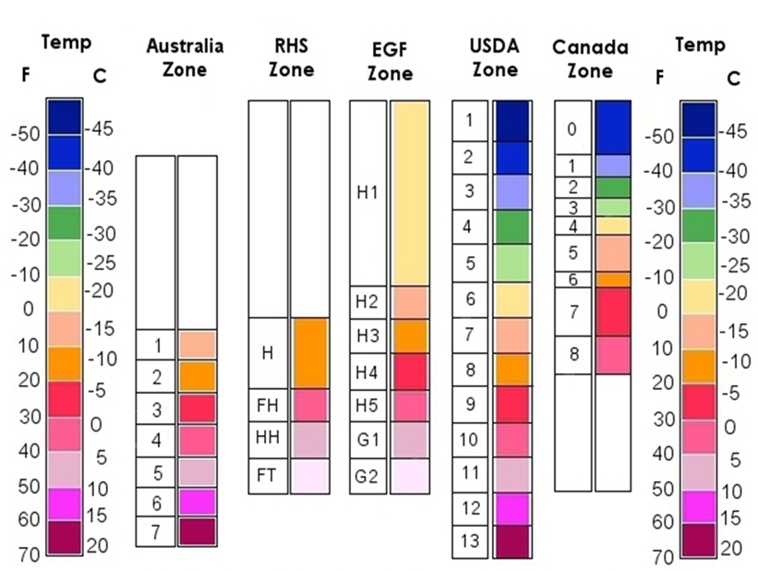

RHS= Royal Horticultural Society, EGF=European Garden Flora,
USDA=U.S. Department of Agriculture

Fig. SI-2: Definitions of hardiness zones from different countries (taken from http://www.edible-landscape-design.com/planting-zone.html)

