Supplement 2. Model grid

Using Biophysical modelling and marine connectivity to assess the risk of natural dispersal of non-indigenous species to comply with the Ballast Water Management Convention

Flemming Thorbjørn Hansen^{1,2}*, Ane Pastor³, Asbjørn Christensen¹, Frank Stuer-Lauridsen⁴

¹ DTU AQUA, National Institute of Aquatic Resources, Kemitorvet 1, 2800 Kgs. Lyngby, Denmark

² Present address: DHI A/S, Agern Alle 5, 2970 Hørsholm, Denmark

³School of Life and Environmental Sciences, Centre for Marine Science, Deakin University, Queenscliff, Victoria, 3220, Australia

⁴ Litehauz Aps, 2800 Kgs. Lyngby, Denmark

* Corresponding author: flth@dhigroup.com

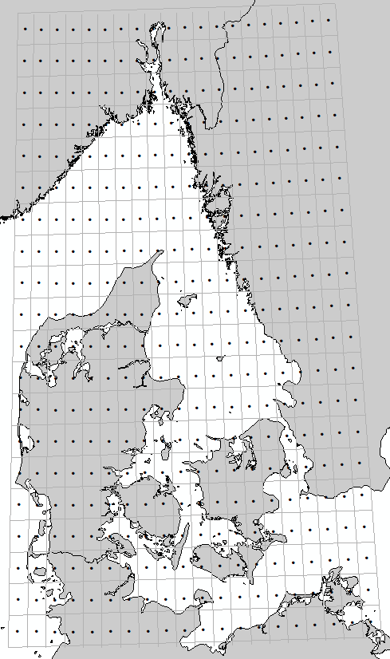
Figure S1. Subdivision of the model domain into subareas (grid lines) as a basis for analysing marine connectivity. The subdivision is based on a regular grid of 20x20 grid cells covering the extent of 8o- 14o E and 54 o- 60 o N each grid cell with a spatial resolution of 0.3 degree in both the longitudinal and latitudinal directions. Nodes indicate the centroid of each grid cell. Notice the map is displayed as projected data in UTM 32 N - WGS84.

