Supplement 4. Cluster analysis

Using Biophysical modelling and marine connectivity to assess the risk of natural dispersal of non-indigenous species to comply with the Ballast Water Management Convention

Flemming Thorbjørn Hansen^{1,2}*, Ane Pastor³, Asbjørn Christensen¹, Frank Stuer-Lauridsen⁴

¹ DTU AQUA, National Institute of Aquatic Resources, Kemitorvet 1, 2800 Kgs. Lyngby, Denmark

² Present address: DHI A/S, Agern Alle 5, 2970 Hørsholm, Denmark

³School of Life and Environmental Sciences, Centre for Marine Science, Deakin University, Queenscliff, Victoria, 3220, Australia

⁴ Litehauz Aps, 2800 Kgs. Lyngby, Denmark

* Corresponding author: flth@dhigroup.com

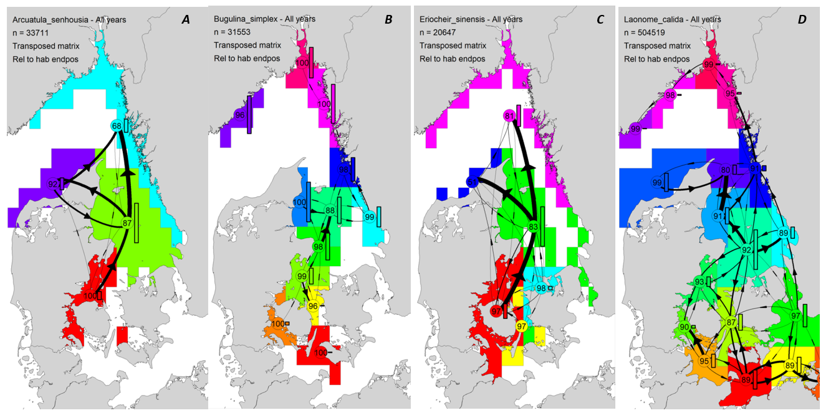

Figure S2. Cluster analysis of transposed (import) connectivity matrices of the simulated agent trajectories for A. senhousia (A), B. simplex (B), E. sinensis (C) and L. calida (D). Each cluster is represented by a polygon with a unique colour. Values in cluster centroids (circles) indicate the self-recruitment within each cluster (in % of the total no. of agents settled). Similarly, the thickness of arrows represents the import of agents between clusters, calculated relative to the total number of agents settled. Bars beside each cluster centroid indicate the proportion of agents that define each cluster relative to the cluster based on the highest number of agents. An upper threshold for arrow thickness was set to 10%.

