Supplementary Information: Russian olive distribution and invasion dynamics along the Powder River, Montana and Wyoming, USA

S1. Remote Sensing of Russian Olive Cover

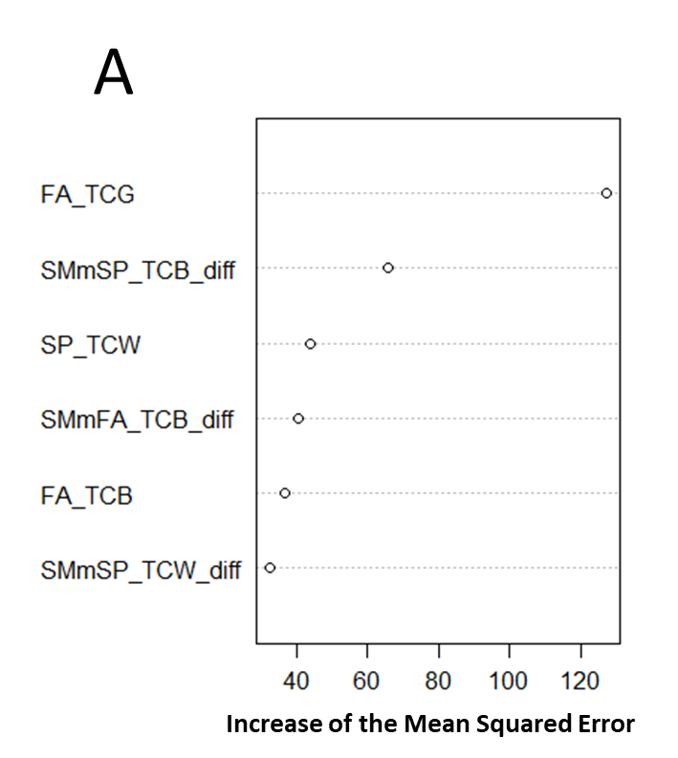
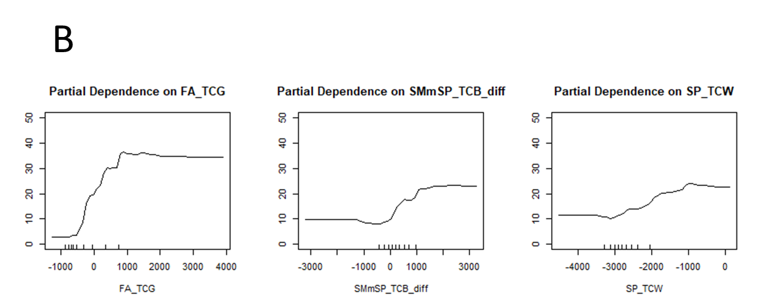

Figure S1.1 A) Variable importance plot for the remote sensing of Russian olive cover using the random forest algorithm. These are the six predictor variables used in the model, and their importance ( FA_TCG = Fall tasseled cap greenness, SMmSP_TCB_diff = Tasseled cap brightness summer to spring difference, SP_TCW= Spring tasseled cap wetness, SMmFA_TCB_diff = Tasseled cap brightness summer to fall difference, FA_TCB = Fall tasseled cap brightness, and SMmSP_TCW_diff = Tasseled cap wetness summer to spring difference). The y-axis depicts the mean squared error (i.e. how much our model accuracy decreases if we leave out that variable). B) The top three predictors and their partial dependence plots showing predicted Russian olive cover on the y-axis and the value of the predictor on the x-axis.

Table S1.1
Predictor Variable Name | Sensor | Citation
Elevation, northness, eastness, slope, landform | Shuttle Radar Topography Mission (SRTM) | National Elevation Dataset (Gesch et al., 2002)
Multi-scale topographic position index (MTPI) | Shuttle Radar Topography Mission (SRTM) | Weiss, 2001
Continuous heat-insolation load index (Chili) | Shuttle Radar Topography Mission (SRTM) | Weiss, 2001
Topographic diversity (TDIV) | Shuttle Radar Topography Mission (SRTM) | Weiss, 2001
PHYSD | Shuttle Radar Topography Mission (SRTM) | Weiss, 2001
Normalized Difference Moisture Index (NDMI: spring, summer, fall, summer to fall difference, summer to spring difference) | Sentinel-2 MSI | McFeeters, 1996
Normalized Difference Vegetation Index (NDVI: spring, summer, fall, summer to spring difference, summer to fall difference) | Sentinel-2 MSI | Kriegler et al, 1969
Normalized burn ratio (NBR: spring, summer, fall, summer to spring difference, summer to fall difference) | Sentinel-2 MSI | Key and Benson 2006
Shortwave infrared 1 band (SWIR1: spring, summer, fall) | Sentinel-2 MSI | Copernicus Sentinel data, 2020
Shortwave infrared 2 band (SWIR2: spring, summer, fall) | Sentinel-2 MSI | Copernicus Sentinel data, 2020
Tasseled cap greenness (TCG: spring, summer, fall, summer to spring difference, summer to fall difference) | Sentinel-2 MSI | Shi and Xu, 2019
Tasseled cap brightness (TCB: spring, summer, fall, summer to spring difference, summer to fall difference) | Sentinel-2 MSI | Shi and Xu, 2019
Tasseled cap wetness (TCW: spring, summer, fall, summer to spring difference, summer to fall difference) | Sentinel-2 MSI | Shi and Xu, 2019
Narrow Near Infrared (NarrowNIR: Summer, fall, spring) | Sentinel-2 MSI | Copernicus Sentinel data, 2020
Near Infrared (NIR: summer, fall, spring) | Sentinel-2 MSI | Copernicus Sentinel data, 2020
Simple Ratio (SR: spring, summer, fall, summer to spring difference, summer to fall difference) | Sentinel-2 MSI | Copernicus Sentinel data, 2020
Green band (spring, summer, fall) | Sentinel-2 MSI | Copernicus Sentinel data, 2020
Blue band (spring, summer, fall) | Sentinel-2 MSI | Copernicus Sentinel data, 2020
Red band (spring, summer, fall) | Sentinel-2 MSI | Copernicus Sentinel data, 2020
Red Edge 1 (fall, spring, summer) | Sentinel-2 MSI | Copernicus Sentinel data, 2020
Red Edge 2 (fall, spring, summer) | Sentinel-2 MSI | Copernicus Sentinel data, 2020
Red Edge 3 (fall, spring, summer) | Sentinel-2 MSI | Copernicus Sentinel data, 2020

Table S1.2. Table of variables from the cropland data layer that were not masked from the final model. All other cropland data layer values were masked from the final model.
Cropland Data Layer Value | Land Cover Classification
“61” | Fallow/Idle Cropland
“63” | Forest
“64” | Shrubland
“65” | Barren
"81" | Clouds/No Data
“82” | Developed
"83" | Water
"87" | Wetlands
"88" | Nonag/Undefined
"92" | Aquaculture
"111" | Open Water
"112" | Perennial Ice/Snow
"121" | Developed/Open Space
"122" | Developed/Low Intensity
"123" | Developed/Med Intensity
"124" | Developed/High Intensity
"131" | Barren
"141" | Deciduous Forest
"142" | Evergreen Forest
"143" | Mixed Forest
“152” | Shrubland
“176” | Grassland/Pasture
“190” | Woody Wetlands
“195” | Herbaceous Wetlands

S2. Grouping Analysis

Table S2.1. Grouping analysis results from field-collected data showing mean and standard deviation (Std. Dev.) and partial R² for field-collected percent cover data, showing the results by group. Conducted in ArcGIS k-means grouping analysis.
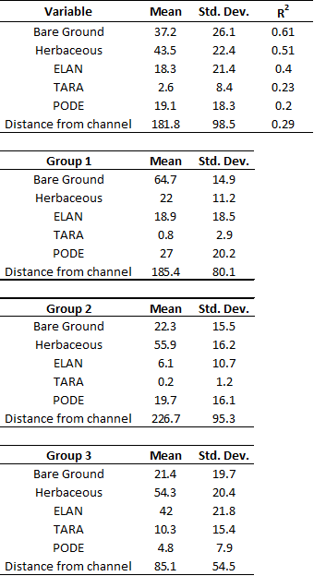
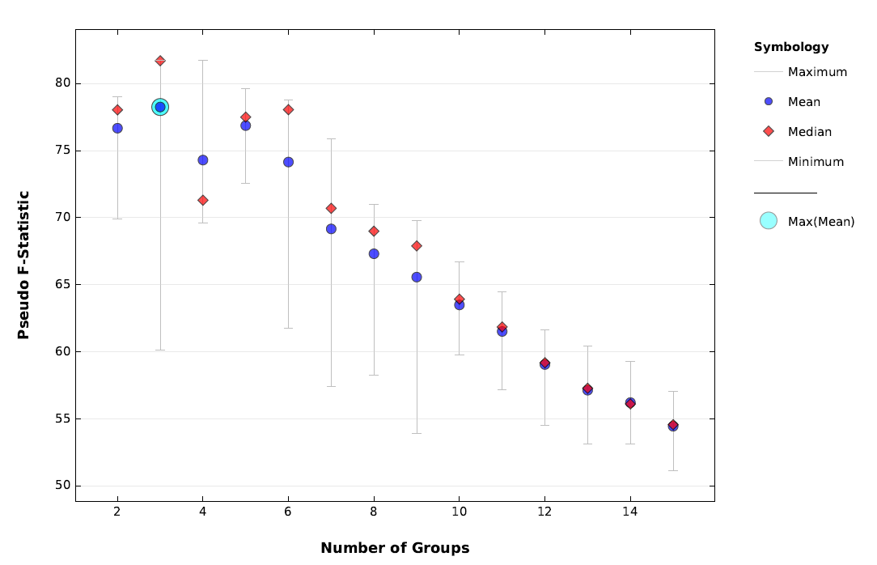
Figure S2.2 Pseudo F-Statistic as a function of number of groups from cluster analysis, showing three groups as the optimal number. Used to determine groups in Table S3.1.

S3. Habitat Suitability Model

Table S3.1. Spearman ranked correlation coefficients for variables considered in the habitat suitability model, colored by correlation value.
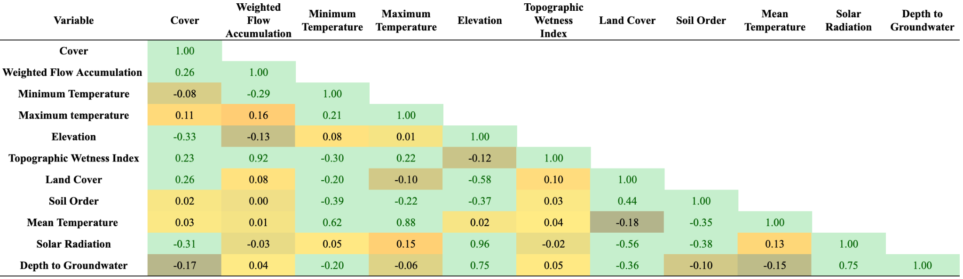

Table S3.2. AICc criteria for model predicting percent Russian olive cover showing AICc, delta AICc, AICc Weight, Cumulative Weight, and Log-Likehood (LL) and candidate models. Those with delta AICc less than 3 are considered most probable.

K | AICc | Delta_AICc | AICcWt | Cum.Wt | LL | Number | Independent Variable |  | Model Parameters
9 | 1502.26 | 0 | 0.26 | 0.26 | -741.91 | 40 | Russian Olive Cover | ~ | Flow Accumulation | + | Elevation | + | Soil Type
10 | 1502.57 | 0.31 | 0.22 | 0.48 | -741.02 | 44 | Russian Olive Cover | ~ | Flow Accumulation | + | Elevation | + | Soil Type | + | mean Temperature
10 | 1502.91 | 0.64 | 0.19 | 0.67 | -741.19 | 48 | Russian Olive Cover | ~ | Flow Accumulation | + | Elevation | + | Soil Type | + | min Temperature
10 | 1503.51 | 1.25 | 0.14 | 0.81 | -741.49 | 52 | Russian Olive Cover | ~ | Flow Accumulation | + | Elevation | + | Soil Type | + | max Temperature
4 | 1505.61 | 3.34 | 0.05 | 0.86 | -748.76 | 11 | Russian Olive Cover | ~ | Flow Accumulation | + | Elevation
10 | 1505.79 | 3.53 | 0.04 | 0.9 | -742.63 | 60 | Russian Olive Cover | ~ | Flow Accumulation | + | Solar Radiation | + | Soil Type | + | min Temperature
9 | 1506.57 | 4.3 | 0.03 | 0.93 | -744.06 | 56 | Russian Olive Cover | ~ | Flow Accumulation | + | Solar Radiation | + | Soil Type
10 | 1508.47 | 6.21 | 0.01 | 0.94 | -743.97 | 58 | Russian Olive Cover | ~ | Flow Accumulation | + | Solar Radiation | + | Soil Type | + | mean Temperature
10 | 1508.52 | 6.26 | 0.01 | 0.96 | -743.99 | 62 | Russian Olive Cover | ~ | Flow Accumulation | + | Solar Radiation | + | Soil Type | + | max Temperature
7 | 1508.91 | 6.65 | 0.01 | 0.97 | -747.32 | 39 | Russian Olive Cover | ~ | Flow Accumulation | + | Elevation | + | Land Cover
7 | 1509.35 | 7.09 | 0.01 | 0.97 | -747.54 | 55 | Russian Olive Cover | ~ | Flow Accumulation | + | Solar Radiation | + | Land Cover
8 | 1509.89 | 7.62 | 0.01 | 0.98 | -746.77 | 61 | Russian Olive Cover | ~ | Flow Accumulation | + | Solar Radiation | + | Land Cover | + | max Temperature
8 | 1510.38 | 8.12 | 0 | 0.98 | -747.02 | 57 | Russian Olive Cover | ~ | Flow Accumulation | + | Solar Radiation | + | Land Cover | + | mean Temperature
8 | 1510.68 | 8.42 | 0 | 0.99 | -747.17 | 43 | Russian Olive Cover | ~ | Flow Accumulation | + | Elevation | + | Land Cover | + | mean Temperature
8 | 1510.73 | 8.47 | 0 | 0.99 | -747.19 | 51 | Russian Olive Cover | ~ | Flow Accumulation | + | Elevation | + | Land Cover | + | max Temperature
8 | 1510.87 | 8.6 | 0 | 0.99 | -747.26 | 47 | Russian Olive Cover | ~ | Flow Accumulation | + | Elevation | + | Land Cover | + | min Temperature
8 | 1511.43 | 9.16 | 0 | 1 | -747.54 | 59 | Russian Olive Cover | ~ | Flow Accumulation | + | Solar Radiation | + | Land Cover | + | min Temperature
8 | 1511.75 | 9.48 | 0 | 1 | -747.7 | 18 | Russian Olive Cover | ~ | Elevation | + | Soil Type
7 | 1516.24 | 13.98 | 0 | 1 | -750.99 | 41 | Russian Olive Cover | ~ | Flow Accumulation | + | Depth to Groundwater | + | Land Cover
3 | 1517.28 | 15.02 | 0 | 1 | -755.61 | 3 | Russian Olive Cover | ~ | Elevation
8 | 1517.87 | 15.6 | 0 | 1 | -750.76 | 53 | Russian Olive Cover | ~ | Flow Accumulation | + | Depth to Groundwater | + | Land Cover | + | max Temperature
8 | 1518 | 15.74 | 0 | 1 | -750.83 | 49 | Russian Olive Cover | ~ | Flow Accumulation | + | Depth to Groundwater | + | Land Cover | + | min Temperature
8 | 1518.23 | 15.97 | 0 | 1 | -750.94 | 45 | Russian Olive Cover | ~ | Flow Accumulation | + | Depth to Groundwater | + | Land Cover | + | mean Temperature
4 | 1518.32 | 16.05 | 0 | 1 | -755.11 | 22 | Russian Olive Cover | ~ | Elevation | + | max Temperature
4 | 1518.93 | 16.67 | 0 | 1 | -755.42 | 20 | Russian Olive Cover | ~ | Elevation | + | mean Temperature
4 | 1519.15 | 16.89 | 0 | 1 | -755.53 | 21 | Russian Olive Cover | ~ | Elevation | + | min Temperature
6 | 1520.51 | 18.25 | 0 | 1 | -754.15 | 19 | Russian Olive Cover | ~ | Elevation | + | Land Cover
4 | 1522.84 | 20.58 | 0 | 1 | -757.37 | 38 | Russian Olive Cover | ~ | Solar Radiation | + | max Temperature
8 | 1523.06 | 20.8 | 0 | 1 | -753.36 | 34 | Russian Olive Cover | ~ | Solar Radiation | + | Soil Type
3 | 1524.34 | 22.08 | 0 | 1 | -759.14 | 10 | Russian Olive Cover | ~ | Solar Radiation
6 | 1525.03 | 22.77 | 0 | 1 | -756.41 | 35 | Russian Olive Cover | ~ | Solar Radiation | + | Land Cover
6 | 1525.04 | 22.78 | 0 | 1 | -756.42 | 13 | Russian Olive Cover | ~ | Flow Accumulation | + | Land Cover
4 | 1525.25 | 22.99 | 0 | 1 | -758.58 | 36 | Russian Olive Cover | ~ | Solar Radiation | + | mean Temperature
4 | 1525.38 | 23.12 | 0 | 1 | -758.64 | 37 | Russian Olive Cover | ~ | Solar Radiation | + | min Temperature
4 | 1525.61 | 23.35 | 0 | 1 | -758.76 | 14 | Russian Olive Cover | ~ | Flow Accumulation | + | Depth to Groundwater
6 | 1532.69 | 30.43 | 0 | 1 | -760.24 | 30 | Russian Olive Cover | ~ | Depth to Groundwater | + | Land Cover
10 | 1532.76 | 30.49 | 0 | 1 | -756.11 | 50 | Russian Olive Cover | ~ | Flow Accumulation | + | Depth to Groundwater | + | Soil Type | + | min Temperature
9 | 1534.55 | 32.29 | 0 | 1 | -758.06 | 42 | Russian Olive Cover | ~ | Flow Accumulation | + | Depth to Groundwater | + | Soil Type
10 | 1536.05 | 33.79 | 0 | 1 | -757.76 | 46 | Russian Olive Cover | ~ | Flow Accumulation | + | Depth to Groundwater | + | Soil Type | + | mean Temperature
10 | 1536.64 | 34.38 | 0 | 1 | -758.05 | 54 | Russian Olive Cover | ~ | Flow Accumulation | + | Depth to Groundwater | + | Soil Type | + | max Temperature
5 | 1538.74 | 36.47 | 0 | 1 | -764.3 | 5 | Russian Olive Cover | ~ | Land Cover
6 | 1539.47 | 37.21 | 0 | 1 | -763.64 | 28 | Russian Olive Cover | ~ | Land Cover | + | max Temperature
6 | 1539.9 | 37.64 | 0 | 1 | -763.85 | 26 | Russian Olive Cover | ~ | Land Cover | + | mean Temperature
3 | 1540.26 | 37.99 | 0 | 1 | -767.1 | 2 | Russian Olive Cover | ~ | Flow Accumulation
6 | 1540.8 | 38.53 | 0 | 1 | -764.3 | 27 | Russian Olive Cover | ~ | Land Cover | + | min Temperature
4 | 1541.77 | 39.51 | 0 | 1 | -766.84 | 32 | Russian Olive Cover | ~ | Depth to Groundwater | + | min Temperature
4 | 1542.23 | 39.97 | 0 | 1 | -767.07 | 16 | Russian Olive Cover | ~ | Flow Accumulation | + | min Temperature
4 | 1542.24 | 39.97 | 0 | 1 | -767.07 | 15 | Russian Olive Cover | ~ | Flow Accumulation | + | mean Temperature
4 | 1542.28 | 40.01 | 0 | 1 | -767.09 | 17 | Russian Olive Cover | ~ | Flow Accumulation | + | max Temperature
8 | 1543.97 | 41.71 | 0 | 1 | -763.81 | 12 | Russian Olive Cover | ~ | Flow Accumulation | + | Soil Type
3 | 1544.66 | 42.39 | 0 | 1 | -769.3 | 6 | Russian Olive Cover | ~ | Depth to Groundwater
4 | 1545.85 | 43.59 | 0 | 1 | -768.88 | 33 | Russian Olive Cover | ~ | Depth to Groundwater | + | max Temperature
4 | 1546.65 | 44.38 | 0 | 1 | -769.28 | 31 | Russian Olive Cover | ~ | Depth to Groundwater | + | mean Temperature
8 | 1553.05 | 50.78 | 0 | 1 | -768.35 | 29 | Russian Olive Cover | ~ | Depth to Groundwater | + | Soil Type
2 | 1556.08 | 53.82 | 0 | 1 | -776.03 | 1 | Russian Olive Cover | ~ | 1
3 | 1557.12 | 54.86 | 0 | 1 | -775.53 | 8 | Russian Olive Cover | ~ | Temperature min
3 | 1557.81 | 55.55 | 0 | 1 | -775.88 | 9 | Russian Olive Cover | ~ | Temperature max
3 | 1558.11 | 55.85 | 0 | 1 | -776.03 | 7 | Russian Olive Cover | ~ | Temperature
8 | 1558.99 | 56.73 | 0 | 1 | -771.32 | 24 | Russian Olive Cover | ~ | Soil Type | + | min Temperature
7 | 1559.24 | 56.98 | 0 | 1 | -772.49 | 4 | Russian Olive Cover | ~ | Soil Type
8 | 1560.57 | 58.31 | 0 | 1 | -772.11 | 25 | Russian Olive Cover | ~ | Soil Type | + | max Temperature
8 | 1561.32 | 59.06 | 0 | 1 | -772.49 | 23 | Russian Olive Cover | ~ | Soil Type | + | mean Temperature

Table S3.3. Most probable model from Table S3.2 model results shown along with coefficients, estimate, standard deviation, error, and p-values.
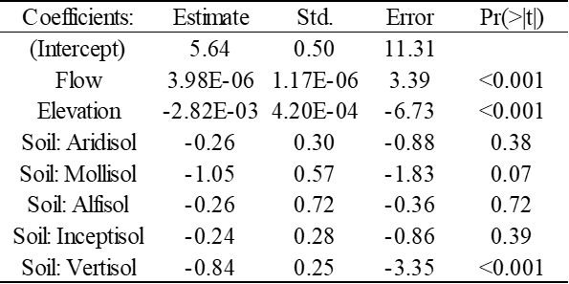

Residual standard error: 1.42 on 414 degrees of freedom
Multiple R-squared: 0.15, Adjusted R-squared: 0.14
F-statistic: 10.38 on 7 and 414 DF, p-value: <0.001.

References

Copernicus Sentinel data (2020) Retrieved from Google Earth Engine [15 June 2021], processed by European Space Agency.

Gesch D, Oimoen M, Greenlee S, Nelson C, Steuck M, Tyler D (2002) The national elevation dataset. Photogrammetric engineering and remote sensing 68(1): 5-32.

Key CH and Benson NC (2006) Landscape assessment (LA). FIREMON: Fire effects monitoring and inventory system, 164, LA-1. USDA Forest Service Gen. Tech. Rep. RMRS-GTR-164-CD.

Kriegler FJ, Malila WA, Nalepka RF, Richardson W (1969) Preprocessing transformations and their effect on multispectral recognition. Remote Sens Environ VI:97–132

McFeeters SK (1996) The use of the Normalized Difference Water Index (NDWI) in the delineation of open water features. International journal of remote sensing 17(7): 1425-1432. https://doi.org/10.1080/01431169608948714

Shi T and Xu H (2019)Derivation of tasseled cap transformation coefficients for Sentinel-2 MSI At-Sensor Reflectance Data. Journal of Selected Topics in Applied Earth Observations and Remote Sensing 12(10): 4038-4048. https://doi.org/10.1109/JSTARS.2019.2938388

Wilson EH and Sader SA (2002) Detection of forest harvest type using multiple dates of Landsat TM imagery. Remote Sensing of Environment 80: 385-396. https://doi.org/10.1016/S0034-4257(01)00318-2

