Comparative landscape genomics reveals species-specific spatial patterns and evidence of human-aided dispersal in a global hotspot for biological invasions
Caitlin C. Mothes^{1*} and Christopher A. Searcy¹
¹Department of Biology, University of Miami, Coral Gables, FL, USA
*Corresponding Author: Email: ccmothes@gmail.com

Supplemental Figures

Figure S1. Invasion history for Agama picticauda (a) and Basiliscus vittatus (b), showing cumulative recorded sightings each consecutive year based on data from GBIF and EDDMaps

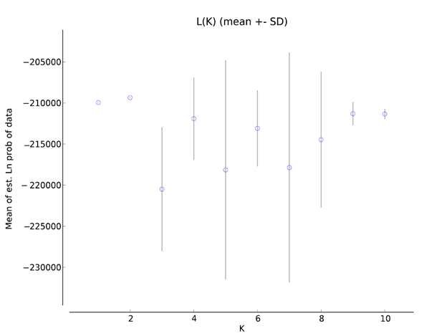
Figure S2. STRUCTURE L(K) estimates for A. picticauda for K = 1-10 with standard deviation bars around the point estimates.

Figure S3. ConStruct model performance across values of K = 1-10 for Agama picticauda (a) and Basiliscus vittatus (b). Red circles indicate spatial model results and yellow triangles represent non-spatial model results. The spatial model outperformed the non-spatial model across all values of K for B. vittatus, corroborating other evidence of greater spatial structure in this species compared to A. picticauda

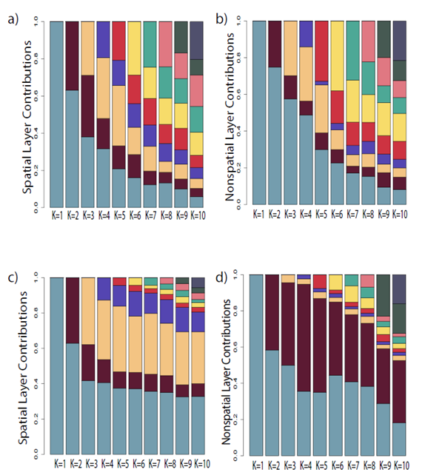
Figure S4. Layer (i.e., cluster) contributions across all values of K are shown for the A. picticauda spatial model (a) and non-spatial model (b), and the same for B. vittatus in (c) and (d).

Figure S5. The optimized resistance surface for percent canopy cover, the best model explaining spatial genetic structure for Basiliscus vittatus, where low percentages of canopy cover were given the lowest resistance to movement.

