Supplementary Figures/Tables

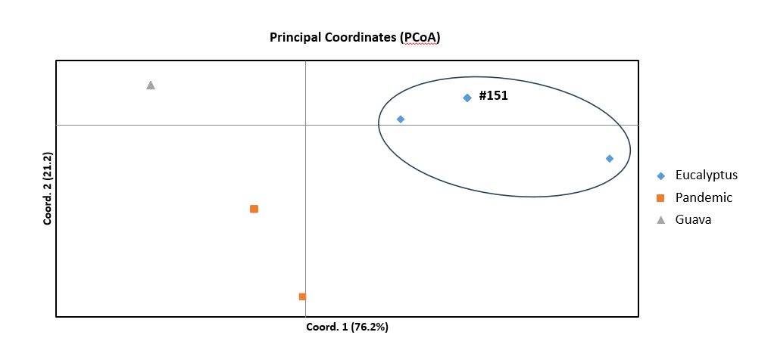
Figure S1. Principal coordinate analysis (PCoA) of four microsatellite loci for six strains of Austropuccinia psidii. Strain #151, used in the current study, had identical allele sizes to the reference isolates of the Eucalyptus biotype.

Figure S2. Principal coordinate analysis (PCoA) of four microsatellite loci for strains of Austropuccinia psidii, with strain names included. Strain #151 was used in the current study.

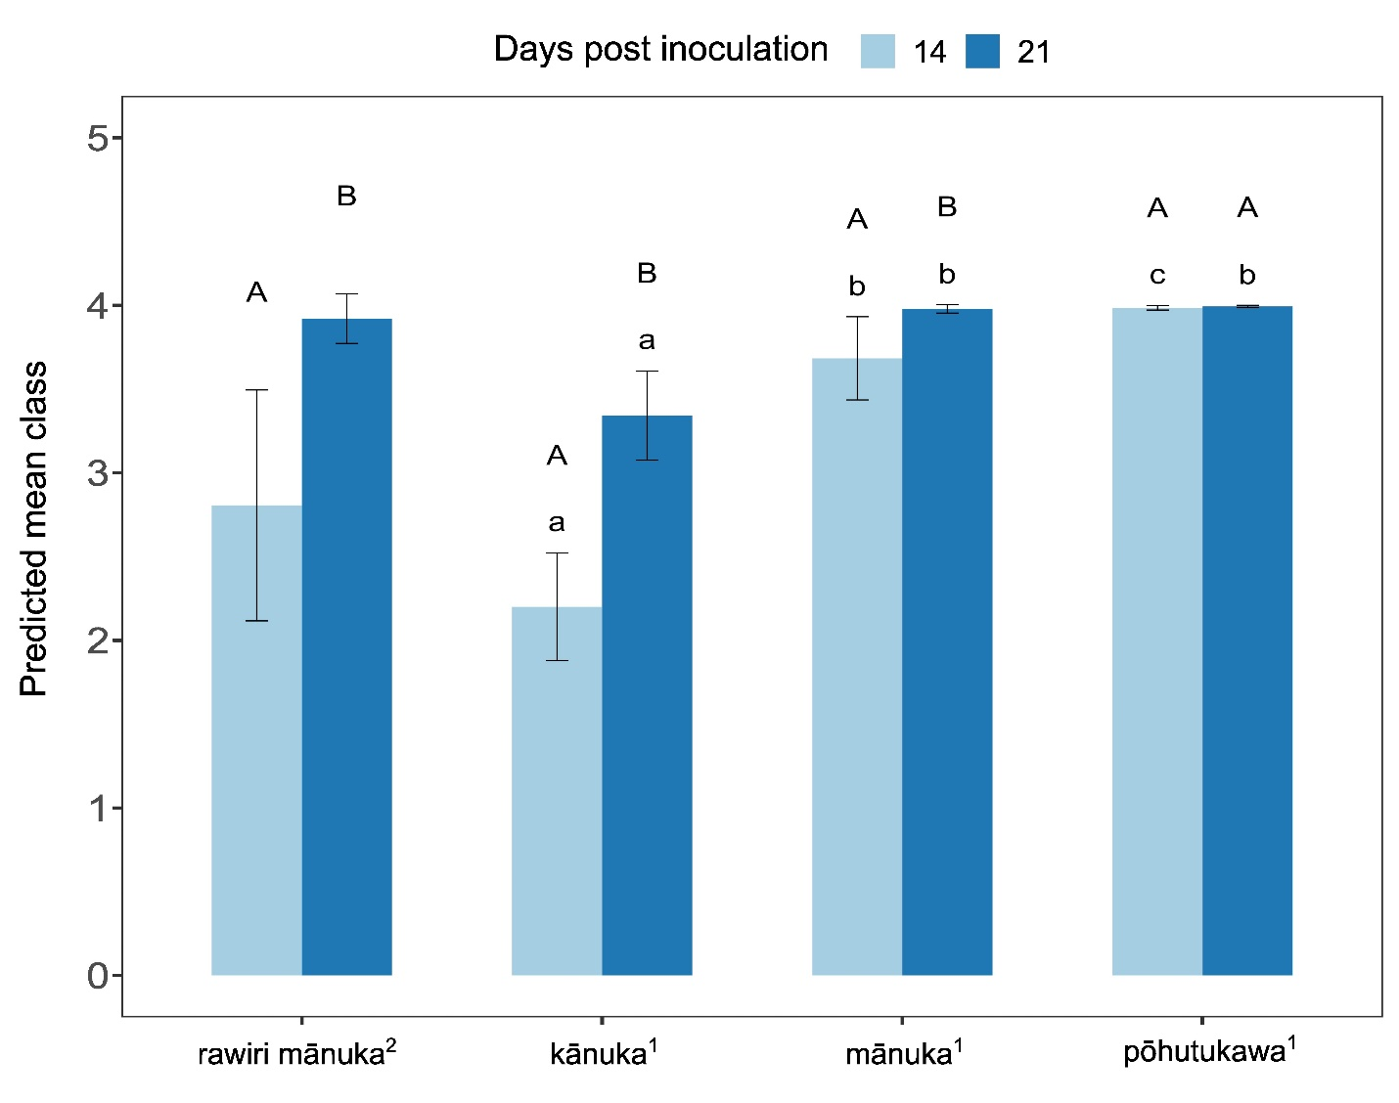

Figure S3. Predicted mean class of disease severity on leaves ± standard errors (SE) of the four species by days post inoculation. The predicted mean class is mean of the ordinal response, interpreted as a numeric value from 1 to 5, calculated from the estimated probability distribution of each score. Different lower-case letters indicate statistically significant differences between species within days post inoculation (rawiri mānuka was not included in this analysis), whereas different upper-case letters denote statistically significant differences between days post inoculation within species (multiple comparison procedures were performed via Tukey-adjusted method using the latent (or link) scale at 𝛼 = 0.05).
¹The CLMM analysis of disease severity on leaf of the three species data as a function of species and/or days post inoculation with seedling nested in family included as random effects.
²The CLMM analysis of disease severity on leaf of rawiri mānuka data as a function of days post inoculation with seedling nested in family included as random effects.

Table S1. Visual assessment scales for scoring symptom development on plants infected by Austropuccinia psidii used in this study.

 | Scale | Visual symptoms
Leaves
 | L1 | No symptoms or flecking evident
 | L2 | Presence of hypersensitive response with flecking or necrosis
 | L3 | Small pustules < 0.8 mm diameter with one or two uredinia
 | L4 | Medium-sized pustules, 0.8-1.6 mm diameter with about 12 uredinia
 | L5 | Large pustules, > 1.6 mm diameter with 20 or more uredinia on leaves, petioles and or shoots
Stems
 | S1 | No evidence of infection on main or lateral stems
 | S2 | 1-2 stem lesions
 | S3 | More than 2 but less than 5 stem lesions
 | S4 | 5 or more stem lesions
Dieback
 | D1 | No dieback
 | D2 | 1 – 25% of tips on a plant showing dieback
 | D3 | 26 – 50% of tips on a plant showing dieback
 | D4 | 50 – 75% of tips on plant showing dieback
 | D5 | 76 – 100% on a plant showing dieback

Table S2. Seed families
Species | Seed family | Number of seedlings inoculated | Origin
Kunzea ericoides ‘gumland ecotype’ (rawiri mānuka) | 1251 | 6 | Northland
Kunzea ericoides ‘gumland ecotype’ (rawiri mānuka) | 1252 | 4 | Northland
Kunzea ericoides ‘gumland ecotype’ (rawiri mānuka) | 1253 | 5 | Northland
Kunzea ericoides ‘gumland ecotype’ (rawiri mānuka) | 1262 | 8 | Northland
Kunzea ericoides ‘gumland ecotype’ (rawiri mānuka) | 1263 | 6 | Northland
Kunzea ericoides (kānuka) | 1165 | 0 | Auckland
Kunzea ericoides (kānuka) | 1246 | 7 | Waikato
Kunzea ericoides (kānuka) | 1247 | 0 | Auckland
Kunzea ericoides (kānuka) | 1248 | 6 | Auckland
Kunzea ericoides (kānuka) | 1249 | 7 | Auckland
Kunzea ericoides (kānuka) | 1250 | 6 | Auckland
Kunzea ericoides (kānuka) | 1297 | 3 | Waikato
Kunzea ericoides (kānuka) | 1298 | 3 | Waikato
Kunzea ericoides (kānuka) | 1299 | 8 | Waikato
Kunzea ericoides (kānuka) | 1300 | 7 | Waikato
Kunzea ericoides (kānuka) | 1456 | 6 | Waikato
Kunzea ericoides (kānuka) | 1457 | 6 | Waikato
Kunzea ericoides (kānuka) | 1458 | 8 | Waikato
Kunzea ericoides (kānuka) | 1459 | 4 | Waikato
Kunzea ericoides (kānuka) | 1460 | 4 | Waikato
Kunzea ericoides (kānuka) | 1462 | 3 | Bay of Plenty
Kunzea ericoides (kānuka) | 1463 | 4 | Bay of Plenty
Kunzea ericoides (kānuka) | 1464 | 6 | Bay of Plenty
Kunzea ericoides (kānuka) | 1465 | 4 | Bay of Plenty
Kunzea ericoides (kānuka) | 1466 | 5 | Bay of Plenty
Kunzea ericoides (kānuka) | 1467 | 3 | Bay of Plenty
Kunzea ericoides (kānuka) | 1468 | 3 | Bay of Plenty
Kunzea ericoides (kānuka) | 1469 | 2 | Bay of Plenty
Kunzea ericoides (kānuka) | 1470 | 8 | Bay of Plenty
Leptospermum scoparium (mānuka) | 1426 | 0 | Auckland
Leptospermum scoparium (mānuka) | 1428 | 0 | Auckland
Leptospermum scoparium (mānuka) | 1429 | 7 | Auckland
Leptospermum scoparium (mānuka) | 1431 | 4 | Bay of Plenty
Leptospermum scoparium (mānuka) | 1432 | 2 | Bay of Plenty
Leptospermum scoparium (mānuka) | 1433 | 3 | Bay of Plenty
Leptospermum scoparium (mānuka) | 1435 | 6 | Bay of Plenty
Leptospermum scoparium (mānuka) | 1436 | 3 | Bay of Plenty
Leptospermum scoparium (mānuka) | 1437 | 5 | Bay of Plenty
Leptospermum scoparium (mānuka) | 1439 | 2 | Bay of Plenty
Leptospermum scoparium (mānuka) | 1440 | 8 | Waikato
Leptospermum scoparium (mānuka) | 1441 | 0 | Waikato
Leptospermum scoparium (mānuka) | 1442 | 0 | Waikato
Leptospermum scoparium (mānuka) | 1445 | 0 | Northland
Leptospermum scoparium (mānuka) | 1446 | 6 | Northland
Leptospermum scoparium (mānuka) | 1448 | 1 | Northland
Leptospermum scoparium (mānuka) | 1450 | 4
Leptospermum scoparium (mānuka) | 1451 | 4 | Northland
Leptospermum scoparium (mānuka) | 1452 | 8 | Northland
Leptospermum scoparium (mānuka) | 1453 | 6 | Northland
Leptospermum scoparium (mānuka) | 1454 | 7 | Northland
Leptospermum scoparium (mānuka) | 1455 | 8 | Northland
Metrosideros excelsa (pōhutukawa) | 1158 | 6 | Bay of Plenty
Metrosideros excelsa (pōhutukawa) | 1159 | 0 | Bay of Plenty
Metrosideros excelsa (pōhutukawa) | 1173 | 8 | Auckland
Metrosideros excelsa (pōhutukawa) | 1174 | 5 | Auckland
Metrosideros excelsa (pōhutukawa) | 1175 | 1 | Auckland
Metrosideros excelsa (pōhutukawa) | 1176 | 8 | Auckland
Metrosideros excelsa (pōhutukawa) | 1218 | 8 | Auckland
Metrosideros excelsa (pōhutukawa) | 1254 | 0 | Bay of Plenty
Metrosideros excelsa (pōhutukawa) | 1255 | 8 | Bay of Plenty
Metrosideros excelsa (pōhutukawa) | 1256 | 7 | Bay of Plenty
Metrosideros excelsa (pōhutukawa) | 1257 | 8 | Waikato
Metrosideros excelsa (pōhutukawa) | 1258 | 8 | Waikato
Metrosideros excelsa (pōhutukawa) | 1259 | 0 | Waikato
Metrosideros excelsa (pōhutukawa) | 1260 | 0 | Waikato
Metrosideros excelsa (pōhutukawa) | 1261 | 0 | Waikato
Metrosideros excelsa (pōhutukawa) | 1267 | 0 | Bay of Plenty
Metrosideros excelsa (pōhutukawa) | 1270 | 0 | Northland
Metrosideros excelsa (pōhutukawa) | 1271 | 0 | Northland
Metrosideros excelsa (pōhutukawa) | 1272 | 0 | Northland
Metrosideros excelsa (pōhutukawa) | 1273 | 0 | Bay of Plenty
Metrosideros excelsa (pōhutukawa) | 1275 | 0 | Bay of Plenty
Metrosideros excelsa (pōhutukawa) | 1276 | 5 | Bay of Plenty
Metrosideros excelsa (pōhutukawa) | 1284 | 6 | Auckland
Metrosideros excelsa (pōhutukawa) | 1285 | 0 | Auckland
Metrosideros excelsa (pōhutukawa) | 1286 | 5 | Northland
Metrosideros excelsa (pōhutukawa) | 1287 | 6 | Northland
Metrosideros excelsa (pōhutukawa) | 1290 | 0 | Auckland
Metrosideros excelsa (pōhutukawa) | 1291 | 0 | Auckland
Metrosideros excelsa (pōhutukawa) | 1292 | 0 | Auckland
Metrosideros excelsa (pōhutukawa) | 1295 | 7 | Auckland
 | Total: | 322

Table S3. Potting mix composition.

Parameters | Units | Substrate
Carbon organic | % | 43
Nitrogen Total | %N total | 0.69
Phosphates | ppmP | 0.15
pH | - | 6.1
C/N ratio | - | 62.3
Granulometry | > 8.0 mm | 0.0
 | 4 - 8 mm | 11.3
 | 2 - 4 mm | 36.8
 | < 2.0 mm | 51.9

Table S4. Spore stages observed on plants grown from New Zealand provenance seed for four species - rawiri mānuka (K. ericoides ‘gumland ecotype’), kānuka (K. ericoides), mānuka (L. scoparium), and pōhutukawa (M. excelsa), at 14- and 21-days post inoculation with by Austropuccinia psidii isolated from Eucalyptus globulus in Uruguay.

 | rawiri mānuka |  | kānuka |  | mānuka |  | pōhutukawa
Spore stage | 14 | 21 | 14 | 21 | 14 | 21 | 14 | 21
Uredinia only | 16 (55.2%) | 13 (44.8%) | 62 (54.9%) | 47 (44.3%) | 55  (65.5%) | 20 (24.4%) | 62 (64.6%) | 24 (25%)
Both uredinia and telia observed | 3 (10.3%) | 10 (34.5%) | 5 (4.4%) | 27 (25.5%) | 7  (8.3%) | 46 (56.1%) | 31 (32.3%) | 68 (70.8%)
Telia only | 0  (0%) | 0  (0%) | 4 (3.5%) | 1 (0.9%) | 4  (4.8%) | 3  (3.7%) | 0  (0%) | 0  (0%)
No pustules developed | 10 (34.5%) | 6 (20.7%) | 42 (37.2%) | 31 (29.2%) | 18 (21.4%) | 13 (15.9%) | 3 (3.1%) | 4  (4.2%)
Total seedlings | 29 | 29 | 113 | 106 | 84 | 82 | 96 | 96

Table S5. Comparison of number of seedlings and families of host species included in this study and aligned prior studies

 | Smith et al. 2020 |  | Soewarto et al. 2021 |  | Soewarto et al -this study
 | Seedlings | Families | Seedlings | Families | Seedlings | Families
Kunzea ericoides ‘gumland ecotype’ (rawiri mānuka) | 70 | 5 | 17 | 5 | 29 | 5
Kunzea ericoides (kānuka) | 292 | 23 | 60 | 15 | 113 | 22
Leptospermum scoparium (mānuka) | 1758 | 132 | 151 | 30 | 84 | 17
Metrosideros excelsa (pōhutukawa) | 570 | 31 | 61 | 17 | 96 | 15
Lophomyrtus bullata (ramarama) | 56 | 3 | NA | NA | NA | NA
Lophomyrtus obcordata (rōhutu) | 5 | 1 | NA | NA | NA | NA
Total | 2751 | 195 | 289 | 67 | 322 | 59

