Supplementary Information

Design of risk-based surveillance to demonstrate absence of Phytophthora agathidicida in New Zealand kauri forests

Biological Invasions

M. Cecilia Lathamª, Audrey Lustig, Nari M. Williams, Andrew McDonald, Taoho Putuawa, Juliane Chetham, Steve Johnson, Ari Carrington, Waitangi Wood, and Dean P. Anderson

ª Corresponding author:
Manaaki Whenua Landcare Research, Lincoln, Canterbury, New Zealand.
Email: arientic@landcareresearch.co.nz

Appendix S1: Calculating uphill/downhill areas along a road/track section on a raster map
Shapefiles depicting the track/road networks were downloaded from koordinates and traplines were sourced from the hapū. These line shapefiles were combined into a single layer and rasterized at a 5 m resolution using QGIS. The proximity algorithm in QGIS was used to generate proximity layers indicating the shortest Euclidean distance from the centre of each cell to a track/road/trapline. Proximity maps were reclassified so that the relative risk of Phytophthora agathidicida (PA) presence would decrease with increasing distance from tracks/roads/traplines. An asymmetric rate of decrease was defined around tracks/roads, so that the relative risk of PA presence would decrease at a slower rate in areas downhill from a road compared to uphill areas. To determine uphill or downhill areas along a road/track section we followed these steps:
- We created an empty 5 m resolution raster that filtered out every cell that is 100 m from any road/track.
- We converted that raster to points so that there is a point for every cell < 100 m from a road/track/trapline (we call these the ‘distance points’).
- We converted the roads/tracks shapefile to a 5 m resolution raster.
- We converted the roads/tracks raster to points so that there is a string of points every 5 m running along the roads/tracks.
- We assigned elevation from the DEM to each distance point.
- We assigned elevation from the DEM to each road point.
- We calculated the elevation difference between each distance point and road/tracks points. Using the distance value and whether it was uphill or downhill, we calculated the risk of PA presence based on the graph in Table 1.
- For each distance point, we summed the relative risk of PA presence to all points on the road/tracks within the 100 m buffer.
- We converted those points back to a raster.
- We reclassified the resulting raster so that the relative risk of PA presence would be contained between 1 and 50.

Appendix S2: Attributing a prior probability of absence to each priority zone in Mangonui and Takahiwai forests based on the proportion of kauri trees showing signs of canopy decline
At the polygon level, or area of interest, we calculate the probability of absence (PoA) of Phytophthora agathidicida (Pa) as
$$PoA=P({Pa}^{-}|D^{-})$$
where P(Pa⁻|D⁻) is the probability of Pa absence (Pa⁻) given no detections (D⁻) in all soil baiting samples within a given area. Formally, this is expressed as:
$$P({Pa}^{-}|D^{-})=\frac{P (D^{-}|{Pa}^{-})× P ({Pa}^{-})}{P \left(D^{-} | {Pa}^{-}\right)×P \left({Pa}^{-}\right)+P \left(D^{-} | {Pa}^{+}\right)×P \left({Pa}^{+}\right)}$$
This can be rewritten in terms of the system sensitivity (SSe) and specificity (SSp) as follows:
$$P\left({Pa}^{-} | D^{-}\right)=\frac{SSp×Prior}{SSp ×Prior+\left(1-SSe\right)×(1-Prior)}$$
where the Prior is the starting probability of absence in a given polygon based on the initial assessment of aerial survey data. Assuming perfect system specificity of the soil baiting surveillance, we can rewrite this equation as follows:
$$PoA=\frac{Prior}{1-SSe×\left(1-Prior\right)}$$
The Prior is a function of the proportion of trees in a polygon that were found to have canopy decline. Given that canopy decline can happen for many reasons, we cannot be certain that it is due to Pa.
As the number of trees with canopy decline increases in a given polygon, our prior confidence in absence will decrease. We estimate the Prior as follows:
$$Prior={\left(1-PPV\right)}^{n}×{NPV}^{m}$$
where n is the number of trees identified with crown decline and m is the number of healthy trees. PPV is the positive predictive value of decline of a given tree using aerial surveillance (AS), which is analogous to the PoA but at the tree level. That is, it is the probability of Pa infection in a cell given detected crown decline. The NPV is the negative predictive value of Pa infection given tree decline using aerial surveillance. At the tree level, the PPV and NPV for a tree are calculated as follows:
$$PPV=P({Pa}_{cell}^{+}|{AS}^{+})$$
The PPV can be written formally as:
$$PPV=\frac{P\left({AS}^{+} | {Pa}_{cell}^{+}\right)×P({Pa}_{cell}^{+})}{P\left({AS}^{+} | {Pa}_{cell}^{+}\right)×P\left({Pa}_{cell}^{+}\right)+P\left({AS}^{-} | {Pa}_{cell}^{-}\right)×P({Pa}_{cell}^{-})}$$
This can be rewritten as follows using the sensitivity and specificity of aerial surveillance (Se_{AS} and Sp_{AS}, respectively); and replacing $P$ with Pa prevalence across all cells (or trees) in the forest (Prev):
$$PPV=\frac{{Se}_{AS}×Prev}{{Se}_{AS}×Prev+\left(1-{Sp}_{AS}\right)×\left(1-Prev\right)}$$
The following equations describe the calculation of the NPV of Pa infection in a given cell:
$$NPV=P({Pa}^{-}|{AS}^{-})$$
$$P\left({Pa}^{-} | {AS}^{-}\right)=\frac{P({AS}^{-}|{Pa}^{-})×P({Pa}^{-})}{P\left({AS}^{-} | {Pa}^{-}\right)×P({Pa}^{-})×P\left({AS}^{-} | {Pa}^{+}\right)×P({Pa}^{+})}$$
$$NPV=\frac{{Sp}_{AS}×\left(1-Prev\right)}{{Sp}_{AS}×\left(1-Prev\right)+\left(1-{Se}_{AS}\right)×Prev}$$
Values for the Prior for each buffer in Mangonui forest were calculated using the data presented in Table S2a. Values for the Prior for each priority zone in Takahiwai forest were calculated using the data presented in Table S2b.

Table S2a: Number of kauri trees and associated crown health score present within each buffer around a historical Phytophthora agathidicida (PA) infection in Mangonui forest, Northland, New Zealand. Canopy health scores were derived from aerial imagery analyses.
Canopy symptoms | Health score | Number of kauri trees per buffer
Canopy symptoms | Health score | 200 | 400 | 600 | 800 | 1000
Healthy canopy | 1 | 167 | 69 | 229 | 286 | 222
Some canopy thinning | 2 | 3 | 1 | 27 | 18 | 4
Canopy thinning and some branch dieback | 3 | - | - | - | - | -
Severe dieback | 4 | - | - | - | - | -
Dead canopy | 5 | 2 | - | 1 | 3 | -
Total |  | 172 | 70 | 257 | 307 | 226

Table S2b: Canopy symptoms and associated crown health score for kauri trees in each management zone in Takahiwai forest, Northland, New Zealand. Canopy health scores were derived from aerial imagery analyses.
Canopy symptoms | Health score | Number of kauri trees per zone
Canopy symptoms | Health score | 1 | 4 | 5 | 6 | 7
Healthy canopy | 1 | 26 | 44 | 25 | 71 | 18
Some canopy thinning | 2 | 2 | 1 | 1 | - | -
Canopy thinning and some branch dieback | 3 | - | 1 | 1 | - | -
Severe dieback | 4 | - | - | - | - | -
Dead canopy | 5 | - | 1 | - | 1 | 1
Total |  | 28 | 47 | 27 | 72 | 19

Appendix S3: Historic assessment of kauri crown health in Waipoua forest
Aerial photography, oblique imagery and LiDAR data were used to identify individual kauri with canopy areas greater than 10 m and that were distinguishable above the understorey for the year 2019; each individual tree was subsequently identified on historical aerial photos from the years 1942, 1950, 1975 and 2016. For each individual tree at each time period, the degree of thinning in the canopy was manually determined and classified into 8 categories: healthy crown, canopy thinning, thinning and some branch dieback, severe dieback, logged, fallen not visible, fallen visible, and dead.
Table S3: Number of kauri trees within each canopy health score for each year when aerial photos were available for Waipoua forest, Northland, New Zealand.
Canopy symptoms | Aerial surveys
Canopy symptoms | 1942 | 1950 | 1975 | 2016 | 2019
Healthy canopy | 19,715 | 20,281 | 20,110 | 19,455 | 19,429
Canopy thinning | 6 | 4 | 5 | 104 | 95
Thinning and some branch dieback | 11 | 14 | 44 | 182 | 145
Severe dieback | 6 | 5 | 27 | 126 | 128
Dead canopy | 226 | 161 | 366 | 648 | 717
Fallen visible | 2 | 2 | 3 | 2 | 0
Fallen not visible | - | - | 94 | 131 | 134
Logged | - | 60 | 73 | 74 | 74
Unknown | 756 | 195 | - | - | -

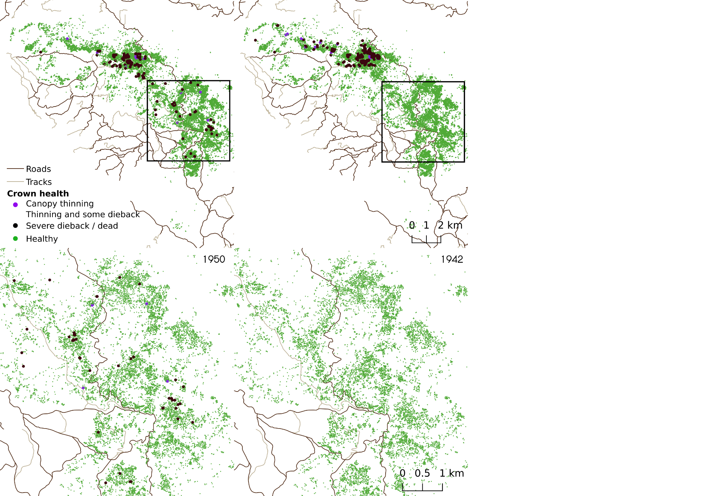
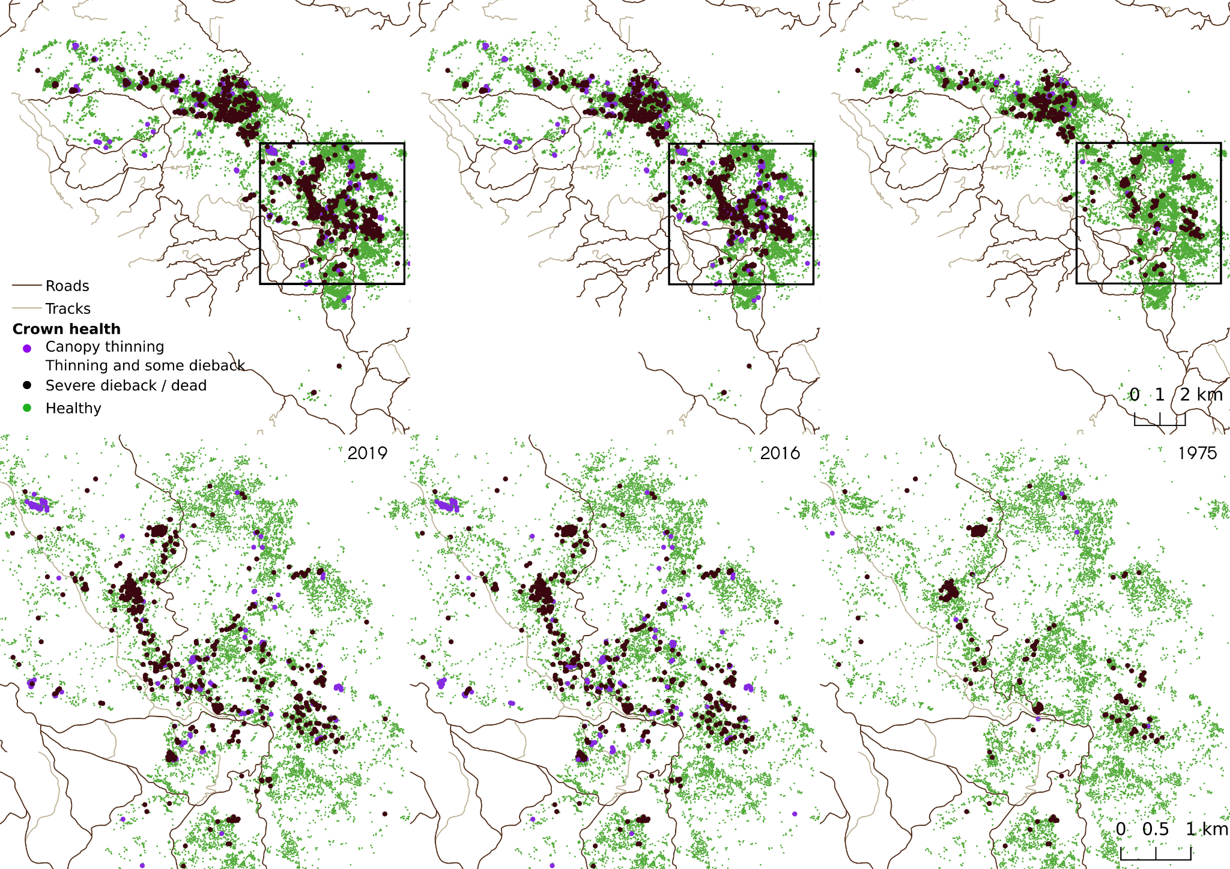

Fig. S3 Aerial crown score used to assess the health of kauri trees in Waipoua forest in 1942, 1950, 1975, 2016 and 2019. Logged and fallen trees are not shown

Appendix S4: Relative risk of Phytophthora agathidicida (PA) presence for priority zones identified in Mangonui and Takahiwai forests, as well as for the whole of Waipoua forest, Northland, New Zealand
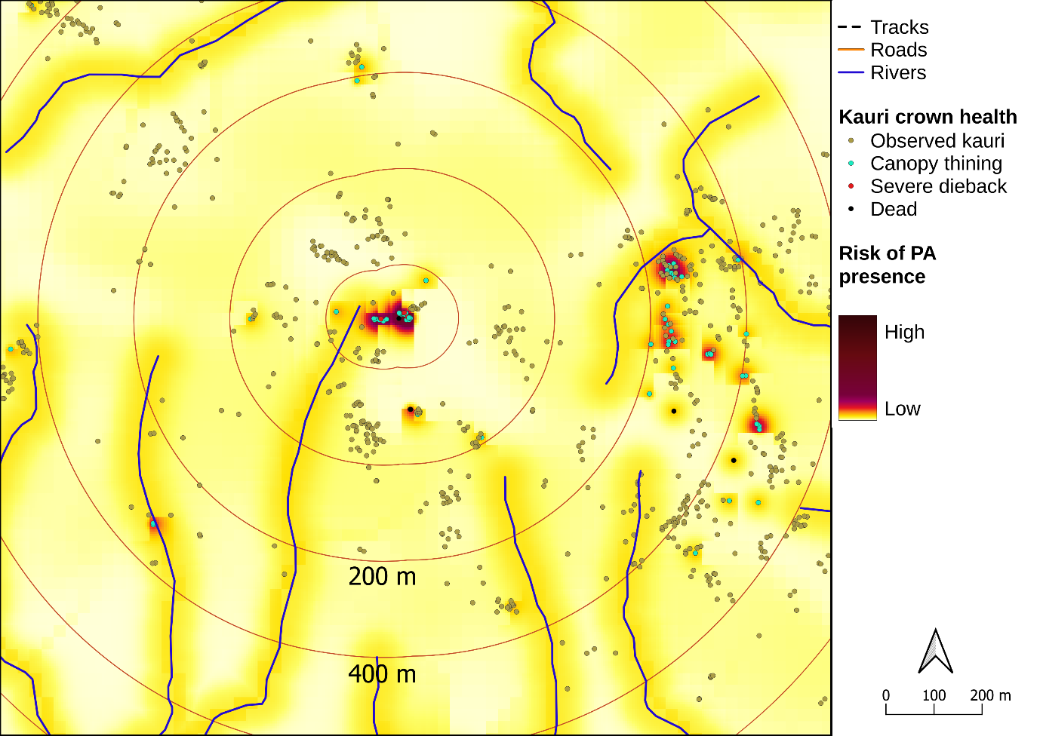
Fig. S4a Example of the relative risk of Phytophthora agathidicida (PA) presence within buffers of increasing size around a historical PA infection in Mangonui forest, Northland, New Zealand

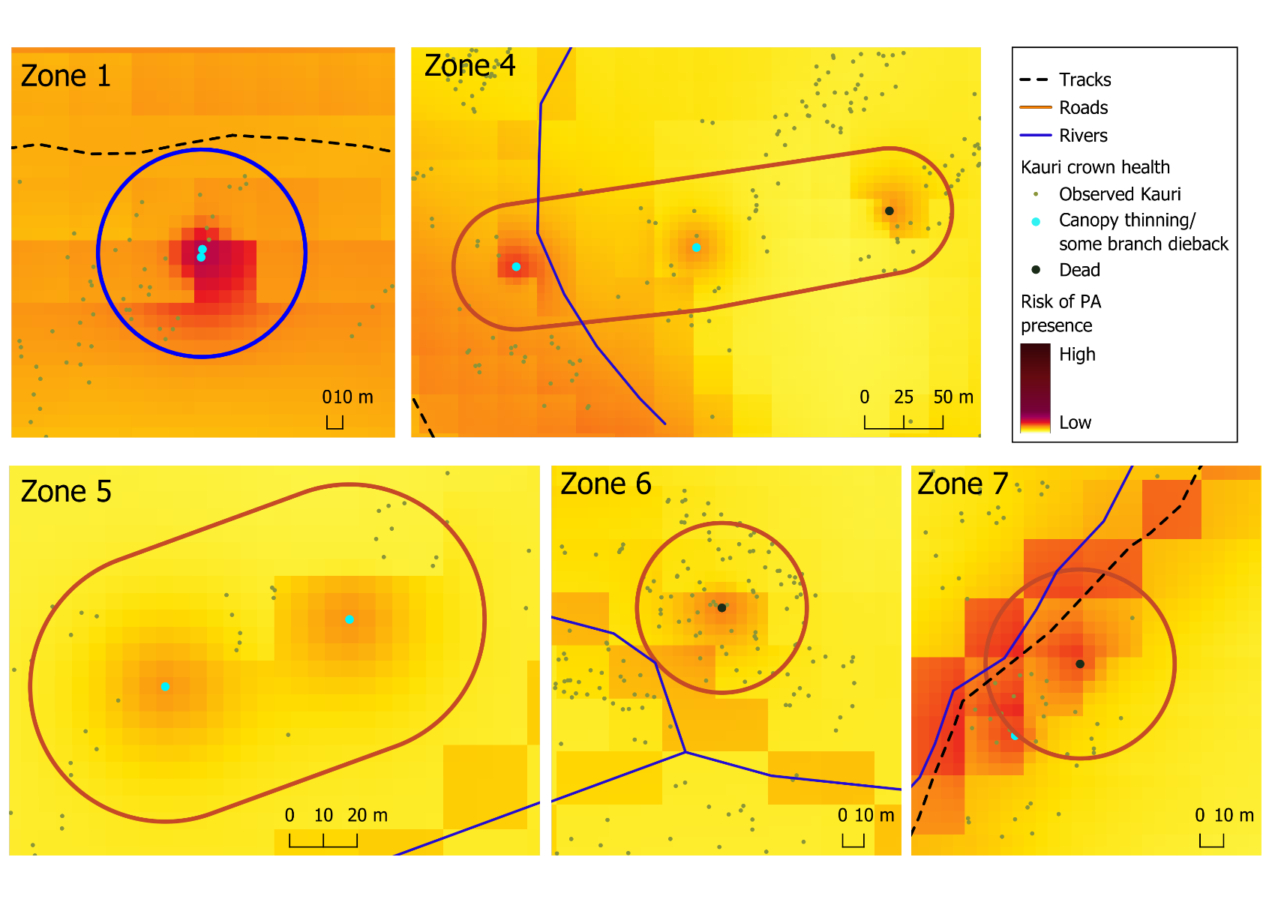
Fig. S4b Example of the relative risk of Phytophthora agathidicida (PA) presence within each of five priority sites in Takahiwai forest, Northland, New Zealand

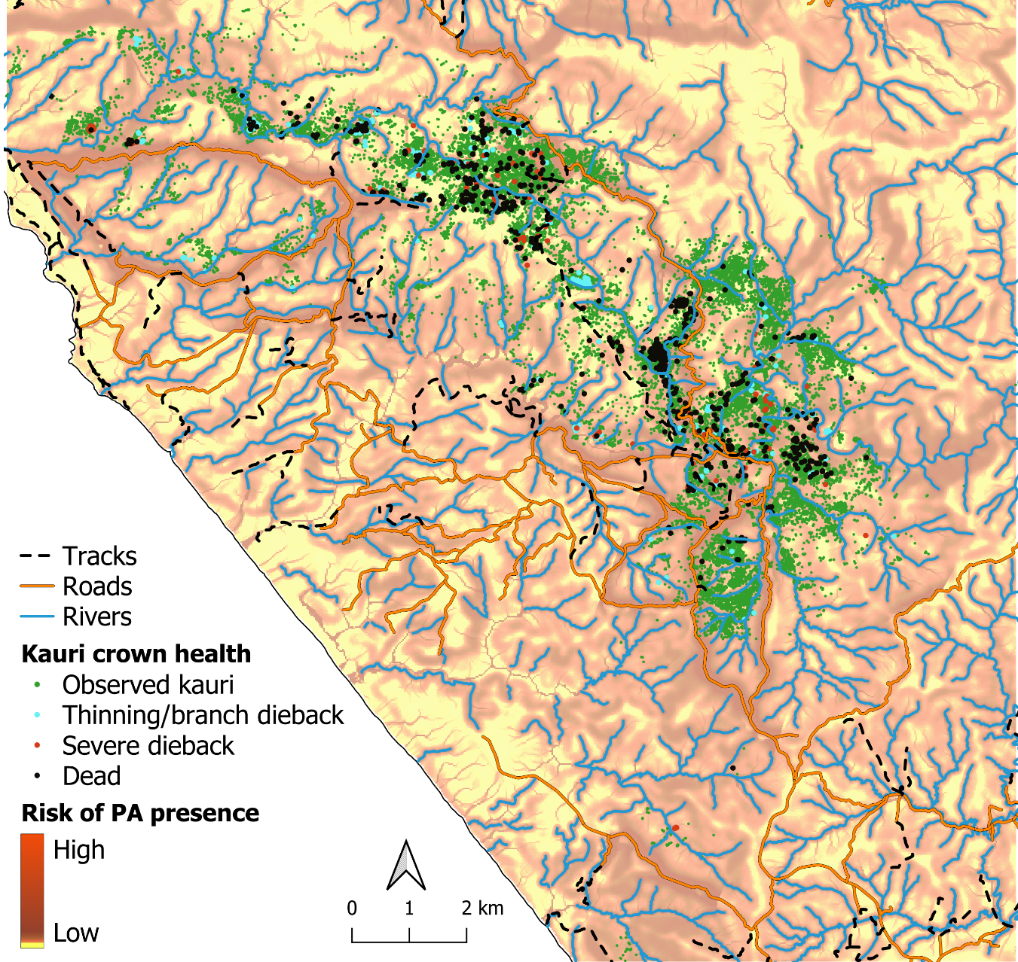
Fig. S4c Relative risk of Phytophthora agathidicida (PA) presence for Waipoua forest, Northland, New Zealand

Appendix S5: Proof of absence modelling
Table S5a: Sampling regime required to achieve an 85% probability of Phytophthora agathidicida (PA) absence (PoA) in each buffer size around a historical PA infection identified in Mangonui forest, Northland, New Zealand. Values reported are means, with minimum and maximum values given in parenthesis.
Buffer (m) | Number of trees sampled | Number of samples per tree | Prior | PoA
200 | 154 out of 154 | 44 | 0.14  (0.02 - 0.44) | 0.889  (0.712 - 0.960)
1000 | 211 out of 211 | 44 | 0.07  (0.01 - 0.35) | 0.863  (0.626 - 0.958)

Table S5b: Sampling regime required to achieve an 95% probability of PA absence (PoA) in each priority zone identified in Takahiwai forest, Northland, New Zealand. Values reported are means, with minimum and maximum values given in parenthesis.
Zone | Number of trees sampled | Number of samples per tree | Prior | PoA
1 | 28 out of 28 | 24 | 0.755  (0.624 - 0.852) | 0.956  (0.933 - 0.975)
4 | 42 out of 47 | 44 | 0.623  (0.452 - 0.768) | 0.946  (0.915 - 0.969)
5 | 27 out of 27 | 24 | 0.762  (0.636 - 0.856) | 0.955  (0.930 - 0.975)
6 | 70 out of 72 | 44 | 0.485  (0.283 - 0.704) | 0.976  (0.940 - 0.924)
7 | 14 out of 14 | 32 | 0.826  (0.723 - 0.901) | 0.953  (0.931 - 0.971)

