Table S1.- Haplotype list per populations and countries of COI sequences from C. marmorata samples from Canada (BOLD database) USA, and Japan.
Country | Code | Population | hap
CANADA | CON | Ontario, Canada | 1,2,7,8,11,13,14,15,21,28,35,36,40,41,43
USA | ARK | Kansas | 2,17
USA | DC | Washington DC | 1,2
USA | DUL | Duluth | 42,44,45,46,47,48
USA | ED |  | 4
USA | FL2 | Florida2 | 2,13,29,31,32
USA | FL3 | Florida3 | 2,20,26
USA | IW | Council Groove | 4
USA | KAN | Kansas2 | 1,2,4,23,26,30
USA | LOU | Louisiana | 2,24,27
USA | MIS | Mississippi | 2,6,22,26
USA | PEL | Misuri | 4,6,9
USA | TAL | Tallahassee | 2,25,37,38,39
JAPAN | FN | Fukuoka | 1,3,12
JAPAN | IM | Iwate | 4,10
JAPAN | KB | Kobe | 2,5,26
JAPAN | KC | Kumamoto | 1,3,33
JAPAN | KG | Kagoshima | 1,3
JAPAN | NAG | Nagasaki, Glover Garden | 2,5,18
JAPAN | ON | Hyogo | 1
JAPAN | SAG | Saga | 5,18,26
JAPAN | SF | Shizuoka | 1,3,,34
JAPAN | TK | Tokio | 1,3
JAPAN | TY | Tochigi | 1,3,13
JAPAN | YA | Yamagoda | 5,18
JAPAN | CER | CER, Otsu | 1,3,9

Table S2. Pairwise F_{ST} among C. marmorata populations from USA and Japan based on SNP´s nuclear markers.
 | ARK | FL2 | MIS | FL3 | CER | SAG
ARK | 0
FL2 | 0.012 | 0
MI | 0.033 | 0.03501 | 0
LF3 | -0.006. | 0.0013 | 0.0304 | 0
CER | 0.21986 | 0.1971 | 0.2191 | 0.2038 | 0
SAG | 0.2174 | 0.0350 | 0.2169 | 0.2152 | 0.0209 | 0

Table S3. Parameter estimates for the selected ABC demographic model (scenario 5).
Parameter | Prior Low | Prior High | Estimate | Median | Q 0.5 | Q 0.95 | NMAE
db | 5 | 500 | 312.362 | 374 | 45 | 496 | 0.706
N1 | 100 | 100000 | 42693.3 | 32784.8 | 7840.59 | 95419 | 0.46
N2 | 100 | 100000 | 38184.9 | 33438.1 | 2157.9 | 91131.4 | 0.777
N2b | 5 | 500 | 321.816 | 351 | 107.251 | 485 | 0.588
N3 | 100 | 100000 | 51578.3 | 52118 | 3346.03 | 96981 | 2.93
N3b | 5 | 500 | 317.144 | 349 | 98 | 485 | 0.589
t1 | 1 | 35 | 21.4376 | 22 | 9 | 35 | 0.543
t2 | 100 | 10000 | 649.74 | 141.279 | 100 | 4134.45 | 0.477

t2 = Time of divergence from G1, t1 = Time of divergence from G2, N1 = population size G1, N2 = population size G2, N3 = population size G3, N2b = Number of migrants G2, N3b = Number of migrants G3, db = Duration of the bottlenecks

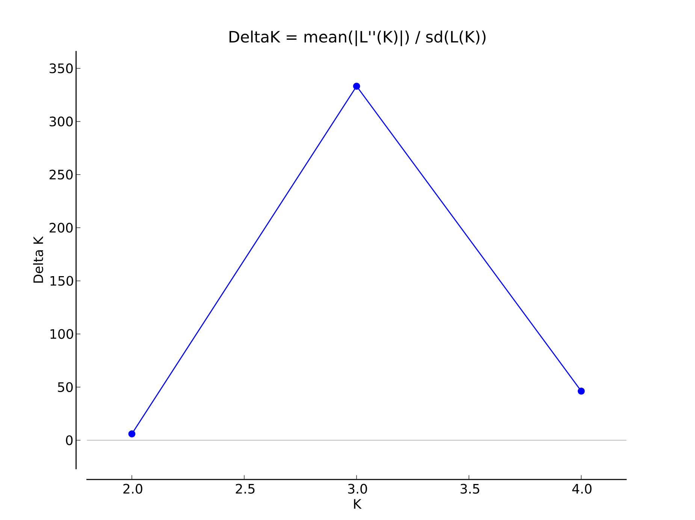
Figure S1.- Values of ∆K and mean Ln P(D) as a function of K from STRUCTURE analysis for Corythucha marmorata COI sequences from native distribution range (i.e., CANADA and USA) and invasive range (JAPAN)

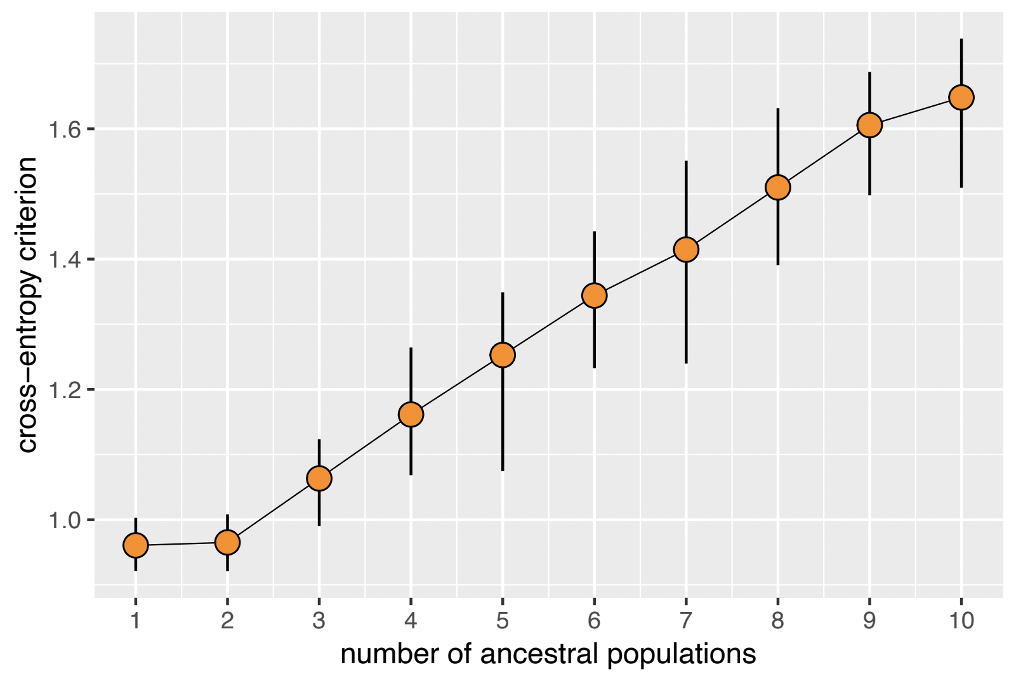
Figure S2.- Cross-entropy graph indicating the optimal number of ancestral populations for K in Corythucha marmorata populations from USA and Japan using the sparse Nonnegative Matrix Factorization (sNMF)
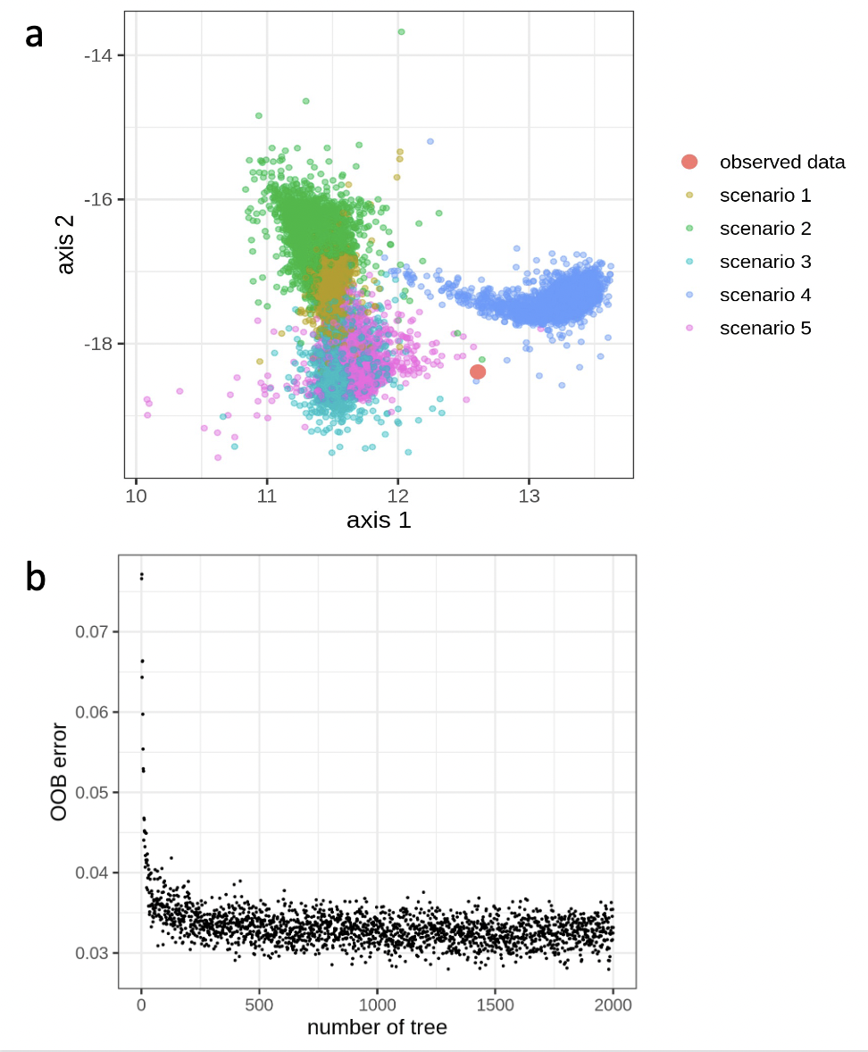

Figure S3.- DIYABC-RF model evaluation. a) Linear discriminant analysis (LDA) from the training data sets of the five scenarios tested in the lacebug demographic history. The observed data (orange circle) are found within the distribution of the simulated prior parameters under the five scenarios. b) The out-of-bag error rate over the number of trees in the forest, indicating enough trees to sample for Random Forest analysis.

