Supplementary material
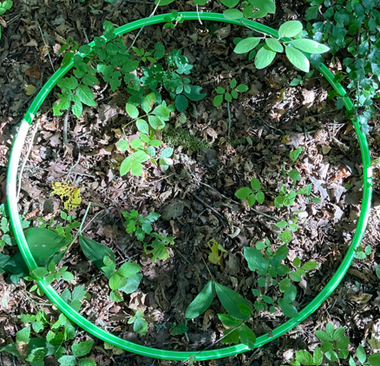
Figure S1. Hula hoop 80 cm plot to measure vascular plants.

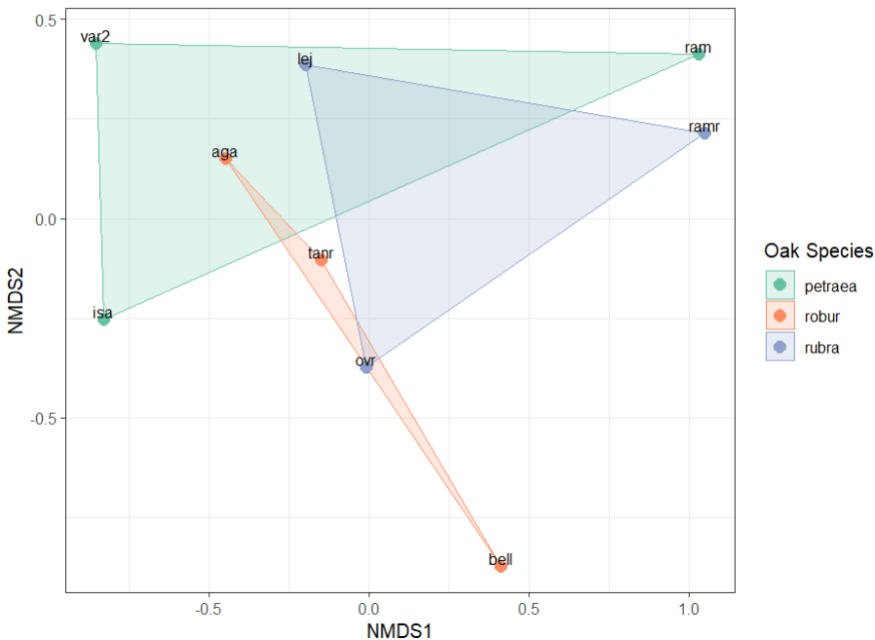
Figure S2. Non-metric multidimensional scaling (NMDS) ordination of understorey vascular‐plant assemblages beneath three oak species. Each point is a study site (site code shown); coloured polygons are the convex hulls enclosing all sites associated with Quercus petraea (green), Q. robur (orange) or Q. rubra (blue). The two-dimensional solution gives an excellent fit (stress = 0.055). A PERMANOVA on Bray–Curtis dissimilarities detected no significant difference in community composition among oak species (R² = 0.235, p = 0.52, 999 permutations). Axes represent the first (NMDS1) and second (NMDS2) ordination dimensions; their absolute values are arbitrary.
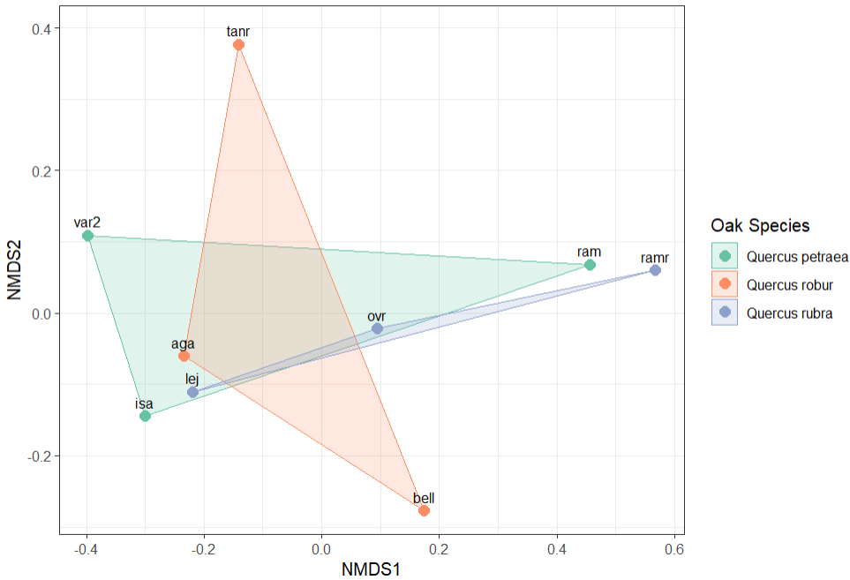
Figure S3. Non-metric multidimensional scaling (NMDS) ordination of operational taxonomic unit (OTU) assemblages beneath three oak species. Each point represents a study site (code shown); coloured polygons are convex hulls enclosing all sites associated with Quercus petraea (green), Q. robur (orange) or Q. rubra (blue). The two-dimensional solution shows a good fit (stress = 0.059). A PERMANOVA on Bray–Curtis dissimilarities detected no significant compositional difference among oak species (R² = 0.211, p = 0.88, 999 permutations). Axes (NMDS1, NMDS2) are dimensionless and their absolute values are arbitrary.
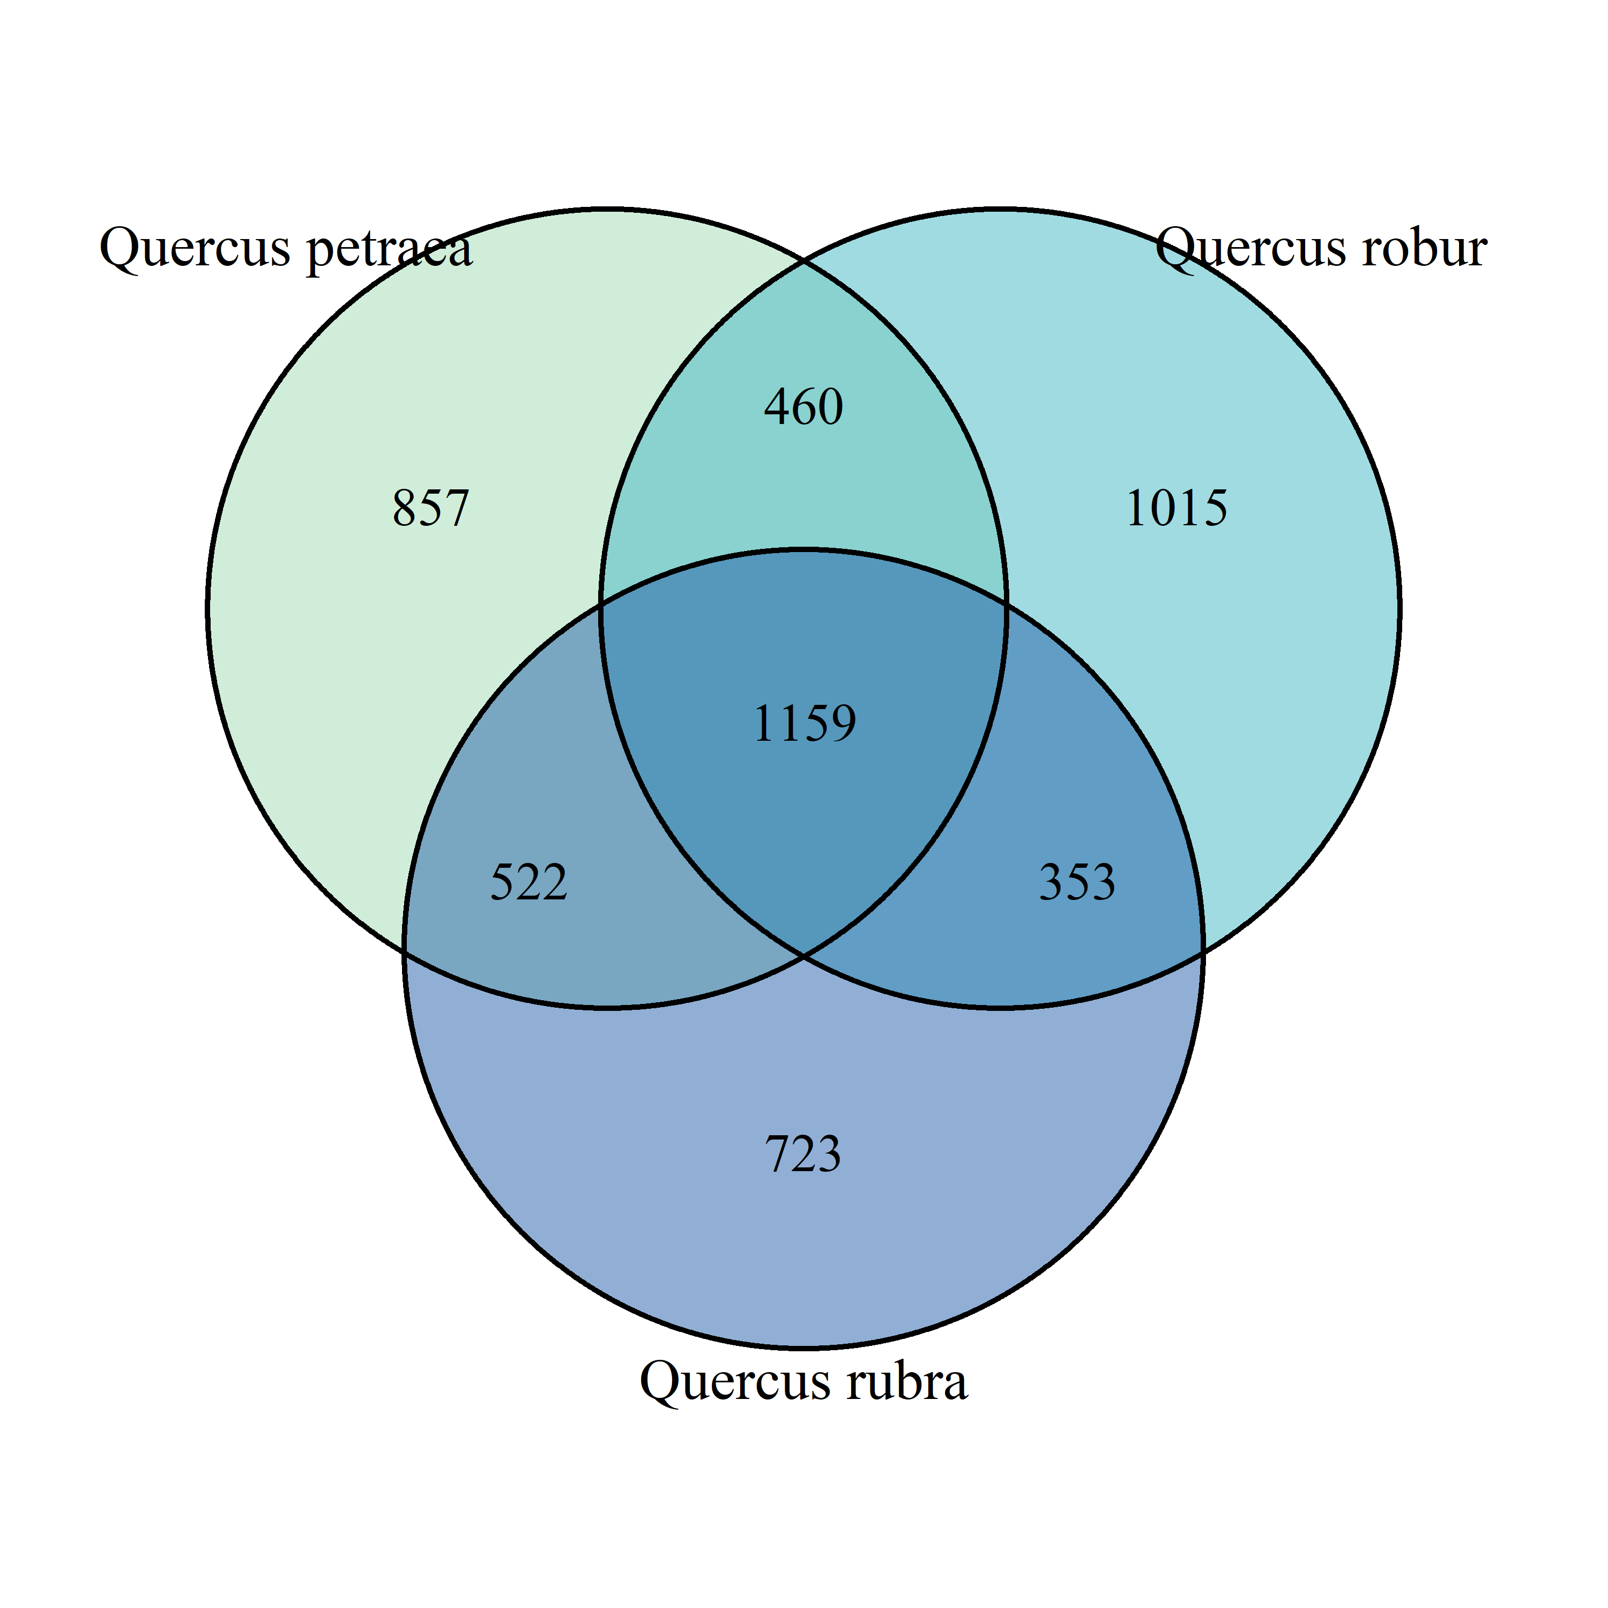
Figure S4. Three‐way Venn diagram showing the overlap in Operational Taxonomic Units (OTUs) detected on the three oak species. Light green, cyan and steel‐blue circles represent Quercus petraea, Q. robur and Q. rubra, respectively. Numbers in the outer segments are OTUs unique to each host (857 for Q. petraea, 1 015 for Q. robur, 723 for Q. rubra); those in the pairwise overlaps are OTUs shared by exactly two hosts (460 between Q. petraea/Q. robur, 522 between Q. petraea/Q. rubra, 353 between Q. robur/Q. rubra); and the center shows the 1 159 OTUs found on all three oak species.

Table S1. Site-level summary statistics for nine oak forest sites in southern Sweden. The table includes data for three sites of each oak species (Q. petraea, Q. robur, Q. rubra). Tree diameter (cm) and leaf herbivory (%) are given as mean ± SE. Species richness is the total number of distinct gall-forming insects (Gall_sp), leaf-miners (Miner_sp), foliar fungi (Fungi_sp), total leaf-inhabiting arthropods (Leaf_insect_sp), and vascular plants (Vascular_sp) recorded per site. OTU richness and Shannon H index are based on metabarcoding catches. Geographic coordinates are in WGS84 decimal degrees.

Site_id | Oak_species | Longitude | Latitude | Tree_diameter | Herbivory_percent | Gall_richness | Miner_richness | Fungi_richness | Leaf_insect_richness | Vascular_plant_richness | OTU_richness | Shannon_H_OTU
aga | Quercus robur | 13,113 | 56,710 | 27.14 ± 2.15 | 7.84 ± 2.87 | 5 | 7 | 0 | 12 | 18 | 1744 | 7.464
bell | Quercus robur | 13,680 | 55,524 | 19.71 ± 1.96 | 5.18 ± 0.72 | 9 | 5 | 0 | 14 | 30 | 1413 | 7.253
isa | Quercus petraea | 13,105 | 56,683 | 29 ± 1.21 | 6.48 ± 1.18 | 7 | 3 | 0 | 10 | 12 | 1307 | 7.175
lej | Quercus rubra | 13,097 | 56,692 | 37.14 ± 2.82 | 6.64 ± 0.51 | 0 | 1 | 1 | 1 | 15 | 1243 | 7.125
ovr | Quercus rubra | 12,905 | 56,716 | 50.43 ± 1.65 | 6.29 ± 1.32 | 2 | 5 | 1 | 7 | 32 | 1550 | 7.346
ram | Quercus petraea | 12,972 | 56,536 | 16.86 ± 0.86 | 9.07 ± 2.96 | 3 | 5 | 0 | 8 | 20 | 1422 | 7.26
ramr | Quercus rubra | 12,970 | 56,536 | 24.29 ± 1.61 | 12.97 ± 2.72 | 1 | 1 | 1 | 2 | 23 | 1174 | 7.068
tanr | Quercus robur | 14,007 | 57,062 | 40 ± 4.3 | 3.14 ± 0.62 | 5 | 7 | 0 | 12 | 39 | 1103 | 7.006
var2 | Quercus petraea | 12,832 | 57,949 | 29 ± 1.9 | 3.18 ± 1.44 | 6 | 3 | 0 | 9 | 19 | 1391 | 7.238

Table S2. OTU taxonomic classification and site presence. The table lists every unique Operational Taxonomic Unit (OTU) detected at each study site, providing the full assigned taxonomic lineage from Phylum to Species. The presence of a row indicates the detection of that OTU at that site. 'NA' signifies that an identification could not be resolved to that specific taxonomic rank.
OTU_ID | Oak_species | Phylum | Class | Order_ | Family | Genus | Species | isa | ram | var2 | aga | bell | tanr | lej | ovr | ramr
OTU_1 | Quercus robur | Arthropoda | Insecta | Diptera | Muscidae | Helina | Helina sp. | 1 | 1 | 1 | 1 | 1 | 1 | 1 | 1 | 1
OTU_10 | Quercus robur | Arthropoda | Insecta | Diptera | Sciaridae | Corynoptera | Corynoptera globiformis | 1 | 1 | 1 | 1 | 1 | 1 | 1 | 1 | 1
OTU_100 | Quercus robur | Arthropoda | Insecta | Diptera | NA | NA | NA | 1 | 1 | 1 | 1 | 1 | 1 | 1 | 1 | 1
OTU_1002 | Quercus robur | Arthropoda | Insecta | Diptera | Phoridae | NA | NA | 1 | 1 | 1 | 1 | 1 | 1 | 1 | 1 | 0

