Low foliar nitrogen and elevated defensive metabolites in the invasive weed Calluna vulgaris (heather) impair biocontrol agent performance.

Supplemental Information Doc. 1
1.1 Assessment of heather beetle impact on amplified metabolites
Heather beetle (HB) larvae were the only insect herbivores on the plants at time of sampling and were present in both treatments. These were sorted into 1st, 2nd or 3rd instar and enumerated. Eighteen plants covering both treatments had very low insect loading i.e. between two 1st instar and three 3rd instar larvae per plant. Costunolide, trans-2-Hexenal, naringin, myricetin-3-xyloside, formononetin, dihydroquercetin, tricin, 3,4-dihydrocoumarin and scopoletin are the seven secondary metabolites showing amplification (see Table 2). Paired t- tests using the mass spectral intensity data (au) for each of these secondary compounds, comparing the plants with insects and those with no insects showed no significant difference (all p = > 0.05) between those groups. Insect herbivory therefore was not associated with amplification of any of these metabolites.
1.2 Metabolite Extraction protocol for UHPLC-MS/MS analysis
For extraction of metabolites for UHPLC-MS/MS analysis, 50 ± 0.5 mg of ground sample was weighed into 2 mL microcentrifuge tubes, each containing a 2.5mm glass bead. To each tube, 800 µL of pre-chilled chloroform:methanol (CHCl₃:CH₃OH; 1:1 v/v) was added and then homogenised for 5 mins at 25 Hz sec⁻¹ using a Retsch MM400 Mill/TissueLyser and stored for 1 hr at -20 ºC. Then, 400ml of HPLC grade H₂O was added to each tube, similarly homogenised, then centrifuged (Sigma 1-14K microcentrifuge) at 4 ºC and 11000 RPM for 15 mins to create a biphasic layer. From each sample, 2 x 200 µl aliquots of the upper layer were pipetted into 2 mL microcentrifuge tubes for C18 and HILIC chromatography analysis. A final 200 µl aliquot was added to a 150 ml tube, ultimately pooling every sample into a homogenous mix, then sub-aliquots (200 µl) of this mix were transferred into microcentrifuge tubes to use as quality controls (QCs). All samples were then dried under a continuous flow of N₂ (3.5 L min⁻¹) at 38 ºC for 60 min using a BT LabSystems sample concentrator and immediately stored at -80 ºC until reconstitution.
Reconstitution solvents which included an internal standard (Cat. # MSK-QC-KIT) (Cambridge Isotope Laboratories Inc.) at the concentration of 10 µl ml⁻¹ were prepared for C18 analysis in acetonitrile: water (CH₃CN:H₂O; 1:9, v/v) and for HILIC in acetonitrile:water (CH₃CN:H₂O; 1:1, v/v). Immediately prior to LC-MS analysis, all samples plus eight QCs were reconstituted by adding 200 µl of solvent, vortexed until dissolved and transferred by pipette to a 200 µl glass insert in an amber autosampler vial, capped and kept chilled until loading. The sequence was: five vials of reconstitution solvent only (blanks), one amino acid standard (A9906; Sigma-Aldrich, NZ), two QCs,56 samples with a QC every 8th slot to finish with a final amino acid.
1.3 Chromatography and tandem mass-spectrometry conditions.
Chromatography and tandem mass-spectrometry analysis of polar and semi-polar compounds were achieved using a Thermo LC–MS system (Thermo Fisher Scientific, Waltham, MA, USA) consisting of a Dionex UltiMate 3000 UHPLC coupled with a high-resolution Q Exactive Focus Quadrupole-Orbitrap mass spectrometer utilising heated electrospray ionisation run in both positive and negative modes.
For semi-polar compounds, samples were cooled in the auto-sampler at 4 °C and a 5 μL aliquot was injected into a 1.9 µm Thermo Hypersil GOLDTM C18 column (UHPLC, 100 mm × 2.1 mm, Thermo Fisher Scientific, USA) at 25 °C with a gradient elution programme and a flow rate of 350 μL min⁻¹. The mobile phase was water with 0.1% formic acid (solvent A), and acetonitrile (C₂H₃N) with 0.1% formic acid (solvent B). Using the Xcalibur software package provided by the manufacturer the gradient elution programme was: held at 5% B (0–3 min), 5–80% B (3–13 min), held at 80% B (13–16 min), 80-100% B (16.0-16.5 min), held at 100 % B (16.5-18 min) returned to 5% B (18–19 min) and allowed to equilibrate for a further 4 min prior to the next injection. Full mass scan spectral data were collected in profile mode over a mass range of 60–900 m/z, at a mass resolution setting of 70,000 with a maximum trap fill time set to auto. ddMS² parameters were: resolution 17,500, isolation window 1.5 m/z, collision energy of 25 with a maximum trap fill time set to auto. Samples were run in both positive and negative ionisation modes separately. Positive ion mode parameters were: spray voltage 3.5 kV; capillary temperature 320 °C; auxiliary heater temperature 350 °C, sheath gas flow (N₂) 35, auxiliary gas 8, and sweep gas of 1 (arbitrary units). Negative ion mode parameters were the same except for spray voltage, −3.5 kV.
For polar compounds, samples were cooled in the auto-sampler at 4 °C and a 5 μL aliquot was injected into a 5 µm ZIC®-pHILIC column (100 mm × 2.1 mm, Merck Darmstadt, Germany) at 25 °C with a gradient elution programme and a flow rate of 150 μL min⁻¹. The mobile phase was 10mM NH₄COOH in water pH adjusted to ∼ 4 with formic acid (solvent A) and 97% CH₃CN (solvent B). The gradient elution programme was: 95% B (0-2 min), 95–20% B (2–17 min), held at 20% B (17-19 min), returned to 95% B (19–19.5 min) and allowed to equilibrate for a further 9.5 min prior to the next injection. Full Mass scan spectral data were collected in profile mode over a mass range of m/z 60-900 at a mass resolution setting of 70,000 with a maximum trap fill time set to auto. ddMS² parameters were: resolution 17,500, isolation window 1.5 m/z, collision energy of 25 with a maximum trap fill time set to auto. Samples were run in both positive and negative ionisation modes separately. Positive ion mode parameters were: spray voltage 3.5 kV; capillary temperature 320 °C; auxiliary heater temperature 280 °C, sheath gas flow (N₂) 25, auxiliary gas 8, and sweep gas of 1 (arbitrary units). Negative ion mode parameters were the same except for spray voltage, −3.5 kV.

Supplemental Figure

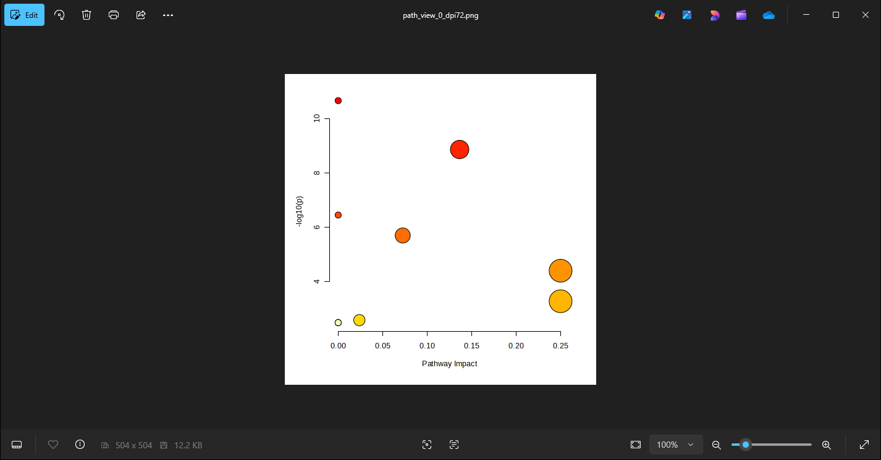
Flavone and flavonol biosynthesis
Biosynthesis of various plant secondary metabolites
Pantothenate and CoA biosynthesis pathway
Flavonoid biosynthesis pathway
Vitamin B6 metabolism
S. Fig. 1. Pathway enrichment analysis for Calluna vulgaris metabolites resulting from the control and treatments plants. The x axis provides the pathway impact value, and the y axis indicates −log10(p) value of significance between the two treatments. The size and colour of the dot represent the impact value, and the pathway p value respectively i.e. increasing p values change from yellow through to red.

