Supporting information

Appendix S1. Dung beetle trait assignment
Species were characterized in terms of seven ecological attributes: food relocation behavior, diet, diel activity, body mass, body mass-adjusted front leg area, body mass-adjusted pronotum volume, and back:front leg lengths. Protocols for trait assignments are described below.

Food relocation behavior
Food relocation behavior assignment followed the classification of Hanski and Cambefort (1991) who categorized dung beetle species as telecoprids, paracoprids or endocoprids. Telecoprid species remove portions of dung, which are rolled various distances and then buried. Paracoprid species construct tunnels below or adjacent to the food resource and transport dung to the bottom of the tunnel. Endocoprid species live within a dung pat and do not exhibit resource allocation.

Diet
Diet preference was investigated using traps baited with cattle dung (n = 72 traps) and carrion (n = 72 traps) using the same sampling design described in the Materials and Methods section. We used the proportion of individuals of each species attracted to a certain bait to determine bait specificity. Species was considered as “coprophage” or “necrophage” when its occurrence was ≥80% on one bait used (cattle dung or carrion), otherwise it was considered “generalist” (Halffter and Arellano 2002). The minimum number of individuals of each species required to calculate diet n = 3.

Diel activity
We obtained information on dung beetle diel activity from the published literature (Pêssoa et al., 2017; Beiroz et al., 2017; Iannuzzi et al., 2016; Audino et al., 2014, Hernández 2002) and personal observations of specialist (Fernando Vaz-de-Mello), where they are classified as: nocturnal, diurnal or mixed.

Body mass
To determine the body mass, all individuals of each species were dried at 42°C for 72 hours and weighed using a balance accurate to 0.0001 g.

Morphological traits (Body mass-adjusted front leg area; body mass-adjusted pronotum volume; back: front leg lengths)
We measured pronotum area, front tibia and femur area, and front and back leg length using a Leica M250 microscope and Life Measurement software (Leica, Wetzlar, Germany); with digital calipers (0.01-mm resolution) we measured pronotum height. Front tibia and femur area were summed to provide a total front leg area, and pronotum height and area were multiplied to estimate pronotum volume (see Griffiths et al. 2015).

References
Audino LD, Louzada J, Comita L (2014) Dung beetle as indicators of tropical forest restauration success: Is it possible to recover species and functional diversity? Biol Conserv 169:248–257
Beiroz W, Slade EM, Barlow J, Silveira JM, Louzada J, Sayer E (2017) Dung beetle community dynamics in undisturbed tropical forests: implications for ecological evaluations of land-use change. Insect Conserv Divers 10:94–106
Griffiths HM, Louzada J, Bardgett RD, Beiroz W, França F, Tregidgo D, Barlow J (2015) Biodiversity and environmental context predict dung beetle-mediated seed dispersal in a tropical forest field experiment. Ecology 96:1607–1619
Halffter G, Arellano L (2002) Response of dung beetle diversity to human-induced changes in a tropical landscape. Biotropica 34:144–154
Hanski I, Cambefort Y (1991) Dung beetle ecology. Princeton University Press, Princeton.
Hernandéz MIM (2002) The night and day of dung beetles (Coleoptera: Scarabaeidae) in the serra do Japi, Brazil: elytra colour related to daily activity. Rev Bras Entomol 46:597–600
Iannuzzi L, Salomão RP, Costa FC, Liberal CN (2016) Environmental patterns and daily activity of dung beetles (Coleoptera: Scarabaeidae) in the Atlantic rain forest. Entomotropica 31:196–207
Pêssoa MB, Izzo TJ, Vaz-de-Mello FZ (2017) Assemblage and functional categorization of dung beetles (Coleoptera: Scarabaeinae) from the Pantanal. PeerJ 5:e3978

Table S1. Abundance and morpho-functional traits of native dung beetles and the exotic species Digitonthophagus gazella sampled over 52 weeks between April 2020 and March 2021 in introduced pasture (Urochloa spp.) in Aquidauana, Mato Grosso do Sul, Brazil.
Species | Abundance (%) | Food  relocation  habit | Diel  Activity | Body  Mass (mg) | Body  mass-adjusted  front leg area | Body  mass-adjusted  pronotum volume | Back:front  leg lengths
Ateuchus sp. | 56 (5.8) | Paracoprid | Nocturnal | 0.0079 | 38.6081 | 461.7164 | 0.7320
Dichotomius bos | 122 (12.7) | Paracoprid | Nocturnal | 0.5221 | 15.9039 | 648.5058 | 0.8271
Dichotomius nisus | 12 (1.3) | Paracoprid | Nocturnal | 0.7552 | 6.8206 | 228.0884 | 0.6955
Dichotomius opacipennis | 6 (0.6) | Paracoprid | Nocturnal | 0.0665 | 36.0232 | 919.8393 | 0.6905
Eurysternus carybaeus | 1 (0.1) | Endocoprid | Mixed | 0.0705 | 36.7601 | 785.9048 | 0.6874
Genieridium bidens | 2 (0.2) | Endocoprid | Unknown | 0.0055 | 31.5447 | 297.3858 | 0.6546
Ontherus appendiculatus | 28 (2.9) | Paracoprid | Nocturnal | 0.0466 | 31.3303 | 534.9569 | 0.7786
Onthophagus hircus | 138 (14.4) | Paracoprid | Mixed | 0.0054 | 63.7901 | 764.3143 | 0.7003
Onthophagus ptox | 5 (0.5) | Paracoprid | Mixed | 0.0051 | 51.7242 | 676.6979 | 0.7364
Tetraechma liturata | 1 (0.1) | Telecoprid | Unknown | 0.0111 | 36.0605 | 457.6623 | 0.6354
Trichillum externenpunctatum | 399 (41.6) | Endocoprid | Nocturnal | 0.0013 | 44.6446 | 456.7207 | 0.5779
Digitonthophagus gazella | 190 (19.8) | Paracoprid | Nocturnal | 0.0459 | 68.9821 | 1131.607 | 0.8308

Table S2. SEM’s d-separation test (Fisher’s C) and Durbin-Watson test for temporal autocorrelation on the uniformly scaled residuals of minimal models of the structural equation modelling evaluating the relation among climatic variables (temperature, precipitation, and humidity), abundance of Digitonthophagus gazella (total, females, and males), and abundance and species richness of native dung beetles (total, paracoprids, and endocoprids) sampled over 52 weeks between April 2020 and March 2021 in introduced pasture (Urochloa spp.) in Aquidauana, Mato Grosso do Sul, Brazil. S = species richness; N = number of individuals.
Model | Response | Predictor | Fisher’s C | P-value | Durbin-Watson  test | P-value
D. gazella | N of native spp. | Temperature | 9.562 | 0.144 | 1.9689 | 0.9121
 | N of D. gazella | Humidity | - | - | 1.8908 | 0.6976
D. gazella females | N of native spp. | Temperature | 7.832 | 0.251 | 1.9689 | 0.9121
 | N of D. gazella females | Humidity | - | - | 1.8831 | 0.6774
D. gazella males | N of native spp. | Temperature | 4.026 | 0.134 | 1.9689 | 0.9121
 | N of D. gazella males | Temperature | - | - | 2.0621 | 0.8251
D. gazella | S of paracoprids | N of paracoprids | 8.146 | 0.228 | 1.9746 | 0.9280
 | N of D. gazella | Humidity | - | - | 1.8908 | 0.6976
D. gazella females | S of paracoprids | N of paracoprids | 8.089 | 0.232 | 1.9746 | 0.9280
 | N of D. gazella females | Humidity | - | - | 1.8831 | 0.6774
D. gazella males | S of paracoprids | N of paracoprids | 5.965 | 0.918 | 1.9746 | 0.9280
 | N of D. gazella males | Temperature | - | - | 2.0621 | 0.8251
D. gazella | N of endocoprids | N of D. gazella | 4.128 | 0.389 | 1.7619 | 0.3955
 | N of endocoprids | Temperature | - | - | 1.6618 | 0.2258
 | N of D. gazella | Humidity | - | - | 1.8908 | 0.6976
D. gazella females | N of endocoprids | N of D. gazella females | 3.736 | 0.443 | 1.5791 | 0.1301
 | N of endocoprids | Temperature | - | - | 1.6618 | 0.2258
 | N of D. gazella females | Humidity | - | - | 1.8831 | 0.6774
D. gazella males | N of endocoprids | N of D. gazella males | 3.521 | 0.532 | 1.8921 | 0.7011
 | N of endocoprids | Temperature | - | - | 1.6618 | 0.2258
 | N of D. gazella males | Temperature | - | - | 2.0621 | 0.8251

Table S3. SEM’s d-separation test (Fisher’s C) and Durbin-Watson test for temporal autocorrelation on the uniformly scaled residuals of minimal models of the structural equation modelling evaluating the relation among climatic variables (temperature, precipitation, and humidity), Digitonthophagus gazella-related traits (male body size, female body size, male horn size), and functional metrics of native dung beetles (body mass, BM; body mass-adjusted front leg area, FLA; body mass-adjusted pronotum volume, PV; back:front leg lengths, BFLL) sampled over 52 weeks between April 2020 and March 2021 in introduced pasture (Urochloa spp.) in Aquidauana, Mato Grosso do Sul, Brazil. F = D. gazella females; M = D. gazella males.
Response | Predictor | Fisher’s C | P-value | Durbin-Watson test | P-value
M Horn | M Body size | 37.541 | 0.957 | 1.9153 | 0.7633
F Body size | M Body size | - | - | 2.0449 | 0.8732
BM | Temperature | - | - | 1.8830 | 0.6773
BM | Humidity | - | - | 1.8830 | 0.6773
FLA | Temperature | - | - | 1.7697 | 0.4114
FLA | Humidity | - | - | 1.7697 | 0.4114
PV | - | - | - | - | -
BFLL | Precipitation | - | - | 2.0763 | 0.786

Figure S1. Body and horn measurement of male and female individuals of Digitonthophagus gazella.

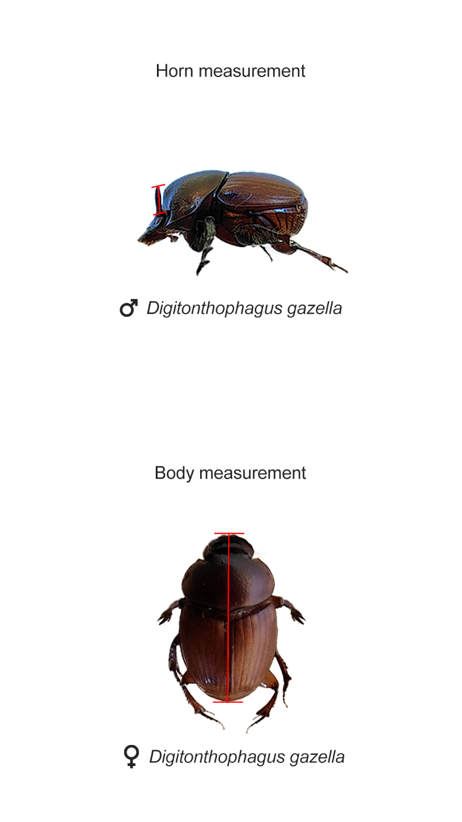

Figure S2. Pearson’s correlation plot among climate variables obtained for the sampling period (April 2020 to March 2021). P-values: * p < 0.05; ** p < 0.01; *** p < 0.001.
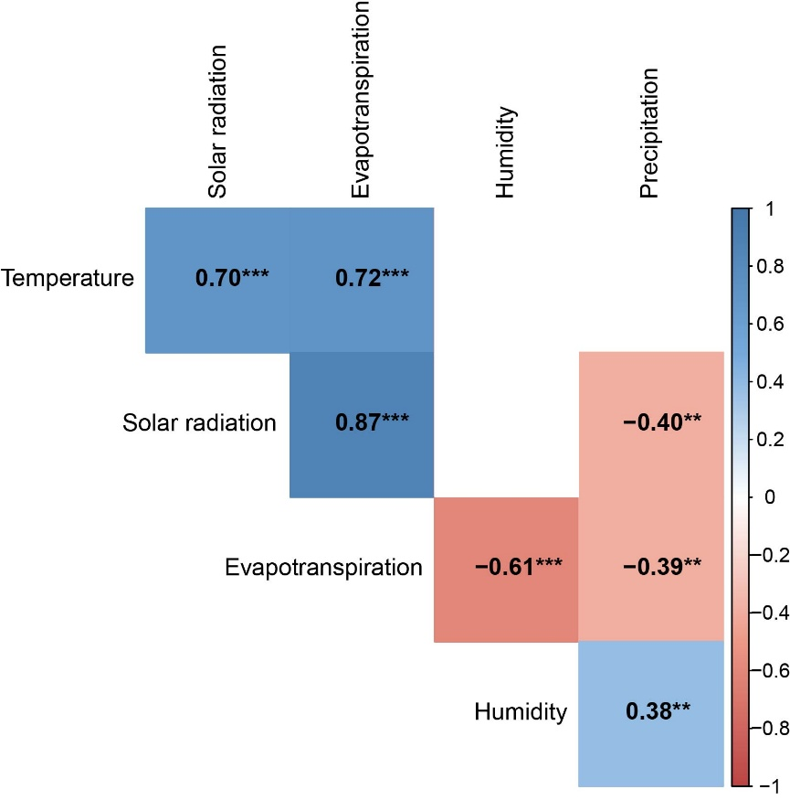

Figure S3. Values of weakly average ambient temperature (ºC), accumulated precipitation (mm), and average ambient humidity (%) during the sampling period (April 2020 to March 2021).
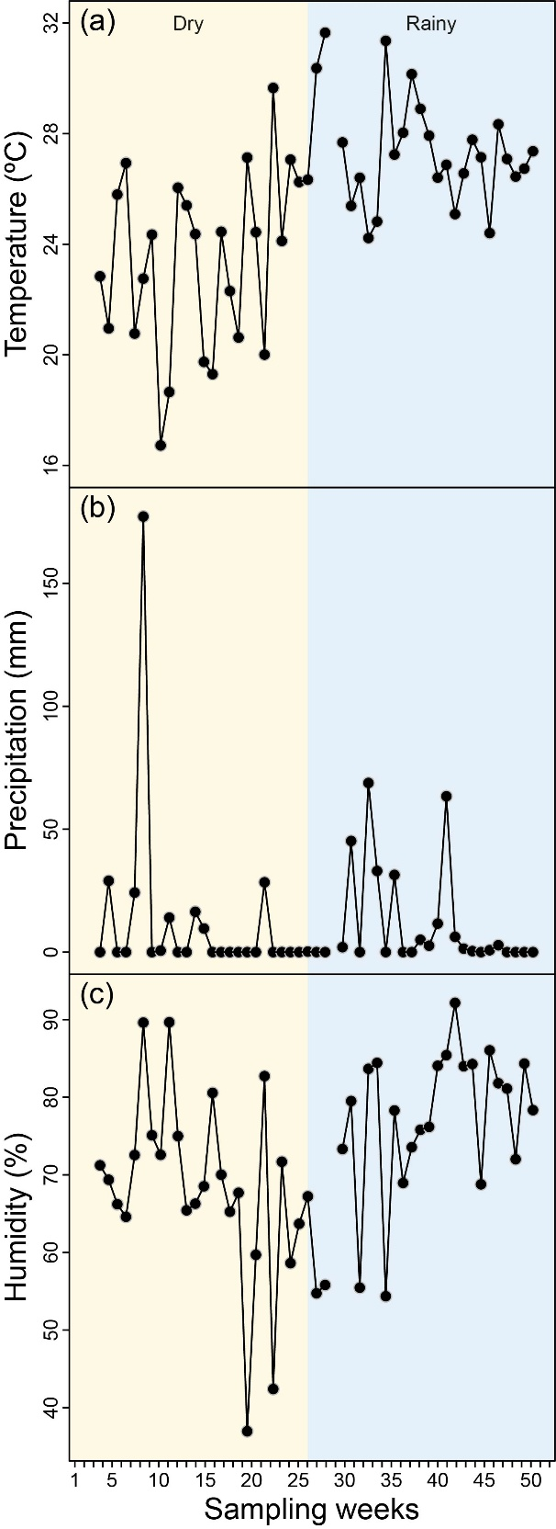

Figure S4. Conceptual models. (a) Conceptual model of the structure of the relationships between climatic variables, abundance of the exotic dung beetle, Digitonthophagus gazella, and abundance and species richness of native dung beetles. (b) Conceptual model of the structure of the relationships between climatic variables, morphological traits of the exotic dung beetle, Digitonthophagus gazella, and community weighted means of morphological traits of native dung beetle species. BM = body mass; FLA = body mass adjusted front leg area; PV = body mass adjusted pronotum volume; BFLL = back:front leg lengths.
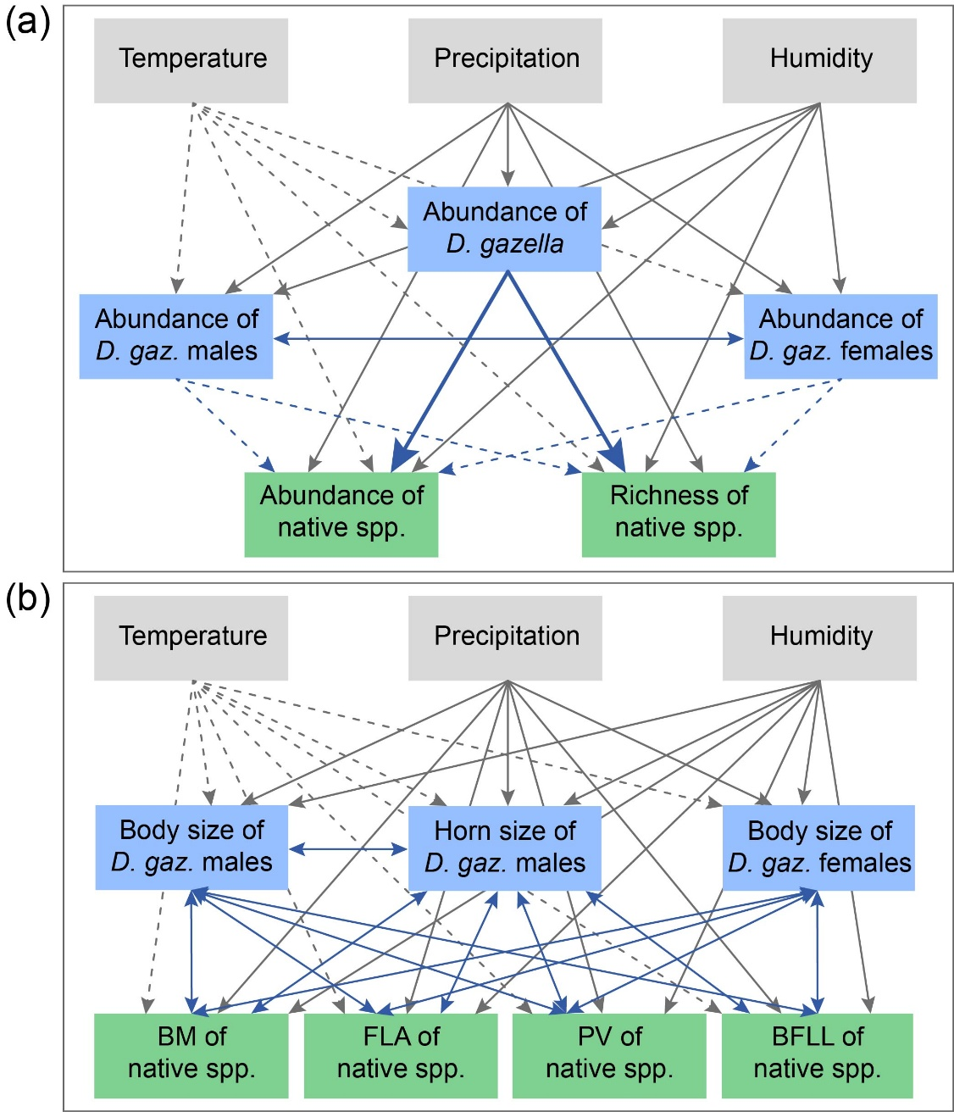

Figure S5. Structural equation modelling evaluating the relation among climatic variables (temperature, precipitation, and humidity), abundance of D. gazella (total, females, and males), and abundance and species richness of native dung beetles.
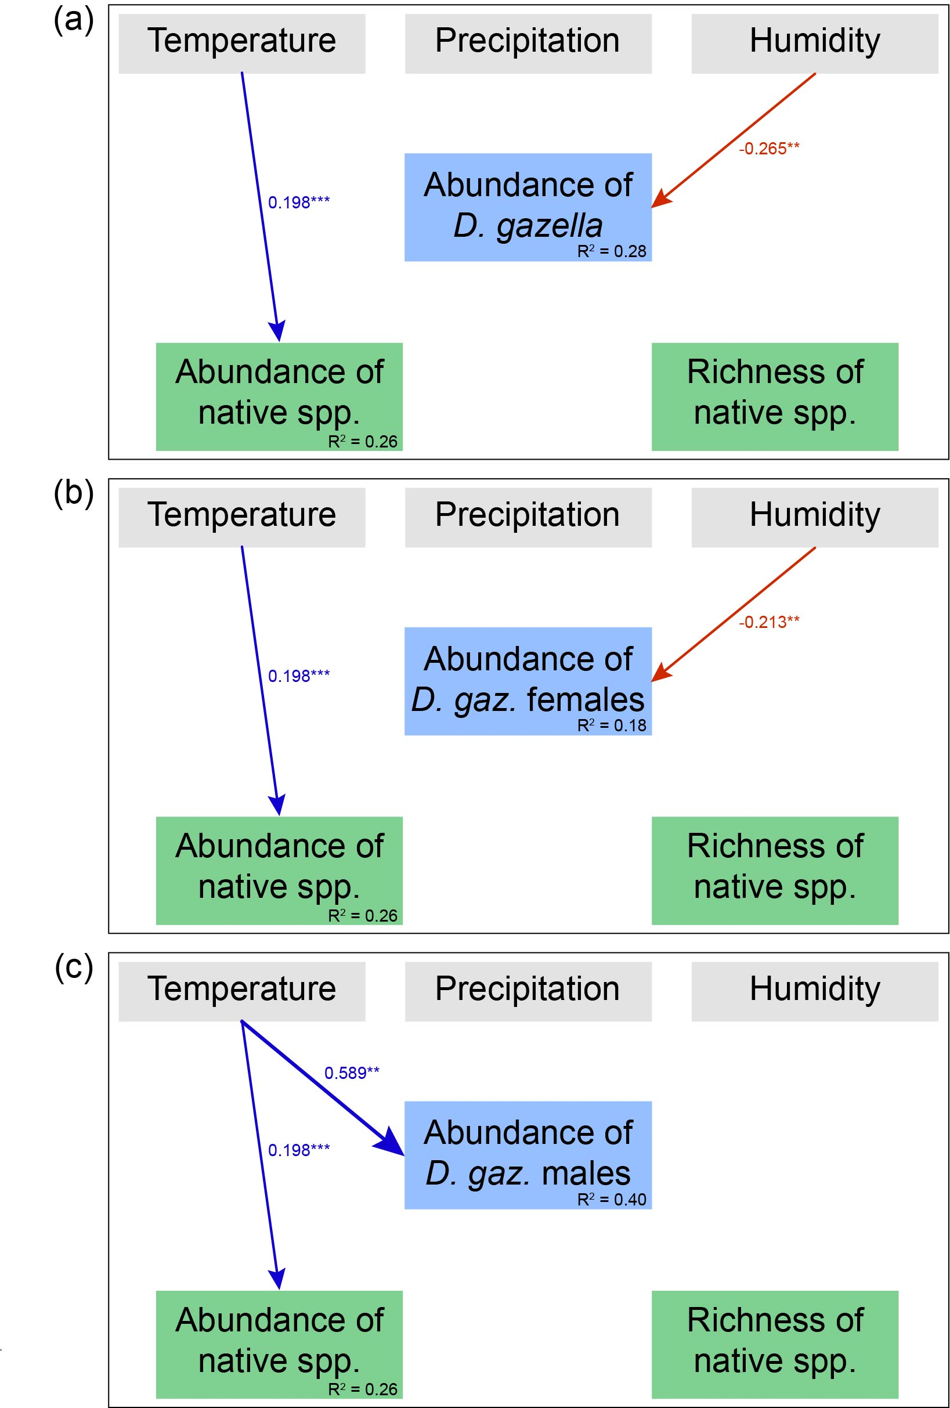

Figure S6. Structural equation modelling evaluating the relation among climatic variables (temperature, precipitation, and humidity), abundance of D. gazella (total, females, and males), and abundance and species richness of native paracoprid dung beetles sampled in introduced pasture (Urochloa spp.) in Aquidauana, Mato Grosso do Sul, Brazil. P-values: <0.05*, <0.01**, <0.001***.
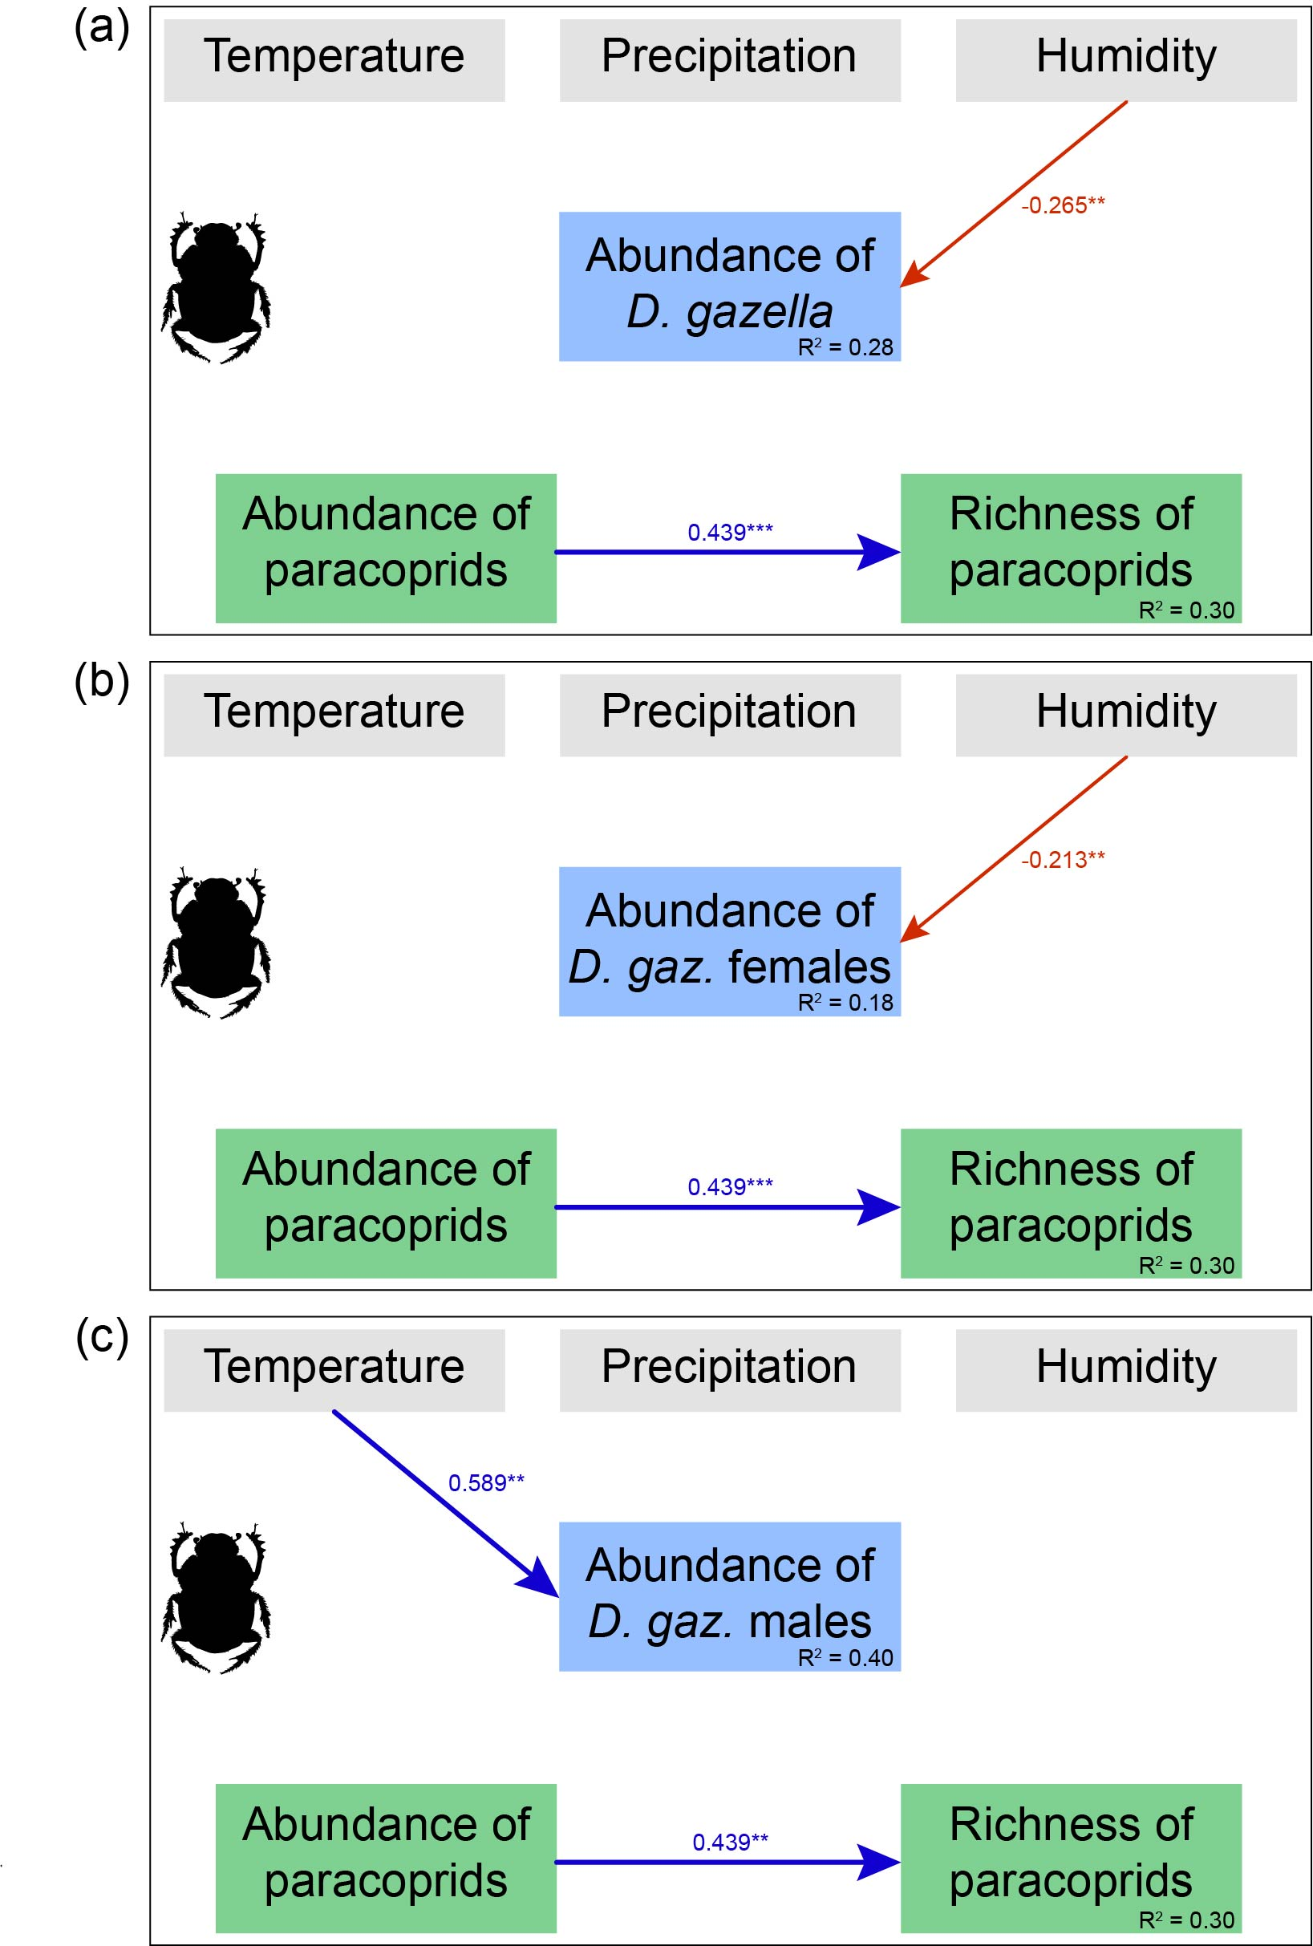
Figure S7. Structural equation modelling evaluating the relation among climatic variables (temperature, precipitation, and humidity), abundance of D. gazella (total, females, and males), and abundance and species richness of native endocoprid dung beetles sampled in introduced pasture (Urochloa spp.) in Aquidauana, Mato Grosso do Sul, Brazil. P-values: <0.05*, <0.01**, <0.001***.
