Supplementary Information
Online Resource 1. Sampling of 11 e-commerce websites advertising plants in Australia
There are several different types e-commerce websites that differ in how people buy and how sellers advertise plants. On marketplace platforms, both individuals and businesses can sell and/or auction plants. Therefore, advertisements are often unique to each seller, leading to a high number of unique advertisements. In contrast, private nursery businesses tend to maintain relatively stable inventories of plants which change less frequently over time. Consequently, nursery websites generally have fewer unique advertisements.
Due to the high number of unique advertisements and the need to manually verify species in marketplace advertisements, we used sampling to assess trade on these platforms. For this study, we included 10,000 previously processed advertisements from our earlier study on the e-commerce platform we refer to here as ‘Marketplace A’ (Maher et al., 2023). Advertisements from Marketplace A were sampled over a 12-month period from 2020 February 1 to 2021 January 31.
For the remaining marketplace platforms (i.e., Marketplace B and C), we used a modified version of the approach described in Maher et al. (2023). Specifically, we extracted 2,000 advertisements each from Marketplace B and C. Each extraction of 2,000 advertisements comprised two samples of 1,000 advertisements. The first sample was a random selection of plant advertisements stratified by jurisdiction. For the second sample we utilised string matching to target listings that may contain plants declared as noxious weeds (Maher et al., 2023). Advertisements for Marketplace B and C were collected over a 12-month period from 2021 January 1 to 2021 December 31.
Ultimately, we manually extracted 14,000 advertisements from three marketplaces and identified species in 13,823 unique advertisements (c. 4.1% of collected marketplace advertisements), accounting for overlap introduced through our sub-sampling of each marketplace. The time period differs from that of Marketplace A due to the timing of the development of web scrapers for Marketplace B and C. As a result, any annual fluctuations in trends and availability of traded plants may not be fully comparable.
For the eight nursery websites, we were able to process all 26,280 advertisements collected from 2020 October 8 to 2023 June 24 (c. 32 months). We extracted scientific names from advertisement titles using string matching and regular expressions. This included removing any unnecessary information such as common names and terms like “tubestock” or “seeds”. We also removed cultivar, hybrid, and variety names.
Online Resource 2. A summary of taxa which could not be resolved to species level using accepted scientific names in the Global Biodiversity Information Facility taxonomic database (GBIF). Total taxa represent the total number of unique taxa observed on the website. Data deficient taxa are those that could not be identified to species level, often hybrids and cultivars. Percent data deficient indicates the percentage of total taxa observed on a website that could not be identified to species level.
Website | Total taxa | Data deficient taxa | Percent data deficient
Specialist Aquarium | 107 | 42 | 39.25%
Specialist Cacti | 225 | 85 | 37.78%
Generalist C | 509 | 183 | 35.95%
Specialist Succulents | 464 | 139 | 29.96%
Marketplace A | 1768 | 481 | 27.21%
Marketplace C | 687 | 175 | 25.47%
Generalist A | 1359 | 319 | 23.47%
Marketplace B | 1001 | 230 | 22.98%
Generalist B | 782 | 158 | 20.20%
Specialist Aquatics | 248 | 50 | 20.16%
Specialist Australian natives | 602 | 117 | 19.44%

Online Resource 3. Native and naturalised distributions of plants.
For native and naturalised distributions, Plants of the World Online (POWO) and the World Checklist of Vascular Plants (WCVP) utilise the World Geographical Scheme for Recording Plant Distributions (WGSRPD), of which there are four geographic units for distribution (Brummit, 2001). Level 3 records distribution at the country scale or by political subdivisions for large countries (i.e., Argentina, Australia, Brazil, Canada, Chile, China, India, Mexico, Russia, South Africa, and USA). Level 1 records distributions within 9 large scale biogeographic regions: Africa, Antarctica, Asia-Temperate, Asia-Tropical, Australasia, Europe, Northern America, Pacific, and Southern America. The shapefiles and geographic unit codes were obtained from the WGSRPD repository (Brummit, 2001). We used ‘level 3’ for finer scale visualisation and descriptive analysis and ‘level 1’ for calculating the proportion of traded species native to those biogeographic regions. Native ranges were obtained for fewer species (3,727 species) than were detected overall (3,822 species) because 58 species could not be resolved between the GBIF and WCVP taxonomic backbones, 30 species were treated as synonyms according to WCVP (reducing this set to 15 species), and 22 species were non-vascular (i.e, not tracheophytes) and therefore not covered by WCVP.

Online Resource 4. Cleaning protocol for species occurrence data.
We used the ‘CoordinateCleaner’ R package to automatically flag spatial and temporal errors in the species occurrence data collected from GBIF (Zizka et al., 2019). We set our cleaning protocol with the package to remove occurrences: (1) missing location data; (2) located 1km around country centroids; (3) has equal absolute longitude and latitude; (4) within one-degree radius around GBIF headquarters; (5) within 100 metre radius around known biodiversity institutions; (6) located in the ocean; (7) with plain zeros or within 0.5 degree of 0° latitude, 0° longitude; (8) 1000 km from the nearest observation (i.e., geographic outliers). All other default settings recommended by the package developers were kept in place.
Next, we removed duplicate occurrences based on latitude and longitude. Then we removed any occurrences with terms suggesting the observation was a cultivated specimen. This was achieved by removing occurrences with terms in the locality field that matched a list of terms adopted from Duursma et al. (2013) (i.e., 'garden', 'nursery', 'greenhouse', 'ornamental', 'experimental', and 'cultivated'). These terms were translated into 11 languages to include those used by Duursma et al. (2013) and those supported by the GBIF user-interface (English, French, Dutch, Spanish, Portuguese, Italian, German, Chinese (simplified and latin text), Japanese (kanji, hiragana, latin text), Russian (Cyrillic and latin text), Arabic (Arabic and latin text)) (GBIF, 2024).
Finally, we excluded occurrences that were not within the recognised native or naturalised range of a species. For native ranges we used POWO and for naturalised ranges we used GloNAF. Both databases divide ranges into countries and by political subdivisions for large countries (Argentina, Australia, Brazil, Canada, Chile, China, India, Mexico, Russia, South Africa, and United States) in accordance with level 3 of the World Geographical Scheme for Recording Plant Distributions (Brummit, 2001).
Online Resource 5. Köppen-Geiger climate classifications observed in Australia (Kottek et al., 2006). The Köppen-Geiger climate codes have been grouped into prominent climate groups.
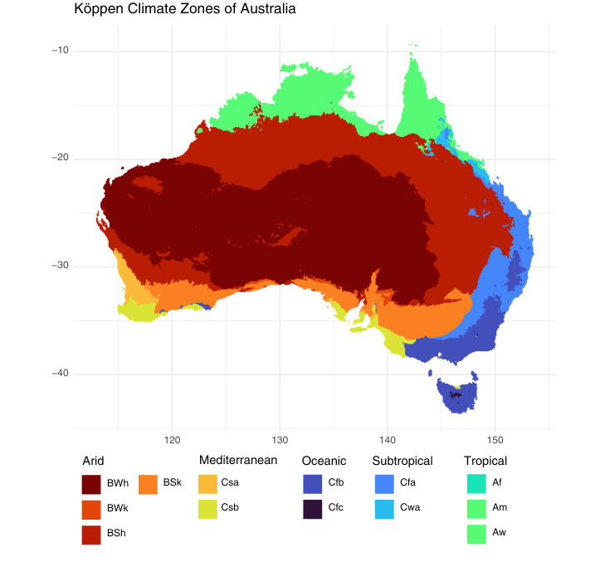
Climate group | Code | Description
Arid | BWh | Hot desert - extremely dry and hot.
Arid | BWk | Cold desert - very dry with cold winters.
Arid | BSh | Hot semi-arid - low rainfall with hot temperatures.
Arid | BSk | Cold semi-arid - low rainfall with cooler temperatures.
Mediterranean | Csa | Hot-summer Mediterranean - dry, hot summers and mild, wet winters.
Mediterranean | Csb | Warm-summer Mediterranean - dry summers and cool, wet winters.
Oceanic | Cfb | Mild oceanic climate - consistent rainfall and warm summers.
Oceanic | Cfc | Cool oceanic climate - consistent rainfall and cold summers.
Subtropical | Cfa | Humid subtropical - consistent rainfall and hot summers.
Subtropical | Cwa | Monsoonal subtropical – dry winter and hot, wet summers.
Tropical | Af | Tropical rainforest – hot and humid with consistent rainfall.
Tropical | Am | Tropical monsoon – high rainfall with a short dry season.
Tropical | Aw | Tropical savanna – warm year-round with dry winter.

Online Resource 6. Proportion of plant species native to different biogeographic regions traded online in Australia. The table presents the total number of plant species native to each region, the number of species traded online in Australia, and the percentage of traded species relative to the total species in each region. Total species native to a biogeographic region according to The World Checklist of Vascular Plants (Govaerts et al., 2021). Biogeographic regions follow level 1 of the World Geographical Scheme for Recording Plant Distributions (Brummit, 2001).
Name | Total species known | Traded species | Percentage
Australasia | 25889 | 875 | 3.38%
Europe | 25664 | 498 | 1.94%
Northern America | 39489 | 689 | 1.74%
Africa | 64867 | 937 | 1.44%
Asia-Temperate | 65060 | 912 | 1.40%
Pacific | 10144 | 108 | 1.06%
Asia-Tropical | 72305 | 652 | 0.90%
Southern America | 108510 | 634 | 0.58%

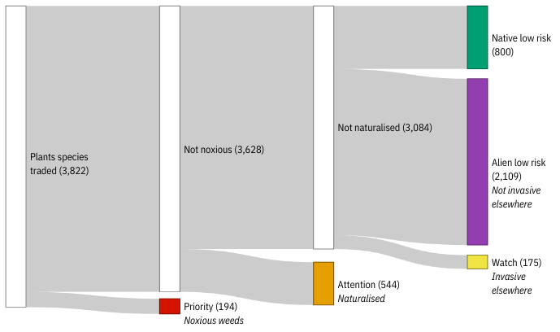
Online Resource 7. Flow diagram illustrating the categorisation of plant species traded online. Priority species are declared noxious weeds and are restricted from trade and cultivation in at least one Australian jurisdiction (i.e., State or Territory); this category may include Australian native species. Attention species are those naturalised in Australia, according to the Australia Plant Census (Australian National Herbarium, 2023), including native species that have naturalised outside their native range within Australia (i.e., native colonising). Watch species are alien plants not yet naturalised in Australia but recognised as invasive elsewhere in the world, according to the Global Register of Introduced and Invasive Species (Pagad et al., 2022). Alien low risk species are not native or naturalised in Australia, and not considered invasive elsewhere. Native low risk species are those native to Australia and not categorised as Priority or Attention species.

