Supporting Information

for Antoniazza, M. et al. Long-term effects of rotational wetland mowing on breeding birds: evidence from a 30-year experiment.

The Supporting Information contains 1 Supplementary Table and 4 Supplementary Figures.

Table S1: Summary of the different plots and mowing regimes.

Figure S1: Evolution of Lake Neuchâtel level and fluctuations from 1856 to 2014.
Figure S2: Map of Gletterens
Figure S3: Map of Cheyres
Figure S4: Distribution of simulated F-values in our permutation Linear Mixed Model analysis.
Plot name |  | Location | Surface  (ha) | Mowing year
 |  | Location | Surface  (ha) | 1985 | 1986 | 1987 | 1988 | 1989 | 1990 | 1991 | 1992 | 1993 | 1994 | 1995 | 1996 | 1997 | 1998 | 1999 | 2000 | 2001 | 2002 | 2003 | 2004 | 2005 | 2006 | 2007 | 2008 | 2009 | 2010 | 2011 | 2012 | 2013 | 2014 | 2015
Cheyres_total |  | Cheyres | 17.5
 | Chy1 | Cheyres | 1.4 |  |  |  |  |  |  |  |  |  |  |  |  |  |  |  |  |  |  |  |  |  |  |  |  | X |  | X |  | X |  | X
 | Chy_ctrl | Cheyres | 2.5
 | Chy2 | Cheyres | 1.1 |  |  | X |  |  | X |  |  |  | X |  |  | X |  |  | X |  |  | X | X |  | X |  | X |  | X |  | X |  | X
 | Chy3 | Cheyres | 1.1 |  |  | X |  |  | X |  |  |  | X |  |  | X |  |  | X |  |  |  | X |  |  | X |  |  |  |  |  | X
 | Chy4 | Cheyres | 1.2 |  |  | X |  |  | X |  |  |  | X |  |  | X |  |  | X |  |  |  | X |  | X |  | X |  | X |  | X |  | X
 | Chy5 | Cheyres | 1.1 | X |  |  | X |  |  | X |  |  |  | X |  |  | X |  |  | X |  | X |  | X |  | X |  | X |  | X |  | X
 | Chy6 | Cheyres | 1.2 | X |  |  | X |  |  | X |  |  |  | X |  |  | X |  |  | X |  | X |  |  |  |  | X |  |  |  |  |  | X
 | Chy7 | Cheyres | 1.1 | X |  |  | X |  |  | X |  |  |  | X |  |  | X |  |  | X |  |  |  |  |  |  |  | X |  |  |  |  |  | X
 | Chy8 | Cheyres | 1.3 | X | X |  |  | X |  |  | X | X |  |  | X |  |  | X |  |  |  | X |  |  |  |  |  |  | X
 | Chy9 | Cheyres | 1.1 |  | X |  |  | X |  |  |  | X |  |  | X |  |  | X |  |  |  | X |  | X | X |  | X |  | X |  | X |  | X
 | Chy10 | Cheyres | 1.0 |  |  |  |  | X |  |  |  | X |  |  | X |  | X |  |  |  |  | X |  | X |  | X |  | X |  | X |  | X | X
 | Chy12 | Cheyres | 0.55 |  |  | X |  |  | X |  |  |  | X |  |  | X |  |  | X |  |  |  |  |  | X |  |  |  |  | X
 | Chy11 | Cheyres | 0.55 |  | X |  |  | X |  |  |  | X |  |  | X |  |  | X |  |  |  | X |  |  | X |  |  |  |  | X
 | Chy13 | Cheyres | 1.0 |  |  |  |  |  | X |  |  |  | X |  |  | X |  |  | X |  |  |  |  |  | X |  | X |  | X |  | X |  | X
 | Chy14 | Cheyres | 1.3 |  |  | X |  |  | X |  |  |  | X |  |  | X |  |  | X |  |  |  |  |  |  | X |  |  |  |  | X
Gletterens_total |  | Gletterens | 16.6
 | Gle1 | Gletterens | 2.0 |  | X |  |  | X |  |  |  |  | X |  |  |  | X |  |  |  | X |  |  |  | X |  |  |  |  |  | X
 | Gle2 | Gletterens | 1.8 |  | X |  |  | X |  |  |  |  | X |  |  |  | X |  |  |  | X |  |  |  |  | X |  |  |  |  |  | X
 | Gle3 | Gletterens | 1.7 |  |  | X |  |  | X |  |  |  |  | X |  |  | X |  | X |  |  |  | X |  |  |  | X |  |  |  |  |  | X
 | Gle4 | Gletterens | 1.8 |  |  |  |  |  |  |  |  |  |  | X |  |  |  |  | X |  |  |  | X |  |  |  |  | X |  |  |  |  |  | X
 | Gle5 | Gletterens | 1.9 | X |  |  | X |  |  | X |  |  |  |  | X |  |  | X |  |  |  | X |  |  |  |  |  |  | X
 | Gle6 | Gletterens | 1.7 | X |  |  | X |  |  | X |  |  |  |  | X |  |  | X |  |  |  | X |  |  | X |  |  |  |  | X
 | Gle7 | Gletterens | 1.2 |  | X |  |  | X |  |  |  | X |  |  |  | X |  |  |  | X |  |  |  | X |  | X |  |  |  |  | X
 | Gle8 | Gletterens | 0.6 |  | X |  |  | X |  |  |  | X |  |  |  | X |  |  |  | X |  |  |  | X |  |  | X |  |  |  |  |  | X
 | Gle_ctrl | Gletterens | 1.1 |  | X |  |  | X |  |  |  | X |  |  |  | X |  |  |  | X |  |  |  | X
 | Gle9 | Gletterens | 1.4 |  | X |  |  | X |  |  |  |  | X |  |  |  | X |  |  |  |  | X | X | X |  | X |  |  |  |  |  | X
 | Gle10 | Gletterens | 1.4 |  | X |  |  | X |  |  |  |  | X |  |  |  | X |  |  |  | X | X | X |  | X | X | X | X | X | X | X | X | X | X
 | Chevroux | Chevroux | 10.2
Table S1: Summary of the different plots and mowing regimes. Plots were mown at the beginning of the years shown with a cross (X).
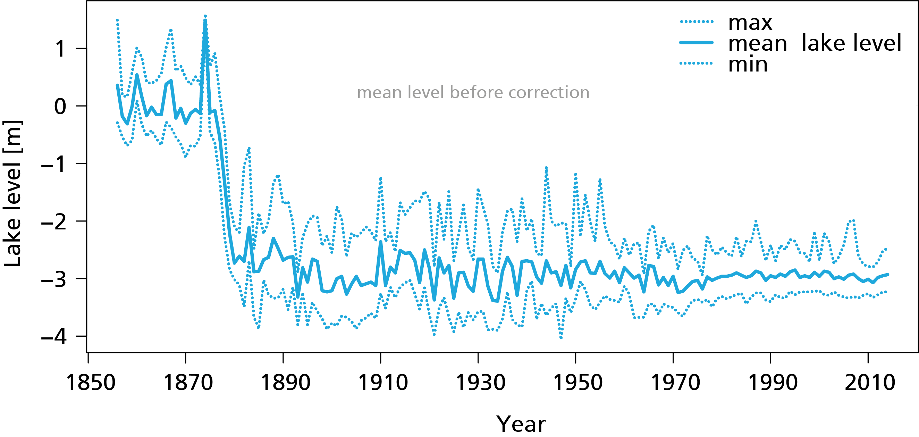
Figure S1: Evolution of Lake Neuchâtel level and fluctuations from 1856 to 2014. In the 1870s, a first correction lowered water level by almost three meters, emerging what became the Grande Cariçaie wetlands. In the 1970s, a second correction decreased flooding magnitude, without modifying average water level. Data from the Swiss Federal Office for the Environment, Hydrology Division.

Figure S2: Map of Gletterens. Plot names correspond to Table S1. The shaded area represents the control plot.
Figure S3: Map of Cheyres. Plot names correspond to Table S1. The shaded area represents the control plot. Yellow polygons represent permanent vegetation plots.
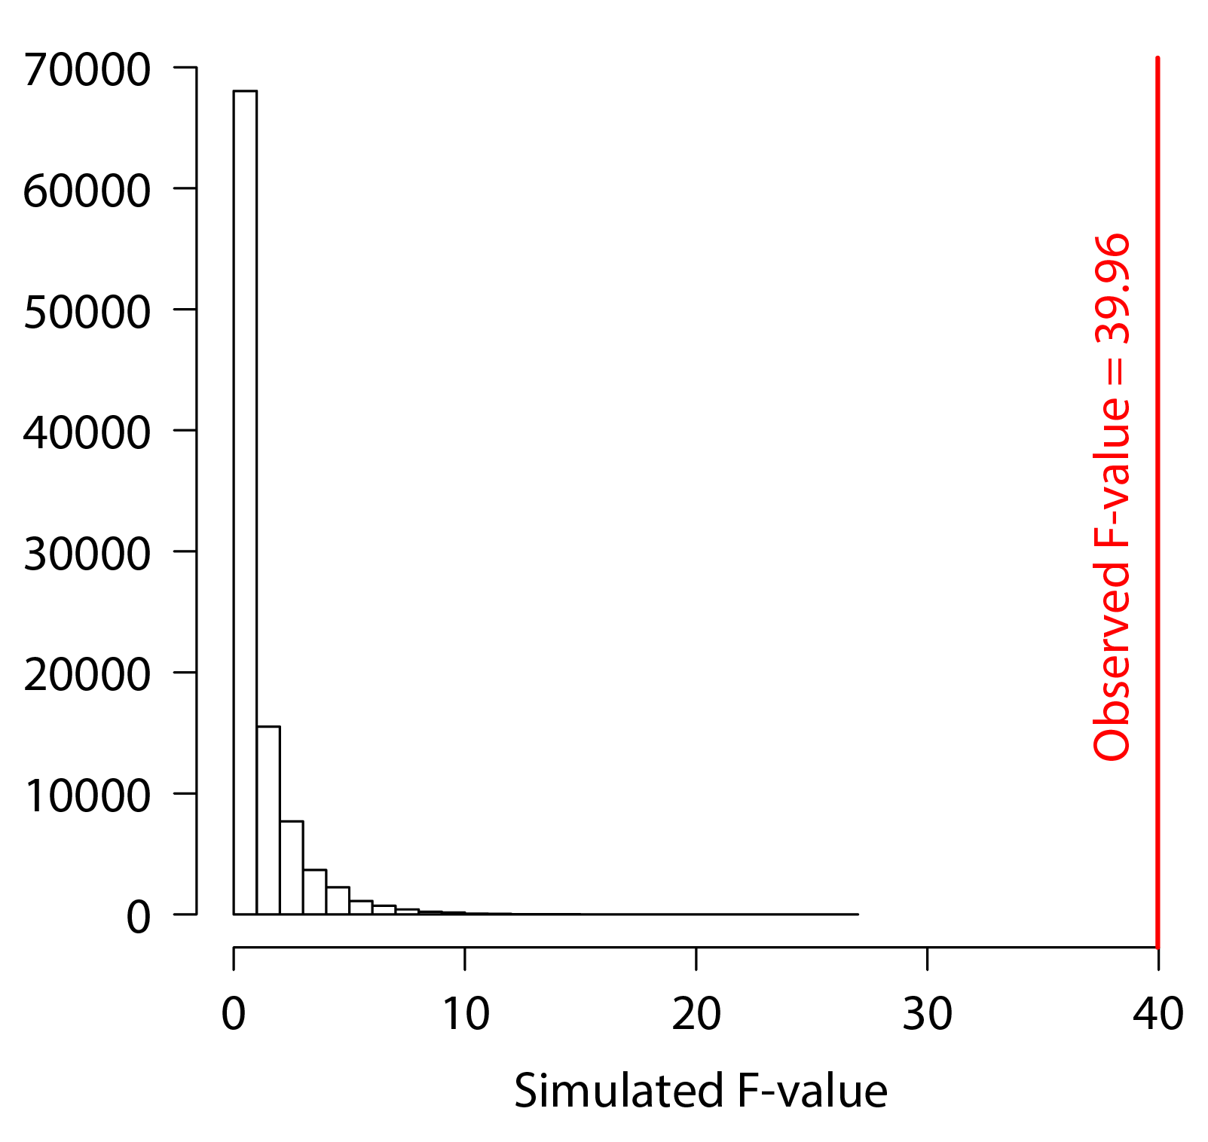
Figure S4: Distribution of simulated F-values in our permutation Linear Mixed Model analysis. The red vertical line indicates the observed F-value with our real data.

