Supplementary Material

Erosion of phylogenetic diversity in Neotropical bat assemblages: findings from a whole-ecosystem fragmentation experiment

Sabhrina G. Aninta, Ricardo Rocha, Adrià López-Baucells, and Christoph F. J. Meyer

Corresponding author: Sabhrina G. Aninta; E-mail: sagitaninta[at]gmail.com

This supplementary material contains:

Fig. S1 Map of the study area at the Biological Dynamics of Forests Fragments Project (BDFFP).
Fig. S2 Map showing the distribution of the 39 sampling sites in the different camps of the BDFFP.
Fig. S3 Phylogenetic relationships of phyllostomid bats and their occurrence in continuous forest and 100 ha, 10 ha and 1 ha fragments across a gradient of interior, edge, and matrix sites.

Table S1. Likelihood ratio tests comparing linear mixed effects models and linear models.
Table S2. Estimated parameters of fixed effects and variance of random effects and confidence intervals (CI) for fixed effects for the models explaining estimated PD, SES_{PD}, MPD, and SES_{MPD} according to Interior (I) – Edge (E) – Matrix (M) and continuous forest (CF) – 100 ha (F100) – 10 ha (F10) – 1 ha (F1) fragments gradient.
Table S3. Multiple pairwise comparisons of linear mixed-effects model testing for differences in phylogenetic richness across the Interior–Edge–Matrix gradient of continuous forest and different-sized fragments.
Table S4. Multiple pairwise comparisons of linear mixed-effects model testing for differences in phylogenetic structure across the Interior–Edge–Matrix gradient of continuous forest and different-sized fragments.
Table S5. Multiple pairwise comparisons of linear mixed-effects model testing for differences in standardized phylogenetic structure across the Interior–Edge–Matrix gradient of continuous forest and different-sized fragments.
Table S6. Moran’s I of the fitted model residuals.
Table S7. Mantel tests between phylogenetic beta diversity metrics and geographic distance.

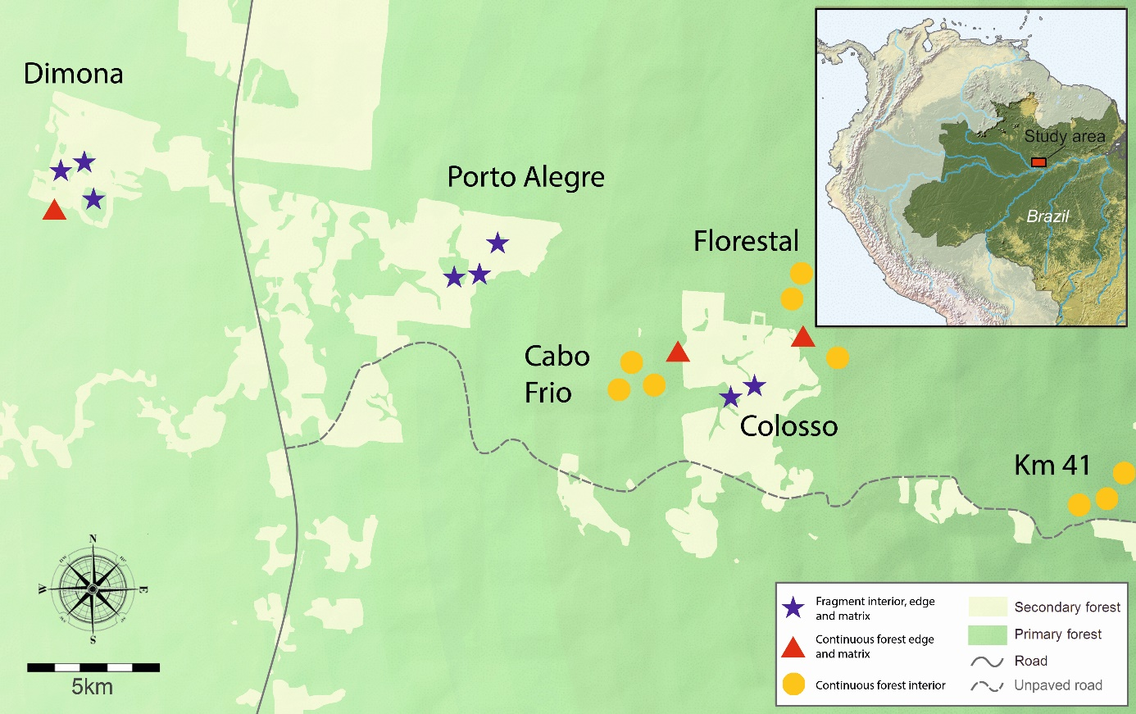
Fig S1. Map of the study sites at the BDFFP, Central Amazon, Brazil. Light grey areas represent the secondary forest matrix and dark green the continuous forest. The symbols represent the clusters of sampling sites, with stars denoting fragment sites where interior, edge, and matrix sites were sampled, triangles denote localities where edge and matrix sites of continuous forest were sampled, and circles correspond to continuous forest interiors.

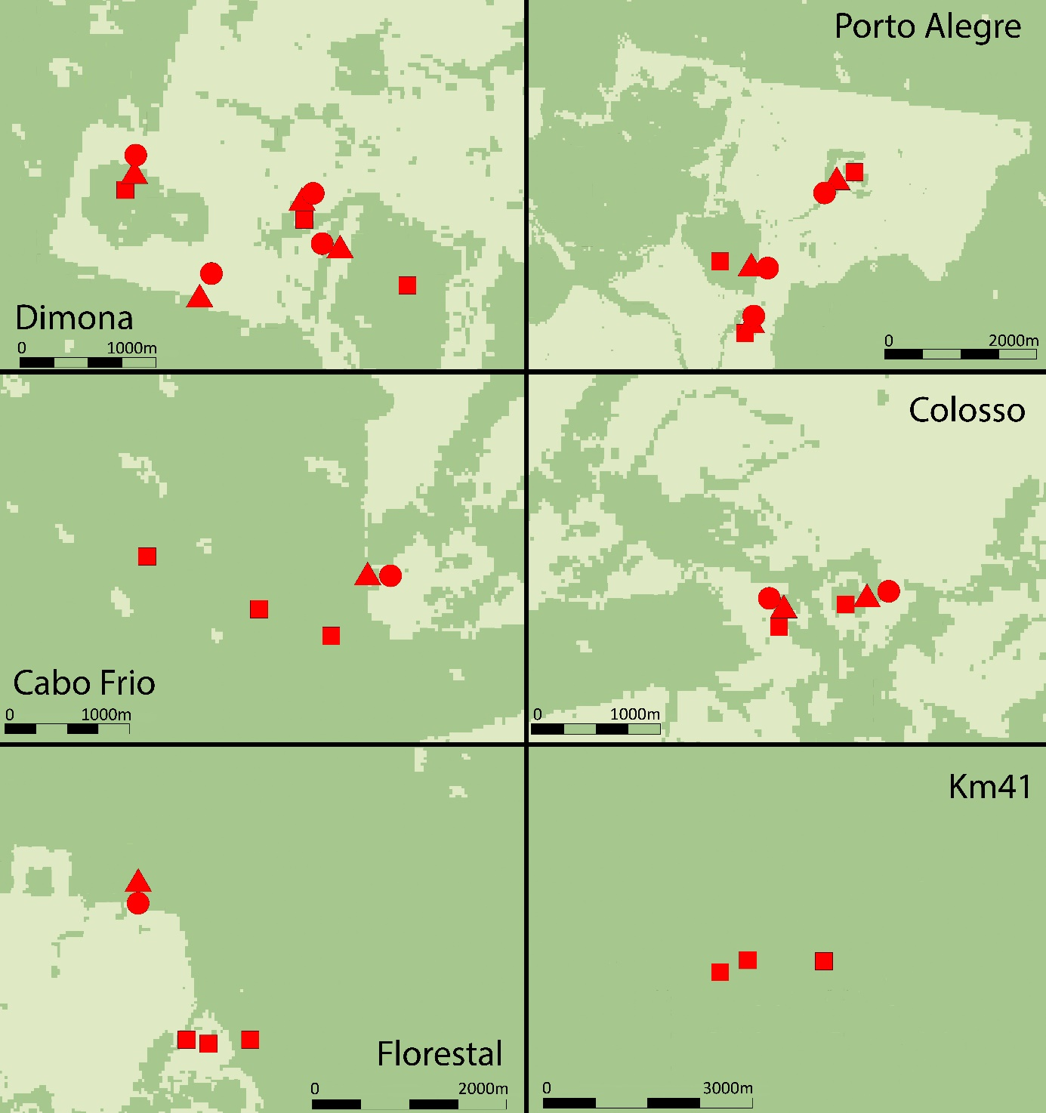
Fig S2. Map showing the distribution of the 39 sampling sites in the different camps (see Fig. S1) of the BDFFP, central Amazon. Dark green represents primary forest and light grey secondary forest. Red symbols denote the sampling sites, i.e. square = interior, triangle = edge, and circle = matrix.

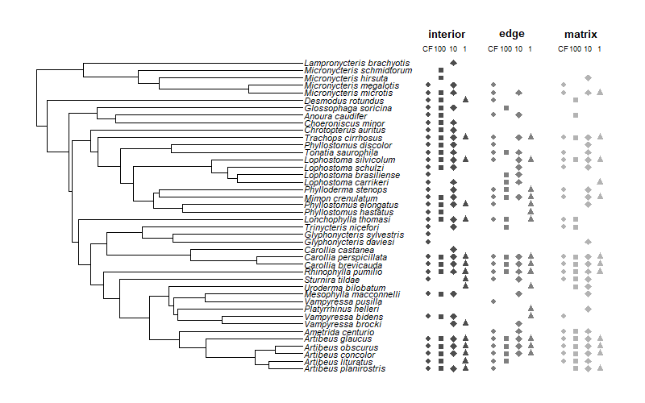
Fig. S3. Phylogenetic relationships of phyllostomid bats at the BDFFP and their occurrence in continuous forest (CF, circle), 100 ha fragments (square), 10 ha fragments (diamond) and 1 ha fragments (triangle) across a gradient of interior, edge, and matrix sites.

Table S1. Results of likelihood ratio tests between linear mixed-effects models and linear models with fixed effects only comparing the fit of IEM gradient (Gradient) and forest size (Size) as explanatory variables of the phylogenetic diversity metrics
Response variable | Model | df | Log(L) | L ratio | P
PD | Gradient * Size | 13 | -150.24
 | Gradient * Size + (1 | Location) | 14 | -150.08 | 0.33 | 0.56
SES_{PD} | Gradient * Size | 13 | -44.41
 | Gradient * Size + (1 | Location) | 14 | -44.40 | 0.02 | 0.88
MPD | Gradient * Size | 13 | -66.88
 | Gradient * Size + (1 | Location) | 14 | -66.88 | 0.01 | 0.91
SES_{MPD} | Gradient * Size | 13 | -42.76
 | Gradient * Size + (1 | Location) | 14 | -42.76 | <0.001 | 0.99

Table S2. Estimated parameters of fixed effect (β) and variance of random effects (σ) and confidence intervals (CI) for fixed effects for the models explaining estimated PD, SES_{PD}, MPD, and SES_{MPD} according to Interior (I) – Edge (E) – Matrix (M) and continuous forest (CF) – 100 ha (F100) – 10 ha (F10) – 1 ha (F1) fragments gradient. SE, standard error for fixed effects; SD, standard deviation for random effects.
Model | Terms | β/σ | SE/SD | t value | CI (95%)
 |  |  |  |  | Lower | Upper
PD
Fixed effects
Intercept |  | 350.164 | 17.740 | 19.74 | 318.386 | 380.039
Size | CF | Reference
 | F100 | 39.065 | 39.136 | 0.998 | -29.290 | 106.925
 | F10 | 24.737 | 33.659 | 0.735 | -31.674 | 82.023
 | F1 | -178.967 | 33.659 | -5.317 | -235.377 | -121.680
gradient | I | Reference
 | E | -89.803 | 32.363 | -2.775 | -144.878 | -35.734
 | M | -109.705 | 32.363 | -3.390 | -164.781 | -55.637
Size * gradient | CF*I | Reference
 | F100*E | -90.428 | 57.718 | -1.567 | -187.080 | 7.523
 | F10*E | -70.086 | 50.696 | -1.382 | -154.920 | 16.008
 | F1*E | 86.818 | 50.696 | 1.713 | 1.984 | 172.912
 | F100*M | -54.293 | 57.718 | -0.941 | -150.945 | 43.658
 | F10*M | -5.149 | 50.696 | -0.102 | -89.982 | 80.945
 | F1*M | 90.852 | 50.696 | 1.792 | 6.019 | 176.946
Random effects
location |  | 188.9 | 13.75
SES_{PD}
Fixed effects
Intercept |  | -1.098 | 0.335 | -3.280 | -1.685 | -0.537
Size | CF
 | F100 | 0.303 | 0.772 | 0.393 | -1.025 | 1.656
 | F10 | 1.090 | 0.660 | 1.653 | -0.015 | 2.198
 | F1 | -0.938 | 0.660 | -1.421 | -2.043 | 0.170
gradient | I | Reference
 | E | -0.284 | 0.653 | -0.435 | -1.392 | 0.805
 | M | -0.651 | 0.653 | -0.996 | -1.759 | 0.438
size * gradient | CF*I
 | F100*E | -0.270 | 1.173 | -0.230 | -2.235 | 1.719
 | F10*E | -0.853 | 1.030 | -0.828 | -2.575 | 0.893
 | F1*E | 1.064 | 1.030 | 1.034 | -0.658 | 2.810
 | F100*M | -1.375 | 1.173 | -1.171 | -3.340 | 0.614
 | F10*M | -1.360 | 1.030 | -1.321 | -3.082 | 0.386
 | F1*M | 0.835 | 1.030 | 0.811 | -0.888 | 2.581
Random effects
location |  | 0.020 | 0.141
MPD
Fixed effects
Intercept |  | 52.158 | 0.766 | 68.119 | 50.909 | 53.429
Size | CF
 | F100 | 1.819 | 1.774 | 1.025 | -1.223 | 4.689
 | F10 | 2.055 | 1.514 | 1.357 | -0.488 | 4.554
 | F1 | -3.813 | 1.514 | -2.518 | -6.356 | -1.314
gradient | I | Reference
 | E | 0.689 | 1.503 | 0.458 | -1.854 | 3.188
 | M | -0.428 | 1.503 | -0.285 | -2.971 | 2.071
size * gradient | CF*I
 | F100*E | -4.030 | 2.703 | -1.491 | -8.553 | 0.536
 | F10*E | -2.626 | 2.371 | -1.107 | -6.590 | 1.382
 | F1*E | -2.299 | 2.371 | 0.969 | -1.665 | 6.307
 | F100*M | -6.787 | 2.703 | -2.511 | -11.310 | -2.220
 | F10*M | -3.070 | 2.371 | -1.295 | -7.034 | 0.938
 | F1*M | 1.7200 | 2.371 | 0.725 | -2.244 | 5.728
Random effects
location |  | 0.078 | 0.279
SES_{MPD}
Fixed effects
Intercept |  | -1.467 | 0.309 | -4.754 | -1.983 | -0.951
Size | CF
 | F100 | 0.972 | 0.724 | 1.344 | -0.237 | 2.182
 | F10 | 1.245 | 0.617 | 2.018 | 0.213 | 2.277
 | F1 | -0.510 | 0.617 | -0.827 | -1.542 | 0.522
gradient | I | Reference
 | E | 0.548 | 0.617 | 0.888 | -0.483 | 1.580
 | M | 0.194 | 0.617 | 0.314 | -0.838 | 1.225
size * gradient | CF*I
 | F100*E | -1.485 | 1.113 | -1.335 | -3.345 | 0.375
 | F10*E | -1.351 | 0.976 | -1.385 | -2.982 | 0.280
 | F1*E | 0.344 | 0.976 | 0.352 | -1.287 | 1.975
 | F100*M | -3.201 | 1.113 | -2.877 | -5.061 | -1.341
 | F10*M | -1.808 | 0.976 | -1.853 | -3.440 | -0.177
 | F1*M | 0.255 | 0.976 | 0.262 | -1.376 | 1.887
Random effects
location |  | 0 | 0

Table S3. Results of multiple pairwise comparisons of linear mixed-effects models testing for differences in phylogenetic richness (Faith’s PD) across the Interior - Edge - Matrix gradient of continuous forest (CF) and different-sized fragments (1 ha, 10 ha, and 100 ha). Significant (adjusted P < 0.05) differences are highlighted in bold.
Assemblages | Estimate | Std. Error | z value | Pr(>|z|)
forest edge - forest interior | -89.803 | 32.363 | -2.775 | 0.186
forest matrix - forest interior | -109.705 | 32.363 | -3.390 | 0.033
100 ha interior - forest interior | 39.065 | 39.136 | 0.998 | 0.998
100 ha edge - forest interior | -141.166 | 39.136 | -3.607 | 0.016
100 ha matrix - forest interior | -124.933 | 39.136 | -3.192 | 0.061
10 ha interior - forest interior | 24.737 | 33.659 | 0.735 | 1.000
10 ha edge - forest interior | -135.152 | 33.659 | -4.015 | 0.003
10 ha matrix - forest interior | -90.117 | 33.659 | -2.677 | 0.232
1 ha interior - forest interior | -178.967 | 33.659 | -5.317 | 0.000
1 ha edge - forest interior | -181.952 | 33.659 | -5.406 | 0.000
1 ha matrix - forest interior | -197.819 | 33.659 | -5.877 | 0.000
forest matrix - forest edge | -19.902 | 39.021 | -0.510 | 1.000
100 ha interior - forest edge | 128.868 | 44.509 | 2.895 | 0.139
100 ha edge - forest edge | -51.363 | 44.509 | -1.154 | 0.992
100 ha matrix - forest edge | -35.131 | 44.509 | -0.789 | 1.000
10 ha interior - forest edge | 114.539 | 39.941 | 2.868 | 0.148
10 ha edge - forest edge | -45.350 | 39.941 | -1.135 | 0.993
10 ha matrix - forest edge | -0.314 | 39.941 | -0.008 | 1.000
1 ha interior - forest edge | -89.164 | 39.941 | -2.232 | 0.518
1 ha edge - forest edge | -92.149 | 39.941 | -2.307 | 0.464
1 ha matrix - forest edge | -108.017 | 39.941 | -2.704 | 0.218
100 ha interior - forest matrix | 148.770 | 44.509 | 3.342 | 0.038
100 ha edge - forest matrix | -31.461 | 44.509 | -0.707 | 1.000
100 ha matrix - forest matrix | -15.228 | 44.509 | -0.342 | 1.000
10 ha interior - forest matrix | 134.442 | 39.941 | 3.366 | 0.036
10 ha edge - forest matrix | -25.447 | 39.941 | -0.637 | 1.000
10 ha matrix - forest matrix | 19.588 | 39.941 | 0.490 | 1.000
1 ha interior - forest matrix | -69.262 | 39.941 | -1.734 | 0.848
1 ha edge - forest matrix | -72.247 | 39.941 | -1.809 | 0.809
1 ha matrix - forest matrix | -88.114 | 39.941 | -2.206 | 0.538
100 ha edge - 100 ha interior | -180.231 | 47.791 | -3.771 | 0.009
100 ha matrix - 100 ha interior | -163.998 | 47.791 | -3.432 | 0.029
10 ha interior - 100 ha interior | -14.328 | 43.865 | -0.327 | 1.000
10 ha edge - 100 ha interior | -174.217 | 43.865 | -3.972 | 0.004
10 ha matrix - 100 ha interior | -129.182 | 43.865 | -2.945 | 0.122
1 ha interior - 100 ha interior | -218.032 | 43.865 | -4.970 | 0.000
1 ha edge - 100 ha interior | -221.017 | 43.865 | -5.039 | 0.000
1 ha matrix - 100 ha interior | -236.884 | 43.865 | -5.400 | 0.000
100 ha matrix - 100 ha edge | 16.233 | 47.791 | 0.340 | 1.000
10 ha interior - 100 ha edge | 165.903 | 43.865 | 3.782 | 0.009
10 ha edge - 100 ha edge | 6.014 | 43.865 | 0.137 | 1.000
10 ha matrix - 100 ha edge | 51.049 | 43.865 | 1.164 | 0.991
1 ha interior - 100 ha edge | -37.801 | 43.865 | -0.862 | 0.999
1 ha edge - 100 ha edge | -40.786 | 43.865 | -0.930 | 0.999
1 ha matrix - 100 ha edge | -56.653 | 43.865 | -1.292 | 0.980
10 ha interior - 100 ha matrix | 149.670 | 43.865 | 3.412 | 0.031
10 ha edge - 100 ha matrix | -10.219 | 43.865 | -0.233 | 1.000
10 ha matrix - 100 ha matrix | 34.816 | 43.865 | 0.794 | 1.000
1 ha interior - 100 ha matrix | -54.033 | 43.865 | -1.232 | 0.986
1 ha edge - 100 ha matrix | -57.018 | 43.865 | -1.300 | 0.978
1 ha matrix - 100 ha matrix | -72.886 | 43.865 | -1.662 | 0.882
10 ha edge - 10 ha interior | -159.889 | 39.021 | -4.097 | 0.003
10 ha matrix - 10 ha interior | -114.854 | 39.021 | -2.943 | 0.123
1 ha interior - 10 ha interior | -203.703 | 39.021 | -5.220 | 0.000
1 ha edge - 10 ha interior | -206.688 | 39.021 | -5.297 | 0.000
1 ha matrix - 10 ha interior | -222.556 | 39.021 | -5.703 | 0.000
10 ha matrix - 10 ha edge | 45.035 | 39.021 | 1.154 | 0.992
1 ha interior - 10 ha edge | -43.814 | 39.021 | -1.123 | 0.993
1 ha edge - 10 ha edge | -46.799 | 39.021 | -1.199 | 0.989
1 ha matrix - 10 ha edge | -62.667 | 39.021 | -1.606 | 0.905
1 ha interior - 10 ha matrix | -88.849 | 39.021 | -2.277 | 0.486
1 ha edge - 10 ha matrix | -91.835 | 39.021 | -2.353 | 0.431
1 ha matrix - 10 ha matrix | -107.702 | 39.021 | -2.760 | 0.193
1 ha edge - 1 ha interior | -2.985 | 39.021 | -0.077 | 1.000
1 ha matrix - 1 ha interior | -18.853 | 39.021 | -0.483 | 1.000
1 ha matrix - 1 ha edge | -15.868 | 39.021 | -0.407 | 1.000

Table S4. Results of multiple pairwise comparisons of linear mixed-effects model testing for differences in phylogenetic structure (MPD) across the Interior - Edge - Matrix gradient of continuous forest (CF) and different-sized fragments (1 ha, 10 ha, and 100 ha). Significant (adjusted P < 0.05) differences are highlighted in bold.
Assemblages | Estimate | Std. Error | z value | Pr(>|z|)
forest edge - forest interior | 0.689 | 1.503 | 0.458 | 1.000
forest matrix - forest interior | -0.428 | 1.503 | -0.285 | 1.000
100 ha interior - forest interior | 1.819 | 1.774 | 1.025 | 0.997
100 ha edge - forest interior | -1.523 | 1.774 | -0.859 | 0.999
100 ha matrix - forest interior | -5.396 | 1.774 | -3.043 | 0.093
10 ha interior - forest interior | 2.055 | 1.514 | 1.357 | 0.970
10 ha edge - forest interior | 0.118 | 1.514 | 0.078 | 1.000
10 ha matrix - forest interior | -1.443 | 1.514 | -0.953 | 0.998
1 ha interior - forest interior | -3.813 | 1.514 | -2.518 | 0.321
1 ha edge - forest interior | -0.825 | 1.514 | -0.545 | 1.000
1 ha matrix - forest interior | -2.521 | 1.514 | -1.665 | 0.880
forest matrix - forest edge | -1.117 | 1.834 | -0.609 | 1.000
100 ha interior - forest edge | 1.130 | 2.059 | 0.549 | 1.000
100 ha edge - forest edge | -2.212 | 2.059 | -1.074 | 0.995
100 ha matrix - forest edge | -6.085 | 2.059 | -2.955 | 0.118
10 ha interior - forest edge | 1.366 | 1.843 | 0.741 | 1.000
10 ha edge - forest edge | -0.571 | 1.843 | -0.310 | 1.000
10 ha matrix - forest edge | -2.132 | 1.843 | -1.157 | 0.991
1 ha interior - forest edge | -4.502 | 1.843 | -2.443 | 0.368
1 ha edge - forest edge | -1.514 | 1.843 | -0.822 | 1.000
1 ha matrix - forest edge | -3.210 | 1.843 | -1.742 | 0.843
100 ha interior - forest matrix | 2.246 | 2.059 | 1.091 | 0.995
100 ha edge - forest matrix | -1.095 | 2.059 | -0.532 | 1.000
100 ha matrix - forest matrix | -4.969 | 2.059 | -2.413 | 0.389
10 ha interior - forest matrix | 2.483 | 1.843 | 1.347 | 0.971
10 ha edge - forest matrix | 0.546 | 1.843 | 0.296 | 1.000
10 ha matrix - forest matrix | -1.015 | 1.843 | -0.551 | 1.000
1 ha interior - forest matrix | -3.385 | 1.843 | -1.837 | 0.791
1 ha edge - forest matrix | -0.398 | 1.843 | -0.216 | 1.000
1 ha matrix - forest matrix | -2.093 | 1.843 | -1.136 | 0.993
100 ha edge - 100 ha interior | -3.341 | 2.246 | -1.488 | 0.942
100 ha matrix - 100 ha interior | -7.215 | 2.246 | -3.212 | 0.057
10 ha interior - 100 ha interior | 0.237 | 2.053 | 0.115 | 1.000
10 ha edge - 100 ha interior | -1.700 | 2.053 | -0.828 | 1.000
10 ha matrix - 100 ha interior | -3.262 | 2.053 | -1.589 | 0.910
1 ha interior - 100 ha interior | -5.632 | 2.053 | -2.743 | 0.200
1 ha edge - 100 ha interior | -2.644 | 2.053 | -1.288 | 0.980
1 ha matrix - 100 ha interior | -4.339 | 2.053 | -2.113 | 0.605
100 ha matrix - 100 ha edge | -3.874 | 2.246 | -1.725 | 0.852
10 ha interior - 100 ha edge | 3.578 | 2.053 | 1.743 | 0.843
10 ha edge - 100 ha edge | 1.641 | 2.053 | 0.799 | 1.000
10 ha matrix - 100 ha edge | 0.080 | 2.053 | 0.039 | 1.000
1 ha interior - 100 ha edge | -2.290 | 2.053 | -1.115 | 0.994
1 ha edge - 100 ha edge | 0.697 | 2.053 | 0.340 | 1.000
1 ha matrix - 100 ha edge | -0.998 | 2.053 | -0.486 | 1.000
10 ha interior - 100 ha matrix | 7.452 | 2.053 | 3.629 | 0.015
10 ha edge - 100 ha matrix | 5.515 | 2.053 | 2.686 | 0.227
10 ha matrix - 100 ha matrix | 3.953 | 2.053 | 1.925 | 0.736
1 ha interior - 100 ha matrix | 1.583 | 2.053 | 0.771 | 1.000
1 ha edge - 100 ha matrix | 4.571 | 2.053 | 2.226 | 0.522
1 ha matrix - 100 ha matrix | 2.876 | 2.053 | 1.400 | 0.962
10 ha edge - 10 ha interior | -1.937 | 1.834 | -1.056 | 0.996
10 ha matrix - 10 ha interior | -3.498 | 1.834 | -1.908 | 0.747
1 ha interior - 10 ha interior | -5.868 | 1.834 | -3.200 | 0.060
1 ha edge - 10 ha interior | -2.881 | 1.834 | -1.571 | 0.916
1 ha matrix - 10 ha interior | -4.576 | 1.834 | -2.495 | 0.335
10 ha matrix - 10 ha edge | -1.562 | 1.834 | -0.851 | 0.999
1 ha interior - 10 ha edge | -3.931 | 1.834 | -2.144 | 0.582
1 ha edge - 10 ha edge | -0.944 | 1.834 | -0.515 | 1.000
1 ha matrix - 10 ha edge | -2.639 | 1.834 | -1.439 | 0.954
1 ha interior - 10 ha matrix | -2.370 | 1.834 | -1.292 | 0.979
1 ha edge - 10 ha matrix | 0.618 | 1.834 | 0.337 | 1.000
1 ha matrix - 10 ha matrix | -1.078 | 1.834 | -0.588 | 1.000
1 ha edge - 1 ha interior | 2.988 | 1.834 | 1.629 | 0.894
1 ha matrix - 1 ha interior | 1.292 | 1.834 | 0.705 | 1.000

Table S5 Results of multiple pairwise comparisons of linear mixed-effects model testing for differences in the standardized phylogenetic structure (SES_{MPD}) across the Interior - Edge - Matrix gradient of continuous forest (CF) and different-sized fragments (1 ha, 10 ha, and 100 ha). Significant (adjusted P < 0.05) differences are highlighted in bold.
Assemblages | Estimate | Std. Error | z value | Pr(>|z|)
forest edge - forest interior | 0.548 | 0.617 | 0.888 | 0.999
forest matrix - forest interior | 0.194 | 0.617 | 0.314 | 1.000
100 ha interior - forest interior | 0.972 | 0.724 | 1.344 | 0.972
100 ha edge - forest interior | 0.036 | 0.724 | 0.049 | 1.000
100 ha matrix - forest interior | -2.035 | 0.724 | -2.813 | 0.169
10 ha interior - forest interior | 1.245 | 0.617 | 2.018 | 0.673
10 ha edge - forest interior | 0.442 | 0.617 | 0.717 | 1.000
10 ha matrix - forest interior | -0.369 | 0.617 | -0.598 | 1.000
1 ha interior - forest interior | -0.510 | 0.617 | -0.827 | 1.000
1 ha edge - forest interior | 0.382 | 0.617 | 0.619 | 1.000
1 ha matrix - forest interior | -0.061 | 0.617 | -0.099 | 1.000
forest matrix - forest edge | -0.355 | 0.756 | -0.469 | 1.000
100 ha interior - forest edge | 0.424 | 0.845 | 0.502 | 1.000
100 ha edge - forest edge | -0.513 | 0.845 | -0.607 | 1.000
100 ha matrix - forest edge | -2.584 | 0.845 | -3.057 | 0.089
10 ha interior - forest edge | 0.697 | 0.756 | 0.922 | 0.999
10 ha edge - forest edge | -0.106 | 0.756 | -0.140 | 1.000
10 ha matrix - forest edge | -0.918 | 0.756 | -1.214 | 0.987
1 ha interior - forest edge | -1.059 | 0.756 | -1.400 | 0.962
1 ha edge - forest edge | -0.166 | 0.756 | -0.220 | 1.000
1 ha matrix - forest edge | -0.609 | 0.756 | -0.806 | 1.000
100 ha interior - forest matrix | 0.779 | 0.845 | 0.921 | 0.999
100 ha edge - forest matrix | -0.158 | 0.845 | -0.187 | 1.000
100 ha matrix - forest matrix | -2.229 | 0.845 | -2.638 | 0.251
10 ha interior - forest matrix | 1.051 | 0.756 | 1.391 | 0.964
10 ha edge - forest matrix | 0.249 | 0.756 | 0.329 | 1.000
10 ha matrix - forest matrix | -0.563 | 0.756 | -0.745 | 1.000
1 ha interior - forest matrix | -0.704 | 0.756 | -0.931 | 0.999
1 ha edge - forest matrix | 0.188 | 0.756 | 0.249 | 1.000
1 ha matrix - forest matrix | -0.255 | 0.756 | -0.337 | 1.000
100 ha edge - 100 ha interior | -0.937 | 0.926 | -1.012 | 0.997
100 ha matrix - 100 ha interior | -3.008 | 0.926 | -3.249 | 0.050
10 ha interior - 100 ha interior | 0.273 | 0.845 | 0.323 | 1.000
10 ha edge - 100 ha interior | -0.530 | 0.845 | -0.627 | 1.000
10 ha matrix - 100 ha interior | -1.342 | 0.845 | -1.588 | 0.910
1 ha interior - 100 ha interior | -1.483 | 0.845 | -1.754 | 0.837
1 ha edge - 100 ha interior | -0.590 | 0.845 | -0.699 | 1.000
1 ha matrix - 100 ha interior | -1.033 | 0.845 | -1.223 | 0.986
100 ha matrix - 100 ha edge | -2.071 | 0.926 | -2.237 | 0.512
10 ha interior - 100 ha edge | 1.210 | 0.845 | 1.431 | 0.956
10 ha edge - 100 ha edge | 0.407 | 0.845 | 0.481 | 1.000
10 ha matrix - 100 ha edge | -0.405 | 0.845 | -0.479 | 1.000
1 ha interior - 100 ha edge | -0.546 | 0.845 | -0.646 | 1.000
1 ha edge - 100 ha edge | 0.346 | 0.845 | 0.410 | 1.000
1 ha matrix - 100 ha edge | -0.097 | 0.845 | -0.114 | 1.000
10 ha interior - 100 ha matrix | 3.281 | 0.845 | 3.882 | 0.006
10 ha edge - 100 ha matrix | 2.478 | 0.845 | 2.932 | 0.125
10 ha matrix - 100 ha matrix | 1.666 | 0.845 | 1.971 | 0.705
1 ha interior - 100 ha matrix | 1.525 | 0.845 | 1.805 | 0.809
1 ha edge - 100 ha matrix | 2.417 | 0.845 | 2.860 | 0.150
1 ha matrix - 100 ha matrix | 1.974 | 0.845 | 2.336 | 0.441
10 ha edge - 10 ha interior | -0.803 | 0.756 | -1.062 | 0.996
10 ha matrix - 10 ha interior | -1.614 | 0.756 | -2.136 | 0.587
1 ha interior - 10 ha interior | -1.755 | 0.756 | -2.322 | 0.451
1 ha edge - 10 ha interior | -0.863 | 0.756 | -1.142 | 0.992
1 ha matrix - 10 ha interior | -1.306 | 0.756 | -1.728 | 0.850
10 ha matrix - 10 ha edge | -0.812 | 0.756 | -1.074 | 0.995
1 ha interior - 10 ha edge | -0.953 | 0.756 | -1.260 | 0.983
1 ha edge - 10 ha edge | -0.060 | 0.756 | -0.080 | 1.000
1 ha matrix - 10 ha edge | -0.503 | 0.756 | -0.666 | 1.000
1 ha interior - 10 ha matrix | -0.141 | 0.756 | -0.186 | 1.000
1 ha edge - 10 ha matrix | 0.751 | 0.756 | 0.994 | 0.998
1 ha matrix - 10 ha matrix | 0.308 | 0.756 | 0.408 | 1.000
1 ha edge - 1 ha interior | 0.892 | 0.756 | 1.180 | 0.990
1 ha matrix - 1 ha interior | 0.449 | 0.756 | 0.594 | 1.000
1 ha matrix - 1 ha edge | -0.443 | 0.756 | -0.586 | 1.000

Table S6. Moran’s I values for the residuals of linear mixed-effects models explaining the effect of IEM and forest size gradients on phylogenetic diversity metrics computed using Monte Carlo simulations (999 simulations).
Models | I | Observed rank | P-value
PD ~ gradient * size | -0.026 | 192.5 | 0.808
SES_{PD} ~ gradient * size | -0.026 | 342.5 | 0.658
MPD ~ gradient * size | -0.026 | 299 | 0.701
SES_{MPD} ~ gradient * size | -0.026 | 491 | 0.509

Table S7. Results of simple Mantel tests between beta diversity metrics (P$β$ and COMDIST) and geographic distance between sites at the BDFFP. Pearson’s product-moment correlation and Spearman’s rank correlation were used to test for linear and non-linear relationships, respectively.
Metric |  | Pearson’s product-moment correlation |  | Spearman’s rank correlation rho
 |  | r | P | r | P
P$β$ | $$β_{total}$$ | 0.134 | 0.013 | 0.117 | 0.024
 | $$β_{repl}$$ | 0.031 | 0.299 | 0.024 | 0.339
 | $$β_{rich}$$ | 0.059 | 0.138 | 0.049 | 0.162
COMDIST |  | 0.055 | 0.230 | 0.021 | 0.368

