Extinction risk and conservation gaps for Aloe (Asphodelaceae) in the Horn of Africa

Supplementary Material
Table A1. Additional species names excluded from the study
Table A2. Assessment ratings
Table A3. IUCN Red List Criteria summary
Table A4. IUCN Threat classification scheme
Figure A5. Testing iterations needed for greedy algorithm
Table A6. Final sequence of patches for all species and threatened species
Table A7. Protected areas per country
Table A8. Aloe species in botanic garden collections
Table A9. Number of banked collections of Aloe in the Millennium Seed Bank
Table A10. List of species not endemic to the study area

Table A1. Additional species names excluded from the study
Genus | Species | author | citation
Aloe | anodonta | T.A.McCoy & Lavranos | CactusWorld 33: 180 (2015)
Aloe | austrosudanica | T.A.McCoy | Avonia 34: 201 (2016)
Aloe | downsiana | T.A.McCoy & Lavranos | CactusWorld 25(3): 139 (2007)
Aloe | ithya | T.A.McCoy & L.E.Newton | Haseltonia 19: 64 (2014)
Aloe | lukeana | T.C.Cole | Cact. Succ. J. (Los Angeles) 87: 156 (2015)
Aloe | montis-nabro | Orlando & El Azzouni | CactusWorld 32: 201 (2014)
Aloe | nigrimontana | T.A.McCoy & Lavranos | CactusWorld 33(3): 183 (2015).
Aloe | nugalensis | Thulin | Nordic J. Bot. 30: 729 (2012).
Aloe | omoana | T.A.McCoy & Lavranos | Cact. World 25: 139 (2007).
Aloe | sanguinalis | Awale & Barkworth | Phytokeys 117: 85-97 (2015)
Aloe | zubb | T.A.McCoy & Lavranos | CactusWorld 33: 31 (2015).

Table A2. Assessment ratings (See separate excel file)
https://github.com/stevenpbachman/thesis_extra/blob/master/A2_assessment_ratings.csv

Table A3. IUCN Red List Criteria summary (see separate pdf)
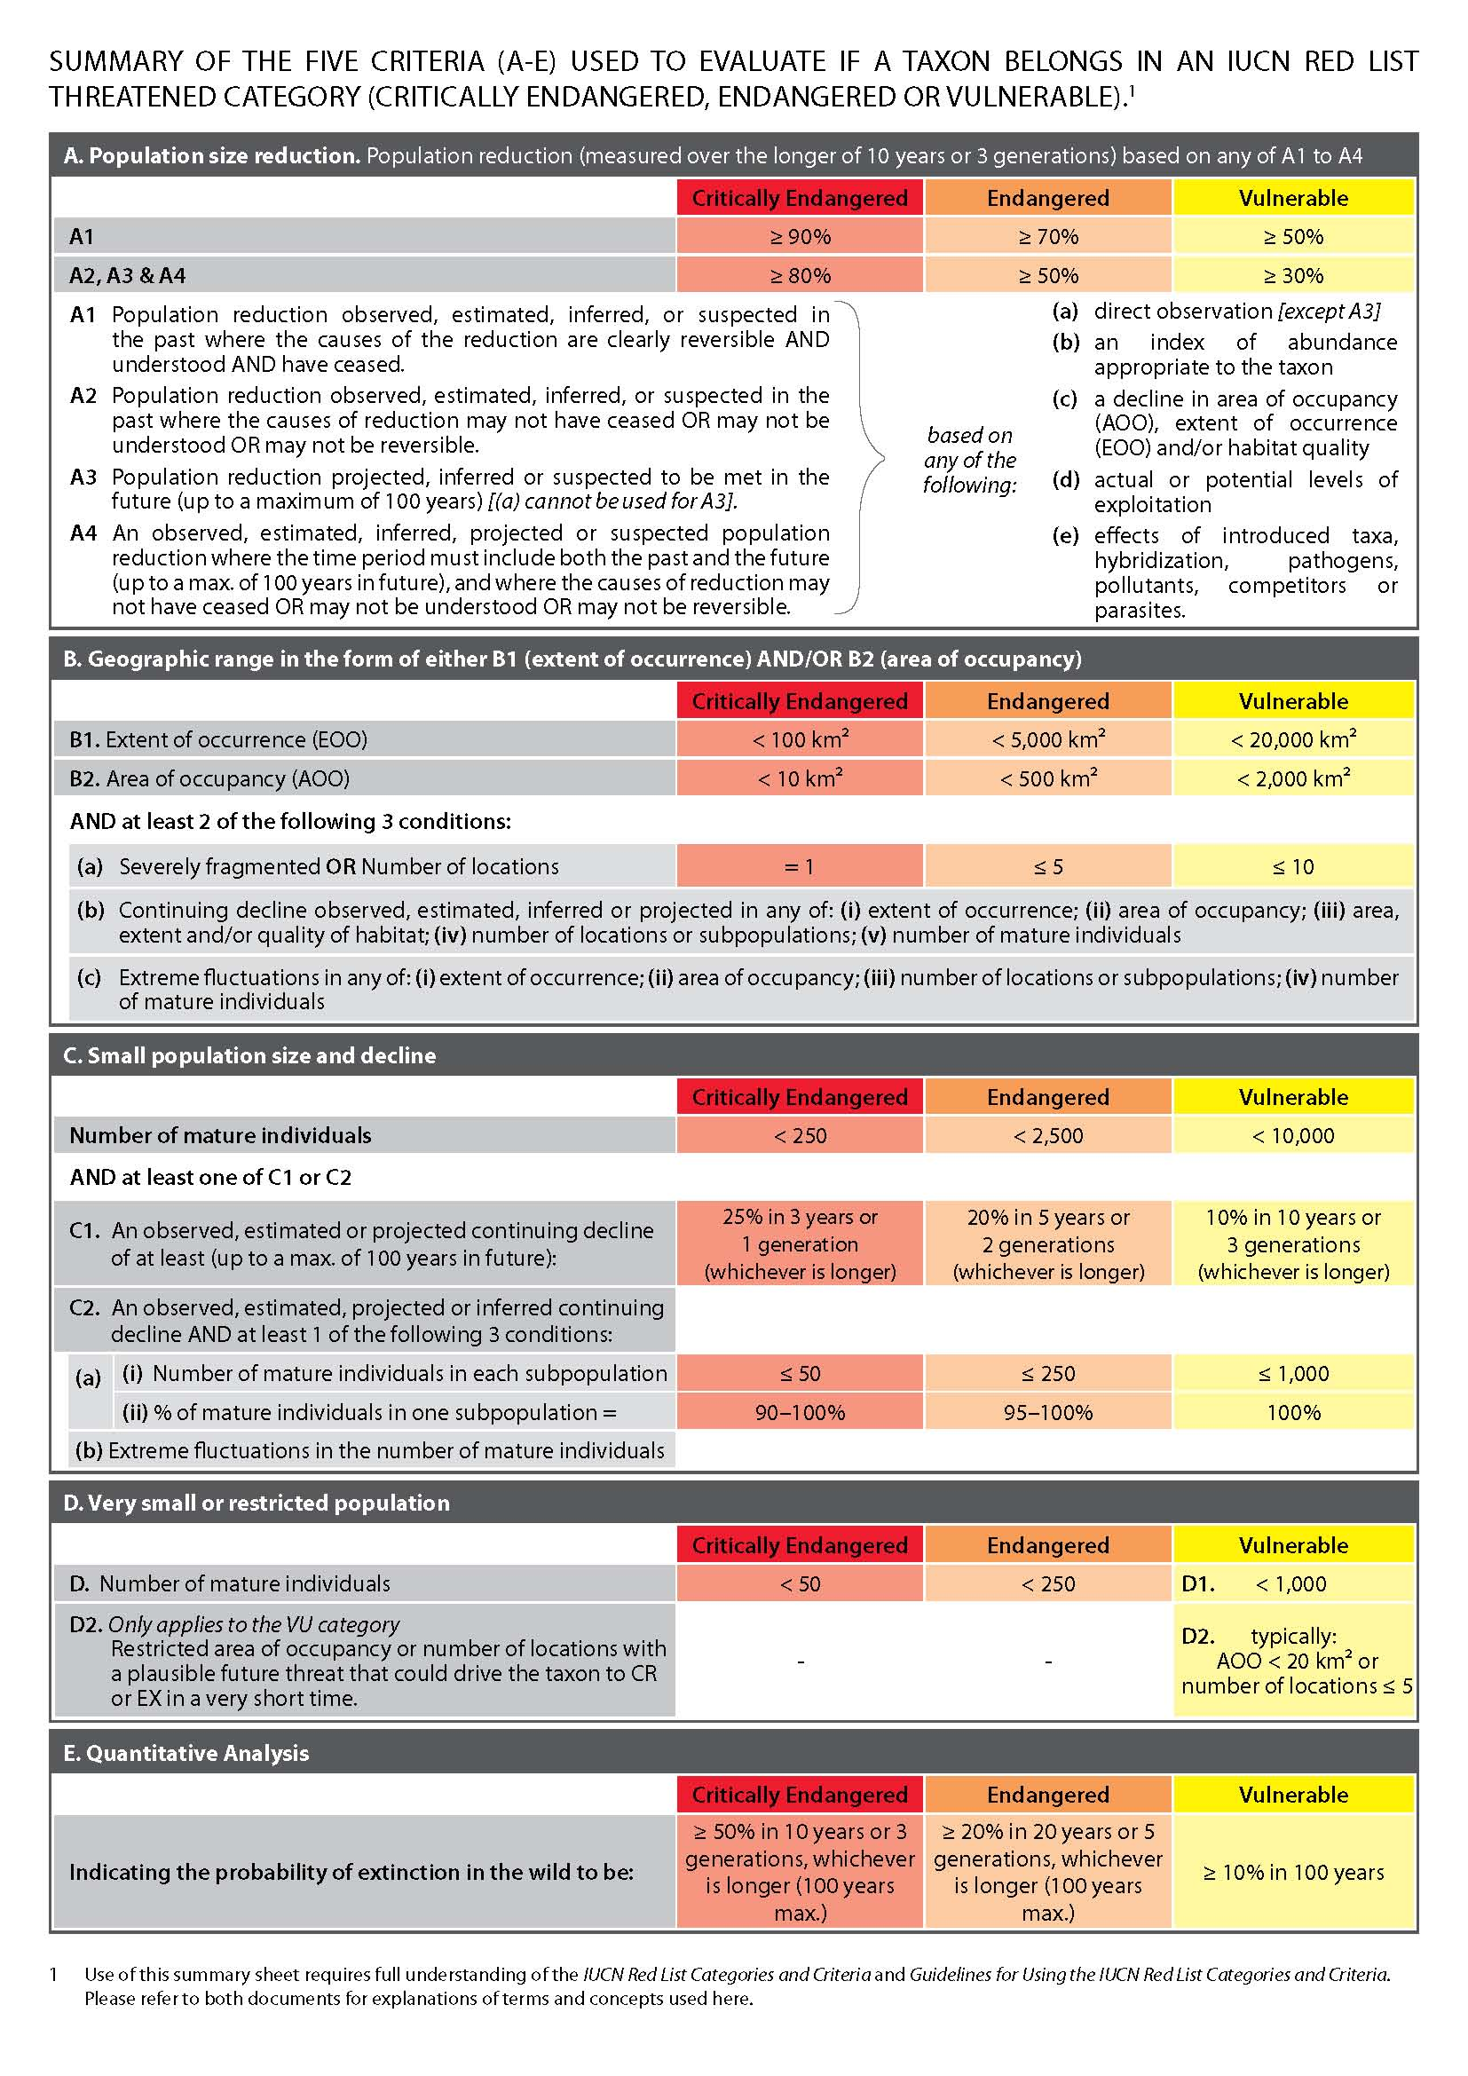
Table A4. IUCN Threat classification scheme
https://www.iucnredlist.org/resources/threat-classification-scheme

1 Residential & commercial development
1.1 Housing & urban areas
1.2 Commercial & industrial areas
1.3 Tourism & recreation areas

2 Agriculture & aquaculture
2.1 Annual & perennial non-timber crops
2.1.1 Shifting agriculture
2.1.2 Small-holder farming
2.1.3 Agro-industry farming
2.1.4 Scale Unknown/Unrecorded
2.2 Wood & pulp plantations
2.2.1 Small-holder plantations
2.2.2 Agro-industry plantations
2.2.3 Scale Unknown/Unrecorded
2.3 Livestock farming & ranching
2.3.1 Nomadic grazing
2.3.2 Small-holder grazing, ranching or farming
2.3.3 Agro-industry grazing, ranching or farming
2.3.4 Scale Unknown/Unrecorded
2.4 Marine & freshwater aquaculture
2.4.1 Subsistence/artisanal aquaculture
2.4.2 Industrial aquaculture
2.4.3 Scale Unknown/Unrecorded

3 Energy production & mining
3.1 Oil & gas drilling
3.2 Mining & quarrying
3.3 Renewable energy

4 Transportation & service corridors
4.1 Roads & railroads
4.2 Utility & service lines
4.3 Shipping lanes
4.4 Flight paths

5 Biological resource use
5.1 Hunting & collecting terrestrial animals
5.1.1 Intentional use (species being assessed is the target)
5.1.2 Unintentional effects (species being assessed is not the target)
5.1.3 Persecution/control
5.1.4 Motivation Unknown/Unrecorded
5.2 Gathering terrestrial plants
5.2.1 Intentional use (species being assessed is the target)
5.2.2 Unintentional effects (species being assessed is not the target)
5.2.3 Persecution/control
5.2.4 Motivation Unknown/Unrecorded
5.3 Logging & wood harvesting
5.3.1 Intentional use: subsistence/small scale (species being assessed is the target [harvest]
5.3.2 Intentional use: large scale (species being assessed is the target)[harvest]
5.3.3 Unintentional effects: subsistence/small scale (species being assessed is not the target)[harvest]
5.3.4 Unintentional effects: large scale (species being assessed is not the target)[harvest]
5.3.5 Motivation Unknown/Unrecorded
5.4 Fishing & harvesting aquatic resources
5.4.1 Intentional use: subsistence/small scale (species being assessed is the target)[harvest]
5.4.2 Intentional use: large scale (species being assessed is the target)[harvest]
5.4.3 Unintentional effects: subsistence/small scale (species being assessed is not the target)[harvest]
5.4.4 Unintentional effects: large scale (species being assessed is not the target)[harvest]
5.4.5 Persecution/control
5.4.6 Motivation Unknown/Unrecorded

6 Human intrusions & disturbance
6.1 Recreational activities
6.2 War, civil unrest & military exercises
6.3 Work & other activities

7 Natural system modifications
7.1 Fire & fire suppression
7.1.1 Increase in fire frequency/intensity
7.1.2 Suppression in fire frequency/intensity
7.1.3 Trend Unknown/Unrecorded
7.2 Dams & water management/use
7.2.1 Abstraction of surface water (domestic use)
7.2.2 Abstraction of surface water (commercial use)
7.2.3 Abstraction of surface water (agricultural use)
7.2.4 Abstraction of surface water (unknown use)
7.2.5 Abstraction of ground water (domestic use)
7.2.6 Abstraction of ground water (commercial use)
7.2.7 Abstraction of ground water (agricultural use)
7.2.8 Abstraction of ground water (unknown use)
7.2.9 Small dams
7.2.10 Large dams
7.2.11 Dams (size unknown)
7.3 Other ecosystem modifications

8 Invasive & other problematic species, genes & diseases
8.1 Invasive non-native/alien species/diseases
8.1.1 Unspecified species
8.1.2 Named species
8.2 Problematic native species/diseases
8.2.1 Unspecified species
8.2.2 Named species
8.3 Introduced genetic material
8.4 Problematic species/diseases of unknown origin
8.4.1 Unspecified species
8.4.2 Named species
8.5 Viral/prion-induced diseases
8.5.1 Unspecified "species" (disease)
8.5.2 Named "species" (disease)
8.6 Diseases of unknown cause

9 Pollution
9.1 Domestic & urban waste water
9.1.1 Sewage
9.1.2 Run-off
9.1.3 Type Unknown/Unrecorded
9.2 Industrial & military effluents
9.2.1 Oil spills
9.2.2 Seepage from mining
9.2.3 Type Unknown/Unrecorded

10 Geological events
10.1 Volcanoes
10.2 Earthquakes/tsunamis
10.3 Avalanches/landslides

11 Climate change & severe weather
11.1 Habitat shifting & alteration
11.2 Droughts
11.3 Temperature extremes
11.4 Storms & flooding
11.5 Other impacts

12 Other options
12.1 Other threat

Figure A5. Testing iterations needed for greedy algorithm
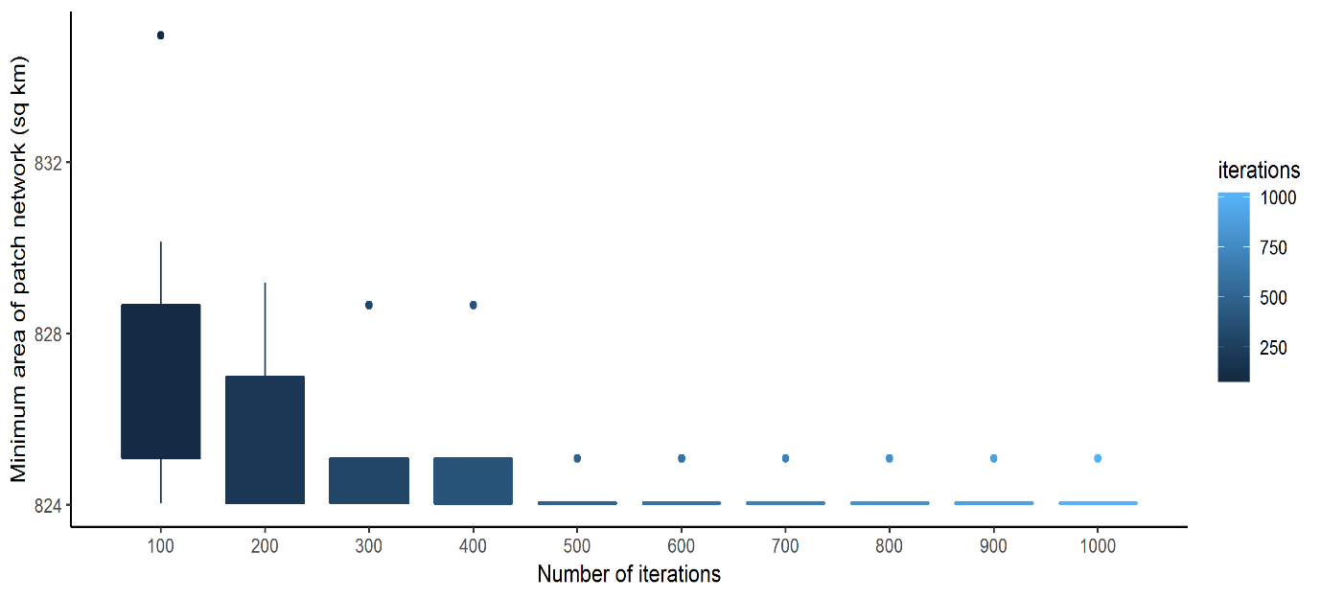
We applied the greedy algorithm to a network of patches derived from 2 km buffers for all Aloe species. The algorithm reports the minimum patch area needed to achieve our target of representing each species. Each iteration of the algorithm could produce a different set of patches, and therefore a different minimum patch area, because when the highest number of species was tied between two or more patches, one patch was chosen at random. We ran the algorithm for 1,000 iterations and checked the minimum patch area that had been calculated at intervals of 100. We ran this procedure 10 times to get average, min and max values at each 100 iteration interval (see box plot). There was variation of up to 10 km in minimum patch area after 100 iterations, but this steadily decreases as the number of iterations increases. The minimum is achieved after 500 iterations with a variation of 1 km from the minimum, which was deemed of sufficient accuracy for the purposes of the analysis. As the algorithm was not particularly process intensive, there was no significant cost of running the algorithm for 1,000 iterations.

Table A6. Final sequence of patches for all species and threatened species
A6a – all species |  |  | A6b – threatened and DD species
Minimum area: | 824.0306 |  | Minimum area: | 541.5795
Iteration number: | 117 |  | Iteration number: | 169
 | Patch ID |  |  | Patch ID
1 | 430 |  | 1 | 430
2 | 444 |  | 2 | 444
3 | 388 |  | 3 | 168
4 | 498 |  | 4 | 362
5 | 269 |  | 5 | 361
6 | 362 |  | 6 | 374
7 | 221 |  | 7 | 309
8 | 168 |  | 8 | 274
9 | 262 |  | 9 | 526
10 | 349 |  | 10 | 394
11 | 166 |  | 11 | 498
12 | 37 |  | 12 | 414
13 | 414 |  | 13 | 272
14 | 407 |  | 14 | 355
15 | 78 |  | 15 | 220
16 | 91 |  | 16 | 449
17 | 459 |  | 17 | 174
18 | 476 |  | 18 | 223
19 | 220 |  | 19 | 266
20 | 406 |  | 20 | 416
21 | 437 |  | 21 | 221
22 | 135 |  | 22 | 365
23 | 527 |  | 23 | 408
24 | 223 |  | 24 | 407
25 | 355 |  | 25 | 230
26 | 423
27 | 417
28 | 425
29 | 384
30 | 416
31 | 378
32 | 408
33 | 365
34 | 212
35 | 445
36 | 501
37 | 102
38 | 266
39 | 272
40 | 394
41 | 453
42 | 278
43 | 515
44 | 172
45 | 230

Table A7. Protected areas per country
Country | % protected | Protected area | Area needed for 17% | Total land area
Sudan | 2.28 | 42698 | 275415 | 1871252
Ethiopia | 17.62 | 200074 | 0 | 1135429
Somalia | 0 | 0 | 108401 | 637655
South Sudan | 15.5 | 98214 | 9495 | 633580
Eritrea | 4.87 | 5936 | 14776 | 121834
Djibouti | 1.57 | 344 | 3369 | 21844

Data derived from WDPA (UNEP-WCMC and IUCN 2018). In the table and chart the text ‘Area needed for 17%’ refers to the Convention on Biological Diversity’s (CBD) Aichi Target 11 to conserve 17% of terrestrial land that is ‘…of particular importance for biodiversity…’ (UNEP/CBD 2010).

Table A8. Aloe species in botanic garden collections (See separate excel file)
https://github.com/stevenpbachman/thesis_extra/blob/master/A8_ex%20situ%20collections.csv

Table A9. Number of banked collections of Aloe in the Millennium Seed Bank grouped by threatened (6) and not threatened species (8). Non-banked species were grouped by threatened (25), not threatened (40), and data deficient (9) species.
Threat Status | Collection status | Count
Data Deficient | Not banked | 9
Not threatened | Banked | 8
Not threatened | Not banked | 40
Threatened | Banked | 6
Threatened | Not banked | 25

Table A10.
Aloe species not endemic to study region
A. calidophila Reynolds
A. canarina S.Carter
A. citrina S.Carter & Brandham
A. ellenbeckii A.Berger
A. erensii Christian
A. labworana (Reynolds) S.Carter
A. lateritia Engl.
A. macleaya Reynolds
A. parvidens M.G.Gilbert & Sebsebe
A. rabaiensis Rendle
A. rivae Baker
A. rugosifolia M.G.Gilbert & Sebsebe
A. ruspoliana Baker
A. schweinfurthii Baker
A. secundiflora Engl.
A. vituensis Baker
A. wrefordii Reynolds

References:
UNEP-WCMC and IUCN (2018) The World Database on Protected Areas (WDPA) [On-line]. In: Cambridge, UK. www.protectedplanet.net.
UNEP/CBD (2010) The Strategic Plan for Biodiversity 2011-2020 and the Aichi Biodiversity Targets. In: UNEP/CBD/COP/DEC/X/2. https://www.cbd.int/decision/cop/?id=12268.

