This document provides electronic supplementary material for the article titled:

Flower plantings promote wild bee conservation in agricultural landscapes

Ulrich Neumüller · Hannah Burger · Hans Richard Schwenninger · Sebastian Hopfenmüller · Sabrina Krausch · Karin Weiß · Manfred Ayasse

Ulrich Neumüller (https://orcid.org/0000-0003-3176-9202) · Hannah Burger · Hans Richard Schwenninger · Sebastian Hopfenmüller · Sabrina Krausch · Karin Weiß · Manfred Ayasse
Institute of Evolutionary Ecology and Conservation Genomics, Ulm University, 89081 Ulm, Germany
Corresponding author: Ulrich Neumüller, telephone: 0049 731 50 22691, e-mail: ulrich.neumueller@uni-ulm.de

Mid-point calculation
Flower cover was recorded in 4 categories: <1%, 1-10%, 10-40% and >40%. For the categories 1-10% and 10-40%, we calculated mid-points by calculating the mean of the upper and lower limits (e.g. (1+10)/2=5.5). The lowest category of <1% was set to 0.5 (as (0+1)/2=0.5). For the higher category >40%, we divided the previous interval by two (30/2=15), added this to the value 40 and divided it by two ((40+30)/2=55). Accordingly, the final factors that were subsequently added to our models were 0.5, 5.5, 25 and 55.

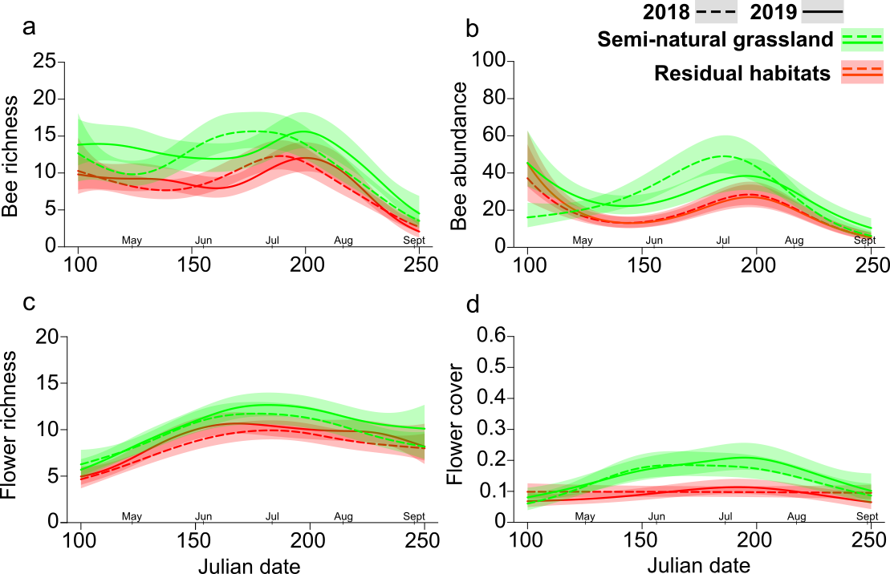
Figure S1 Temporal patterns of bee richness (a), bee abundance (b), flower richness (c) and flower cover (d) in semi-natural grassland (in green) and residual habitats (in red) for 2018 (dashed line) and 2019 (solid line). Shaded areas around the lines represent 95% confidence intervals. Coefficients of the underlying GAMs are given in Table S5.
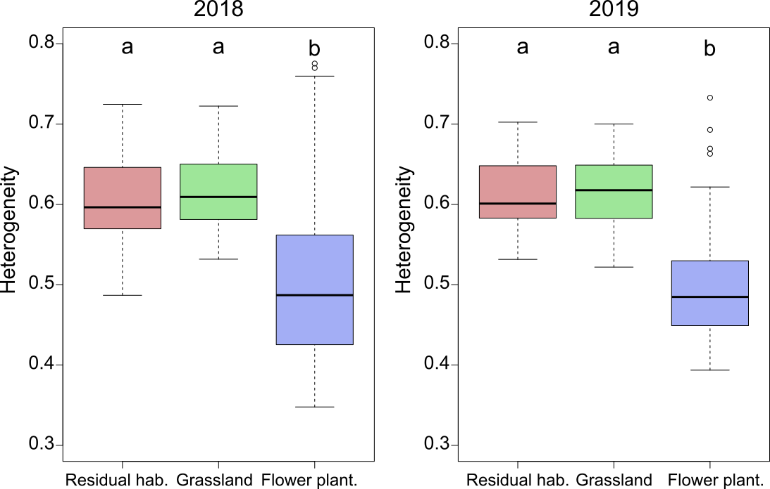
Figure S2. Compositional heterogeneity of flowering plant communities within the three habitat types and the two years. Boxes represent the median and 25th/75th percentile of the distances for grouping centroid calculated with betadisper. Whiskers extend to 1.5 times the interquartile range. Boxes that do not share common letters are significantly different (P ≤ 0.05). Coefficients of the pairwise comparison are given in Table S9.

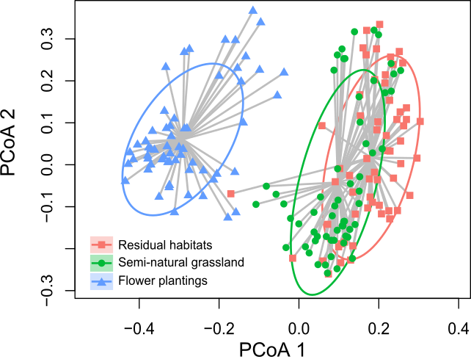
Figure S3. Multidimensional scaling (MDS) of flowering plant species in the three habitat types. Ellipses indicate 95% confidence intervals. Whereas semi-natural grassland and residual habitats show a large overlap, flower plantings are clearly separated.

Table S1. Composition of seed mixtures for the various geographic regions. As some research areas were clustered (Fig. 2), seed mixtures were adapted for the 13 geographic regions.

 | Quantity of seeds (grams per 100m²) in the 13 geographic regions
Regionally native plants | UR 2k | UR 3ö1 | UR 3ö2 | UR 3k | UR 4ö | UR 9 kD | UR 9 öD | UR 9 kR | UR 11 k | UR 13 k | UR 13 ö | UR 16 k | UR 17 k
Achillea millefolium | 2 | 1 | 1 | 1 | 1 | 1 | 1 | 1 | 1 | 1 | 1 | 1 | 2
Anchusa officinalis | - | - | - | 1 | 0.5 | - | - | - | - | - | - | - | -
Anthyllis vulneraria | - | - | - | - | - | - | - | - | 1.3 | 1.3 | 1.3 | - | 3
Ballota nigra | - | - | 0.5 | 0.5 | - | 1 | 1 | - | 1.5 | 1.5 | 1.5 | 1.5 | -
Barbarea vulgaris | 2 | 2.5 | 2.5 | 2.5 | - | 2 | 2 | 1 | 2 | 2 | 2 | 2 | 3
Berteroa incana | - | 2 | 2.1 | 2.1 | 2 | 1.5 | 1.5 | - | - | - | - | - | -
Campanula rapunculus | 0.5 | - | - | - | - | - | - | - | - | - | - | - | -
Campanula rapunculoides | - | 0.2 | 0.2 | 0.2 | 0.2 | - | - | - | 0.1 | 0.1 | 0.1 | - | -
Campanula rotundifolia | - | - | - | - | - | - | - | - | 0.1 | - | - | - | -
Campanula trachelium | - | - | - | - | - | - | - | - | - | - | - | 0.4 | -
Carduus nutans | 1 | 1 | 1 | 1 | 1 | - | - | - | - | 3 | 3 | - | -
Centaurea cyanus | 3 | 2.3 | 2.3 | 2.3 | 2.8 | 2.3 | 2.3 | 5.5 | 2 | 2 | 2 | 4 | 3
Centaurea jacea | 2 | 4 | 4 | 4 | 4 | 4 | 4 | 3 | 2 | 2 | 2 | 4 | 3
Centaurea scabiosa | - | 3 | 3 | 3 | 3 | 3 | 3 | 3 | 2 | 2 | 2 | - | 3
Centaurea stoebe | - | 4 | 4 | 3 | 4 | - | - | - | - | - | - | - | -
Cichorium intybus | 2 | 2 | 3 | 3 | 2 | 2 | 2 | - | - | 2 | 2 | 2 | 2
Clinopodium vulgare | - | - | - | - | - | 0.5 | 0.5 | 0.5 | - | - | - | 2 | 0.5
Crepis biennis | 2.5 | 4 | - | - | 4 | - | - | - | 1.5 | 3.5 | 1.5 | 1.5 | 2
Crepis capillaris | 0.5 | - | - | - | - | - | - | - | - | - | - | - | -
Daucus carota | 1 | 2 | 2 | 2 | 2 | 2 | 2 | 4 | 2 | 2 | 2 | 2 | 2
Echium vulgare | 2 | 3 | 3 | 3 | 3.3 | 3 | 3 | 4 | 2 | 2 | 2 | 2 | 3
Helichrysum arenarium | - | - | 0.2 | 0.2 | - | - | - | - | - | - | - | - | -
Hypericum perforatum | 1 | 2 | 2 | 2 | 2 | 2 | 2 | - | 2 | 2 | 2 | 2 | 2
Hypochaeris radicata | 1.5 | 1 | 1 | 1 | 1 | 1 | 1 | 1 | 1 | - | - | 1.5 | 0.5
Knautia arvensis | 2 | 2 | 2 | 2 | 2 | 2 | 2 | 1.5 | 2 | 2 | 2 | 2 | 2
Lathyrus tuberosus | - | - | - | - | - | - | - | - | - | 1.5 | 1.5 | - | -
Leontodon autumnalis | 1 | - | - | - | - | - | - | 1 | 0.5 | 0.5 | 0.5 | 0.5 | 0.5
Leucanthemum vulgare | 1 | 1 | 1.5 | 1.5 | 1 | 1 | 1 | 3 | 1 | 1 | 1 | 1 | 1
Lotus corniculatus | 1 | 1 | 1.5 | 1.5 | 1 | 1.5 | 1.5 | 2 | 1 | 1 | 1 | 1 | 1
Lythrum salicaria | 1 | - | - | - | - | 1 | 1 | - | - | - | - | 2 | 1
Malva alcea | - | 3 | - | - | - | - | - | - | - | - | - | - | -
Malva moschata | - | - | - | - | - | 2 | 2 | 2 | 1.5 | 1.5 | 1.5 | 1.5 | 2
Malva neglecta | - | - | 3 | 3 | - | - | - | - | - | - | - | - | -
Malva sylvestris | 2 | - | - | - | 3 | 2 | 2 | - | - | - | - | - | -
Melilotus officinalis | 0.5 | 0.5 | 0.5 | 0.5 | 0.5 | - | - | - | 0.5 | 0.5 | 0.5 | - | -
Onobrychis viciifolia | - | - | - | - | - | - | - | 3.5 | 3 | 3 | 3 | 3 | 3
Origanum vulgare | 1 | - | - | - | - | 2 | 2 | 2 | 1.5 | 1.5 | 1.5 | 1.5 | 2
Papaver rhoeas | 3 | 2 | 2.5 | 2.5 | 2 | 2 | 2 | 4 | - | - | - | 1.5 | 3
Picris hieracoides | 1 | - | - | - | - | 1 | 1 | 1 | 2 | - | - | - | -
Pimpinella saxifraga | 1 | 1 | - | - | 1 | - | - | - | - | - | - | - | -
Potentilla argentea | - | 1 | 1 | 1 | 1 | 1 | 1 | 2 | - | - | - | - | -
Prunella vulgaris | 1 | 1 | 1.5 | 1.5 | 1.5 | 1 | 1 | 1 | 1 | - | - | 1.5 | 2
Raphanus raphanistrum | 1 | - | - | - | - | - | - | - | 1.5 | 1.5 | 1.5 | - | -
Reseda lutea | 1 | - | - | - | - | - | - | - | - | 0.5 | 0.5 | 0.5 | 1
Salvia pratensis | - | - | - | - | - | 3 | 3 | 3 | 3 | 3 | 3 | 3 | 4
Silene vulgaris | - | 0.8 | - | - | - | - | - | - | - | - | - | - | 0.5
Sinapis arvensis | 2.5 | 2 | 2.5 | 2.5 | 3 | 2 | 2 | 4 | 3 | 2 | 2 | 2 | 2
Solidago virgaurea | - | 0.5 | 0.5 | 0.5 | 0.5 | - | - | - | 1 | 1 | 1 | - | -
Stachys palustris | 1 | - | 1 | 1 | - | - | - | - | - | - | - | - | -
Succisa pratensis | - | - | 0.5 | 0.5 | - | - | - | - | - | - | - | - | -
Symphytum officinale | - | - | - | - | - | - | - | - | - | - | - | 1 | -
Tanacetum vulgare | 0.5 | 0.2 | 0.2 | 0.2 | 0.2 | 0.2 | 0.2 | - | 0.1 | 0.1 | 0.1 | 0.1 | -
Taraxacum officinalis | 1 | - | - | - | - | - | - | - | 1 | - | - | - | -
Tragopogon pratensis | - | - | - | - | - | - | - | 3 | 2 | 2 | 2 | - | 2
Trifolium arvense | 2 | - | - | - | - | 2 | 2 | 2 | 1.4 | - | - | - | -
Trifolium campestre | 1 | - | - | - | - | - | - | - | - | - | - | - | -
Trifolium pratense | 2 | - | - | - | 1.5 | - | - | 2 | 2 | 2 | 2 | 2 | 2
Vicia sepium | 0.5 | - | - | - | - | - | - | - | - | - | - | - | -
Verbascum densiflorum | - | - | - | - | - | - | - | - | - | 1 | 1 | - | 2
Verbascum nigrum | 1 | 2 | - | - | 1 | 1 | 1 | - | 0.5 | - | - | - | -
Cultured plants
Allium cepa | - | - | - | - | - | - | - | - | - | - | - | - | 3
Allium schoenoprasum | 3 | 4 | 4 | 4 | 4 | 4 | 4 | 4 | 4 | 4 | 3 | 4 | -
Anethum graveolens | 3 | 3 | 4 | 3 | 3 | 3 | 5 | 3 | 2 | 3 | 4 | 3 | 3
Anthemis tinctoria | 5 | 5 | - | 5 | 5 | 5 | - | 5 | 4 | 5 | - | 5 | -
Borago officinalis | 4 | 4 | 4 | 4 | 4 | 4 | 4.5 | 4 | 3 | 4 | 3 | 4 | 3
Brassica nigra | 4 | 4 | 4 | 4 | 4 | 4 | 4 | 4 | 4 | 4 | 4 | 4 | 4
Brassica oleracea | 4 | 4 | 4 | 4 | 4 | 4 | 4 | 4 | 3 | 4 | 4 | 4 | 3
Camelina sativa | 4 | 4 | 4.5 | 4 | 4 | 4 | 4 | 4 | 4 | 4 | 6 | 4 | 3
Coriandrum sativum | 3 | 3 | 4 | 3 | 3 | 3 | 3 | 3 | 3.5 | 3 | 4 | 3 | 3
Foeniculum arvense | - | - | - | - | - | - | - | - | - | - | - | 2 | -
Leonurus cardiaca | 2 | 2 | - | 2 | 2 | 2 | - | 2 | 2 | 2 | - | - | -
Medicago sativa | 1.5 | 1.5 | 2 | 1.5 | 1.5 | 1.5 | 1.5 | 1.5 | 1.5 | 1.5 | 1.5 | 1.5 | 2
Raphanus sativus | 3 | 3 | 3 | 3 | 3 | 3 | 3 | 3 | 2.5 | 3 | 4 | 3 | 3
Reseda luteola | 3 | 3 | 4 | 3 | 3 | 3 | 4 | 3 | 4 | 3 | 3 | 3 | 3
Scorzonera hispanica | 1 | - | 2 | 2 | - | - | 2 | - | 2 | - | 1.5 | 2 | 1.5
Sinapis alba | 2.5 | 2.5 | 2.5 | 2.5 | 2.5 | 2.5 | 3 | 2.5 | 3.5 | 2.5 | 4 | 2.5 | 2
Trifolium incarnatum | 2 | 2 | 2 | 2 | 2 | 4 | 3 | 2 | 2 | 2 | 2 | 2 | 2.5
Vicia sativa | 3 | 3 | 4 | 3 | 3 | 3 | 5 | 3 | 5 | 3 | 4 | 3 | 4
Vicia villosa | 2 | - | 2 | - | - | - | - | 2 | - | - | 2 | - | -
Sum (grams per m²) | 100 | 100 | 100 | 100 | 100 | 100 | 100 | 100 | 100 | 100 | 100 | 100 | 100

Table S2. List of species classified as either threatened or rare by the Red List of Germany
Bee species | Residual habitats | Grasslands | Flower plantings | Total
Ammobates punctatus | 0 | 0 | 1 | 1
Andrena agilissima | 0 | 0 | 92 | 92
Andrena alfkenella | 11 | 4 | 23 | 38
Andrena argentata | 977 | 107 | 19 | 1103
Andrena barbilabris | 133 | 51 | 7 | 191
Andrena bimaculata | 12 | 24 | 10 | 46
Andrena bucephala | 0 | 1 | 0 | 1
Andrena chrysopus | 0 | 5 | 0 | 5
Andrena chrysopyga | 0 | 1 | 1 | 2
Andrena combinata | 1 | 0 | 0 | 1
Andrena curvungula | 0 | 2 | 0 | 2
Andrena denticulata | 10 | 5 | 13 | 28
Andrena distinguenda | 3 | 2 | 6 | 11
Andrena fulvago | 2 | 13 | 1 | 16
Andrena fuscipes | 1 | 0 | 0 | 1
Andrena hattorfiana | 1 | 22 | 8 | 31
Andrena humilis | 12 | 13 | 3 | 28
Andrena intermedia | 0 | 0 | 2 | 2
Andrena labialis | 9 | 14 | 6 | 29
Andrena marginata | 0 | 11 | 0 | 11
Andrena mitis | 0 | 2 | 3 | 5
Andrena nana | 2 | 0 | 1 | 3
Andrena nasuta | 0 | 16 | 1 | 17
Andrena nigriceps | 2 | 6 | 11 | 19
Andrena nitidiuscula | 6 | 1 | 3 | 10
Andrena niveata | 16 | 8 | 9 | 33
Andrena pallitarsis | 0 | 1 | 0 | 1
Andrena pandellei | 28 | 19 | 6 | 53
Andrena pilipes | 25 | 50 | 113 | 188
Andrena pontica | 40 | 20 | 1 | 61
Andrena suerinensis | 4 | 1 | 7 | 12
Andrena viridescens | 25 | 43 | 12 | 80
Anthidiellum strigatum | 7 | 36 | 7 | 50
Anthidium oblongatum | 0 | 6 | 4 | 10
Anthidium punctatum | 2 | 44 | 10 | 56
Anthidium septemspinosum | 0 | 6 | 17 | 23
Anthophora aestivalis | 1 | 5 | 8 | 14
Anthophora bimaculata | 36 | 25 | 9 | 70
Anthophora furcata | 46 | 21 | 1 | 68
Anthophora pubescens | 4 | 0 | 0 | 4
Anthophora quadrimaculata | 5 | 0 | 3 | 8
Anthophora retusa | 0 | 2 | 4 | 6
Bombus confusus | 0 | 15 | 19 | 34
Bombus humilis | 69 | 214 | 171 | 454
Bombus jonellus | 1 | 0 | 0 | 1
Bombus pomorum | 9 | 13 | 3 | 25
Bombus ruderarius | 6 | 9 | 8 | 23
Bombus soroeensis | 55 | 180 | 317 | 552
Bombus subterraneus | 0 | 8 | 3 | 11
Bombus sylvarum | 312 | 660 | 580 | 1552
Bombus wurflenii | 4 | 11 | 5 | 20
Ceratina chalybea | 1 | 43 | 14 | 58
Coelioxys afra | 3 | 15 | 1 | 19
Coelioxys conoidea | 0 | 5 | 0 | 5
Coelioxys quadridentata | 1 | 4 | 2 | 7
Coelioxys rufescens | 0 | 1 | 0 | 1
Colletes fodiens | 169 | 233 | 114 | 516
Colletes marginatus | 1 | 3 | 2 | 6
Colletes similis | 156 | 94 | 383 | 633
Dasypoda hirtipes | 361 | 318 | 370 | 1049
Epeolus cruciger | 0 | 1 | 0 | 1
Epeolus variegatus | 32 | 64 | 33 | 129
Eucera dentata | 0 | 5 | 18 | 23
Eucera interrupta | 0 | 1 | 0 | 1
Eucera longicornis | 12 | 18 | 2 | 32
Halictus leucaheneus | 71 | 43 | 38 | 152
Halictus quadricinctus | 193 | 282 | 629 | 1104
Halictus sexcinctus | 111 | 246 | 307 | 664
Halictus submediterraneus | 31 | 60 | 39 | 130
Hoplitis anthocopoides | 3 | 1 | 0 | 4
Hoplitis tridentata | 2 | 5 | 3 | 10
Hylaeus pectoralis | 0 | 0 | 1 | 1
Hylaeus variegatus | 25 | 36 | 71 | 132
Lasioglossum aeratum | 1 | 10 | 6 | 17
Lasioglossum brevicorne | 9 | 13 | 3 | 25
Lasioglossum costulatum | 12 | 23 | 16 | 51
Lasioglossum euboeense | 1 | 0 | 0 | 1
Lasioglossum intermedium | 0 | 0 | 2 | 2
Lasioglossum interruptum | 52 | 81 | 385 | 518
Lasioglossum laeve | 1 | 0 | 0 | 1
Lasioglossum laevigatum | 1 | 5 | 3 | 9
Lasioglossum lativentre | 26 | 15 | 21 | 62
Lasioglossum limbellum | 3 | 4 | 1 | 8
Lasioglossum lineare | 52 | 32 | 49 | 133
Lasioglossum lissonotum | 0 | 3 | 0 | 3
Lasioglossum majus | 3 | 24 | 0 | 27
Lasioglossum marginatum | 0 | 1 | 1 | 2
Lasioglossum marginellum | 0 | 1 | 2 | 3
Lasioglossum minutulum | 0 | 2 | 1 | 3
Lasioglossum nigripes | 0 | 7 | 1 | 8
Lasioglossum nitidiusculum | 3 | 1 | 3 | 7
Lasioglossum parvulum | 3 | 1 | 3 | 7
Lasioglossum pauperatum | 0 | 1 | 5 | 6
Lasioglossum quadrinotatulum | 2 | 0 | 2 | 4
Lasioglossum quadrinotatum | 2 | 4 | 4 | 10
Lasioglossum sexnotatum | 9 | 9 | 4 | 22
Lasioglossum tricinctum | 0 | 0 | 5 | 5
Lithurgus chrysurus | 1 | 0 | 0 | 1
Megachile centuncularis | 4 | 12 | 4 | 20
Megachile circumcincta | 5 | 4 | 6 | 15
Megachile genalis | 0 | 2 | 0 | 2
Megachile lagopoda | 3 | 2 | 1 | 6
Megachile ligniseca | 0 | 0 | 3 | 3
Megachile maritima | 7 | 15 | 18 | 40
Megachile pilidens | 18 | 124 | 42 | 184
Melecta luctuosa | 0 | 1 | 0 | 1
Melitta tricincta | 45 | 35 | 8 | 88
Nomada argentata | 0 | 1 | 0 | 1
Nomada armata | 0 | 3 | 0 | 3
Nomada atroscutellaris | 0 | 11 | 0 | 11
Nomada femoralis | 0 | 6 | 1 | 7
Nomada melathoracica | 0 | 0 | 1 | 1
Nomada rostrata | 2 | 2 | 0 | 4
Nomada stigma | 0 | 0 | 1 | 1
Nomada zonata | 13 | 24 | 20 | 57
Nomioides minutissimus | 12 | 21 | 0 | 33
Osmia andrenoides | 0 | 3 | 0 | 3
Osmia gallarum | 1 | 5 | 0 | 6
Osmia leaiana | 0 | 1 | 7 | 8
Osmia mustelina | 2 | 1 | 0 | 3
Osmia niveata | 0 | 1 | 2 | 3
Osmia parietina | 1 | 0 | 0 | 1
Osmia rufohirta | 0 | 11 | 0 | 11
Osmia spinulosa | 0 | 26 | 10 | 36
Osmia xanthomelana | 0 | 3 | 0 | 3
Pseudoanthidium nanum | 2 | 12 | 2 | 16
Rophites algirus | 0 | 6 | 0 | 6
Rophites quinquespinosus | 6 | 1 | 0 | 7
Sphecodes schenckii | 0 | 0 | 2 | 2
Stelis odontopyga | 0 | 2 | 0 | 2
Stelis signata | 1 | 2 | 0 | 3
Tetralonia malvae | 0 | 110 | 0 | 110
Tetraloniella dentata | 2 | 17 | 0 | 19
Trachusa byssina | 23 | 18 | 0 | 41
Total | 3377 | 3894 | 4200 | 11471

Table S3. Pairwise comparisons of the first (2018) and the second (2019) years. Bold p-values indicate significant differences (p < 0.05). The comparison was based on GAM models and performed with emmeans. All p-values are Tukey-adjusted for multiple testing.
Response variable | Comparison | estimate | SE | t | p-value
Bee richness (df=1771) | Residual habitats 2019 x 2018 | 0.025 | 0.048 | 0.525 | 0.600
 | Semi-nat. grassland 2019 x 2018 | 0.108 | 0.046 | 2.338 | 0.019
 | Flower plantings 2019 x 2018 | 0.287 | 0.046 | 6.287 | <0.001
Bee abundance (df=1770) | Residual habitats 2019 x 2018 | 0.088 | 0.074 | 1.189 | 0.234
 | Semi-nat. grassland 2019 x 2018 | 0.049 | 0.073 | 0.673 | 0.501
 | Flower plantings 2019 x 2018 | 0.172 | 0.072 | 2.373 | 0.018
Red List Bee richness  (df=1771) | Residual habitats 2019 x 2018 | -0.079 | 0.073 | -1.091 | 0.275
Red List Bee richness  (df=1771) | Semi-nat. grassland 2019 x 2018 | -0.076 | 0.062 | -1.218 | 0.223
 | Flower plantings 2019 x 2018 | 0.327 | 0.064 | 5.115 | <0.001
Red List bee abundance  (df=1766) | Residual habitats 2019 x 2018 | -0.127 | 0.101 | -1.267 | 0.205
Red List bee abundance  (df=1766) | Semi-nat. grassland 2019 x 2018 | -0.184 | 0.097 | -1.893 | 0.059
 | Flower plantings 2019 x 2018 | 0.343 | 0.097 | 3.534 | <0.001

Table S4. Pairwise comparisons of bee richness and abundance in semi-natural grassland, residual habitats and flower plantings. Bold p-values indicate significant differences (p < 0.05). The comparison was based on GAM models and performed with emmeans. All p-values are Tukey-adjusted for multiple testing.
Response variable | Year | Comparison | estimate | SE | t | p-value
Bee richness (df=1771) | 2018 | Semi-nat. grassland x Residual habitats | 0.218 | 0.047 | 4.595 | <0.001
 | 2018 | Flower plantings x Residual habitats | 0.179 | 0.047 | 3.765 | 0.001
 | 2018 | Flower plantings x Semi-nat. grassland | -0.039 | 0.047 | -0.833 | 0.683
 | 2019 | Semi-nat. grassland x Residual habitats | 0.300 | 0.047 | 6.448 | <0.001
 | 2019 | Flower plantings x Residual habitats | 0.441 | 0.046 | 9.573 | <0.001
 | 2019 | Flower plantings x Semi-nat. grassland | 0.141 | 0.045 | 3.148 | 0.005
Bee abundance (df=1770) | 2018 | Semi-nat. grassland x Residual habitats | 0.430 | 0.073 | 5.868 | <0.001
 | 2018 | Flower plantings x Residual habitats | 0.586 | 0.073 | 8.010 | <0.001
 | 2018 | Flower plantings x Semi-nat. grassland | 0.156 | 0.073 | 2.145 | 0.081
 | 2019 | Semi-nat. grassland x Residual habitats | 0.391 | 0.073 | 5.371 | <0.001
 | 2019 | Flower plantings x Residual habitats | 0.670 | 0.073 | 9.227 | <0.001
 | 2019 | Flower plantings x Semi-nat. grassland | 0.279 | 0.072 | 3.863 | <0.001
Red List Bee richness  (df=1771) | 2018 | Semi-nat. grassland x Residual habitats | 0.467 | 0.067 | 6.982 | <0.001
Red List Bee richness  (df=1771) | 2018 | Flower plantings x Residual habitats | 0.204 | 0.069 | 2.937 | 0.009
 | 2018 | Flower plantings x Semi-nat. grassland | -0.264 | 0.064 | -4.089 | <0.001
 | 2019 | Semi-nat. grassland x Residual habitats | 0.470 | 0.068 | 6.897 | <0.001
 | 2019 | Flower plantings x Residual habitats | 0.610 | 0.067 | 9.082 | <0.001
 | 2019 | Flower plantings x Semi-nat. grassland | 0.139 | 0.062 | 2.259 | 0.062
Red List bee abundance  (df=1766) | 2018 | Semi-nat. grassland x Residual habitats | 0.396 | 0.098 | 4.026 | <0.001
Red List bee abundance  (df=1766) | 2018 | Flower plantings x Residual habitats | 0.214 | 0.099 | 2.159 | 0.079
 | 2018 | Flower plantings x Semi-nat. grassland | -0.183 | 0.098 | -1.874 | 0.147
 | 2019 | Semi-nat. grassland x Residual habitats | 0.339 | 0.099 | 3.413 | 0.002
 | 2019 | Flower plantings x Residual habitats | 0.684 | 0.098 | 6.967 | <0.001
 | 2019 | Flower plantings x Semi-nat. grassland | 0.345 | 0.097 | 3.563 | 0.001

Table S5. Results of Gam models testing for temporal patterns in bee richness, bee abundance, flower richness and flower cover in the three habitat categories and the two study years. Bold p-values indicate significance (p < 0.05).
Response variable | term | edf | Chi ² | p-value
Bee richness | s(East, North) | 14.899 | 138.394 | <0.001
 | s(Day) : Residual habitats 2018 | 4.989 | 89.024 | <0.001
 | s(Day) : Residual habitats 2019 | 5.747 | 69.552 | <0.001
 | s(Day) : Semi-natural grassland 2018 | 5.084 | 107.910 | <0.001
 | s(Day) : Semi-natural grassland 2019 | 5.180 | 41.712 | <0.001
 | s(Day) : Flower plantings 2018 | 4.445 | 136.896 | <0.001
 | s(Day) : Flower plantings 2019 | 5.270 | 90.839 | <0.001
Bee abundance | s(East, North) | 14.679 | 132.052 | <0.001
 | s(Day) : Residual habitats 2018 | 2.956 | 65.412 | <0.001
 | s(Day) : Residual habitats 2019 | 2.963 | 72.991 | <0.001
 | s(Day) : Semi-natural grassland 2018 | 2.913 | 118.561 | <0.001
 | s(Day) : Semi-natural grassland 2019 | 2.931 | 36.166 | <0.001
 | s(Day) : Flower plantings 2018 | 2.917 | 190.916 | <0.001
 | s(Day) : Flower plantings 2019 | 2.955 | 117.470 | <0.001
Flower richness | s(East, North) | 13.956 | 191.489 | <0.001
 | s(Day) : Residual habitats 2018 | 3.557 | 52.790 | <0.001
 | s(Day) : Residual habitats 2019 | 4.458 | 67.941 | <0.001
 | s(Day) : Semi-natural grassland 2018 | 3.693 | 51.499 | <0.001
 | s(Day) : Semi-natural grassland 2019 | 3.778 | 80.951 | <0.001
 | s(Day) : Flower plantings 2018 | 4.219 | 60.467 | <0.001
 | s(Day) : Flower plantings 2019 | 4.751 | 95.301 | <0.001
Flower cover | s(East, North) | 16.429 | 215.559 | <0.001
 | s(Day) : Residual habitats 2018 | 1.087 | 0.026 | 0.917
 | s(Day) : Residual habitats 2019 | 3.022 | 14.454 | 0.005
 | s(Day) : Semi-natural grassland 2018 | 3.724 | 41.873 | <0.001
 | s(Day) : Semi-natural grassland 2019 | 3.529 | 39.221 | <0.001
 | s(Day) : Flower plantings 2018 | 5.508 | 201.100 | <0.001
 | s(Day) : Flower plantings 2019 | 5.080 | 153.723 | <0.001

Response variable | term | edf | Chi squared | p-value
Flower richness 2018 | s(East, North) | 9.544 | 108.793 | <0.001
 | s(Day) : Annual | 4.242 | 99.473 | <0.001
 | s(Day) : Perennial | 3.064 | 144.601 | <0.001
Flower richness 2019 | s(East, North) | 12.114 | 162.688 | <0.001
 | s(Day) : Annual | 3.787 | 22.669 | <0.001
 | s(Day) : Perennial | 3.811 | 213.292 | <0.001
Flower cover 2018 | s(East, North) | 14.165 | 178.832 | <0.001
 | s(Day) : Annual | 4.065 | 164.600 | <0.001
 | s(Day) : Perennial | 3.869 | 143.135 | <0.001
Flower cover 2019 | s(East, North) | 15.480 | 248.150 | <0.001
 | s(Day) : Annual | 5.463 | 174.914 | <0.001
 | s(Day) : Perennial | 3.856 | 166.754 | <0.001
Table S6. Results of Gam models testing for temporal patterns in flower richness and in flower cover of annual and perennial plants in flower plantings. Bold p-values indicate significance (p < 0.05).

Table S7. Results of post-hoc tests comparing the correlation of bee richness and flower richness in the three habitat types. Bold p-values indicate significant differences in estimate slopes (p < 0.05).
Slope comparison (df=1747) | estimate | SE | t | p-value
Residual habitats - Semi-nat. grassland | 0.005 | 0.008 | 0.698 | 0.764
Residual habitats - Flower plantings | -0.021 | 0.008 | -2.506 | 0.033
Semi-nat. grassland - Flower plantings | -0.027 | 0.008 | -3.358 | 0.002

Table S8. The five plants that produced the highest flower cover for each sampling event in 2019. Percentual flower cover was averaged over all flower plantings. During the first sampling event, mainly annual plants provided the highest flower cover. In the consecutive events, most of the plants that provided a particularly high flower cover were perennial.

First sampling round | % flower cover |  | Second sampling round | % flower cover
Barbarea vulgaris | 3.979 |  | Leucanthemum vulgare | 16.630
Taraxacum agg. | 2.548 |  | Reseda luteola | 4.689
Ornithopus perpusillus | 1.462 |  | Trifolium incarnatum | 4.671
Anchusa officinalis | 1.160 |  | Centaurea cyanus | 4.474
Camelina sativa | 1.122 |  | Camelina sativa | 3.046
Third sampling round | % flower cover |  | Fourth sampling round | % flower cover
Anthemis tinctoria | 22.157 |  | Datura stramonium | 15.849
Echium vulgare | 10.691 |  | Anthemis tinctoria | 9.156
Achillea millefolium | 4.960 |  | Medicago sativa | 6.545
Centaurea cyanus | 4.918 |  | Achillea millefolium | 4.462
Centaurea stoebe | 4.700 |  | Echium vulgare | 4.335
Fifth sampling round | % flower cover
Datura stramonium | 14.903
Medicago sativa | 6.416
Trifolium pratense | 5.595
Achillea millefolium | 4.295
Echium vulgare | 3.389

Bees in flower plantings | estimate | lower CI | higher CI | p-value
2018 x 2019 | 0.019 | -0.049 | 0.011 | 0.209
Plants 2018 | estimate | lower CI | higher CI | p-value
Semi-nat. grassland x Residual habitats | 0.013 | -0.019 | 0.044 | 0.605
Flower plantings x Residual habitats | -0.095 | -0.126 | -0.063 | <0.001
Flower plantings x Semi-nat. grassland | -0.108 | -0.139 | -0.076 | <0.001
Plants 2019 | estimate | lower CI | higher CI | p-value
Semi-nat. grassland x Residual habitats | 0.004 | -0.020 | 0.028 | 0.926
Flower plantings x Residual habitats | -0.112 | -0.136 | -0.088 | <0.001
Flower plantings x Semi-nat. grassland | -0.116 | -0.140 | -0.092 | <0.001
Table S9. Comparison of compositional heterogeneity of bee and plant communities. Bold p-values indicate significant differences (p < 0.05).

