SUPPLEMENTARY INFORMATION
Article title: Climate change is creating a mismatch between protected areas and suitable habitats for frogs and birds in Puerto Rico
Journal: Biodiversity and Conservation
Marconi Campos-Cerqueira¹, Adam J. Terando^{2,3}, Brent A. Murray^{4,5}, Jaime A. Collazo⁶ and T. Mitchell Aide^{1,7}

¹ Rainforest Connection, 77 Van Ness Ave, Suite 101-1717, San Francisco, CA, 94102, USA
² US Geological Survey, Southeast Climate Adaptation Science Center, Raleigh, NC 27695, USA
³ Department of Applied Ecology, North Carolina State University, Raleigh, NC 27695, USA
⁴U.S. Fish and Wildlife Service, Science Applications, San Juan, PR, 00926, U.S.A
⁵ Davis College of Agriculture, Natural Resources, and Design, West Virginia University, Morgantown, WV 26501, U.S.A.
⁶U.S. Geological Survey, North Carolina Cooperative Fish and Wildlife Research Unit, Department of Applied Ecology, North Carolina State University, Raleigh, NC 27695, U.S.A.
⁷Department of Biology, University of Puerto Rico-Rio Piedras, San Juan, Puerto Rico 00931-3360

Correspondence
Marconi Campos-Cerqueira, Science Department, Rainforest Connection, San Francisco, CA, 94102, USA. Email: marconi@rfcx.org

TABLE S1: Model performance for each species and method

Methods/Species | AUC | COR | TSS | Deviance
Buteo platypterus
rf | 0.7 | 0.15 | 0.52 | 0.42
svm | 0.76 | 0.22 | 0.61 | 0.5
mlp | 0.63 | 0.13 | 0.45 | 0.43
rbf | 0.67 | 0.13 | 0.55 | 0.43
Antrostomus noctitherus
glm | 0.93 | 0.52 | 0.88 | 0.32
rf | 0.91 | 0.53 | 0.81 | 0.34
svm | 0.86 | 0.4 | 0.76 | 0.54
brt | 0.92 | 0.48 | 0.85 | 0.38
cart | 0.76 | 0.34 | 0.53 | 0.63
maxlike | 0.9 | 0.43 | 0.82 | 6.84
mars | 0.86 | 0.38 | 0.78 | 2.5
mlp | 0.94 | 0.52 | 0.86 | 0.36
rbf | 0.89 | 0.42 | 0.8 | 0.37
Coccyzus vieilloti
glm | 0.72 | 0.36 | 0.46 | 1.27
rf | 0.79 | 0.49 | 0.54 | 1.14
svm | 0.81 | 0.53 | 0.56 | 1.41
brt | 0.74 | 0.39 | 0.49 | 1.3
cart | 0.71 | 0.37 | 0.43 | 2.03
maxlike | 0.69 | 0.36 | 0.43 | 2.08
mars | 0.76 | 0.46 | 0.5 | 1.38
mlp | 0.74 | 0.44 | 0.48 | 1.88
rbf | 0.76 | 0.42 | 0.5 | 1.3
Geotrygon montana
rf | 0.76 | 0.25 | 0.64 | 0.3
svm | 0.88 | 0.43 | 0.77 | 0.3
brt | 0.65 | 0.08 | 0.5 | 0.31
cart | 0.67 | 0.25 | 0.36 | 0.35
Icterus portoricensis
rf | 0.63 | 0.21 | 0.35 | 1.08
brt | 0.61 | 0.17 | 0.31 | 1.03
mars | 0.64 | 0.19 | 0.34 | 1.23
mlp | 0.64 | 0.21 | 0.36 | 1.44
rbf | 0.63 | 0.18 | 0.33 | 1.12
Loxigilla portoricensis
glm | 0.69 | 0.36 | 0.38 | 1.1
rf | 0.78 | 0.46 | 0.51 | 1.01
svm | 0.76 | 0.44 | 0.5 | 1.35
brt | 0.7 | 0.44 | 0.45 | 1.04
cart | 0.7 | 0.37 | 0.42 | 1.76
mars | 0.71 | 0.38 | 0.41 | 1.21
mlp | 0.71 | 0.37 | 0.44 | 1.49
rbf | 0.68 | 0.36 | 0.42 | 1.13
Melanerpes portoricensis
svm | 0.64 | 0.25 | 0.31 | 1.83
Nesospingus speculiferus
glm | 0.88 | 0.64 | 0.67 | 0.78
rf | 0.92 | 0.7 | 0.76 | 0.66
svm | 0.92 | 0.72 | 0.79 | 0.69
brt | 0.89 | 0.62 | 0.69 | 0.91
cart | 0.83 | 0.57 | 0.66 | 1.24
maxlike | 0.88 | 0.62 | 0.67 | 1.14
mars | 0.91 | 0.68 | 0.75 | 0.8
mlp | 0.89 | 0.64 | 0.73 | 0.99
rbf | 0.87 | 0.62 | 0.68 | 0.84
Setophaga adelaidae
glm | 0.77 | 0.4 | 0.51 | 1.07
rf | 0.83 | 0.54 | 0.64 | 0.94
svm | 0.84 | 0.52 | 0.68 | 1.18
brt | 0.75 | 0.39 | 0.49 | 1.11
cart | 0.77 | 0.46 | 0.52 | 1.66
maxlike | 0.75 | 0.4 | 0.49 | 4.68
mars | 0.79 | 0.45 | 0.55 | 1.23
mlp | 0.8 | 0.48 | 0.57 | 1.39
rbf | 0.79 | 0.42 | 0.56 | 1.13
Setophaga angelae
glm | 0.94 | 0.53 | 0.89 | 0.39
rf | 0.92 | 0.52 | 0.82 | 0.4
svm | 0.92 | 0.49 | 0.84 | 0.45
brt | 0.93 | 0.48 | 0.87 | 0.44
cart | 0.74 | 0.35 | 0.48 | 0.92
maxlike | 0.9 | 0.55 | 0.8 | 6.01
mars | 0.93 | 0.55 | 0.85 | 1.1
mlp | 0.94 | 0.52 | 0.89 | 0.43
rbf | 0.92 | 0.5 | 0.82 | 0.43
Spindalis portoricensis
glm | 0.77 | 0.47 | 0.47 | 1.17
rf | 0.75 | 0.45 | 0.46 | 1.18
svm | 0.73 | 0.42 | 0.45 | 1.62
brt | 0.74 | 0.4 | 0.43 | 1.25
cart | 0.69 | 0.35 | 0.38 | 1.81
maxlike | 0.77 | 0.47 | 0.5 | 1.25
mars | 0.75 | 0.41 | 0.45 | 1.42
mlp | 0.72 | 0.38 | 0.39 | 1.53
rbf | 0.77 | 0.46 | 0.46 | 1.16
Vireo altiloquus
glm | 0.66 | 0.3 | 0.42 | 1
rf | 0.89 | 0.64 | 0.7 | 0.66
svm | 0.87 | 0.64 | 0.67 | 0.79
brt | 0.82 | 0.52 | 0.56 | 0.86
cart | 0.76 | 0.45 | 0.52 | 1.28
maxlike | 0.65 | 0.4 | 0.34 | 6.42
mars | 0.78 | 0.48 | 0.55 | 1.41
mlp | 0.85 | 0.6 | 0.66 | 0.95
rbf | 0.79 | 0.44 | 0.52 | 0.92
Vireo latimeri
rf | 0.72 | 0.38 | 0.43 | 1.18
svm | 0.71 | 0.34 | 0.49 | 1.88
brt | 0.68 | 0.29 | 0.35 | 1.26
cart | 0.65 | 0.26 | 0.31 | 2.24
mars | 0.63 | 0.2 | 0.3 | 1.52
mlp | 0.75 | 0.4 | 0.5 | 1.67
rbf | 0.66 | 0.28 | 0.35 | 1.32
Eleutherodactylys brittoni
glm | 0.74 | 0.41 | 0.44 | 1.19
rf | 0.79 | 0.51 | 0.53 | 1.06
svm | 0.77 | 0.47 | 0.49 | 1.49
brt | 0.77 | 0.47 | 0.48 | 1.21
cart | 0.73 | 0.38 | 0.43 | 1.81
maxlike | 0.7 | 0.43 | 0.39 | 7.35
mars | 0.76 | 0.43 | 0.49 | 1.25
mlp | 0.75 | 0.4 | 0.46 | 1.51
rbf | 0.75 | 0.44 | 0.46 | 1.13
Eleutherodactylus gryllus
glm | 0.93 | 0.66 | 0.86 | 0.5
rf | 0.82 | 0.67 | 0.77 | 0.19
svm | 0.8 | 0.65 | 0.79 | 0.26
brt | 0.92 | 0.62 | 0.84 | 0.21
cart | 0.82 | 0.59 | 0.64 | 0.21
maxlike | 0.88 | 0.51 | 0.77 | 3.72
mars | 0.77 | 0.46 | 0.63 | 2.09
mlp | 0.95 | 0.78 | 0.9 | 0.17
rbf | 0.98 | 0.58 | 0.95 | 0.16
Eleutherodactylus hedricki
glm | 0.96 | 0.61 | 0.93 | 0.27
rf | 0.96 | 0.62 | 0.89 | 0.26
svm | 0.95 | 0.66 | 0.87 | 0.27
brt | 0.9 | 0.47 | 0.79 | 0.38
cart | 0.8 | 0.5 | 0.62 | 0.59
maxlike | 0.92 | 0.56 | 0.85 | 3.19
mars | 0.87 | 0.5 | 0.72 | 2.41
mlp | 0.96 | 0.69 | 0.91 | 0.26
rbf | 0.96 | 0.62 | 0.92 | 0.26
Eleutherodactylus locustus
glm | 0.88 | 0.36 | 0.8 | 0.31
rf | 0.74 | 0.28 | 0.65 | 0.28
svm | 0.85 | 0.25 | 0.78 | 0.32
brt | 0.7 | 0.12 | 0.53 | 0.29
maxlike | 0.75 | 0.18 | 0.54 | 4.44
mlp | 0.88 | 0.38 | 0.79 | 0.26
rbf | 0.88 | 0.24 | 0.81 | 0.26
Eleutherodactylus portoricensis
glm | 0.93 | 0.52 | 0.83 | 0.31
rf | 0.95 | 0.65 | 0.89 | 0.27
svm | 0.9 | 0.65 | 0.81 | 0.32
brt | 0.91 | 0.48 | 0.81 | 0.36
cart | 0.76 | 0.49 | 0.63 | 0.47
maxlike | 0.94 | 0.56 | 0.86 | 0.54
mars | 0.83 | 0.52 | 0.7 | 1.36
mlp | 0.95 | 0.66 | 0.87 | 0.29
rbf | 0.91 | 0.5 | 0.8 | 0.33
Eleutherodactylus richmondi
glm | 0.65 | 0.12 | 0.49 | 0.45
rf | 0.83 | 0.26 | 0.69 | 0.34
svm | 0.68 | 0.17 | 0.49 | 0.48
brt | 0.78 | 0.17 | 0.64 | 0.37
maxlike | 0.63 | 0.06 | 0.44 | 7.08
mars | 0.78 | 0.19 | 0.64 | 1.12
mlp | 0.66 | 0.11 | 0.48 | 0.54
rbf | 0.66 | 0.12 | 0.46 | 0.41
Eleutherodactylus unicolor
glm | 0.98 | 0.59 | 0.97 | 0.25
rf | 0.97 | 0.68 | 0.93 | 0.14
svm | 1 | 0.82 | 0.99 | 0.11
brt | 0.95 | 0.53 | 0.9 | 0.2
cart | 0.79 | 0.5 | 0.57 | 0.33
maxlike | 0.95 | 0.5 | 0.91 | 1.41
mars | 0.88 | 0.63 | 0.78 | 1.37
mlp | 0.99 | 0.83 | 0.99 | 0.07
rbf | 0.98 | 0.6 | 0.98 | 0.16
Eleutherodactylus wightmanae
glm | 0.78 | 0.41 | 0.56 | 0.84
rf | 0.81 | 0.46 | 0.56 | 0.8
svm | 0.78 | 0.39 | 0.56 | 1.06
brt | 0.76 | 0.38 | 0.53 | 0.88
cart | 0.73 | 0.35 | 0.45 | 1.39
maxlike | 0.78 | 0.4 | 0.57 | 1.15
mars | 0.81 | 0.48 | 0.53 | 1.1
mlp | 0.77 | 0.42 | 0.52 | 1.08
rbf | 0.8 | 0.43 | 0.58 | 0.87

TABLE S2: Relative importance of the variables (%) in the models using the correlation approach.
Species | Temperature Seasonality | Mean Temperature of Wettest Quarter | Precipitation Seasonality | Precipitation of Warmest Quarter | Elevation
Birds
Antrostomus noctitherus | 59 | 17.1 | 43.2 | 19.2 | 14.9
Buteo platypterus | 8.5 | 11.2 | 26.9 | 8.2 | 11.4
Coccyzus vieilloti | 45.9 | 23.4 | 30.8 | 21.9 | 17.1
Geotrygon montana | 28.2 | 33.2 | 38.5 | 17.2 | 50.9
Icterus portoricensis | 32.4 | 23.6 | 34.3 | 35.9 | 31.7
Loxigilla portoricensis | 13.4 | 41.8 | 8.8 | 16.3 | 28.3
Melanerpes portoricensis | 50.9 | 23.7 | 26.1 | 22.1 | 32.5
Nesospingus speculiferus | 18.3 | 8.2 | 7.6 | 57 | 15
Setophaga adelaidae | 23.9 | 17.3 | 12.4 | 54.9 | 27
Setophaga angelae | 30.4 | 13.7 | 15.9 | 59.3 | 14.9
Todus mexicanus | 23.6 | 36.5 | 14.9 | 25.9 | 23.5
Vireo altiloquus | 20.9 | 45.1 | 16.2 | 29 | 21.3
Vireo latimeri | 50.2 | 23.5 | 30.7 | 29.5 | 11.9
Average | 31.20 | 24.48 | 23.56 | 30.49 | 23.11
Frogs
E. brittoni | 40.2 | 14 | 10.1 | 39.7 | 19.9
E. gryllus | 13.6 | 31.6 | 34.9 | 57.8 | 17.8
E. hedricki | 21.8 | 20.4 | 20.9 | 54.9 | 27.4
E. locustus | 48.3 | 30.8 | 28.2 | 62.7 | 21.6
E. portoricensis | 23 | 38.5 | 19.7 | 38.3 | 28.6
E. richmondi | 35.9 | 25.9 | 11.8 | 23.4 | 69.6
E. unicolor | 8.8 | 29.3 | 47.8 | 39.5 | 15.2
E. wightmanae | 15.5 | 31.9 | 19.7 | 37.1 | 18.9
Average | 25.89 | 27.80 | 24.14 | 44.18 | 27.38
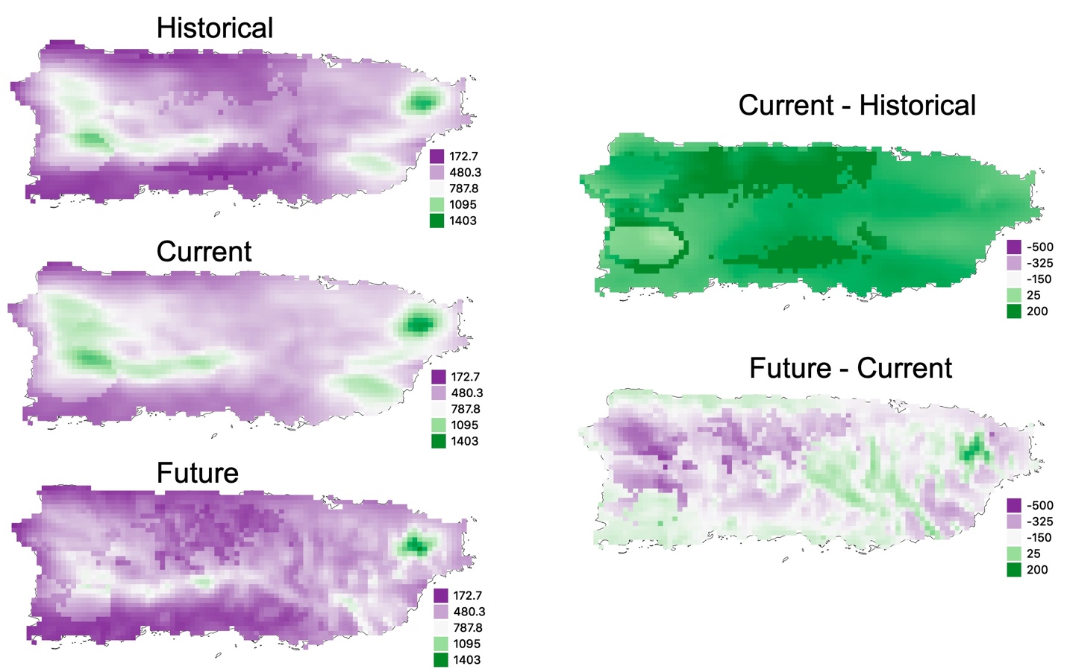

FIGURE S1: Comparison of covariate Precipitation in the warmest quarter among different scenarios. First column depicts historical (1980-1989), current (2005-2014) and future (2040-2060) scenarios. Second column depicts the difference of covariate Precipitation in the warmest quarter between historical and current scenarios and between current and future scenarios. Unit values are expressed in millimeters.

