Supplementary Material

HUNTING PRESSURE MODULATES THE COMPOSITION AND SIZE STRUCTURE OF TERRESTRIAL AND ARBOREAL VERTEBRATES IN AMAZONIAN FORESTS

Andressa B. Scabin^{a,b} and Carlos A. Peres^{b,c *}
ª Programa de Pós-Graduação em Ecologia, Universidade Federal do Rio Grande do Norte - Natal, RN, Brazil. ORCID: 0000-0001-5377-2123
^{b} Instituto Juruá, Rua das Papoulas, 97 Aleixo – Manaus, AM
^{c} Centre for Ecology, Evolution and Conservation, School of Environmental Sciences, University of East Anglia, Norwich, UK. ORCID: 0000-0002-1588-8765
Camera Trapping Methods
The commercial camera trap models used in this study were: Bushnell Trophy-Cam, Reconyx HC500 Hyperfire, and Browning Dark Ops. Camera traps were set to take three sequential photographs and/or one 10-sec videos. In all cases, camera sensors were set to high sensitivity. Three camera grids were operated simultaneously for an approximate period of 30 days each, so that each grid was sampled during only one period (dry or wet season). The selection of grids that were established at the same time depended on geographic logistical issues that would ensure the installation and subsequent removal of cameras at any area in the shortest amount of time, as we only had about 120 functioning cameras available. The spatial configuration of camera-trapping grids is described in the main text, but all cameras were unbaited and deployed away from visible trails. We recorded the number of days and hours each camera remained functional. For all cameras placed in the forest canopy, we built a customized protection device made of PVC pipes, because the combination of heavy rain and direct solar radiation damaged several cameras during a pilot study, with a significant reduction in the number of damaged cameras after this protection was installed. We have no evidence whatsoever to suggest that this unobstrusive PVC shelter either inhibited or increased camera-trapping detection rates for any arboreal species. Canopy camera-trapping at 15 to 20 m above ground was made possible by a professional tree climber, and each camera deployment required large trees to be climbed at least twice during installation and removal.

Table S1. Information about our 30 sampling sites. Information includes code name; name of the community or locality where each unit was located; name of the protected area or town; geographic coordinates and the metric of hunting pressure (see text) attributed to each camera-trapping grid.

Sample unit code | Locality | Site denomination | Lat | Long | Hunting Pressure*
P01 | Riozinho | Carauari town | -4.77285 | -66.95521 | 11.6
P02 | Riozinho | Carauari town | -4.80499 | -66.93954 | 13.8
P03 | Riozinho | Carauari town | -4.759 | -66.96839 | 10.8
P04 | Riozinho | Carauari town | -4.78323 | -66.96498 | 11.8
P05 | Gumo do Facão | RESEX Médio Juruá | -5.05074 | -67.12075 | 6.5
P06 | Gumo do Facão | RESEX Médio Juruá | -5.05872 | -67.12659 | 6.5
P07 | Roque | RESEX Médio Juruá | -5.08408 | -67.22807 | 4.9
P08 | Roque | RESEX Médio Juruá | -5.09622 | -67.22901 | 4.9
P09 | Bom Jesus | RDS Uacari | -5.39348 | -67.21051 | 3.5
P10 | Bom Jesus | RDS Uacari | -5.40296 | -67.20496 | 3.4
P11 | Bauana | RDS Uacari | -5.44378 | -67.27795 | 3.5
P12 | Bauana | RDS Uacari | -5.4507 | -67.2694 | 3.4
P13 | Vila Ramalho | RESEX Médio Juruá | -5.57658 | -67.50482 | 3.2
P14 | Vila Ramalho | RESEX Médio Juruá | -5.58331 | -67.50894 | 3.2
P15 | Tabuleiro | RESEX Médio Juruá | -5.52478 | -67.69476 | 3.1
P16 | Tabuleiro | RESEX Médio Juruá | -5.51461 | -67.69478 | 3.1
P17 | Pupunha | RDS Uacari | -5.57097 | -67.78001 | 2.9
P18 | Pupunha | RDS Uacari | -5.57145 | -67.79002 | 2.8
P19 | São José | RDS Uacari | -5.7569 | -67.88616 | 2.7
P20 | São José | RDS Uacari | -5.74766 | -67.90272 | 2.6
P21 | Cachoeira | RDS Uacari | -5.79108 | -67.877 | 2.7
P22 | Cachoeira | RDS Uacari | -5.79838 | -67.88075 | 2.7
P23 | Xibauá | RDS Uacari | -5.88588 | -67.86581 | 2.6
P24 | Xibauá | RDS Uacari | -5.87709 | -67.872 | 2.6
P25 | São Sebastião | Xerua | -6.06008 | -67.90543 | 2.4
P26 | São Sebastião | Xerua | -6.05482 | -67.91276 | 2.4
P27 | Kiriru | Itamarati town | -6.37413 | -68.23926 | 4.3
P28 | Kiriru | Itamarati town | -6.38082 | -68.2645 | 4.2
P29 | Porão | Itamarati | -6.55647 | -68.28748 | 3.1
P30 | Porão | Itamarati | -6.56518 | -68.28165 | 3.1
* see Methods in the main text for an explanation of how this metric was obtained.

Table S2. Species or (morphospecies) recorded in our camera trapping grids and species trait values used to obtain the aggregate biomass and classify species into functional groups of arboreal, terrestrial, game, non-game, small-bodied species and into the five trophic levels. BM: body mass; ST: stratum = T: terrestrial, A: arboreal; CT: camera trap = G: camera deployed near the ground, C: camera deployed in the canopy; GS: group size, Game: hunted =Y: yes, N: no. TL: trophic level. Source: Wilman et al (2004), Peres (1993) and Projeto Médio Jurua (PMJ, unpubl.data).

ORDER / Species name | English name | BM (g) | ST | CT | GS | Game | TL
Mammals
ARTIODACTYLA
Mazama americana | Red Brocket Deer | 22,799 | T | G | 1.1 | Y | 1
Mazama nemorivaga | Grey Brocket Deer | 16,633 | T | G | 1.2 | Y | 2
Pecari tajacu | Collared Peccary | 21,266 | T | G | 2.01 | Y | 2
CARNIVORA
Atelocynus microtis | Short Eared Dog | 7,749 | T | G | 1.2 | N | 4
Speothos venaticus | Bush Dog | 5,999 | T | G | 1 | N | 5
Leopardus pardalis | Ocelot | 11,900 | T | G | 1.3 | Y | 5
Leopardus wiedii | Margay | 3,249 | T | G | 1 | N | 4
Panthera onca | Jaguar | 90,000 | T | G | 1.4 | Y | 5
Puma concolor | Puma | 45,000 | T | G | 1 | N | 5
Puma yagouaroundi | Jaguarundi | 6,875 | T | G | 1 | N | 4
Eira barbara | Tayra | 3,910 | T | G, C | 1.3 | N | 5
Galictis vittata | Greater Grison | 3,200 | T | G | 1 | N | 4
Nasua nasua | South American Coati | 3,793 | T | G | 11.9 | N | 3
Potos flavus | Kinkajou | 3,000 | A | C | 3 | N | 2
Procyon cancrivorus | Crab-Eating Raccoon | 6,949 | T | G | 1 | N | 4
Pteronura brasiliensis | Giant Otter | 23,99 | T | G | 8.5 | Y | 5
CINGULATA
Priodontes maximus | Giant Armadillo | 45,359 | T | G | 1.2 | Y | 4
Dasypus kappleri | Greater Long Nosed Armadillo | 9,500 | T | G | 1 | Y | 4
Dasypus novemcinctus | Nine-Banded Armadillo | 4,203 | T | G | 1 | Y | 4
DIDELPHIMORPHIA
Caluromys lanatus | Brown-Eared Woolly Opossum | 325 | A | C | 1 | N | 2
Didelphis marsupialis | Commom Opossum | 1,091 | T | G, C | 1 | N | 4
Didelphideae (small)* | Opossum | 25 | T | G, C | 1 | N | 4
Glironia venusta | Bushy-Tailed Opossum | 114 | A | C | 1 | N | 4
ORDER / Species name | English name | BM (g) | ST | CT | GS | Game | TL
Mammals
DIDELPHIMORPHIA
Metachirus nudicaudatus | Four-Eyed Opossum | 375 | T | G | 1 | N | 4
Philander sp* | Four-Eyed Opossum | 325 | T | G, C | 1 | N | 4
PERISSODACTYLA
Tapirus terrestres | Lowland Tapir | 150,000 | T | G | 1.2 | Y | 1
PILOSA
Cyclopes didactylus | Pigmy Anteater | 329 | A | G | 1 | N | 4
Choloepus didactylus | Southern Two-Toed Sloth | 5,160 | A | C | 1 | N | 1
Myrmecophaga tridactyla | Giant Anteater | 22,333 | T | G | 1.2 | N | 4
Tamandua tetradactyla | Southern Tamandua | 5,515 | T | G, C | 1.1 | N | 4
PRIMATES
Alouatta seniculus | Red Howler Monkey | 6,145 | A | C | 6.2 | Y | 2
Aotus sp.* | Night Monkey | 1,060 | A | C | 3.5 | N | 3
Ateles chamek | Black Spider Monkey | 8, 900 | A | C | 11.7 | Y | 3
Cacajao calvus calvus | White Bald-Headed Uacari | 2,900 | A | C | 30 | N | 3
Callicebus cupreus | Red Titi Monkey | 915 | A | C | 3.5 | N | 2
Callicebus torquatus | Collared Titi Monkey | 1,050 | A | C | 3.5 | N | 2
Cebuella pygmaea | Pygmy Marmoset | 125 | A | C | 7 | N | 3
Cebus unicolor | White-Fronted Capuchin | 2,629 | A | G, C | 19.8 | Y | 3
Lagothrix cana | Grey Woolly Monkey | 8,500 | A | C | 19.6 | Y | 2
Pithecia albicans | Buffy Saki | 2,800 | A | C | 5.5 | N | 3
Pithecia monachus | Monk Saki | 1,537 | A | C | 5.5 | N | 3
Saguinus fuscicollis | Saddleback Tamarin | 387 | A | G, C | 5 | N | 3
Saguinus mystax | Moustached Tamarin | 618 | A | G, C | 5 | N | 3
Saimiri boliviensis | Squirrel Monkey | 860 | A | G, C | 47.5 | N | 3
Saimiri macrodon | Ecuatorian Squirrel Monkey | 860 | A | G, C | 31 | N | 3
Sapajus macrocephalus | Larged-Headed Capuchin | 2,500 | A | G, C | 18 | Y | 3
RODENTIA
Coendou sp.* | Brazilian Porcupine | 4,399 | A | G, C | 1 | N | 1
Cuniculus paca | Lowland Paca | 8,172 | T | G | 1 | Y | 2
Dasyprocta spp.* | Agouti | 3,500 | T | G | 1,2 | Y | 2
Echimyid rodent* | Spiny Rat | 300 | A | C | 1 | N | 1
Myoprocta spp* | Acouchy | 966 | T | G | 1 | N | 2
Proechimys spp* | Spiny Rat | 292 | T | G | 1 | N | 1
Rhipidomys sp* | Climbing Mouse | 80 | A | C | 1 | N | 2
Small rodent* | Mouse | 34 | T | G, C | 1 | N | 2
ORDER / Species name | English name | BM (g) | ST | CT | GS | Game | TL
Mammals
Very small rodent* | Mouse | 17 | T | G, C | 1 | N | 2
Guerlinguetus ignitus | Bolivian Squirrel | 190 | A | G, C | 1.2 | N | 2
Urosciurus spadiceus | Southern Amazon Red Squirrel | 800 | A | G, C | 1.4 | N | 2
Birds
CUCULIFORMES
Neomorphus pucheranii | Red-Billed Ground Cuckoo | 330 | T | G | 1 | N | 4
GALLIFORMES
Mitu tuberosum | Razor-billed Curassow | 2,769 | T | G, C | 1.6 | Y | 2
Odontophorus stellatus | Wood Quail | 335 | T | G | 5.4 | N | 2
Penelope jacquacu | Spix's Guan | 1,487 | A | G, C | 4.9 | Y | 2
GRUIFORMES
Psophia leucoptera | Pale Winged Trumpeter | 1,315 | T | G | 5.8 | Y | 2
PICIFORMES
Pteroglossus azara mariae | Brown Mandibled Aracari | 144 | A | C | 4 | N | 3
Pteroglossus beauharnaesii | Curl-Crested Aracari | 215 | A | C | 7.5 | N | 3
Pteroglossus inscriptus | Lettered Aracari | 125 | A | C | 4.5 | N | 3
Ramphastos tucanus | Red Billed Toucan | 659 | A | C | 2 | Y | 3
Selenidera reinwardtii | Golden Collared Toucanet | 161 | A | C | 2 | N | 3
TINAMIFORMES
Crypturellus spp* | Small tinamous | 241 | T | G | 1.2 | Y | 3
Tinamus guttatus | White Throated Tinamou | 686 | T | G | 1.5 | Y | 2
Tinamus major | Large Tinamou | 1,026 | T | G | 1 | Y | 3
Reptiles
TESTUDINATA
Chelonoidis spp. | Red/yellow footed tortoise | 4,580 | T | G | 1.2 | Y | 4
For species with * we use the traits based on Wilman et al (2014) following Table A2b

Table S2b. List of vertebrate taxa surveyed in this study and their respective reference taxa used to obtain species trait data.
Taxa | Reference taxa
Didelphidae (small) | Marmosa murina
Philander sp. | Philander mcilhennyi
Coendou sp. | Coendou prehensilis
Dasyprocta spp. | Dasyprocta fuliginosa
Proechimys spp. | Proechimys pattoni
Myoprocta spp. | Myoprocta pratti
Rodentia (small) | Hylaeamys perenesis
Rodentia (very small) | Oecomys bicolor
Crypturellus sp. | Crypturellus bartletti
Aotus sp. | Aotus nigrisceps

Figure S1. Map of the study area in the Médio Juruá region of Western Brazilian Amazonia. The reserve boundaries in the RESEX Médio Juruá and RDS Uacari are outlined in black. Coloured circles indicate the location of our camera-trapping grids. Circles are colour-coded according to our proxy of hunting pressure (see colour gradient) and circle area is proportional to aggregate game biomass per grid. The main Juruá River channel is shown in white. Grey background shows elevation where lighter shading represents higher terrain.
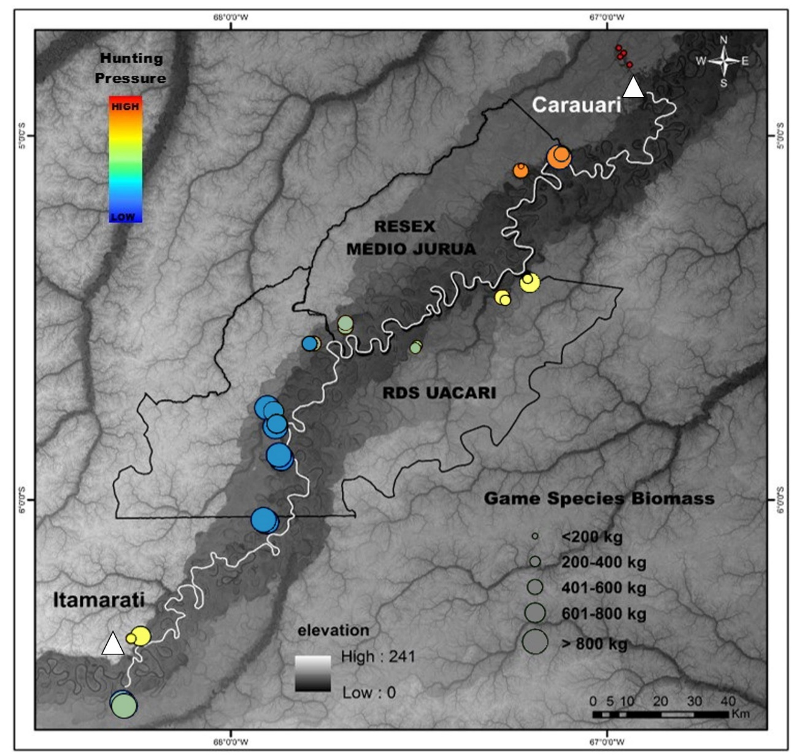

Table S3. Selected models for predicting the aggregate biomass of several functional groups from model selection based on AIC, were models were defined as equally ‘good’ if ΔAIC <2 of the best fitted model. SM: Selected Model, HP: Hunting Pressure, VAR_TF: proportion of Várzea forest, WL: floodplain water level, CEC: soil cation exchange capacity.
 | Intercept | HP | VAR_TF | WL | CEC | AIC | R²
Aggregate biomass
SM1 | -8.879e-12 | -5.394e-01 | 2.907e-01 | - | - | 66.76 | 0.46
SM2 | -2.307e-11 | -6.460e-01 | - | 2.016e-01 | - | 68.39 | 0.43
SM3 | -2.355e-11 | -6.593e-01 | - | - | - | 68.47 | 0.41
Game species
SM1 | -2.563e-11 | -7.177e-01 | - | 2.755e-01 | - | 59.56 | 0.58
SM2 | -1.726e-11 | -6.520e-01 | 1.687e-01 | 2.168e-01 | - | 60.04 | 0.59
SM3 | -1.320e-11 | -6.289e-01 | 2.593e-01 | - | - | 60.97 | 0.46
Small mammals
SM1 | 1.047e-10 | 5.956e-01 | - | - | 3.315e-01 | 76.18 | 0.25
SM2 | 8.868e-11 | 5.428e-01 | -2.156e-01 | - | 4.220e-01 | 76.87 | 0.25
SM3 | 1.237e-10 | 4.631e-01 | - | - | - | 77.68 | 0.18
Arboreal species
SM1 | -5.468e-11 | -5.331e-01 | - | - | - | 75.16 | 0.25
Terrestrial species
SM1 | -5.678e-12 | -4.400e-01 | 2.810e-01 | 3.613e-01 | - | 62.65 | 0.55
SM2 | -1.962e-11 | -5.494e-01 | - | 4.590e-01 | - | 64.33 | 0.50
SM3 | -3.087e-11 | -4.744e-01 | - | 4.149e-01 | 1.950e-01 | 64.42 | 0.52
Browsers
SM1 | -2.668e-11 | - | - | - | 3.735e-01 | 80.23 | 0.10
SM2 | -2.967e-11 | - | - | -1.661e-01 | 4.154e-01 | 81.38 | 0.09
SM3 | 1.049e-17 | - | - | - | - | 82.44 | -
Grazers
SM1 | -1.840e-11 | -5.152e-01 | - | 4.304e-01 | - | 68.13 | 0.43
Frugivores
SM1 | 1.610e-10 | -4.912e-01 | - | - | - | 76.71 | 0.21
Omnivores
SM1 | -7.048e-11 | - | - | - | 4.867e-01 | 76.87 | -
SM2 | - | - | - | - | - | - | -
Carnivores
SM1 | -1.302e-10 | - | 3.548e-01 | - | - | 80.67 | 0.09
SM2 | -1.526e-10 | -2.723e-01 | - | - | - | 82.29 | 0.03
SM3 | -1.429e-10 | - | - | - | - | 82.44 | -

Table S4. Akaike importance weights for model parameters predicting the aggregate biomass of several functional groups from the modelling average. Models were defined as equally ‘good’ if ΔAIC <2 of the best fitted model. The importance of explanatory variables was calculated by their frequency of occurrence in these models. Importance weights range from 0 (parameter with no explanatory weight) to 1(parameter in all ‘best’ models). Numbers in brackets are the number of the models in which any given variable was present.
Model parameter | Importance weights (n containing models)
Model parameter | Game species | Small | Arboreal | Terrestrial | Browsers | Grazers | Frugivores | Omnivores | Carnivores
Hunting Pressure | 1.00(3) | 1.00(3) | 1.00(1) | 1.00(3) | 0.00 (0) | 1.00(1) | 1.00(1) | 0.00(0) | 0.23(1)
Water Level | 0.75(2) | 0.00(0) | 0.00(0) | 1.00(3) | 0.21(1) | 1.00(1) | 0.00(0) | 0.00(0) | 0.00(0)
% of Várzea forest | 0.49(2) | 0.20(1) | 0.00(0) | 0.47(1) | 0.00(0) | 0.00(0) | 0.00(0) | 0.28(1) | 0.50(1)
CEC* | 0.00(0) | 0.68(2) | 0.00(0) | 0.19(1) | 0.76(2) | 0.00(0) | 0.00(0) | 1.00(2) | 0.00(0)
*CEC = soil cation exchange capacity
Table S5. GLM results using PCoA Axes 1 and 2 for the relative abundance and aggregate biomass of vertebrates for all species combined, and considered separately as either game or non-game species. HP: Hunting Pressure, Var: proportion of Várzea forest, WL: floodplain water level, CEC: soil cation exchange capacity.

RELATIVE ABUNDANCE | Axis | predictor | estimate | p | BIOMASS | Axis | predictor | estimate | p
All species | PCoA1 | HP | -7.18e-02 | 0.033* |  | PCoA1 | HP | -1.39e-01 | 0.001*
All species |  | Var | 2.26e-02 | 0.523 | All species |  | Var | 5.10e-02 | 0.227
All species |  | WL | 2.67e-02 | 0.409 | All species |  | WL | 3.02e-02 | 0.428
All species |  | CEC | 2.03e-02 | 0.563 | All species |  | CEC | -6.02e-03 | 0.884
All species | PCoA2 | HP | -9.68e-02 | 0.002* | All species | PCoA2 | HP | 4.19-02 | 0.195
All species |  | Var | 1.90e-02 | 0.598 | All species |  | Var | 3.67e-03 | 0.916
All species |  | WL | 1.33e-02 | 0.502 | All species |  | WL | -8.06e-02 | 0.018*
All species |  | CEC | -3.07e-02 | 0.303 | All species |  | CEC | -2.49e-03 | 0.943
 | PCoA1 | HP | -1.28e-01 | 0.000* |  | PCoA1 | HP | -1.60e-01 | 0.000*
Game species |  | Var | 2.98e-02 | 0.306 | Game species |  | Var | 5.14e-02 | 0.225
Game species |  | WL | 8.17e-02 | 0.004* | Game species |  | WL | 6.74e-02 | 0.085
Game species |  | CEC | 7.94e-03 | 0.781 | Game species |  | CEC | -1.05e-02 | 0.799
Game species | PCoA2 | HP | -3.52e-02 | 0.210 | Game species | PCoA2 | HP | 1.68e-02 | 0.618
Game species |  | Var | -1.02e-03 | 0.973 | Game species |  | Var | -8.81e-04 | 0.981
Game species |  | WL | 1.95e-02 | 0.484 | Game species |  | WL | -6.76e-02 | 0.055
Game species |  | CEC | -2.36e-02 | 0.438 | Game species |  | CEC | -4.52e-03 | 0.902
 | PCoA1 | HP | -5.79e-03 | 0.896 |  | PCoA1 | HP | -1.02e-01 | 0.066
Non-game species |  | Var | -1.03e-02 | 0.832 | non-game species |  | Var | -2.20e-02 | 0.713
Non-game species |  | WL | -5.77e-03 | 0.897 | non-game species |  | WL | -1.78e-02 | 0.743
Non-game species |  | CEC | -5.09e-02 | 0.299 | non-game species |  | CEC | 4.83e-02 | 0.481
Non-game species | PCoA2 | HP | 1.02e-01 | 0.004* | non-game species | PCoA2 | HP | -2.52e-02 | 0.546
Non-game species |  | Var | -3.70e-02 | 0.307 | non-game species |  | Var | 8.86e-02 | 0.063
Non-game species |  | WL | 3.54e-02 | 0.284 | non-game species |  | WL | -1.04e-01 | 0.019*
Non-game species |  | CEC | 5.40e-02 | 0.138 |  |  | CEC | -2.04e-02 | 0.654

Figure S2. (A) Effects of our metric of hunting pressure on the mean (± 95% confidence intervals) body mass (g, log₁₀ x) of all individual terrestrial and arboreal vertebrates recorded in each of our camera-trapping grids. Social species for which more than one conspecific were recorded within the same photos count as single individuals. (B) Camera-trapping grids were ordered from the least to the most hunted sites. Size of circles are proportional to the mean (untransformed) body mass of all individuals detected within each grid.
