Supplementary Information
Online Resource 1: Species selected in this study (n= 116) and their classification according to their significant (p < 0.05, 999 randomizations, two-tailed test) diagnostic power for each habitat subtype in terms of presence/absence scores (P/A), abundance (AB) and functional association values (ϕ) based on functional traits or Grime’s CSR strategies scores. P/A and AB columns indicate only the presence (1) of species, while ϕ_traits and ϕ_CSR columns indicate the Standardized Effect Size (SES) of each functional association; bold values of each indicator specify exclusive species. The dark diversity probability is reported for all the species of each habitat subtype and marked in red when higher than 0.6. For each species is also reported the scores of Grimes CSR strategies (Competitor, Stress-tolerant, Ruderal) and of the first two axes of the PCA (PC1_economics and PC2_size). This table is provided as a separate spreadsheet (.xlsx)
Online Resource 2: Principal Component Analysis on trait values of all diagnostic species calculated using the functional association (ϕ) based on functional traits (n = 122). Legend: H = plant height, C/N = carbon to nitrogen ratio, LA = leaf area, LDMC = leaf dry matter content, LNC = leaf nitrogen content, SLA = specific leaf area.
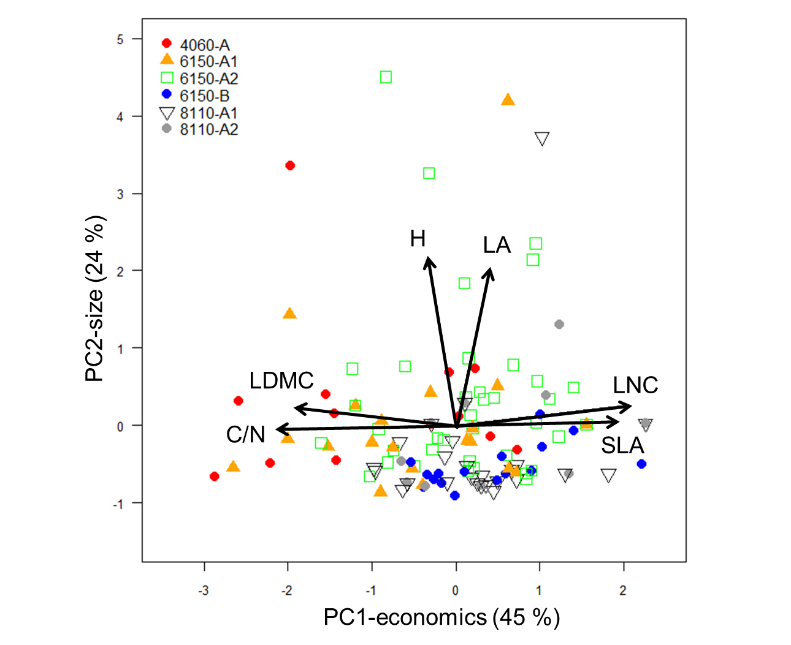
Online Resource 3: Pearson’s correlation coefficients (r) of trait values with the first two axes of the Principal Component Analysis (PC1 and PC2) for all diagnostic species obtained using the trait-based functional association (ϕ) of each habitat subtype (n = 122). Bold values are statistically significant (p ≤ 0.01) (critical value of r = 0.18, df = 120). Legend: H = plant height, C/N = carbon to nitrogen ratio, LA = leaf area, LDMC = leaf dry matter content, LNC = leaf nitrogen content, SLA = specific leaf area.
Plant trait | PC1-economics | PC2-size
H | -0.13 | 0.87
C/N | -0.85 | -0.02
LA | 0.17 | 0.82
LDMC | -0.77 | 0.04
LNC | 0.85 | 0.11
SLA | 0.79 | 0.01
Online Resource 4: CSR strategies triangle of all diagnostic species calculated using the functional association (ϕ) based on Grime’s CSR strategies (n = 122).

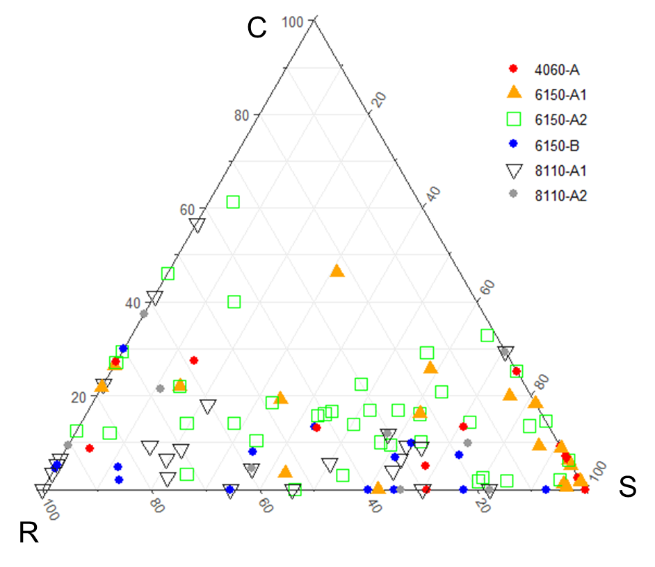
Online Resource 5: Comparison of C-, S-and R- strategies scores and of the first two principal components (PC1–economics and PC2–size) scores, of all diagnostic species among each habitat subtype, calculated using respectively the functional association (ϕ) based on CSR strategies and functional traits. The boxplots display the median (line in the middle of the boxes), the interquartile range (boxes), ± 1.5 times the interquartile range (whiskers) and outliers (circles). The Kruskal-Wallis test was always significant (p < 0.01); small letters indicate the post hoc comparisons.
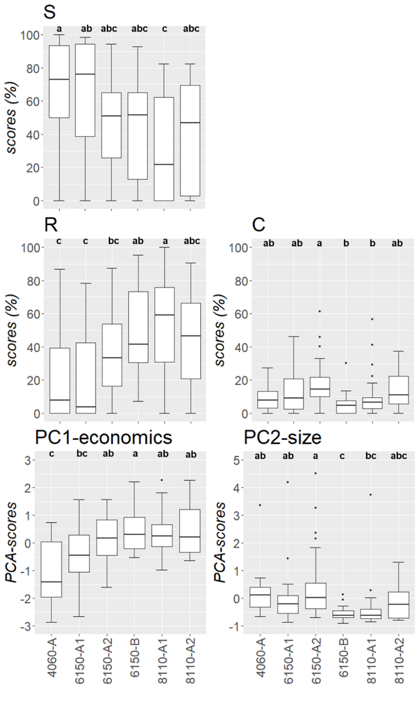

Online Resource 6: Overlapped estimated areas between pairs of kernel density distribution curves for each habitat subtype and indicators based on presence/absence (P/A), abundance (AB) and functional methods (ϕ) based on functional traits or Grime’s CSR strategies scores (ϕ _trait or ϕ_CSR).
 |  | P/A vs. AB | P/A vs. ϕ_trait | P/A vs. ϕ_CSR | AB vs. ϕ_trait | AB vs. ϕ_CSR | ɸ_trait vs. ϕ_CSR
4060-A | PC1-economics | 0.96 | 0.79 | 0.83 | 0.79 | 0.83 | 0.94
 | PC2-size | 0.94 | 0.67 | 0.72 | 0.71 | 0.76 | 0.93
 | C | 0.95 | 0.84 | 0.87 | 0.81 | 0.85 | 0.90
 | S | 0.96 | 0.88 | 0.93 | 0.89 | 0.92 | 0.91
 | R | 0.95 | 0.87 | 0.90 | 0.88 | 0.90 | 0.93
6150-A1 | PC1-economics | 0.87 | 0.80 | 0.78 | 0.87 | 0.87 | 0.95
 | PC2-size | 0.90 | 0.85 | 0.88 | 0.82 | 0.86 | 0.91
 | C | 0.84 | 0.87 | 0.90 | 0.83 | 0.83 | 0.96
 | S | 0.94 | 0.89 | 0.88 | 0.92 | 0.92 | 0.96
 | R | 0.90 | 0.89 | 0.92 | 0.89 | 0.93 | 0.96
6150-A2 | PC1-economics | 0.98 | 0.86 | 0.86 | 0.87 | 0.87 | 0.99
 | PC2-size | 0.98 | 0.89 | 0.89 | 0.91 | 0.91 | 0.97
 | C | 0.97 | 0.85 | 0.82 | 0.86 | 0.83 | 0.93
 | S | 0.98 | 0.87 | 0.87 | 0.88 | 0.88 | 0.98
 | R | 0.98 | 0.89 | 0.89 | 0.90 | 0.90 | 0.97
6150-B | PC1-economics | 0.94 | 0.84 | 0.84 | 0.85 | 0.85 | 1.00
 | PC2-size | 0.90 | 0.74 | 0.74 | 0.75 | 0.75 | 1.00
 | C | 0.94 | 0.90 | 0.90 | 0.86 | 0.86 | 1.00
 | S | 0.94 | 0.86 | 0.86 | 0.86 | 0.86 | 1.00
 | R | 0.92 | 0.86 | 0.86 | 0.84 | 0.84 | 1.00
8110-A1 | PC1-economics | 0.89 | 0.86 | 0.79 | 0.94 | 0.87 | 0.92
 | PC2-size | 0.92 | 0.81 | 0.80 | 0.86 | 0.85 | 0.98
 | C | 0.89 | 0.90 | 0.84 | 0.94 | 0.88 | 0.91
 | S | 0.94 | 0.93 | 0.89 | 0.96 | 0.88 | 0.91
 | R | 0.94 | 0.95 | 0.92 | 0.94 | 0.88 | 0.92
8110-A2 | PC1-economics | 0.84 | 0.83 | 0.83 | 0.70 | 0.70 | 1.00
 | PC2-size | 0.92 | 0.69 | 0.69 | 0.67 | 0.67 | 1.00
 | C | 0.89 | 0.84 | 0.84 | 0.79 | 0.79 | 1.00
 | S | 0.88 | 0.95 | 0.95 | 0.87 | 0.87 | 1.00
 | R | 0.87 | 0.96 | 0.96 | 0.86 | 0.86 | 1.00

