SUPPLEMENTAL FILE S1
Prediction of the minimum effective size of a population viable in the long term
Biodiversity and Conservation
Noelia Pérez-Pereira¹, Jinliang Wang², Humberto Quesada¹ and Armando Caballero¹

¹ Centro de Investigación Mariña, Universidade de Vigo, Facultade de Bioloxía, 36310 Vigo, Spain.
² Institute of Zoology, Zoological Society of London, London, United Kingdom

Corresponding author: Noelia Pérez-Pereira, Centro de Investigación Mariña, Universidade de Vigo, Departamento de Bioquímica, Xenética e Inmunoloxía, Facultade de Bioloxía, Campus de Vigo, 36310 Vigo, Spain. Tel: +34 986813828. Fax: +34 986812556. Email: noeperez@uvigo.es

Table A1. Mutational model assumed by Pérez-Pereira et al. (2021a).

U | U_{L} | $$\overline{s}$$ | β | $$\overline{h}$$ | B ± sd
0.2 | 0.015 | 0.2 | 0.33 | 0.283 | 6.111 ± 0.129

U: haploid deleterious mutation rate per generation. U_{L}: haploid lethal mutation rate per generation, where the homozygous lethal selection coefficient is s = 1 and the dominance coefficient of lethal alleles is h = 0.02. $\overline{s}$: average homozygous selection coefficient for deleterious mutations. β: shape parameter of the gamma distribution of homozygous selection coefficients; $\overline{h}$: average coefficient of dominance of deleterious mutations; B: average and standard deviation of the inbreeding load of a large equilibrium population

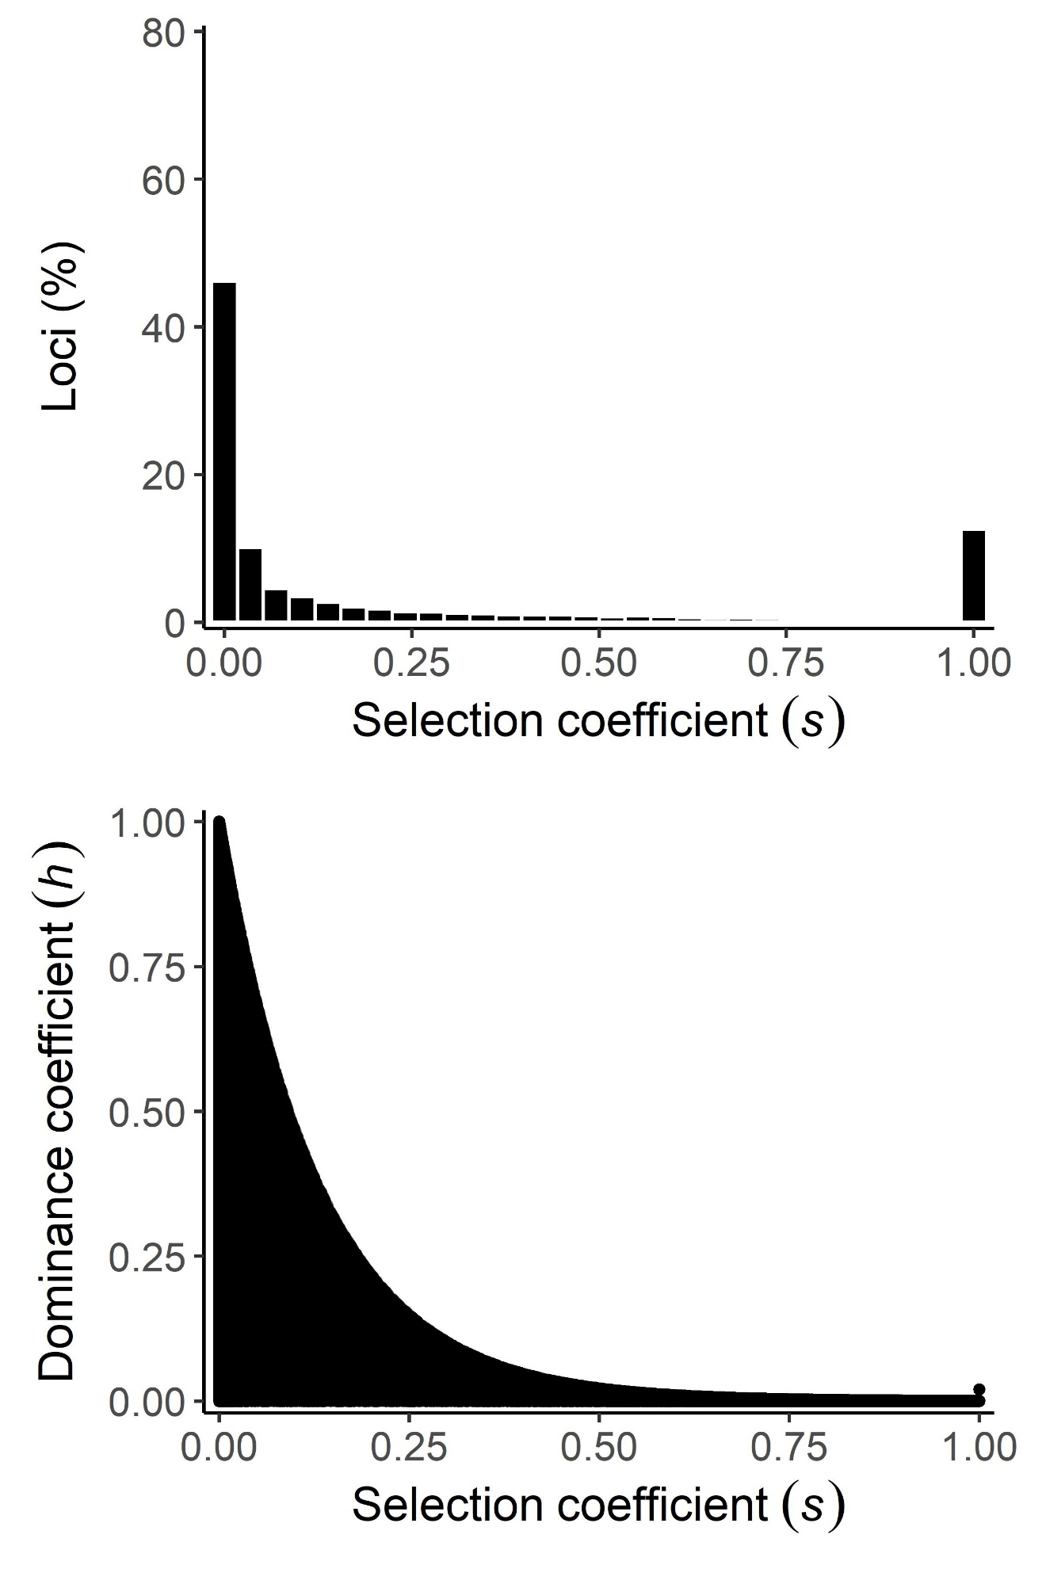
Fig. A1 (analogous to Fig. S1) Distribution of homozygous selection coefficients of mutations (s) for the mutational model of Table A1. The first row shows a histogram for the percentage of loci per value of s. The second row shows the relationship between selection coefficients (s) and dominance coefficients (h)

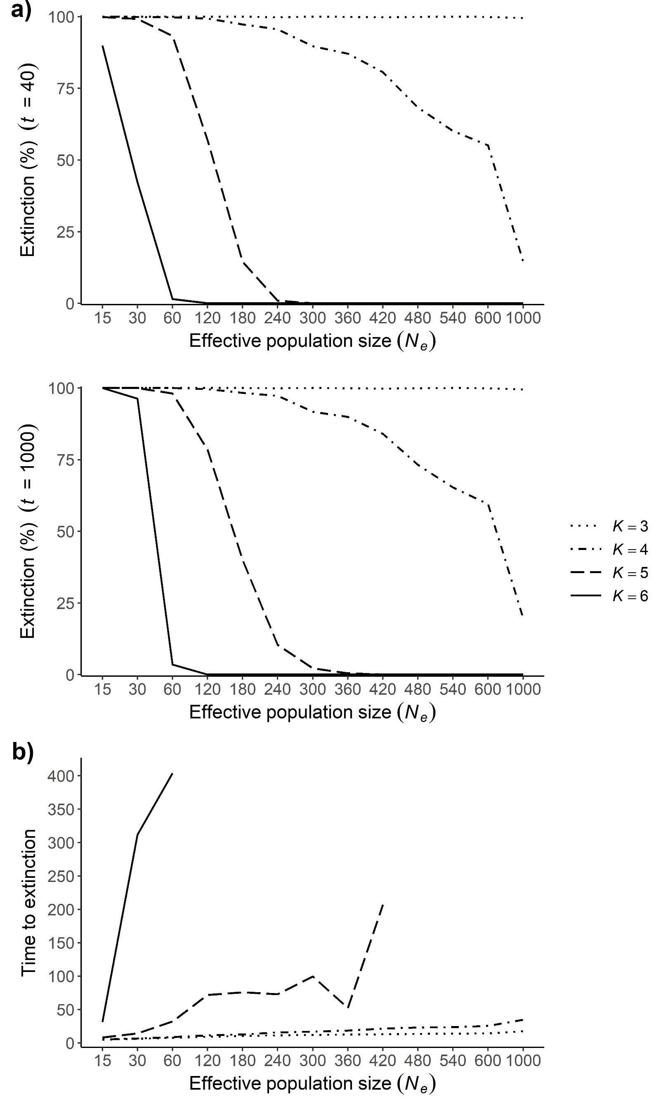
Fig. A2 (analogous to Fig. 1 of the main text) a) Probability of extinction, represented as percentage of extinct lines after 40 generations (first row) or 1000 generations (second row) for different effective population sizes (N_{e}) and reproductive rates (K) under the mutational model of Table A1. b) Mean times to extinction (in generations) for different effective population sizes (N_{e}) and reproductive rates (K)
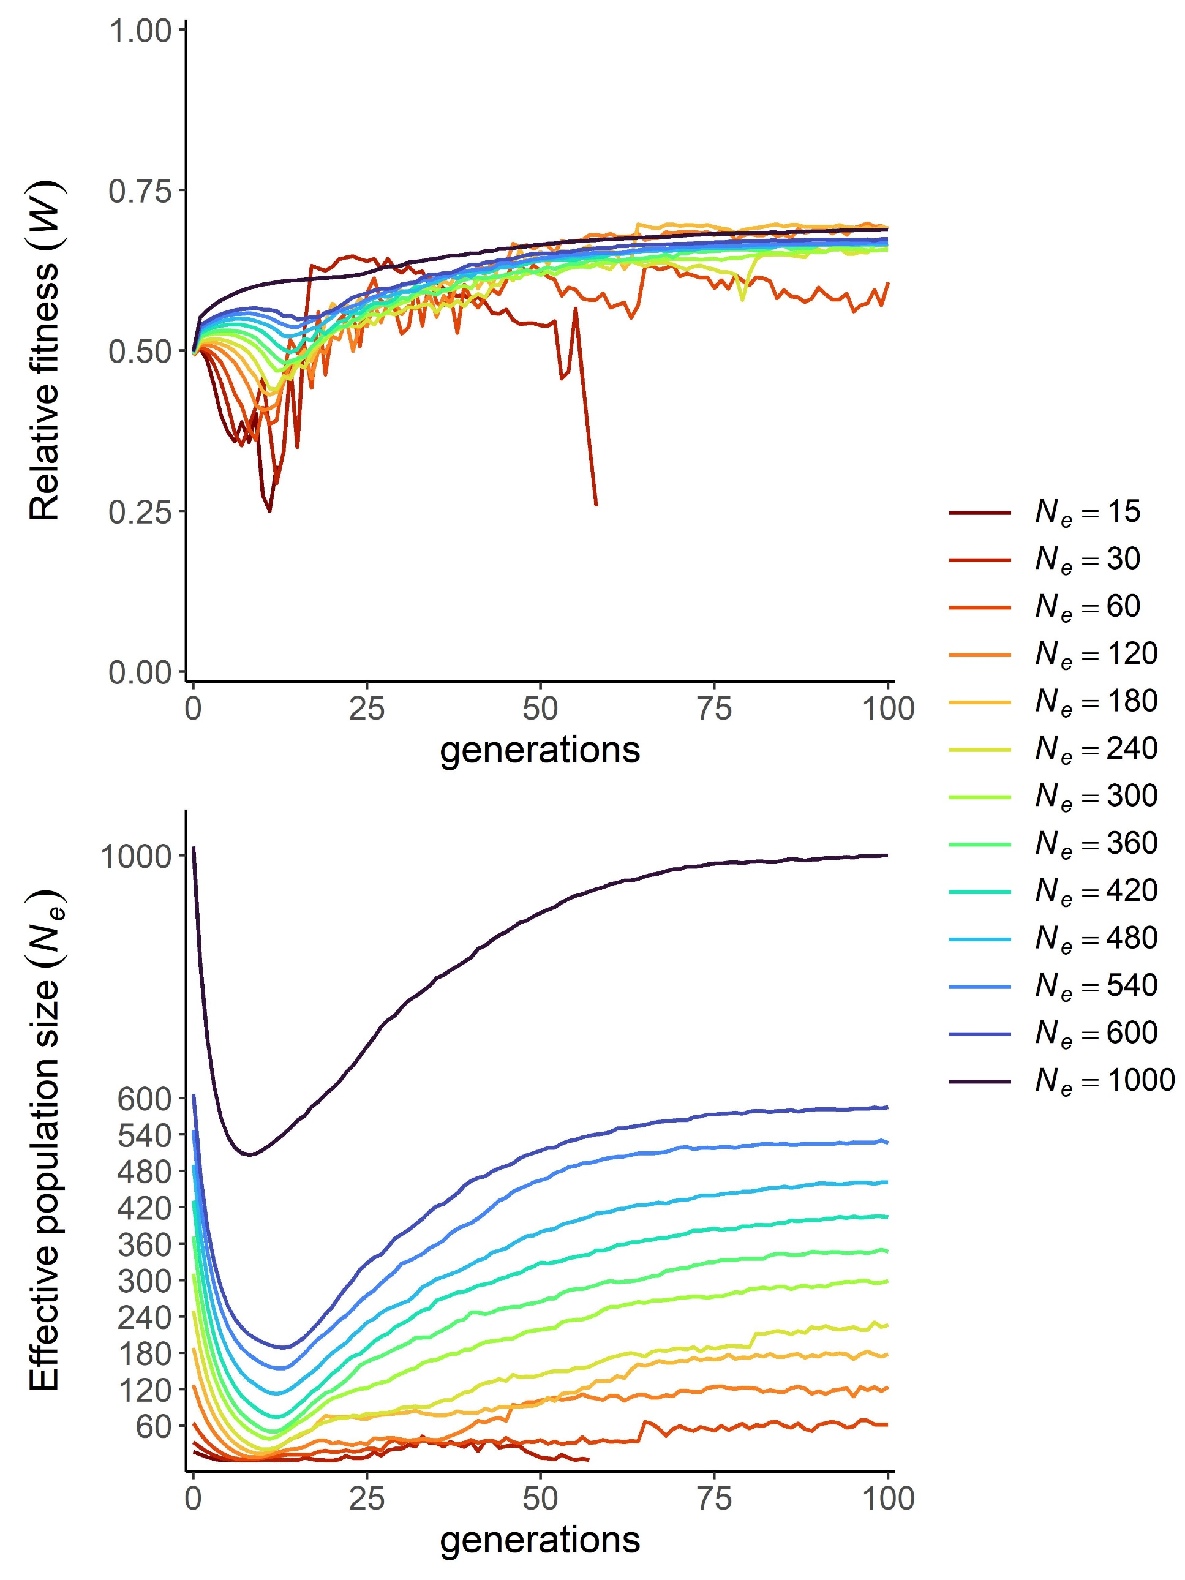
Fig. A3 (analogous to Fig. 2 of the main text) Relative fitness (W) and realized effective population size (N_{e}) in the first 100 generations. Results correspond to a reproductive rate of K = 4 under the mutational model of Table A1

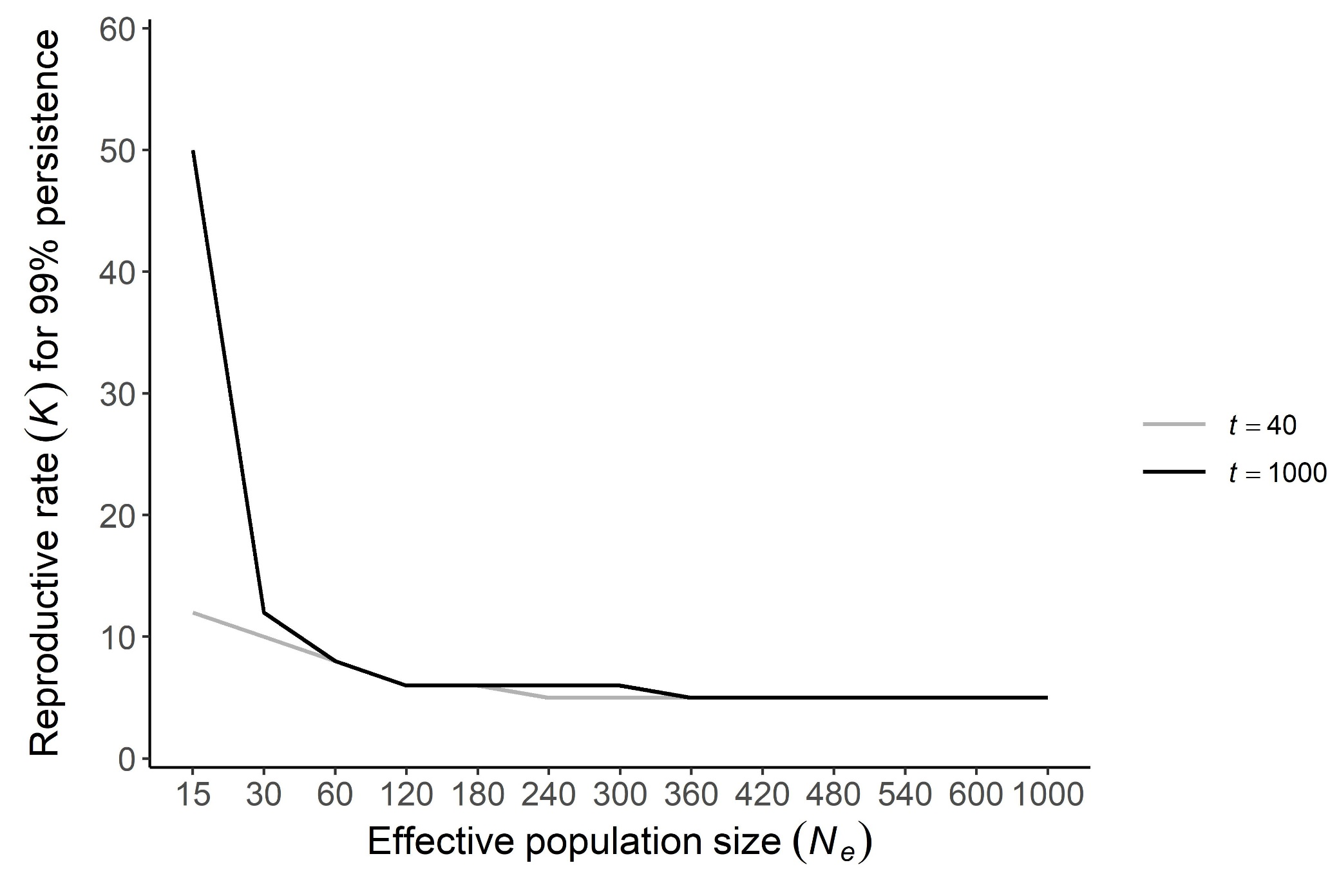
Fig. A4 (analogous to Fig. 3 of the main text) Minimum reproductive rate (K) necessary for a population of effective size N_{e} to persist in the long term (40 or 1000 generations) with a 99% probability under the mutational model of Table A1. The absence of a solid line for a particular N_{e} indicates that no K value was found that ensured the persistence of that line for the time t considered (evaluated up to a maximum of K = 60)

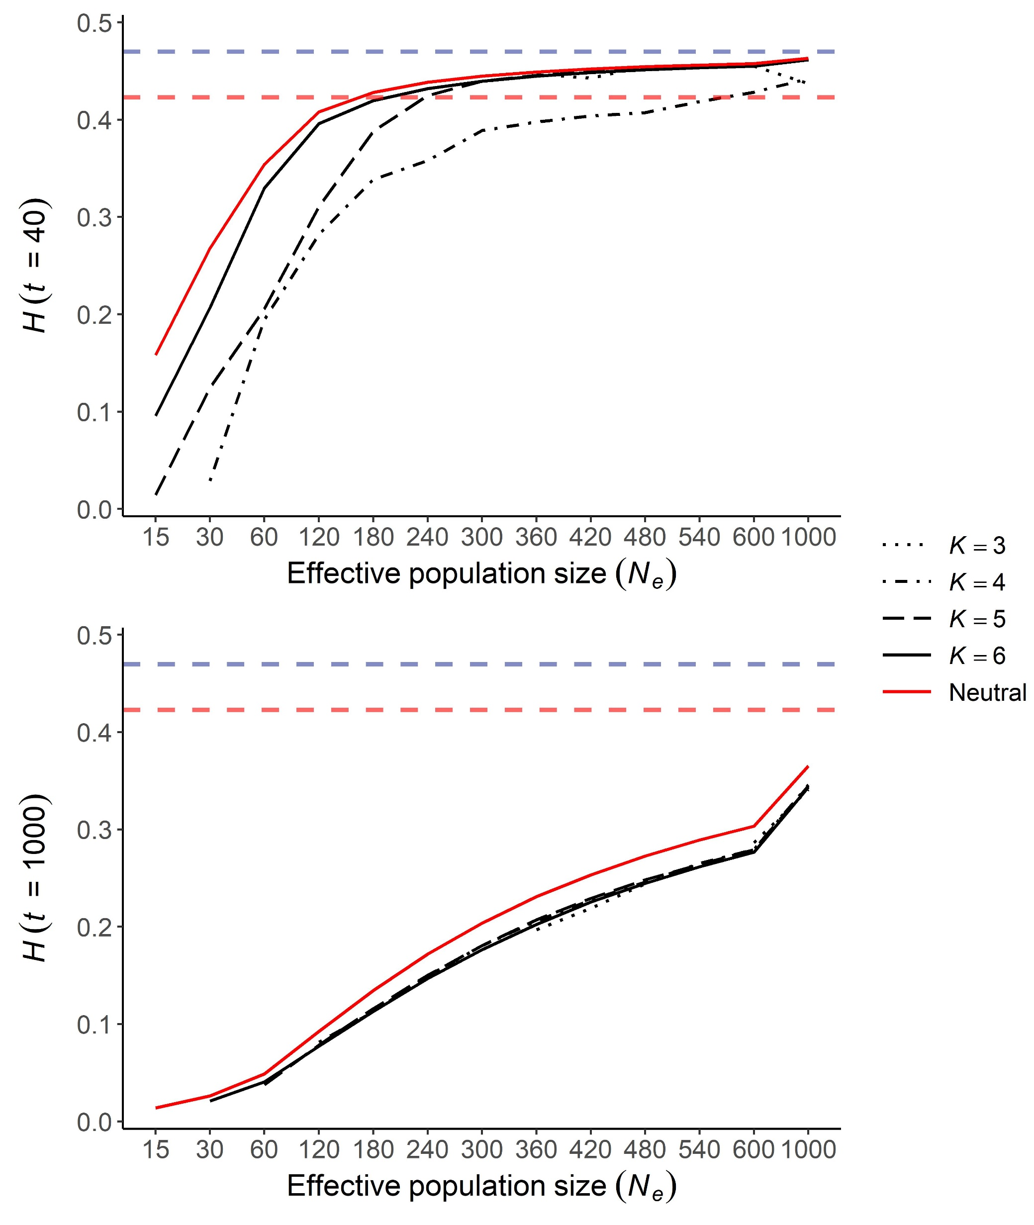
Fig. A5 (analogous to Fig. 4 of the main text) Observed mean heterozygosity (H) for neutral alleles as a function of effective population size (N_{e}) of the lines at generations t = 40 (first row) and t = 1000 (second row) under the mutational model of Table A1. Black lines indicate simulations with selection, the solid red line indicates simulations without selection (neutral) for comparative purposes, the horizontal dashed blue line indicates the initial mean heterozygosity at generation 0 (H₀), and the horizontal dashed red line indicates a 90% threshold in genetic diversity to be retained
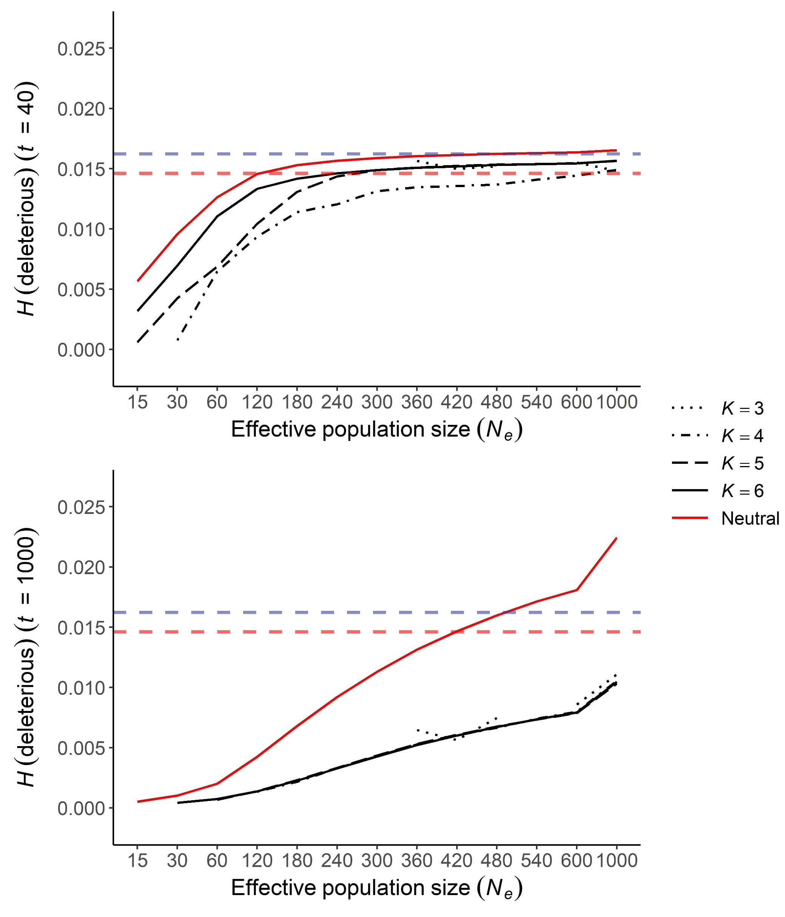
Fig. A6 (analogous to Fig. 5 of the main text) Mean heterozygosity (H) for deleterious alleles as a function of effective population size (N_{e}) at generations t = 40 (first row) and t = 1000 (second row) under the mutational model of Table A1. Black lines indicate simulations with selection, the solid red line indicates simulations without selection (neutral) for comparative purposes, the horizontal dashed blue line indicates the initial mean heterozygosity at generation 0 (H₀), and the horizontal dashed red line indicates a 90% threshold in genetic diversity to be retained

SUPPLEMENTAL MATERIAL

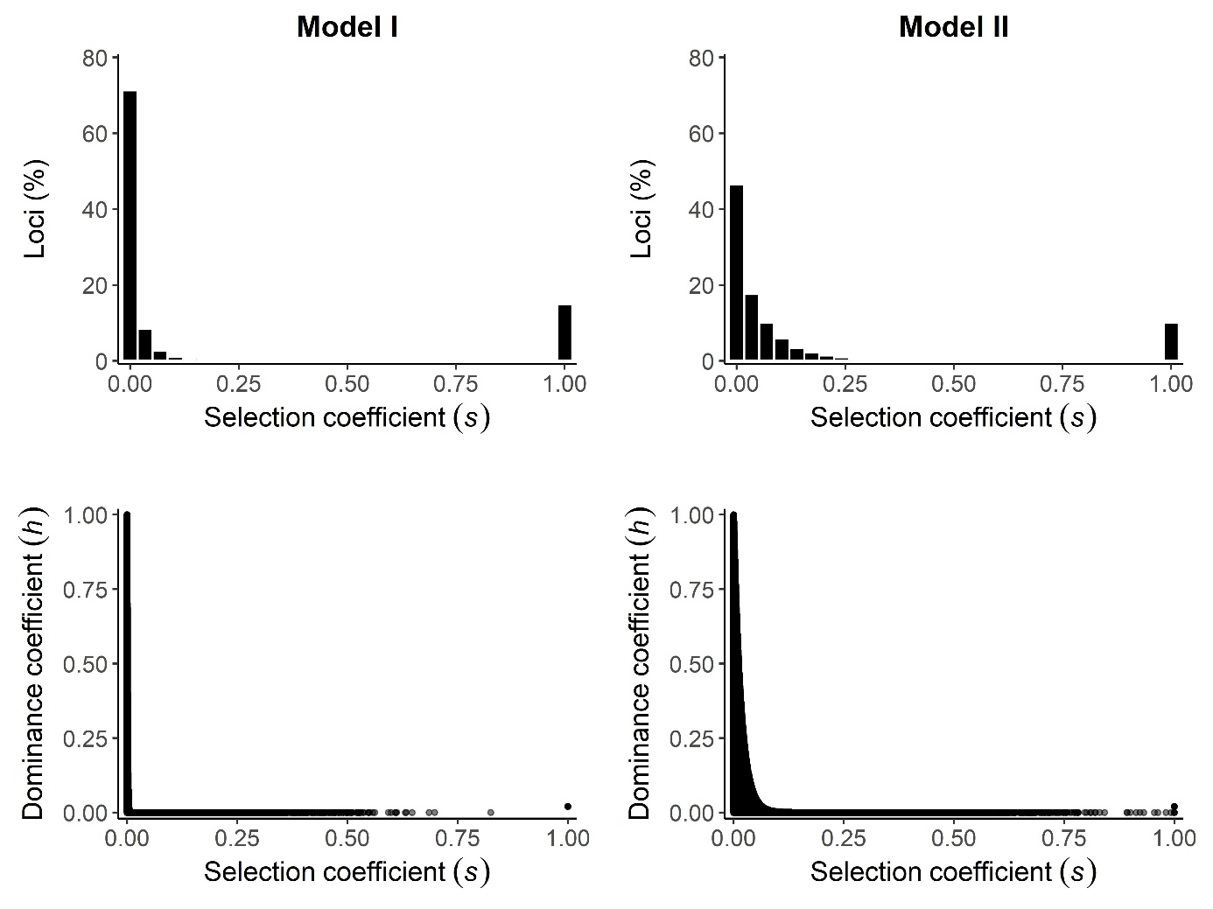

Fig. S1 Distribution of homozygous selection coefficients of mutations (s) for two mutational models (see Table 1 of the main text). The first row shows a histogram for the percentage of loci with different s values. The second row shows the relationship between selection coefficients (s) and dominance coefficients (h)

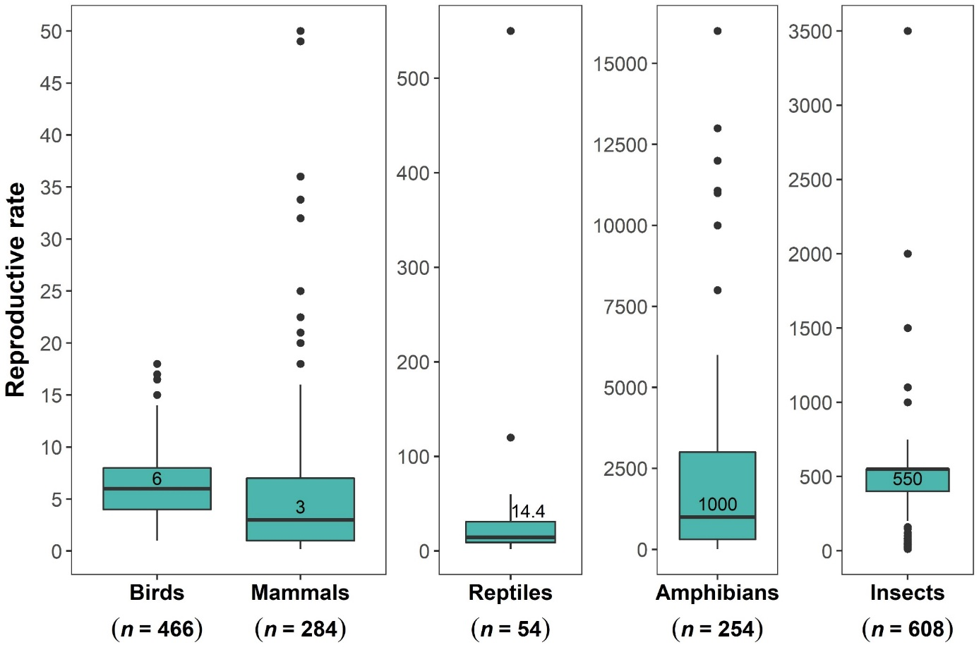

Fig. S2 Reproductive rates collected from Vance et al. (2003), Brook et al. (2006), Traill et al. (2007), Rytwinski and Fahrig (2011), and Quesnelle et al. (2014). Reproductive rates were measured as total number of eggs laid (mean clutch size × mean number of clutches) or young born (mean litter size × mean number of litters) per female per year. Boxes indicate the interquartile range (50% of the estimates), and the median is indicated by the horizontal thick line and its corresponding value above. Whiskers show the minimum and maximum values within 1.5 times the interquartile range and black dots correspond to outliers

