Extraordinary diversity among allopatric species in the genus Goniurosaurus (Squamata: Eublepharidae): understanding niche evolution and the need of conservation measures.
Journal name Biodiversity and Conservation
Hai Ngoc Ngo^{1, 2, 3} Dennis Rödder⁴ Lee Grismer⁵ Truong Quang Nguyen^{6,7} Minh Duc Le^{8,9,10} Shuo Qi¹¹ Thomas Ziegler^{2,3}
¹Institute of Genome Research, Vietnam Academy of Science and Technology, Hanoi, Vietnam
²Institute of Zoology, University of Cologne, Zülpicher Strasse 47b, 50674, Germany
³Cologne Zoo, Riehler Straße 173, 50735, Cologne, Germany
⁴ LIB, Museum Koenig Bonn, Leibniz Institut zur Analyse des Biodiversitätswandels, Adenauerallee 127, 53113, Bonn, Germany
⁵Herpetology Laboratory, Department of Biology, La Sierra University, Riverside, CA, USA
⁶Institute of Ecology and Biological Resources, Vietnam Academy of Science and Technology, Hanoi, Vietnam
⁷Graduate University of Science and Technology, Vietnam Academy of Science and Technology, Hanoi, Vietnam
⁸Department of Environmental Ecology, Faculty of Environmental Sciences, University of Science, Hanoi, Vietnam
⁹ Central Institute for Natural Resources and Environmental Studies, Vietnam National University, Hanoi, Vietnam
¹⁰ Department of Herpetology, American Museum of Natural History, New York, New York 10024, USA
¹¹State Key Laboratory of Biocontrol/The Museum of Biology, School of Life Sciences, Sun Yat-sen University, Guangzhou, Guangdong 510275, China
Corresponding author: Hai Ngoc Ngo. E-mail: ngohai2709@gmail.com, Orcid ID: 0000-0001-5471-965X

Supplementary information
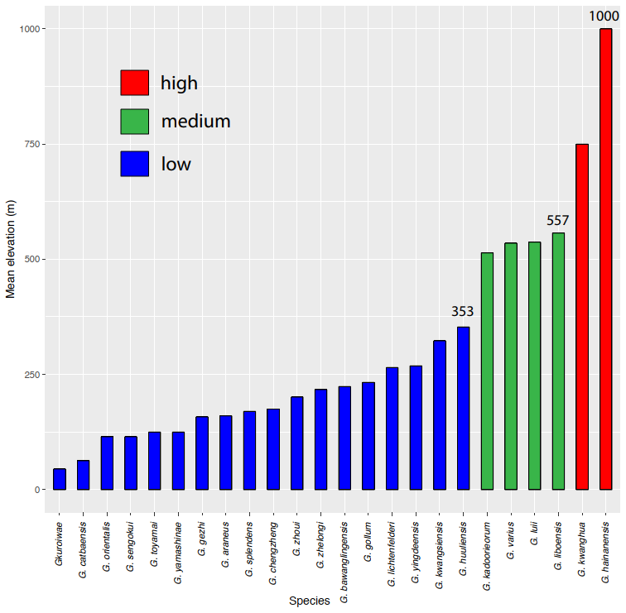
Fig. S1 The mean elevation was recorded in all Goniurosaurus species

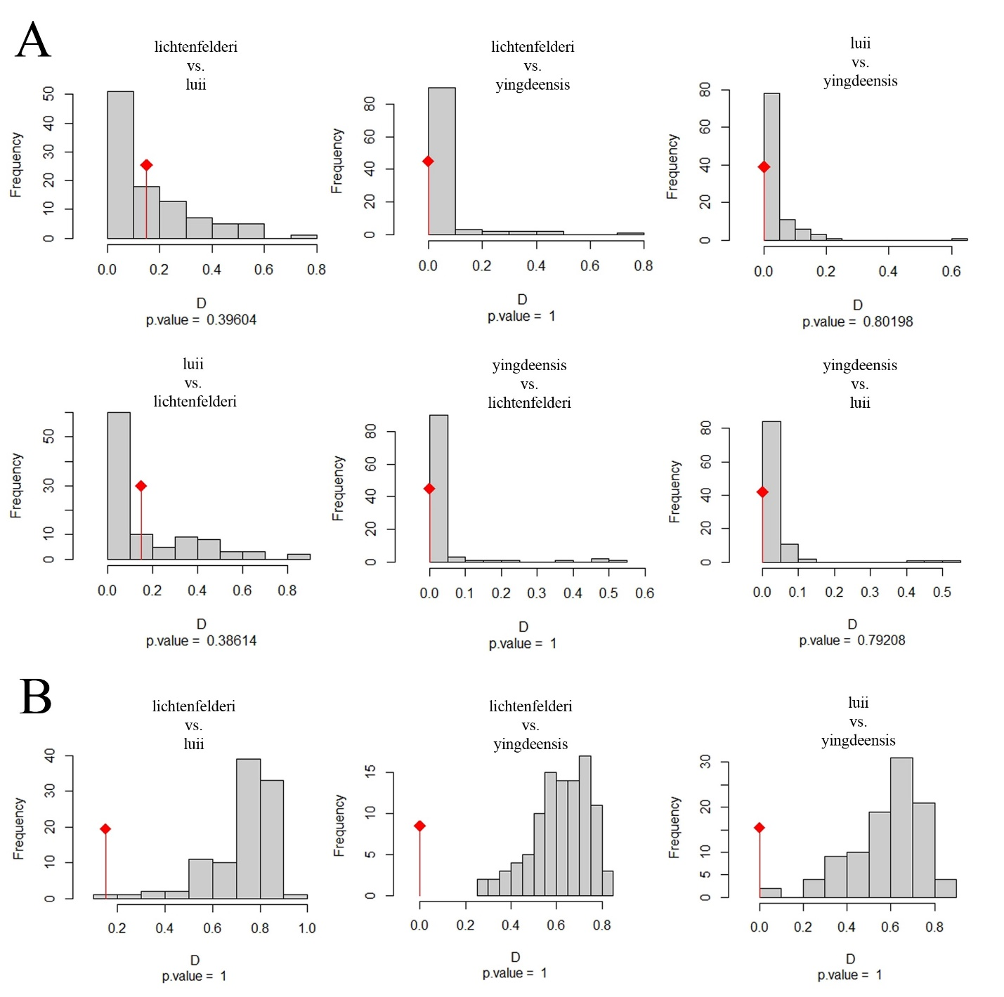
Fig. S2 Histograms showed the observed niche overlap D between given Goniurosaurus group-pairs with diamond bars, and simulated niche overlaps (grey bars) on tests of A. Niche similarity in two directions and B. Niche equivalence. All calculated 100 iterations

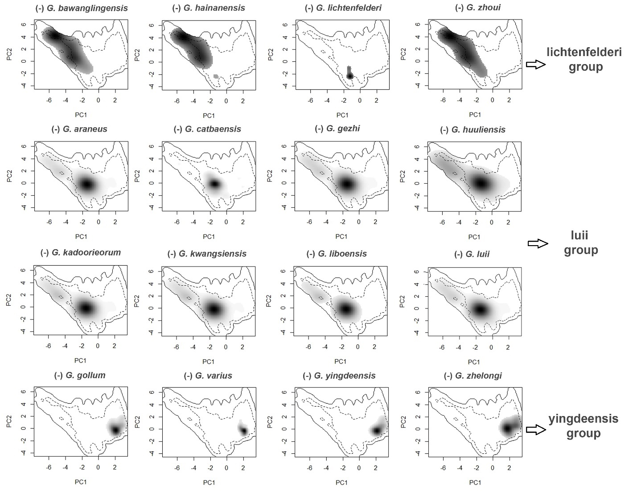
Fig. S3 Climatic niche spaces of remaining species in the PCA-env after excluding records of one species from pooled coordinate data of each Goniurosaurus group along the first two axes (PC1 and PC2). The solid (100%) and dashed contour (50%) lines illustrate the available macro-climate space. (-) indicates that the Goniurosaurus species was omitted

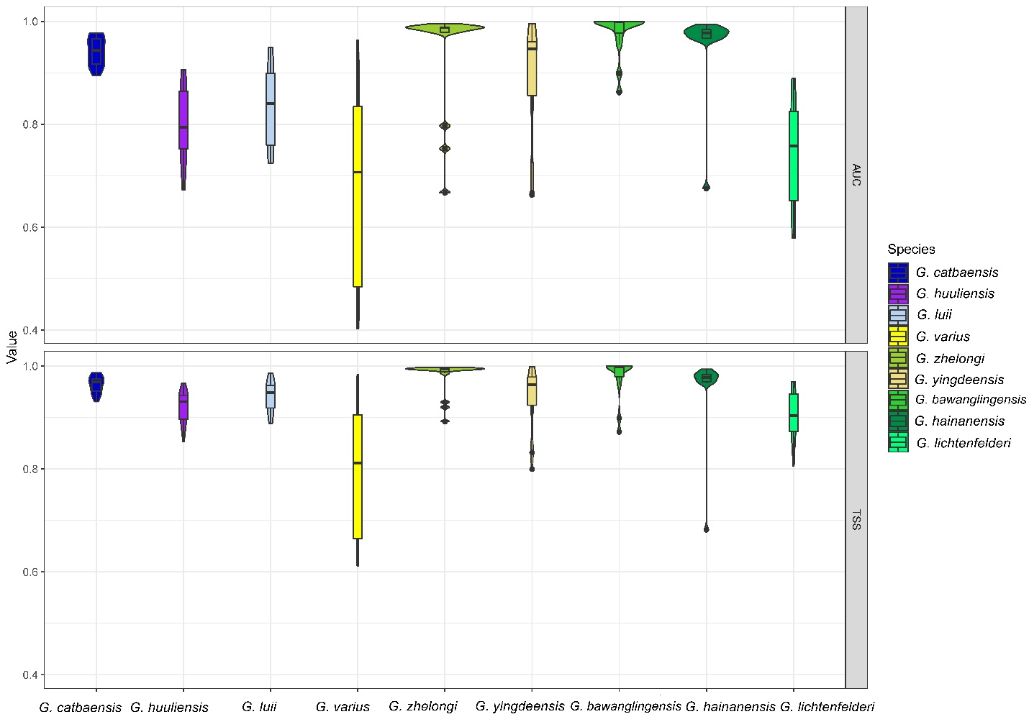
Fig. S4 Violin plots overlay with box plots showing the range, frequency, mean (horizontal black bars), and 50% quartile (black rectangle) of the AUC and TSS indices in ensemble models (EMS) of nine Goniurosaurus species from China and Vietnam (higher values indicate better-performing models)

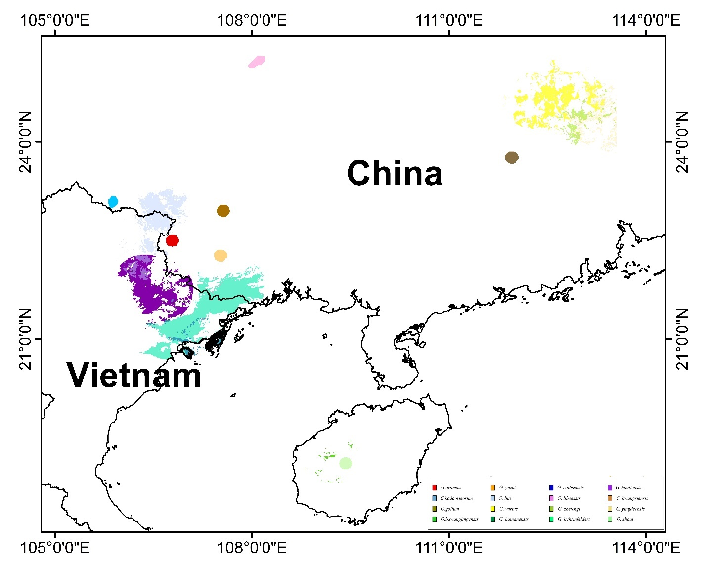
Fig. S5 Potential distributions of 16 Goniurosaurus species in China and Vietnam were identified by using ensemble models (EMS) and circling suitable sites

