Supplementary materials
S1 PBR of all forests for different biodiversity metrics
Productivity tended to show a similar pattern with biodiversity calculated by Margalef, Shannon and Simpson metric
 | Margalef | Shannon | Simpson
Mammals | 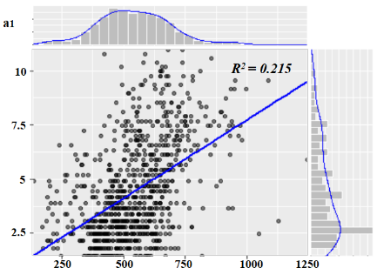 | 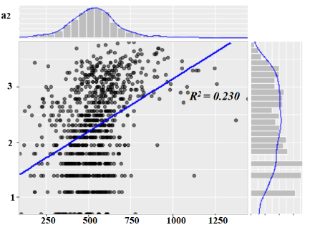 | 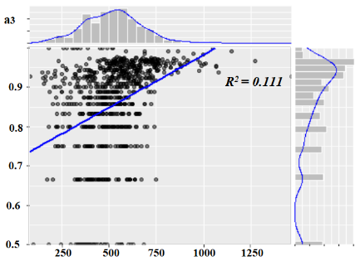
Birds | 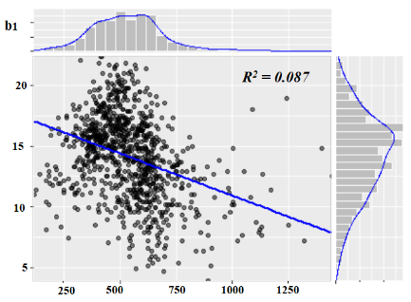 | 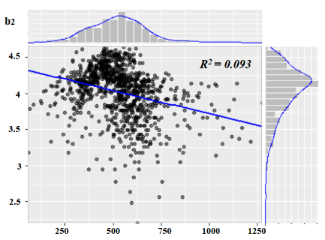 | 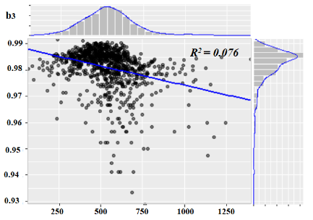
Herptiles | 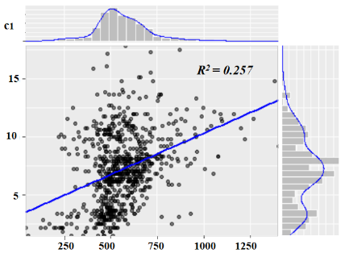 | 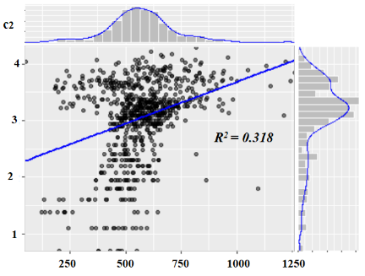 | 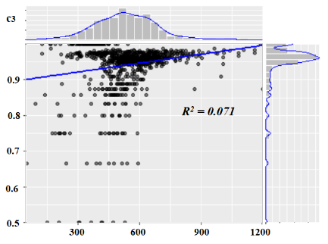
Butterflies | 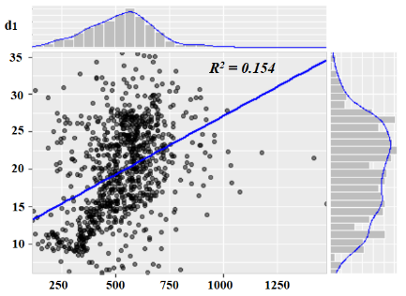 | 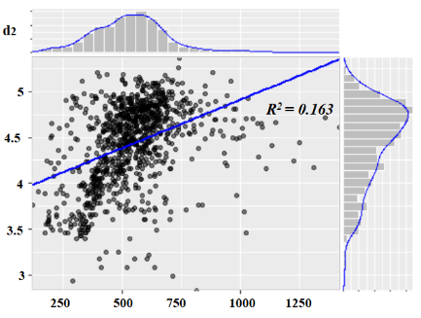 | 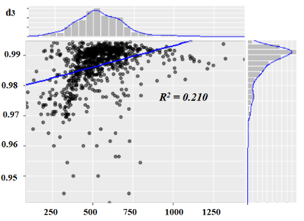
Figure S1: Relationships between overall productivity and (a) mammals, (b) birds, (c) herptiles and (d) butterflies as determined by (1) Margalef (2) Shannon and (3) Simpson biodiversity metrics

S2 PBR in monoculture coniferous and monoculture broadleaved forests
PBR followed a similar pattern in different forest types with a slightly stronger relationship observed in coniferous than broadleaved forests. This finding is suggesting that productivity in coniferous forests is a better predictor for diversity than productivity in broadleaved forests.
Coniferous | Broadleaved
Birds
Mammals
All Species
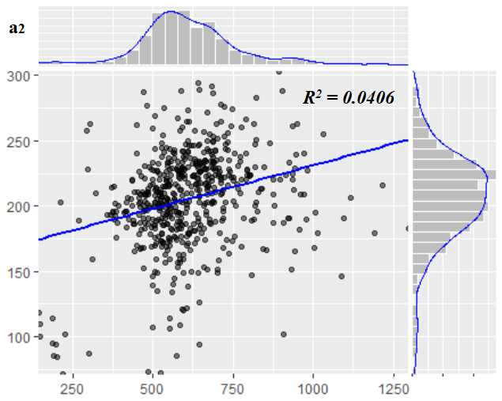
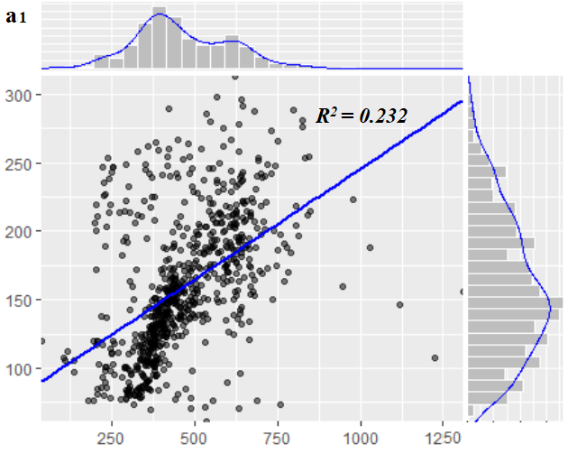
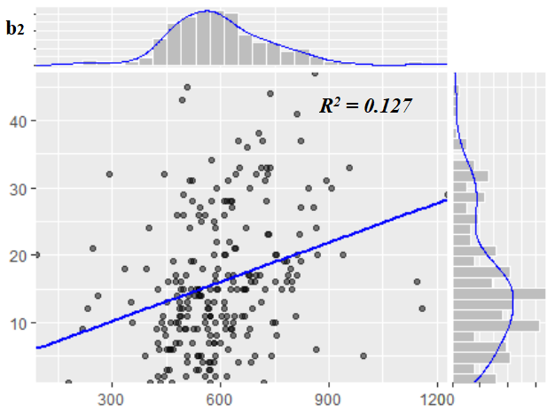
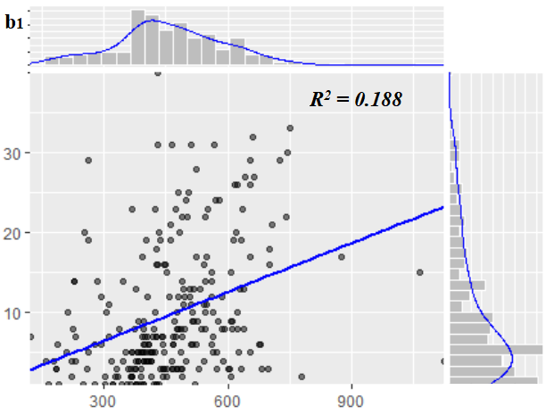
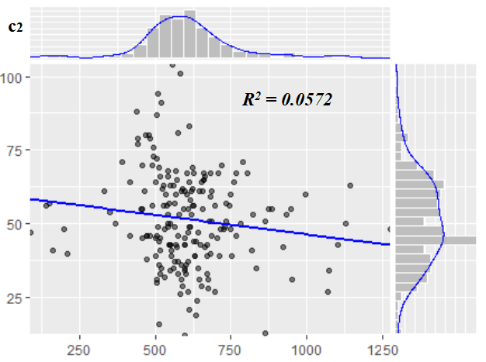
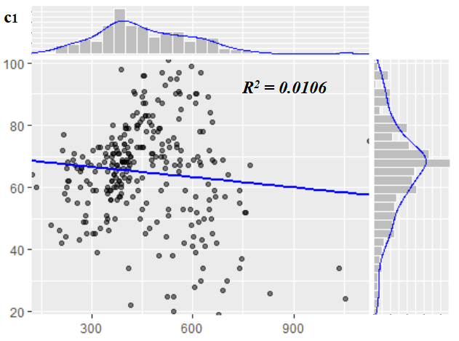

Coniferous | Broadleaved
Butterflies
Herptiles
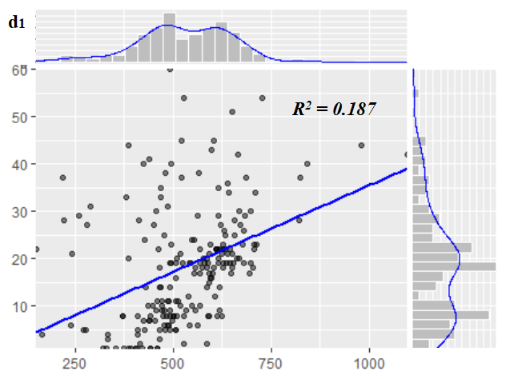
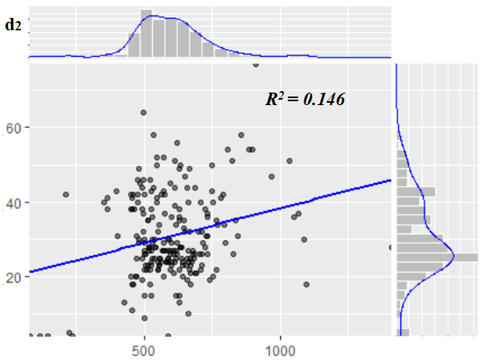
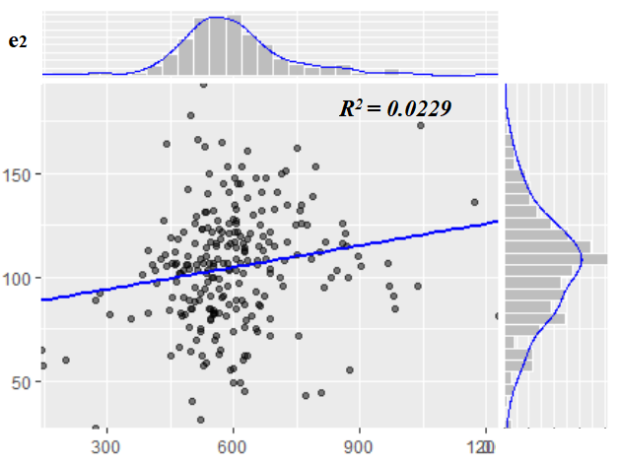
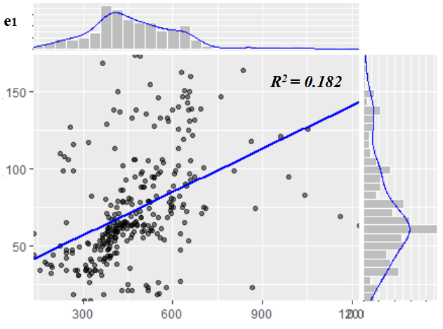
Figure S2: Relationship between monoculture productivity of (1) coniferous and (2) broadleaved, and (a) overall biodiversity, (b) mammals, (c) birds, (d) herptiles and (e) butterflies

S3 Spatial congruence for 10% and 5% quantiles
Spatial congruence was much more visible at the 30% quantile threshold, but shows similar patterns at 10% and 5% thresholds.
10% | 5%
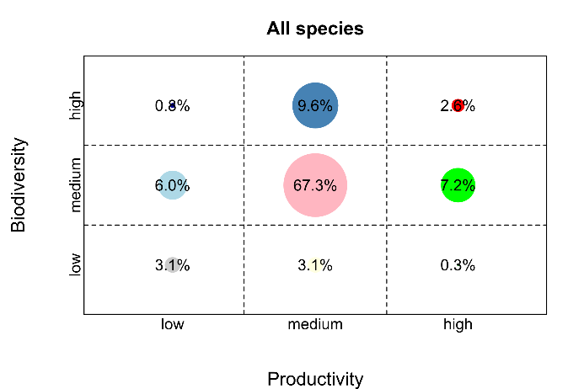 | 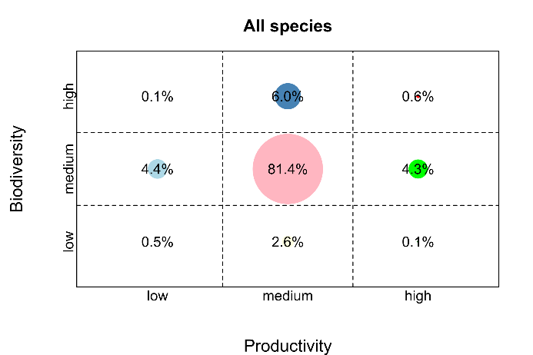
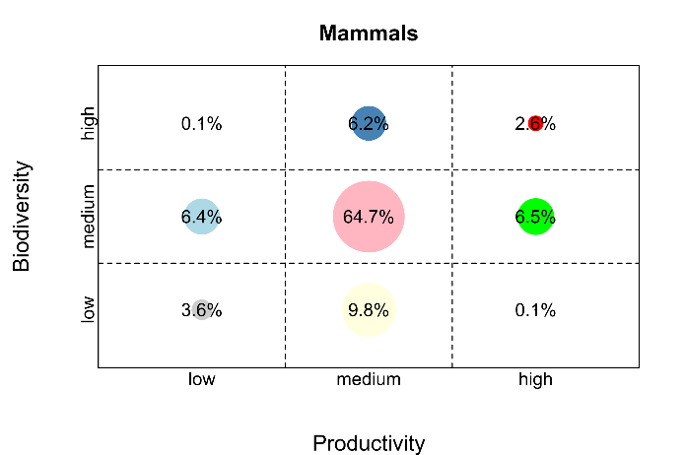 | 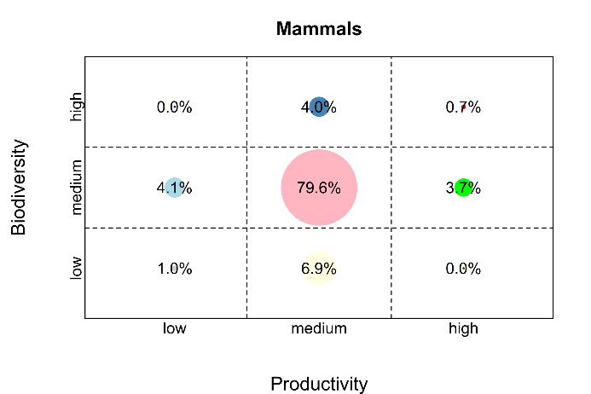
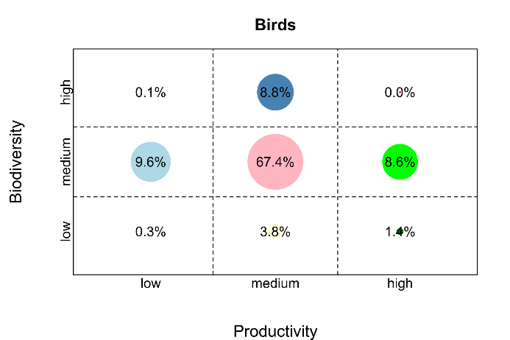 | 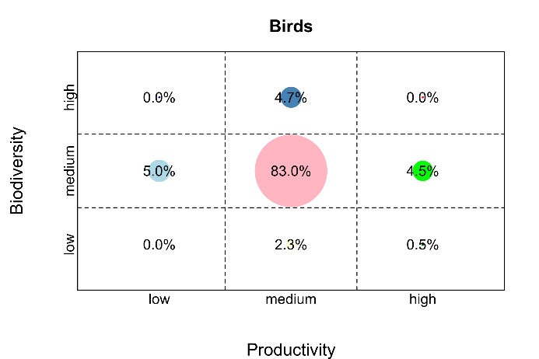
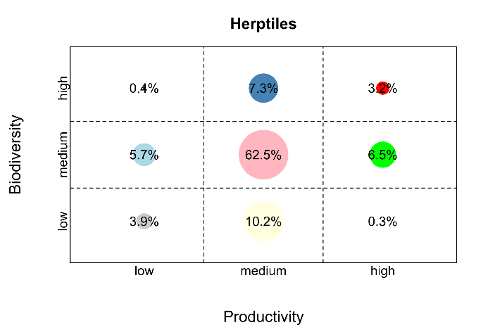 | 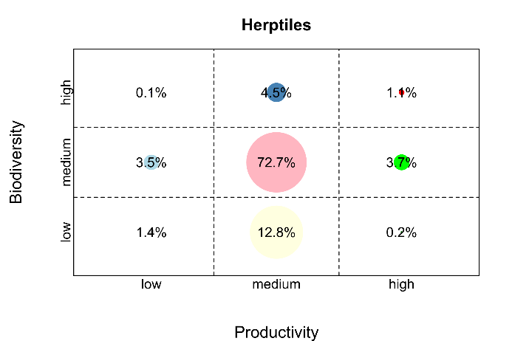
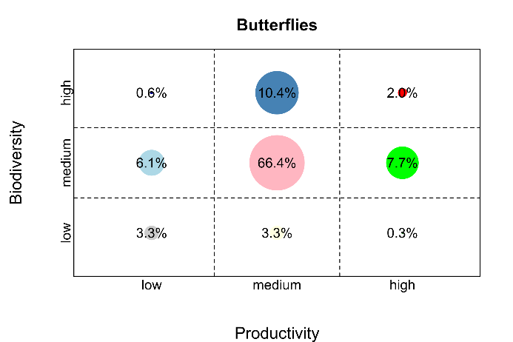 | 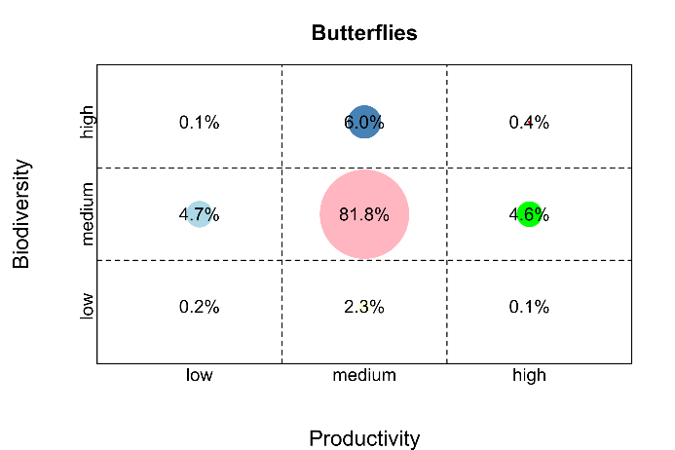
Figure S 1: Bubble charts of spatial congruence between productivity and overall biodiversity and diversity of mammals, birds, herptiles and butterflies at 10% and 5% threshold values. Because the middle dot would occupy most space, the relative size has been 5-fold reduced, to enhance the relative differences between the remaining bubbles.

