Supplementary material
Table S1: Fuzzy Silhouette index for different minimum frequencies of species occurrence in the different cluster solutions.
No. of infauna cluster | Minimum frequency of occurrence (%) of species considered in analysis
No. of infauna cluster | 1 | 5 | 10 | 15
2 | 0.2746 | 0.2937 | 0.3151 | 0.3329
3 | 0.2453 | 0.2410 | 0.2341 | 0.2069
4 | 0.1825 | 0.1885 | 0.1953 | 0.2361
5 | 0.1803 | 0.1982 | 0.1810 | 0.2707

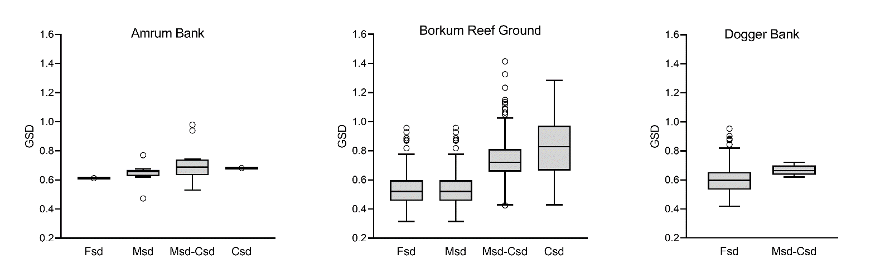
Figure S1: Graphical standard deviation (GSD) of the sand types of the three sandbanks in the German EEZ of the North Sea: fine sand (Fsd), medium sand (Msd), medium to coarse sand (Msd-Csd) and coarse sand (Csd).

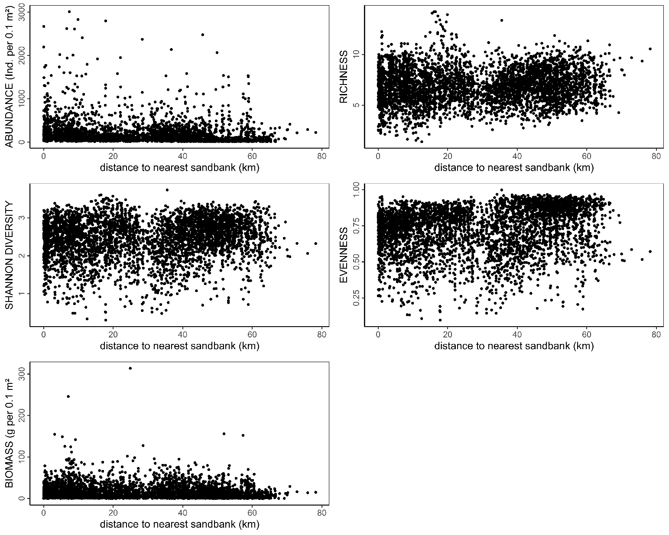
Figure S2: The calculated univariate parameters (total abundance, species richness, Shannon diversity, Pielou's evenness, and total biomass per sample) as a function of distance from sandbanks for each station of this study.

