Supplementary material
Hanzelka J, Baroni D, Martikainen P, Eeva T, Laaksonen T (2023) Cavity-breeding birds create specific microhabitats for diverse arthropod communities in boreal forests. Biodivers Conserv. https://doi.org/10.1007/s10531-023-02653-4

DNA metabarcoding procedure
The DNA taxonomic identification of arthropods, including DNA extraction and bioinformatics, was conducted by Bioname Oy, Turku, Finland.

1. Samples
For DNA metabarcoding we prepared arthropod samples from the nest types (nest numbers: One-season = 15, Accum = 14, PO hoard = 7, PO nest = 7, PO nest old = 10, Small-GT = 4, Small-PF = 5). We separated all the arthropod individuals by hand from each nest and combined them as a sample of arthropods for a given nest. The samples were stored in ethanol in 50 ml tubes.

2. DNA extraction
A clean piece of 300 µm mesh was set on top of the tube, and ethanol was slowly drained into a sterile tube, exactly for 35 min, or until the time interval between drops was at least 20 sec. The average wet weight of the samples was 3.08 ± 2.73 g.
A negative extraction control sample was added into each extraction batch to measure the purity of reagents and the level of cross-contamination.
DNA lysis buffer was added to the samples and incubated for exactly 2 hours 45 minutes. The short incubation time decreases bias between large and small individuals, as well as hard- and soft-bodied animals.
The DNA lysate was purified using magnetic solution, and the clean DNA was eluted to 100 µL of RNAse and DNAse free water.
DNA purity and integrity were assessed by PCR success rate.

3. PCR
The cytochrome oxidase subunit I (COI) gene fragment was amplified using a universal primer pair (Table S1). All the primers included a linker-tag, to enable the subsequent attachment of NGS adapters.
To increase the amplicon library diversity, each primer was used as four different versions, so that they included so called heterogeneity spacers between the linker-tag and the actual locus-specific oligonucleotide.
A blank PCR control was added to each PCR batch to measure the purity of reagents and the level of cross-contamination.
A mock community sample was added to the analysis to test the amplification bias and sensitivity of the methods. The mock sample included an equal amount of DNA from seven exotic insect species (from orders Blattodea, Coleoptera, Hymenoptera, and Orthoptera) originating from several continents outside Europe.
All PCR reactions were carried out as two technical replicates, and each replicate contained two heterogeneity versions of each primer.
The reaction setup followed Kankaanpää et al. (2020) and included 5 µL of 2× MyTaq HS Red Mix (Bioline, UK), 2.4 µL of H₂O, 150 nM of each primer (two forward and two reverse primer versions), and 2 µL of DNA extract per each sample in 10 µL volume.
Cycling conditions were 5 min in 95°C, then 34 cycles of 30 sec in 95°C, 30 sec in 48°C and 30 sec in 72°C, ending with 10 min in 72°C.

4. NGS library preparation
Library preparation followed Vesterinen et al. (2016) with minor modifications as follows.
We used a dual indexing strategy, where each reaction (including technical replicates) was prepared with a unique combination of forward and reverse indices.
For a reaction volume of 10 µL, we mixed 5 µL of MyTaq HS RedMix, 500 nM of each tagged and indexed primer (i7 and i5) and 3 µL of locus‐specific PCR product from the first PCR phase.
For library preparation PCR, we used the following protocol: initial denaturation for 3 min at 98°C, then 15 cycles of 20 sec at 95°C, 15 sec at 60°C and 30 sec at 72°C, followed by 3 min at 72°C.
All the indexed reactions were then pooled and purified using magnetic beads (Vesterinen et al., 2018).
Sequencing was done on an Illumina MiSeq v3 PE 2x300 (Illumina Inc., San Diego, California, USA) run together with other libraries, including PhiX control library by the Turku Centre for Biotechnology, Turku, Finland.

5. Bioinformatics
The reads were demultiplexed into samples and then trimmed as follows.
The primers were removed using software CUTADAPT (Martin, 2011) with 20% rate for primer mismatches and 100 bp minimum length.
Trimmed amplicons were analysed and denoised using DADA2 pipeline (Callahan et al., 2016) with truncation lengths 250 and 220 for R1 and R2 reads, and maxee error 1.
To maximise the taxonomic coverage, the resulting amplicon sequence variants (ASV) were assigned to taxa using a custom database with SINTAX (Edgar, 2010) in VSEARCH (Rognes et al., 2016) and BOLD (Ratnasingham & Hebert, 2007) identification engine with a powerful custom script (Vesterinen et al., 2020). One of our databases was constructed for this purpose by downloading all the public sequences from BOLD, adding sequences from our own mock community, and then building the database files. Another database was downloaded from MIDORI server (Leray et al., 2018). Thirdly, mainly to assign otherwise non-assigned sequence variants, we applied GenBank BLAST (Altschul et al., 1990; Benson, 2004).
The negative extraction controls and PCR blanks had very few or no reads, indicating low or zero level of cross-contamination.
Six out of seven (86%) mock species were found in the data, and only in the correct mock samples and not in other samples, referring to near zero tag-jumping rate. The missing taxa was a parasitoid wasp species, and the primers might not amplify this group of hymenopterans as well as others (five other species in the order Hymenoptera was observed in the data).
Then, reads were filtered for non-target taxa (including three bird species and one rodent), and low abundance ASV’s. The taxonomic assignments were only accepted when the taxon was found in both technical replicates.

Parameters of cavity and nest types
We compared the cavity and nest volumes among different nest types using Kruskal-Wallis test. Dunn’s post hoc test showed differences between particular cavity and nest type groups (Fig. S2a,b), calculated by function ‘dunnTest’ in package ‘FSA’ (Ogle et al., 2022), while applying Benjamini-Hochberg adjustment of p-values.

The excavated cavities and nest boxes differed in their volume (Kruskal-Wallis test: χ² = 52.9, df = 8, p < 0.001, Fig. S2a). The small nest boxes (median = 2.4 L) had a smaller cavity volume than medium-sized nest boxes and excavated cavities (median = 4.75–6.80 L), with an exception of pine cavities (median = 3.85 L) having also relatively small volume. The volume of nests built within the cavities/nest boxes also varied (Kruskal-Wallis test: χ² = 62.3, df = 8, p < 0.001; Fig. S2b). Nest volumes reflected the cavity volumes and nests in small nest boxes (median = 0.7–1.1 L) were smaller than the other nests types (median = 3–5 L) except compared to the nests in pine cavities (median = 1.85 L) and PO-nests (median = 1.4 L). Nest materials varied among the species and nest types (Fig. S2c).

(B)
(A)
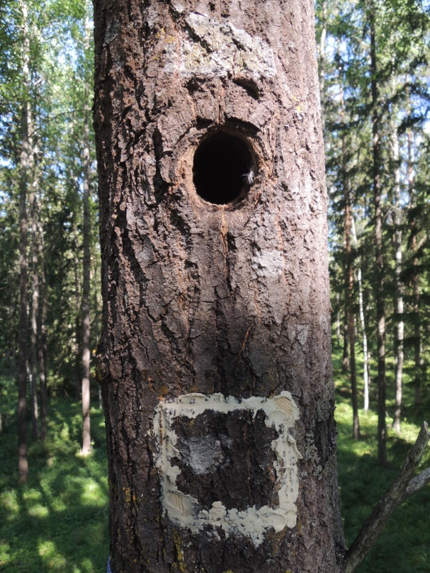
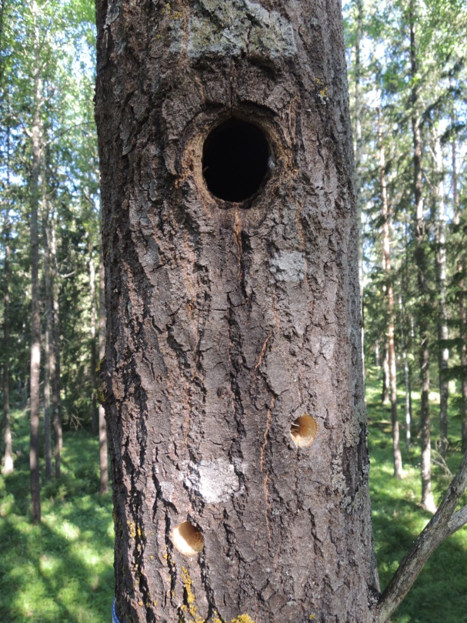
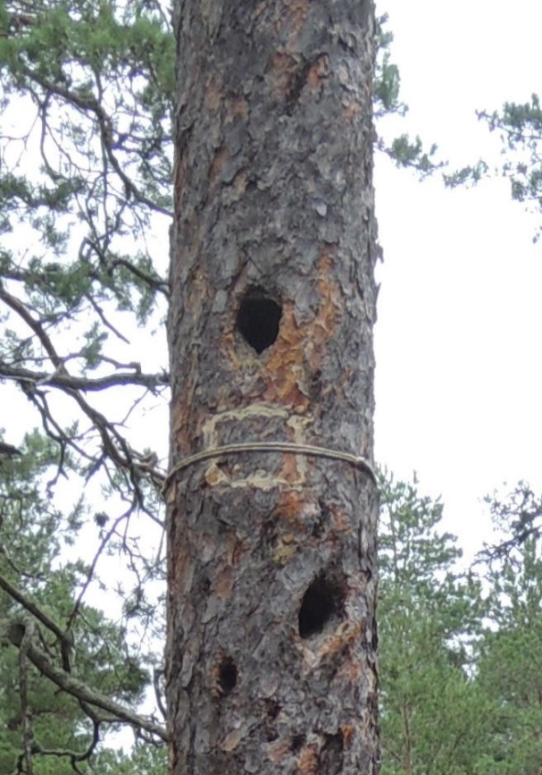
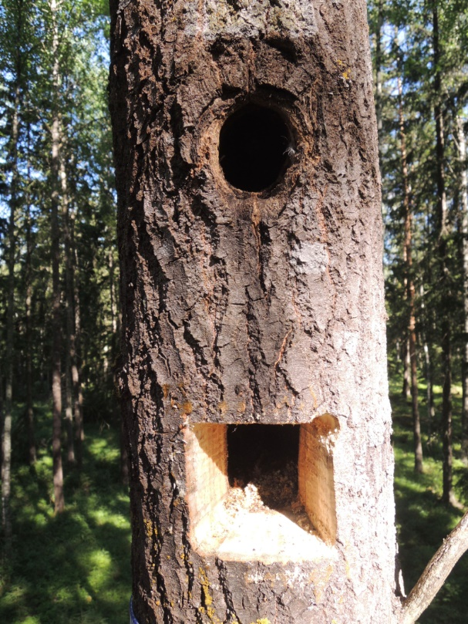

(D)
(C)

Fig. S1 The process of extraction of a nest from an excavated cavity. (A) Two 20 mm holes were drilled below the cavity entrance, (B) a wooden block was cut out, (C) after a nest had been extracted, the window was fastened back together with two wooden sticks filling the drilled holes, and all the joints were filled with linseed oil putty, (D) a hemp rope was tied around the tree trunk to keep the wooden block in the position.
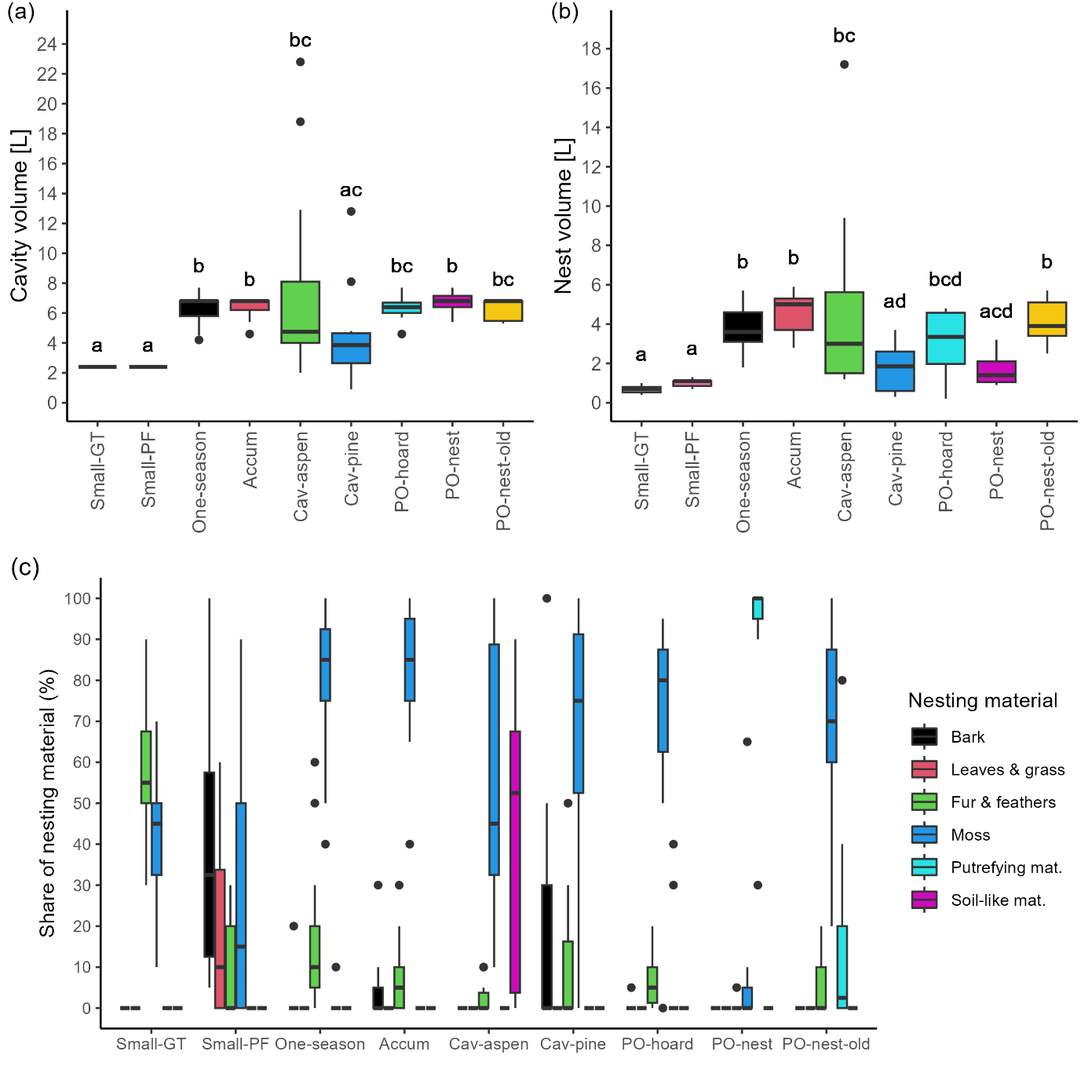 Fig. S2 Volume of (a) cavities and (b) nests according to the nest types, and (c) share of the types of nesting material in particular nest types. Different letters indicate significant differences in the cavity and nest volumes between the nest types. Small-GT = nests of great tit in small nest boxes, Small-PF = nests of pied flycatcher in small nest boxes, One-season = nests of great tit built in the current breeding season, Accum = accumulated nests of great tit, Cav-aspen = accumulated nests of great and blue tit in common aspen, Cav-pine = accumulated nests of great tit and pied flycatcher in Scots pine, PO-hoard = nests containing old food hoards accumulated by pygmy owl, with fresh or accumulated great tit nests, PO-nest = nests of pygmy owl, built in the current breeding season, PO-nest-old = one to three years old nests of pygmy owl, with fresh or accumulated great tit nests on top.
Table S1 Primers used in the DNA metabarcoding analysis.
Name | Target | Gene | Oligonucleotide | Reference
BF3 | Arthropoda | COI | CCHGAYATRGCHTTYCCHCG | Elbrecht et al. (2019)
BR2 | Animal | COI | TCDGGRTGNCCRAARAAYCA | Elbrecht et al. (2019)

Table S2 Scores of the arthropod taxa on the first two axes derived from constrained correspondence analyses (CCA) on arthropod communities occupying nests in (a) different cavity types (two types: medium-sized nest boxes and excavated tree cavities), (b) different nest types in medium-sized nest boxes and excavated cavities (seven nest types: One-season = nests of great tit built in the current breeding season, Accum = accumulated nests of great tit, PO-hoard = nests containing old food hoards accumulated by pygmy owl, with fresh or accumulated great tit nests, PO-nest = nests of pygmy owl, built in the current breeding season, PO-nest-old = one to three years old nests of pygmy owl, with fresh or accumulated great tit nests on top, Cav-pine = accumulated nests of great tit and pied flycatcher in Scots pine, Cav-aspen = accumulated nests of great and blue tit in common aspen), and (c) in small nest boxes (two nest types: Small-GT = nests of great tit in small nest boxes, Small-PF = nests of pied flycatcher in small nest boxes). Note that in (a) the second axis in the CCA is unconstrained (CA1) by design because the cavity type has only two levels.
(a)
Abbreviation | Taxon | CCA1 | CA1
Flea | Ceratophyllus sp. | 0.4152 | 0.7767
Raph | Raphidiidae larvae | 0.5587 | 0.6278
Pseudosc | Pseudoscorpiones | 2.1656 | 0.2002
Julida | Julida | -0.6966 | -0.0747
Litho | Lithobiomorpha | 0.8740 | 0.2572
Lumbr | Lumbricinae | -0.6902 | -0.6537
Tin | Tineidae pupae + larvae | -0.0959 | 0.3275
Lep | other Lepidoptera pupae | -0.0042 | 1.0836
Proto | Protocalliphora sp. pupae | 0.0885 | 0.4816
Fann | Fanniidae pupae | 0.1056 | -0.8397
Dipt_pup | other Diptera fly pupae | -0.1919 | -0.2045
Dipt_lar | Diptera fly larvae | -0.5121 | -0.8889
OrnChl | Ornithomya chloropus pupae | -0.2117 | 0.1044
OrnAvi | Ornithomya avicularia pupae | -0.5167 | 0.1056
Tipul | Tipulidae larvae | -1.2627 | 0.1167
Syrph | Syrphidae pupae | -0.7550 | 0.3407
CamHer | Camponotus herculeanus | 0.0481 | 0.0215
Form | other Formicidae | 0.6260 | 0.4834
Myrm | Myrmicinae | -0.0123 | 1.3445
Ichneu | Ichneumonidae | 0.2823 | 0.1642
DolSax | Dolichovespula saxonica | 0.4985 | 0.7725
AlpDia | Alphitobius diaperinus | -0.8864 | -0.5633
AthHar | Atheta harwoodi | -0.2646 | -2.3684
AthVag | Atheta vaga | -0.1477 | -0.7971
AtoMor | Atomaria morio | 2.1656 | 0.2002
BisPar | Bisnius parcus | -0.2513 | -1.9542
BisSub | Bisnius subuliformis | -0.7371 | -0.7212
CarPum | Carcinops pumilio | -0.1944 | -1.8187
CatTri | Catops tristis | 0.0040 | 0.5186
CryBad | Cryptophagus badius | 0.5301 | 0.6537
CryLap | Cryptophagus lapponicus | -0.0531 | 1.0481
CryScu | Cryptophagus scutellatus | -0.0531 | 1.0481
DenCor | Dendrophilus corticalis | -0.4833 | -0.7696
DerLar | Dermestes lardarius | 0.2677 | -3.1345
DerMur | Dermestes murinus | 0.3197 | -0.6352
GnaBuy | Gnathoncus buyssoni | 0.2486 | -0.0095
GnaCom | Gnathoncus communis | -0.0972 | -0.9918
GnaNan | Gnathoncus nannetensis | 0.0993 | -1.0011
GnaNid | Gnathoncus nidorum | -0.2646 | -2.3684
GnaRot | Gnathoncus rotundatus | -0.2565 | -2.1262
HapVil | Haploglossa villosula adults | 0.6728 | 0.8173
Hapl_pup | Haploglossa villosula pupae | 2.1493 | 0.2963
MarMer | Margarinotus merdarius | -0.3079 | -1.4051
MarStr | Margarinotus striola | -0.2565 | -1.1504
NicVes | Nicrophorus vespilloides | 0.1259 | 1.0686
PhiSuc | Philonthus succicola | -0.2483 | -1.8839
QueBre | Quedius brevicornis | -0.7686 | -0.1988
QueMes | Quedius mesomelinus | -0.2334 | -1.3571
QueMic | Quedius microps | -1.1879 | -0.4295
QueSci | Quedius scitus | -0.0449 | 0.7190
QueXan | Quedius xanthopus | -1.2612 | 0.4833
RhyAte | Rhyncolus ater | 1.0278 | 0.3000
SciAlp | Sciodrepoides alpestris | -0.2450 | -1.5526
SciFum | Sciodrepoides fumatus | -0.1956 | -1.0488
SepTes | Sepedophilus testaceus | 2.1656 | 0.2002
TroSca | Trox scaber | -0.4667 | -0.8130
Hist_ad | Histeridae (undet.) | 0.2051 | 0.2604
Staph | Staphylinidae (undet.) | 0.3470 | -0.5673
Elat | Elateridae larvae | -1.4998 | -0.0137
Hist_lar | Histeridae larvae | 0.5541 | 0.1540
Scarab_lar | Scarabaeoidea larvae | -0.4684 | -0.0811
Teneb | Tenebrionidae larvae | -0.6391 | -1.0884
Col_lar | Coleoptera larvae (undet.) | 0.4733 | 0.2909
Col_pup | Coleoptera pupae (undet.) | -0.3634 | 0.1391

(b)
Abbreviation | Taxon | CCA1 | CCA2
Flea | Ceratophyllus sp. | 0.8440 | -0.0462
Raph | Raphidiidae larvae | 0.7294 | -0.1279
Pseudosc | Pseudoscorpiones | 1.5401 | -1.7855
Julida | Julida | -0.4010 | 0.8991
Litho | Lithobiomorpha | 0.7506 | -0.5808
Lumbr | Lumbricinae | -0.8796 | 0.2673
Tin | Tineidae pupae + larvae | 0.1745 | 0.1031
Lep | other Lepidoptera pupae | 0.8686 | 0.1375
Proto | Protocalliphora sp. pupae | 0.3899 | 0.2578
Fann | Fanniidae pupae | -0.4774 | -0.3447
Dipt_pup | other Diptera fly pupae | -0.2754 | 0.1788
Dipt_lar | Diptera fly larvae | -1.2633 | -0.3987
OrnChl | Ornithomya chloropus pupae | -0.1252 | 0.3224
OrnAvi | Ornithomya avicularia pupae | -0.1371 | 0.5600
Tipul | Tipulidae larvae | -0.6616 | 1.5982
Syrph | Syrphidae pupae | -0.3878 | 0.9625
CamHer | Camponotus herculeanus | -0.4145 | 0.2033
Form | other Formicidae | 0.7267 | -0.5555
Myrm | Myrmicinae | 0.6517 | -0.3481
Ichneu | Ichneumonidae | 0.6388 | -0.3194
DolSax | Dolichovespula saxonica | 0.9597 | 0.1608
AlpDia | Alphitobius diaperinus | -0.7279 | -0.0382
AthHar | Atheta harwoodi | -1.7061 | -0.8688
AthVag | Atheta vaga | -0.4841 | -0.1397
AtoMor | Atomaria morio | 1.5401 | -1.7855
BisPar | Bisnius parcus | -1.7100 | -0.8991
BisSub | Bisnius subuliformis | -0.9958 | 0.1574
CarPum | Carcinops pumilio | -1.7266 | -1.0287
CatTri | Catops tristis | 0.1998 | 0.6913
CryBad | Cryptophagus badius | 0.5508 | -0.5693
CryLap | Cryptophagus lapponicus | 1.3257 | 0.2147
CryScu | Cryptophagus scutellatus | 1.3257 | 0.2147
DenCor | Dendrophilus corticalis | -0.7105 | -0.3291
DerLar | Dermestes lardarius | -0.1107 | -0.1012
DerMur | Dermestes murinus | -0.1814 | -0.9461
GnaBuy | Gnathoncus buyssoni | 0.0867 | -0.2724
GnaCom | Gnathoncus communis | -0.8793 | -0.5417
GnaNan | Gnathoncus nannetensis | -0.8834 | -0.6102
GnaNid | Gnathoncus nidorum | -1.7061 | -0.8688
GnaRot | Gnathoncus rotundatus | -1.7085 | -0.8873
HapVil | Haploglossa villosula adults | 1.1921 | -0.3568
Hapl_pup | Haploglossa villosula pupae | 1.5449 | -1.7485
MarMer | Margarinotus merdarius | -1.6295 | -0.7549
MarStr | Margarinotus striola | -1.7085 | -0.8873
NicVes | Nicrophorus vespilloides | 0.8263 | 0.8834
PhiSuc | Philonthus succicola | -1.7109 | -0.9059
QueBre | Quedius brevicornis | -0.6512 | 0.7079
QueMes | Quedius mesomelinus | -1.7153 | -0.9400
QueMic | Quedius microps | -0.7344 | 1.4013
QueSci | Quedius scitus | 1.3233 | 0.1961
QueXan | Quedius xanthopus | -0.7131 | 1.5681
RhyAte | Rhyncolus ater | 0.4603 | -0.4251
SciAlp | Sciodrepoides alpestris | -1.7119 | -0.9136
SciFum | Sciodrepoides fumatus | -1.0105 | -0.6638
SepTes | Sepedophilus testaceus | 1.5401 | -1.7855
TroSca | Trox scaber | -0.9193 | -0.1277
Hist_ad | Histeridae (undet.) | 0.4468 | -0.1019
Staph | Staphylinidae (undet.) | -0.8181 | -0.5462
Elat | Elateridae larvae | -0.6435 | 2.1117
Hist_lar | Histeridae larvae | 0.2987 | -0.3085
Scarab_lar | Scarabaeoidea larvae | -0.5552 | 0.8535
Teneb | Tenebrionidae larvae | -0.6629 | -0.3210
Col_lar | Coleoptera larvae (undet.) | 0.4889 | -0.2368
Col_pup | Coleoptera pupae (undet.) | -0.1079 | 0.6608

(c)
Abbreviation | Taxon | CCA1 | CA1
Flea | Ceratophyllus sp. | -0.4806 | -0.3763
Raph | Raphidiidae larvae | 1.4797 | -0.2799
Tin | Tineidae pupae + larvae | -0.1514 | -0.3243
Lep | other Lepidoptera pupae | -0.3252 | 5.9027
Proto | Protocalliphora sp. pupae | 0.0275 | -0.2363
Dipt_lar | Diptera fly larvae | -1.0649 | -0.0746
OrnChl | Ornithomya chloropus pupae | 0.4539 | 0.1633
OrnAvi | Ornithomya avicularia pupae | 0.3858 | -0.4679
Form | other Formicidae | 1.4797 | 0.7884
Ichneu | Ichneumonidae | 1.8495 | 1.7198
DerMur | Dermestes murinus | -1.0649 | -0.0746
GnaBuy | Gnathoncus buyssoni | -0.1277 | 0.0652
Hist_ad | Histeridae (undet.) | 0.0634 | 3.0744
Hist_lar | Histeridae larvae | 0.0844 | -0.2501

Table S3 The results of ANOVA permutation tests for constrained correspondence analyses (CCA) on arthropod communities associated with (a) different cavity types (two types: medium-sized nest boxes and excavated tree cavities), (b) different nest types in medium-sized nest boxes and excavated cavities (seven nest types: One-season = nests of great tit built in the current breeding season, Accum = accumulated nests of great tit, PO-hoard = nests containing old food hoards accumulated by pygmy owl, with fresh or accumulated great tit nests, PO-nest = nests of pygmy owl, built in the current breeding season, PO-nest-old = one to three years old nests of pygmy owl, with fresh or accumulated great tit nests on top, Cav-pine = accumulated nests of great tit and pied flycatcher in Scots pine, Cav-aspen = accumulated nests of great and blue tit in common aspen), (c) nests in small nest boxes (two nest types: Small-GT = nests of great tit in small nest boxes, Small-PF = nests of pied flycatcher in small nest boxes), (d) types of nesting material in medium-sized nest boxes and excavated cavities, and (e) types of nesting material in small nest boxes. χ² = inertia related to respective constrained axes, Pseudo-F = ratio of constrained (χ²) and unconstrained total inertia (χ² residuals) divided by the rank (Df for residuals). The tests were defined by 999 permutations.

(a)
Axis | Df | χ² | Pseudo-F | p
CCA1 | 1 | 0.2 | 3.1 | 0.001
Residuals | 86 | 5.0

(b)
Axis | Df | χ² | Pseudo-F | p
CCA1 | 1 | 0.4 | 7.4 | 0.001
CCA2 | 1 | 0.2 | 3.0 | 0.001
CCA3 | 1 | 0.1 | 2.5 | 0.006
CCA4 | 1 | 0.1 | 1.3 | 0.505
CCA5 | 1 | 0.1 | 1.0 | 0.821
CCA6 | 1 | 0.0 | 0.6 | 0.984
Residuals | 81 | 4.3

(c)
Axis | Df | χ² | Pseudo-F | p
CCA1 | 1 | 0.2 | 1.2 | 0.251
Residuals | 14 | 2.5

(d)
Axis | Df | χ² | Pseudo-F | p
CCA1 | 1 | 0.1 | 2.6 | 0.092
CCA2 | 1 | 0.1 | 1.8 | 0.220
CCA3 | 1 | 0.1 | 1.3 | 0.635
CCA4 | 1 | 0.1 | 1.0 | 0.777
CCA5 | 1 | 0.0 | 0.4 | 0.986
Residuals | 77 | 4.1

(e)
Axis | Df | χ² | Pseudo-F | p
CCA1 | 1 | 0.3 | 1.4 | 0.781
CCA2 | 1 | 0.1 | 0.7 | 0.965
CCA3 | 1 | 0.1 | 0.6 | 0.957
CCA4 | 1 | 0.0 | 0.3 | 0.950
Residuals | 11 | 2.1

Table S4 Associations between arthropod taxa and (a) different cavity types (two types: medium-sized nest boxes and excavated tree cavities) and (b) different nest types (seven nest types for medium-sized nest boxes and excavated tree cavities: One-season = nests of great tit built in the current breeding season, Accum = accumulated nests of great tit, PO-hoard = nests containing old food hoards accumulated by pygmy owl, with fresh or accumulated great tit nests, PO-nest = nests of pygmy owl, built in the current breeding season, PO-nest-old = one to three years old nests of pygmy owl, with fresh or accumulated great tit nests on top, Cav-pine = accumulated nests of great tit and pied flycatcher in Scots pine, Cav-aspen = accumulated nests of great and blue tit in common aspen; and two types for small nest boxes: Small-GT = nests of great tit in small nest boxes, Small-PF = nests of pied flycatcher in small nest boxes). Separate analyses were run in the latter case, i) for nests in medium-sized nest boxes and excavated cavities, and ii) for nests in small nest boxes. Significant point-biserial coefficients (95% CI not overlapping zero) describing the associations, both positive (attraction, blue background) and negative (avoidance, pink background), are depicted. Numbers of nests for each nest type are provided.
(a)
Abbreviation | Excavated_  tree_cavities  n = 24 | Nest_boxes  n = 69 |  | Abbreviation | Excavated_  ree_cavities  n = 24 | Nest_boxes  n = 69
Proto | -0.27 | 0.27 |  | CarPum | -0.13 | 0.13
Dipt_pup | -0.14 | 0.14 |  | CatTri | -0.09 | 0.09
Lep | -0.17 | 0.17 |  | CryBad | -0.13 | 0.13
Tin | -0.15 | 0.15 |  | CryLap | -0.09 | 0.09
Fann | -0.16 | 0.16 |  | CryScu | -0.09 | 0.09
OrnChl | 0.16 | -0.16 |  | DenCor | 0.27 | -0.27
OrnAvi | 0.27 | -0.27 |  | DerMur | -0.09 | 0.09
Flea | -0.22 | 0.22 |  | GnaBuy | -0.30 | 0.30
Hist_lar | -0.25 | 0.25 |  | GnaCom | -0.13 | 0.13
Dipt_lar | 0.08 | -0.08 |  | GnaNan | -0.28 | 0.28
Raph | -0.34 | 0.34 |  | GnaNid | -0.09 | 0.09
Litho | -0.04 | 0.04 |  | GnaRot | -0.12 | 0.12
CamHer | -0.14 | 0.14 |  | HapVil | -0.12 | 0.12
Form | -0.25 | 0.25 |  | Col_lar | -0.04 | 0.04
Myrm | -0.09 | 0.09 |  | MarMer | -0.14 | 0.14
Ichneu | -0.14 | 0.14 |  | MarStr | -0.09 | 0.09
Staph | -0.20 | 0.20 |  | NicVes | -0.09 | 0.09
Der_lar | -0.12 | 0.12 |  | PhiSuc | -0.09 | 0.09
DolSax | -0.09 | 0.09 |  | Col_pup | 0.22 | -0.22
Elat | 0.19 | -0.19 |  | Hapl_pup | -0.09 | 0.09
Tipul | 0.25 | -0.25 |  | QueBre | 0.32 | -0.32
Syrph | 0.20 | -0.20 |  | QueMes | -0.12 | 0.12
Pseudosc | -0.09 | 0.09 |  | QueMic | 0.15 | -0.15
Julida | 0.25 | -0.25 |  | QueSci | -0.09 | 0.09
Teneb | 0.17 | -0.17 |  | QueXan | 0.15 | -0.15
Lumbr | 0.16 | -0.16 |  | RhyAte | -0.12 | 0.12
AlpDia | 0.30 | -0.30 |  | SciAlp | -0.11 | 0.11
AthHar | -0.09 | 0.09 |  | SciFum | -0.12 | 0.12
AthVag | -0.12 | 0.12 |  | SepTes | -0.09 | 0.09
AtoMor | -0.09 | 0.09 |  | TroSca | 0.03 | -0.03
BisPar | -0.13 | 0.13 |  | Hist_ad | 0.03 | -0.03
BisSub | 0.22 | -0.22 |  | Scarab_lar | 0.18 | -0.18

(b)
Abbreviation | One-season  n = 27 | Accum  n = 15 | Cav-aspen  n = 14 | Cav-pine  n = 10 | PO-hoard  n = 10 | PO-nest  n = 7 | PO-nest-old  n = 10 |  | Small-GT  n = 10 | Small-PF  n = 10
Proto | -0.08 | 0.60 | -0.11 | -0.16 | -0.04 | -0.15 | -0.05 |  | 0.10 | -0.10
Dipt_pup | -0.19 | -0.19 | -0.09 | -0.15 | 0.37 | 0.19 | 0.06 |  | 0.23 | -0.23
Lep | 0.22 | 0.12 | -0.07 | -0.07 | -0.07 | -0.07 | -0.07 |  | 0.23 | -0.23
Tin | -0.11 | 0.09 | -0.12 | -0.05 | 0.37 | -0.13 | -0.05 |  | 0.18 | -0.18
Fann | -0.10 | -0.02 | -0.10 | -0.09 | -0.07 | 0.36 | 0.01 |  | NA | NA
OrnChl | -0.13 | -0.02 | 0.21 | -0.01 | 0.12 | -0.14 | -0.03 |  | -0.26 | 0.26
OrnAvi | -0.15 | 0.08 | 0.20 | 0.17 | -0.12 | -0.06 | -0.12 |  | 0.20 | -0.20
Flea | 0.33 | 0.09 | -0.09 | -0.09 | -0.07 | -0.10 | -0.06 |  | 0.34 | -0.34
Hist_lar | 0.03 | -0.05 | -0.10 | -0.19 | 0.08 | 0.00 | 0.22 |  | 0.02 | -0.02
Dipt_lar | -0.13 | -0.13 | 0.06 | -0.10 | -0.13 | 0.54 | -0.13 |  | NA | NA
Raph | 0.21 | -0.03 | -0.18 | -0.14 | 0.36 | -0.18 | -0.04 |  | -0.41 | 0.41
Litho | 0.12 | 0.15 | 0.07 | -0.09 | -0.09 | -0.09 | -0.09 |  | NA | NA
CamHer | -0.09 | -0.04 | -0.09 | -0.09 | 0.21 | 0.17 | -0.09 |  | NA | NA
Form | 0.30 | -0.09 | -0.13 | -0.07 | -0.07 | -0.13 | 0.20 |  | -0.41 | 0.41
Myrm | 0.18 | -0.03 | -0.03 | -0.03 | -0.03 | -0.03 | -0.03 |  | NA | NA
Ichneu | 0.16 | -0.01 | -0.12 | 0.03 | -0.12 | -0.12 | 0.18 |  | -0.28 | 0.28
Staph | -0.13 | -0.06 | -0.13 | -0.13 | 0.06 | 0.41 | -0.03 |  | NA | NA
Der_lar | -0.07 | -0.07 | -0.07 | -0.07 | 0.08 | -0.04 | 0.24 |  | NA | NA
DolSax | -0.04 | 0.25 | -0.04 | -0.04 | -0.04 | -0.04 | -0.04 |  | NA | NA
Elat | -0.05 | -0.05 | 0.32 | -0.05 | -0.05 | -0.05 | -0.05 |  | NA | NA
Tipul | -0.07 | -0.07 | 0.43 | -0.07 | -0.07 | -0.07 | -0.07 |  | NA | NA
Syrph | -0.05 | -0.06 | 0.34 | -0.06 | -0.06 | -0.06 | -0.06 |  | NA | NA
Pseudosc | 0.18 | -0.03 | -0.03 | -0.03 | -0.03 | -0.03 | -0.03 |  | NA | NA
Julida | -0.06 | -0.07 | 0.43 | -0.07 | -0.07 | -0.07 | -0.07 |  | NA | NA
Teneb | -0.05 | -0.05 | 0.27 | -0.02 | -0.05 | -0.05 | -0.05 |  | NA | NA
Lumbr | -0.05 | -0.05 | 0.28 | -0.05 | -0.05 | -0.05 | -0.05 |  | NA | NA
AlpDia | -0.11 | -0.11 | 0.15 | 0.25 | -0.11 | 0.06 | -0.11 |  | NA | NA
AthHar | -0.06 | -0.06 | -0.06 | -0.06 | -0.06 | 0.35 | -0.06 |  | NA | NA
AthVag | -0.06 | -0.05 | -0.07 | -0.07 | -0.06 | 0.39 | -0.07 |  | NA | NA
AtoMor | 0.18 | -0.03 | -0.03 | -0.03 | -0.03 | -0.03 | -0.03 |  | NA | NA
BisPar | -0.09 | -0.09 | -0.09 | -0.09 | -0.09 | 0.53 | -0.09 |  | NA | NA
BisSub | -0.09 | -0.09 | 0.33 | -0.05 | -0.09 | 0.07 | -0.09 |  | NA | NA
CarPum | -0.09 | -0.09 | -0.09 | -0.09 | -0.09 | 0.52 | -0.09 |  | NA | NA
CatTri | -0.04 | 0.25 | -0.04 | -0.04 | -0.04 | -0.04 | -0.04 |  | NA | NA
CryBad | 0.02 | -0.06 | -0.06 | -0.06 | -0.06 | -0.06 | 0.27 |  | NA | NA
CryLap | 0.18 | -0.03 | -0.03 | -0.03 | -0.03 | -0.03 | -0.03 |  | NA | NA
CryScu | 0.18 | -0.03 | -0.03 | -0.03 | -0.03 | -0.03 | -0.03 |  | NA | NA
DenCor | -0.10 | -0.10 | 0.27 | 0.12 | -0.07 | -0.02 | -0.10 |  | NA | NA
DerMur | -0.05 | -0.05 | -0.05 | -0.05 | -0.05 | -0.05 | 0.29 |  | 0.23 | -0.23
GnaBuy | -0.03 | -0.14 | -0.18 | -0.17 | 0.08 | 0.46 | -0.02 |  | 0.24 | -0.24
GnaCom | -0.18 | -0.18 | -0.18 | -0.05 | 0.01 | 0.55 | 0.02 |  | NA | NA
GnaNan | -0.16 | -0.18 | -0.18 | -0.18 | 0.04 | 0.77 | -0.10 |  | NA | NA
GnaNid | -0.06 | -0.06 | -0.06 | -0.06 | -0.06 | 0.35 | -0.06 |  | NA | NA
GnaRot | -0.08 | -0.08 | -0.08 | -0.08 | -0.08 | 0.51 | -0.08 |  | NA | NA
HapVil | 0.24 | -0.02 | -0.04 | -0.05 | -0.05 | -0.05 | -0.05 |  | NA | NA
Col_lar | 0.19 | -0.05 | 0.04 | -0.05 | -0.05 | -0.05 | -0.05 |  | NA | NA
MarMer | -0.13 | -0.13 | -0.10 | -0.13 | -0.13 | 0.74 | -0.13 |  | NA | NA
MarStr | -0.06 | -0.06 | -0.06 | -0.06 | -0.06 | 0.35 | -0.06 |  | NA | NA
NicVes | -0.04 | 0.25 | -0.04 | -0.04 | -0.04 | -0.04 | -0.04 |  | NA | NA
PhiSuc | -0.06 | -0.06 | -0.06 | -0.06 | -0.06 | 0.35 | -0.06 |  | NA | NA
Col_pup | 0.02 | -0.05 | 0.41 | -0.09 | -0.09 | -0.09 | -0.09 |  | NA | NA
Hapl_pup | 0.18 | -0.03 | -0.03 | -0.03 | -0.03 | -0.03 | -0.03 |  | NA | NA
QueBre | -0.11 | -0.07 | 0.54 | -0.11 | -0.11 | -0.03 | -0.11 |  | NA | NA
QueMes | -0.08 | -0.08 | -0.08 | -0.08 | -0.08 | 0.48 | -0.08 |  | NA | NA
QueMic | -0.04 | -0.04 | 0.25 | -0.04 | -0.04 | -0.04 | -0.04 |  | NA | NA
QueSci | 0.18 | -0.03 | -0.03 | -0.03 | -0.03 | -0.03 | -0.03 |  | NA | NA
QueXan | -0.04 | -0.04 | 0.25 | -0.04 | -0.04 | -0.04 | -0.04 |  | NA | NA
RhyAte | 0.05 | -0.06 | -0.06 | -0.06 | 0.24 | -0.06 | -0.06 |  | NA | NA
SciAlp | -0.08 | -0.08 | -0.08 | -0.08 | -0.08 | 0.46 | -0.08 |  | NA | NA
SciFum | -0.05 | -0.08 | -0.08 | -0.08 | -0.08 | 0.42 | -0.08 |  | NA | NA
SepTes | 0.18 | -0.03 | -0.03 | -0.03 | -0.03 | -0.03 | -0.03 |  | NA | NA
TroSca | -0.14 | -0.14 | -0.04 | -0.04 | -0.08 | 0.58 | -0.14 |  | NA | NA
Hist_ad | 0.01 | -0.08 | -0.08 | 0.15 | 0.15 | -0.08 | -0.08 |  | 0.15 | -0.15
Scarab_lar | -0.06 | -0.06 | 0.30 | -0.06 | 0.00 | -0.05 | -0.06 |  | NA | NA

References
Altschul, S. F., Gish, W., Miller, W., Myers, E. W., & Lipman, D. J. (1990). Basic local alignment search tool. Journal of Molecular Biology, 215(3), 403–410. https://doi.org/10.1016/S0022-2836(05)80360-2
Benson, D. A. (2004). GenBank. Nucleic Acids Research, 33(Database issue), D34–D38. https://doi.org/10.1093/nar/gki063
Callahan, B. J., McMurdie, P. J., Rosen, M. J., Han, A. W., Johnson, A. J. A., & Holmes, S. P. (2016). DADA2: High-resolution sample inference from Illumina amplicon data. Nature Methods, 13(7), 581–583. https://doi.org/10.1038/nmeth.3869
Edgar, R. C. (2010). Search and clustering orders of magnitude faster than BLAST. Bioinformatics, 26(19), 2460–2461. https://doi.org/10.1093/bioinformatics/btq461
Elbrecht, V., Braukmann, T. W. A., Ivanova, N. V., Prosser, S. W. J., Hajibabaei, M., Wright, M., Zakharov, E. V., Hebert, P. D. N., & Steinke, D. (2019). Validation of COI metabarcoding primers for terrestrial arthropods. PeerJ, 7, e7745. https://doi.org/10.7717/peerj.7745
Kankaanpää, T., Vesterinen, E., Hardwick, B., Schmidt, N. M., Andersson, T., Aspholm, P. E., Barrio, I. C., Beckers, N., Bêty, J., Birkemoe, T., DeSiervo, M., Drotos, K. H. I., Ehrich, D., Gilg, O., Gilg, V., Hein, N., Høye, T. T., Jakobsen, K. M., Jodouin, C., … Roslin, T. (2020). Parasitoids indicate major climate‐induced shifts in arctic communities. Global Change Biology, 26(11), 6276–6295. https://doi.org/10.1111/gcb.15297
Leray, M., Ho, S.-L., Lin, I.-J., & Machida, R. J. (2018). MIDORI server: A webserver for taxonomic assignment of unknown metazoan mitochondrial-encoded sequences using a curated database. Bioinformatics, 34(21), 3753–3754. https://doi.org/10.1093/bioinformatics/bty454
Martin, M. (2011). Cutadapt removes adapter sequences from high-throughput sequencing reads. EMBnet.Journal, 17(1), 10. https://doi.org/10.14806/ej.17.1.200
Ogle, D. H., Doll, J. C., Wheeler, P., & Dinno, A. (2022). FSA: Fisheries Stock Analysis. R package version 0.9.3, https://github.com/fishR-Core-Team/FSA.
Ratnasingham, S., & Hebert, P. D. N. (2007). BARCODING: Bold: The Barcode of Life Data System (http://www.barcodinglife.org). Molecular Ecology Notes, 7(3), 355–364. https://doi.org/10.1111/j.1471-8286.2007.01678.x
Rognes, T., Flouri, T., Nichols, B., Quince, C., & Mahé, F. (2016). VSEARCH: A versatile open source tool for metagenomics. PeerJ, 4, e2584. https://doi.org/10.7717/peerj.2584
Vesterinen, E. J., Kaunisto, K. M., & Lilley, T. M. (2020). A global class reunion with multiple groups feasting on the declining insect smorgasbord. Scientific Reports, 10(1), 16595. https://doi.org/10.1038/s41598-020-73609-9
Vesterinen, E. J., Puisto, A. I. E., Blomberg, A. S., & Lilley, T. M. (2018). Table for five, please: Dietary partitioning in boreal bats. Ecology and Evolution, 8(22), 10914–10937. https://doi.org/10.1002/ece3.4559
Vesterinen, E. J., Ruokolainen, L., Wahlberg, N., Peña, C., Roslin, T., Laine, V. N., Vasko, V., Sääksjärvi, I. E., Norrdahl, K., & Lilley, T. M. (2016). What you need is what you eat? Prey selection by the bat Myotis daubentonii. Molecular Ecology, 25(7), 1581–1594. https://doi.org/10.1111/mec.13564

