Supplementary Information to the paper

Temporal changes in boreal vegetation under 70 years of conservation
Tuija Maliniemi^{1,2*}, Karoliina Huusko³, Lauralotta Muurinen³, John-Arvid Grytnes², Helena Tukiainen¹, Risto Virtanen³ and Janne Alahuhta¹
¹ Geography Research Unit, University of Oulu, Finland
² Department of Biological Sciences, University of Bergen, Norway
³ Ecology and Genetics Research Unit, University of Oulu, Finland
* Corresponding author: tuija.maliniemi@oulu.fi, Geography Research Unit, P.O.Box 8000, FI-90014 University Of Oulu, Finland

Appendix S1. Long-term (1950-2020) climatic trends in the study area. a) Mean annual temperatures (linear fit F = 25.2, adjusted R² = 0.26, p > 0.001), b) total annual precipitation (linear fit; F = 8.3, adjusted R² = 0.09, p > 0.005), c) mean summer (June, July, August) temperatures (linear fit; F = 2.8, adjusted R² = 0.03, p = 0.097) and d) mean summer (June, July, August) precipitation (linear fit; F = 4.9, adjusted R² = 0.05, p = 0.030) . Solid black lines present real annual variation. Red solid lines are linear fits and red dashed lines smoothed conditional means. Data source is E-OBS data that includes daily temperature and precipitation values from 10 x 10 km raster (Cornes et al. 2018).

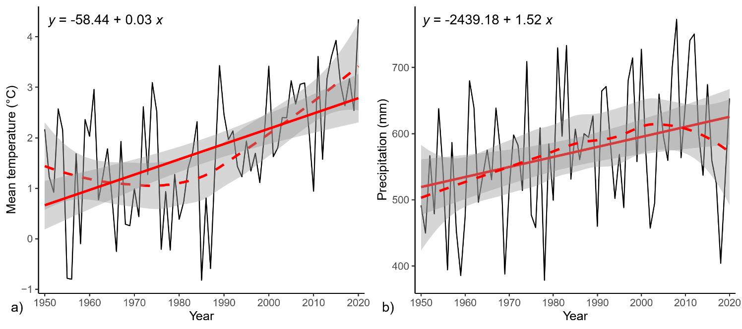
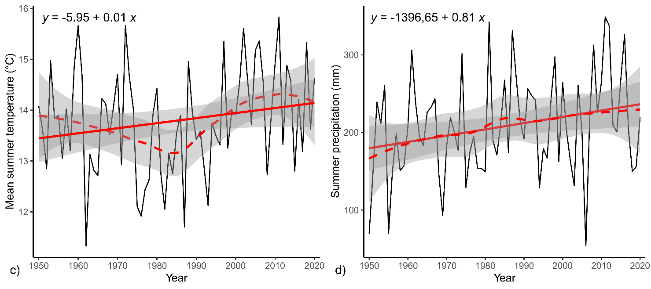

References:
Cornes, R., van der Schrier, G., van den Besselaar, E. J. M. & Jones, P. D. (2018). An ensemble version of the E-OBS temperature and precipitation datasets. Journal of Geophysical Research: Atmospheres, 123(17), https://doi.org/10.1029/2017JD028200

Appendix S2. On relocating the subtype of paludified forests
The relocation of seasonally hydrated sites, a subtype of paludified forests in this study, were the only exception of habitats that were not found or identifiable by their plant communities during the resurvey. This was despite good descriptions on their site locations in Jalas (1953), and these sites were looked for very carefully. Not many potential localities existed in the study area, where seasonally hydrated sites could have been located (i.e., clear, rather large depressions on the eastern side). We walked through the whole eastern part of the study area and located all the potential depression, spending a whole day on this. The sites we eventually considered the right ones located at places where the original descriptions indicated them to be located yet they were no longer recognizable by their original plant communities. These sites are most likely the right ones and soil samples verified the earlier presence of this habitat type: sphagnum and carex peat were found in each of them - these sites were earlier dominated by sedges (Carex sp.) and peat mosses (Sphagnum sp.) but were replaced by pine forest species over the years. Thus, the disappearance of this specific habitat type is most likely a real observation rather than a result of the relocation error.
References:
Jalas, J. (1953). Vegetation and flora in the planned national park of Rokua in Northern Finland. Silva Fennica, 81, 4640.

Appendix S3. Species list. Species frequencies are given across all sites and separately for each habitat type during the original survey and the resurvey (ALL = All sites, n = 42; S = Sun-exposed habitats, n = 7; F = Heath forests, n = 11; P = Paludified forests, n = 9; M = Mires, n = 10; E = Eulittoral habitats, n = 6). Abbrev. = Abbreviation.
Abbrev. | Vascular plants | ALL | S | F | P | M | E
Agrcap | Agrostis capillaris L. | 2 / 0 | 2 / 0
Agrsto | Agrostis stolonifera L. | 1 / 0 |  |  | 1 / 0
Alninc | Alnus incana (L.) Moench | 2 / 1 |  | 2 / 1
Andpol | Andromeda polifolia L. | 14 / 19 |  |  | 6 / 6 | 8 / 9 | 0 / 4
Antdio | Antennaria dioica (L.) Gaertn. | 6 / 0 | 5 / 0 | 1 / 0
Arcuva | Arctostaphylos uva-ursi (L.) Spreng. | 5 / 5 | 4 / 5 | 1 / 0
Avefle | Avenella flexuosa (L.) Drejer | 6 / 7 | 3 / 3 | 2 / 3 | 1 / 1
Betnan | Betula nana L. | 1 / 1 |  |  | 1 / 1
Betpen | Betula pendula Roth | 2 / 0 |  | 2 / 0
Betpub | Betula pubescens Ehrh. | 5 / 11 | 1 / 0 | 1 / 4 | 3 / 4 |  | 0 / 3
Calepi | Calamagrostis epigejos (L.) Roth | 4 / 0 | 1 / 0 | 3 / 0
Calneg | Calamagrostis neglecta (Ehrh.) G.Gaertn., B.Mey. & Scherb. | 1 / 0 |  |  |  |  | 1 / 0
Calphr | Calamagrostis phragmitoides Hartm. | 0 / 2 |  |  |  |  | 0 / 2
Calpal | Calla palustris L. | 0 / 2 |  |  |  |  | 0 / 2
Calvul | Calluna vulgaris (L.) Hull | 14 / 19 | 4 / 6 | 9 / 9 | 1 / 4
Camrot | Campanula rotundifolia L. | 1 / 0 | 1 / 0
Caraqu | Carex aquatilis Wahlenb. | 0 / 2 |  |  |  |  | 0 / 2
Carcan | Carex canescens L. | 1 / 3 |  |  | 1 / 0 |  | 0 / 3
Careri | Carex ericetorum Pollich | 7 / 5 | 7 / 5
Carglo | Carex globularis L. | 4 / 2 |  |  | 4 / 2
Carlas | Carex lasiocarpa Erhr. | 7 / 2 |  |  | 3 / 0 |  | 4 / 2
Carlim | Carex limosa L. | 8 / 10 |  |  |  | 7 / 9 | 1 / 1
Carnig | Carex nigra (L.) Reichard | 2 / 2 |  |  | 1 / 1 |  | 1 / 1
Carpau | Carex pauciflora Lightf. | 1 / 3 |  |  | 1 / 1 | 0 / 2
Carros | Carex rostrata Stokes | 8 / 5 |  |  | 1 / 0 | 2 / 0 | 5 / 5
Carves | Carex vesicaria L. | 1 / 0 |  |  |  |  | 1 / 0
Chacal | Chamaedaphne calyculata (L.) Moench | 2 / 5 |  |  | 1 / 2 | 1 / 1 | 0 / 2
Chaang | Chamaenedron angustifolium (L.) Scop. | 2 / 1 |  | 2 / 1
Compal | Comarum palustre L. | 0 / 1 |  |  |  |  | 0 / 1
Conmaj | Convallaria majalis L. | 8 / 5 | 5 / 2 | 3 / 3
Droang | Drosera anglica Huds. | 7 / 6 |  |  | 1 / 0 | 5 / 6 | 1 / 0
Drorot | Drosera rotudifolia L. | 10 / 11 |  |  | 2 / 1 | 8 / 9 | 0 / 1
Eleaci | Eleocharis acicularis (L.) Roem. & Schult. | 2 / 0 |  |  |  |  | 2 / 0
Elepal | Eleocharis palustris (L.) Roem. & Schult. | 2 / 0 |  |  |  |  | 2 / 0
Empnig | Empetrum nigrum L. | 9 / 17 |  | 4 / 5 | 5 / 8 | 0 / 3 | 0 / 1
Equflu | Equisetum fluviatile L. | 2 / 2 |  |  |  |  | 2 / 2
Eriang | Eriophorum angustifolium Honck. | 3 / 2 |  |  | 2 / 0 | 1 / 0 | 0 / 2
Erivag | Eriophorum vaginatum L. | 8 / 13 |  |  | 2 / 2 | 5 / 8 | 1 / 3
Fesovi | Festuca ovina L. | 6 / 5 | 6 / 5
Gymdry | Gymnocarpium dryopteris (L.) Newman | 1 / 0 |  | 1 / 0
Hieumb | Hieracium umbellatum L. | 4 / 0 | 3 / 0 | 1 / 0
Junfil | Juncus filiformis L. | 3 / 2 |  |  | 1 / 0 |  | 2 / 2
Juncom | Juniperus communis L. | 2 / 5 | 0 / 2 | 2 / 3
Linbor | Linnaea borealis L. | 0 / 1 |  | 0 / 1
Lobdor | Lobelia dortmanna L. | 1 / 0 |  |  |  |  | 1 / 0
Luzmul | Luzula multiflora (Ehrh.) Lej. | 1 / 0 | 1 / 0
Luzpil | Luzula pilosa (L.) Willd. | 1 / 1 | 0 / 1 | 1 / 0
Lycann | Lycopodium annotinum L. | 1 / 0 |  | 1 / 0
Lyccom | Lycopodium complanatum L. | 4 / 2 | 3 / 2 | 1 / 0
Lyseur | Lysimachia europaea (L.) U. Manns & Anderb. | 1 / 0 |  | 1 / 0
Lysthy | Lysimachia thyrsiflora L. | 2 / 3 |  |  |  |  | 2 / 3
Melpra | Melampyrum pratense L. | 2 / 0 |  | 2 / 0
Mentri | Menyanthes trifoliata L. | 1 / 1 |  |  |  |  | 1 / 1
Narstr | Nardus stricta L. | 1 / 0 |  |  | 1 / 0
Picabi | Picea abies (L.) H. Karst. | 1 / 0 |  | 1 / 0
Piloff | Pilosella officinarum F. W. Schultz & Sch. Bip. | 3 / 0 | 3 / 0
Pinsyl | Pinus sylvestris L. | 15 / 33 | 0 / 7 | 11 / 11 | 4 / 7 | 0 / 7 | 0 / 1
Polodo | Polygonatum odoratum (Mill.) Druce | 1 / 0 | 1 / 0
Poptre | Populus tremula L. | 5 / 1 | 2 / 0 | 3 / 1
Pteaqu | Pteridium aquilinum (L.) Kuhn | 1 / 0 |  | 1 / 0
Ranfla | Ranunculus flammula L. | 1 / 0 |  |  |  |  | 1 / 0
Rhotom | Rhododendron tomentosum Harmaja | 4 / 8 |  | 1 / 1 | 3 / 5 |  | 0 / 3
Rhyalb | Rhynchospora alba (L.) Vahl | 4 / 8 |  |  |  | 4 / 7 | 0 / 1
Rosmaj | Rosa majalis Herm. | 1 / 0 | 1 / 0
Rubcha | Rubus chamaemorus L. | 1 / 3 |  |  | 1 / 1 | 0 / 2
Rubsax | Rubus saxatilis L. | 1 / 0 |  | 1 / 0
Rumala | Rumex acetosella L. | 4 / 3 | 4 / 3
Salcap | Salix caprea L. | 1 / 0 |  | 1 / 0
Schpal | Scheuchzeria palustris L. | 7 / 9 |  |  |  | 7 / 9
Solvir | Solidago virgaurea L. | 5 / 4 | 2 / 1 | 3 / 3
Sorauc | Sorbus aucuparia L. | 2 / 1 |  | 2 / 1
Stegra | Stellaria graminea L. | 1 / 0 | 1 / 0
Thyser | Thymus serpyllum L. | 7 / 5 | 6 / 4 | 1 / 1
Trices | Trichoflorum caespitosa (L.) Hartm. | 5 / 5 |  |  |  | 5 / 5
Vacmic | Vaccinium microcarpum (Turcz. ex Rupr.) Schmalh. | 2 / 9 |  |  | 1 / 2 | 1 / 7
Vacmyr | Vaccinium myrtillus L. | 11 / 20 | 0 / 4 | 6 / 7 | 5 / 9
Vacoxy | Vaccinium oxycoccos L. | 4 / 9 |  |  | 1 / 1 | 3 / 6 | 0 / 2
Vaculi | Vaccinium uliginosum L. | 7 / 10 |  | 2 / 2 | 5 / 5 |  | 0 / 3
Vacvit | Vaccinium vitis-idaea L. | 18 / 23 | 1 / 3 | 11 / 11 | 6 / 9
Viocan | Viola canina L. | 1 / 0 | 1 / 0
 | Bryophytes
Aulpal | Aulacomnium palustre (Hedw.) Schwägr. | 5 / 4 |  |  | 3 / 4 | 1 / 0 | 1 / 0
Calcor | Calliergon cordifolium (Hedw.) Kindb. | 1 / 5 |  |  | 0 / 1 | 0 / 1 | 1 / 3
Cerpur | Ceratodon purpureus (Hedw.) Brid. | 1 / 1 | 1 / 1
Dicdru | Dicranum drummondii Müll.Hal. | 1 / 1 |  | 1 / 1
Dicfus | Dicranum fuscescens Sm. | 11 / 12 |  | 7 / 7 | 4 / 5
Dicmaj | Dicranum majus Sm. | 0 / 1 |  | 0 / 1
Dicpol | Dicranum polysetum Sw. ex anon. | 10 / 21 | 0 / 4 | 7 / 11 | 3 / 6
Dicsco | Dicranum scoparium Hedw. | 2 / 3 | 0 / 1 | 1 / 0 |  |  | 1 / 2
Dicund | Dicranum undulatum Schrad. ex Brid. | 0 / 4 |  |  | 0 / 3 | 0 / 1
Hylspl | Hylocomium splendens (Hedw.) Schimp. | 5 / 7 |  | 5 / 4 | 0 / 3
Phifon | Philonotis fontana (Hedw.) Brid. | 1 / 0 |  |  |  |  | 1 / 0
Plesch | Pleurozium schreberi (Willd. ex Brid.) Mitt. | 16 / 25 | 2 / 3 | 7 / 11 | 7 / 9 |  | 0 / 2
Pohnut | Pohlia nutans (Hedw.) Lindb. | 2 / 4 | 0 / 4 |  |  | 1 / 0 | 1 / 0
Polcom | Polytrichum commune Hedw. | 7 / 1 |  | 1 / 0 | 6 / 1
Poljun | Polytrichum juniperinum Hedw. | 2 / 2 | 0 / 1 | 2 / 0 | 0 / 1
Pollon | Polytrichum longisetum Sw. ex Brid. | 1 / 0 |  |  |  |  | 1 / 0
Polpil | Polytrichum piliferum Hedw. | 9 / 7 | 7 / 7 | 2 / 0
Polstr | Polytrichum strictum Menzies ex Brid. | 5 / 5 |  |  | 4 / 3 | 1 / 1 | 0 / 1
Pticri | Ptilium crista-castrensis (Hedw.) De Not. | 3 / 5 |  | 3 / 2 | 0 / 3
Ptypse | Ptychostomum pseudotriquetrum | 1 / 0 |  |  |  |  | 1 / 0
 | (Hedw.) J.R.Spence & H.P.Ramsay ex Holyoak & N.Pedersen
Raccan | Racomitrium canescens (Hedw.) Brid. | 0 / 3 | 0 / 3
Sanunc | Sanionia uncinata (Hedw.) Loeske | 1 / 0 |  | 1 / 0
Sarexa | Sarmentypnum exannulatum (Schimp.) Hedenäs | 2 / 4 |  |  |  |  | 2 / 4
Sphang | Sphagnum angustifolium (C.E.O.Jensen ex Russow) C.E.O.Jensen | 5 / 11 |  |  | 3 / 6 | 2 / 3 | 0 / 2
Sphbal | Sphagnum balticum (Russow) C.E.O.Jensen | 5 / 3 |  |  | 1 / 0 | 4 / 3
Sphcom | Sphagnum compactum Lam. & DC. | 3 / 4 |  |  | 0 / 1 | 3 / 3
Sphcap | Sphagnum capillifolium (Ehrh.) Hedw. | 1 / 2 |  |  | 1 / 2
Sphcus | Sphagnum cuspidatum Ehrh. ex Hoffm. | 2 / 8 |  |  |  | 2 / 8
Sphfus | Sphagnum fuscum (Schimp.) H.Klinggr. | 2 / 7 |  |  | 1 / 1 | 1 / 6
Sphinu | Sphagnum inundatum Russow | 2 / 0 |  |  |  |  | 2 / 0
Sphjen | Sphagnum jensenii H.Lindb. | 5 / 6 |  |  |  | 5 / 6
Sphmed | Sphagnum medium coll. | 4 / 7 |  |  | 1 / 2 | 3 / 5
Sphpap | Sphagnum papillosum Lindb. | 4 / 4 |  |  |  | 4 / 4
Sphrip | Sphagnum riparium Ångstr. | 0 / 5 |  |  |  |  | 0 / 5
Sphrus | Sphagnum russowii Warnst. | 2 / 5 |  |  | 1 / 2 | 1 / 1 | 0 / 2
Sphsqu | Sphagnum squarrosum Crome | 0 / 3 |  |  | 0 / 1 |  | 0 / 2
Sphsub | Sphagnum subfulvum Sjörs | 1 / 0 |  |  |  | 1 / 0
Splsph | Splachnum sphaericum Hedw. | 1 / 0 |  |  |  |  | 1 / 0
Strstr | Straminergon stramineum (Dicks. ex Brid.) Hedenäs | 1 / 2 |  |  |  | 1 / 0 | 0 / 2
Warflu | Warnstorfia fluitans (Hedw.) Loeske | 3 / 2 |  |  |  | 1 / 0 | 2 / 2
Hepaticae | Hepaticae | 6 / 11 |  | 0 / 1 | 1 / 1 | 5 / 8 | 0 / 1
Pticil | Ptilidium ciliare (L.) Hampe | 3 / 2 |  | 3 / 1 |  |  | 0 / 1
 | Lichens
Ceteri | Cetraria ericetorum Opiz | 4 / 5 | 4 / 5
Cetisl | Cetraria islandica (L.) Ach. | 5 / 16 | 3 / 7 | 2 / 7 | 0 / 1 | 0 / 1
Claarb | Cladonia arbuscula (Wallr.) Flot. | 19 / 20 | 7 / 7 | 9 / 8 | 3 / 4 | 0 / 1
Claran | Cladonia rangiferina (L.) F. H. Wigg. | 18 / 20 | 6 / 7 | 9 / 9 | 3 / 4
Claste | Cladonia stellaris (Opiz) Pouzar & Vězda | 9 / 16 | 3 / 7 | 6 / 8 | 0 / 1
Clasty | Cladonia stygia (Fr.) Ruoss | 0 / 1 |  |  |  | 0 / 1
Cladonia | Cladonia sp. | 14 / 11 | 7 / 7 | 5 / 4 | 2 / 0
Flaniv | Flavocetraria nivalis (L.) Kärnefelt & A. Thell | 1 / 0 | 1 / 0
Ochrol. | Ochrolechia sp. | 1 / 2 | 1 / 2
Pelapt | Peltigera apthosa (L.) Willd. | 2 / 0 |  | 1 / 0 | 1 / 0
Pelcan | Peltigera canina (L.) Willd. | 3 / 0 | 3 / 0
Pelpol | Peltigera polydactylon (Neck.) Hoffm. | 1 / 0 |  |  | 1 / 0
Stepas | Stereocaulon paschale (L.) Hoffm. | 7 / 7 | 6 / 7 | 1 / 0

* Sphagnum cuspidatum includes S. majus; Sphagnum medium includes S. divinum;
** Cladonia sp. includes C. chlorophaea, C. coccifera, C. cornuta, C. crispata, C. deformis, C. fimbriata, C, furcata, C. gracilis, C. sulphurina, C. uncialis, C. verticillata.

Appendix S4. Spearman’s rank correlations between ecological indicators across all study sites and within each habitat.

All study sites | Phosphorus | Nitrogen | Soil reaction | Moisture | Light | Continent. | Cold requir. | Heat requir.
Soil disturbance | 0.18 | 0.07 | 0.20 | -0.18 | 0.28 | -0.10 | -0.27 | 0.13
Phosphorus | 1.00 | 0.57 | 0.19 | 0.01 | -0.07 | -0.18 | -0.30 | 0.09
Nitrogen |  | 1.00 | 0.41 | 0.05 | -0.21 | -0.09 | -0.32 | 0.15
Soil reaction |  |  | 1.00 | -0.12 | 0.12 | 0.05 | -0.28 | 0.12
Moisture |  |  |  | 1.00 | 0.14 | 0.12 | 0.34 | 0.06
Light |  |  |  |  | 1.00 | -0.09 | -0.10 | 0.14
Continentality |  |  |  |  |  | 1.00 | 0.39 | 0.06
Cold requirement |  |  |  |  |  |  | 1.00 | -0.15
Forests
Soil disturbance | 0.10 | 0.06 | 0.02 | -0.18 | 0.41 | 0.19 | -0.12 | 0.13
Phosphorus | 1.00 | 0.64 | -0.02 | 0.24 | 0.01 | -0.45 | -0.26 | 0.16
Nitrogen |  | 1.00 | 0.11 | 0.25 | -0.02 | -0.23 | -0.28 | 0.22
Soil reaction |  |  | 1.00 | -0.40 | 0.29 | -0.05 | -0.21 | 0.38
Moisture |  |  |  | 1.00 | -0.13 | -0.02 | 0.40 | -0.14
Light |  |  |  |  | 1.00 | -0.01 | -0.36 | 0.31
Continentality |  |  |  |  |  | 1.00 | 0.25 | 0.03
Cold requirement |  |  |  |  |  |  | 1.00 | -0.41
Paludified forests
Soil disturbance | 0.35 | 0.14 | 0.02 | 0.13 | 0.08 | -0.35 | -0.14 | -0.04
Phosphorus | 1.00 | 0.45 | 0.02 | -0.08 | -0.27 | -0.23 | -0.47 | -0.13
Nitrogen |  | 1.00 | 0.42 | 0.15 | -0.16 | -0.14 | -0.36 | -0.13
Soil reaction |  |  | 1.00 | 0.17 | 0.18 | -0.13 | -0.27 | 0.26
Moisture |  |  |  | 1.00 | 0.34 | 0.02 | 0.21 | 0.18
Light |  |  |  |  | 1.00 | -0.22 | 0.09 | 0.32
Continentality |  |  |  |  |  | 1.00 | 0.36 | 0.24
Cold requirement |  |  |  |  |  |  | 1.00 | 0.07
Mires
Soil disturbance | 0.44 | 0.03 | -0.06 | 0.51 | 0.40 | -0.36 | -0.18 | 0.13
Phosphorus | 1.00 | 0.37 | -0.06 | 0.28 | -0.14 | -0.32 | -0.33 | -0.52
Nitrogen |  | 1.00 | 0.27 | 0.23 | -0.25 | 0.26 | -0.20 | -0.25
Soil reaction |  |  | 1.00 | 0.12 | -0.24 | 0.36 | -0.22 | -0.05
Moisture |  |  |  | 1.00 | 0.37 | -0.28 | 0.07 | 0.13
Light |  |  |  |  | 1.00 | -0.31 | 0.38 | 0.24
Continentality |  |  |  |  |  | 1.00 | -0.01 | 0.46
Cold requirement |  |  |  |  |  |  | 1.00 | 0.12
Eulitoral
Soil disturbance | 0.27 | 0.00 | 0.02 | 0.06 | 0.35 | -0.17 | -0.23 | 0.04
Phosphorus | 1.00 | 0.67 | 0.33 | 0.33 | 0.00 | -0.12 | -0.19 | -0.19
Nitrogen |  | 1.00 | 0.52 | 0.48 | -0.28 | -0.04 | -0.28 | 0.10
Soil reaction |  |  | 1.00 | 0.45 | 0.18 | 0.05 | -0.26 | 0.05
Moisture |  |  |  | 1.00 | 0.12 | -0.09 | -0.23 | 0.18
Light |  |  |  |  | 1.00 | -0.15 | 0.00 | 0.02
Continentality |  |  |  |  |  | 1.00 | 0.39 | -0.03
Cold requirement |  |  |  |  |  |  | 1.00 | -0.10
Sun-exposed
Soil disturbance | -0.05 | -0.17 | 0.05 | -0.33 | 0.16 | 0.17 | 0.10 | 0.14
Phosphorus | 1.00 | 0.38 | -0.36 | 0.27 | -0.05 | -0.29 | -0.22 | 0.13
Nitrogen |  | 1.00 | 0.04 | 0.36 | -0.18 | -0.13 | -0.16 | 0.02
Soil reaction |  |  | 1.00 | -0.36 | 0.34 | 0.33 | 0.01 | 0.15
Moisture |  |  |  | 1.00 | -0.53 | -0.07 | 0.25 | -0.15
Light |  |  |  |  | 1.00 | 0.04 | -0.27 | 0.30
Continentality |  |  |  |  |  | 1.00 | 0.42 | 0.15
Cold requirement |  |  |  |  |  |  | 1.00 | -0.30

Appendix S5. The order of non-significant ecological indicators removed from GLMM models.
Model: | Across sites | Order of removal | Variable | χ² | p
 |  | 1 | Light | 0.01 | 0.9208
 |  | 2 | Cold.requirement | 0.05 | 0.8252
 |  | 3 | Heat.requirement | 0.16 | 0.6914
 |  | 4 | Moisture | 0.45 | 0.5032
 |  | 5 | Nitrogen..N. | 0.81 | 0.3674
 |  | 6 | Soil.disturbance | 3.64 | 0.0565
 |  | 7 | Continentality | 3.38 | 0.0659
 | Forests | Order of removal | Variable | χ² | p
 |  | 1 | Soil.reaction..pH. | 0.0463 | 0.8297
 |  | 2 | Heat.requirement | 0.2535 | 0.61462
 |  | 3 | Phosphorus..P. | 0.2904 | 0.58998
 |  | 4 | Soil.disturbance | 0.4757 | 0.49038
 |  | 5 | Light | 0.3064 | 0.57991
 |  | 6 | Continentality | 0.4693 | 0.49329
 |  | 7 | Nitrogen..N. | 1.012 | 0.31442
 |  | 8 | Cold.requirement | 2.3659 | 0.12402
 |  | 9 | Moisture | 2.311 | 0.1285
 | Paludified | Order of removal | Variable | χ² | p
 | forests | 1 | Heat.requirement | 0.0013 | 0.971766
 |  | 2 | Nitrogen..N. | 0.085 | 0.770614
 |  | 3 | Soil.disturbance | 0.2331 | 0.62925
 |  | 4 | Phosphorus..P. | 0.0989 | 0.753132
 |  | 5 | Cold.requirement | 0.3968 | 0.528725
 |  | 6 | Light | 0.2992 | 0.584414
 |  | 7 | Continentality | 1.7691 | 0.183498
 | Sun-exposed | Order of removal | Variable | χ² | p
 | sites | 1 | Heat.requirement | 0.617 | 0.432147
 |  | 2 | Moisture | 0.2742 | 0.600515
 |  | 3 | Light | 3.6133 | 0.057321
 |  | 4 | Cold.requirement | 1.899 | 0.168185
 |  | 5 | Continentality | 3.7537 | 0.052691
 | Mires | Order of removal | Variable | χ² | p
 |  | 1 | Nitrogen..N. | 0.0101 | 0.919952
 |  | 2 | Soil.reaction..pH. | 0.0002 | 0.990102
 |  | 3 | Light | 0.1618 | 0.687519
 |  | 4 | Phosphorus..P. | 1.3191 | 0.250753
 |  | 5 | Cold.requirement | 1.6241 | 0.202516
 |  | 6 | Soil.disturbance | 0.6392 | 0.424019
 |  | 7 | Continentality | 1.779 | 0.182273
 |  | 8 | Heat.requirement | 1.4918 | 0.221943
 | Eulitoral | Order of removal | Variable | χ² | p
 | sites | 1 | Light | 0.0226 | 0.880539
 |  | 2 | Soil.disturbance | 0.0828 | 0.773511
 |  | 3 | Cold.requirement | 0.7456 | 0.387872
 |  | 4 | Heat.requirement | 1.4873 | 0.222639
 |  | 5 | Phosphorus..P. | 1.5183 | 0.217872
 |  | 6 | Nitrogen..N. | 1.0948 | 0.295411
 |  | 7 | Continentality | 2.3528 | 0.125059

Appendix S6. Habitat-specific NMDS ordinations with 95 % -confidence ellipses based on cover data and Bray-Curtis dissimilarity for a) heath forests (PERMANOVA: F = 1.84 , r² = 0.08 , p = 0.012; PERMDISP: F = 0.65, p = 0.426), b) paludified forests (PERMANOVA: F = 2.24 , r² = 0.12 , p = 0.004; PERMDISP: F = 6.09, p = 0.025), c) mires (PERMANOVA: F = 1.43 , r² = 0.08 , p = 0.014; PERMDISP: F = 21.78, p = 0.002) and d) eulitoral sites (PERMANOVA: F = 0.85, r² = 0.08 , p = 0.031; PERMDISP: F = 0.01, p = 0.997). To facilitate interpretation of compositional shifts over time, 50 % most abundant and 50 % best fitting species are displayed. These were assessed using R package ‘goeveg’ (Friedemann & Schellenberg, 2021). In addition, habitat subtypes are displayed for heath forests and paludified forests to inform management. Species abbreviations in Appendix S3.
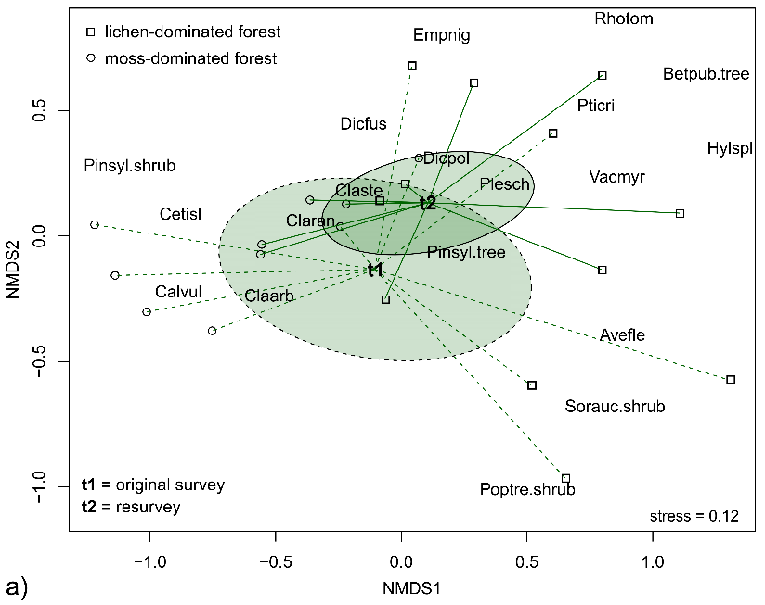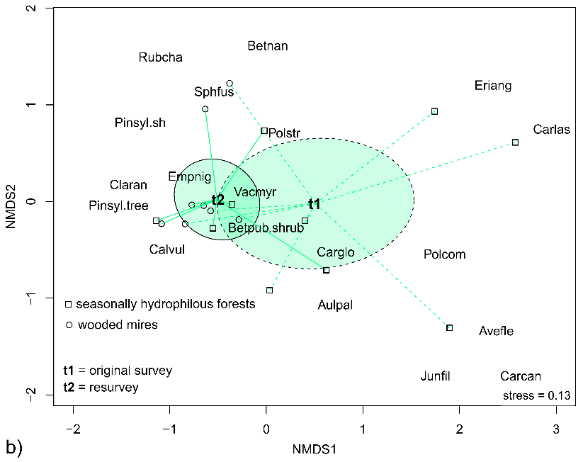
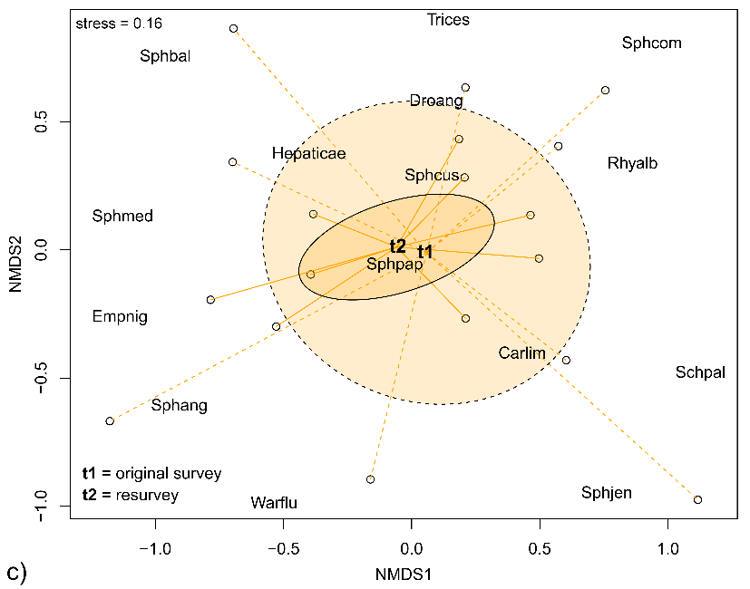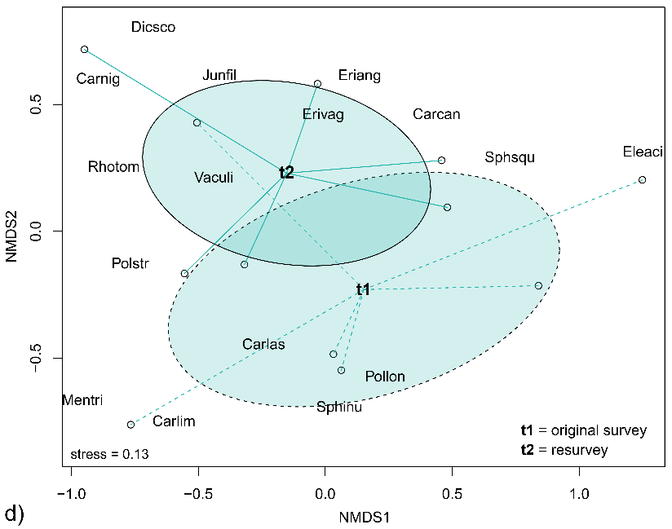

References:
Friedemann, G. & Schellenberg, J. (2021). Package “goeveg”: Functions for Community Data and Ordinations (R package version 0.5.1). Available at: https://cran.r-project.org/web/packages/goeveg

Appendix S7. a) Scatterplot between SERr and SERa. Interpretation of change after Hillebrand et al. 2018. b) Paired t-test statistics for temporal comparisons of species richness variables.
a)
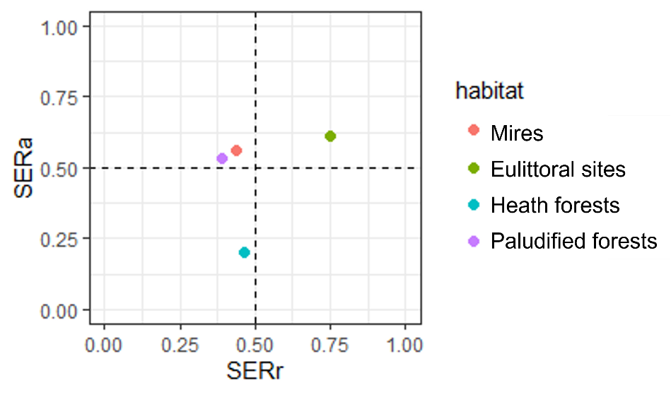
b)
Total | habitat | t | df | p | mean of the differences
richness | all sites | -3.13 | 41 | 0.003 | -2.5
 | heath forests | 0.93 | 10 | 0.372 | 1.3
 | paludified forests | -1.55 | 8 | 0.16 | -3.1
 | sun-exposed sites | -0.29 | 6 | 0.784 | -0.4
 | mires | -5.2 | 8 | <0.001 | -5.6
 | eulittoral sites | -4.23 | 5 | 0.008 | -6.3
Vascular | habitat | t | df | p | mean of the differences
plant | all sites | -1.13 | 41 | 0.265 | -0.7
richness | heath forests | 1.31 | 10 | 0.218 | 1.4
 | paludified forests | -0.97 | 8 | 0.359 | -1
 | sun-exposed sites | 1.69 | 6 | 0.144 | 2.7
 | mires | -4.69 | 8 | 0.002 | -3.7
 | eulittoral sites | -5.5 | 5 | 0.003 | -3.7
Cryptogam | habitat | t | df | p | mean of the differences
richness | all sites | -4.38 | 41 | <0.001 | -1.8
 | heath forests | -0.23 | 10 | 0.824 | -0.2
 | paludified forests | -1.73 | 8 | 0.121 | -2.1
 | sun-exposed sites | -4.26 | 6 | 0.005 | -3.1
 | mires | -3.51 | 8 | 0.008 | -1.9
 | eulittoral sites | -2.79 | 5 | 0.038 | -2.7

References:
Hillebrand, H., Blasius, B., Borer, E. T., Chase, J. M., Downing, J. A., Klemens Eriksson, B., Filstrup, C. T., Harpole, S., Hodapp, D., Larsen S., Lewandowska, A. M., Seabloom, E. W., Van de Waal, D. B., & Ryabov, A. B. (2018). Biodiversity change is uncoupled from species richness trends: Consequences for conservation and monitoring. Journal of Applied Ecology, 55, 169–184.

Appendix S8. Mean canopy cover (± 95% confidence intervals) in forested habitat types during both surveys. Canopy cover has decreased most likely due decreased forest regeneration and local tree falls due strong winds.
