Biodiversity and Conservation
Unravelling the genetic pattern of seagrass (Posidonia oceanica) meadows in the Eastern Mediterranean Sea
Victoria Litsi-Mizan ^{1, 2}, Catalina A. García-Escudero ^{1, 2}, Costas S. Tsigenopoulos ³, Kostas Tsiaras ⁴, Vasilis Gerakaris ⁴, Eugenia T. Apostolaki ^{2*}
¹ University of Crete, Biology department, Voutes University Campus, P.O. Box 2208, GR-70013, Heraklion, Crete, Greece.
² Institute of Oceanography, Hellenic Centre for Marine Research, PO Box 2214, GR-71003, Heraklion, Crete, Greece.
³ Institute of Marine Biology, Biotechnology and Aquaculture, Hellenic Centre for Marine Research, PO Box 2214, 71003 Heraklion, Greece.
⁴ Institute of Oceanography, Hellenic Centre for Marine Research, PO Box 712, 19013, Anavyssos, Attiki, Greece.
*Correspondence: Eugenia T. Apostolaki. Email: eapost@hcmr.gr

Tables
Table S1: Coordinates and sampling depth (m) of 18 P. oceanica sampling sites.
Sea | Region | Site | Site code | LAT | LON | Depth (m)
Ionian Sea | Ionian Sea | Parga | PAR | 39.25 | 20.47 | 15
Ionian Sea | Ionian Sea | Kefalonia | KEF | 38.10 | 20.60 | 15
N. Aegean  Sea | N. Aegean Sea | Afyto | AFY | 40.06 | 23.47 | 5
N. Aegean  Sea | N. Aegean Sea | Limnos | LIM | 39.90 | 25.27 | 5
N. Aegean  Sea | N. Aegean Sea | Lesvos | LES | 39.07 | 26.47 | 5
N. Aegean  Sea | N. Aegean Sea | Trikeri | TRI | 39.16 | 23.07 | 5
S. Aegean Sea | Saronikos Gulf | Sounio | SOU | 37.65 | 24.02 | 5.8
S. Aegean Sea | Cyclades Islands | Serifos | SER | 37.13 | 24.42 | 7
S. Aegean Sea | Cyclades Islands | Koufonisi | KOU | 36.92 | 25.60 | 9.2
S. Aegean Sea | Cyclades Islands | Ios | IOS | 36.67 | 25.39 | 6.8
S. Aegean Sea | Cyclades Islands | Santorini | SAN | 36.35 | 25.39 | 7.6
S. Aegean Sea | Cyclades Islands | Perivolos | PER | 36.34 | 25.46 | 13
S. Aegean Sea | Dodecanese Islands | Nisyros | NIS | 36.59 | 27.21 | 6
S. Aegean Sea | Dodecanese Islands | Stroggyli | STR | 36.24 | 27.77 | 8
Cretan Sea | Crete | Gouves | GOU | 35.34 | 25.30 | 4
Cretan Sea | Crete | Ag. Nikolaos | NIK | 35.26 | 25.76 | 15
Cretan Sea | Crete | Sfakia | SFA | 35.20 | 24.13 | 15
Cretan Sea | Crete | Lentas | LEN | 34.93 | 24.91 | 11

Table S2: List of 12 amplified microsatellites combined in four multiplexes.
Primer Name | Type | Concentration added (pmol) | Label | Sequences | Reference
Multiplex 1
Po5-39 | Neutral | 5 | ATTO 565 | F:CATTTGGCTGAGTCCCTTTC  R:GTCCAAGGCTTCCGTGATGG | Alberto et al., 2003
Po15 | Neutral | 10 | ATTO 550 | F:AAGCACGCCGCTTAAACCATA  R:CATGTTAGTAGGCAATATACTAGGC | Alberto et al., 2003
Po5-49 | Neutral | 10 | YAKIMA YELLOW | GGCTCGATGGTGCATTTCAGC  GGCTCGATGGTGCATTTCAGC | Alberto et al., 2003
Multiplex 2
Po5-10 | Neutral | 10 | ATTO 550 | F:ATGAGACTCCCACAATAACA  R:CATGGGAAGGTATAGAAGC | Alberto et al., 2003
Po4-3 | Neutral | 10 | FAM | F:ACAGAAACTACGAACCATCAG  R:TAAGGAGAAGGAGAAGGAAA | Alberto et al., 2003
Po5 | Neutral | 5 | YAKIMA YELLOW | F:CACAATGGCCCGGTAGCA  R:GTGGTTGCGTGCCTTCGGTTG | Alberto et al., 2003
Multiplex 3
Pooc-229 | EST-linked | 5 | ATTO 565 | F:CTCAGGGGAAGGTAGAAGAGATG  R:CTGCTTTGTTTCCTCAAAAAGTG | Arranz et al., 2013
Pooc-333 | EST-linked | 10 | FAM | F:AAAAGTGTTTGAGAGAAACAACTCG  R:ACCTTTGACTTCTCCTTCTGAATCT | Arranz et al., 2013
Pooc-PC045G11F | EST-linked | 5 | ATTO 550 | F:CTCCACCATCCGCCCCCATTTG  R:CTTCGACAACCTTGCAGGCCCT | Arranz et al., 2013
Multiplex 4
Pooc-361 | EST-linked | 10 | FAM | F:TCCTCCCAATCTAATTTGCTG  R:AAGAACAGTGAGCGCCAGAC | Arramz et al., 2013
Pooc-PC003H09 | EST-linked | 10 | ATTO 550 | F:GTGTTTTGGGCTTGACTAAGAGAT  R:AGGCAACAATTAAGATAGCCCAAAC | Arramz et al., 2013
Pooc-153 | EST-linked | 5 | ATTO 565 | F:AGCTAGCAAGCTCGTGCA  R:GACGGTGCTGTTCCACGT | Arramz et al., 2013

Figures
Fig. S1. Identification of outlier loci based on Bayescan analysis (Foll & Gaggiotti, 2008) and posterior probabilities distribution generated by MCMC. Locus Pooc-PC045G11F was found to be under selection (q value < 0.05).

Fig. S2 Pairwise F_{ST} values among sites. All pairwise comparisons were significant at 0.05 level, except for one combination (PAR-KEF), after 1,000 bootstraps.

.
Fig. S3 Pairwise Jost’s D (Dest) genetic distances among sites

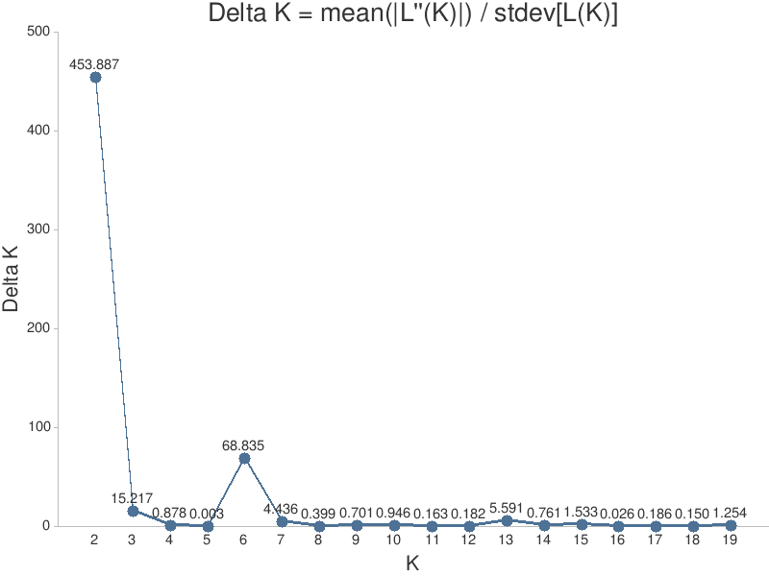
Fig. S4 Delta- K values according to Evanno Method (Evanno et al., 2005). K=2 and K= 6 are the most likely numbers of clusters.

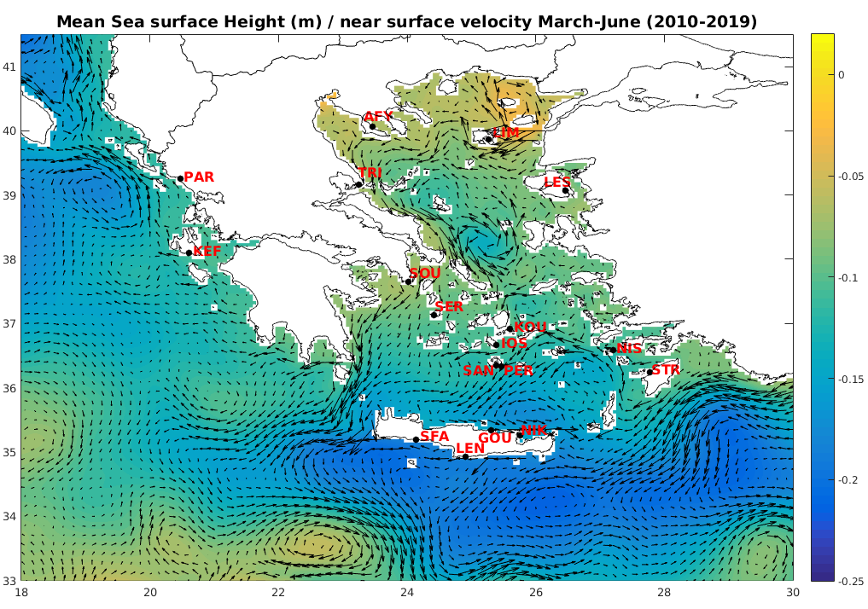

Fig. S5 Simulated mean sea surface height (m) and near surface current velocity for March-June period 2010-2019.

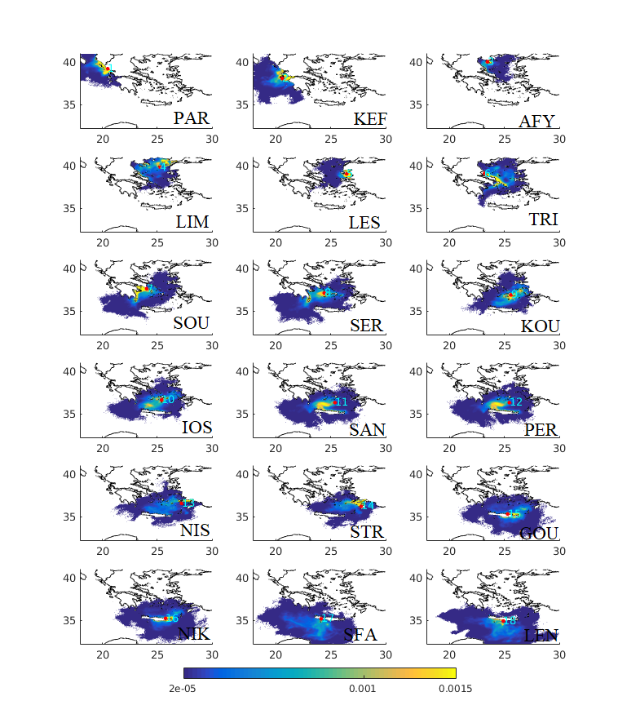
Fig. S6 Oceanographic connectivity maps between the 18 sampling sites in the Ionian, Aegean, and Cretan Seas, after an advection time of 28 days considering the period 2010-2019.

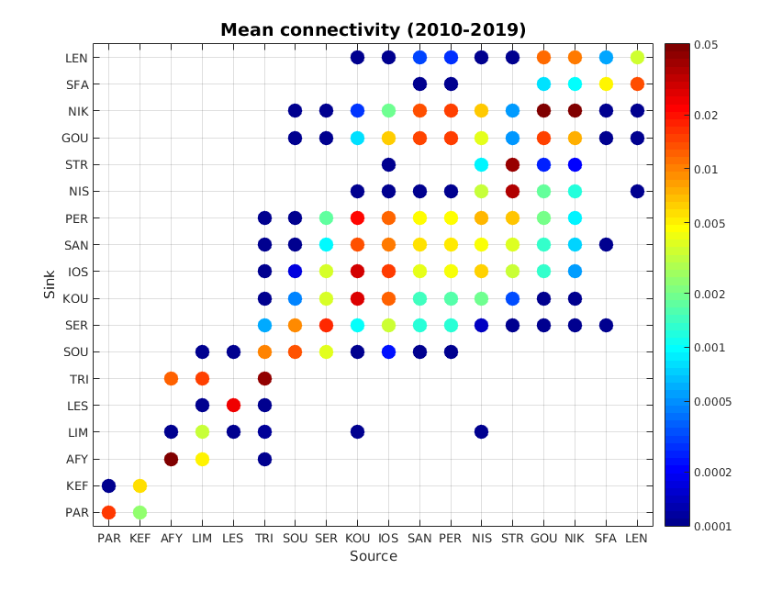
Fig. S7 Matrix of distribution probabilities of a particle released from one site reaching another site after an advection of 28 days considering the period 2010-2019.

.

Supplementary Materials and Methods
Oceanographic (potential) connectivity
The hydrodynamic model is based on the Princeton Ocean Model (POM; Blumberg and Mellor, 1983) that is currently operational within the POSEIDON forecasting system (Korres et al., 2007), www.poseidon.hcmr.gr). A hybrid ensemble data assimilation algorithm (Tsiaras et al., 2021; K. P. Tsiaras et al., 2017) was implemented to correct the simulated near surface circulation, using satellite altimetry and sea surface temperature data, obtained from the European Copernicus database (http://marine.copernicus.eu/). The Lagrangian drift model is based on Pollani et al., 2001 and evaluates the particles’ displacement from ocean currents and random movement due the horizontal mixing. The interested reader may refer to Tsabaris et al., 2021; K. Tsiaras et al., 2021 for more details on the model description and implementation. The atmospheric forcing was obtained from the POSEIDON operational weather forecast (Papadopoulos & Katsafados, 2009).

References
Alberto, F., Correia, L., Arnaud-Haond, S., Billot, C., Duarte, C. M., & Serrao. (2003). New microsatellite markers for the endemic Mediterranean seagrass Posidonia oceanica. Molecular Ecology Notes, 3, 253–255. https://doi.org/10.1046/j.1471-8286.2003.00415.x
Annika, P., George, T., George, P., Konstantinos, N., Costas, D., & Koutitas, C. (2001). The Poseidon Operational Tool for the Prediction of Floating Pollutant Transport. Marine Pollution Bulletin, 43(7–12), 270–278. https://doi.org/10.1016/S0025-326X(01)00080-7
Arranz, S. E., Avarre, J., Balasundaram, C., Bouza, C., Calcaterra, N. B., Cezilly, F., Chen, S., Cipriani, G., Cruz, V. P., D’Esposito, D., Daniel, C., Dejean, A., Dharaneedharan, S., Díaz, J., Du, M., Durand, J., Dziadek, J., Foresti, F., Peng‐cheng, F., … Zhuang, Z. (2013). Permanent Genetic Resources added to Molecular Ecology Resources Database 1 December 2012–31 January 2013. Molecular Ecology Resources, 13(3), 546–549. https://doi.org/10.1111/1755-0998.12095
Blumberg, A.F., Mellor, G.L. (1983). Diagnostic and prognostic numerical circulation studies of the South Atlantic Bight. Journal of Geophysical Research, 88, 4579 -4592. https://doi.org/10.1029/JC088iC08p04579
Evanno, G., Regnaut S., & Goudet, J. (2005). Detecting the number of clusters of individuals using the software structure: A simulation study. Molecular Ecology, 14(8), 2611–2620. https://doi.org/10.1111/j.1365-294X.2005.02553.x
Foll, M., & Gaggiotti, O. (2008). A genome-scan method to identify selected loci appropriate for both dominant and codominant markers: A Bayesian perspective. Genetics, 180(2), 977–993. https://doi.org/10.1534/genetics.108.092221
Korres, G., Hoteit, I., & Triantafyllou, G. (2007). Data assimilation into a Princeton Ocean Model of the Mediterranean Sea using advanced Kalman filters. Journal of Marine Systems, 65(1–4), 84–104. https://doi.org/10.1016/j.jmarsys.2006.09.005
Papadopoulos, A., & Katsafados, P. (2009). Verification of operational weather forecasts from the POSEIDON system across the Eastern Mediterranean. Natural Hazards and Earth System Sciences, 9(4), 1299–1306. https://doi.org/10.5194/nhess-9-1299-2009
Tsabaris, C., Tsiaras, K., Eleftheriou, G., & Triantafyllou, G. (2021). 137Cs ocean distribution and fate at East Mediterranean Sea in case of a nuclear accident in Akkuyu Nuclear Power Plant. Progress in Nuclear Energy, 139. https://doi.org/10.1016/j.pnucene.2021.103879
Tsiaras, K., Hatzonikolakis, Y., Kalaroni, S., Pollani, A., & Triantafyllou, G. (2021). Modeling the Pathways and Accumulation Patterns of Micro- and Macro-Plastics in the Mediterranean. Frontiers in Marine Science, 8. https://doi.org/10.3389/fmars.2021.743117
Tsiaras, K. P., Hoteit, I., Kalaroni, S., Petihakis, G., & Triantafyllou, G. (2017). A hybrid ensemble-OI Kalman filter for efficient data assimilation into a 3-D biogeochemical model of the Mediterranean. Ocean Dynamics, 67(6), 673–690. https://doi.org/10.1007/s10236-017-1050-7

