Appendix B
Diverging responses to natural and anthropogenic habitats in Aftrotropical birds and butterflies
Habel, J.C., Mulwa, M, Wagner, L., Schmitt, T., Teucher, M., Ulrich, W.

Figure B1. Numbers of insectivorous birds in the dry (a) and rainy (b) seasons in dependence on the numbers of butterflies. Red data points: forest interior, violet: forest edge, grey: orchard, green: pasture. Given are ordinary least squares logarithmic regression lines. None of the regressions is significant at P < 0.05.

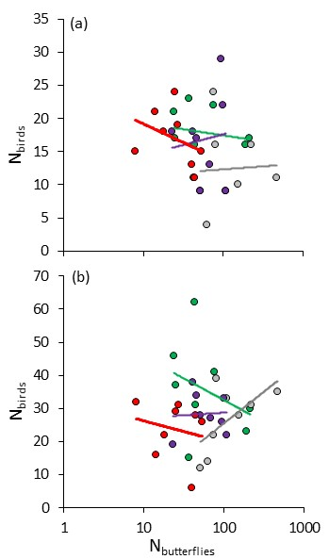
Figure B2. Cluster analysis (Ward’s method) did not consistently separate habitats with respect to bird and butterfly community, except for forest butterfly communities in the rainy season. Numbers refer to percentages of clusters identified from 9999 bootstrap samples.

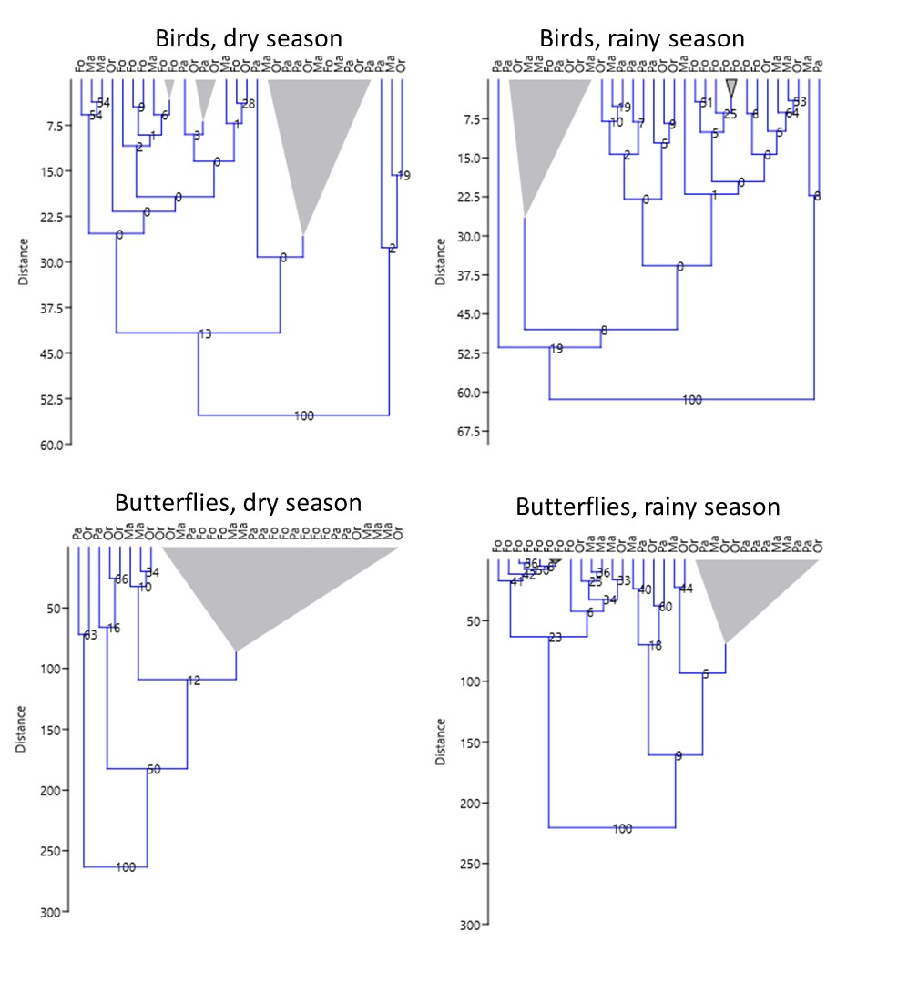

Figure B4. Unconstrained seriation of bird records among four habitat types (Fo: forest interior, Ma: forest edges, Or: orchard, Pa: pasture) in the dry and rainy seasons.
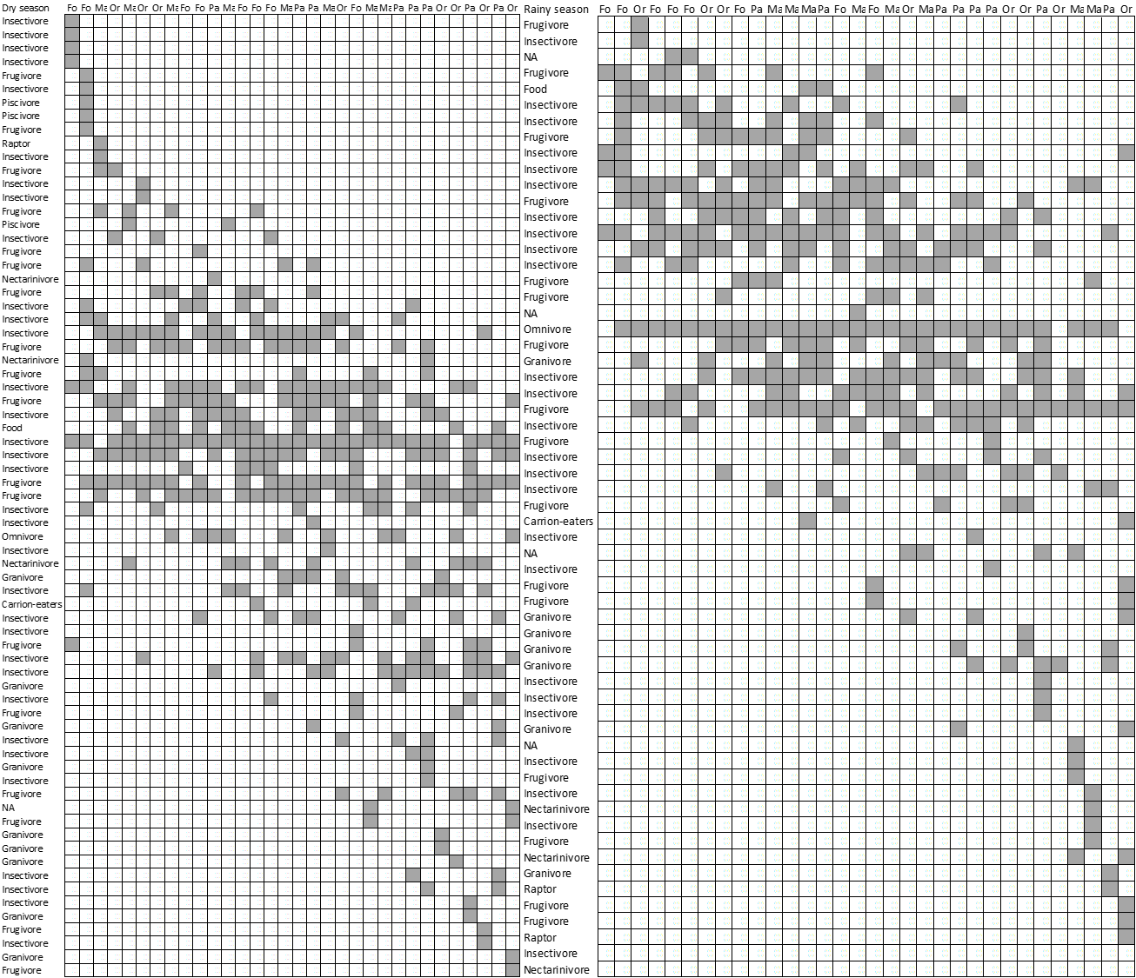

Figure B5. Unconstrained seriation of butterfly records among four habitat types (Fo: forest interior, Ma: forest edges, Or: orchard, Pa: pasture) in the dry and rainy seasons. Row names refer to the forest association classes; classes: 1: forest associated – 3: savannah associated.
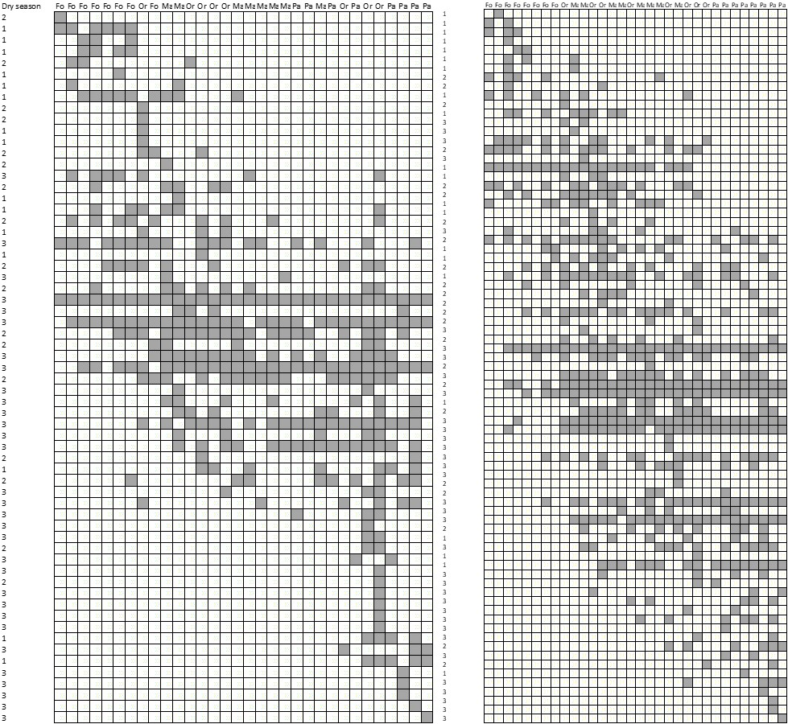
Table B1. Listing of 26 bird and 18 butterfly species occurring in all four habitat types. In bold are marked ten bird and five butterfly species, which occurred in all habitat types in the dry and the rainy season.

Birds |  | Butterflies
Dry season | Rainy season | Dry season |  | Rainy season
Camaroptera brachyura | Camaroptera brevicaudata | Belenois thysa |  | Acraea anemosa
Centropus superciliosus | Centropus superciliosus | Borbo fatuellus |  | Catopsilia florella
Corvus splendens | Chrysococcyx klaas | Catopsilia florella |  | Colotis euippe
Cossypha caffra | Cossypha heuglini | Coeliades forestan |  | Danaus chrysippus
Cossypha heuglini | Cryptolybia olivacea | Danaus chrysippus |  | Hypolimnas misippus
Dicrurus adsimilis | Dicrurus adsimilis | Graphium antheus |  | Junonia natalica
Dryoscopus cubla | Dryoscopus cubla | Graphium colonna |  | Junonia oenone
Hedydipna collaris | Indicator meliphilus | Graphium porthaon |  | Papilio demodocus
Laniarius aethiopicus | Laniarius aethiopicus | Hypolimnas misippus
Lophoceros alboterminatus | Nicator gularis | Hypolycaena pachalica
Nicator gularis | Phoeniculus purpureus | Junonia hierta
Pogoniulus pusillus | Phyllastrephus terrestris | Junonia oenone
Pogonornis melanopterus | Prinia subflava | Melanitis leda
Psalidoprocne holomelas | Pycnonotus barbatus | Papilio demodocus
Pycnonotus barbatus | Streptopelia capicola | Pseudacrea lucretia
Streptopelia capicola | Turdoides squamulata
Tchagra senegalus | Turtur chalcospilos
Turdoides squamulata
Turtur chalcospilos

Table B2. K-means cluster analysis: numbers of transects identified among four clusters and probability levels of Fisher’s exact contingency table test.

 | Birds, dry season |  |  |  | Birds, rainy season
Habitat/Cluster | 1 | 2 | 3 | 4 | 1 | 2 | 3 | 4
Forest interior | 7 | 1 | 0 | 0 | 0 | 7 | 0 | 1
Forest edge | 5 | 2 | 1 | 0 | 0 | 4 | 2 | 2
Orchard | 2 | 2 | 0 | 1 | 0 | 3 | 2 | 3
Pasture | 3 | 5 | 0 | 0 | 1 | 2 | 2 | 3
Fisher's exact test | 0.16 |  |  |  | 0.35
 | Butterflies, dry season |  |  |  | Butterflies, rainy season
Forest interior | 8 | 0 | 0 | 0 | 8 | 0 | 0 | 0
Forest edge | 6 | 2 | 0 | 0 | 0 | 4 | 2 | 2
Orchard | 3 | 3 | 1 | 1 | 0 | 3 | 1 | 4
Pasture | 0 | 6 | 1 | 1 | 0 | 0 | 2 | 6
Fisher's exact test | <0.001 |  |  |  | <0.001

Table B3. Condensed data for birds and butterflies in the four habitats and two seasons. S, S_{E}, N: observed and estimated species richness, and numbers of individuals.

Taxon | Habitat | Dry season |  |  | Wet season
 |  | S | S_{E} | N | S | S_{E} | N
Generalist birds | Forest interior | 19 | 22 | 140 | 18 | 18 | 170
Generalist birds | Forest edge | 19 | 21 | 224 | 23 | 25 | 195
Generalist birds | Orchard | 19 | 21 | 158 | 20 | 23 | 161
Generalist birds | Pasture | 19 | 22 | 183 | 23 | 27 | 206
Specialist birds | Forest interior | 22 | 32 | 48 | 22 | 32 | 48
Specialist birds | Forest edge | 12 | 18 | 23 | 12 | 18 | 23
Specialist birds | Orchard | 19 | 26 | 70 | 19 | 26 | 70
Specialist birds | Pasture | 22 | 28 | 93 | 22 | 28 | 93
Generalist butterflies | Forest interior | 7 | 9 | 136 | 15 | 21 | 70
Generalist butterflies | Forest edge | 9 | 12 | 335 | 15 | 16 | 777
Generalist butterflies | Orchard | 8 | 8 | 721 | 15 | 15 | 956
Generalist butterflies | Pasture | 6 | 6 | 482 | 15 | 18 | 1000
Specialist butterflies | Forest interior | 17 | 25 | 93 | 18 | 22 | 141
Specialist butterflies | Forest edge | 20 | 24 | 195 | 35 | 49 | 202
Specialist butterflies | Orchard | 39 | 51 | 492 | 42 | 57 | 293
Specialist butterflies | Pasture | 21 | 28 | 167 | 31 | 43 | 198

Table B4: Proportions of species jointly occurring in pairs of habitats during the rainy (upper triangle) and dry (lower triangle) season. In total, 100 % (dry) and 74 % (rainy) of birds and 45 % (dry) and 100 % (rainy) of butterflies were recorded in all four habitat types.

 |  | Forest interior | Forest margin | Orchard | Pasture
 |  | Generalist birds
Dry season | Forest interior |  | 0.78 | 0.81 | 0.78
Dry season | Forest edge | 1.00 |  | 0.87 | 1.00
Dry season | Orchard | 1.00 | 1.00 |  | 0.87
Dry season | Pasture | 1.00 | 1.00 | 1.00
 |  | Specialist birds
Dry season | Forest interior |  | 0.17 | 0.35 | 0.11
Dry season | Forest edge | 0.10 |  | 0.19 | 0.00
Dry season | Orchard | 0.11 | 0.19 |  | 0.24
Dry season | Pasture | 0.22 | 0.13 | 0.14
 |  | Generalist butterflies
Dry season | Forest interior |  | 1.00 | 1.00 | 1.00
Dry season | Forest edge | 0.60 |  | 1.00 | 1.00
Dry season | Orchard | 0.67 | 0.70 |  | 1.00
Dry season | Pasture | 0.63 | 0.67 | 0.75
 |  | Specialist butterflies
Dry season | Forest interior |  | 0.26 | 0.18 | 0.02
Dry season | Forest edge | 0.42 |  | 0.48 | 0.29
Dry season | Orchard | 0.24 | 0.40 |  | 0.46
Dry season | Pasture | 0.09 | 0.28 | 0.30

