Species and ecological communities as management surrogates for threatened biodiversity
Biodiversity and Conservation
Javiera Olivares-Rojas^{1*}, Carly N. Cook¹, Michelle S. Ward^{2,3,4}, Jessica C. Walsh¹
¹School of Biological Sciences, Monash University, Clayton, VIC 3800, Australia
²Centre for Biodiversity and Conservation Science, The University of Queensland, St Lucia, QLD, Australia
³School of Earth and Environmental Sciences, The University of Queensland, Brisbane, QLD, Australia
⁴World Wide Fund for Nature-Australia, Brisbane, QLD, Australia
*Corresponding author: javiera.olivaresrojas@monash.edu; +61 (03) 9905 9736

SUPPLEMENTARY METHODS

Appendix 1: Spatial data

Threatened ecological communities’ spatial data
We applied two raster masks to refine the spatial distributions of threatened ecological communities (TECs) in Australia (Fig. 2, main text). We used the Australian National Vegetation Information System (NVIS V.5; DAWE, 2020a) as a broad vegetation type mask, including only natural vegetation categories (Table A1) and excluding cleared, non-native vegetation, buildings and unknown/no data. The second raster mask was obtained from the Catchment Scale Land Use of Australia dataset (Update 2020; ABARES, 2020), used to create a natural land-use layer by removing areas that were cleared or transformed into land-uses other than Conservation and Natural Environments, Grazing Native Vegetation and Water. For both masks, we extracted the subcategories of interest with the ‘Extract by Attributes’ tool and converted them to polygon data, to then be clipped with the TECs occupancy layer (Fig. 2, Methods from main text). We resolved spatial inconsistencies and overlaps found between 17 TECs to ensure that the geographic ranges for each TEC were spatially exclusive. Refer to Methods in main text for a description on this process. Below is the list of TECs that were modified (Table A2). Data processing was done in ArcGIS Pro 2.7.1.
Table A1. Natural vegetation classes considered in the NVIS mask.
NVIS Major Sub-group name
'Acacia Forests and Woodlands' | 'Mallee Woodlands and Shrublands'
'Acacia Open Woodlands' | 'Mangroves'
'Acacia Shrublands' | 'Melaleuca Forests and Woodlands'
'Callitris Forests and Woodlands' | 'Naturally bare - sand, rock, claypan, mudflat'
'Casuarina Forests and Woodlands' | 'Other Forests and Woodlands'
'Chenopod Shrublands Samphire Shrublands and Forblands' | 'Other Grasslands, Herblands Sedgelands and Rushlands'
'Eucalypt Low Open Forests' | 'Other Open Woodlands'
'Eucalypt Open Forests' | 'Other Shrublands'
'Eucalypt Open Woodlands' | 'Rainforests and Vine Thickets'
'Eucalypt Tall Open Forests' | 'Regrowth, modified native vegetation'
'Eucalypt Woodlands' | 'Sea and estuaries'
'Heathlands' | 'Tropical Eucalypt Woodlands/Grasslands'
'Hummock Grasslands' | 'Tussock Grasslands'
'Inland aquatic – freshwater, salt lakes, lagoons' | 'Unclassified Forest'
'Low Closed Forests and Tall Closed Shrublands' | 'Unclassified native vegetation'
'Mallee Open Woodlands and Sparse Mallee Shrublands'

Table A2. List of 17 threatened ecological communities (TECs) that were modified due to spatial inconsistencies.
TEC Name
Banksia Woodlands of the Swan Coastal Plain ecological community
Central Hunter Valley eucalypt forest and woodland
Coolibah - Black Box Woodlands of the Darling Riverine Plains and the Brigalow Belt South Bioregions
Corymbia calophylla - Xanthorrhoea preissii woodlands and shrublands of the Swan Coastal Plain
Cumberland Plain Shale Woodlands and Shale-Gravel Transition Forest
Grassy Eucalypt Woodland of the Victorian Volcanic Plain
Illawarra-Shoalhaven Subtropical Rainforest of the Sydney Basin Bioregion
Natural grasslands on basalt and fine-textured alluvial plains of northern New South Wales and southern Queensland
Natural Temperate Grassland of the South Eastern Highlands
Peppermint Box (Eucalyptus odorata) Grassy Woodland of South Australia
Poplar Box Grassy Woodland on Alluvial Plains
Proteaceae Dominated Kwongkan Shrublands of the Southeast Coastal Floristic Province of Western Australia
Sedgelands in Holocene dune swales of the southern Swan Coastal Plain
Tasmanian Forests and Woodlands dominated by black gum or Brookers gum (Eucalyptus ovata / E. brookeriana)
Tuart (Eucalyptus gomphocephala) Woodlands and Forests of the Swan Coastal Plain ecological community
Weeping Myall Woodlands
White Box-Yellow Box-Blakely's Red Gum Grassy Woodland and Derived Native Grassland

Threatened species spatial data
For the species geographic range layer, we applied only the land-use mask. We used a natural land-use layer for known and likely occurrences following the process described above, plus a non-natural land-use layer for known occurrences, because species can still persist in disturbed and converted environments. This non-natural land use layer included the sub-category Production native forests and the categories: Production from Dryland Agriculture and Plantations (e.g., cropping, perennial horticulture), Production from irrigated agriculture and plantations (e.g., irrigated cropping), and Intensive uses (e.g., intensive horticulture, urban residential, transport and communication).

Appendix 2: Costs of Threat Abatement Strategies
Yong et al. (2023) cost models include the following actions: planning (i.e., office and field planning), implementation (e.g., fencing sensitive areas), monitoring and evaluation. From the 18 threat abatement strategies, we excluded the strategies biosecurity, invasive fish management, map and protect refugia, and policy and education. These strategies could not be compared to the other 14 strategies costed by AUD km⁻² year⁻¹ (e.g., invasive fish management was costed per river distance (km), and differentiated on whether the invasive fish was tilapia or trout in order to install barriers, level of detail we did not assess).
Hydrology management costs were estimated per instream structure across the management area. Here, we calculated the average number of instream structures (e.g. reservoirs/dams, locks) per km² across the distribution of a species that required this action. To do this, we extracted the species that are threatened by altered hydrology from our species-threat matrix (n=96) and dissolved the different polygons that represented each species distribution, to calculate the total area in km². Then, we obtained the total number of instream structures from the National Surface Water Information website from the Australian Government (https://www.ga.gov.au/scientific-topics/national-location-information/national-surface-water-information) and divided this by the total area of the species threatened by hydrology. This resulted in low and best costs of $487 AUD km⁻² year⁻¹ and an upper cost of 495 AUD km⁻² year⁻¹.

Appendix 3: Prioritization framework
We run four different scenarios which differed in their objective function. Scenario 1’s objective was to maximize the benefit to all threatened species considered in this study. Scenario 2’s objective was to maximize the benefit to all threatened species and threatened ecological communities. Each scenario consisted of a comparison between two approaches, depending on the type of surrogate evaluated. Details of the objective function, benefit function and cost function for each scenario are detailed below in Tables A3. Notation used is explained in Table A4.
Table A3. Scenarios used to compare the cost-effectiveness of each approach, and the objective, benefit and cost functions employed per scenario.
Scenarios / Functions | Objective Function | Benefit Function | Costs Function
Community approach  Scenario 1a | $$\max{\sum_{a=1}^{h}{B_{a}\left(z\right), }}$$  $$s.t.z_{a}C_{a}<=Budget$$ | $$B_{a}=\sum_{j=1}^{n}{\left(\frac{O_{aj}W_{a}}{\sum_{k=1}^{m}{T_{jk}}}\sum_{k=1}^{m}{T_{ak}T_{jk}}\right)}$$ | $$C_{a}=\sum_{k=1}^{s}{p_{k}G_{a}}$$
Species-only approach  Scenario 1b | $$\max{\sum_{i=1}^{n}{B_{i}\left(x\right),}}$$  $$s.t.x_{i}C_{i}<=Budget$$ | $$B_{i}=\sum_{j=1}^{n}{\left(\frac{O_{ij}W_{i}}{\sum_{k=1}^{m}{T_{jk}}}\sum_{k=1}^{m}{T_{ik}T_{jk}}\right)}$$ | $$C_{i}=\sum_{k=1}^{s}{p_{k}G_{i}}$$
Combined approach  Scenario 2a | $$\max{\sum_{c=1}^{f}{B_{c}\left(u\right)},}$$  $$s.t.u_{c}C_{c}<=Budget$$ | $$B_{c}=\sum_{b=1}^{f}{\left(\frac{O_{cb}W_{c}}{\sum_{k=1}^{m}{T_{bk}}}\sum_{k=1}^{m}{T_{ck}T_{bk}}\right)}$$ | $$C_{c}=\sum_{k=1}^{s}{p_{k}G_{c}}$$
Species-only approach  Scenario 2b | $$\max{\sum_{i=1}^{n}{B_{i}\left(x\right)},}$$  $$s.t.x_{i}C_{i}<=Budget$$ | $$B_{i}=\sum_{b=1}^{f}{\left(\frac{O_{ib}W_{i}}{\sum_{k=1}^{m}{T_{bk}}}\sum_{k=1}^{m}{T_{ik}T_{bk}}\right)}$$ | $$C_{i}=\sum_{k=1}^{s}{p_{k}G_{i}}$$

Table A4. Notation used in the different formulas of the prioritization framework.
Symbol | Explanation
B | Benefit of surrogate feature
C | Cost of managing all threats
i | Surrogate species
j | Benefiting species
a | Surrogate TEC
b | Benefitting species and TECs
c | Surrogate species or TECs
n | Total number of species
h | Total number of TECs
f | Total number of species and TECs
k | Threat abatement strategy
m | Total number of threat abatement strategies
s | Total number of threat abatement strategies of the surrogate feature
O | Proportion of overlap between surrogate and benefitting features
W | Weight (=1)
T | Matrix of binary variables indicating the threat abatement strategies for each species or TECs
p | Cost ($ km⁻²)
G | Species or TEC geographic range (km²)
vector x | List of surrogate species
vector z | List of surrogate TECs
vector u | List of surrogate species & TECs
Then, for each scenario we run an analysis for different types of costs (minimum, ‘best’ or most common across Australia, and maximum as per Yong et al. 2023), to explore the sensitivity of these different costs on the overall priority lists. In the main text we report best cost estimates results for all four scenarios.
The R code along with the files required to run the prioritization framework for the combined approach (Scenario 2a), can be found in this GitHub repository link: https://github.com/joli0010/code-TEC-prioritization-framework

REFERENCES
Australian Bureau of Agricultural and Resource Economics and Sciences [ABARES]. (2020). Catchment scale land use of Australia – Update December 2020. https://www.agriculture.gov.au/abares/aclump/catchment-scale-land-use-of-australia-update-december-2020
Department of Agriculture, Water and the Environment [DAWE]. (2020a). National Vegetation Information System (NVIS) data products V5.0. https://www.environment.gov.au/land/native-vegetation/national-vegetation-information-system/data-products
Yong, C., Ward, M., Watson, J. E. M., Reside, A. E., van Leeuwen, S., Legge, S., Geary, W. L., Lintermans, M., Kennard, M. J., Stuart, S., & Carwardine, J. (2023). The costs of managing key threats to Australia's biodiversity. Journal of Applied Ecology 00:1– 13.

SUPPLEMENTARY RESULTS

Appendix 4: Prioritization framework under lower and upper costs data
Below is the full summary of the results under each scenario, with lower, best and upper cost estimate of threat abatement strategies.
Table A5. Summary of results for each of the four scenarios, under the lower, best and upper cost estimates of threat abatement strategies.
 |  | Scenario 1a: Community-approach | Scenario 1b: Species-only approach | Scenario 2a: Combined approach | Scenario 2b:  Species-only approach
Best cost | Surrogate features | 22 | 56 | 101 | 100
Best cost | Benefiting features | 13 | 98 | 45 | 45
Best cost | Additional features | 19 | 264 | 254 | 243
Best cost | Total benefit | 55 | 413 | 396 | 386
Best cost | Total cost (AUD) | $124,883,292 | $125,521,542 | $124,823,387 | $123,716,509
Best cost | Cost-effectiveness | 0.000352 | 0.035 | 0.036 | 0.035
Lower costs | Surrogate features | 18 | 125 | 131 | 132
Lower costs | Benefiting features | 11 | 45 | 49 | 53
Lower costs | Additional features | 19 | 282 | 288 | 273
Lower costs | Total benefit | 48 | 448 | 464 | 454
Lower costs | Total cost (AUD) | $79,854,415 | $123,395,795 | $124,813,698 | $124,929,134
Lower costs | Cost-effectiveness | 0.00059 | 0.1 | 0.1 | 0.1
Upper costs | Surrogate features | 11 | 88 | 85 | 86
Upper costs | Benefiting features | 7 | 38 | 42 | 43
Upper costs | Additional features | 16 | 177 | 179 | 173
Upper costs | Total benefit | 34 | 295 | 303 | 300
Upper costs | Total cost (AUD) | $116,846,254 | $123,675,007 | $124,201,152 | $124,923,569
Upper costs | Cost-effectiveness | 0.00008 | 0.026 | 0.026 | 0.026

Maximizing benefit to threatened species
Higher overall benefits and cost-effectiveness were found under lower costs estimates, where more surrogate features were prioritized and a greater number of species receiving benefit under the same budget (Table A5, Fig. A1 and Fig. A2). Upper costs presented the poorest performance in the number of features selected (Table A5, Fig. A1), however the cumulative benefits were similar to best cost results (Fig. A2). The lower number of surrogate features prioritized under the best cost scenario might be explained by the species providing the greatest benefit (B=53), Dasyurus geoffroii (Western Quoll), also the most expensive to manage (C=$24,067,188), but providing benefits to 52 other co-occurring species. The community-approach (scenario 1a) under lower cost scenarios presented low total costs ($79,854,415) relative to the proposed budget. The reason for this is that the next most cost-effective TEC, Alpine Sphagnum Bogs and Associated Fens, which benefits 15 other species, is highly costly to manage and increases the total cost to $164,279,694, exceeding the budget.
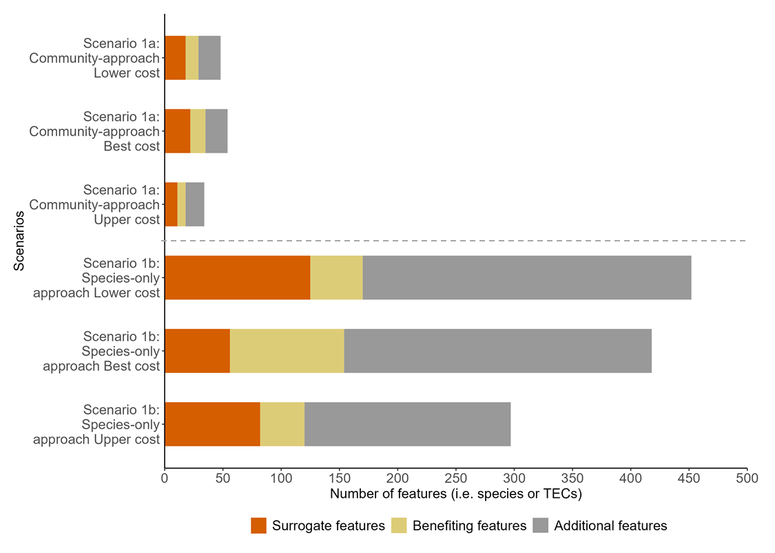
Fig. a1 Number of surrogates, benefiting and additional features (i.e., species or threatened ecological communities (TECs)) per scenario for lower, best and upper cost estimates when the objective is to maximize benefit to threatened species. Only best cost estimates (middle bar for each scenario) are shown in main text

Fig. a2 Number of threatened species that would receive benefit per additional dollar invested under lower, best and upper cost estimates. Cumulative costs are presented in millions of Australian dollars (AUD) per year

Maximizing benefit to species and TECs
As per scenario 1, priority species and TECs under lower and upper costs estimates in scenario 2 follow similar patterns (Fig. a3 and Fig. a4), with higher benefits and cost-effectiveness under lower costs estimates across scenarios (Table A5). Best and upper costs remained consistent, with upper costs presenting the poorest performance in both scenarios (Fig. a3 and Fig. a4).
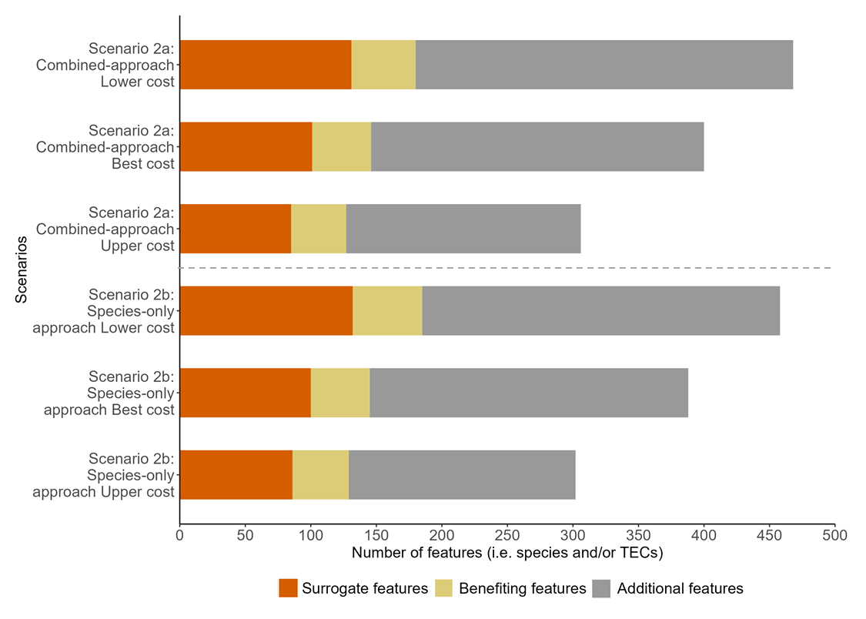
Fig. a3 Number of surrogates, benefiting and additional features (i.e., species or threatened ecological communities (TECs)) per scenario for lower, best and upper cost estimates when the objective is to maximize benefit to threatened species and TECs. Only best cost estimates (middle bar for each scenario) are shown in main text
Fig. a4 Number of threatened species and threatened ecological communities (TECs) that would receive benefit per additional dollar invested under lower, best and upper cost estimates. Cumulative costs are presented in millions of Australian dollars (AUD) per year

Appendix 5: Characteristics of priority species and TECs
Regarding the priority lists featuring the selected surrogate and additional species and TECs, both the species-only list and the combined approach (scenario 2) have similar selections of specific species. The majority of the priority features in the combined-approach list are species, with four TECs being prioritized as management surrogates and 15 identified as additional TECs. More details about the specific species and TECs selected per scenario can be found in Table A8 in Supporting Information (excel format).
Importantly, from each priority list, only two bird species (Thalassarche bulleri platei and Pterodroma mollis) and one mammal (Neophoca cinereal), rely on both terrestrial and marine habitats, thus, would require additional management to address marine-related threats and ensure their full recovery. However, the aim of the study was to maximize conservation benefit to threatened species and ecological communities, not necessarily ensuring each species persistence.

The Akaike Information Criterion (AIC) values of the four generalized linear models tested under our combined-approach scenario (scenario 2a) are presented in Table A6. The model with the lowest AIC was considered the best-fitted model, in this case the model including the interaction between taxa and geographic range. Model results for the best-fit model are shown in Table A7.
Table A6. Akaike Information Criterion (AIC) obtained for each model tested for the combined-approach scenario.
Model type | AIC
With interaction between variables | 1283.8
Without interaction between variables | 1340.9
Geographic range | 1348.2
Taxa | 1610.1
Null | 1630.5

Table A7. Results of the best-fit model for the combined-approach scenario, which included the interaction between taxonomic group and geographic range variables (Significance codes: 0 ‘***’ 0.001 ‘**’ 0.01 ‘*’ 0.05 ‘.’).
Coefficients | Estimate | Std. Error | z value | Pr(>|z|)
taxon Birds | -0.8359869 | 0.5794547 | -1.443 | 0.1491
taxon Fish | -0.4745029 | 0.5249455 | -0.904 | 0.366
taxon Amphibians | -0.5087802 | 0.556406 | -0.914 | 0.3605
taxon Invertebrates | 0.8404119 | 0.3984723 | 2.109 | 0.0349*
taxon Mammals | 1.0214156 | 0.5360661 | 1.905 | 0.0567.
taxon Plants | -0.4465316 | 0.0887212 | -5.033 | 4.83E-07***
taxon Reptiles | 0.7662255 | 0.7064091 | 1.085 | 0.2781
taxon TEC | 8.5381114 | 3.6126477 | 2.363 | 0.0181*
Geographic range | -0.0013478 | 0.0009916 | -1.359 | 0.1741
taxon Fish:Geographic range | -0.0002776 | 0.0017407 | -0.159 | 0.8733
taxon Frogs:Geographic range | 0.0008404 | 0.001082 | 0.777 | 0.4373
taxon Invertebrates:Geographic range | -0.0143411 | 0.0070521 | -2.034 | 0.042*
taxon Mammals:Geographic range | -0.000718 | 0.0013021 | -0.551 | 0.5813
taxon Plants:Geographic range | -0.0008829 | 0.0010429 | -0.847 | 0.3972
taxon Reptiles:Geographic range | -0.0019653 | 0.0020081 | -0.979 | 0.3277
taxon TEC:Geographic range | -1.7027001 | 0.7350911 | -2.316 | 0.0205*

