Supplementary Information

Emerging patterns of genetic diversity in the Critically Endangered Malayan tiger (Panthera tigris jacksoni).

Biodiversity and Conservation

Kate Allberry; Jeffrine Japning Rovie-Ryan; Nur Alizati Nabila Binti Giarat Ali; Nurul-Ain Elias; Mark Rayan Darmaraj; Christopher Chai Thiam Wong; Lau Ching Fong; Olutolani Smith; Khairul Amirin Bin Mohamed; Izereen Bin Amat Mukri; Muhammad Hafiz Bin Mohd Yazid; Matthew J. Struebig; Rob Ogden; Jim J. Groombridge*

*Corresponding Author
J.Groombridge@kent.ac.uk
Durrell Institute of Conservation and Ecology, School of Anthropology and Conservation, University of Kent, Canterbury, UK

Supplementary Table. 1 Mitochondrial primer sets used in this study from Mondol et al. (2009a)

Primer Name | Primer sequence | Amplicon size (bp)
TIGCYT B F2 | CGTCTGTCTATACATGCA | 200
TIGCYT B R2 | TACTCTACTAGGTCGGTC
TIGCYT B F3 | ATGTCTTTTTGAGGGGCA | 191
TIGCYT B R3 | GTATTGGATCCTGTTTCG
TIGCYT B F4 | TTAACCCTAGCAGCAGTC | 184
TIGCYT B R4 | TGTAGTTATCAGGGTCTC

Supplementary Table. 2 Characteristics of 16 microsatellites for tiger used in this study. All loci were optimised from Menotti-Raymond et al. (1999). With the exception of ZN and FCA310, all primers were selected based on a minimum threshold for number of alleles (k = 5) and expected heterozygosity (0.6). The ZN and FCA310 were included in the panel based on documented amplification success (Luo et al. 2004, Smith 2012, Aziz et al. 2017)

Locus | Allele size range (bp) | Region | A | H_{e} | Source
FCA672 | 82-105 | Bandipur, India | 5 | 0.73 | Mondol et al. 2009b
D15 | 119-139 | NS tiger reserve, India | 8 | 0.74 | Bhagavatula and Singh 2006
Fca126 | 134-154 | Terai Arc, India | 7 | 0.65 | Singh et al. 2017
Fca232 | 99-124 | Western Ghats, India | 10 | 0.84 | Mondol et al. 2015
F41 | 111-139 | Sundarbans, Bangladesh | 6 | 0.63 | Aziz et al. 2017
FCA441 | 137-157 | Bandipur, India | 5 | 0.64 | Mondol et al. 2009b
FCA628 | 85-155 | Western Ghats, India | 8 | 0.83 | Mondol et al. 2015
FCA304 | 116-129 | Terai Arc, India | 5 | 0.67 | Singh et al. 2017
FCA229 | 157-170 | Sumatra | 6 | 0.64 | Smith et al. 2018
ZN | 163-166 | Sundarbans, Bangladesh | - | - | Aziz et al. 2017
FCA279 | 99-107 | Sundarbans, Bangladesh | 7 | 0.78 | Aziz et al. 2017
FCA090 | 111-119 | Terai Arc, India | 6 | 0.73 | Singh et al. 2017
FCA310 | 108-137 | Sumatra | 4 | 0.39 | Smith et al. 2018
FCA043 | 111-130 | NS tiger reserve, India | 6 | 0.77 | Bhagavatula and Singh 2006
E7 | 137-151 | Sundarbans, Bangladesh | 5 | 0.56 | Bhagavatula and Singh 2006
FCA230 | 98-115 | Sundarbans, Bangladesh | 7 | 0.54 | Aziz et al. 2017

Supplementary Table. 3 Locus name, primer sequences, annealing temperature (T_{A}), forward primer fluorescent dye (FD), and PCR multiplexes (PM) used in this study

Locus name | Forward sequence | Reverse sequence | T_{A} (°C) | FD | PM
FCA672 | AAGTTGCTTGCACACACTGC | TCCAAGAGCCTTTTCAGTTAGG | 55 | HEX | Set 1
D15 | TGTGACCTTTCTCTAGTTTC | GCACAAAACATTCAGTCTCC | 55 | FAM | Set 1
FCA126 | GCCCCTGATACCCTGAATG | CTATCCTTGCTGGCTGAAGG | 55 | ROX | Set 1
FCA232 | ATGACCATCTCAAACTTCATGG | AGCTGAGTTTGCGTTTATCATG | 55 | HEX | Set 2
F41 | GTCTGCATCTTCAAATAGGA | GTACCTGAGTTGGCTGTTGA | 55 | FAM | Set 2
FCA441 | ATCGGTAGGTAGGTAGATATAG | GCTTGCTTCAAAATTTTCAC | 55 | ROX | Set 2
FCA628 | CCCCTGCTCATTCTCTCTCA | GTGCCTGGCACAGCATAAG | 55 | FAM | Set 3
FCA304 | TCATTGGCTACCACAAAGTAGG | CTGCATGCCATTGGGTAAC | 55 | HEX | Set 3
FCA229 | CAAACTGACAAGCTTAGAGGGC | GCAGAAGTCCAATCTCAAAGTC | 54 | ROX | Set 3
ZN (ZFx/Zfy) | AAGTTTACACAACCACCTGG | CACAGAATTTACACTTGTGCA | 55 | FAM | Set 3
FCA279 | AGCCAAGTAATATTCCTCTGTG | GTCCATCCGCAGATGAATG | 55 | ROX | Set 4
FCA090 | ATCAAAAGTCTTGAAGAGCATGG | TGTTAGCTCATGTTCATGTGTCC | 54 | HEX | Set 4
FCA310 | TTAATTGTATCCCAAGTGGTCA | TAATGCTGCAATGTAGGGCA | 55 | FAM | Set 4
FCA043 | GAGCCACCCTAGCACATATACC | AGACGGGATTGCATGAAAAG | 55 | FAM | Set 5
E7 | GCCCCAAAGCCCTAAAATAA | GCATGTCGGACAGTAAAGCA | 55 | NED | Set 5
FCA230 | AAGAATGGACTTGGGAAATGG | AAACCACAACAGGCAAAAGG | 52 | NED | Set 5

Supplementary Table. 4 GenBank cytochrome-b sequences (n = 103) used for haplotype analysis across five tiger subspecies

Subspecies | Accession numbers | Source
Malayan tiger  (P. t. jacksoni) | EF17935 - EF179376  EU184691-EU184702 | (J. Ryan unpubl. data)
Indochinese tiger  (P. t. corbetti) | KC495059, AF053049  KC879289 - KC879297 | (Dubach et al. 2013)  (Cracraft et al. 1998)
Sumatran tiger  (P. t. sumatrae) | AF053040 - AF053054 | (Cracraft et al. 1998)
Bengal tiger  (P. t. tigris) | AF053018 - AF053025  AF053053 | (Cracraft et al. 1998)
Siberian tiger  (P. t. altaica) | AF053026 - AF053039 | (Cracraft et al. 1998)

Supplementary Table. 5 Total number of samples collected and shared by NGOs in this study

Sampling area | Area (km²) | Protection status | Sampling duration | Samples collected | Sample type | Total # tiger samples | Tiger samples genotyped* | Positive tiger ID
Royal Belum State Park | 1,175 | State Park | 5 months | 80 | Soil/scat | 1 | 1 | 1
Old scat samples |  | - | - | 138 | Scat | 6 | 6 | 6
Amanjaya/Banding Forest Reserve |  | Forest reserve | 1 month | 10 | Scat | 0 | 0 | 0
Temengor Forest Reserve | 1,440 | Forest reserve | 1 month | 28 | Scat | 0 | 0 | 0
Taman Negara National Park |  | National Park | - | 12 | Spray | 12 | 12** | 9
Kenyir |  | None | - | 1 | Scat | 1 | 1 | 1
Primary Linkage 1 (Merapoh) |  | None | - | 21 | Scat | 2 | 2 | 2
Cameron Highlands |  | - | - | 1 | Scat | 1 | 0 | 1
N/A – blood samples |  | - | - | 4 | Blood | 4 | 4 | 4
Total |  |  |  | 295 |  | 27 | 26 | 24
*Genotyped samples include tiger only
**Three wild-sourced tiger spray samples failed to amplify with mitochondrial primers for species ID but were retained for genotyping on the basis of a high degree of confidence that the sample was from tiger from local camera trap monitoring.

Supplementary Table. 6 Population genetic variability at 16 microsatellite loci for samples (n = 22) collected from Peninsular Malaysia

Locus | A | H_{o} | uH_{e**} | PIC | A_{r} | NA | HWE | P_{IDsibs} | S_{g}
FCA441 | 3 | 0.864 | 0.551 | 0.434 | 2.224 | -0.243 | No* | 0.560 | 25
FCA230 | 6 | 0.450 | 0.683 | 0.632 | 3.220 | 0.191 | ND | 0.453 | 23
FCA232 | 2 | 0.000 | 0.097 | 0.090 | 1.281 | 0.735 | ND | 0.908 | 23
FCA090 | 5 | 0.667 | 0.603 | 0.510 | 2.585 | -0.086 | ND | 0.518 | 19
FCA279 | 5 | 0.133 | 0.678 | 0.597 | 2.988 | 0.682 | ND | 0.466 | 15
FCA043 | 5 | 0.222 | 0.660 | 0.580 | 3.072 | ND | ND | 0.484 | 10
E7 | 2 | 0.444 | 0.523 | 0.372 | 1.987 | ND | ND | 0.597 | 9
FCA229 | 6 | 0.091 | 0.844 | 0.778 | 4.075 | 0.797 | ND | 0.363 | 11
FCA628 | 2 | 0.000 | 0.366 | 0.286 | 1.838 | ND | ND | 0.699 | 9
ZN | 2 | 0.000 | 0.303 | 0.239 | 1.773 | ND | ND | 0.751 | 6
FCA310 | 5 | 0.429 | 0.670 | 0.587 | 3.241 | ND | ND | 0.483 | 7
D15 | 4 | 0.429 | 0.758 | 0.646 | 3.261 | ND | ND | 0.434 | 7
FCA672 | 5 | 0.429 | 0.846 | 0.752 | 4.007 | ND | ND | 0.377 | 7
FCA126 | 4 | 0.833 | 0.652 | 0.552 | 3.045 | ND | ND | 0.503 | 6
F41 | 3 | 0.500 | 0.607 | 0.468 | 2.714 | ND | ND | 0.555 | 4
FCA304 | 3 | 0.000 | 0.800 | 0.593 | 3.000 | ND | ND | 0.463 | 3
Mean number of alleles per locus (A), observed heterozygosity (H_{o}), unbiased expected heterozygosity (uH_{e}), Polymorphic Information Content (PIC), Allelic Richness (A_{r}), null alleles (NA), Hardy-Weinberg Equilibrium (HWE), probability of identity for siblings (PID_{sibs}), number of samples successfully genotyped per locus (S_{g}), at 16 microsatellites for 22 individuals. ND = test not done. NS = insignificant result.
*Significant result.
**Unbiased He used to account for small sample sizes at each locus (Nei 1978).

Supplementary Table. 7 Comparison of measures of microsatellite-derived genetic diversity across tiger (Panthera tigris) subspecies

N | N_{s} | Subspecies | Mean H_{o}  (95% CIs) | Mean H_{e}  (95% CIs) | A_{r} (95% CIs) | Country | Source
22 | 16 | P. t. jacksoni  (Malayan tiger) | 0.35±SD 0.036  (0.271±0.409) | 0.60±SD 0.050  (0.50±0.70) | 3.88±SD 1.45  (1.038±6.772) | Malaysia | This study
53 | 10 | P. t. tigris  (Bengal tiger) | 0.37±SD 0.02  (0.331±0.409) | 0.68±SD 0.04  (0.602±0.758) | 5.5±SD 1.65  (2.266±8.734) | Bangladesh (Sundarbans) | (Aziz et al. 2017)
113 | 30 | P. t. tigris  (Bengal tiger) | 0.37±SD 0.009  (0.352±0.388) | 0.72±SD 0.018  (0.685±0.755) | 7.30±SD 2.25  (2.89±11.71) | India | (Luo et al. 2004)
16 | 30 | P. t. sumatrae  Sumatran tiger) | 0.47±SD 0.02  (0.431±0.509) | 0.49±SD 0.03  (0.431±0.549) | 3.60±SD 1.48  (0.699±6.501) | Sumatra | (Luo et al. 2004)
37 | 8 | P. t. tigris  (Bengal tiger) | 0.58±0.170  (0.247±0.913) | 0.57±0.113  (0.348±0.792) | 3.67±2.036  (-0.321±7.661) | Nepal (Chitwan NP) | (Thapa et al. 2018)
33 | 30 | P. t. corbetti  (Indochinese tiger) | 0.64±SD 0.016  (0.609±0.671) | 0.67±SD 0.027  (0.617±0.723) | 6±SD 1.81  (2.452±9.548) | Northern Indochina (Thailand; Cambodia) | (Luo et al. 2004)
34 | 30 | P. t. altaica  (Amur tiger) | 0.47±SD 0.016  (0.439±0.501) | 0.46±SD 0.040  (0.382±0.538) | 3.47±SD 1.22  (1.079±5.861) | Russian Far East | (Luo et al. 2004)
Number of samples (N), Number of loci (N_{s}), observed heterozygosity (H_{o}), expected heterozygosity (H_{e}), allelic richness (A_{r})
*Unbiased He used to account for small sample sizes at each locus (Nei, 1978)

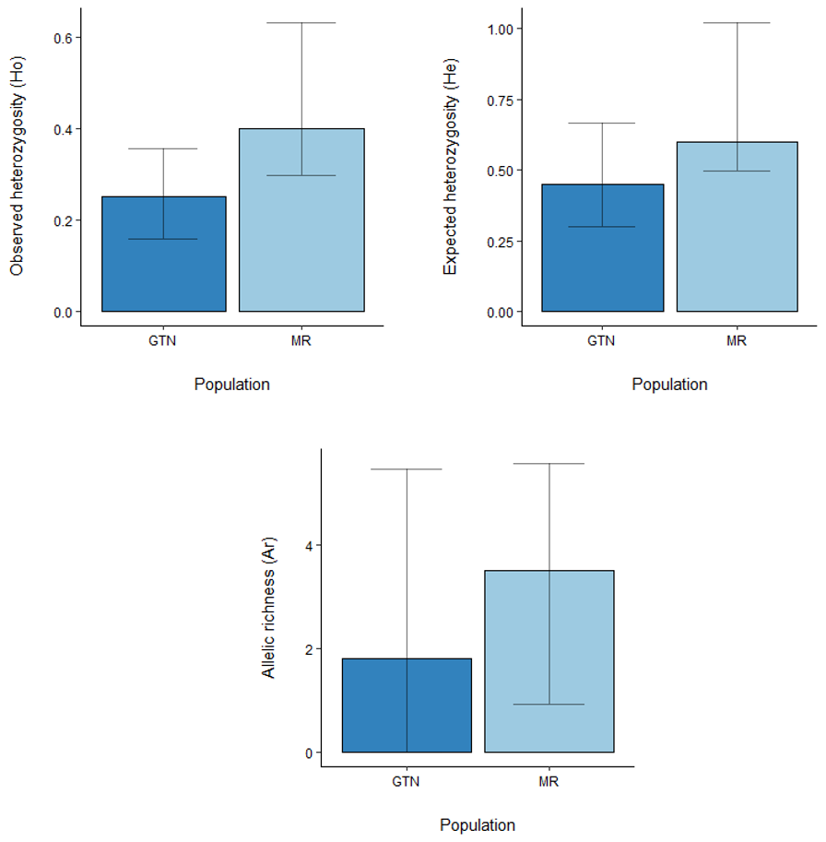

Supplementary Fig. S1 Comparison of nuclear genetic diversity between the MR (light blue), and the GTN region (dark blue) with 95% confidence intervals represented by error bars. a) Expected heterozygosity (H_{e}); b) Observed heterozygosity (H_{o}), and c) Allelic richness (A_{r}). Where the lower 95% confidence interval for A_{r} was below 0 (-0.250), the lower limit was set to 0 to reflect the nature of the data (i.e. a minus value for A_{r} (number of alleles) is not possible)

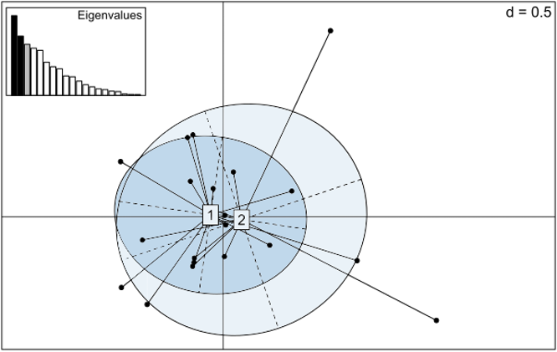
Supplementary Fig. S2 PCA of k = 2 subpopulations to summarise the genetic diversity within and between sample groups. The principal components of the analysis are the artificial variables summarising genetic diversity, visualised here as a scatterplot. The eigenvalues indicate the amount of variance represented by each principal component. Samples from the GTN subpopulation (n = 13) are represented by the dark blue ellipsis (1) and samples from the MR subpopulation (n = 9) are represented by the light blue ellipsis (2)

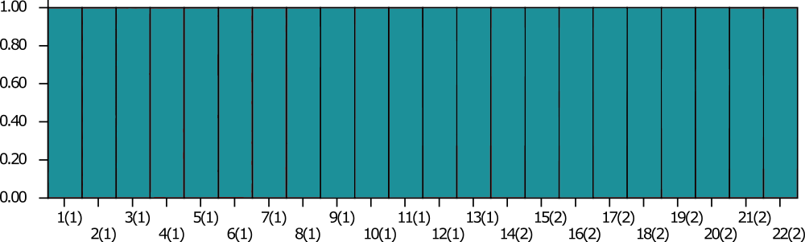
(a)

(b)

Supplementary Fig. S3 STRUCTURE bar plots for 22 individual tigers assigned to each of k clusters under the admixture model (plot a) and population informed model (plot b). Plots are grouped by two pre-defined putative populations: Greater Taman Negara (1) and Main Range (2). Each vertical bar represents an individual tiger and is coloured according to the individual’s estimated ancestral coefficient values (Q). Both plots are based on 16 loci and suggest no distinct population structure with a single ancestral cluster (k = 1)

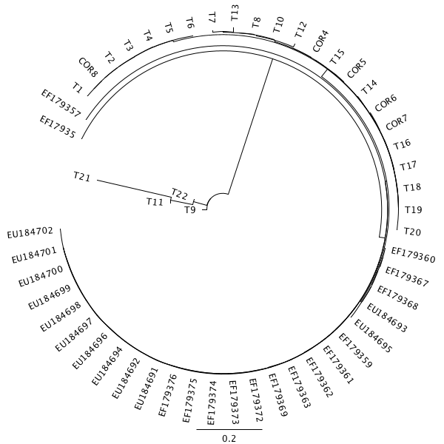

Supplementary Fig. S4 Alignment of 174bp new cytochrome-b sequences in this study (T1-T22) with mtDNA haplotypes from Luo et al. 2004 (COR4, COR5, COR6, COR7, COR8) and sequences from J. Ryan unpubl. data (EF17935 - EF179376 and EU184691-EU184702).

Supplementary Fig. S5 Haplotype network of five tiger subspecies based on a 136bp cytochrome-b fragment from 103 individual tigers. Leopard (yellow) and lion (orange) haplotypes are included as outgroups. 14 haplotypes (H9-H22) are identified. Each circle denotes one haplotype, with coloured pie segments representing the membership of each subspecies of individual tigers

