Supplementary Information

Online Resource 1: Species rarefaction curve for Bukit Timah Nature Reserve juxtaposed with species rarefaction curves for (a) Singapore Botanic Gardens Rainforest and (b) Learning Forest, both with 95% confidence intervals
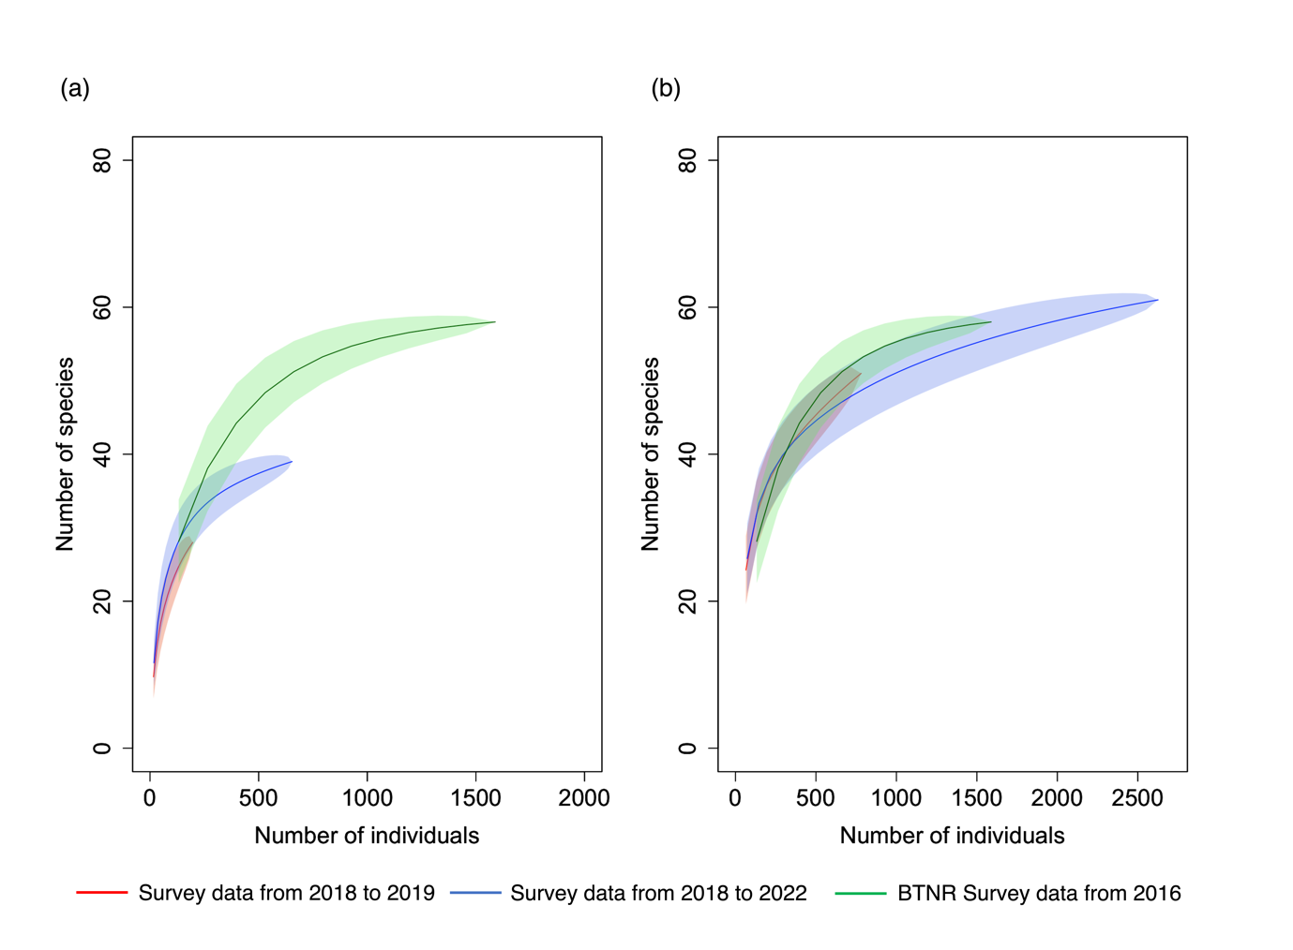
Online Resource 2: Definitions for the origin of each bird species used in the analysis as defined in Yong et al. (2017).
Origin
native | occur naturally and are generally present throughout the year
introduced | introduced by humans and have established breeding populations in Singapore
migratory | undertake seasonal movements and occur annually

Online Resource 3: Definitions of the habitat specialisations, feeding guilds and foraging strata of each species used in the analysis.
Habitat specialisation
forest | primarily in wooded habitats
generalist | primarily in other habitats such as parkland and open country
Feeding Guild
omnivore | fruits and/or nectar as well as small animals
carnivore | arthropods as well as other animals
frugivore | mostly fruits such as figs
insectivore | mostly arthropods
nectarivore | mostly nectar from flowers
granivore | grass seeds and other grains
Foraging strata
ground | predominantly inhabit the forest floor and up to 2 metres above the ground
understorey | predominantly inhabit shrubs or low trees 2 to 5 metres above the ground
canopy | predominantly inhabit the tree canopy above 5 metres from ground level
mixed | readily move between multiple layers

Online Resource 4: Species list for all forest communities covered in this study.

Common Name | Scientific Name | Origin | Habitat Specialisation | Feeding Guild | Foraging Strata | Contem SBGR | 1998 SBGR | 1898 SBGR | LF | BTNR
Abbott’s Babbler | Malacocincla abbotti | Native | Forest-specialist | Insectivore | Understorey |  | √
Ashy Tailorbird | Orthotomus ruficeps | Native | Generalist | Insectivore | Understorey |  |  | √ | √
Asian Fairy-bluebird | Irena puella | Native | Forest-specialist | Frugivore | Canopy |  |  |  |  | √
Asian Glossy Starling | Aplonis panayensis | Native | Generalist | Omnivore | Canopy | √ | √ | √ | √ | √
Asian Koel | Eudynamys scolopaceus | Native | Generalist | Omnivore | Canopy | √ | √ |  | √
Asian Red-eyed Bulbul | Pycnonotus brunneus | Native | Forest-specialist | Omnivore | Canopy | √ |  |  | √ | √
Banded Bay Cuckoo | Cacomantis sonneratii | Native | Forest-specialist | Insectivore | Canopy |  |  |  | √ | √
Banded Woodpecker | Chrysophlegma miniaceum | Native | Forest-specialist | Insectivore | Canopy | √ | √ |  | √ | √
Black-crested Bulbul | Rubigula flaviventris | Introduced | Forest-specialist | Omnivore | Canopy |  |  |  |  | √
Barred Buttonquail | Turnix suscitator | Native | Generalist | Granivore | Ground |  |  | √
Black-naped Oriole | Oriolus chinensis | Native | Generalist | Omnivore | Canopy | √ | √ | √ | √ | √
Blue-breasted Quail | Coturnix chinensis | Native | Generalist | Granivore | Ground |  |  | √
Blue-crowned Hanging Parrot | Loriculus galgulus | Native | Generalist | Frugivore | Canopy | √ | √ |  | √ | √
Blue-eared Kingfisher | Alcedo meninting | Native | Forest-specialist | Carnivore | Understorey |  |  | √ |  | √
Blue-rumped Parrot | Psittinus cyanurus | Native | Forest-specialist | Frugivore | Canopy |  |  |  | √ | √
Blue-throated Bee-eater | Merops viridis | Native | Generalist | Insectivore | Canopy | √ | √ |  | √ | √
Blue-winged Leafbird | Chloropsis cochinchinensis | Native | Forest-specialist | Frugivore | Canopy |  |  |  |  | √
Brahminy Kite | Haliastur indus | Native | Generalist | Carnivore | Canopy |  |  | √ | √
Brown-throated Sunbird | Anthreptes malacensis | Native | Generalist | Nectarivore | Mixed | √ | √ | √ | √ | √
Changeable Hawk-Eagle | Nisaetus cirrhatus | Native | Forest-specialist | Carnivore | Canopy | √ | √ | √ |  | √
Chestnut-bellied Malkoha | Phaenicophaeus sumatranus | Native | Forest-specialist | Insectivore | Canopy |  |  |  |  | √
Cinereous Bulbul | Hemixos cinereus | Native | Forest-specialist | Omnivore | Canopy |  |  |  |  | √
Coconut Lorikeet | Trichoglossus haematodus | Introduced | Generalist | Frugivore | Canopy |  |  |  | √
Collared Kingﬁsher | Todiramphus chloris | Native | Generalist | Carnivore | Understorey |  | √ |  | √
Common Emerald Dove | Chalcophaps indica | Native | Forest-specialist | Frugivore | Ground |  |  | √ |  | √
Common Flameback | Dinopium javanense | Native | Generalist | Insectivore | Canopy | √ |  | √ | √ | √
Common Hill Myna | Gracula religiosa | Native | Forest-specialist | Omnivore | Canopy | √ | √ | √ | √ | √
Common Iora | Aegithina tiphia | Native | Generalist | Insectivore | Canopy | √ | √ | √ | √
Common Myna | Acridotheres tristis | Native | Generalist | Omnivore | Mixed |  | √
Common Tailorbird | Orthotomus sutorius | Native | Generalist | Insectivore | Understorey | √ |  |  | √ | √
Coppersmith Barbet | Megalaima haemacephala | Native | Generalist | Frugivore | Canopy |  | √
Cream-vented Bulbul | Pycnonotus simplex | Native | Forest-specialist | Omnivore | Canopy |  |  |  |  | √
Crimson Sunbird | Aethopyga siparaja | Native | Forest-specialist | Nectarivore | Understorey | √ | √ | √ | √ | √
Dark-necked Tailorbird | Orthotomus atrogularis | Native | Forest-specialist | Insectivore | Understorey | √ | √ |  | √ | √
Dark-sided Flycatcher | Muscicapa sibirica | Migratory | Forest-specialist | Insectivore | Canopy |  |  |  |  | √
Golden-bellied Gerygone | Gerygone sulphurea | Native | Generalist | Insectivore | Canopy |  |  |  | √
Greater Coucal | Centropus sinensis | Native | Forest-specialist | Carnivore | Understorey |  | √ |  |  | √
Greater Green Leafbird | Chloropsis sonnerati | Native | Forest-specialist | Frugivore | Canopy |  |  |  |  | √
Greater Racket-tailed Drongo | Dicrurus paradiseus | Native | Forest-specialist | Insectivore | Mixed | √ | √ | √ | √ | √
Green Broadbill | Calyptomena viridis | Native | Forest-specialist | Frugivore | Mixed |  |  | √
Grey Heron | Ardea cinerea | Native | Generalist | Carnivore | Mixed |  |  |  | √
Grey-headed Fish Eagle | Haliaeetus ichthyaetus | Native | Forest-specialist | Carnivore | Canopy |  |  |  | √
Grey-rumped Treeswift | Hemiprocne longipennis | Native | Generalist | Insectivore | Canopy |  | √
House Crow | Corvus splendens | Introduced | Generalist | Omnivore | Canopy |  | √
Javan Myna | Acridotheres javanicus | Introduced | Generalist | Omnivore | Mixed | √ | √ |  | √ | √
Laced Woodpecker | Picus vittatus | Native | Forest-specialist | Insectivore | Mixed | √ |  |  | √
Large-billed Crow | Corvus macrorhynchos | Native | Forest-specialist | Omnivore | Canopy | √ | √ | √ | √
Lesser Coucal | Centropus bengalensis | Native | Generalist | Carnivore | Understorey |  |  | √ |  | √
Lesser Green Leafbird | Chloropsis cyanopogon | Native | Forest-specialist | Frugivore | Canopy |  |  |  |  | √
Lineated Barbet | Psilopogon lineatus | Introduced | Generalist | Frugivore | Canopy | √ |  |  | √ | √
Little Bronze Cuckoo | Chrysococcyx minutillus | Native | Generalist | Insectivore | Canopy |  |  |  | √
Little Spiderhunter | Arachnothera longirostra | Native | Forest-specialist | Nectarivore | Understorey |  |  | √ |  | √
Long-tailed Parakeet | Psittacula longicauda | Native | Generalist | Frugivore | Canopy | √ | √ | √ | √ | √
Malayan Pied Fantail | Rhipidura javanica | Native | Generalist | Insectivore | Understorey |  |  |  | √
Olive-backed Sunbird | Cinnyris jugularis | Native | Generalist | Nectarivore | Mixed | √ |  |  | √
Olive-winged Bulbul | Pycnonotus plumosus | Native | Forest-specialist | Omnivore | Mixed | √ | √ | √ | √ | √
Orange-bellied Flowerpecker | Dicaeum trigonostigma | Native | Forest-specialist | Nectarivore | Canopy | √ | √ |  | √ | √
Oriental Dollarbird | Eurystomus orientalis | Native | Forest-specialist | Insectivore | Canopy | √ | √ | √ | √ | √
Oriental Magpie-Robin | Copsychus saularis | Native | Forest-specialist | Insectivore | Understorey | √ | √ | √ | √
Oriental Pied Hornbill | Anthracoceros albirostris | Native | Generalist | Omnivore | Canopy | √ |  |  | √
Oriental White-eye | Zosterops palpebrosus | Introduced | Generalist | Omnivore | Canopy |  |  |  |  | √
Pied Imperial Pigeon | Ducula bicolor | Native | Generalist | Frugivore | Canopy | √ |  |  | √
Pin-striped Tit-Babbler | Mixornis gularis | Native | Forest-specialist | Insectivore | Understorey | √ | √ |  | √ | √
Pink-necked Green Pigeon | Treron vernans | Native | Generalist | Frugivore | Canopy | √ | √ | √ | √ | √
Plaintive Cuckoo | Cacomantis merulinus | Native | Forest-specialist | Insectivore | Canopy |  |  | √ |  | √
Red Junglefowl | Gallus gallus | Native | Forest-specialist | Omnivore | Ground | √ |  |  | √ | √
Red-breasted Parakeet | Psittacula alexandri | Introduced | Generalist | Frugivore | Canopy |  |  |  | √
Red-crowned Barbet | Psilopogon rafflesii | Native | Forest-specialist | Frugivore | Canopy |  |  |  |  | √
Red-whiskered Bulbul | Pycnonotus jocosus | Introduced | Generalist | Omnivore | Canopy | √ |  |  | √
Rose-ringed Parakeet | Psittacula krameri | Introduced | Generalist | Frugivore | Canopy |  |  |  | √
Rhinoceros Hornbill | Buceros rhinoceros | Native | Forest-specialist | Frugivore | Canopy |  |  | √
Rock Pigeon | Columba livia | Introduced | Generalist | Omnivore | Mixed |  | √
Rufous Woodpecker | Micropternus brachyurus | Native | Forest-specialist | Insectivore | Canopy |  |  | √ | √ | √
Rufous-tailed Tailorbird | Orthotomus sericeus | Native | Forest-specialist | Insectivore | Understorey |  |  |  |  | √
Rusty-breasted Cuckoo | Cacomantis sepulcralis | Native | Forest-specialist | Insectivore | Canopy |  |  |  |  | √
Scarlet-backed Flowerpecker | Dicaeum cruentatum | Native | Generalist | Nectarivore | Canopy | √ | √ |  | √ | √
Short-tailed Babbler | Pellorneum malaccense | Native | Forest-specialist | Insectivore | Understorey |  |  |  |  | √
Spotted Dove | Spilopelia chinensis | Native | Generalist | Omnivore | Ground | √ | √ | √ | √
Straw-headed Bulbul | Pycnonotus zeylanicus | Native | Forest-specialist | Omnivore | Mixed |  |  |  | √ | √
Stork-billed Kingfisher | Pelargopsis capensis | Native | Generalist | Carnivore | Understorey |  |  |  | √
Square-tailed Drongo-Cuckoo | Surniculus lugubris | Native | Forest-specialist | Insectivore | Canopy |  |  | √ |  | √
Sulphur-crested Cockatoo | Cacatua galerita | Introduced | Generalist | Frugivore | Canopy |  |  |  | √
Sunda Pygmy Woodpecker | Dendrocopos moluccensis | Native | Generalist | Insectivore | Canopy |  |  | √
Sunda Scops Owl | Otus lempiji | Native | Forest-specialist | Carnivore | Understorey |  |  |  | √
Swinhoe’s White-eye | Zosterops simplex | Introduced | Generalist | Omnivore | Canopy |  |  |  | √
Tanimbar Corella | Cacatua goffiniana | Introduced | Generalist | Frugivore | Canopy | √ | √
Thick-billed Green Pigeon | Treron curvirostra | Native | Forest-specialist | Frugivore | Canopy |  |  |  |  | √
Van Hasselt’s Sunbird | Leptocoma brasiliana | Native | Forest-specialist | Nectarivore | Canopy |  |  |  |  | √
Violet Cuckoo | Chrysococcyx xanthorhynchus | Native | Forest-specialist | Insectivore | Canopy |  | √ |  | √ | √
White-bellied Sea Eagle | Haliaeetus leucogaster | Native | Generalist | Carnivore | Canopy |  |  | √ | √ | √
White-breasted Waterhen | Amaurornis phoenicurus | Native | Generalist | Carnivore | Ground | √ |  |  | √ | √
White-crested Laughingthrush | Garrulax leucolophus | Introduced | Forest-specialist | Insectivore | Understorey | √ |  |  | √ | √
White-rumped Munia | Lonchura striata | Native | Forest-specialist | Granivore | Understorey |  |  |  | √
White-rumped Shama | Copsychus malabaricus | Native | Forest-specialist | Insectivore | Understorey |  |  |  | √
White-throated Kingfisher | Halcyon smyrnensis | Native | Generalist | Carnivore | Understorey | √ | √ | √ | √
Yellow Bittern | Ixobrychus sinensis | Native | Generalist | Carnivore | Mixed |  |  |  | √
Yellow-vented Bulbul | Pycnonotus goiavier | Native | Generalist | Omnivore | Canopy | √ | √ | √ | √ | √

Online Resource 5: Firth’s regression models that were fitted for model selection, with extinction probability as the response variable and combinations of body mass, wing-to-tarsus ratio and feeding guild as explanatory variables.
Extinction probability ~ | df | AICc | ΔAIC | Weight
body mass + wing-to-tarsus ratio | 3 | 31.8 | 0.00 | 0.603
body mass | 2 | 32.7 | 0.95 | 0.375
feeding guild + body mass + wing-to-tarsus ratio | 6 | 39.8 | 7.99 | 0.011
feeding guild + body mass | 5 | 40.1 | 8.31 | 0.009
wing-to-tarsus ratio | 2 | 44.4 | 12.60 | 0.001
null model | 1 | 45.5 | 13.72 | 0.001
feeding guild + wing-to-tarsus ratio | 5 | 51.6 | 19.81 | 0.000
feeding guild | 4 | 52.1 | 20.36 | 0.000

