Supplementary Materials 1

Table S1. Seafloor invertebrate taxa (operational taxonomic unit [OTU] and common name) for which abundance data (as individuals per 1000 m²) were used in development of Joint Species Distribution Models (JSDMs). Orange cells represent VME indicator taxa recognised by the South Pacific Regional Fisheries Management Organisation (SPRFMO) which were used specifically for mapping VME indices (grey cells represent taxa that are VME indicator taxa but which were not used to map VME indices - see Methods for rationale). The number of individual OTU encompassed by each taxon (N) and the number of sites at which each taxon occurred (Site) are provided for context.
Phylum | Class | Sub class | OTU | Common name | N OTU | Site
Annelida | Polychaeta |  | Polychaeta | Polychaete worms | 10 | 136
 |  | Palpata | Hyalinoecia spp. | Quill worms | 1 | 149
Arthropoda | Hexanauplia | Thecostraca | Barnacles | Barnacles | 1 | 12
 | Malacostraca | Eumalacostraca | Brachyura | True crabs | 17 | 204
 |  |  | Caridea | Shrimps and prawns | 8 | 325
 |  |  | Crustacean (lobster) | Lobsters | 2 | 11
 |  |  | Galatheidae / Chirostylidae | Squat lobsters | 6 | 253
 |  |  | Paguridae | Hermit crabs | 1 | 373
 |  |  | Lithodidae | King crabs | 2 | 5
 |  |  | Metanephrops challengeri | Scampi | 2 | 109
 |  |  | Serolidae | Serolid isopods | 3 | 63
 | Pycnogonida |  | Pycnogonida | Sea spiders | 2 | 42
Brachiopoda | Rhynconellata |  | Brachiopoda | Lamp shells | 2 | 90
Bryozoa | Gymnolaemata |  | Bryozoa | Bryozoans | 9 | 279
Chordata | Ascidiacea |  | Ascidiacea | Sea squirts | 7 | 206
Cnidaria | Anthozoa | Hexacorallia | Anemones | Anemones | 31 | 409
 |  |  | Antipatharia | Black corals | 7 | 46
 |  |  | Ceriantharia | Cerianthid anemones | 1 | 220
 |  |  | Corallimorpharia | Corallimorpharia | 5 | 41
 |  |  | Caryophylliidae | Solitary corals | 2 | 97
 |  |  | Stephanocyathus spp. | Solitary coral | 1 | 25
 |  |  | Enallopsammia spp. | Stony coral | 1 | 7
 |  |  | Flabellum spp. | Solitary coral | 7 | 220
 |  |  | Goniocorella dumosa | Stony coral | 1 | 69
 |  |  | Madrepora spp. | Stony coral | 1 | 8
 |  |  | Solenosmillia variabilis | Stony coral | 1 | 9
 |  |  | Epizoanthidae | Commensal zoanthid | 1 | 35
 |  |  | Zoanthidea | Zoanthid | 1 | 53
 |  | Octocorallia | Alcyonacea‡ | Soft corals | 5 | 86
 |  |  | Taiaroa tauhou | Solitary soft coral | 1 | 111
 |  |  | Anthomastus spp. | Soft coral | 1 | 116
 |  |  | Telesto spp. | Soft coral | 1 | 42
 |  |  | Gorgonacea^{ᵻ} | Branching erect soft corals | 4 | 114
 |  |  | Isididae | Bamboo corals | 3 | 53
 |  |  | Paragorgiidae | Bubblegum corals | 2 | 3
 |  |  | Primnoidae | Primnoid soft coals | 6 | 65
 |  |  | Radicipes spp. | Spiral whip corals | 1 | 74
 |  |  | Pennatulaceaᶫ | Sea pens | 12 | 172
 |  |  | Kophobelemnon spp. | Sea pen | 1 | 30
 | Hydrozoa | Hydroidolina | Stylasteridae | Hydrocorals | 4 | 109
 |  |  | Hydrozoa | Hydroids | 2 | 271
Echinodermata | Asteroidea |  | Asteroidea | Sea stars | 37 | 429
 |  |  | Brisingidae | Suspension-feeding sea stars | 5 | 93
 | Crinoidea | Articulata | Crinoidea (stalked) | Sea lilies | 1 | 14
 |  |  | Crinoidea (motile) | Sea lilies | 2 | 98
 | Echinoidea | Cidaroidea | Cidaroidea | Pencil urchins | 7 | 206
 |  | Euechinoidea | Euechinoidea | Regular urchins | 12 | 203
 |  |  | Dermechinus horridus | Urchin | 1 | 27
 |  |  | Echinothurioida | Tam O’shanter urchins | 4 | 166
 |  |  | Spatangoida | Burrowing urchins | 3 | 190
 | Holothuroidea |  | Holothuroidea | Sea cucumbers | 31 | 235
 |  |  | Enypniastes eximia | Swimming sea cucumber | 1 | 18
 | Ophiuroidea |  | Ophiuroidea | Brittle stars | 12 | 143
 |  |  | Gorgonocephalidae | Basket stars | 2 | 17
Echiura |  |  | Echiura | Spoon worms | 1 | 23
Foraminifera |  |  | Xenophyophoroidea | Giant forams | 2 | 96
Mollusca | Bivalvia |  | Bivalvia | Bivalves | 6 | 47
 | Gastropoda |  | Gastropoda | Snails (grazing) | 12 | 305
 |  |  | Buccinidae & Ranellidae | Whelks | 2 | 343
 |  |  | Volutidae | Large predatory snail | 3 | 172
 |  |  | Scaphopoda | Tusk shells | 1 | 36
 |  |  | Nudibranchia | Sea slugs | 4 | 49
 | Cephalopoda | Coleoidea | Octopoda | Octopus | 7 | 91
Porifera | Demospongiae |  | Demospongiae | Common sponges | 51 | 316
 |  | Heteroscleromorpha | Cladorhizidae | Cladorhizidae | 25 | 32
 | Hexactinellida |  | Hexactinellida | Glass sponges | 34 | 148
 |  |  | Hyalascus spp. | Glass sponge | 1 | 37
‡ The order Alcyonacea is no longer accepted as a taxonomic group, but is used to represent the VME indicator taxon used by SPRFMO to identify “true soft corals” excluding Gorgonacea (see below).
^{ᵻ} The order Gorgonacea is no longer accepted as a taxonomic group, but is used to here represent the VME indicator taxon used by SPRFMO to identify “sea fans”; suborders Holaxonia, Calcaxonia and Scleraxonia of the Octocorallia.
ᶫ Pennatulacea is used here to represent those taxa in the Order Pennatuloidea.

Table S2. Explanatory variables considered for use in Joint Species Distribution Models (JSDMs). The environmental variables are grouped into four categories: seafloor characteristics, water chemistry, water physics, and productivity. The symbol * represents those variables upscaled by Georgian et al. (2019) and the symbol ++ those variables upscaled by Stephenson et al. (2022). Highlighted cells represent those variables selected in the final model (see section Joint Species Distribution Modelling for further information – spatial distributions of these explanatory variables are available in Figure S1, Supplementary Materials 1).

Variable | Name | Units | Native resolution | Description | Reference
Seafloor characteristics
Depth * | bathy | m | 1 km² | Depth at the seafloor was interpolated from contours generated from various sources, including multi-beam and single-beam echo sounders, satellite gravimetric inversion, and others (Mitchell et al., 2012). | NIWA bathymetry
Depth standard deviation * | std | – | – | Calculated from the bathy layer, using window sizes of 15 grid cells. | Derived from bathy
Profile curvature * | profcurv | – | – | Calculated from the bathy layer. | Derived from bathy
Bathymetric Position Index – broad * | bpi_broad | – | – | Terrain metrics were calculated using an inner annulus of 12 km and a radius of 62 km using the NIWA bathymetry layer in the Benthic Terrain Modeler in ArcGIS 10.3.1.1 (Wright et al., 2012). Bathymetric Position Index (BPI) is a measure of where a referenced location is relative to the locations surrounding it. | Derived from bathy
Trawl history | trawl | m² | 5 km² | Trawl swept area per 5 x 5 km grid cell for the period 1989 to 2016 | (Baird and Wood, 2018)
Water chemistry
Dissolved oxygen * | dissox | ml l⁻¹ | 1° | Annual average water oxygen concentration at the seafloor. | Stephenson et al., 2022
Salinity * | salinity | psu | 0.25° | Annual average water salinity concentration at the seafloor. | Stephenson et al., 2022
Silicate ⁺⁺ | silicate | μmol l⁻¹ | 1° | Annual average water silicate concentration at the seafloor. | Stephenson et al., 2022
Water physics
Temperature residuals ⁺⁺ | tempres | °C | 0.25° | Residuals from a GLM relating temperature to depth using natural splines – this highlights areas where average temperature is higher or lower than would be expected for any given depth (Leathwick et al., 2006). | Derived from temperature and depth; Stephenson et al., 2022
Dynamic topography ⁺⁺ | dynoc | m | 0.25° | Quantifies anomalies in sea surface height against 20-y mean, based on satellite altimetry data. Useful for identifying oceanic fronts, mesoscale structure. | http://www.aviso.oceanobs.com
Tidal current speed | tidalcurr | ms⁻¹ | 1 km² | Maximum depth-averaged (NZ bathymetry) flows from tidal currents calculated from a tidal model for New Zealand waters (Walters et al., 2001) | Stephenson et al., 2022
Sea surface temperature gradient | sstgrad | °C km⁻¹ | 1 km² | Smoothed magnitude of the spatial gradient of annual mean SST. This indicates frontal locations where mixing of different water bodies is occurring (Leathwick et al., 2006) | Stephenson et al., 2022
Productivity
Eppley-VGPM * | epp_mean | mg C m⁻² d⁻¹ | 0.167° | Net primary production in the surface mixed layer estimated by the Eppley-modified Vertically Generalised Production Model (Behrenfeld and Falkowski, 1997) | Oregon State University
Carbon-Based Productivity Model-2 * | cbpm | mg C m⁻² d⁻¹ | 0.167° | Net primary production in the surface mixed layer estimated by the Carbon-Based Productivity Model-2 (Behrenfeld et al., 2005;Westberry et al., 2008). | Oregon State University
Seabed POC flux ⁺⁺ | flux | mg C m⁻² d⁻¹ | 9 km² | Net primary production in the surface mixed layer estimated as the VGPM model exported to the seabed. Export fraction and flux attenuation factor with depth estimated by refitting sediment trap and thorium-based measurements to environmental data (VGPM, SST) as Kaiser et al. (2023);Lutz et al. (2002);Pinkerton (2016) and using data from Cael et al. (2018). | NIWA

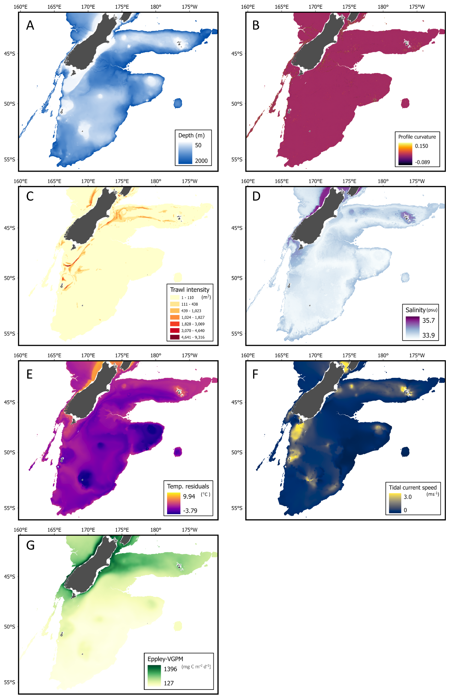
Figure S1. Spatial distribution of explanatory variables used in joint species distribution modelling: A) Depth; B) Profile curvature; C) Trawl history; D) Salinity; E) Temperature residuals; F) Tidal current speed; G) Mean Eppley-VGPM.

Table S3. Vulnerability score of VME indicator morphotypes to bottom trawling
Taxon | SPRFMO VME indicator taxa | Vulnerability score | Morphotype | Notes
Alcyonacea | Alcyonacea | 2.05906846 | octocorals_fleshy_arborescent-alcyonacea; octocorals_fleshy_mushroom-alcyonacea | average these two classes
Anemones | Actinaria | 1.957890021 | anemones_solitary-actiniaria
Anthomastus sp. | Alcyonacea | 1.957890021 | octocorals_fleshy_mushroom-alcyonacea
Antipatharia | Antipatharia | 2.273030283 | octocorals_seafan_fern_simple-antipatharia
Ascidiacea
Asteroidea
Barnacles
Bivalvia
Brachiopoda
Brachyura
Brisingidae | Brisingidae | 2.097617696 | Echinoderms_Feather stars_Unstalked-crinoids | No appropriate label in standard CATAMI list. Use same vulnerability as for unstalked crinoids
Bryozoa | Bryozoa | 2.177326603 | bryozoans_hard_branching-bryozoans; bryozoans_hard_encrusting-bryozoans; bryozoans_hard_fenestrate-bryozoans; bryozoans_soft_dendroid-bryozoans; bryozoans_soft_foliaceous-bryozoans | average all CATAMI codes except 'massive'
Buccinidae
Caridea
Caryophylliidae | Scleractinia | 2.776388541 | stony_corals_solitary-scleractinia
Ceriantharia | Actinaria | 1.695582496 | anemones_solitary-corallimorpharia | Burrowing taxon, so choose lowest anmeone value
Cidaroidea
Cladorhizidae | Porifera | 2.457980201 | sponges_erect_1d-porifera | selected lowest sponge value
Corallimorpharia
Crinoidea (motile) | Crinoidea | 2.097617696 | Echinoderms_Feather stars_Unstalked-crinoids | Added relevant CATAMI label then scored as for stalked but reducing 'rareness' and 'sessility' from 3 to 2
Crinoidea (stalked) | Crinoidea | 2.720294102 | crinoid_stalked-crinoid_stalked
Crustacean lobster
Demospongiae | Porifera | 2.776388541 | sponges_erect_2d-porifera | selected mid-vulnerability category from CATAMI sponges
Dermechinus horridus
Echinothurioida
Echiura
Enypniastes.eximia
Epizoanthidae | Zoantharia | 2.549509757 | anemones_colonial-zoantharia | review: commensal so consider adjusting vulnerability downwards
Euechinoidea
Flabellum | Scleractinia | 2.62202212 | stony_corals_solitary_free-scleractinia
Galatheidae Chirostylidae
Gastropoda
Goniocorella dumosa | Scleractinia | 2.776388541 | stony_corals_colonial-scleractinia
Gorgonacea | Gorgonacea | 2.624256248 | octocorals_bottle_brush_complex-gorgonacea; octocorals_bottle_brush_simple-gorgonacea; octocorals_branching_arborescent-gorgonacea; octocorals_branching_bushy-gorgonacea; octocorals_seafan_flexible-gorgonacea; octocorals_whip-gorgonacea | average all Gorgonacea
Gorgonocephalidae
Hexactinellida | Porifera | 2.776388541 | sponges_erect_2d-porifera | selected mid-vulnerability category
Holothuroidea
Hyalascus sp. | Porifera | 2.776388541 | sponges_cup_tube_chimney-porifera
Hyalinoecia sp.
Hydrozoa | Hydrozoa | 2.549509757 | hydroids_colonial_feather-hydroidolina | All in jSDM are bushy colonial
Isididae | Gorgonacea | 2.62202212 | octocorals_branching_arborescent-gorgonacea
Kophobelemnon sp. | Pennatulacea | 2.389211864 | octocorals_quill-pennatulacea
Metanephrops challengeri
Nudibranchia
Octopoda
Ophiuroidea
Paguridae
Pennatulacea | Pennatulacea | 2.389211864 | octocorals_quill-pennatulacea | In jSDM data most are 'quill' form
Polychaeta
Primnoidae | Gorgonacea | 2.62202212 | octocorals_branching_arborescent-gorgonacea
Psolidae
Pycnogonida
Radicipes sp | Gorgonacea | 2.423839929 | octocorals_whip-gorgonacea
Ranellidae
Scaphopoda
Scleractinia | Scleractinia | 2.776388541 | stony_corals_colonial-scleractinia | in jSDM data all are 'colonial'
Serolidae
Siphonophore
Spatangoida
Stephanocyathus sp | Scleractinia | 2.776388541 | stony_corals_solitary-scleractinia
Stylasteridae | Stylasteridae | 2.614064524 | hydrocorals_branching-stylasterids
Taiaroa tauhou | Gorgonacea | 1.695582496 | anemones_solitary-corallimorpharia | review: burrowing, small, solitary - use burrowing anemone value from CATAMI
Telesto sp. | Gorgonacea | 2.776388541 | octocorals_branching_bushy-gorgonacea | review: very small - adjust vulnerability
Volutidae
Worm indet
Xenophyophoroidea
Zoanthidea | Zoantharia | 2.549509757 | anemones_colonial-zoantharia

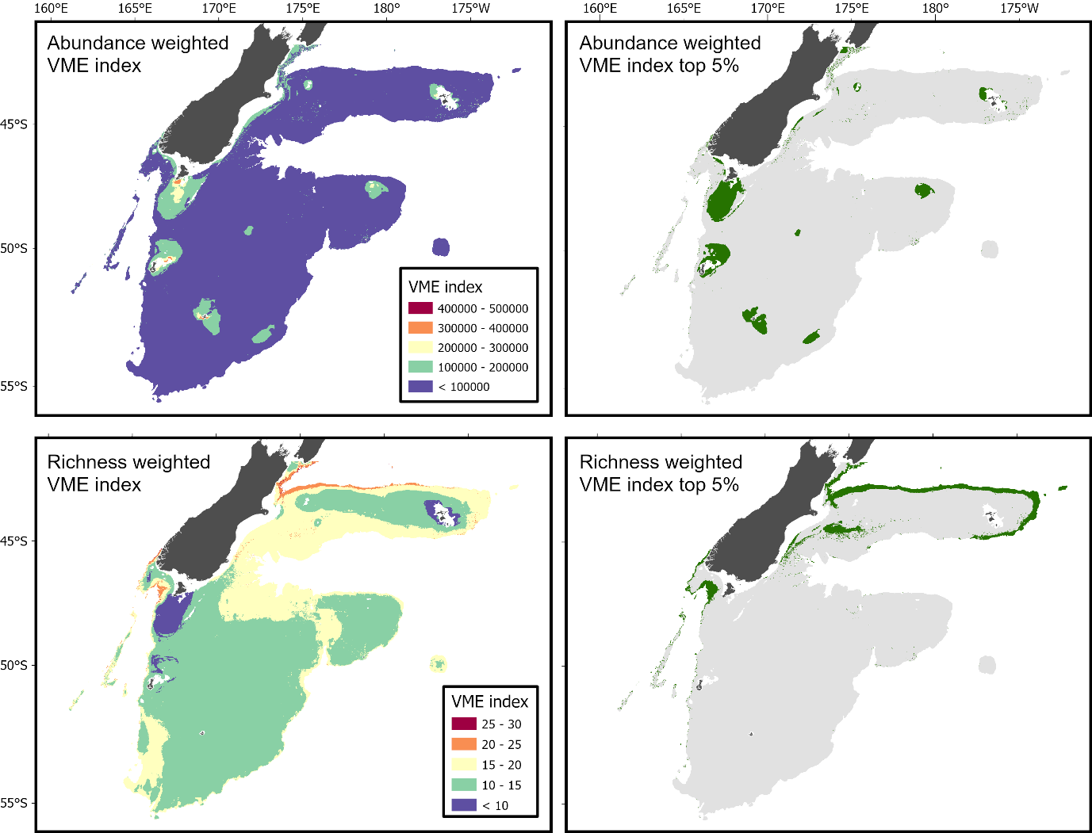
Figure S2. Predicted abundance-based VME index (top left) and top 5% of abundance-based VME index values (95th percentile threshold; top right). Predicted richness-based VME index (bottom left) and top 5% of richness-based VME index values (95th percentile threshold; bottom right).

