Supporting Information to be submitted as separate files for submission

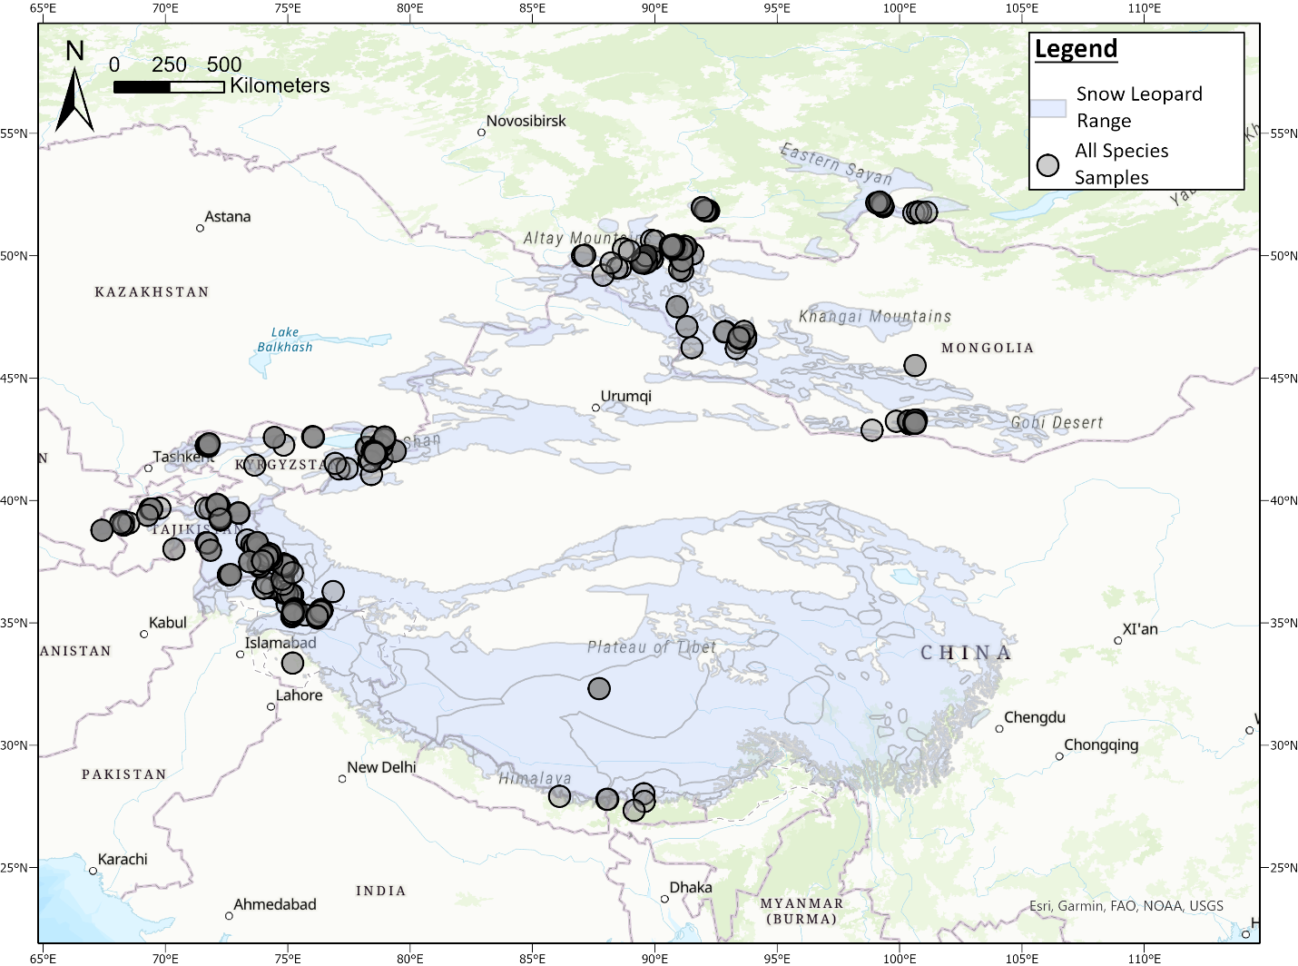

Appendix S1. Map of Central Asia showing current snow leopard range showing all samples (scats, blood, tissue) collected from 2008-2019 (n = 507).

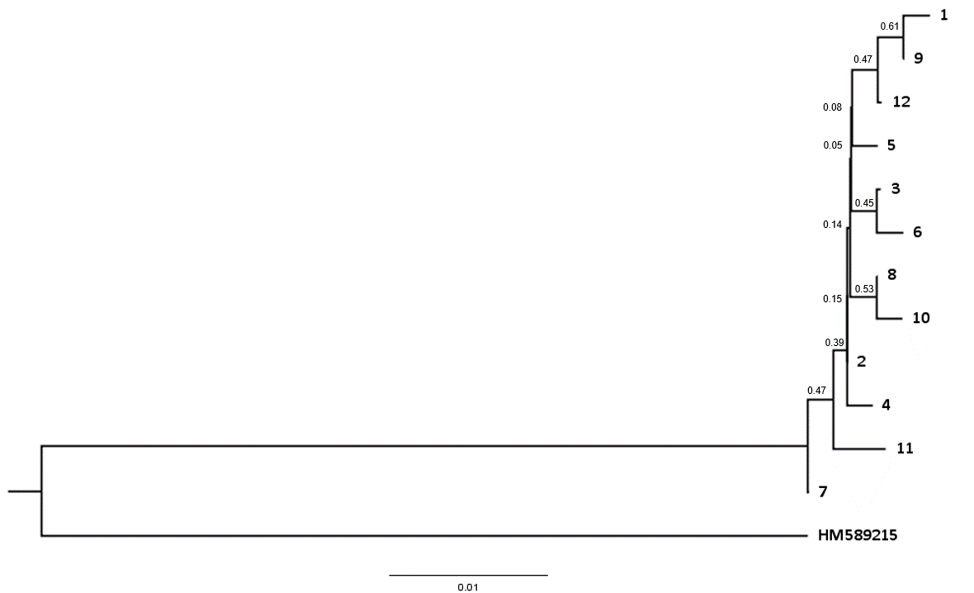

Appendix S2. Maximum likelihood tree showing 12 mitochondrial genome haplotypes from 80 snow leopards. Rooted with a GenBank sequence of tiger from China.

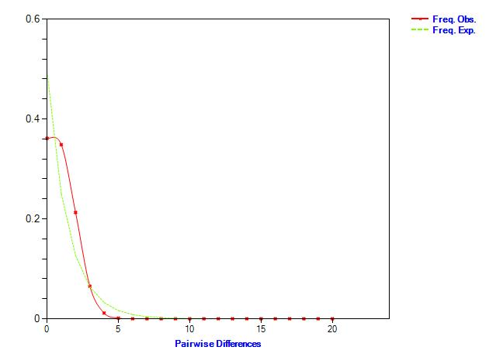

Appendix S3. Mismatch distribution analysis showing graph of observed mismatch frequencies (in red) of the sudden expansion model for the global dataset.

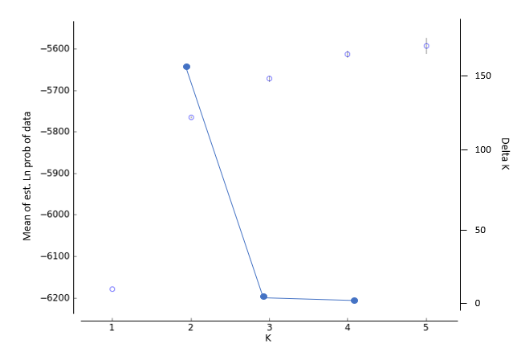

Appendix S4. Statistical output from Structure Harvester suggesting the optimal K with ΔK and LnP(D). Values at each K for ΔK are denoted by the blue line, and values for LnP(D) are represented by blue circles, with bars showing the standard deviation.

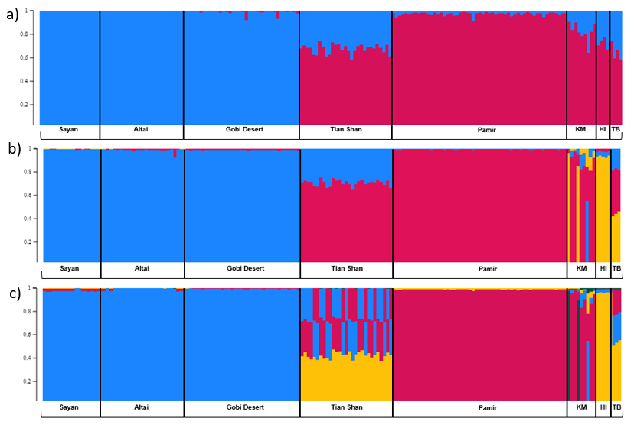

Appendix S5. Individual assignment test of 182 individuals using microsatellites in program structure (Pritchard et al., 2000). Each bar represents an individual’s assignment into K clusters. Statistical results based on both the standard calculation of L’(K) and the Evanno’s ΔK support the best K is 2. We show graphs a) K= 2, and b) K= 3, and c) K=4.

