Appendix 1. All 42 covariates evaluated for inclusion in species distribution models (SDMs) for Canada lynx in the Southern Rocky Mountains of the western United States; those that were included in any one of the three candidate models are indicated with an ‘x’ in the column under that model (Literature, Abiotic, Combined).
Table 1. Covariates evaluated for use in developing species distribution models (SDMs) for Canada lynx in the Southern Rocky Mountains of the western United States.
Category | Covariate Description | Units; Range | Source | Combined |  | Abiotic |  | Literature
Climate | Degree days below 18ºc | 2462-9232 | 1
Climate | Frost-free period | days; 15-198 | 1
Climate | Integrated moisture index | 60-6055 | 2
Climate | Mean annual precipitation | mm; 255-4837 | 1
Climate | Mean annual relative humidity | %; 44-75 | 1 |  | x |  | x | x
Climate | Mean annual temperature | ºC; -1 to 12 | 1
Climate | Mean summer (May to Sep) precipitation | mm; 111-596 | 1
Climate | Mean temperature in coldest month | ºC; -9 to 2 | 1 |  | x |  | x | x
Climate | Mean temperature in warmest month | ºC; 9 to 24 | 1
Climate | Minimum snow density | 0-0.19 | 3
Climate | Number of frost-free days | days; 28-277 | 1
Climate | Precipitation as snow | mm; 7 - 1463 | 1 |  | x |  | x
Climate | Snow depth | m; 0 - 3 | 3
Climate | Snow water equivalent | m; 0 – 1.2 | 3
Climate | Summer heat moisture index (Mean Temp Warmest Mo/(Mean Summer Precip/1000)) | 22-216 | 1
Climate | Summer mean temperature (Jun to Aug) | ºC; 8 - 23 | 1
Climate | Summer precipitation (Jun to Aug) | mm; 56 - 305 | 1 |  | x |  | x | x
Climate | Winter mean temperature (Dec to Feb ) | ºC; -9 to 2.7 | 1
Climate | Winter precipitation (Dec to Feb) | mm; 34 - 846 | 1
Climate | Modis Terra Normalized Difference Snow Index (presence of snow in a pixel) | 0-100 | 12
Soil | Soil bulk density at 5cm (The lighter the bulk density then potentially more organic matter and better water holding capacity) | (kg m⁻³) 200-2870 | 4 |  |  |  |  | x
Soil | Soil organic carbon at 5 cm | ‰ (g kg⁻¹) 0-450 | 4
Soil | Soil ph (The wetter the habitat in a general sense then the lower the ph. Alpine fir and that climatic zone would be expected to have a low ph from litter, high precipitation and cold temps) | pH x 10  20-110 | 4 |  | x |  | x
Topography | Elevation | m, 0- 5089 | 5
Topography | Slope | degrees, 0-81 | 6 |  |  |  |  | x
Topography | Surface ratio |  | 7 |  | x |  | x | x
Topography | TPI (1k, 5k, 10k) | unitless, 10k: -1000-1100, 5k: -806-891, 1k: -350-430 | 8 |  | x |  | x | x
Topography | Compound Topographic Index | 2.3 – 23.7 | 2 |  | x |  | x | x
Topography | North facing aspect
Anthro | Lights from cities, towns, and other sites with persistent lighting, including gas flares, as a proxy for human disturbance | unitless; 0 - 1106 | 5 |  | x |  |  | x
Anthro | Road density | km/km2; 0-50 | 11 |  | x
Anthro | Distance to highway |  | 11
Veg | Normalized difference vegetation index | -1 to 1 | 5, 9 |  | x |  |  | x
Veg | Forest heterogeneity (Standard deviation of forest presence or absence at 1k, 5k, 10k scales) | unitless; 1k: 0-47, 5k: 0-43, 10k: 0-43 | 6 |  | x |  |  | x
Veg | Percent forest cover | %, 0-100 | 5, 10
Veg | Landfire EVT130, category 3050,  Rocky Mountain Lodgepole Pine Forest |  | 13 |  |  |  |  | x
Veg | Landfire EVT130, category 3055,  Rocky Mountain Subalpine Dry-Mesic Spruce-Fir Forest and Woodland |  | 13 |  |  |  |  | x
Veg | Landfire EVT130, category 3056,  Rocky Mountain Subalpine Mesic-Wet Spruce-Fir Forest and Woodland |  | 13
Veg | Landire EVT130, category 3050, 3055, 3056, 3061 |  | 13 |  | x
Veg | Landire EVT130, category 3061,  Inter-Mountain Basins Aspen-Mixed Conifer Forest and Woodland |  | 13
Veg | Landfire EVT130, category 3252,  Rocky Mountain Subalpine/Upper Montane Riparian Shrubland |  | 13
Veg | Landfire EVT 130, Any Forest Type |  | 13
Veg | Landfire EVT 130, Closed Canopy Forest |  | 13 |  |  |  |  | x
Veg | NLCD Canopy Cover |  | 14
Veg | NLCD Evergreen Forest |  | 14

Data Sources:
1: Wang, T. et al. 2016. Locally downscaled and spatially customizable climate data for historical and future periods for North America. PLoS One 11: e0156720.
2: Evans, J. S. et al. 2014. An ArcGIS toolbox for surface gradient and geomorphometric modeling, version 2.0. https://evansmurphy.wixsite.com/evansspatial/arcgis-gradient-metrics-toolbox, Accessed June 2017.
3: National Operational Hydrologic Remote Sensing Center 2004. Snow data assimilation system (SNODAS) data products at NSIDC, Version 1. https://nsidc.org/data/g02158, Accessed June 2017.
4: Hengl, T. et al. 2017. SoilGrids250m: Global gridded soil information based on machine learning. PLoS 12: e0169748.
5: Gorelick, N. et al. 2017. Google Earth Engine: Planetary-scale geospatial analysis for everyone. Remote Sensing of the Environment 202: 18–27.
6: ESRI 2011. ArcGIS Desktop: Release 10.5. Redlands, CA: Environmental Systems Research Institute.
7: Jenness, J. 2013. DEM Surface Tools for ArcGIS. -Jenness Enterprises. http://www.jennessent.com/arcgis/surface_area.htm, Accessed June 2017.
8: Jenness, J. et al. 2013. Land Facet Corridor Designer: Extension for ArcGIS. - Jenness Enterprises. http://www.jennessent.com/arcgis/land_facets.htm, Accessed June 2017.
9: Landsat 5 and 8, United States Geological Survey Data, 2000 – 2015. https://glovis.usgs.gov/, Accessed June 2017.
10: Hansen, M. C. et al. 2013. High-Resolution Global Maps of 21st-Century Forest Cover Change. Science 342: 850–853.
11: OpenStreetMap Foundation 2017. OpenStreetMap. https://www.openstreetmap.org/about, Access June 2017.
12: Hall, D. ., Salomonson, V. ., & Riggs, G. A. (2016). MODIS/Terra Snow Cover Daily L3 Global 500m Grid. NASA National Snow and Ice Data Center Distributed Data Active Archive Center. https://nsidc.org/data/data-programs/nsidc-daac
13: LANDFIRE. (2012). LANDFIRE Existing Vegetation Type layer. Version 1.3.0. U.S. Department of Interior, Geological Survey. [Online]. http://landfire.cr.usgs.gov/viewer/
14: Wickham, J., Stehman, S.V., Sorenson, D.G., Gass, L., and Dewitz, J.A., 2021, Thematic accuracy assessment of the NLCD 2016 land cover for the conterminous United States: Remote Sensing of Environment, v. 257, art. no. 112357, at https://doi.org/10.1016/j.rse.2021.112357

Appendix 2. Validation of SDM models
Table 1. Validation of species distribution models (SDMs) for Canada lynx independent (location i.e., not used to build SDMs) data from ARGOS satellite telemetry (winter = 550 locations, summer = 449) using AUC, Continuous Boyce Index, and the percentage of independent location data above the 95% “Likely” habitat threshold. SDM model “Literature” was built on abiotic and biotic literature-informed covariates; “Abiotic” from abiotic-based covariates, and “Combined” based on abiotic and biotic covariates consistent with Olson et al 2021.

 | Validation Dataset | Literature | Abiotic | Combined
AUC Validation | Argos Winter | 0.90 | 0.91 | 0.91
AUC Validation | Argos Summer | 0.87 | 0.88 | 0.88
AUC Validation | Average | 0.89 | 0.90 | 0.90
Continuous Boyce Index Validation | Argos Winter | 1.00 | 1.00 | 0.99
Continuous Boyce Index Validation | Argos Summer | 0.98 | 0.99 | 0.99
Continuous Boyce Index Validation | Average | 0.99 | 1.00 | 0.99
Percent of Independent Locations in 95% Threshold | Argos Winter | 0.47 | 0.60 | 0.58
Percent of Independent Locations in 95% Threshold | Argos Summer | 0.43 | 0.57 | 0.54
Percent of Independent Locations in 95% Threshold | Average | 0.45 | 0.59 | 0.56

Appendix 3. Analysis to determine the avoidance behaviour of Canada lynx to houses and building structures.
To determine the area of overlap between lynx habitat and human habitation in western Colorado, we performed the following steps. We obtained the polygonised footprints of all existing man-made structures in Colorado from the ‘Building Footprints’ dataset created by Microsoft (Microsoft, 2021). This dataset uses AI-assisted mapping applied to Bing imagery from 2012-2020 to detect edges and angles consistent with buildings, determine building pixels, and convert these pixels into a single polygon associated with each structure. This results in a close-fitting polygon shape that outlines the extent of the building as seen from above. However, the disturbance ‘footprint’ of a human habitation is likely larger, due to areas cleared of trees and vegetation cover for lawns, parking, and roads, as well as human activities associated with buildings that generate noise and novel conditions. We hypothesized that Canada lynx are likely to respond to human disturbances beyond this outline, but an estimate of this disturbance distance for lynx in our study area was unknown. Therefore, we calculated the distance from each lynx GPS location in our study area (n=92730) to the nearest building footprint. We also calculated the distance to the nearest building for a set of background locations (n=236776; 100 point per km²) within lynx minimum convex polygons to provide an index of random proximity to building locations. Based on anecdotal field observations and visual inspection of the data, we observed that lynx in forest conditions appeared to move closer to buildings than those in more open habitat. Thus, we split our data by forest/non-forest habitat using the 2011 National Land Cover Database at 30m resolution, and considering “Deciduous”, “Evergreen”, and “Mixed” forest types as forested, and all other categories as “Non-Forest”. Finally, we limited our dataset to only lynx and background locations that were within 1km of a building, to focus our avoidance analysis on areas that could reasonably be expected to respond to a building. Before beginning the analysis, we visually inspected the ‘buildings’ layer for accuracy and located several locations in wilderness areas marked as buildings but that appeared to be large rocks on closer inspection. We deleted any building footprint inside wilderness areas from the analysis.
We analysed lynx response to buildings visually using histograms and density distributions and statistically using Manly’s selection ratio (Manly et al., 2002) calculated with the ‘adehabitatHS’ package (Calenge, 2006) in program R. We calculated the selection ratio by first binning distances into 50m bins, from 0-1000m away from a building, and then counting the number of used and random locations that fell inside a given bin around any building within a lynx home range. We then calculated selection ratios according to the equation w_{j} = u_{j}/a_{j}, where u_{j} is the proportion of used locations in each habitat class j and a_{j} is the proportion of available locations (Calenge, 2006).
We found evidence of lynx avoidance of buildings within 200m or less in forested conditions (Figure 1). Interestingly, lynx appeared to move more closely to buildings in open areas, with avoidance only in the 0-50m bin, although the sample size of lynx points in open areas was much lower (Figure 1 & 2). This could be due to lynx seeking any type of cover when moving through open areas, even that associated with outbuildings or yards. Alternatively, this could merely be an artifact of the distribution of buildings on the landscape, with more buildings in open areas and therefore greater likelihood of lynx randomly passing near to one. Based on this analysis, we determined that lynx are fairly tolerant of building proximity but may exhibit avoidance at distances of 200m or less. Thus, we buffered all polygons in our ‘Buildings’ layer by 200m for use in our overlap analysis.

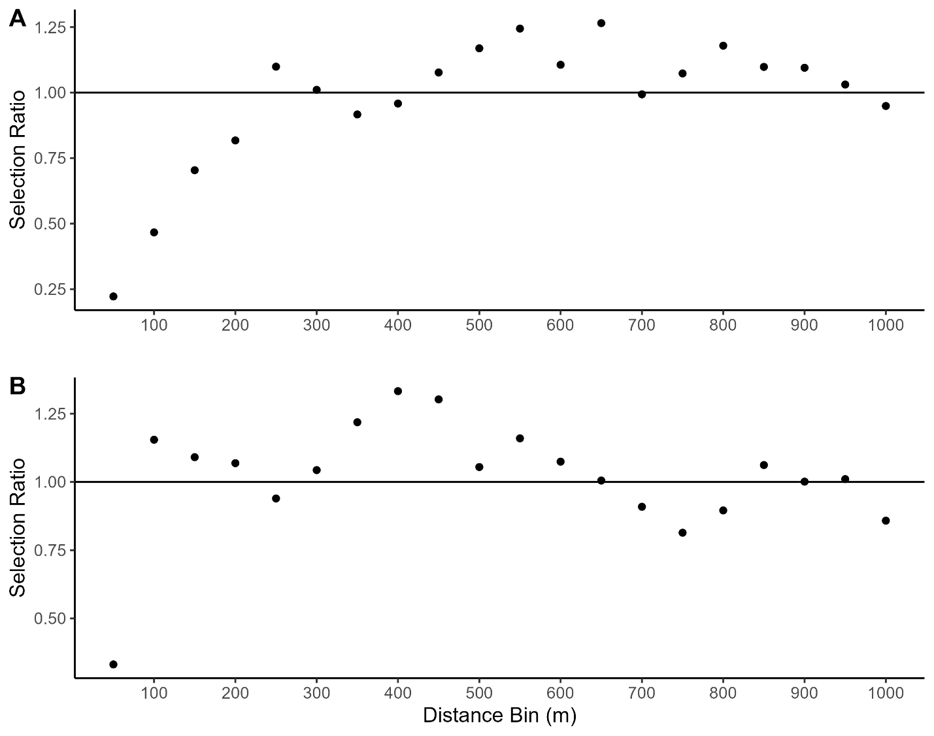
Figure 1: Plot of Manly’s selection ratio for lynx locations within 1km of buildings in lynx home ranges in western Colorado. Selection is binned into 50m distance categories, with each dot corresponding to selection or avoidance of buildings by lynx at that distance. Dots below the solid horizontal line indicate avoidance, while dots above or near the line indicate preference or non-response, respectively. Panel A shows selection in forested habitat, while panel B shows open habitat.
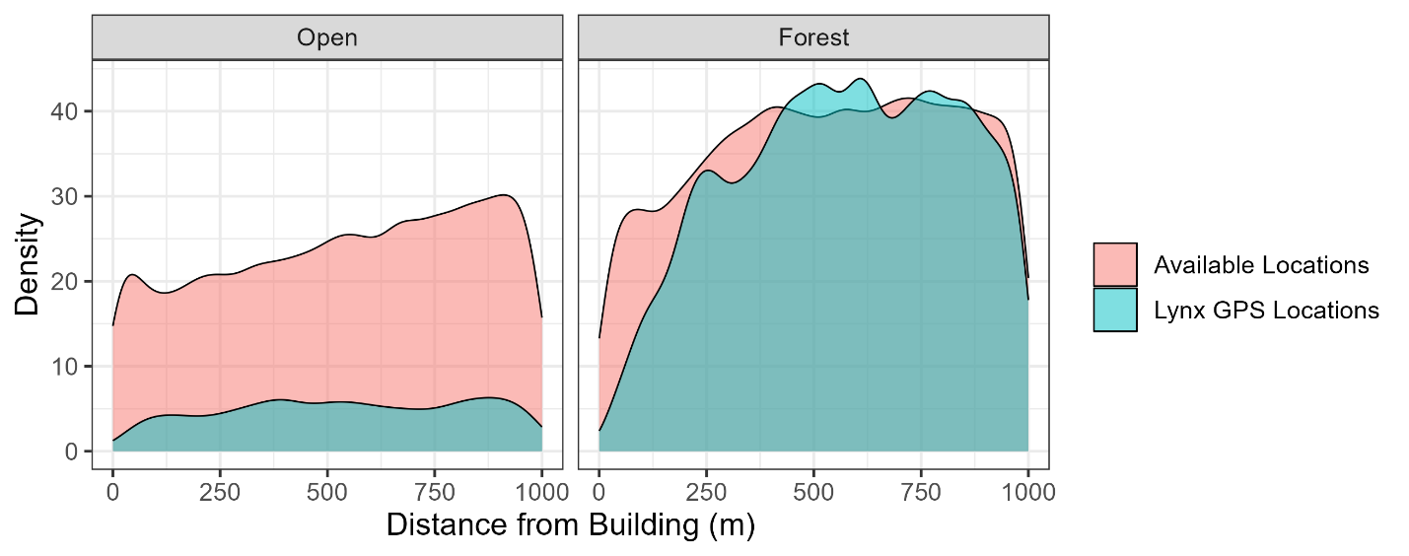
Figure 2: This plot shows the probability density function of the distance from buildings of lynx locations compared to available (random) locations. Only locations within 1km of a building are shown. Density functions are scaled by sample size to illustrate the difference in number of lynx locations in open versus forested habitat.

Literature Cited:
Calenge, C. (2006). The package adehabitat for the R software: a tool for the analysis of space and habitat use by animals. Ecological Modelling, 197, 516–519.
Manly, B. F. J., McDonald, L. L., Thomas, D. L., McDonald, T. L., & Erickson, W. P. (2002). Resource selection by animals: statistical design and analysis for field studies (2nd Editio). Kluwer Academic Publishers.
Microsoft. (2021). Building Footprints. https://www.microsoft.com/en-us/maps/building-footprints. Accessed 1 Feb, 2023.

Appendix 4: The distribution of Canada lynx in the Southern Rocky Mountains of the western United States, based on the “Literature” and “Abiotic” SDM models.
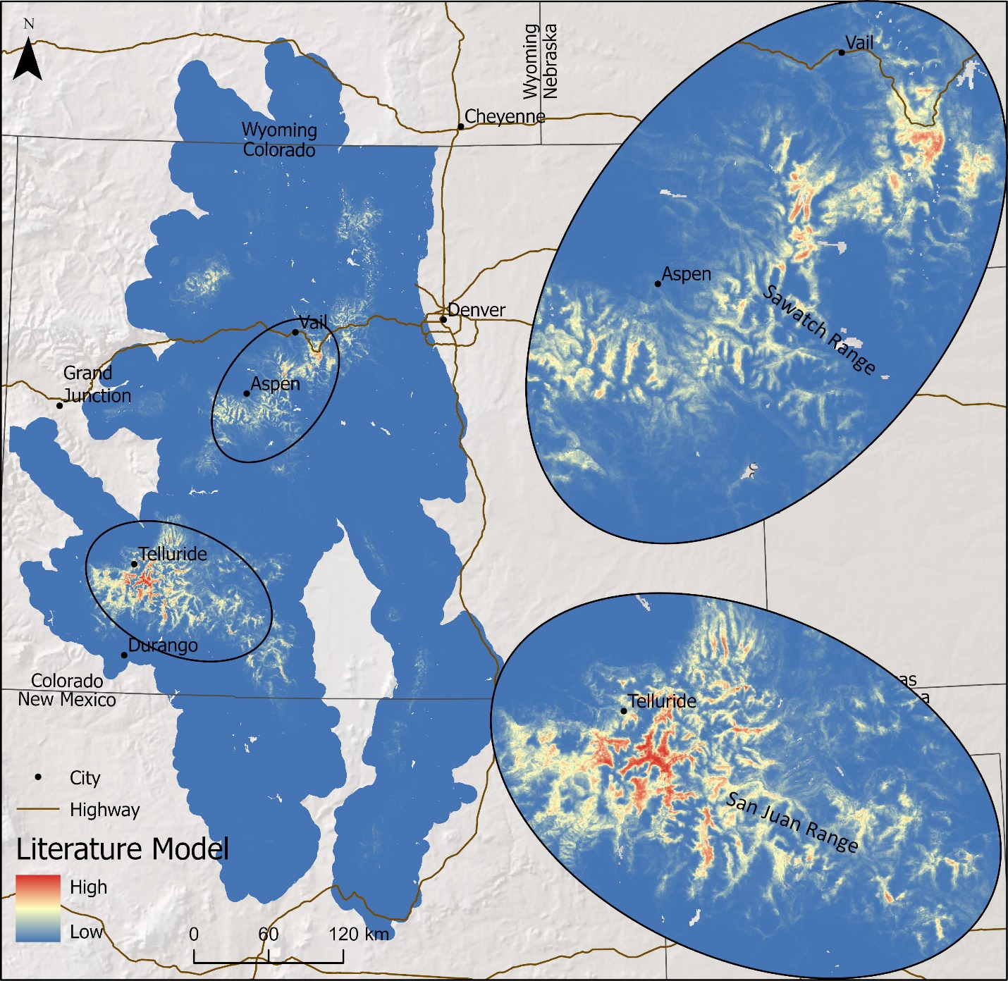

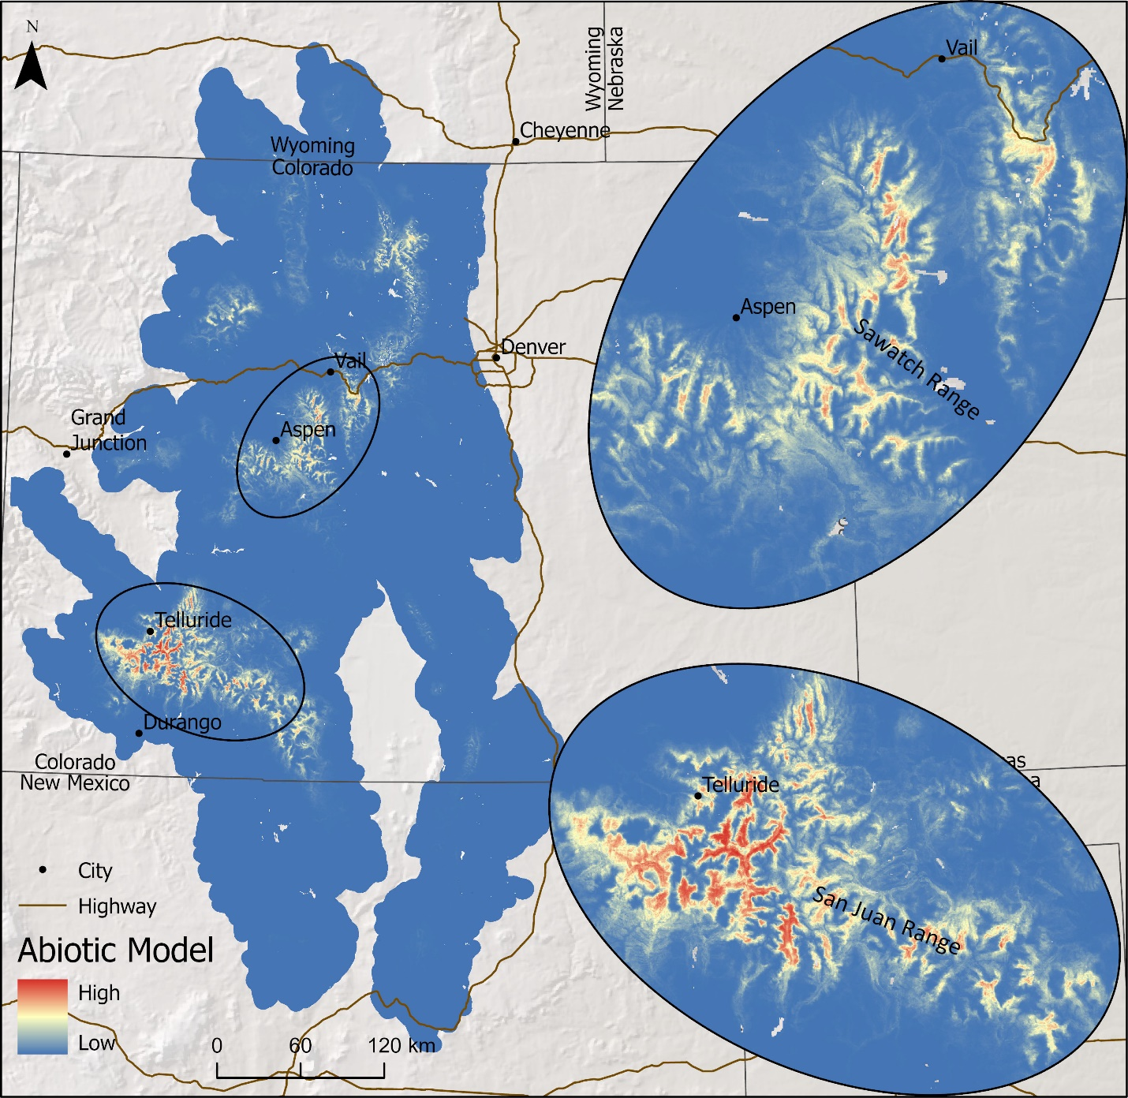

Appendix 5: Spatial overlap of Canada lynx habitat with natural and human caused disturbance.
Table 1. The detailed spatial overlap between current habitat for Canada lynx (from the Combined SDM habitat quality thresholds Unlikely, Likely, and Core) and natural and human-caused disturbed or protected areas in the Southern Rocky Mountains of the western United States. The amount of habitat (km²) impacted by each disturbance type and the percent out of the total area in each lynx habitat threshold that this equates to is shown. Overlap between protected and disturbed areas, as well as areas that are neither protected nor disturbed, prevents percents in each threshold category from summing to 1.
 |  | Area (km2) |  |  |  | Percent Overlap (%)
Overlap Type | Years | Unlikely |  | Likely + Core | Core | Unlikely | Likely + Core | Core
Fires | 1990-2022 | 12265 |  | 291 | 5 | 8 | 5 | 1
Insect Outbreaks
Spruce beetles | 2000-2022 | 7377 |  | 1454 | 74 | 5 | 25 | 17
Pine beetles | 2000-2022 | 15854 |  | 391 | 12 | 11 | 7 | 3
Total Insect |  | 22193 |  | 1756 | 86 | 15 | 31 | 19
Forest Management
Fuel treatment | 1990-2022 | 2964 |  | 73 | 1 | 2 | 1 | 0.2
Thinning | 1990-2022 | 1328 |  | 53 | 0.2 | 1 | 1 | 0
Tree harvest | 1990-2022 | 1958 |  | 149 | 12 | 1 | 3 | 3
Total forest management | 1990-2022 | 4638 |  | 167 | 12 | 3 | 3 | 3
Human Disturbance
Urbanization (buildings plus lynx avoidance buffers) |  | 11445 |  | 159 | 13 | 8 | 3 | 3
Developed Recreation (ski resorts) |  |  | 236 | 109 | 10 | 0.2 | 2 | 2
Total Human Disturbance |  |  | 11656 | 253 | 22 | 8 | 4 | 5
Total Disturbed (all sources) |  |  | 43642 | 2128 | 108 | 29 | 37 | 24
Protected landscapes
Roadless areas |  |  | 17973 | 1191 | 116 | 12 | 21 | 26
Wilderness and Nat. Parks |  |  | 14546 | 2396 | 103 | 10 | 42 | 23
Total Protected |  |  | 32174 | 3578 | 217 | 21 | 62 | 49
Total Lynx Habitat |  |  | 150421 | 5727 | 441 | - | - | -

Appendix 6. The overlap of forest management (e.g., fuel treatments, tree thinning, tree harvest) over habitat for Canada lynx in the Southern Rocky Mountains of the western United States as defined by Likely (95% withheld data) and Core (50% of withheld) habitat thresholds.
