Appendix 2. Rates of drainage of Belarusian Polesie peatlands.

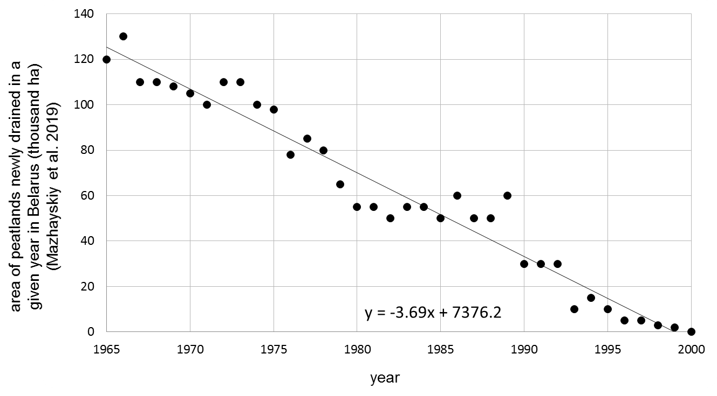
Figure A1. Area of peatlands newly drained each year in Belarus (thousand ha), based on data in Mazhayskiy et al. (2019). The linear regression line calculated.

References
Mazhayskiy Y, Rokochynskiy A, Volchak A, Meshyk A, Jeznach J (ed) (2019) Природообустройство Полесья, Книга 1. Белорусское Полесье, Том 2. Преобразование и спользование природных ресурсов/ Environmental Engineering in Polesye, Book 1. Belarusian Polesye, Volume 2. Transformation and use of natural resources. Brest – Rivne – Warsaw – Ryazan, Belarus – Ukraine – Poland – Russia (in Russian)

Table A2. The calculated area of peatlands in the Belarusian Polesie, included in Kulczyński's study, potentially drained in a given year, multiplied by the number of years it has remained drained. The total area of drained peatlands in the Belarusian Polesie, included in Kulczyński's study was about 415,000 ha [c] (the total area of peatlands drawn by Kulczyński (1940) – ca. 8,000 km²; 72% of the Kulczyński (1940) peatlands were located on the present-day territory of Belarus; ca. 72% of their area has been drained until present).
year | area of peatlands newly drained in a given year in Belarus (thousand ha) |  | the area of peatland drained in Belarus in a given year as a percentage of the total area of peatland drained between 1965 and 2000 (%) [a] | the number of years from the given year to 2023 [b] | the area of peatlands in the Belarusian Polesie, included in Kulczyński's study, potentially drained in a given year x the number of years it remains drained  (ha year) [a]*[b]*[c]
year | after Mazhayskiy et al. (2019) | fitted value of the linear regression line |  | the number of years from the given year to 2023 [b]
1965 | 120 | 125.35 | 5.72% | 59 | 1 400 301
1966 | 130 | 121.66 | 5.55% | 58 | 1 336 045
1967 | 110 | 117.97 | 5.38% | 57 | 1 273 185
1968 | 110 | 114.28 | 5.21% | 56 | 1 211 723
1969 | 108 | 110.59 | 5.05% | 55 | 1 151 659
1970 | 105 | 106.9 | 4.88% | 54 | 1 092 991
1971 | 100 | 103.21 | 4.71% | 53 | 1 035 721
1972 | 110 | 99.52 | 4.54% | 52 | 979 848
1973 | 110 | 95.83 | 4.37% | 51 | 925 373
1974 | 100 | 92.14 | 4.20% | 50 | 872 295
1975 | 98 | 88.45 | 4.04% | 49 | 820 614
1976 | 78 | 84.76 | 3.87% | 48 | 770 331
1977 | 85 | 81.07 | 3.70% | 47 | 721 445
1978 | 80 | 77.38 | 3.53% | 46 | 673 956
1979 | 65 | 73.69 | 3.36% | 45 | 627 865
1980 | 55 | 70 | 3.19% | 44 | 583 171
1981 | 55 | 66.31 | 3.03% | 43 | 539 874
1982 | 50 | 62.62 | 2.86% | 42 | 497 975
1983 | 55 | 58.93 | 2.69% | 41 | 457 473
1984 | 55 | 55.24 | 2.52% | 40 | 418 368
1985 | 50 | 51.55 | 2.35% | 39 | 380 661
1986 | 60 | 47.86 | 2.18% | 38 | 344 351
1987 | 50 | 44.17 | 2.02% | 37 | 309 438
1988 | 50 | 40.48 | 1.85% | 36 | 275 923
1989 | 60 | 36.79 | 1.68% | 35 | 243 805
1990 | 30 | 33.1 | 1.51% | 34 | 213 085
1991 | 30 | 29.41 | 1.34% | 33 | 183 761
1992 | 30 | 25.72 | 1.17% | 32 | 155 835
1993 | 10 | 22.03 | 1.01% | 31 | 129 307
1994 | 15 | 18.34 | 0.84% | 30 | 104 176
1995 | 10 | 14.65 | 0.67% | 29 | 80 442
1996 | 5 | 10.96 | 0.50% | 28 | 58 105
1997 | 5 | 7.27 | 0.33% | 27 | 37 166
1998 | 3 | 3.58 | 0.16% | 26 | 17 624
1999 | 2 | -0.11 | 0.00% | 25 | -
2000 | 0 | -3.8 | 0.00% | 24 | -
Total |  |  | 100.00% |  | 19 923 895

