Not all protected areas are created equal: Quality vs quantity in the quest to achieve 30 x 30

Supplementary Tables

Table S1. IUCN protected area categories. Source: (Dudley, 2008).

Category | Type | Description
Ia | Strict Nature Reserve | Strictly protected for biodiversity and also possibly geological/ geomorphological features, where human visitation, use and impacts are controlled and limited to ensure protection of the conservation values.
Ib | Wilderness Area | Usually, large unmodified or slightly modified areas, retaining their natural character and influence, without permanent or significant human habitation, protected and managed to preserve their natural condition.
II | National Park | Large natural or near-natural areas protecting large-scale ecological processes with characteristic species and ecosystems, which also have environmentally and culturally compatible spiritual, educational and visitor opportunities.
III | Natural Monument or Feature | Areas set aside to protect a specific natural monument, which can be a landform, sea mount, marine cavern, geological feature such as a cave, or a living feature such as an ancient grove.
IV | Habitat or Species Management Area | Areas to protect particular species or habitats, where management reflects this priority. Many will need regular, active interventions to meet the needs of particular species or habitats, but this is not a requirement of the category.
V | Protected Landscape or Seascape | Where the interaction of people and nature over time has produced a distinct character with significant ecological, biological, cultural and scenic value: and where safeguarding the integrity of this interaction is vital to protecting and sustaining the area and its associated nature conservation and other values.
VI | Protected Area with Sustainable Use of Natural Resources | Areas which conserve ecosystems, together with associated cultural values and traditional natural resource management systems. Generally large, mainly in a natural condition, with a proportion under sustainable natural resource management and where low-level non-industrial natural resource use compatible with nature conservation is seen as one of the main aims.

Table S2. Total number of species listed as critically endangered, endangered, and vulnerable on the IUCN Red List of Threatened Species used in the identification of threatened species hotspots

Country | Total number of species listed | Number of species without range maps or marine species | Number of species with range maps < 100 km² | Total number of species used for hotspot identification
Australia | 1966 | 793 | 107 | 1066
Canada | 229 | 88 | 4 | 137
Finland | 106 | 41 | 1 | 64
Germany | 313 | 80 | 15 | 218
New Zealand | 323 | 107 | 31 | 185
United Kingdom | 265 | 121 | 29 | 115

Table S3. Area and percentage of protection for each protected area network, percentage of the area of each protected area network made up of International Union for Conservation of Nature (IUCN) categories I-IV, V-VI & Unassigned. (Unassigned includes areas designated Not Applicable, Not Assigned, and Not Reported. Sources: World Database on Protected Areas (UNEP-WCMC, 2024).

Country | Area protected (km²) | Percent protected (%) | IUCN I-IV (%) | IUCN V-VI (%) | Unassigned (%)
Australia | 1618162.4 | 21.3 | 38.7 | 60.4 | 0.8
Canada | 1363350.7 | 13.7 | 86.8 | 2.3 | 10.9
Finland | 45449 | 13.4 | 76.8 | 0.4 | 22.8
Germany | 133988.4 | 37.5 | 12.2 | 70.8 | 17.0
New Zealand | 89197.1 | 33.3 | 78.4 | 19.3 | 2.3
United Kingdom | 67404.5 | 27.6 | 37.7 | 54.0 | 8.3

Table S4. Threatened species hotspots. Number, area and percentage of protection. Sources: IUCN Red List of Threatened Species database (IUCN, 2024a); World Database on Protected Areas (UNEP-WCMC, 2024).

Country | Number of hotspots | Area of hotspots (km²) | Area protected (km²) | Percent protected (%)
Australia | 4257 | 425700 | 75700 | 17.7
Canada | 4738 | 473800 | 18900 | 3.9
Finland | 123 | 12300 | 400 | 3.2
Germany | 157 | 15700 | 6300 | 40.1
New Zealand | 123 | 12300 | 7700 | 62.6
United Kingdom | 139 | 13900 | 3000 | 21.5

Table S5. Species richness hotspots. Number, area and percentage of protection. Sources: IUCN Red List of Threatened Species database (2024b); World Database on Protected Areas (UNEP-WCMC, 2024).

Country | Number of hotspots | Area of hotspots (km²) | Area protected (km²) | Percent protected (%)
Australia | 496 | 446400 | 116100 | 26.0
Canada | 513 | 461700 | 54900 | 11.9
Finland | 22 | 19800 | 900 | 4.5
Germany | 22 | 19800 | 9000 | 45.5
New Zealand | 21 | 18900 | 3600 | 19.0
United Kingdom | 19 | 17100 | 3600 | 21.1

Table S6. Key biodiversity areas (KBAs). Number, area and percentage of protection. Sources: World Database of Key Biodiversity Areas (BirdLife International, 2023); World Database on Protected Areas (UNEP-WCMC, 2024).

Country | Number of KBAs | Area of KBAs  (km²) | Percentage of  land area (%) | Area protected  (km²) | Percent protected  (%)
Australia | 325 | 449645.0 | 5.9 | 260028.9 | 57.8
Canada | 301 | 251828.6 | 2.5 | 131090.3 | 52.1
Finland | 99 | 20439.6 | 6.0 | 18633.0 | 91.2
Germany | 573 | 56890.0 | 15.9 | 40755.7 | 71.6
New Zealand | 137 | 7196.1 | 2.7 | 1267.3 | 17.6
United Kingdom | 308 | 24067.7 | 9.8 | 20101.3 | 83.5

Table S7. Ecoregions. Number and percentage of the mean area of ecoregions protected; number and percentage of ecoregions with > 30% of area protected. Sources: Terrestrial Ecoregions of the World dataset (Olsen et al., 2001; Dinerstein et al., 2017); World Database on Protected Areas (UNEP-WCMC, 2024).

Country | Ecoregions | Mean ecoregion  protection (%) | Ecoregions with  > 30% protection | Ecoregions with  > 30% protection (%)
Australia | 41 | 24.1 | 15 | 36.6
Canada | 53 | 18.0 | 7 | 13.2
Finland | 3 | 31.1 | 1 | 33.3
Germany | 5 | 42.4 | 4 | 80.0
New Zealand | 11 | 47.9 | 6 | 54.5
United Kingdom | 4 | 33.9 | 3 | 75.0

Table S8. Climate stable areas. Area of the 30th percentile of climate stability index values for each county and their percentage of protection. Sources: Climate Stability Index - Future SSP2-4.5 (Herrando-Moraira et al., 2022); World Database on Protected Areas (UNEP-WCMC, 2024).

Country |  | Area of the 30th percentile  of CSI values (km²) | Percentage of  land area (%) | Climate stable area  protected (km²) | Percent protected  (%)
Australia |  | 2288781.7 | 30.1 | 588649.9 | 25.7
Canada |  | 3315285.0 | 33.3 | 433945.7 | 13.1
Finland |  | 108955.2 | 32.2 | 5796.4 | 5.3
Germany |  | 101762.1 | 28.5 | 35701.7 | 35.1
New Zealand |  | 79325.6 | 29.6 | 6577.9 | 8.3
United Kingdom |  | 68955.1 | 28.2 | 15805.8 | 22.9

Table S9. Protected areas > 3000 km². Number, area and percentage of protection. World Database on Protected Areas (UNEP-WCMC, 2024).

Country | Number of PAs  > 3000 km² | Area protected  (km²) | Mean PA size  (km²) | Percentage of  total protection (%)
Australia | 108 | 1225143.0 | 11343.9 | 75.7
Canada | 103 | 911745.3 | 8851.9 | 66.9
Finland | 2 | 6634.2 | 3317.1 | 14.6
Germany | 0 | 0.0 | 0.0 | 0.0
New Zealand | 4 | 29284.4 | 7321.1 | 32.8
United Kingdom | 1 | 4528.1 | 4528.1 | 6.7

Table S10. Large intact areas (LIAs). Number, area and percentage of protection. Sources: The Last of the Wild and Pressure Free Lands (Allen et al., 2017); World Database on Protected Areas (UNEP-WCMC, 2024).

Country | Number of LIAs | Area of LIAs  (km²) | Percentage of  land area (%) | Area protected  (km²) | Percent protected  (%)
Australia | 118 | 2026363.0 | 26.7 | 880951.0 | 43.5
Canada | 142 | 7350217.4 | 73.9 | 1154158.0 | 15.7
Finland | 3 | 18545.4 | 5.5 | 10535.2 | 56.8
Germany | 0 | 0.0 | 0.0 | 0.0 | 0.0
New Zealand | 10 | 19424.4 | 7.2 | 16712.0 | 86.0
United Kingdom | 0 | 0.0 | 0.0 | 0.0 | 0.0

Table S11. Ecoregions of Australia. Source: Terrestrial Ecoregions of the World dataset (Olsen et al., 2001; Dinerstein et al., 2017).

Ecoregion |  | Area (km²) | Area protected (km²) | Percentage protected (%)
1 | Arnhem Land tropical savanna | 157129.9 | 69298.0 | 44.1
2 | Australian Alps montane grasslands | 11999.4 | 7639.8 | 63.7
3 | Brigalow tropical savanna | 341496.0 | 13974.7 | 4.1
4 | Cape York Peninsula tropical savanna | 115816.0 | 42367.2 | 36.6
5 | Carnarvon xeric shrublands | 90144.3 | 15199.5 | 16.9
6 | Carpentaria tropical savanna | 358380.8 | 50910.1 | 14.2
7 | Central Ranges xeric scrub | 281049.7 | 90073.2 | 32.0
8 | Christmas and Cocos Islands tropical forests | 38.1 | 0.0 | 0.0
9 | Coolgardie woodlands | 137255.1 | 45331.9 | 33.0
10 | Eastern Australia mulga shrublands | 253515.7 | 11024.9 | 4.3
11 | Eastern Australian temperate forests | 221271.7 | 44680.2 | 20.2
12 | Einasleigh upland savanna | 128067.6 | 10066.8 | 7.9
13 | Esperance mallee | 115442.9 | 47310.4 | 41.0
14 | Eyre and York mallee | 60700.2 | 9120.8 | 15.0
15 | Gibson desert | 155524.2 | 91294.0 | 58.7
16 | Great Sandy-Tanami desert | 820774.0 | 338301.3 | 41.2
17 | Great Victoria desert | 423733.5 | 125805.6 | 29.7
18 | Jarrah-Karri forest and shrublands | 10403.6 | 4699.4 | 45.2
19 | Kimberly tropical savanna | 346065.6 | 110565.2 | 31.9
20 | Lord Howe Island subtropical forests | 9.8 | 9.6 | 98.1
21 | Mitchell grass downs | 459496.9 | 10740.0 | 2.3
22 | Mount Lofty woodlands | 23722.7 | 2129.8 | 9.0
23 | Murray-Darling woodlands and mallee | 197879.4 | 36919.0 | 18.7
24 | Naracoorte woodlands | 27467.8 | 2735.4 | 10.0
25 | New Guinea mangroves | 5.0 | 0.0 | 0.0
26 | Norfolk Island subtropical forests | 33.1 | 0.0 | 0.1
27 | Nullarbor Plains xeric shrublands | 195001.8 | 62060.9 | 31.8
28 | Pilbara shrublands | 179134.9 | 15090.7 | 8.4
29 | Queensland tropical rain forests | 32441.3 | 13810.7 | 42.6
30 | Simpson desert | 583394.1 | 129400.1 | 22.2
31 | Southeast Australia temperate forests | 272280.5 | 35685.7 | 13.1
32 | Southeast Australia temperate savanna | 321998.8 | 13442.2 | 4.2
33 | Southwest Australia savanna | 168564.3 | 24335.6 | 14.4
34 | Southwest Australia woodlands | 46017.9 | 5860.5 | 12.7
35 | Swan Coastal Plain Scrub and Woodlands | 14987.9 | 1820.1 | 12.1
36 | Tasmanian Central Highland forests | 18689.0 | 6375.0 | 34.1
37 | Tasmanian temperate forests | 18053.4 | 4111.3 | 22.8
38 | Tasmanian temperate rain forests | 31052.6 | 19566.2 | 63.0
39 | Tirari-Sturt stony desert | 376462.6 | 38649.0 | 10.3
40 | Victoria Plains tropical savanna | 224880.0 | 16284.1 | 7.2
41 | Western Australian Mulga shrublands | 459615.8 | 44274.9 | 9.6
 | Average | 187317.0 | 39291.8 | 24.1

Table S12. Ecoregions of Canada. Source: Terrestrial Ecoregions of the World dataset (Olsen et al., 2001; Dinerstein et al., 2017).

Ecoregion |  | Area (km²) | Area protected (km²) | Percentage protected (%)
1 | Alaska-St. Elias Range tundra | 22672.8 | 21472.1 | 94.7
2 | Alberta-British Columbia foothills forests | 116549.9 | 2216.7 | 1.9
3 | Alberta Mountain forests | 38906.4 | 27514.1 | 70.7
4 | Arctic coastal tundra | 44898.6 | 10398.9 | 23.2
5 | Arctic foothills tundra | 5294.7 | 2395.3 | 45.2
6 | Baffin coastal tundra | 8409.4 | 396.2 | 4.7
7 | British Columbia mainland coastal forests | 117033.1 | 32084.5 | 27.4
8 | Brooks-British Range tundra | 25372.7 | 9995.6 | 39.4
9 | Canadian Aspen forests and parklands | 383132.6 | 15279.3 | 4.0
10 | Cascade Mountains leeward forests | 30101.7 | 7902.4 | 26.3
11 | Central British Columbia Mountain forests | 69155.1 | 10806.6 | 15.6
12 | Central Canadian Shield forests | 458547.2 | 59803.7 | 13.0
13 | Central Pacific coastal forests | 31813.3 | 5346.0 | 16.8
14 | Davis Highlands tundra | 81022.7 | 27384.4 | 33.8
15 | Eastern Canadian forests | 477306.9 | 59898.5 | 12.5
16 | Eastern Canadian Shield taiga | 726567.5 | 111478.5 | 15.3
17 | Eastern forest-boreal transition | 324617.6 | 29936.4 | 9.2
18 | Eastern Great Lakes lowland forests | 91789.0 | 1827.2 | 2.0
19 | Fraser Plateau and Basin complex | 133700.3 | 20432.5 | 15.3
20 | Gulf of St. Lawrence lowland forests | 39470.5 | 3014.1 | 7.6
21 | High Arctic tundra | 454800.3 | 46838.1 | 10.3
22 | Interior Alaska-Yukon lowland taiga | 38898.8 | 11446.4 | 29.4
23 | Interior Yukon-Alaska alpine tundra | 111987.2 | 4276.0 | 3.8
24 | Lake | 193610.3 | 18411.1 | 9.5
25 | Low Arctic tundra | 749081.6 | 153100.3 | 20.4
26 | Mid-Continental Canadian forests | 355002.1 | 71327.6 | 20.1
27 | Middle Arctic tundra | 966757.8 | 60680.7 | 6.3
28 | Midwestern Canadian Shield forests | 528952.4 | 62632.7 | 11.8
29 | Montana Valley and Foothill grasslands | 14823.0 | 31.1 | 0.2
30 | Muskwa-Slave Lake forests | 249261.9 | 39943.6 | 16.0
31 | New England-Acadian forests | 119199.2 | 10005.8 | 8.4
32 | Newfoundland Highland forests | 16360.2 | 1409.6 | 8.6
33 | North Central Rockies forests | 142041.3 | 33388.1 | 23.5
34 | Northern Canadian Shield taiga | 582481.8 | 69022.6 | 11.8
35 | Northern Cordillera forests | 250274.6 | 47698.3 | 19.1
36 | Northern mixed grasslands | 108872.1 | 6527.3 | 6.0
37 | Northern short grasslands | 132862.4 | 14294.9 | 10.8
38 | Northern tall grasslands | 33702.8 | 660.0 | 2.0
39 | Northern transitional alpine forests | 24689.6 | 2486.9 | 10.1
40 | Northwest Territories taiga | 327684.8 | 72352.1 | 22.1
41 | Ogilvie-MacKenzie alpine tundra | 187236.7 | 49053.1 | 26.2
42 | Okanagan dry forests | 38869.2 | 2563.0 | 6.6
43 | Pacific Coastal Mountain icefields and tundra | 23622.5 | 5404.1 | 22.9
44 | Palouse grasslands | 52.2 | 11.4 | 21.8
45 | Puget lowland forests | 5647.7 | 431.7 | 7.6
46 | Queen Charlotte Islands | 8899.6 | 4249.8 | 47.8
47 | Rock and Ice | 129921.7 | 17680.4 | 13.6
48 | South Avalon-Burin oceanic barrens | 1900.4 | 89.4 | 4.7
49 | Southern Great Lakes forests | 25736.5 | 346.5 | 1.3
50 | Southern Hudson Bay taiga | 361991.5 | 53843.2 | 14.9
51 | Torngat Mountain tundra | 30041.1 | 13219.5 | 44.0
52 | Western Great Lakes forests | 74264.0 | 9657.2 | 13.0
53 | Yukon Interior dry forests | 59139.4 | 1521.3 | 2.6
 | Average | 180660.9 | 25362.0 | 18.0

Table S13. Ecoregions of Finland. Source: Terrestrial Ecoregions of the World dataset (Olsen et al., 2001; Dinerstein et al., 2017).

Ecoregion |  | Area (km²) | Area protected (km²) | Percentage protected (%)
1 | Sarmatic mixed forests | 3611.2 | 81.1 | 2.2
2 | Scandinavian and Russian taiga | 326870.2 | 41746.0 | 12.8
3 | Scandinavian Montane Birch forest and grasslands | 3837.5 | 2999.6 | 78.2
 | Average | 111439.6 | 14942.2 | 31.1

Table S14. Ecoregions of Germany. Source: Terrestrial Ecoregions of the World dataset (Olsen et al., 2001; Dinerstein et al., 2017).

Ecoregion |  | Area (km²) | Area protected (km²) | Percentage protected (%)
1 | Alps conifer and mixed forests | 3460.1 | 2150.0 | 62.1
2 | Atlantic mixed forests | 77575.8 | 23200.2 | 29.9
3 | Baltic mixed forests | 31197.1 | 13629.0 | 43.7
4 | Central European mixed forests | 48806.6 | 18080.7 | 37.0
5 | Western European broadleaf forests | 194770.6 | 76104.1 | 39.1
 | Average | 71162.0 | 26632.8 | 42.4

Table S15. Ecoregions of New Zealand. Source: Terrestrial Ecoregions of the World dataset (Olsen et al., 2001; Dinerstein et al., 2017).

Ecoregion |  | Area (km²) | Area protected (km²) | Percentage protected (%)
1 | Cantebury-Otago tussock grasslands | 52250.9 | 4685.5 | 9.0
2 | Chatham Island temperate forests | 592.2 | 42.6 | 7.2
3 | Fiordland temperate forests | 10697.1 | 10650.2 | 99.6
4 | Nelson Coast temperate forests | 14502.6 | 11414.2 | 78.7
5 | North Island temperate forests | 83241.7 | 16734.6 | 20.1
6 | Northland temperate kauri forests | 28162.4 | 3385.3 | 12.0
7 | Rakiura Island temperate forests | 1396.2 | 1299.8 | 93.1
8 | Richmond temperate forests | 12472.3 | 4882.5 | 39.1
9 | South Island montane grasslands | 40031.8 | 26166.0 | 65.4
10 | South Island temperate forests | 11355.1 | 2402.3 | 21.2
11 | Westland temperate forests | 5252.2 | 4305.6 | 82.0
 | Average | 23632.2 | 7815.3 | 47.9

Table S16. Ecoregions of United Kingdom. Source: Terrestrial Ecoregions of the World dataset (Olsen et al., 2001; Dinerstein et al., 2017).

Ecoregion |  | Area (km2) | Area protected (km2) | Percentage protected (%)
1 | Caledon conifer forests | 21690.0 | 8974.9 | 41.4
2 | Celtic broadleaf forests | 152985.2 | 34211.9 | 22.4
3 | English Lowlands beech forests | 44789.2 | 13963.1 | 31.2
4 | North Atlantic moist mixed forests | 20043.4 | 8148.4 | 40.7
 | Average | 59877.0 | 16324.6 | 33.9

Supplementary Figures

Fig. S1. Geoprocessing model used to convert each polygon shape file to a raster file at a resolution of 10 km x 10 km.

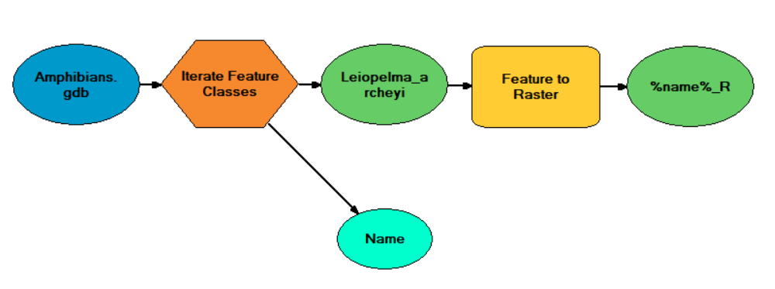

Fig. S2. Geoprocessing model used to reclassify individual raster maps by making all old values = 1, and no data = 0.

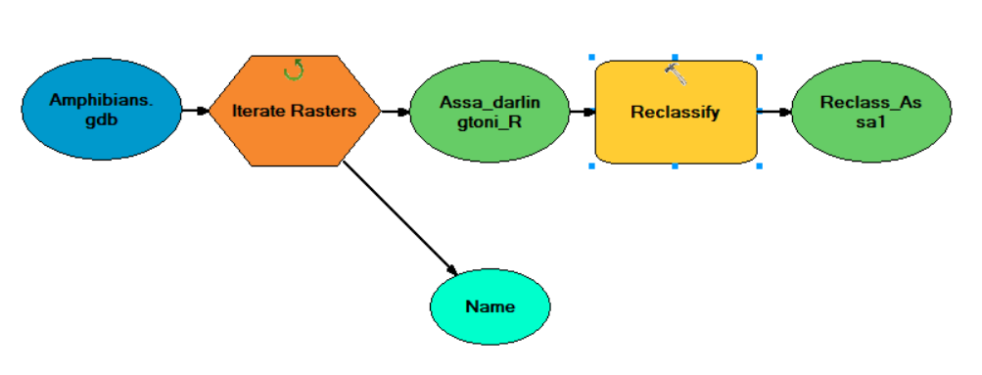

Fig. S3. Geoprocessing model used to overlay raster maps and sum the values in each cell.

