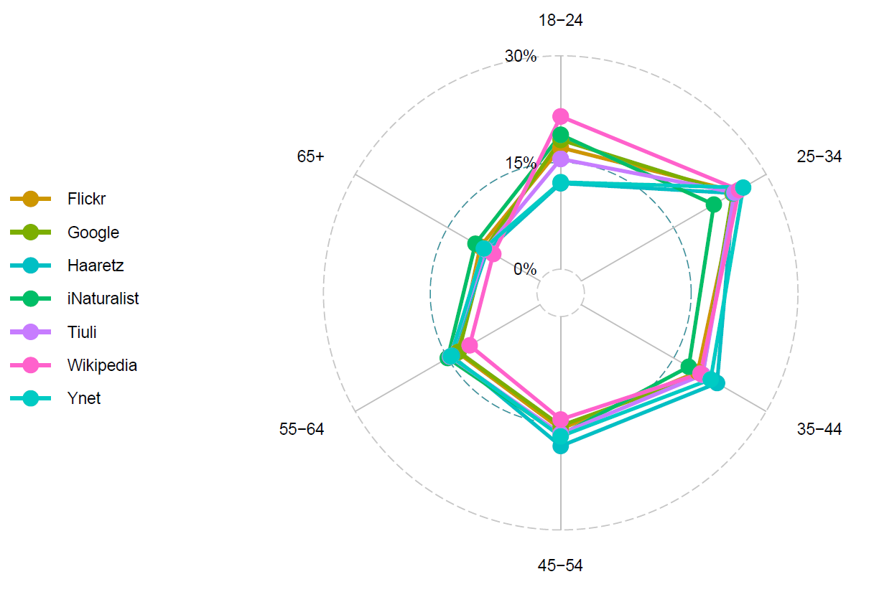
Fig S1: User age distribution across the different platforms. Data obtained from https://www.similarweb.com/

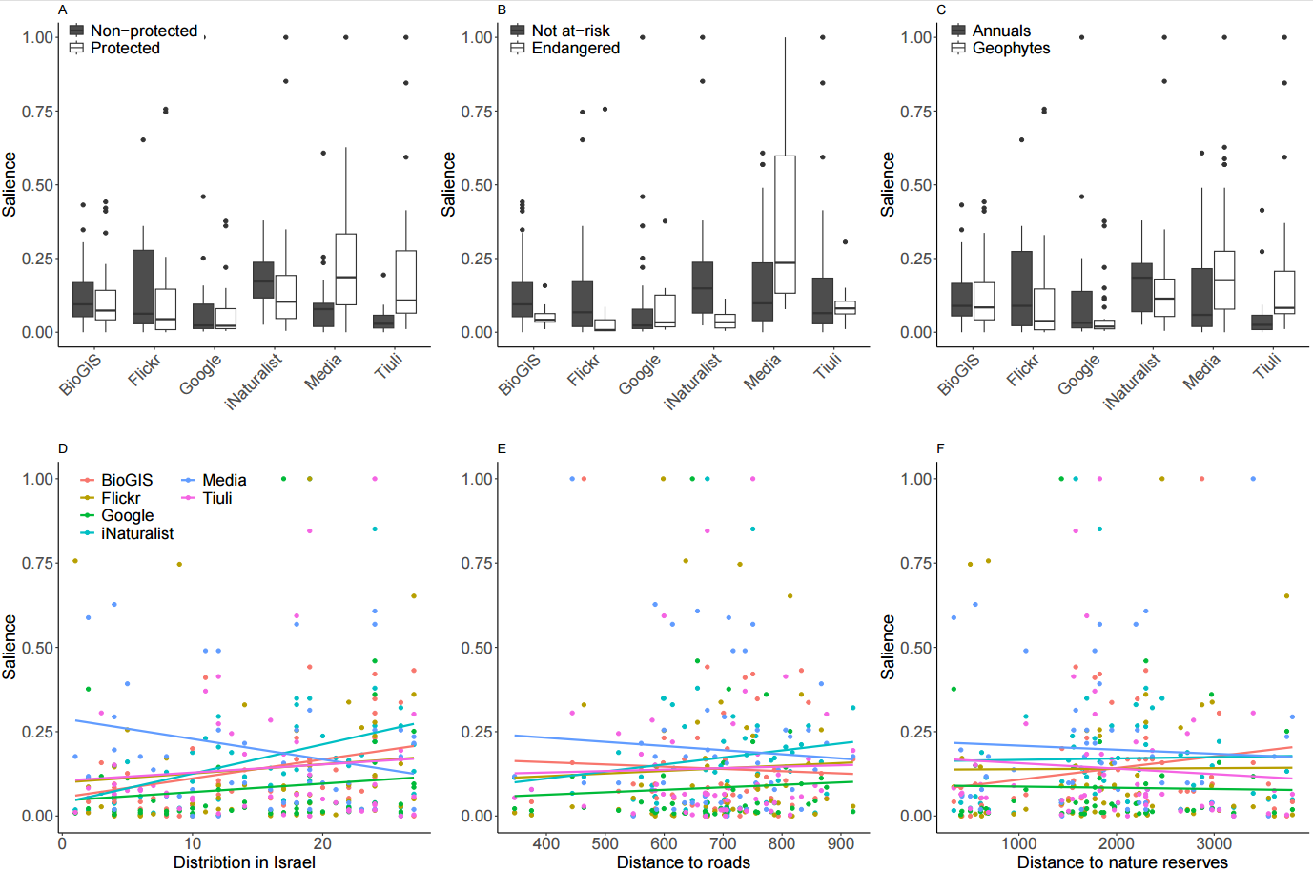
Fig. S2: Attributes of species compared to their salience across digital platforms including data only from 2010-2020. Plant species’ (N=53) salience, are displayed as proportions of the highest value in each platform. Displayed are links between salience and (A) the species protection status by the Israeli low (protected or not), showing median and interquartile range; (B) the species endangered status (endangered or not-at-risk); (C) growth form – annual or geophyte, showing median and interquartile range; (D) the species occurrence in Israel based on number of regions in Israel the species grows in; (E) the species mean distance to the nearest road (meters); and (F) the species mean distance to nature reserves).

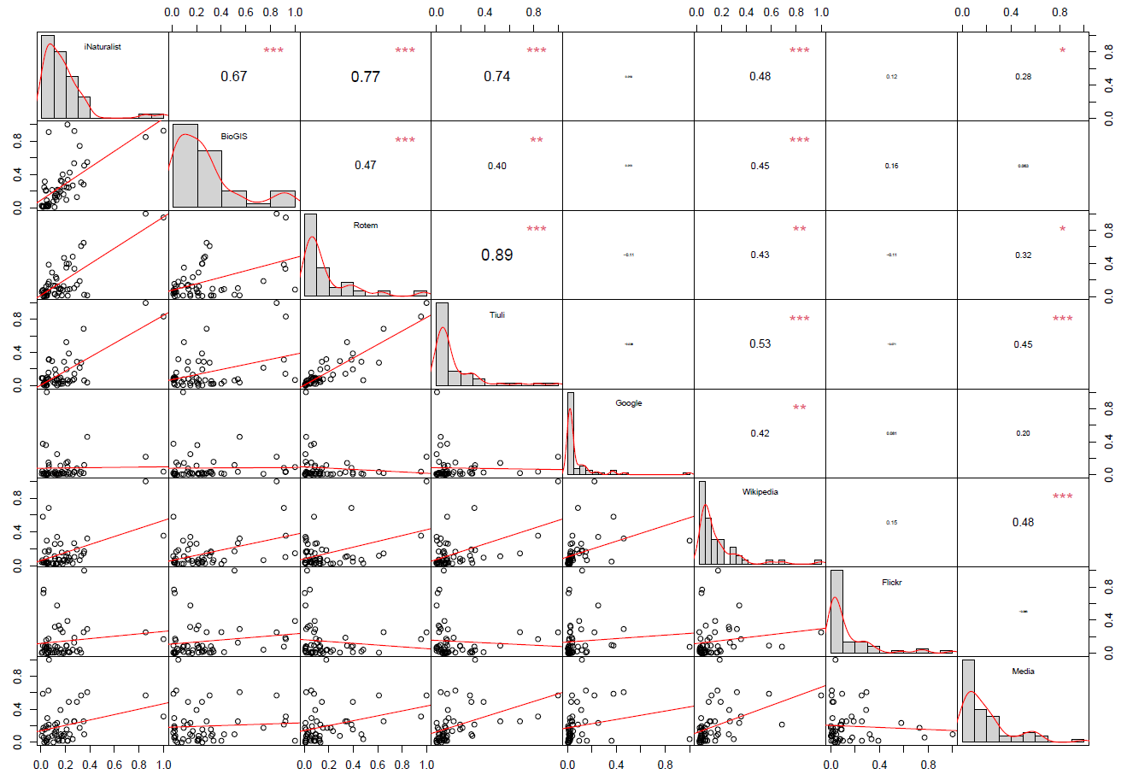

Fig. S3: Correlations between the different digital sources used in the Israeli wildflower example.
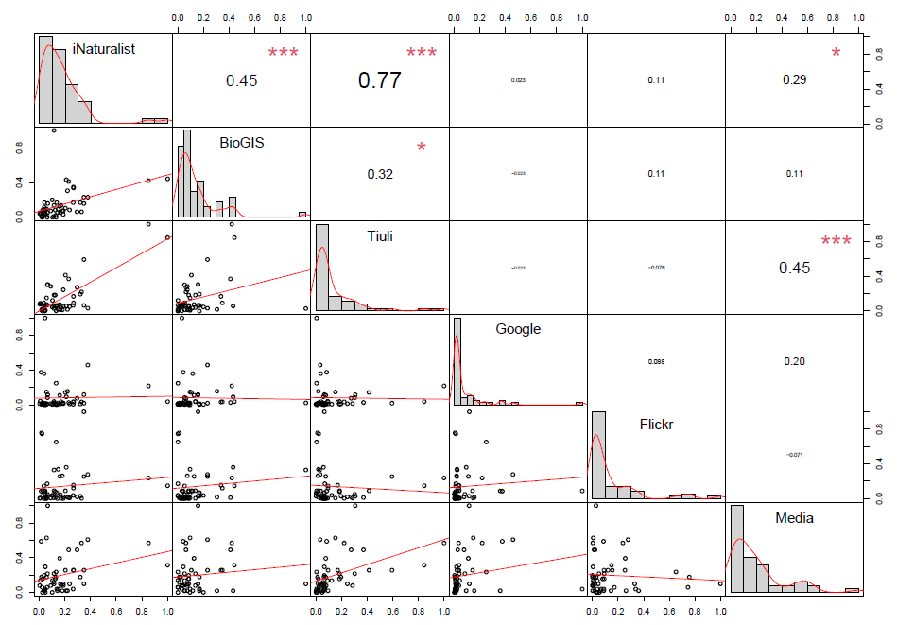

Fig. S4: Correlations between the six digital sources used over the time period of 2010-2020 in the Israeli wildflower example.

