Taxonomic bias towards charismatic and easy-to-find mammals
shapes knowledge of parasites

SUPPLEMENTARY MATERIALS
Figures S1 to S4
Table S1

Figure S1. Pearson pairwise correlation among potential predictors of taxonomic bias in the knowledge of parasites across mammals.
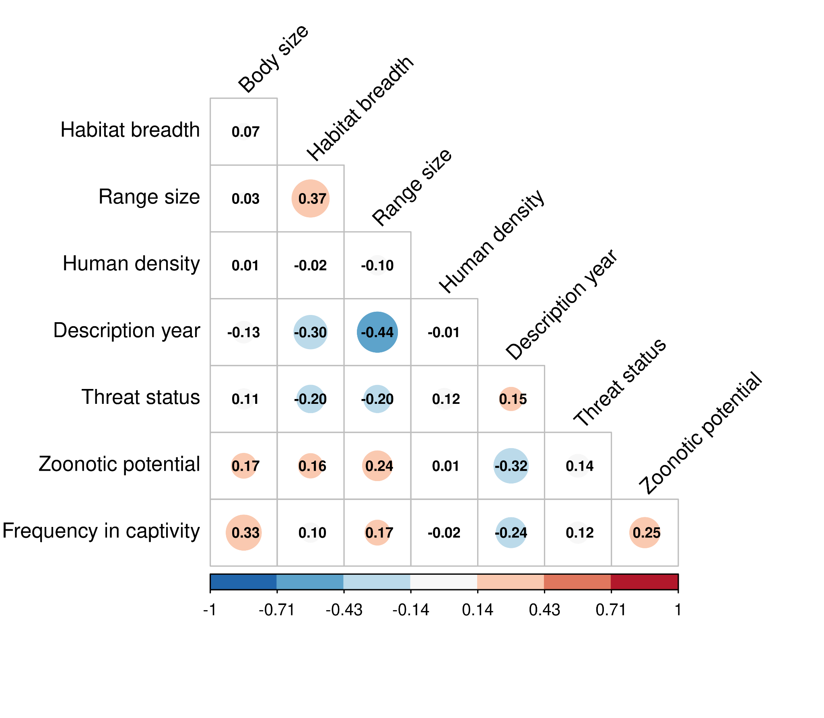
Figure S2. R-hat values for intercept and predictors of a Bayesian Generalized Linear Mixed Model, predicting the probability of having at least one parasitological record for mammals in the Host-Parasite database of Farrell et al., 2022.
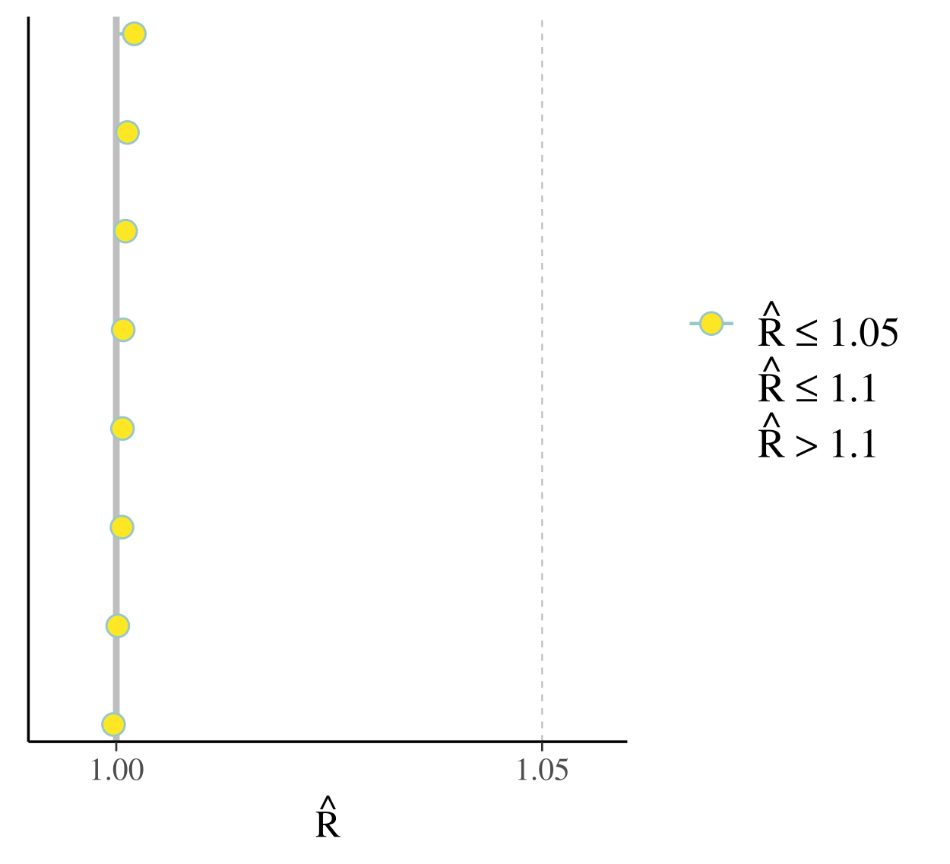
Figure S3. Trace plots for predictors of a Bayesian Generalized Mixed Model predicting the probability of having at least one parasitological record for mammals in the Host-Parasite database of Farrell et al., 2022.

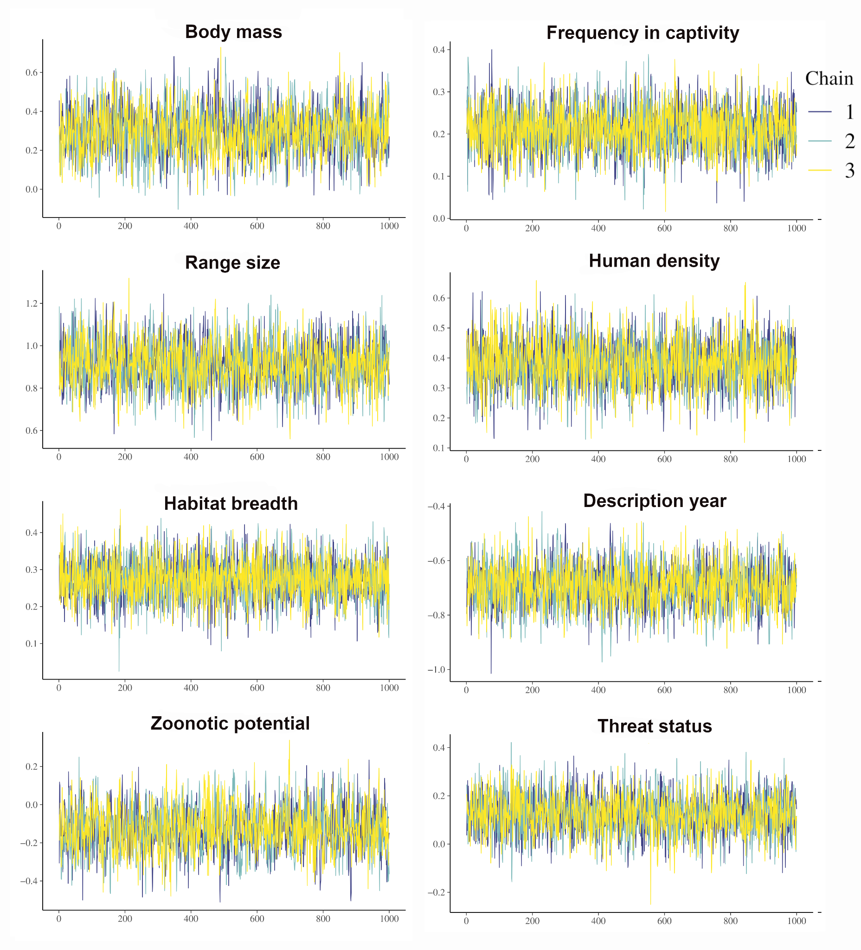
Figure S4. Posterior predictive checks for 100 posterior draws from a Bayesian Generalized Linear Mixed Model predicting the probability of hhaving at least one parasitological record for mammals in the Host-Parasite database of Farrell et al., 2022.

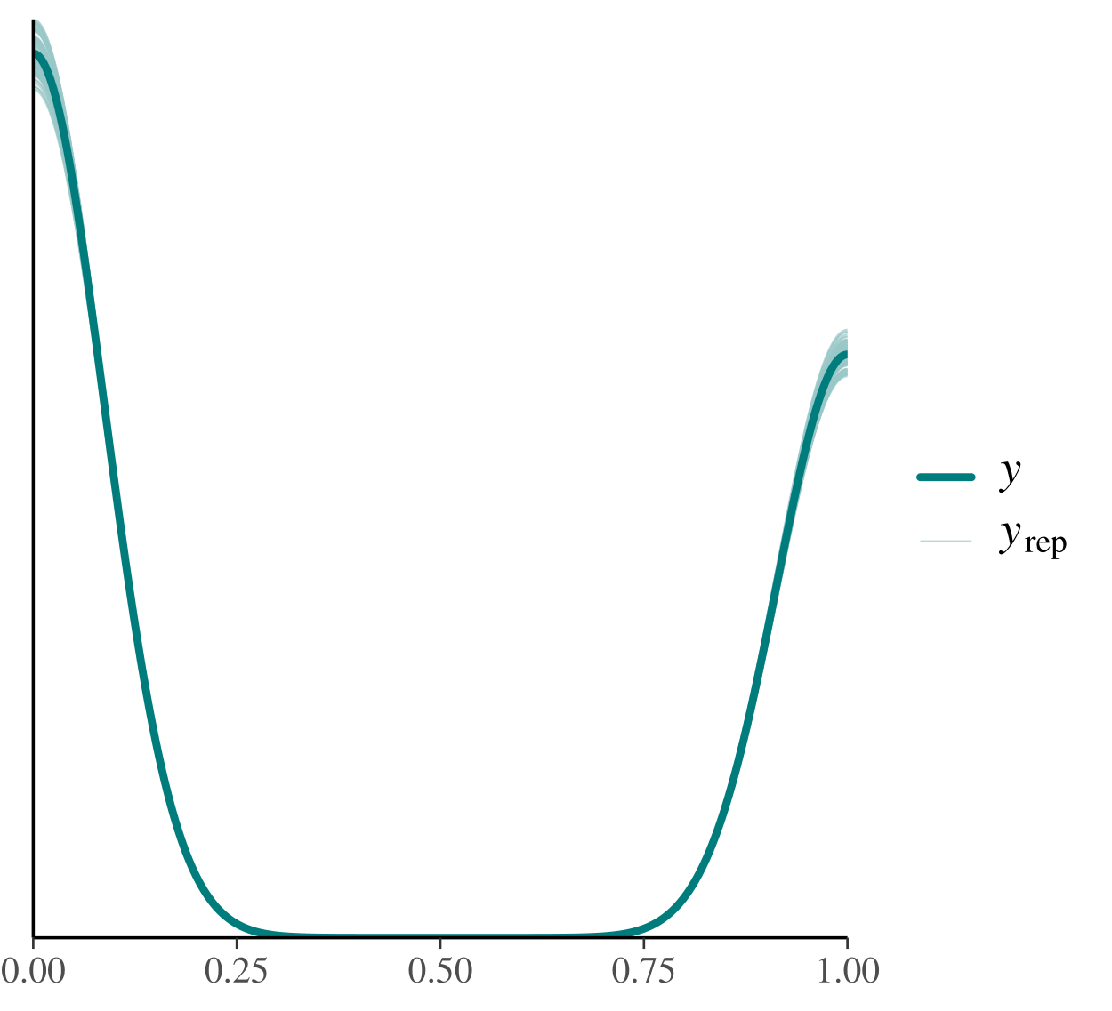
Table S1. Variance Inflation Factor among potential predictors of taxonomic bias in the knowledge of parasites across mammals.

Predictor | Variance Inflation Factor
Body size | 2.246
Range size | 2.010
Description year | 1.849
Zoonotic potential | 1.745
Threat status | 1.606
Frequency in captivity | 1.328
Habitat breadth | 1.171
Human density | 1.040

References
Farrell, M.J., Elmasri, M., Stephens, D.A. & Davies, T.J. (2022) Predicting missing links in global host–parasite networks. Journal of Animal Ecology 91, 715–726.

