Taxonomic bias towards charismatic and easy-to-find mammals
shapes knowledge of parasites

SUPPLEMENTARY MATERIALS
Figures S1 to S7
Table S1

Figure S1. Pearson pairwise correlation among potential predictors of taxonomic bias in the knowledge of parasites across mammals.
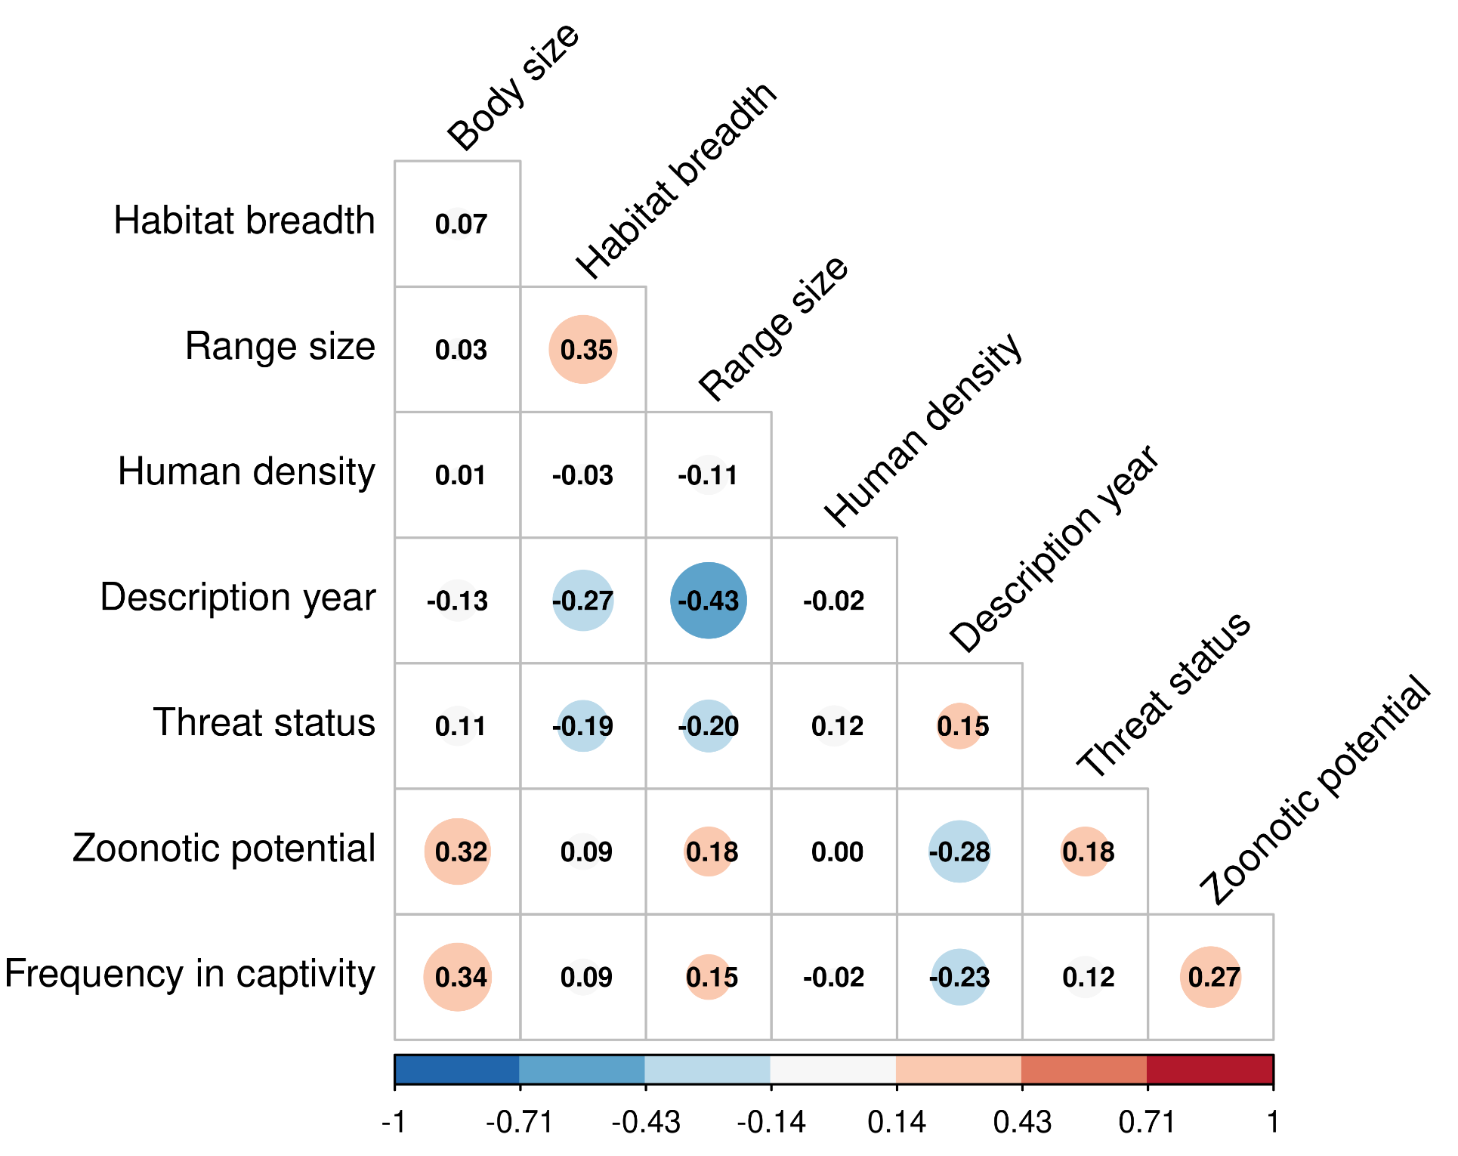
Figure S2. Distribution of values for predictors of research effort on parasites across mammal species, before undergoing any transformation.
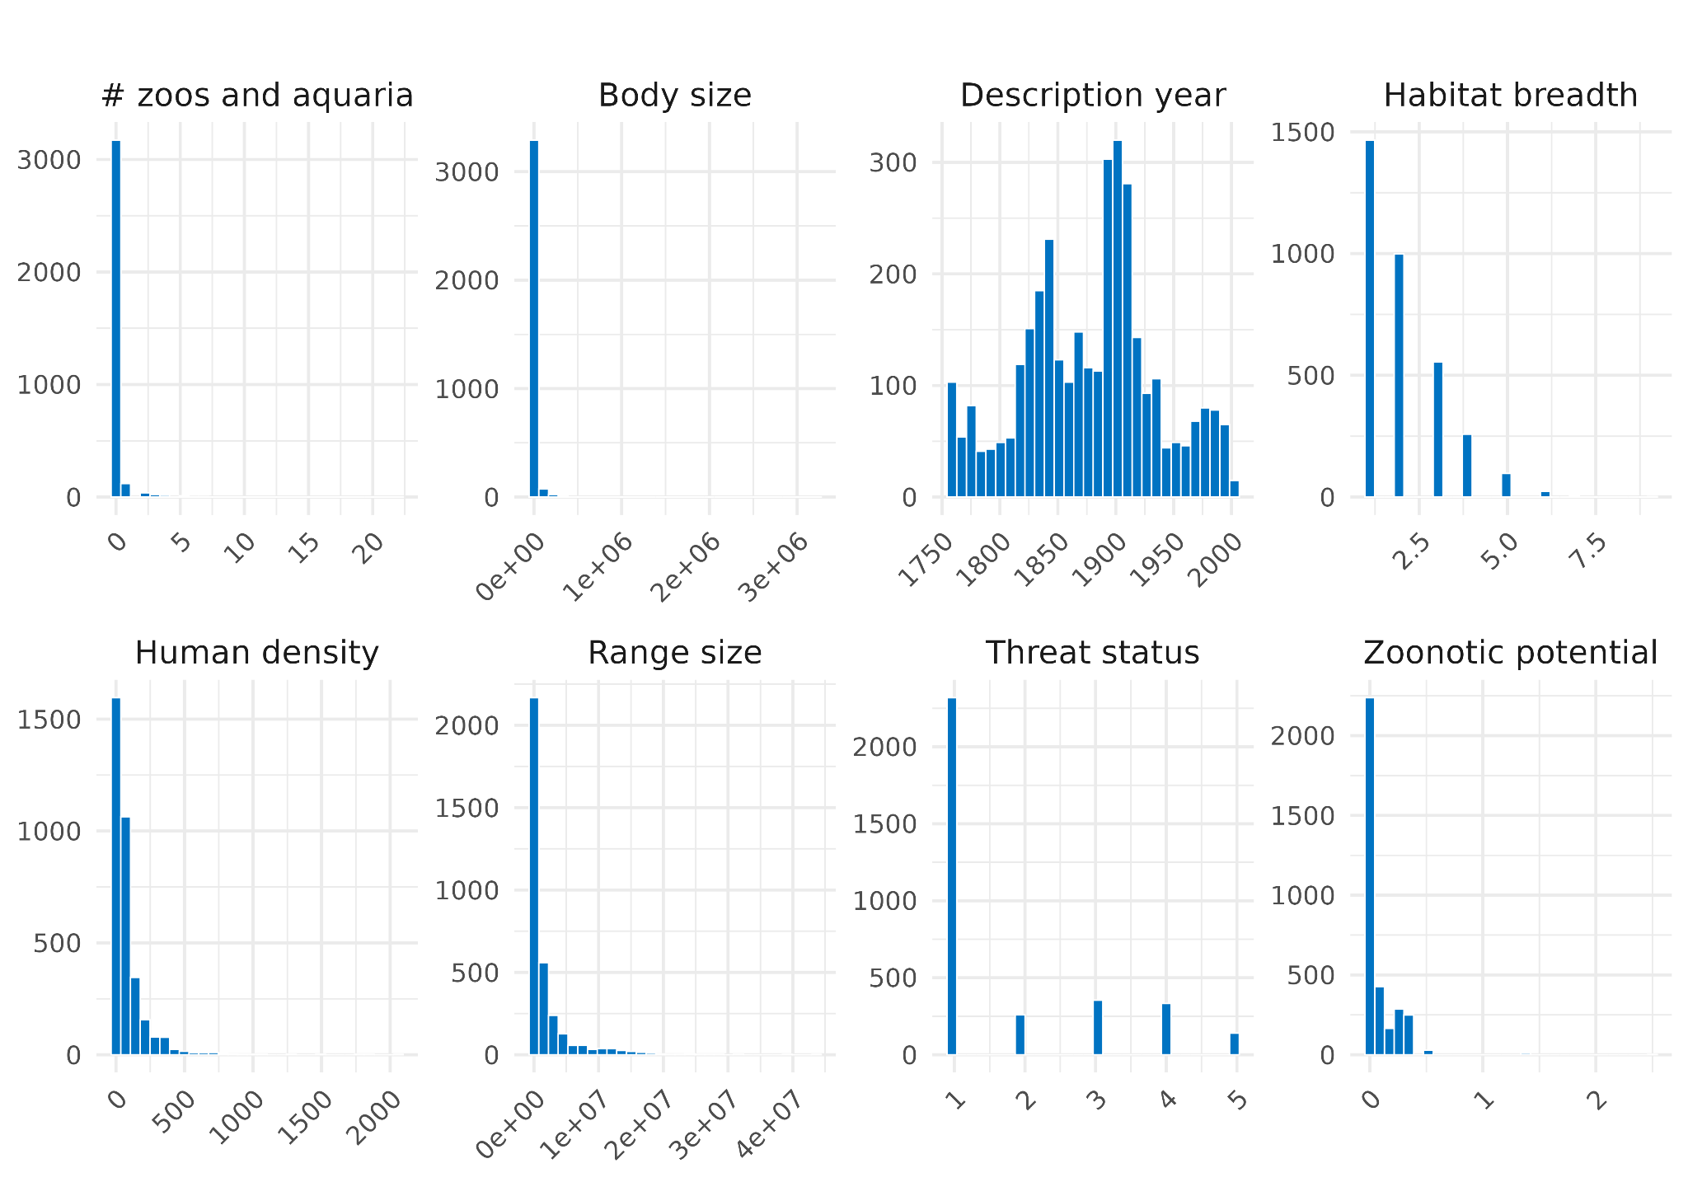
Figure S3. Distribution of values for predictors of research effort on parasites across mammal species, after log-transformation of continuous variables and scaling of all variables.
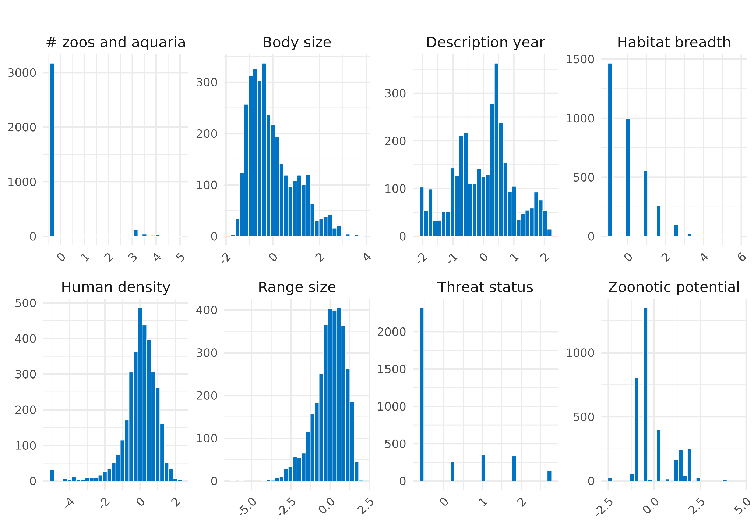
Figure S4. R-hat values for the intercept and predictors of a Bayesian Generalized Linear Mixed Model, predicting the number of parasitological studies across mammal species. Each point refers to a predictor (apart from the first one which indicates the intercept) and the yellow points indicate R-hat values below 1.05.
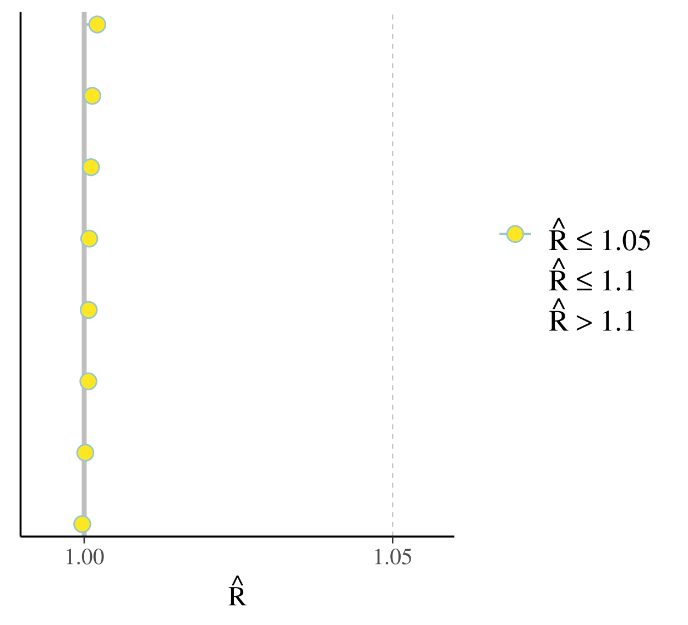
Figure S5. Trace plots for predictors of a Bayesian Generalized Mixed Model predicting the number of parasitological studies across mammal species. These plots indicate three chains with different colours and their mixing is an indication of the reliability of the results, as different explorations of parameter space converge towards the same optimum.

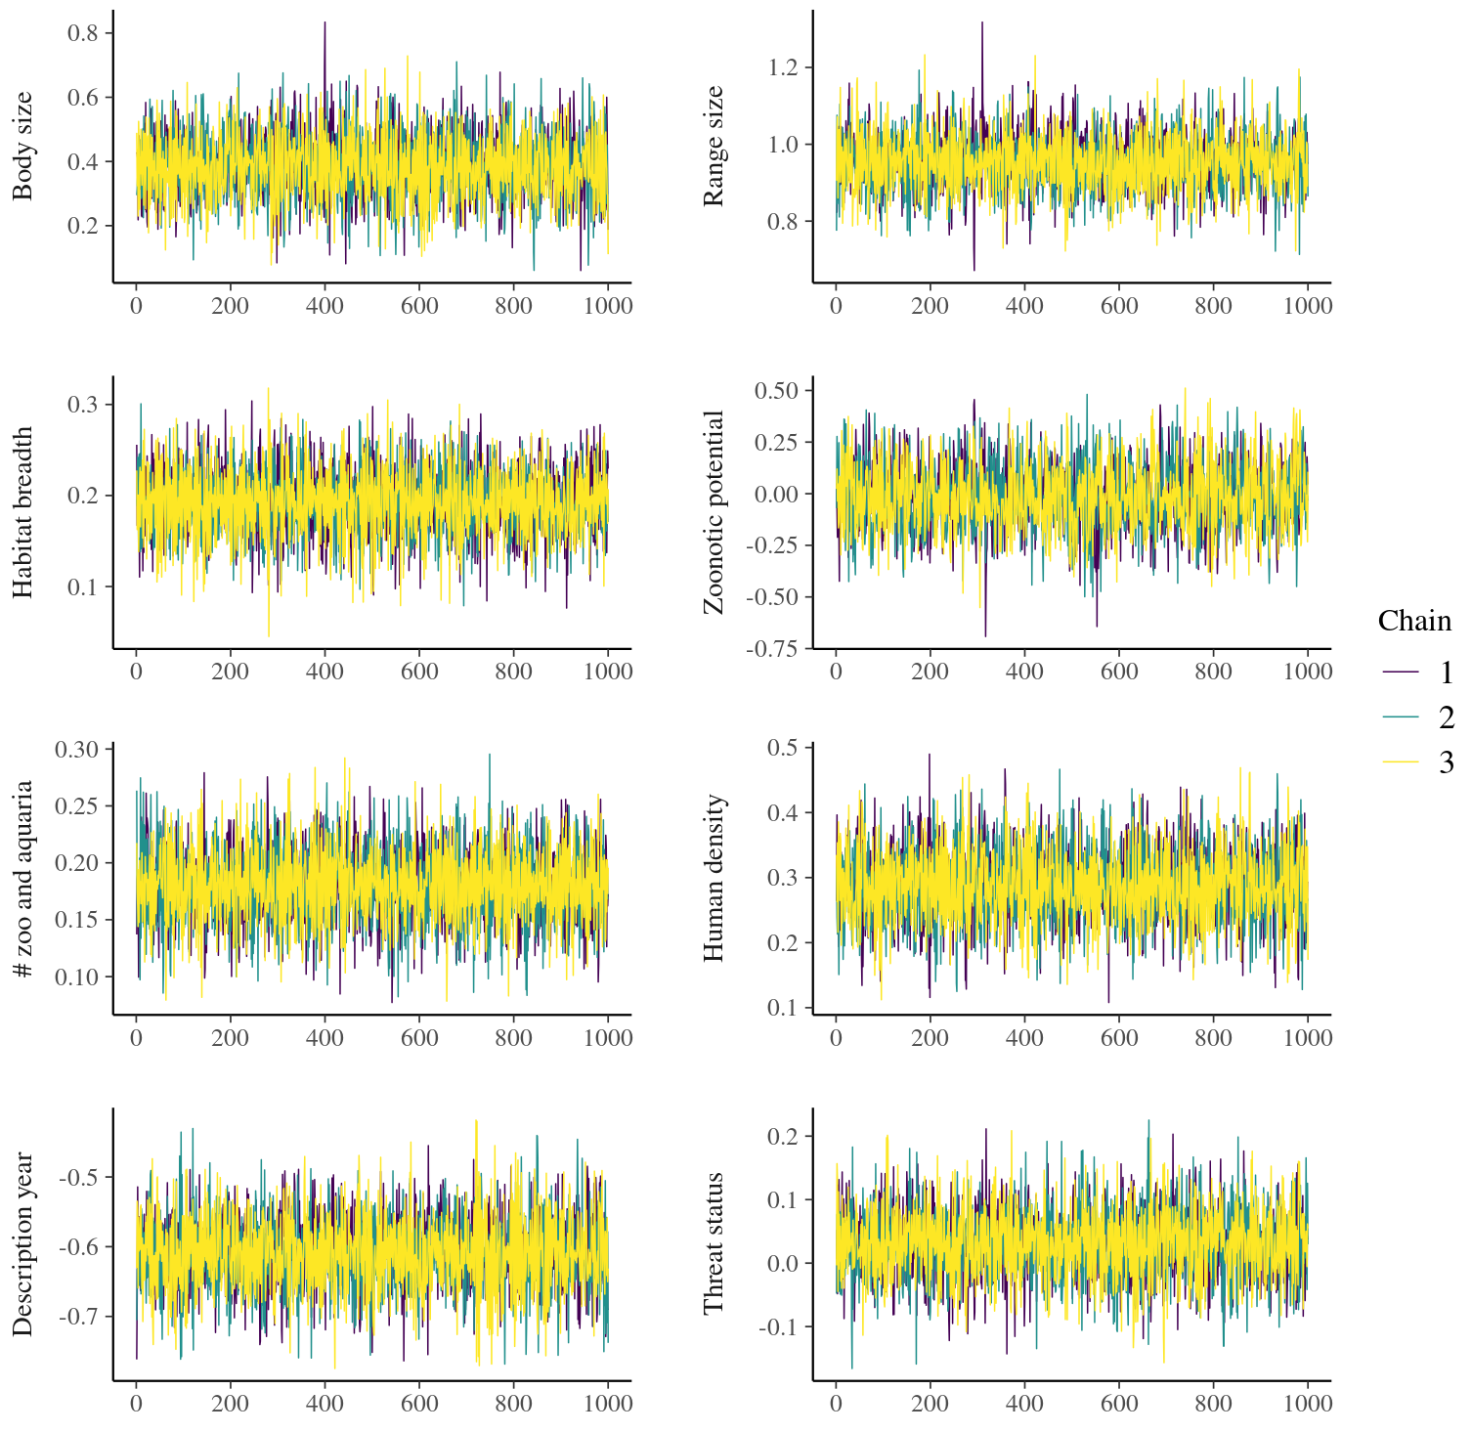
Figure S6. Posterior predictive checks for 100 posterior draws from a Bayesian Generalized Linear Mixed Model predicting the number of parasitological studies across mammal species. The y line represents the distribution of the observed outcomes whereas lines indicated with y rep represent the posterior draws. As the y and yrep curves overlay, simulated data well represent the observed data and the model is therefore deemed reliable.
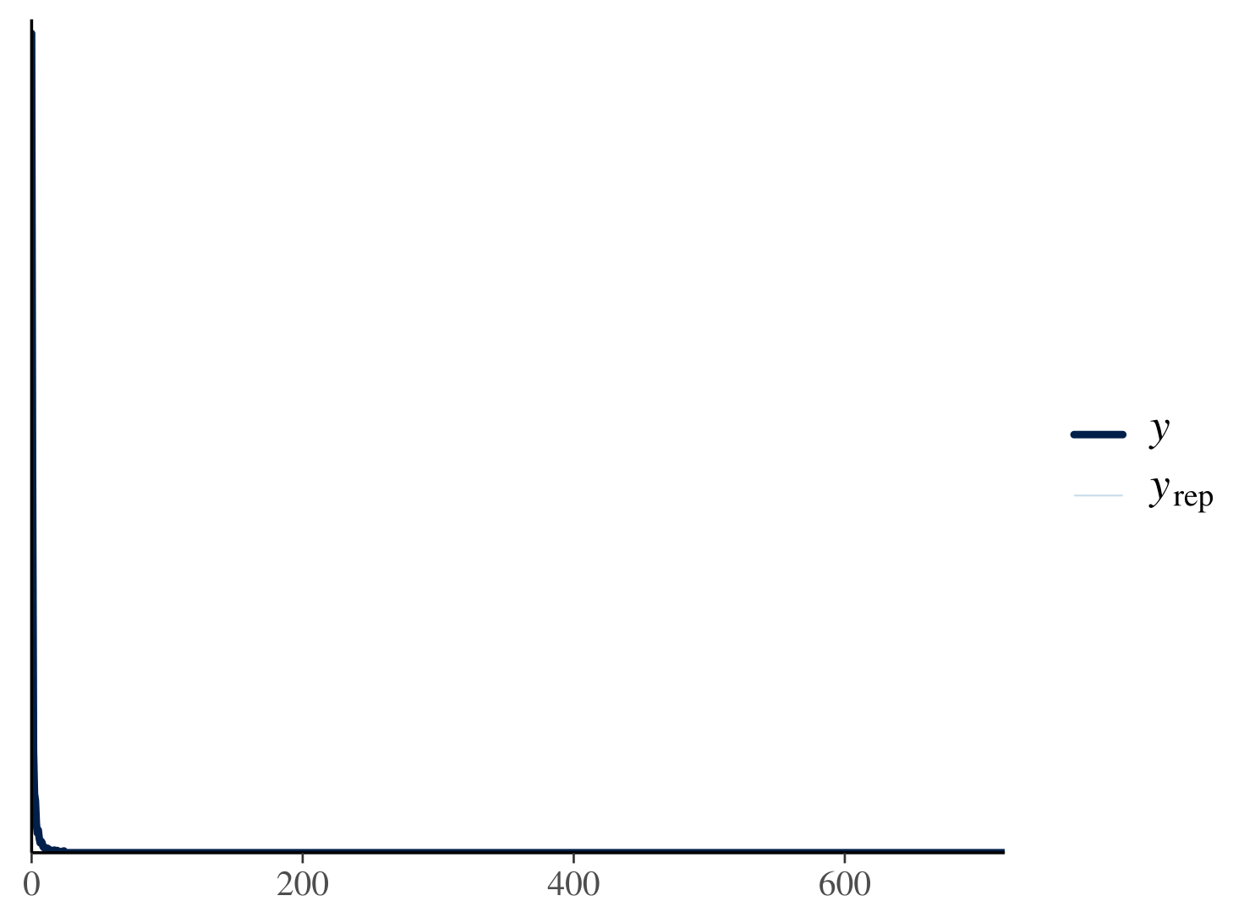
Figure S7. Importance of different variables as predictors of the parasitological (with a focus on viruses) research intensity across mammals. The plots represent the posterior distribution of a Bayesian Generalized Linear Mixed Model, vertical lines represent model estimates, inner shaded areas represent 50% credible intervals whereas continuous lines represent 95% intervals. Light blue: 95% intervals do not overlap zero; dark blue: 95% intervals overlap zero.
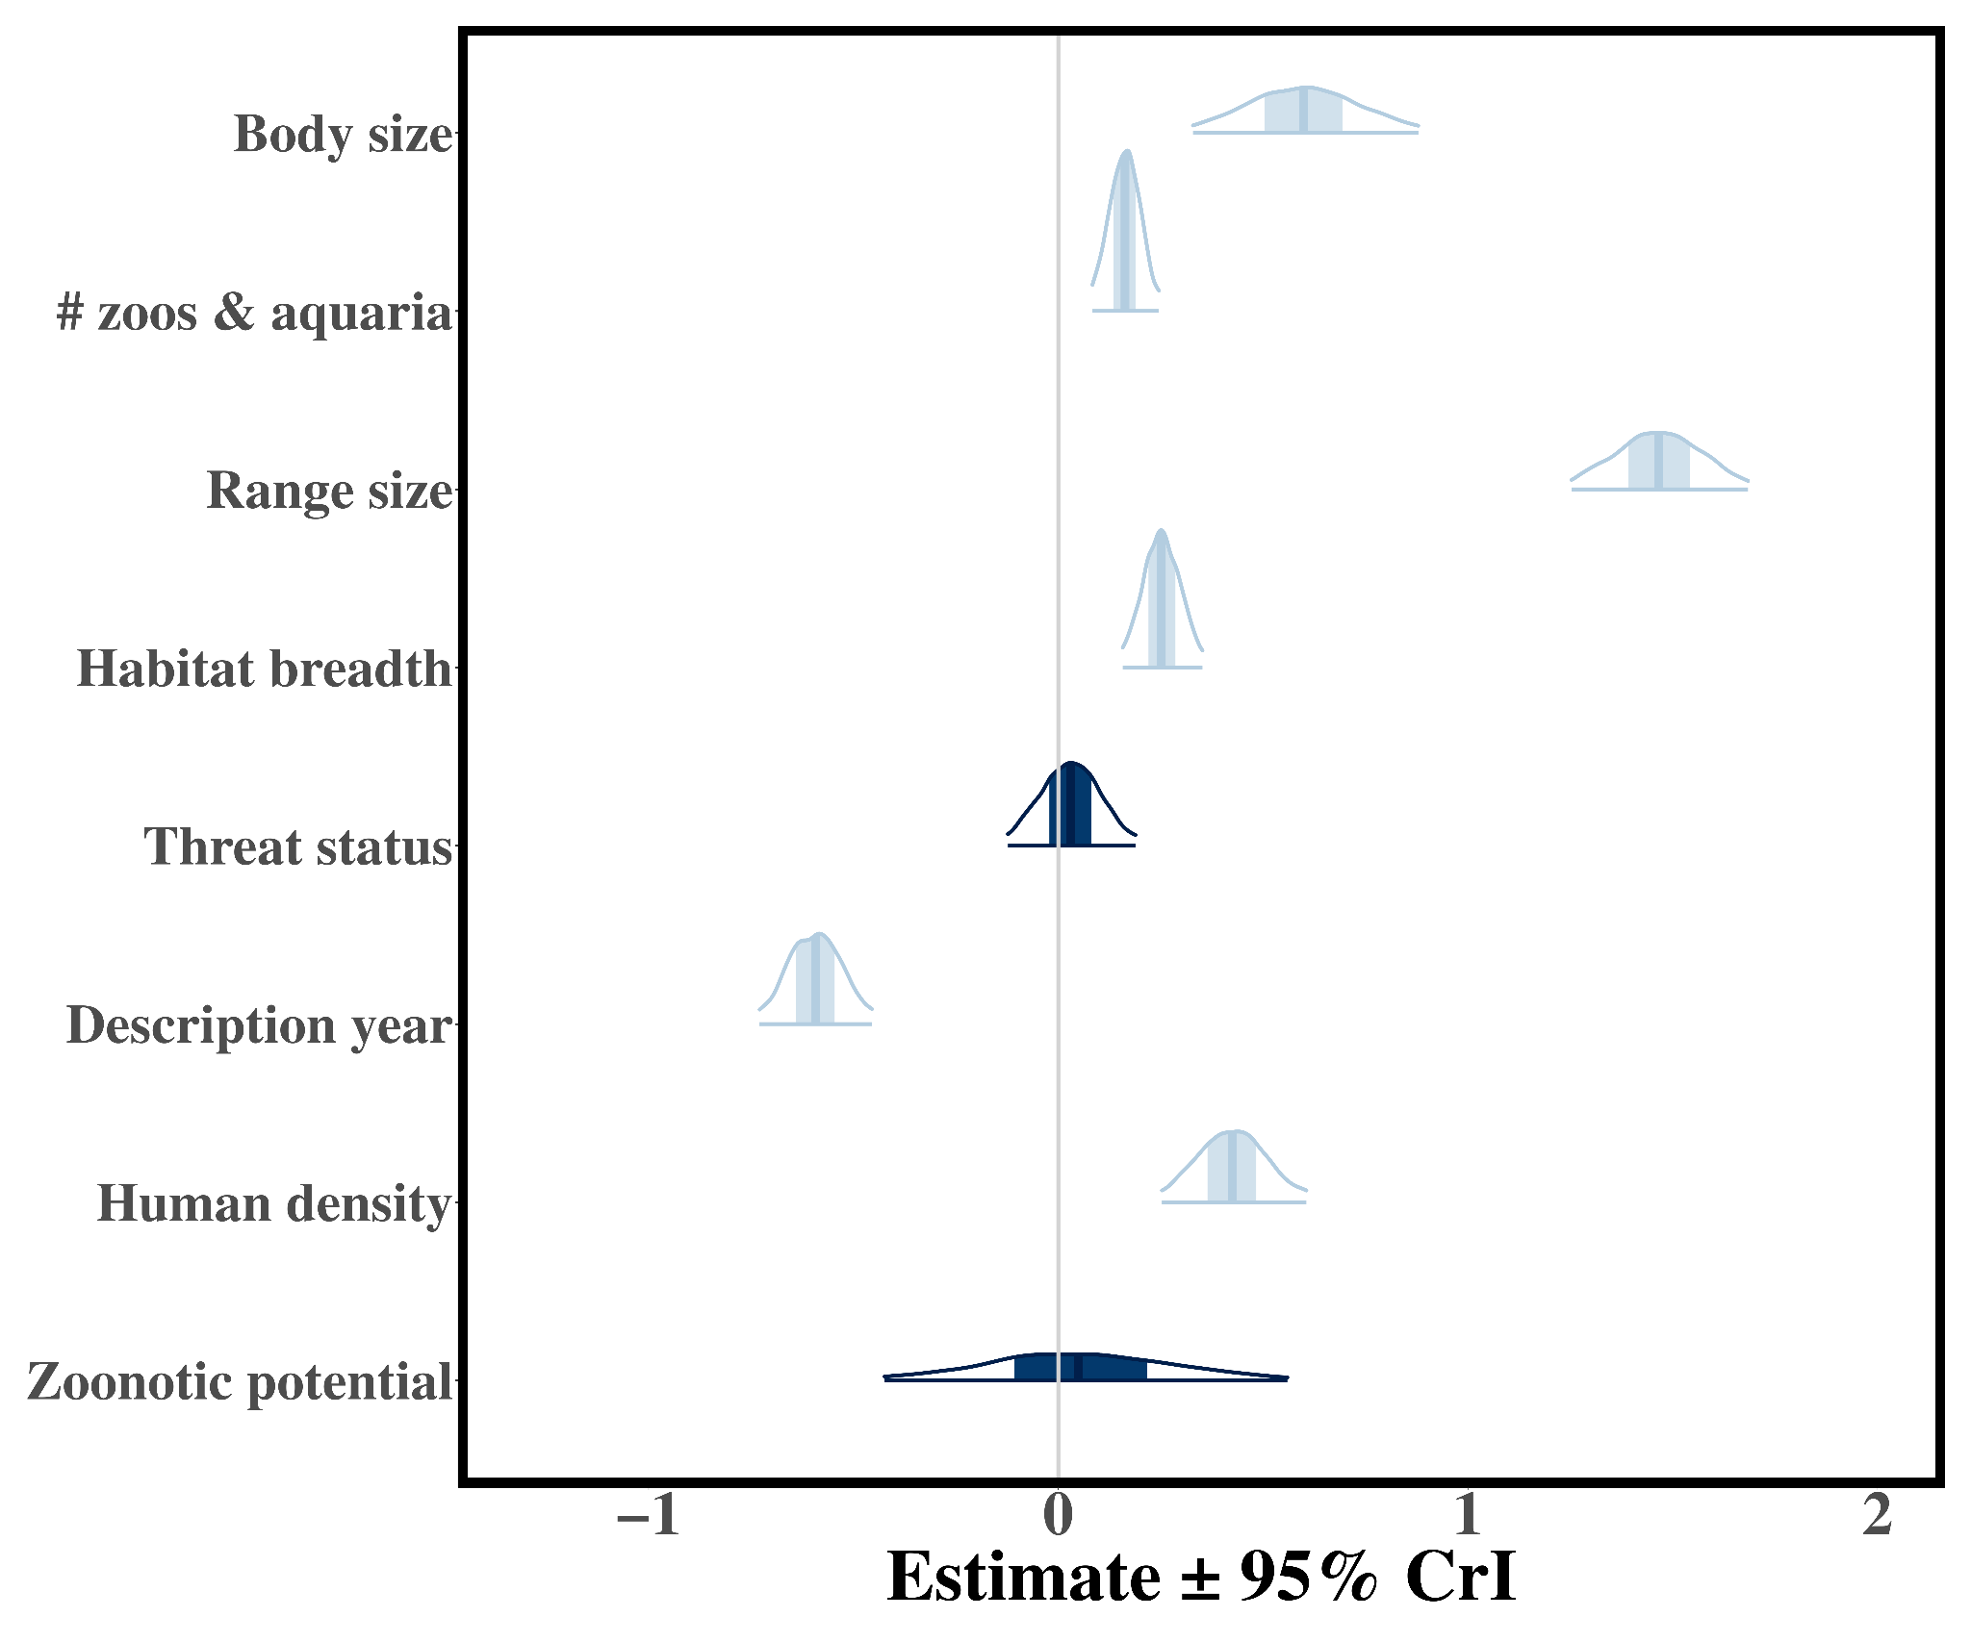
Table S1. Variance Inflation Factor among potential predictors of taxonomic bias in the knowledge of parasites across mammals. Values above three might indicate potential multicollinearity of predictors.

Predictor | Variance Inflation Factor
Body size | 2.292
Range size | 1.977
Zoonotic potential | 1.844
Description year | 1.789
Threat status | 1.616
Frequency in captivity | 1.344
Habitat breadth | 1.153
Human density | 1.041

