Supplementary data

Biodiversity and Conservation

Where and how to conserve butterflies amid climate change: a model-based approach on Papilio alexanor

Luca Anselmo^{1*}, Enrico Caprio¹, Andrea Baruzzi², Matteo Serafini³, Simona Bonelli¹

¹ Università degli Studi di Torino, Dipartimento di Scienze della Vita e Biologia dei Sistemi, Via Accademia Albertina 13, Torino, 10123, Italia
²Via della Milana 44, 40026, Imola (BO), Italy
³Ente Parco Naturale Regionale delle Alpi Liguri, Via Roma 11, Rezzo (IM), 18026, Italy
*Corresponding author, luca.anselmo@unito.it, Via Accademia Albertina 13, 10123, Turin, Italy

Supplementary information S1
Additional information on host plants

P. alexanor is an oligophagous species, locally monophagous at least in Italy (Bonelli et al., 2015, Balletto et al., 2023). In Southern Europe, P. alexanor utilizes two host plants, both belonging to the Apiaceae Lindl. family: Opopanax chironium (L.) W.D.J.Koch and Ptychotis saxifraga (L.) Loret & Barrandon. Although some authors reported other possible host plant species (Kahlhber 1976; Nel and Chauliac 1983; Sala and Bollino 1991; Bollino and Sala 2004; Balletto et al. 2023), these were not included in our analyses. David and Sanetra (1994) had already detailed the possible causes of confusion and reasons for excluding these species, and other authors supported possible misidentifications due to morphological similarity (Descimon 1991; Nel 1991). Therefore, also according to our field experience, we assumed that P. alexanor requires O. chironium and P. saxifraga for reproduction in Southern Europe. The distribution of O. chironium in France is limited to the south-central and, predominantly, the south-eastern departments (Julve 2018), thus closely mirroring the southern distribution of P. alexanor. In Italy, the geographical overlap between this plant and P. alexanor is very limited, since in addition to Liguria, the species is widely present in the central and southern administrative regions (Pignatti 2017; Bartolucci et al. 2024), where, however, the butterfly has been sighted only occasionally (Bollino and Sala 2004; Balletto et al. 2023). In France, P. saxifraga is primarily distributed in the south-eastern region. Still, it is also reported, albeit discontinuously, in areas where the butterfly has not been recorded, such as the central-eastern Departments (Julve 2018). In Italy, it is primarily reported in presence areas of the species, i.e. the western and central-eastern Alps (Pignatti 2017; Bartolucci et al. 2024). Considering this information, the distribution of host plants in Southern Europe appears broader than that of P. alexanor. Specifically, it coincides with the northernmost range of O. chironium and the southernmost range of P. saxifraga. The two plants exhibit markedly different appearances. O. chironium is notably larger and more conspicuous (100-250 cm tall), with thick stems that bear numerous inflorescences composed of many yellow flowers. In contrast, P. saxifraga is a smaller plant (30-80 cm tall), with thin stems that support few inflorescences bearing small white petals (Pignatti, 2017).

References
Balletto E, Barbero F, Bonelli S, Casacci LP, Dapporto L (2023) Fauna d'Italia, Vol. LIV: Lepidoptera Papilionoidea Butterflies. Calderini, Rimini
Bartolucci F, Peruzzi L, Galasso G, Albano A, Alessandrini A, Ardenghi NMG et al (2018) An updated checklist of the vascular flora native to Italy. Plant Biosyst 152(2):179-303. https://doi.org/10.1080/11263504.2017.1419996
Bollino M, Sala G (2004) Synopsis of Papilio alexanor Esper, 1799 (An updated revue of its taxonomy and biology). Natura Edizioni Scientifiche, Bologna
David C, Sanetra M (1994) Verbreitung, Biologie und Autökologie von Papilio alexanor Esper, 1799 in der südwestlichen Alpenregion (Lepidoptera: Papilionidae). Nachr Entomol Ver Apollo 15(1-2):1-24
Descimon H (1991) Le choix des plantes nourricières chez quelques Papilionidae et Pieridae provençaux et méditerranéens (Lepidoptera: Papilionoidea). Ecol Mediterr 17:51-61
Kahlheber D (1976) Beitrag zur Biologie von Papilio alexanor ESPER. Nachrichten des Entomologischen Vereins. Apollo 1:49-51
Julve P (2018) Chorodep. Listes départementales des plantes de France. Version 2018.04 du 24 avril 2018. Programme chorologie départementale de Tela Botanica. https://www.tela-botanica.org/bdtfx-nn-45594-repartition . Accessed 13 March 2024
Nel J (1991) Sur la plasticité écologique et la biologie de quelques Lépidoptères (Rhopalocera) du sud-est méditerranéen de la France (Première partie). Linneana Belg 13(4):159-220
Nel J, Chauliac A (1983) Une nouvelle sous-espéce de Papilio alexanor Esper Isolée dans la Provence méridionale. Alexanor 13:16-20
Pignatti S (2017) Flora d’Italia (seconda edizione). Edagricole
Sala G. Bollino M (1991) Papilio alexanor Esper from Italian Maritime Alps: a new subspecies (Lepldoptera: Papilionldae). Atalanta 22(2-4):75-79

Table S1 Ecological indicators of P. alexanor host plants. The values ​​are entered on an increasing ordinal scale depending on the source. Abbreviations: Oc = O. chironium, Ps = P. saxifraga.
Ecological indicator | Pignatti et al. (2005) |  | Landolt et al. (2010) |  | Julve (2021) |  | Chytrý et al. (2024)
Ecological indicator | Oc | Ps | Oc | Ps | Oc | Ps | Oc | Ps
Moisture | 4/12 | 2/12 | 2/5 | 2/5 | 3/9 | 3/9 | 4/12 | 2/12
Reaction | 5/9 | 3/9 | 2/5 | 4/5 | 8/9 | 8/9 | 7/9 | 3/9
Nutrients | 3/9 | 2/9 | 3/5 | 2/5 | 4/9 | 3/9 | 3.5/9 | 2/9
Temperature | 8/12 | 7/12 | 4/5 | 4.5/5 | 7/9 | 5/9 | 7.3/12 | 7.5/12
Continentality | 4/9 | 3/9 | 3/5 | 1/5 | 4/9 | 5/9 | - | -
Light | 7/12 | 7/12 | 4/5 | 4/5 | 7/9 | 8/9 | 7/9 | 7/9

References

Chytrý M, Řezníčková M, Novotný P, Holubová D, Preislerová Z, Attorre F, Biurrun I, Blažek P, Bonari G, Borovyk D, Čeplová N, Danihelka J, Davydov D, Dřevojan P, Fahs N, Guarino R, Güler B, Hennekens SM, Hrivnák R, Kalníková V, Kalusová V, Kebert T, Knollová I, Knotková K, Koljanin D, Kuzemko A, Loidi J, Lososová Z, Marcenò C, Midolo G, Milanović D, Mucina L, Novák P, von Raab-Straube E, Reczyńska K, Schaminée JHJ, Štěpánková P, Świerkosz K, Těšitel J, Těšitelová T, Tichý L, Vynokurov D, Willner W, Axmanová I (2024) FloraVeg.EU: an online database of European vegetation, habitats, and flora. Appl Veg Sci 27:e12798. https://doi.org/10.1111/avsc.12798

Julve P (2021) Baseflor. Index botanique, écologique et chorologique de la flore de France. Version : 27 avril 2021. https://www.tela-botanica.org/projets/phytosociologie. Accessed 13 March 2024

Landolt E, Baümler B, Erhardt A, Hegg O, Klötzli F, Lämmler W, Nobis M, Rudmann K, Schweingruber FH, Theurillat JP, Urmi E, Vust M, Wohlgemuth T (2010) Flora indicativa - Ökologische Zeigerwerte und biologische Kennzeichen zur Flora der Schweiz und der Alpen. Verlag Haupt, Bern

Pignatti S, Menegoni P, Pietrosanti S (2005) Bioindicator values of vascular plants of the Flora of Italy. Braun-Blanquetia 39:1-97

Supplementary information S2
Dispersal ability of P. alexanor

Some authors consider this species capable of noticeable movements: Balletto and Kudrna (1985) describe it as between sedentary and migratory, and De Groot (2022) suggests that it may disperse very far. Lafranchis et al. (2015) attribute to P. alexanor the ability to cover long distances and temporarily settle in newly colonized sites. According to Bonelli et al. (2015) and Balletto et al. (2023), in the absence of documented stable populations, observations recorded over the years in southern Italy would likely refer to individuals that have moved over considerable distances from the Balkans. Kahlheber (1976) describes it as reluctant to leave its breeding sites; Sala and Bollino (2004) report observations up to a few hundred meters away from a small area of presence in Turkey; Heikkinen et al. (2010) classify it as sedentary, and Moussus et al. (2021, 2024) assign it a medium dispersal capacity (up to a few km). Finally, Balletto et al. (2023) report an observation of a vagrant specimen at an exceptional elevation of 2100 m near Col di Tenda (FR). In that area, the nearest reproductive site is at 1600 m (Balletto et al. 2023; pers. obs.), which is at a minimum distance of about 1 km. No specific studies have been conducted on the dispersal ability of P. alexanor.
As suggested by Sekar (2012), we do not consider wingspan a reliable proxy for dispersal capacity. However, since some authors have suggested a low propensity for the species to move far and frequently from reproductive sites, and to constrain predictions on more likely colonizable areas, we adopted a conservative approach, assuming its dispersal ability does not differ significantly from that of several other European species. According to Stevens et al. (2013), based on their study of 50 butterfly species of Northwestern Europe, the average dispersal distance is about 200 m and 90% of the species have a mean dispersal distance of up to 350 m. Some species are observed and predicted to travel more than 1 km on average, but very long-distance dispersal events were relatively infrequent. Most species rarely move beyond 5 km, with long-distance dispersal events occurring with an average probability of less than 0.01.

References

Balletto E, Kudrna O (1985) Some Aspects of the Conservation of Butterflies in Italy, with Recommendations for a Future Strategy (Lepidoptera Hesperiidae & Papilionoidea). Boll Soc Entomol Ital 117(1-3):39-59

Balletto E, Barbero F, Bonelli S, Casacci LP, Dapporto L (2023) Fauna d'Italia, Vol. LIV: Lepidoptera Papilionoidea Butterflies. Calderini, Rimini

Bollino M, Sala G (2004) Synopsis of Papilio alexanor Esper, 1799 (An updated revue of its taxonomy and biology). Natura Edizioni Scientifiche, Bologna
Bonelli S, Barbero F, Casacci LP, Balletto E (2015) Habitat preferences of Papilio alexanor Esper, [1800]: implications for habitat management in the Italian Maritime Alps. Zoosystema 37(1):169-177. https://doi.org/10.5252/z2015n1a7
De Groot GA (2022) Connectivity needs for grassland arthropods. ETC/BD report to the EEA, Paris

Heikkinen RK, Luoto M, Leikola N, Pöyry J, Settele J, Kudrna O, Marmion M, Fronzek S, Thuiller W (2010) Assessing the vulnerability of European butterflies to climate change using multiple criteria. Biodivers Conserv 19: 695-723. https://doi.org/10.1007/s10531-009-9728-x
Kahlheber D (1976) Beitrag zur Biologie von Papilio alexanor ESPER. Nachrichten des Entomologischen Vereins. Apollo 1:49-51
Lafranchis T, Jutzeler D, Guillo JY (2015) Le Vie des Papillons: Ecologie, Biologie et Comportement des Rhopalocères de France. Diatheo

Moussus JP, Lorin T, Cooper A (2022) Guide pratique des papillons de France. Delachaux et Niestlé

Moussus JP (2024) Papillons de jour d’Europe occidentale. Delachaux et Niestlé

Sekar S (2012) A meta-analysis of the traits affecting dispersal ability in butterflies: can wingspan be used as a proxy?. J Anim Ecol 81:174-184. https://doi.org/10.1111/j.1365-2656.2011.01909.x

Stevens VM, Trochet A, Blanchet S, Moulherat S, Clobert J, Baguette M (2013) Dispersal syndromes and the use of life-histories to predict dispersal. Evol Appl 6:630-642. https://doi.org/10.1111/eva.12049

Supplementary information S3
Conservation status of P. alexanor

P. alexanor is listed in Annex IV of the Habitats Directive 92/43/EEC (HD) as a strictly protected species. According to Article 17 of the HD, it must be regularly monitored, and Member States are required to provide a report on its conservation status every six years. According to the synthesis of latest reports (available at https://nature-art17.eionet.europa.eu/), this species has shown an Unfavourable-Inadequate (U1) conservation status in Italy (assessed only for the Alpine bioregion), while in France it was reported as Favourable (FV) in the Alpine bioregion and Unfavourable-Bad (U2) in the Mediterranean bioregion. According to the IUCN Red Lists extinction risk assessments, this species was classified Least Concern (LC) at European level (van Swaay et al. 2010), LC at Mediterranean level (van Swaay et al. 2014), Endangered (EN) in Italy (Bonelli et al. 2018), LC in France at national level (UICN France et al. 2012), LC in Provence-Alpes-Côte d’Azur administrative region (Bence 2014) and Critically Endangered (CR) in Auvergne-Rhône-Alpes administrative region (Baillet and Guicherd 2018). Worryingly, an important and seemingly isolated French Mediterranean population reproducing on O. chironium, referred to subsp. destelensis Nel & Chauliac, 1983, appears to be extinct (Houard and Jaulin 2018; Bence and Richaud 2019).

References

Baillet Y, Guicherd G (2018) Dossier de présentation de la liste rouge Rhopalocères & Zygènes de Rhône-Alpes. Flavia APE, Trept

Bence S (2014) Liste rouge régionale des Rhopalocères et Zygènes de Provence-Alpes-Côte d’Azur. CEN PACA

Bence S, Richaud S (2019) Atlas des papillons de jour et zygènes de Provence-Alpes-Côte d’Azur. CEN PACA, Le naturographe, Gap

Bonelli S, Casacci LP, Barbero F, Cerrato C, Dapporto L, Sbordoni V, Scalercio S, Zilli A, Battistoni A, Teofili C, Rondinini C, Balletto E (2018) The first red list of Italian butterflies. Insect Conserv Divers 11:506-521. https://doi.org/10.1111/icad.12293

Houard X, Jaulin S (2018) Plan national d’actions en faveur des « Papillons de jour » - Agir pour la préservation de nos lépidoptères diurnes patrimoniaux 2018-2028. Office pour les insectes et leur environnement - DREAL Auvergne-Rhône-Alpes. Ministère de la Transition écologique et solidaire

van Swaay C, Wynhoff I, Verovnik R, Wiemers M, López Munguira M, Maes D, Sasic M, Verstrael T, Warren M, Settele J (2010) Papilio alexanor (Europe assessment). The IUCN Red List of Threatened Species 2010, e.T174220A7031155. https://www.iucnredlist.org/species/174220/7031155. Accessed 15 September 2023

van Swaay C, Wynhoff I, Wiemers M, Katbeh-Bader A, Power A, Benyamini D, Tzirkalli E, Balletto E, Monteiro E, Karaçetin E, Franeta F, Pe'er G, Welch H, Thompson K, Pamperis L, Dapporto L, Šašić M, López Munguira M, Micevski N, Dupont P, Garcia-Pereira P, Moulai, R, Caruana R, Verovnik R, Bonelli S, Beshkov S (2014) Papilio alexanor (Mediterranean assessment). The IUCN Red List of Threatened Species 2014, e.T174220A53719934. https://www.iucnredlist.org/species/174220/53719934. Accessed on 15 September 2023

UICN France, MNHN, Opie, SEF (2012) La Liste rouge des espèces menacées en France - Chapitre Papillons de jour de France métropolitaine. Dossier électronique

Supplementary information S4
Additional information on presence data
The presence data refer to:
- observations collected by the authors from 2021 to 2023. In Italy the data collection was concentrated in the areas of presence already known (Balletto et al. 2007; unpublished data) and extended to adjacent areas. In France, specific field research was conducted only near the border and in localities where reproduction on both host plants was reported, specifically in Department 06. It is important to report that these last surveys seemed to confirm the phenological mismatch between the two CUs (Nel 1991; Bonelli et al. 2015), as on the same dates (from June 25 to 27) and at a distance of only 770 m (200 m of elevation difference), only a few late-stage larvae were found on O. chironium, while only egg-laying activity and a first instar larve were observed on P. saxifraga. These data referred exclusively to pre-imaginal stages (found within an altitudinal range of 90 to 1740 m a.s.l.) and were all accompanied by information on the host plants on which they were observed;
- observations collected from 2008 to 2010 by Bonelli et al. (2015) as part of a study on the habitat preferences of P. alexanor in the Italian Maritime Alps. These were referred exclusively to pre-imaginal stages with P. saxifraga as host plant;
- observations referred to P. alexanor provided by public databases: Global Biodiversity Information Facility (GBIF Secretariat, https://www.gbif.org), iNaturalist (https://www.inaturalist.org), Observation (https://www.observation.org), and Silene (https://www.silene.eu). In many cases, the developmental stage was reported (egg, larva or adult), but no information on host plant species. When possible, the photographs attached to the records were examined to provide additional information, e.g. the host plant on which the caterpillar or egg was located or on which an adult female was photographed laying eggs.

References

Balletto E, Bonelli S, Cassulo LA (2007) Insecta Lepidoptera Papilionoidea. In: Ruffo S., Stoch F. (ed) Checklist and distribution of the Italian Fauna - 10,000 terrestrial and freshwater species. Memorie del Museo Civico di Storia Naturale di Verona, 2° serie, Sez. Scienze della Vita 17, Verona + CD Rom

Bonelli S, Barbero F, Casacci LP, Balletto E (2015) Habitat preferences of Papilio alexanor Esper, [1800]: implications for habitat management in the Italian Maritime Alps. Zoosystema 37(1):169-177. https://doi.org/10.5252/z2015n1a7

GBIF Secretariat (2024) GBIF Occurrence Download https://doi.org/10.15468/dl.t4qkct

Nel J (1991) Sur la plasticité écologique et la biologie de quelques Lépidoptères (Rhopalocera) du sud-est méditerranéen de la France (Première partie). Linneana Belg 13(4):159-220

Supplementary information S5
Variable preparation and selection

Bioclimatic predictors (Hijmans et al. 2005) were obtained starting from the mean monthly maximum and minimum temperature from 2000 to 2019 and monthly precipitation from 2000 to 2018, provided by the CHELSA ver. 2.1 database (Karger et al. 2017, 2021). We chose this specific time interval as current conditions rather than using ready-to-use bioclimatic predictors for the period 2081-2010, because the presence data were mostly more recent, therefore to achieve the best possible alignment between current distribution and current climate conditions. Although these variables were already at high resolution (~ 1 km), we chose to perform a statistical downscaling (Wilby et al., 2004; Pielke and Wilby, 2012) to bring them to an even finer resolution of 250 m.
To do so, the maximum and minimum temperature monthly data for each year were averaged, and then downscaled through regression techniques using a set of topographic variables at 250 m resolution, considered to be among those most closely related to climate in complex landscapes (Lenoir et al. 2017). We chose elevation, aspect (northing), slope and Topographic Position Index (TPI) obtained from the aggregation of elevation over Europe from the GMES RDA project (EU DEM ver. 1, available at https://sdi.eea.europa.eu) at the original resolution of 25 m, and distance from sea using coastline polygon provided by the European Environment Agency (available at eea.europa.eu). All calculations were performed with the package terra ver. 1.7-29 (Hijmans 2023) in R ver. 4.3.2 (R Core Team 2023). To detect any relationship between temperature and topographic variables in the study area, we performed linear regressions by randomly extracting values from 1000 pixels of each monthly temperature map at its original resolution and the corresponding topographic variables at their final resolution. Before this, we ensured the absence of strong multicollinearity (Pearson ∣r∣ < 0.7) among the topographic variables using the usdm package ver. 2.1-7 (Naimi et al. 2014) in R. We also performed variable selection using a backwards stepwise approach based on AIC to identify the best-fitting model. Only regressions with an R² of at least 0.8 and p < 0.01 were considered reliable. Subsequently, each monthly temperature variable was downscaled to the final resolution (i.e., 250 m) based on robust regression modelling with the spatialEco package ver. 1.2-0 (Evans 2019) in R, using the topographic variables selected through the above process for each model. Since the statistical downscaling of precipitation using topographic variables is generally unsatisfactory (Martin et al. 2013; Mammola et al. 2019), downscaling was achieved through resampling using bilinear interpolation, thereby spatializing this data across the study area to match the resolution of other variables. To evaluate the effectiveness of the downscaling procedure, we use monthly maximum and minimum temperature and precipitation from 2000 to 2022 observed in 302 meteorological stations distributed on study area (obtained at https://meteo.data.gouv.fr for France and at https://scia.isprambiente.it for Italy). Downscaled data closely followed the monthly trend of the observed data, although there was a general tendency to underestimate temperature and overestimate precipitation (Figs S1-S3). Given the overall distributions, the differences were deemed sufficiently small to use the downscaled variables to derive 19 bioclimatic variables, with the dismo package ver. 1.3-14 (Hijmans et al. 2023) in R. Among these, only those considered most ecologically important and not highly correlated with each other (∣r∣<0.7) were selected for the modelling (Merow et al. 2013; Fourcade et al. 2018), using the package corrplot ver. 0.92 (Taiyun et al. 2021) in R. We selected mean annual air temperature (BIO1) as the main general descriptor of local climate, precipitation amount of the wettest month (BIO13) and precipitation seasonality (BIO15) as not highly correlated with BIO1 and each other, and because precipitation can particularly affect plant growth (Fig. S4).
To perform future predictions, maximum, minimum temperature and precipitation data projected to 2071-2100 according to three CMIP6 climate scenarios (SSP1-2.6, SSP3-7.0 and SSP5-8.5) and calculated based on 5 General Circulation Models (GFDL-ESM4, UKESM1-0-LL, MPI-ESM1-2-HR, IPSL-CM6A-LR, MRI-ESM2-0), were obtained from CHELSA database. These climate data were averaged and downscaled and were used to derive projected bioclimatic variables under the three scenarios, using the same procedure applied to those related to current period.
Vegetation cover predictors were derived from MOD44B - MODIS/Terra Vegetation Continuous Fields (Townsend and DiMiceli 2015; DiMiceli et al. 2021). This source provides fractional estimates of three basic land cover components at a global scale (percent tree cover; percent non-tree vegetation; and percent non-vegetated ground) at 250 m spatial resolution and at yearly temporal resolution (available at search.earthdata.nasa.gov). We averaged data from 2000 to 2023 and re-projected to match the other variables. Given that the target species select natural or semi-natural environments (Balletto et al. 2023), we ensured that the vegetation cover values of pixel corresponding to urbanized areas and cultivated lands were set at a minimum, according to the CORINE Land Cover 2018 (available at doi.org/10.2909/960998c1-1870-4e82-8051-6485205ebbac).
Two variables linked to bedrock chemistry were obtained from the European map of groundwater pH and Ca2+ concentration (on a ln scale) provided by Hájek et al. (2021). Their original resolution (the same of CHELSA climatic data) was brought to 250 m using bilinear resampling. As these variables were highly correlated (with ∣r∣>0.7), only the calcium variable was retained, as known to be an important abiotic factor for the host plants (see Section 2.2). Finally, since the caterpillars of P. alexanor are extremely heliophiles (Balletto et al., 2023), we calculated the mean irradiance at the central hour of the days corresponding to mid-May and mid-August in QGIS ver. 3.28 with GRASS (QGIS Development Team 2022), i.e. the temporal extremes in which pre-imaginal stages develop (Balletto et al. 2023).
The final set of 8 predictors to be used in the modelling were: BIO1, BIO13, BIO15, groundwater calcium (hereafter calcium), percent tree cover, percent non-tree vegetation, percent non-vegetated ground and irradiance, after having verified the absence of strong correlation between them (∣r∣<0.7) (Fig. S5). To ensure high accuracy in distance and area calculations, all data were projected using UTM Zone 32N (EPSG:32632), as most of the study area and presence data fall within this zone.

References
Balletto E, Barbero F, Bonelli S, Casacci LP, Dapporto L (2023) Fauna d'Italia, Vol. LIV: Lepidoptera Papilionoidea Butterflies. Calderini, Rimini

DiMiceli C, Townshend J, Carroll M, Sohlberg R (2021) Evolution of the representation of global vegetation by vegetation continuous fields. Remote Sens Environ 254:112271. https://doi.org/10.1016/j.rse.2020.112271

Evans JS (2019) spatialEco. R package version 1.2-0. https://github.com/jeffreyevans/spatialEco (accessed 11 March 2024)

Fourcade Y, Besnard AG, Secondi J (2018) Paintings predict the distribution of species, or the challenge of selecting environmental predictors and evaluation statistics. Glob Ecol Biogeogr 27:245–256. https://doi.org/10.1111/geb.12684

Hájek M, Jiménez-Alfaro B, Hájek O, Brancaleoni L, Cantonati M, Carbognani M, Dedić A, Dítě D, Gerdol R, Hájková P, Horsáková V, Jansen F, Kamberović J, Kapfer J, Kolari THM, Lamentowicz M, Lazarević P, Mašić E, Moeslund JE, Pérez-Haase A, Peterka T, Petraglia A, Pladevall-Izard E, Plesková Z, Segadelli S, Semeniuk Y, Singh P, Šímová A, Šmerdová E, Tahvanainen T, Tomaselli M, Vystavna Y, Biţă-Nicolae C, Horsák M (2021) A European map of groundwater pH and calcium. Earth Syst Sci Data 13:1089–1105. https://doi.org/10.5194/essd-13-1089-2021

Hijmans RJ, Cameron SE, Parra JL, Jones PG, Jarvis A (2005) Very high resolution interpolated climate surfaces for global land areas. Int J Clim 25:1965–1978. https://doi.org/10.1002/joc.1276

Hijmans RJ (2023) terra: Spatial Data Analysis. R package version 1.7-29. https://CRAN.R-project.org/package=terra (accessed 15 September 2023)

Hijmans ARJ, Phillips S, Leathwick J, Elith J, Hijmans MRJ (2023) dismo: Species Distribution Modeling. R package version 1.3-14. https://CRAN.R-project.org/package=dismo. Accessed 13 March 2024

Karger DN, Conrad O, Böhner J, Kawohl T, Kreft H, Soria-Auza RW, Zimmermann NE, Linder HP, Kessler M (2017) Climatologies at high resolution for the earth’s land surface areas. Sci Data 4:170122. https://doi.org/10.1038/sdata.2017.122

Karger DN, Conrad O, Böhner J, Kawohl T, Kreft H, Soria-Auza RW, Zimmermann NE, Linder HP, Kessler M (2021) Climatologies at high resolution for the earth’s land surface areas. EnviDat. https://doi.org/10.16904/envidat.228.v2.1

Lenoir J, Hattab T, Pierre G (2017) Climatic microrefugia under anthropogenic climate change: implications for species redistribution. Ecography 40(2):253–266. https://doi.org/10.1111/ecog.02788

Mammola S, Milano F, Vignal M, Andrieu J, Isaia M (2019) Associations between habitat quality, body size and reproductive fitness in the alpine endemic spider Vesubia jugorum. Global Ecol Biogeogr 28:1325–1335. https://doi.org/10.1111/geb.12935

Martin N, Carrega P, Adnes C (2013) Downscaling a fine résolution spatiale des températures actuelles et futures par modélisation statistique des sorties ALADIN-Climat sur les Alpes Maritimes (France). Climatologie 10:51–72

Merow C, Smith MJ, Silander JA (2013) A practical guide to MaxEnt for modeling species’ distributions: what it does, and why inputs and settings matter. Ecography 36:1058–1069. https://doi.org/10.1111/j.1600-0587.2013.07872.x

Naimi B, Hamm NA, Groen TA, Skidmore AK, Toxopeus AG (2014) Where is positional uncertainty a problem for species distribution modelling. Ecography 37:191–203. https://doi.org/10.1111/j.1600-0587.2013.00205.x

Pielke RA, Wilby RL (2012) Regional climate downscaling: what’s the point? Eos 93:52–53. https://doi.org/10.1029/2012EO050008

QGIS Development Team (2022) QGIS Geographic Information System. Open Source Geospatial Foundation Project. http://qgis.osgeo.org. Accessed 01 September 2022

R Core Team (2023) R: A language and environment for statistical computing. R Foundation for Statistical Computing, Vienna, Austria. https://www.R-project.org/. Accessed 15 September 2023

Taiyun W, Simko V, Levy M, Xie Y, Jin Y, Zemla J, Freidank M, Cai J, Protivinsky T (2021) corrplot: Visualization of a Correlation Matrix. https://cran.r-project.org/web/packages/corrplot/index.html (accessed 11 March 2024)

Townsend J, DiMiceli C (2015) MOD44B MODIS/Terra Vegetation Continuous Fields Yearly L3 Global 500m SIN Grid. NASA LP DAAC. University of Maryland and MODAPS SIPS - NASA. http://doi.org/10.5067/MODIS/MOD44B.006

Wilby RL, Charles SP, Zorita E, Timbal B, Whetton P, Mearns LO (2004) Guidelines for use of climate scenarios developed from statistical downscaling methods. Supporting material of the Intergovernmental Panel on Climate Change, prepared on behalf of Task Group on Data and Scenario Support for Impacts and Climate Analysis. IPCC Data Distribution Centre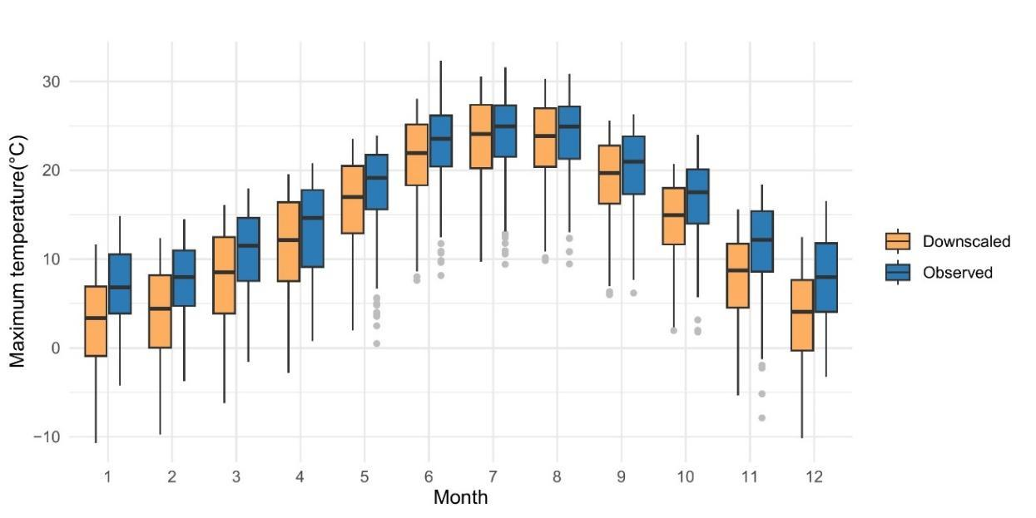

Fig. S1 Distribution of monthly maximum temperatures data, showing the comparison between the results of the downscaling procedure and observed values at weather stations (N = 302)

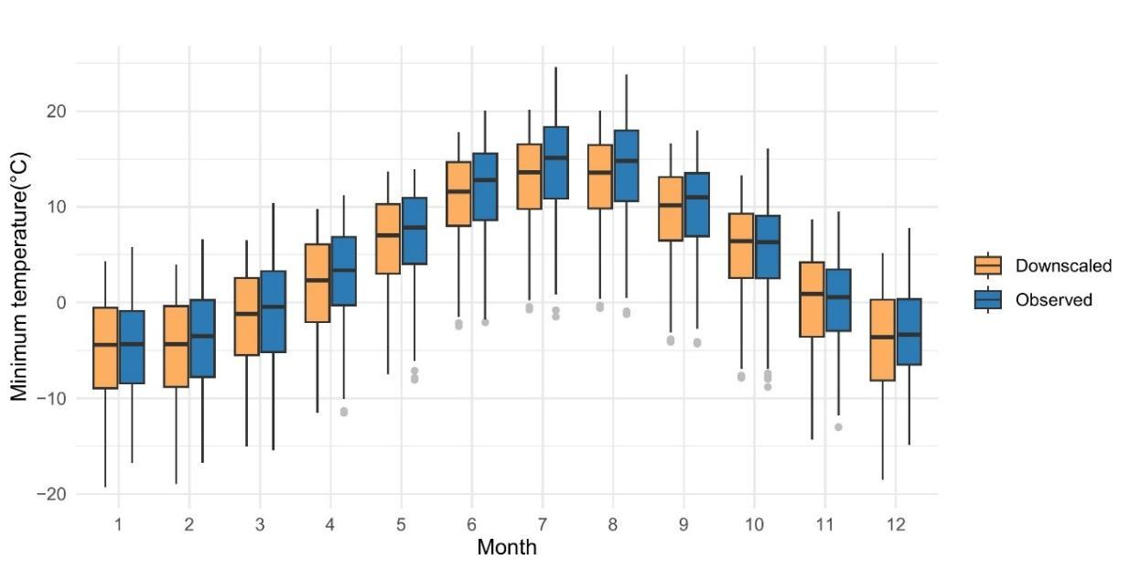
Fig. S2 Distribution of monthly minimum temperatures data, showing the comparison between the results of the downscaling procedure and observed values at weather stations (N = 302)

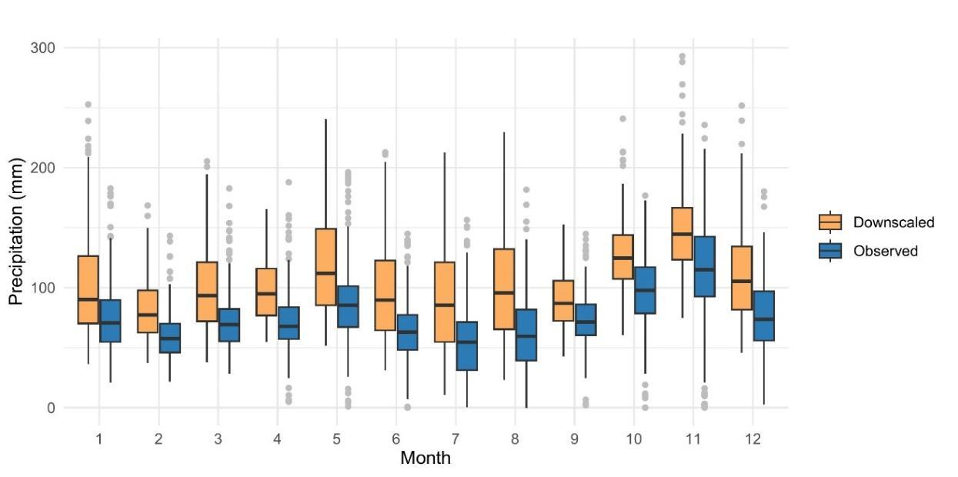
Fig. S3 Distribution of monthly precipitation data, showing the difference between the results of downscaling procedure and observed values at weather stations (N = 302)

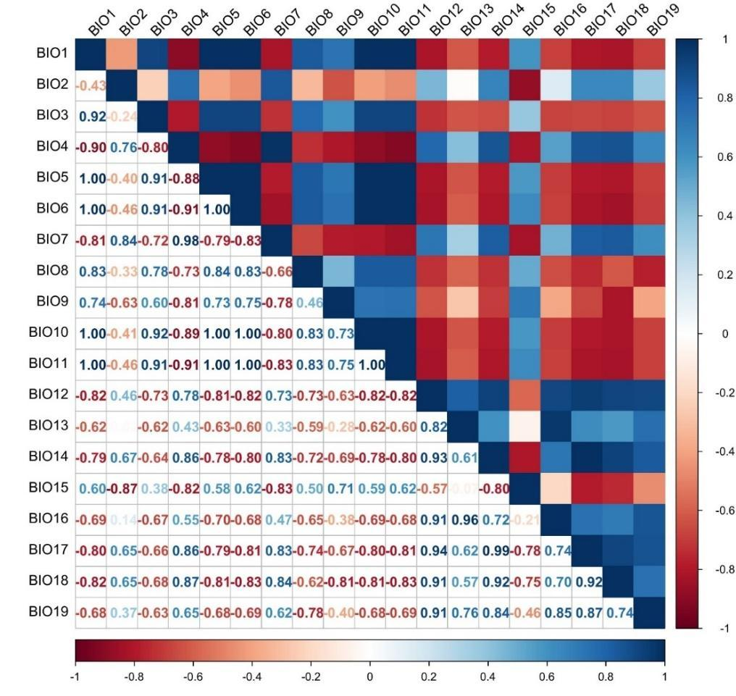

Fig. S4 Pairwise correlation between bioclimatic variables

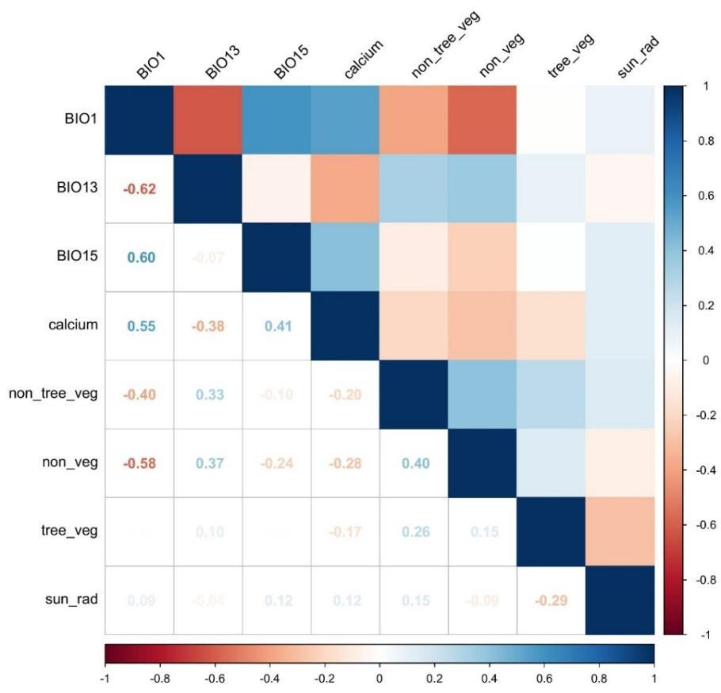

Fig. S5 Pairwise correlation between the final set of predictors used in the modelling

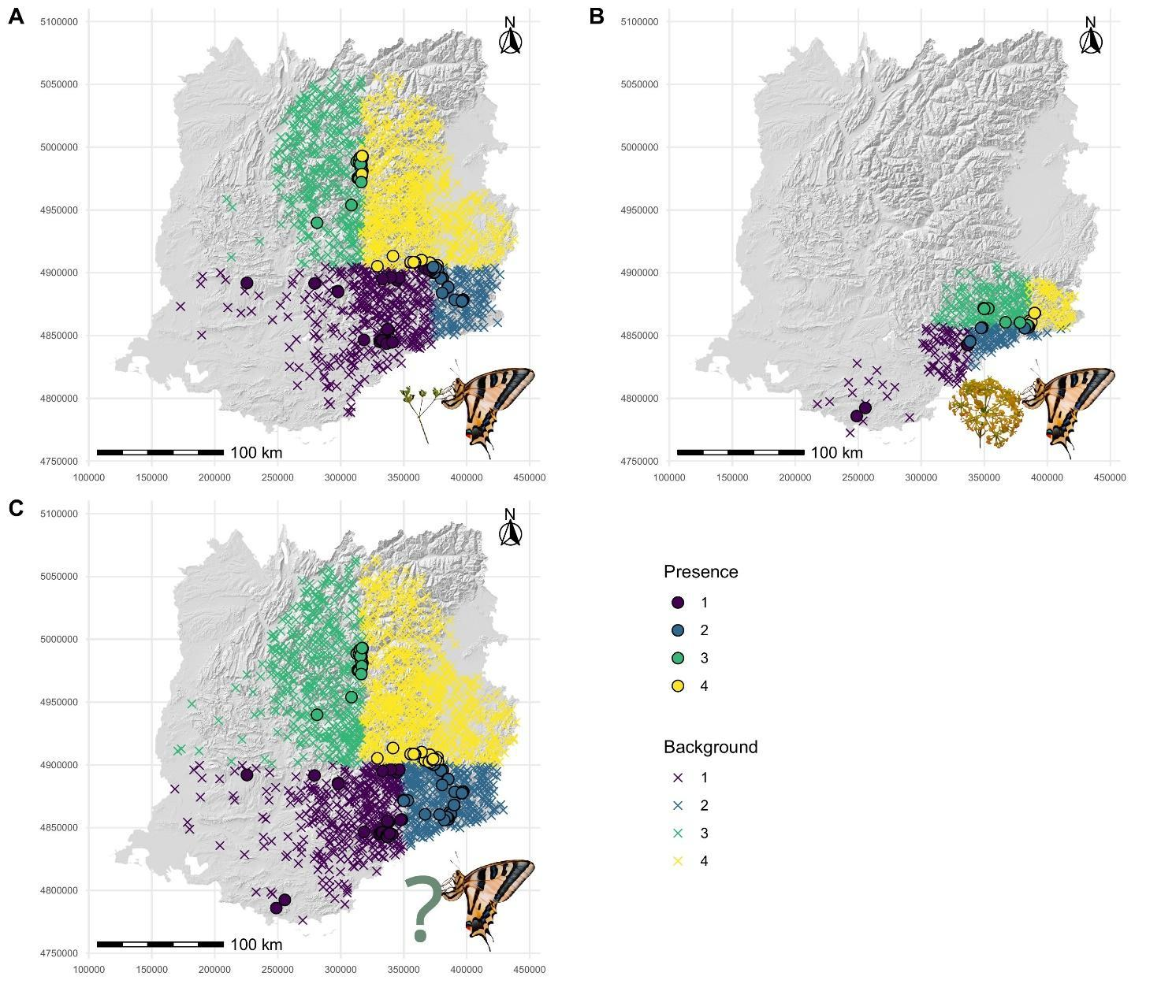
Fig. S6 Maps of presence data and background sample used in ModPs (A), ModOc (B) and ModT (C). Colours refer to the spatial blocks used in the cross-validation of models

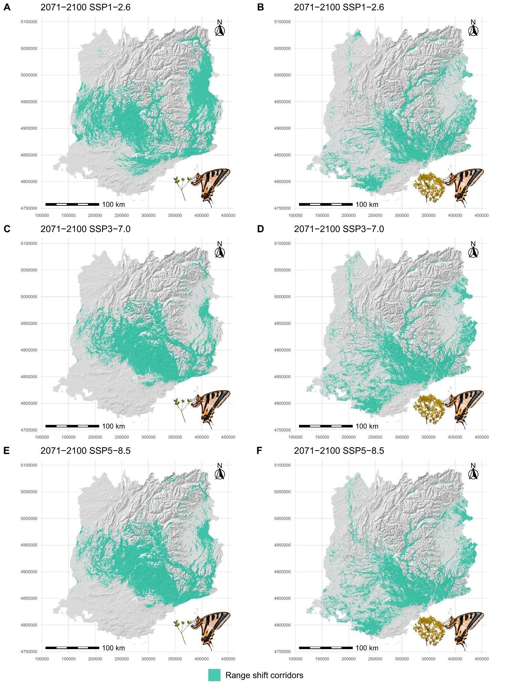

Fig. S7 Corridors connecting current constrained predicted presence areas and future predicted presence areas, according to different scenarios and host plant used: P. saxifraga (A-E) and O. chironium (B-F). These were selected by applying a binarization threshold equal to the mean current plus one standard deviation of the Circuitscape output. In the MigClim simulation, the areas outside these, as well as outside the current and future predicted presence areas, were considered as barriers to short-distance dispersal.

Supplementary information S6
Additional information on host plant data

The presence referred to P. saxifraga and O. chironium data belongs to public databases: Global Biodiversity Information Facility (GBIF Secretariat, https://www.gbif.org), iNaturalist (https://www.inaturalist.org), Observation (https://www.observation.org), and Silene (https://www.silene.eu).

References

GBIF Secretariat, 2024. GBIF Occurrence Download https://doi.org/10.15468/dl.t4qkct

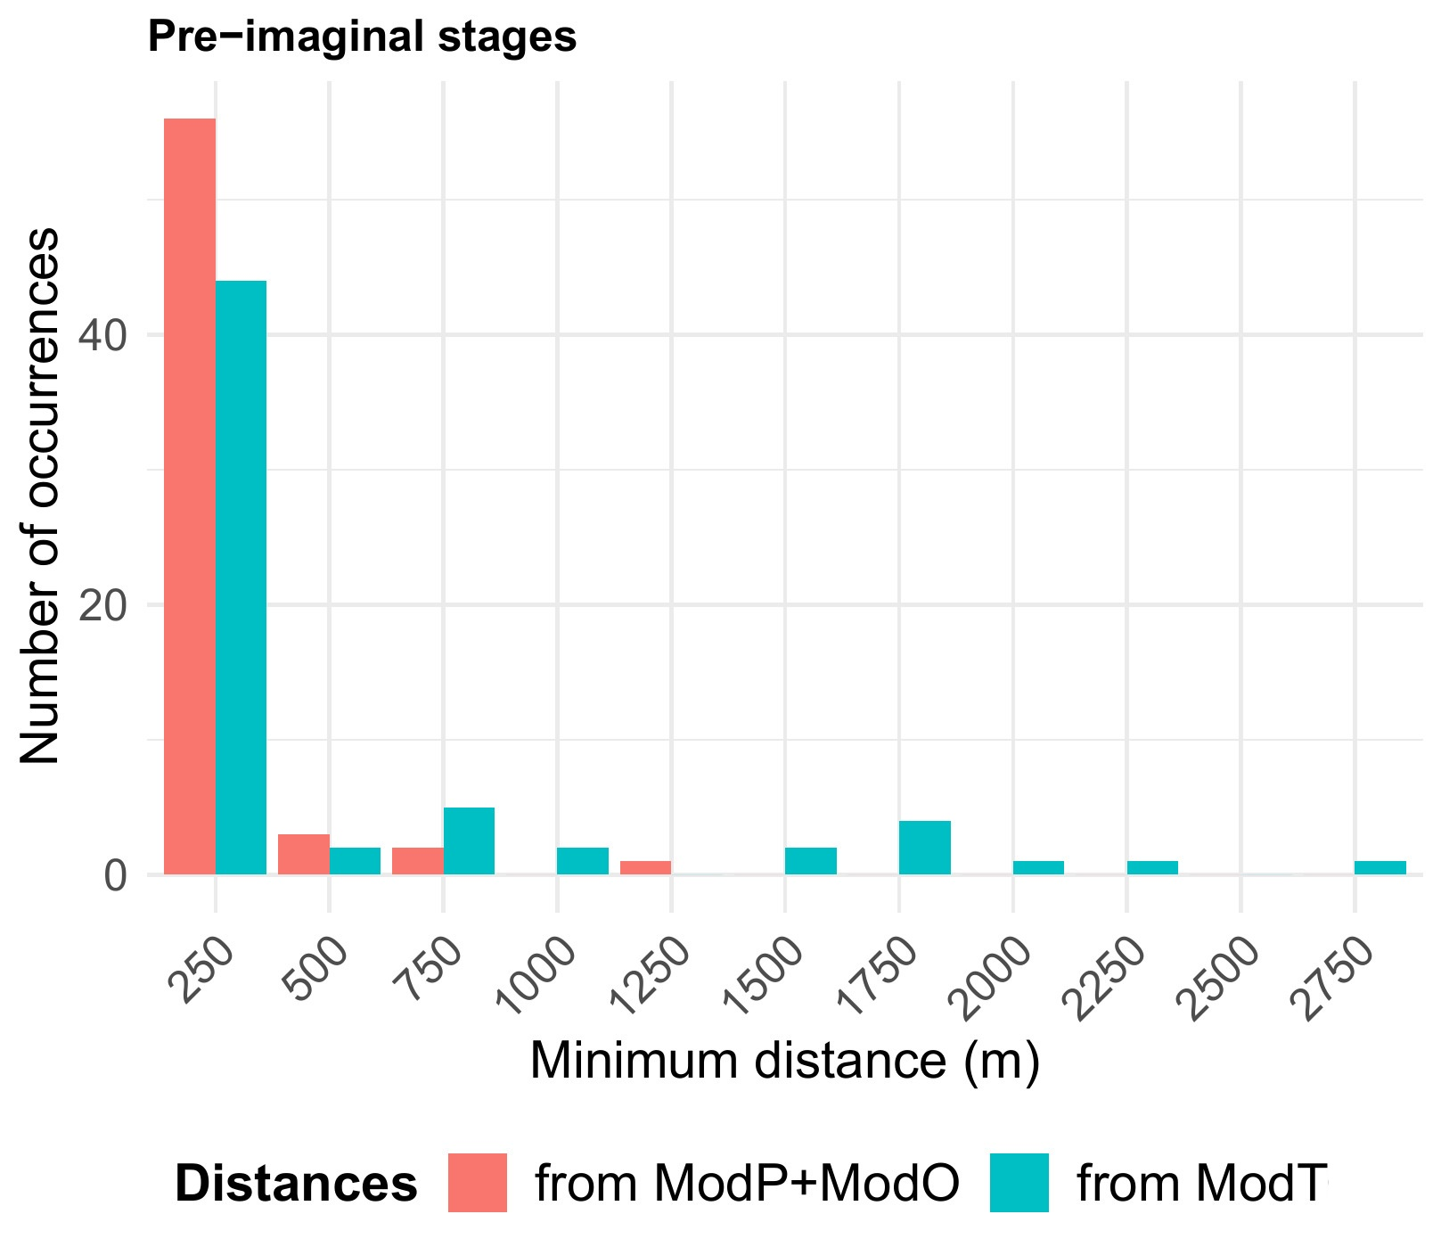
Fig. S8 Histogram of minimum distances between independent data and unconstrained predicted presence areas. Each category shown on the X-axis includes distances starting from a minimum value greater than the previous category, up to and including the maximum value (e.g., from 0 to 250 m, from over 250 to 500 m, and so on). The Y-axis reports the number of occurrences falling within each distance category.

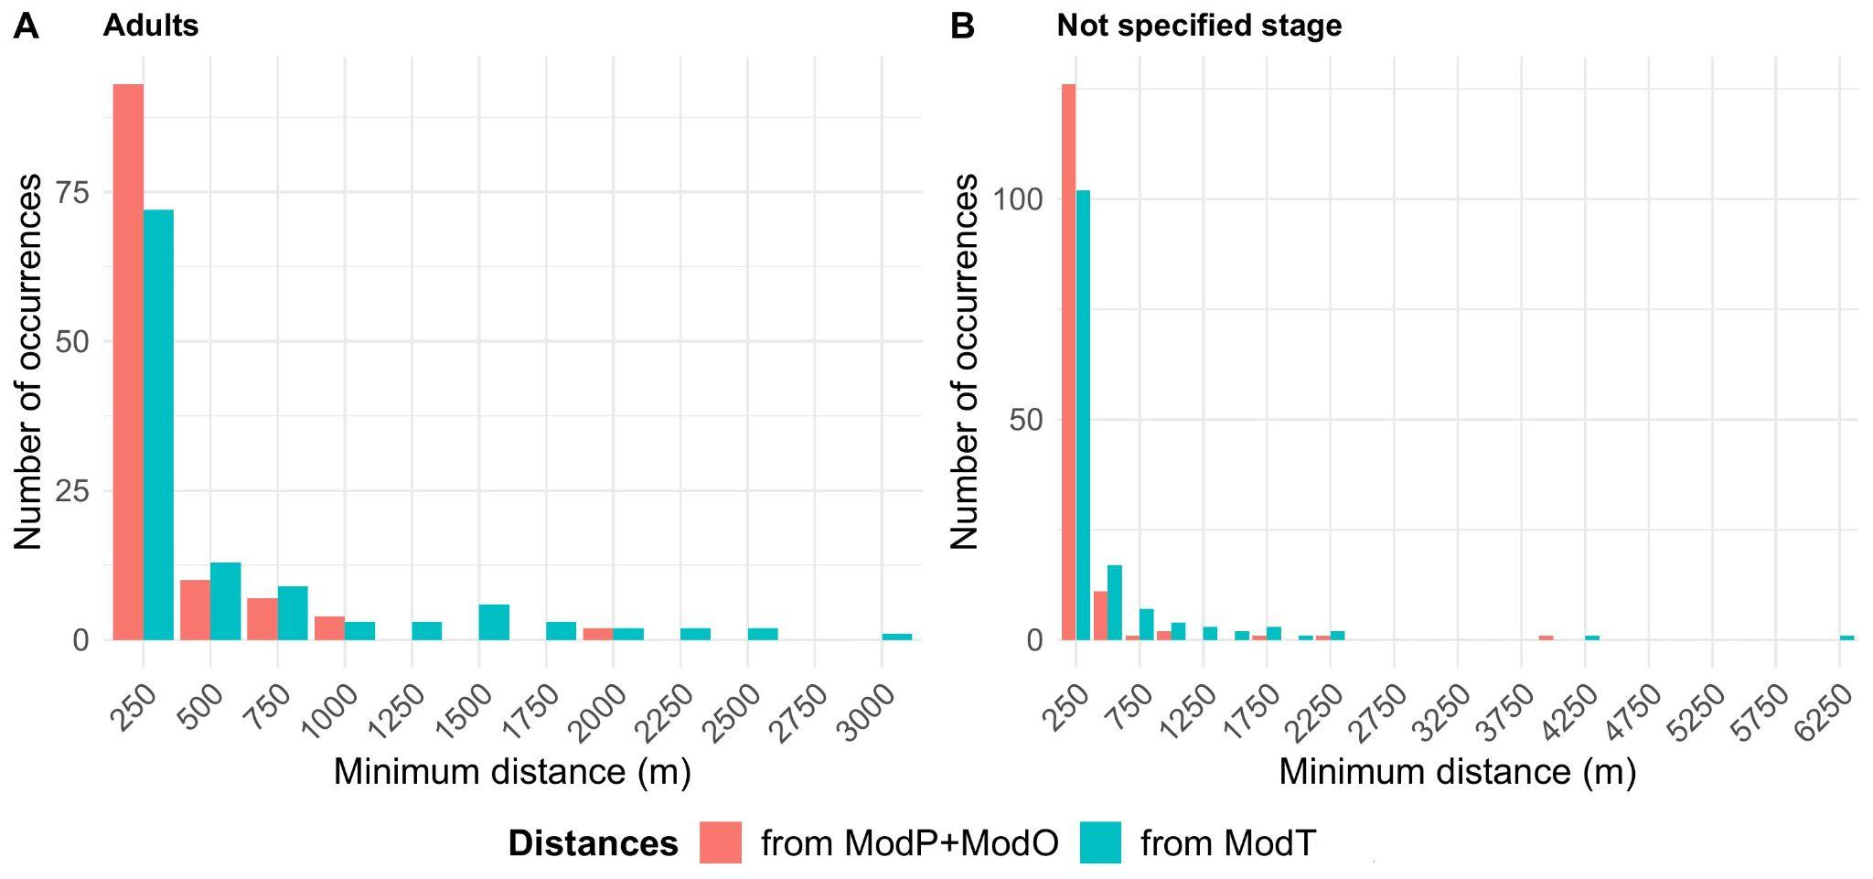
Fig. S9 Histogram of minimum distances between independent data and unconstrained predicted presence areas. Each category shown on the X-axis includes distances starting from a minimum value greater than the previous category, up to and including the maximum value (e.g., from 0 to 250 m, from over 250 to 500 m, and so on). The Y-axis reports the number of occurrences falling within each distance category.

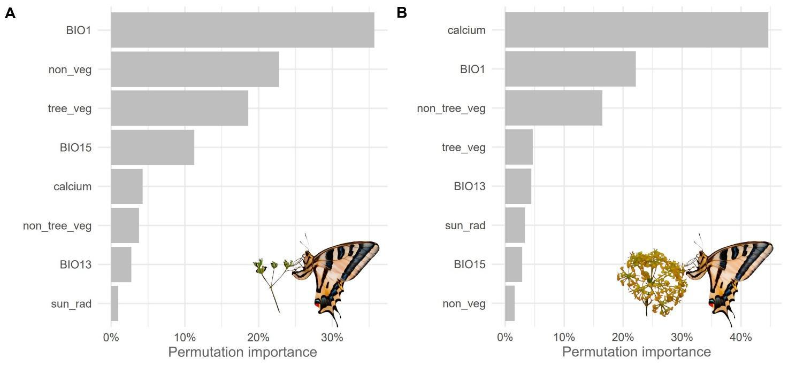

Fig. S10 Histograms of variable importance in ModPs (A) and ModOc (B)

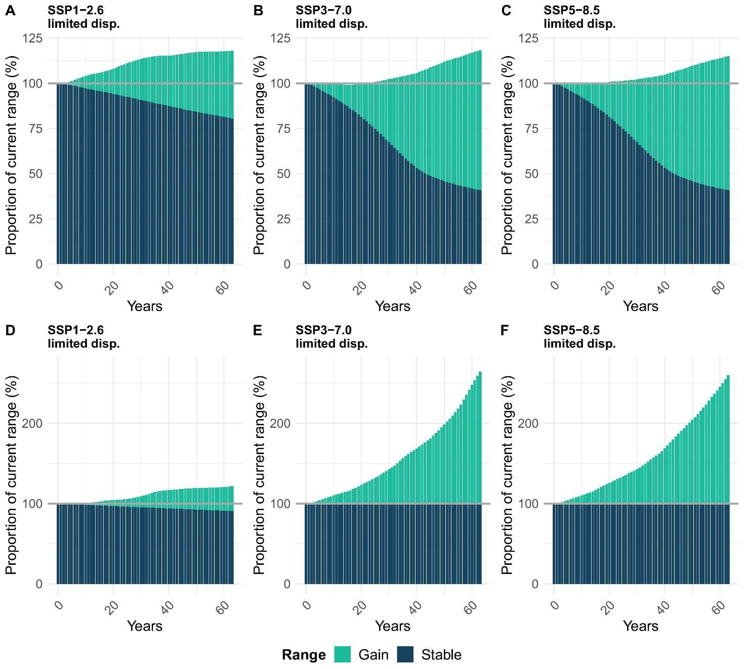
Fig. S11 Histograms at annual intervals showing percent range changes relative to the current range for CUPs (A-C) and CUOc (D-F), concerning only dispersal-constrained predictions.

Table S2 Elevation (m a.s.l.) of the presence areas in the current constrained and future dispersal-constrained predictions, according to the different host plant and scenarios.
Host plant | Current  period  (mean ± SD) | 2071-2100  SSP1-2.6  (mean ± SD) | 2071-2100  SSP3-7.0  (mean ± SD) | 2071-2100  SSP5-8.5  (mean ± SD)
P. saxifraga | 1211 ± 336 | 1316 ± 353 | 1816 ± 443 | 1947 ± 440
O. chironium | 581 ± 286 | 344 ± 228 | 411 ± 246 | 435 ± 258
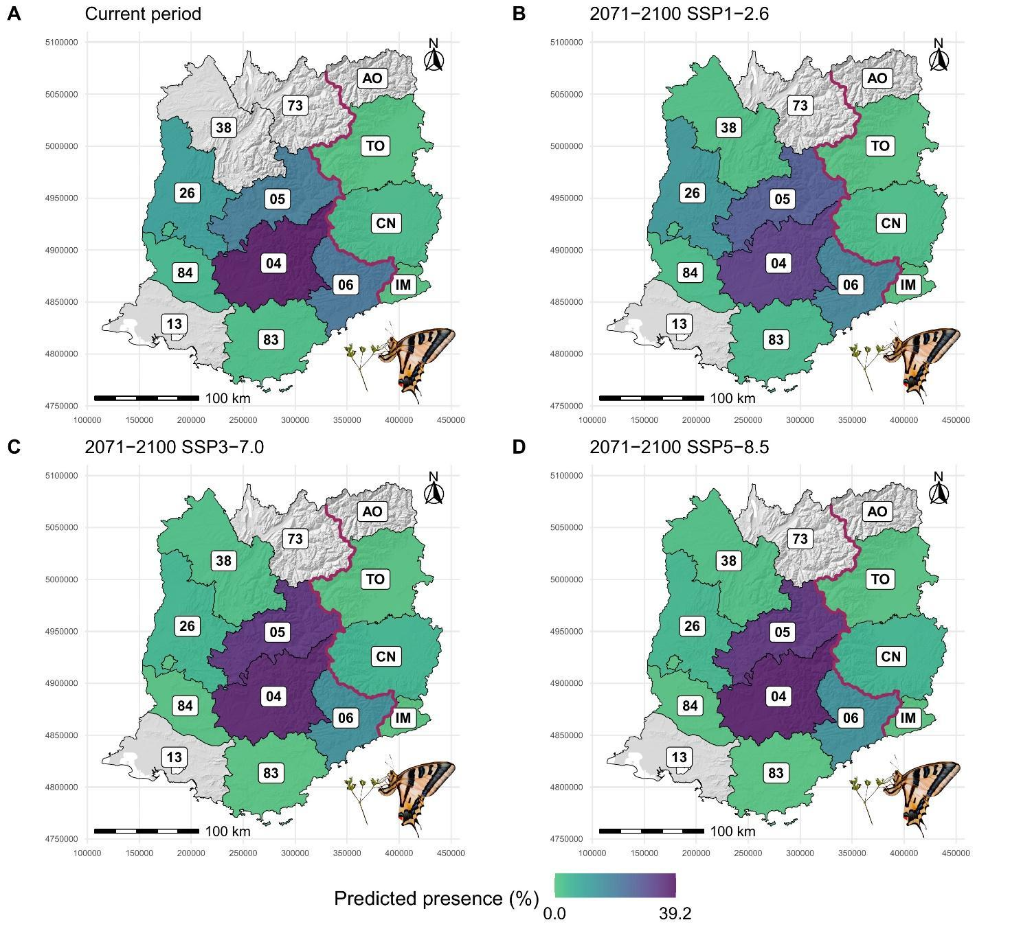
Fig. S12 Maps reporting the coverage of the current constrained and future dispersal-constrained predicted area of CUPs provided by the similarly-sized administrative units.
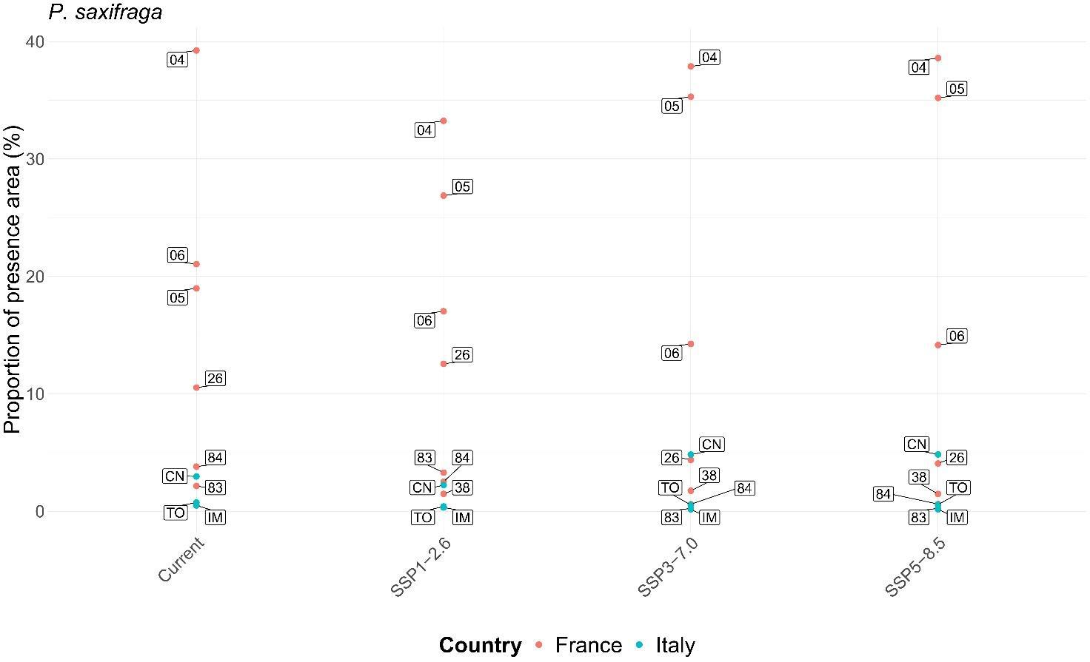
Fig. S13 Ranking charts reporting the coverage of the current constrained and future dispersal-constrained predicted area of CUPs provided by the similarly-sized administrative units. Only the labels referring to the five most covering cells per category are shown.

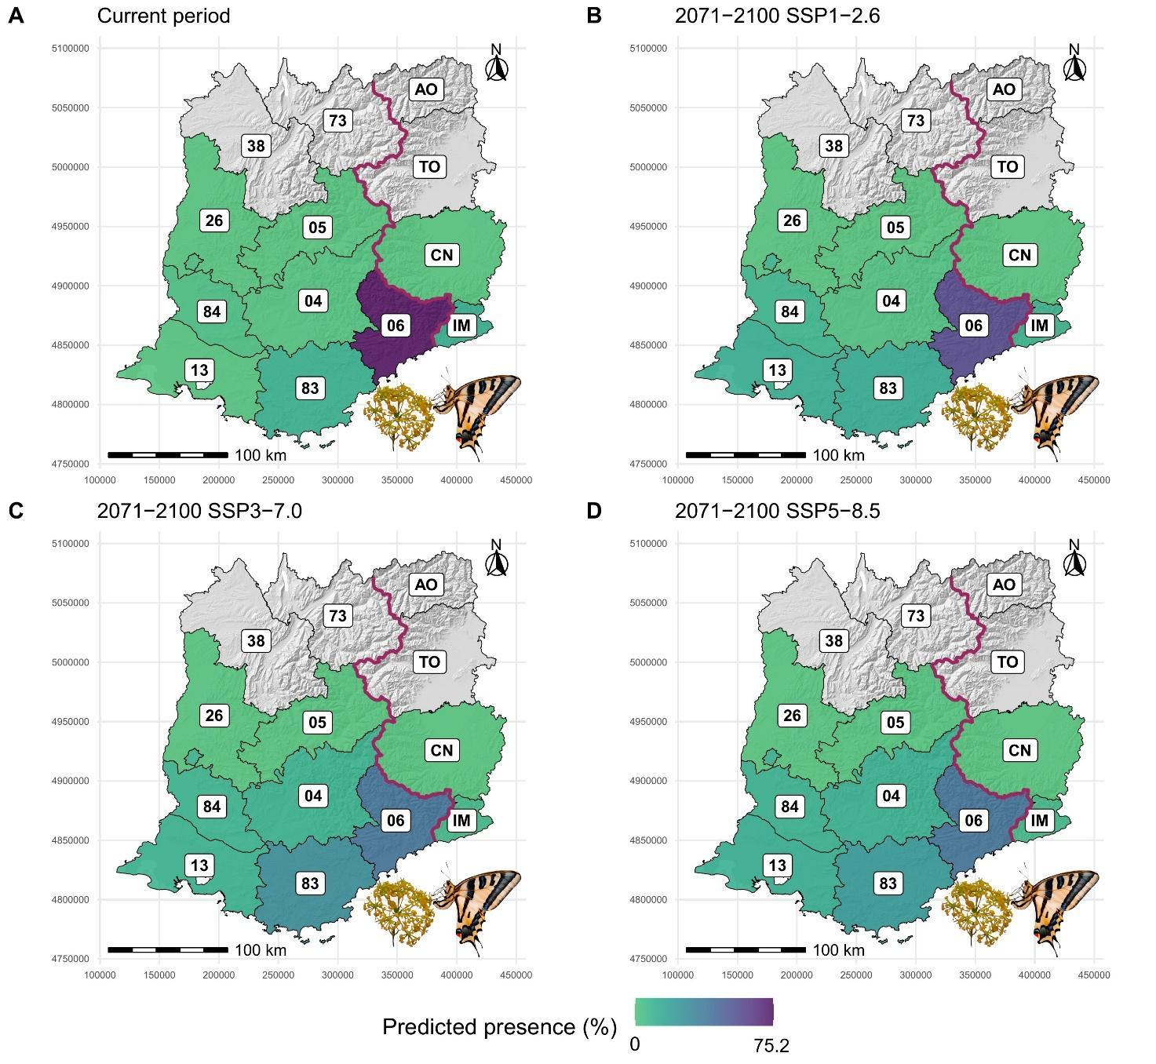
Fig. S14 Maps reporting the coverage of the current constrained and future dispersal-constrained predicted area of CUOc provided by the similarly-sized administrative units.

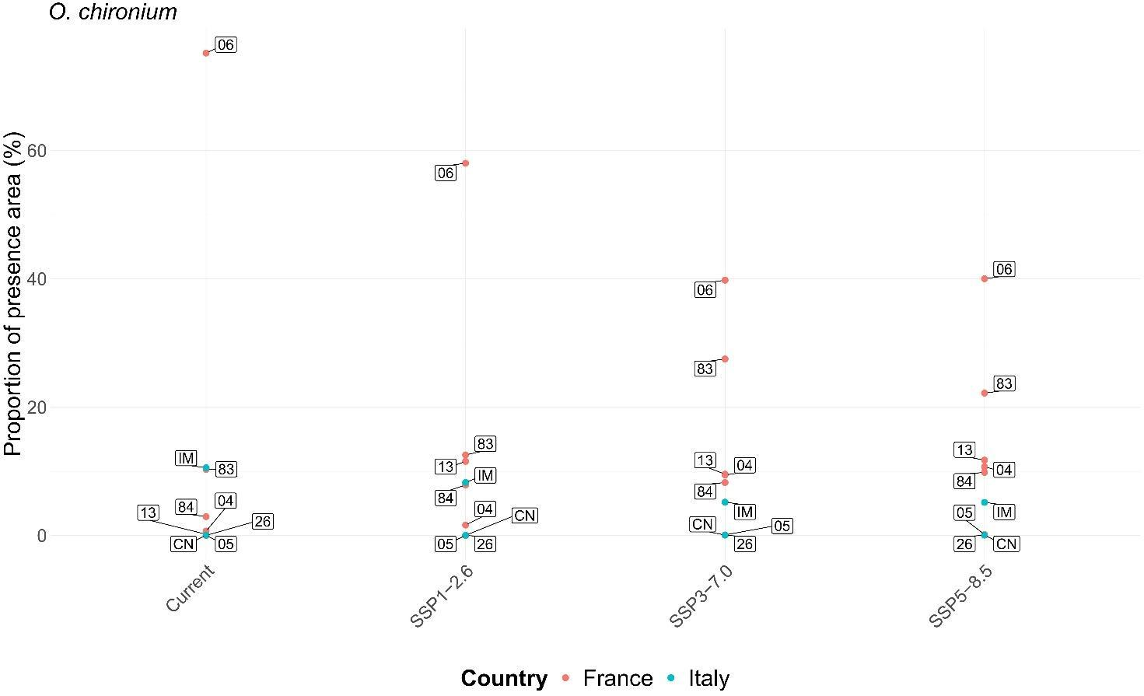
Fig. S15 Ranking charts reporting the coverage of the current constrained and future dispersal-constrained predicted area of CUOc provided by the similarly-sized administrative units. Only the labels referring to the five most covering cells per category are shown.

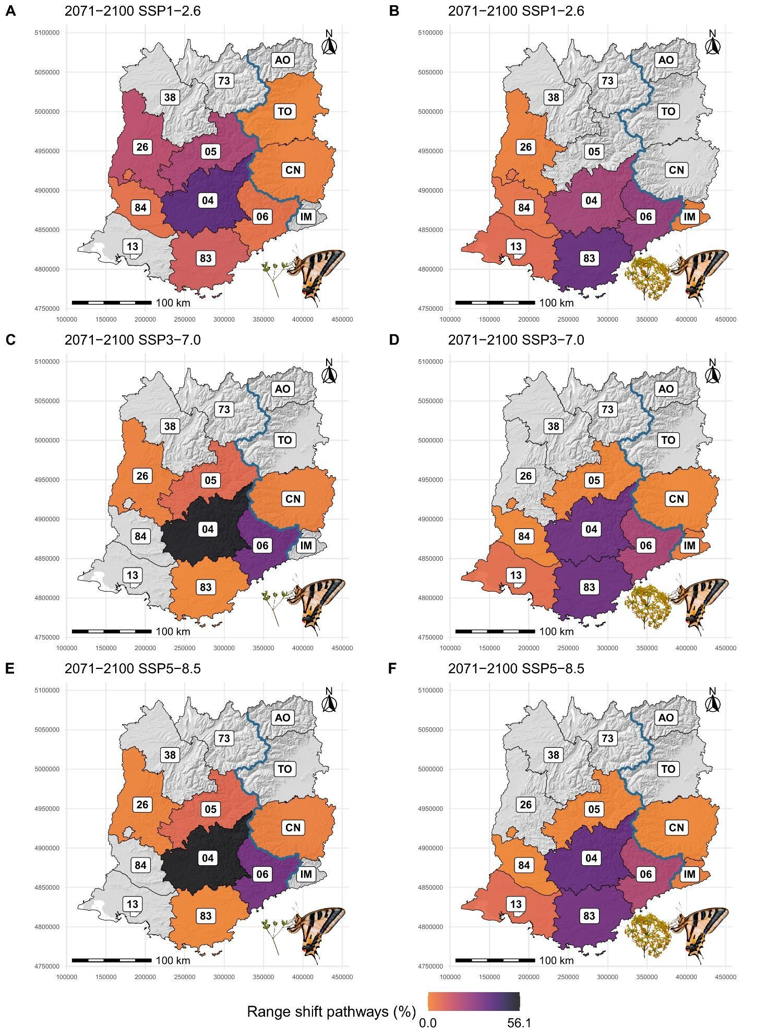
Fig. S16 Maps reporting the coverage of range shift pathways of CUPs (A, C, E) and CUOc (B, D, F) provided by the similarly-sized administrative units.

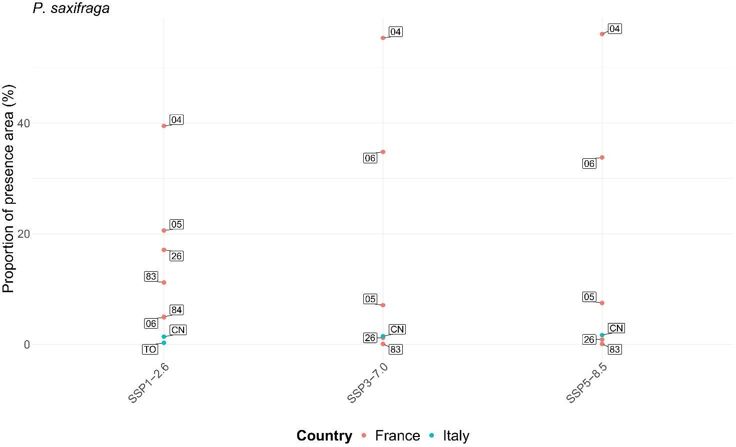
Fig. S17 Ranking charts reporting the coverage of range shift pathways of CUPs provided by the similarly-sized administrative units. Only the labels referring to the five most covering cells per category are shown.

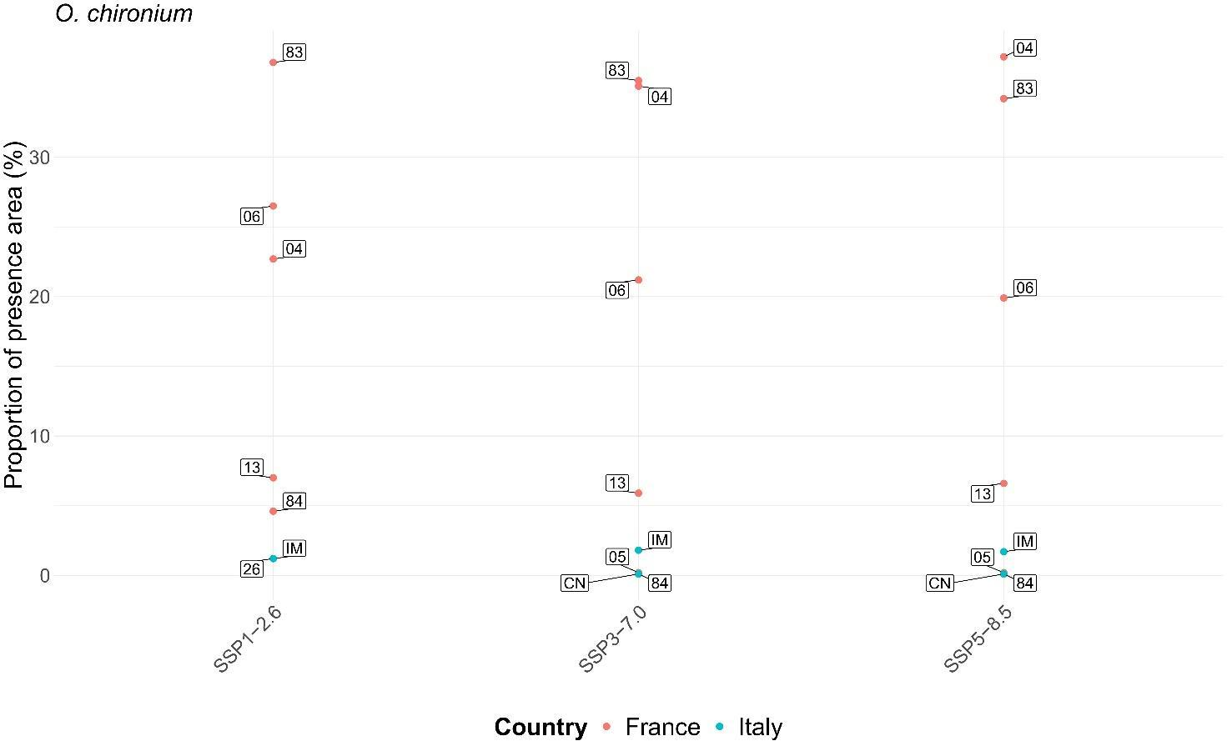
Fig. S18 Ranking charts reporting the coverage of range shift pathways of CUOc provided by the similarly-sized administrative units. Only the labels referring to the five most covering cells per category are shown.
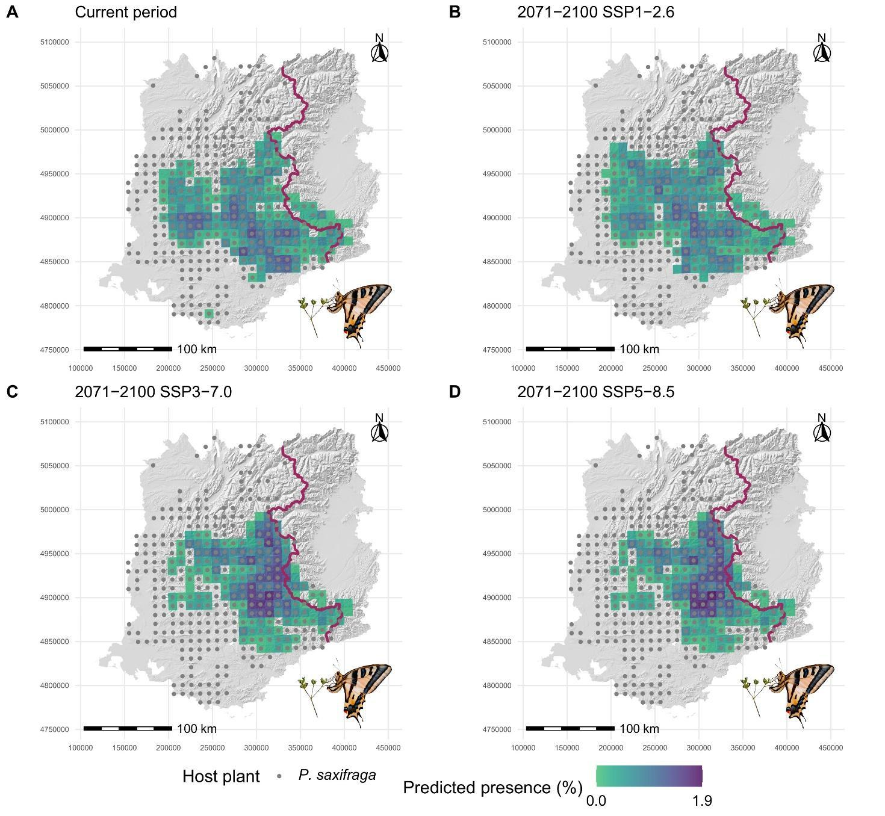
Fig. S19 Maps reporting the coverage of the current constrained and future dispersal-constrained predicted area of CUPs provided by HD 10 x 10 km grid cells. The points indicate the cells where at least one host plant observation occurs.

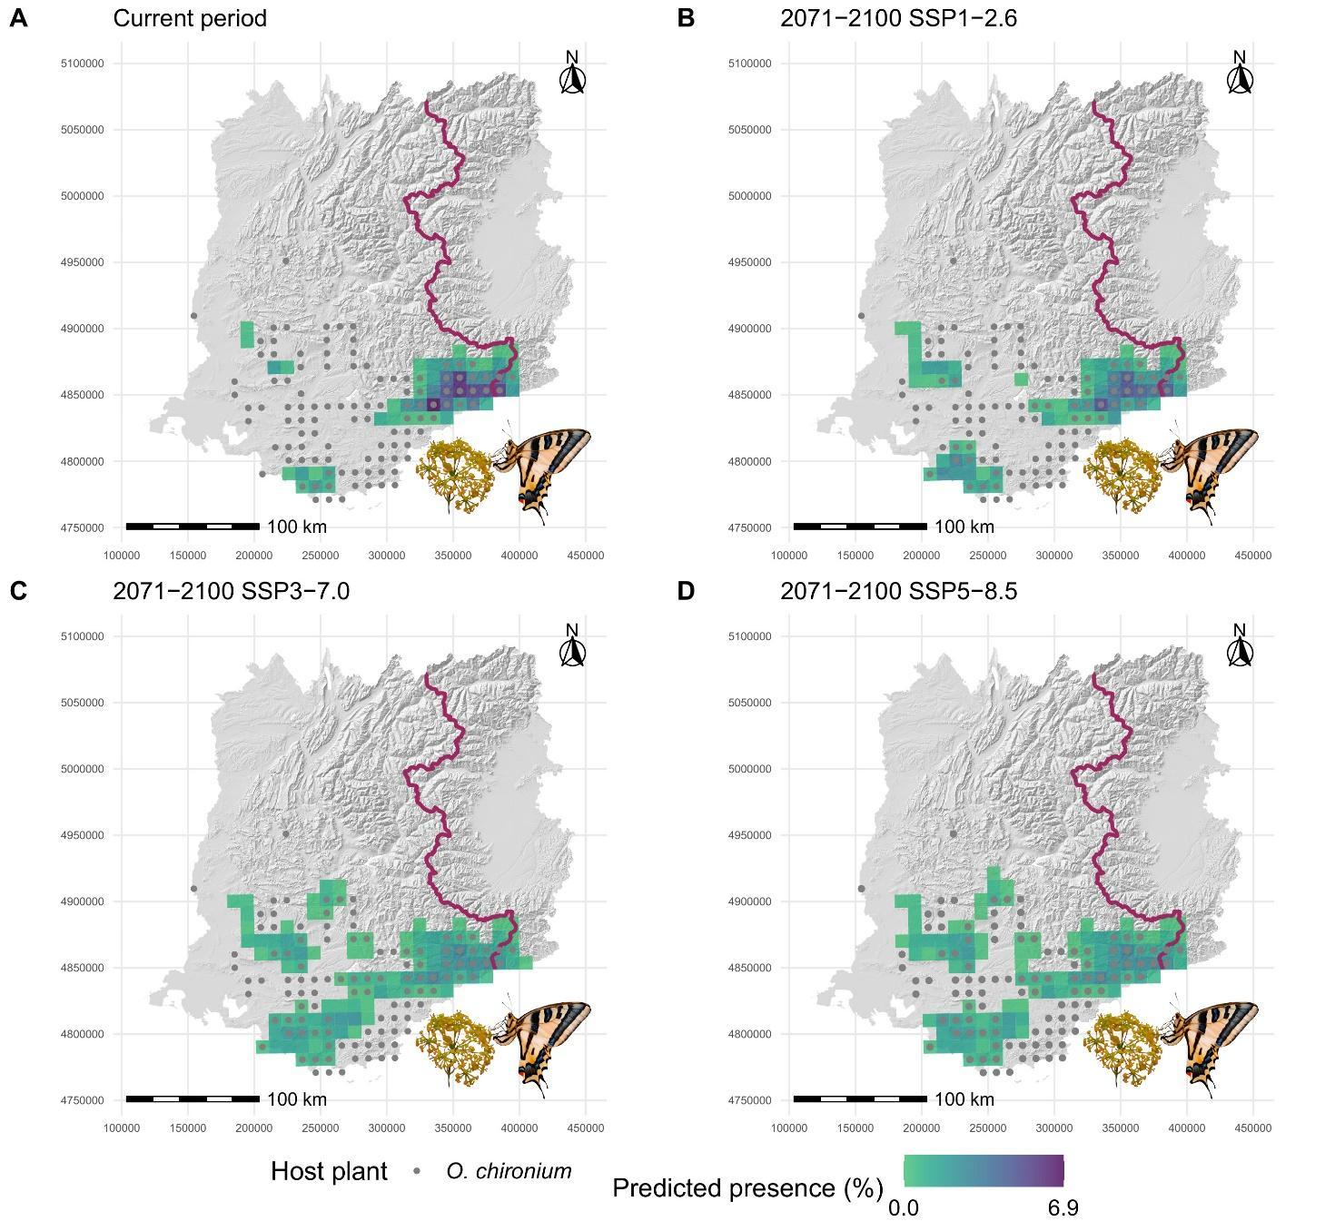
Fig. S20 Maps reporting the coverage of the current constrained and future dispersal-constrained predicted area of CUOc provided by HD 10 x 10 km grid cells. The points indicate the cells where at least one host plant observation occurs.

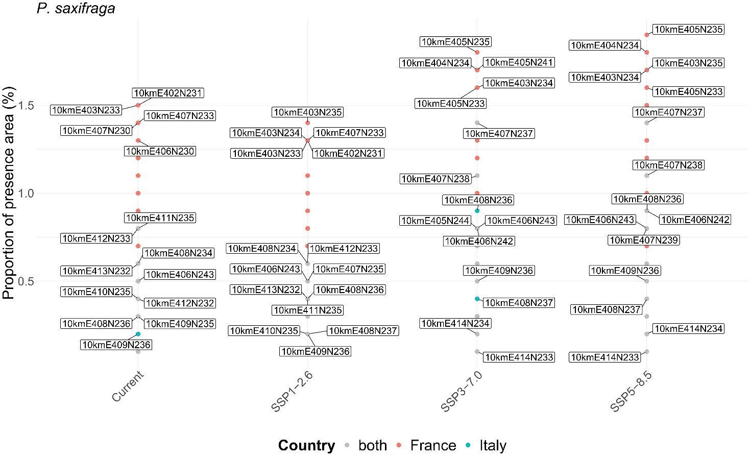
Fig. S21 Ranking charts reporting the coverage of the current constrained and future dispersal-constrained predicted area of CUPs provided by HD 10 x 10 km grid cells. Only the labels referring to the five most covering cells per category are shown.

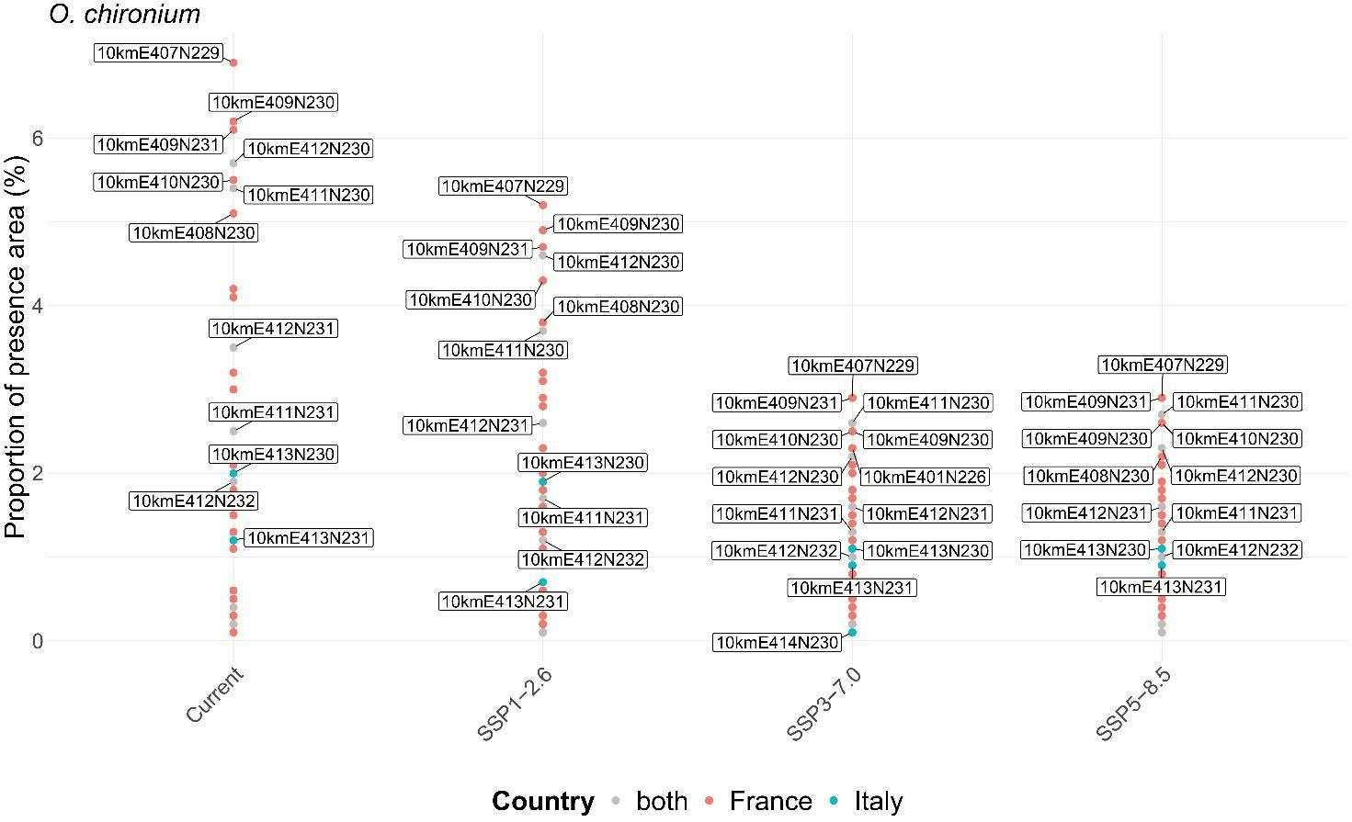
Fig. S22 Ranking charts reporting the coverage of the current constrained and future dispersal-constrained predicted area of CUOc provided by HD 10 x 10 km grid cells. Only the labels referring to the five most covering cells per category are shown.
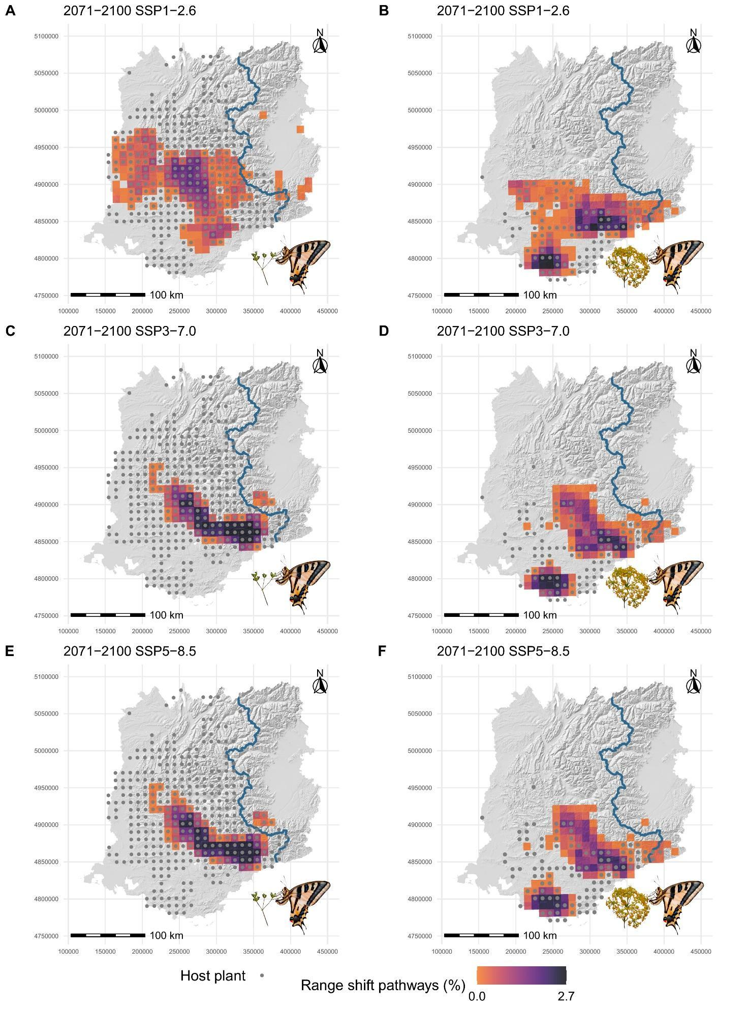
Fig. S23 Maps reporting the coverage of range shift pathways of CUPs (A, C, E) and CUOc (B, D, F) provided by HD 10 x 10 km grid cells. The points indicate the cells where at least one host plant observation occurs.

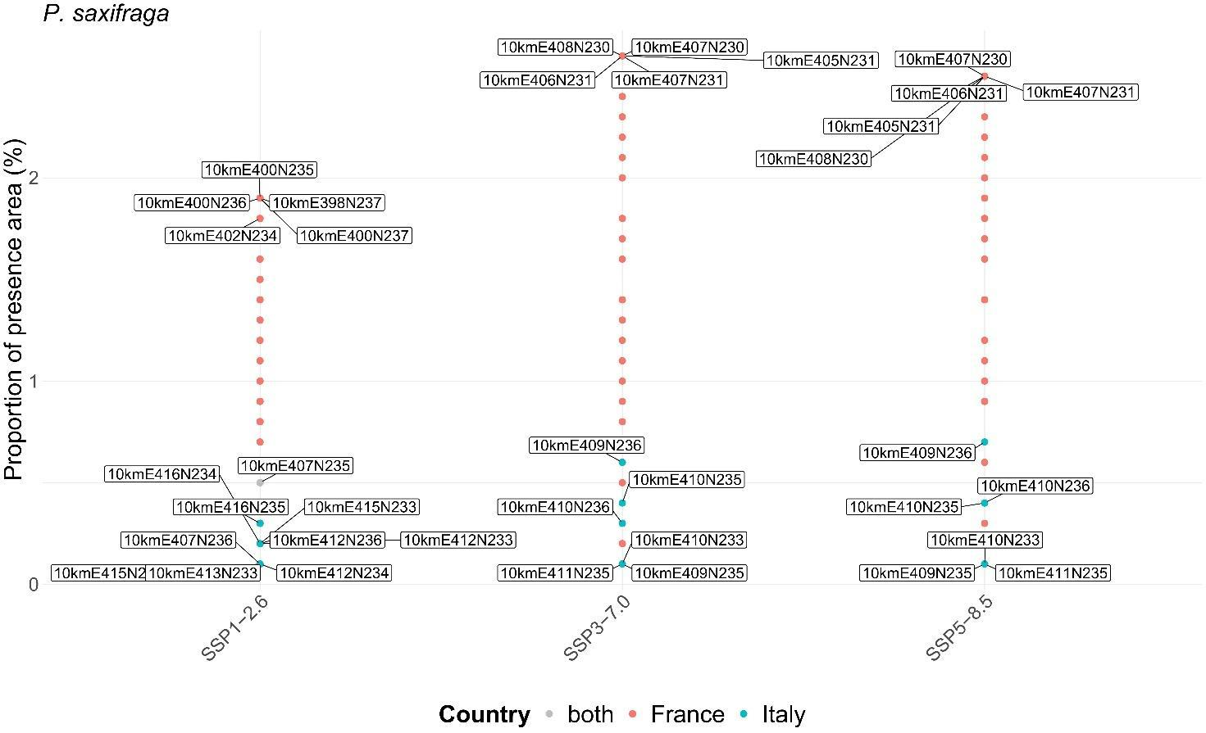
Fig. S24 Ranking charts reporting the coverage of range shift pathways of CUPs provided by HD 10 x 10 km grid cells. Only the labels referring to the five most covering cells per category are shown.

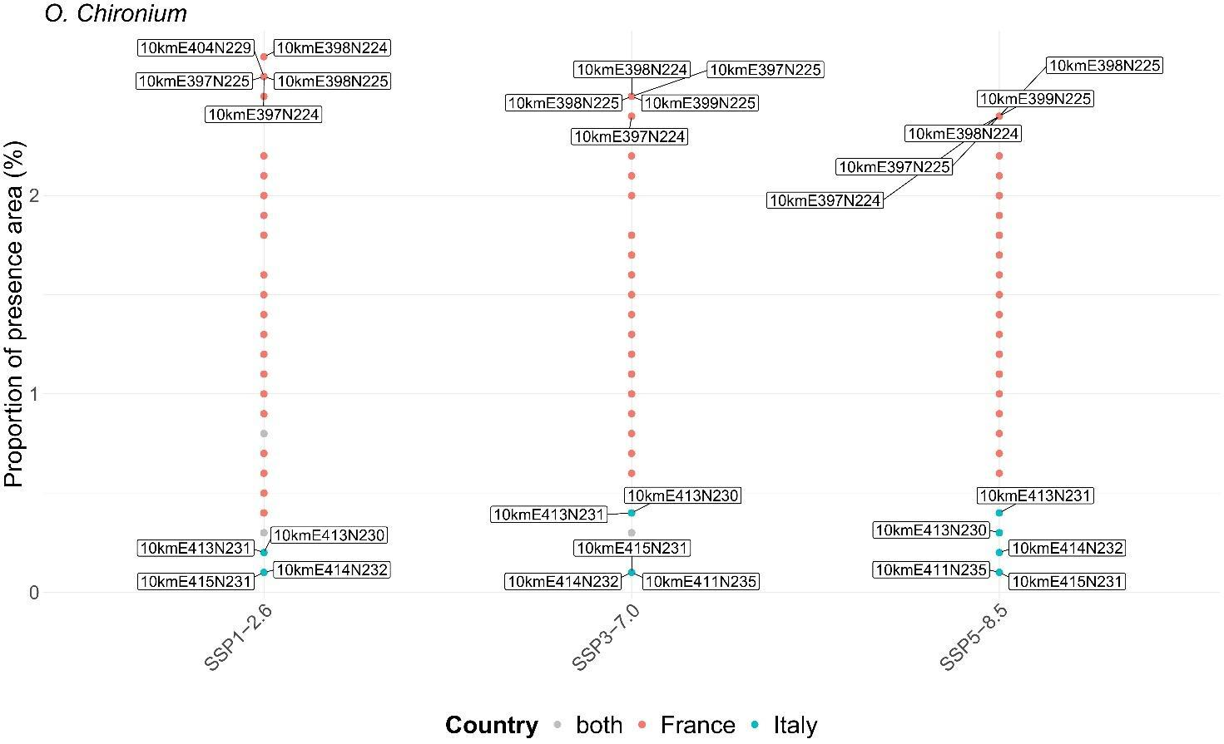
Fig. S25 Ranking charts reporting the coverage of range shift pathways of CUOc provided by HD 10 x 10 km grid cells. Only the labels referring to the five most covering cells per category are shown.

Table S3 Percentage of change in 10 × 10 km grid cells of the Habitat Directive abundance covering the predicted presence areas in 2071-2100 compared to the current period, distinguished based on the host plant used and according to different scenarios.

Host plant | SSP1-2.6 | SSP3-7.0 | SSP5-8.5
P. saxifraga | +5.4 | -13.5 | -14.1
O. chironium | +32.7 | +105.8 | +107.7
Both plants | +14.8 | +18.2 | +16.7

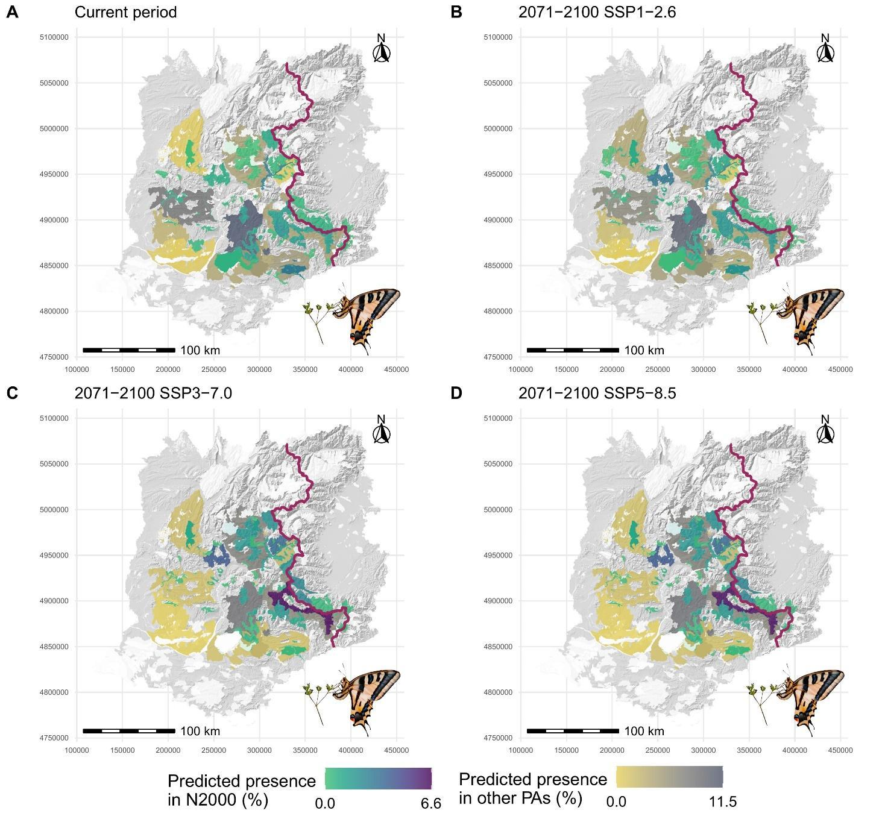
Fig. S26 Maps reporting the coverage of the current constrained and future dispersal-constrained predicted area of CUPs provided by different kinds of PAs.
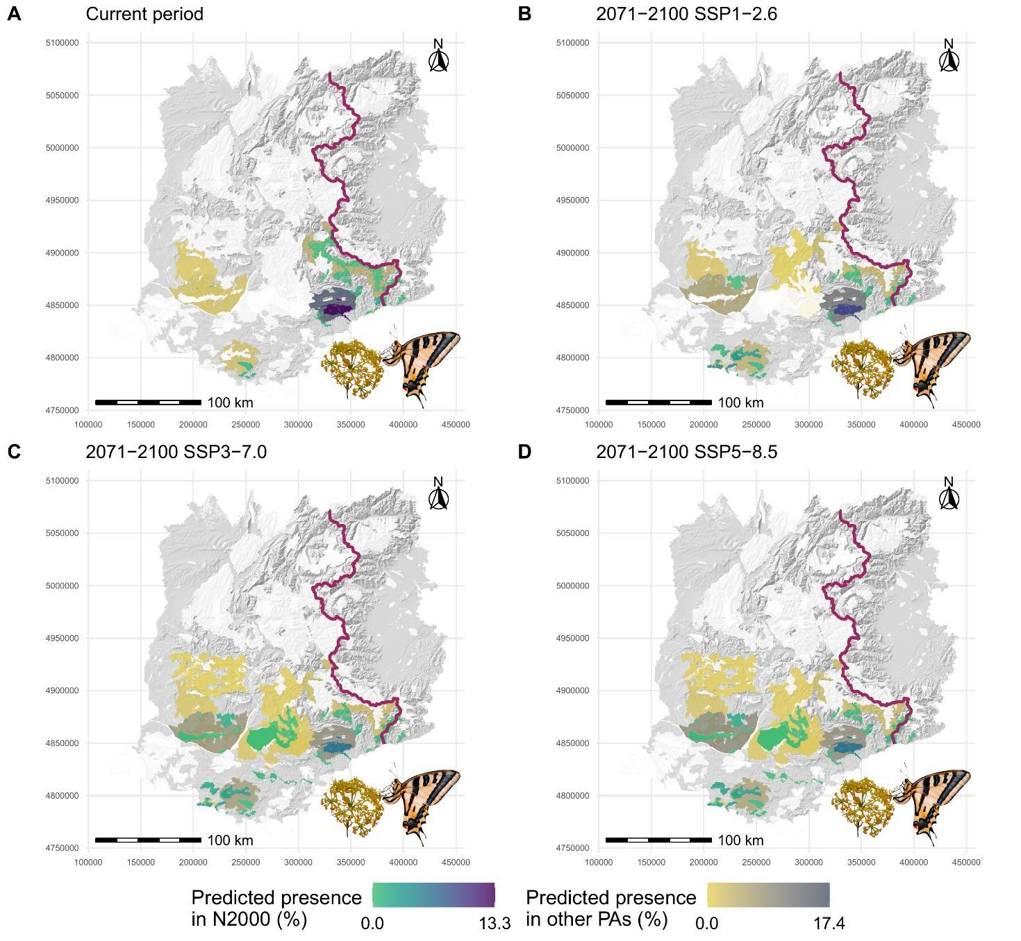
Fig. S27 Maps reporting the coverage of the current constrained and future dispersal-constrained predicted area of CUOc provided by different kinds of PAs.

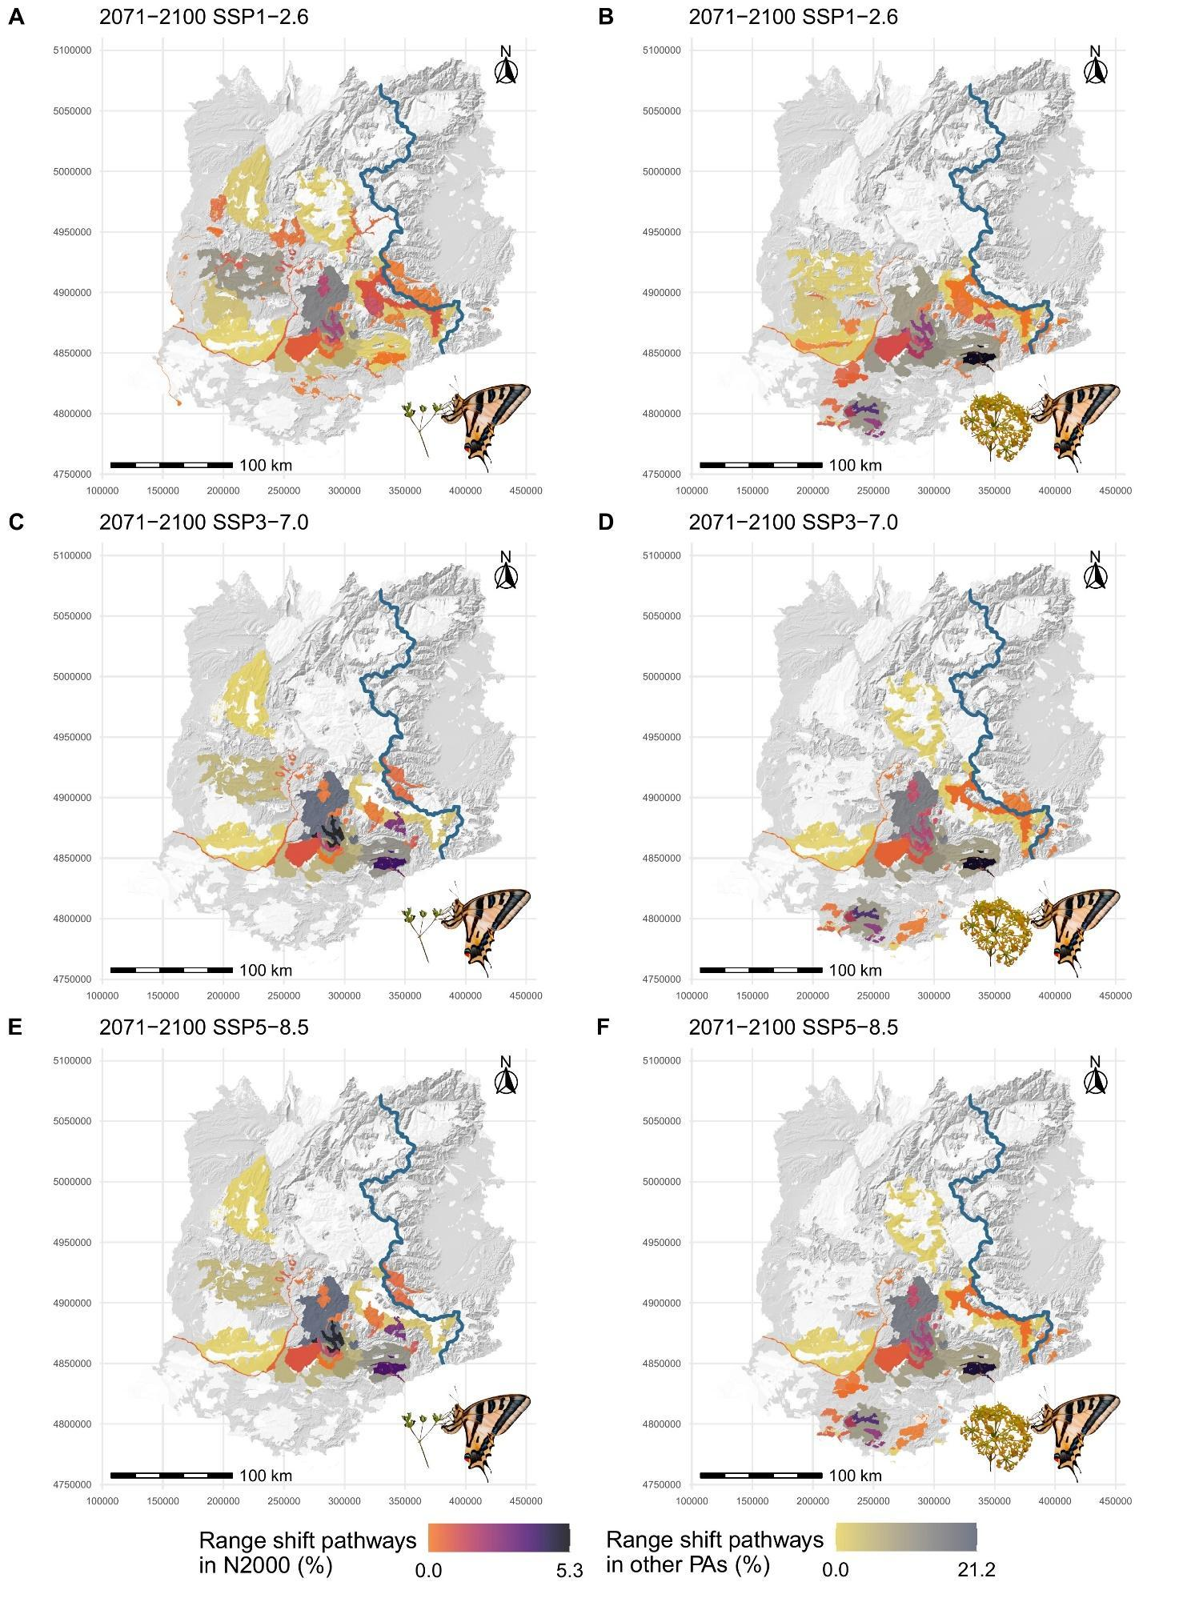
Fig. S28 Maps reporting the coverage of range shift pathways of CUPs (A, C, E) and CUOc (B, D, F) provided by different kinds of PAs.

