Supplementary information
Abandoned croplands show higher insectivorous bat species and functional diversity than forest fragments in a communal land area of the Eastern Cape, South Africa
K. R. van der Meulen, L. R. Richards, R.T Shackleton and M. I. Cherry
Corresponding author: khiavdmeulen@gmail.com

TABLES
Table S1: Triangular distance matrix (m) for field sites one through eight.
 | V1 | V2 | V3 | V4 | V5 | V6 | V7 | V8
1 | 0 | 3458.026 | 2044.036 | 3507.74 | 4474.532 | 3750.287 | 5359.523 | 8145.34
2 | 3458.026 | 0 | 1516.392 | 589.5573 | 1766.775 | 304.6758 | 2320.263 | 4744.873
3 | 2044.036 | 1516.392 | 0 | 1772.127 | 2976.16 | 1821.023 | 3721.643 | 6260.352
4 | 3507.74 | 589.5573 | 1772.127 | 0 | 1250.638 | 578.6311 | 1950.234 | 4640.359
5 | 4474.532 | 1766.775 | 2976.16 | 1250.638 | 0 | 1583.817 | 931.507 | 3924.667
6 | 3750.287 | 304.6758 | 1821.023 | 578.6311 | 1583.817 | 0 | 2055.411 | 4440.756
7 | 5359.523 | 2320.263 | 3721.643 | 1950.234 | 931.507 | 2055.411 | 0 | 3006.069
8 | 8145.34 | 4744.873 | 6260.352 | 4640.359 | 3924.667 | 4440.756 | 3006.069 | 0

Table S2. Corresponding field category, plot ID (Njwaxu and Shackleton 2019), and coordinates for study sites in the Willowvale area, Eastern Cape, South Africa. Site 8 was not investigated by Njwaxu and Shackleton (2019) but additional vegetation assessments were made here.
Site | Field Category | plot ID | Coordinates
1 | 60 | 60d | S 32.38012 E028.62333
2 | 60 | 60g | S 32.40850 E 028.63839
3 | 70 | 70f | S 32.39808 E 028.62797
4 | 70 | 70l | S 32.40633 E 028.64412
5 | 80 | 80f | S 32.40842 E028.65721
6 | 80 | 80h | S 32.41056 E028.64053
7 | Forest | F7 | S 32.41599 E028.66146
8 | Forest | - | S32.4421704 E28.6694458  and  S32.44191 E028.67212

Table S3. Generalised linear model (GLM) and ANOVA outputs assessing the effect of microphone model (SM2BAT and SM4BAT) on a) total bat passes per night, b) bat passes per hour, and c) Shannon-Weiner diversity in former fields and forest fragments in the Willowvale area of Eastern Cape, South Africa.
Model | df | F-value | P-value
- Total bat passes/night  Microphone type | 1 | 2.81 | 0.10
- Bat passes/hour  Microphone type | 1 | 2.60 | 0.11
- Diversity  Microphone type | 1 | 1.55 | 0.22

Table S4. Audio settings for SM4BAT and SM2BAT passive acoustic monitors for autumn and spring sampling

SM4 AUDIO Settings |  | SM2+ AUDIO Settings
Gain | 12dB | Gain Left  Gain Right | + 0.0 dB  + 0.0 dB
16K high filter | Off
Sample Rate | 384kHz | Sample Rate | 384 kHz
Min duration | 1.5ms | Trigger Max length | 15s
Max duration | None
Min Trig Frequency | 12 kHz | Dig HPF Left  Dig HPF Right  Dig LPF Left  Dig LPF Right | Fs/32  Fs/32  Off  Off
Trigger level | 6dB | Trigger level Left  Trigger level right | 10 SNR  10 SNR
Trigger Window | 1.0s | Trigger win Left  Trigger win Right | 1.0s  1.0s
Max length | 15s
Compression | none | Div Ratio  Nap Trigger Level | 16  Off
 |  | Channels | Mono-L
 |  | Bits | 16
File Format | WAV | File Format | WAV

Table S5: Explanatory variables for candidate generalised linear models used to assess predictors of Species Richness, Peilou Evenness, Shannon-Weiner diversity, and activity (total passes/night; average passes/hour/night). ENE: east-northeast; WNW: west-northwest; WSW: west-southwest; NNW: north-northwest; W: west; SSW: south-southwest; SE: southeast.
Field | Age Category | Distance to water source (m) | Distance to nearest road (m) | Distance to nearest house (m) | Distance to nearest forest patch (m) | Aspect
1 | 1960 | 258.52 | 583.09 | 642.95 | 142.46 | ENE
2 | 1960 | 690.33 | 133.96 | 212.66 | 180.57 | WNW
3 | 1970 | 1 229.41 | 165.02 | 184.69 | 244.95 | WSW
4 | 1970 | 1 046.19 | 100.13 | 32.85 | 148.01 | NNW
5 | 1980 | 805.84 | 509.97 | 247.04 | 81.57 | NNW
6 | 1980 | 443.6 | 259.88 | 56.3 | 103.85 | W
7 | Forest | 583.2 | 24.75 | 79.23 | 0 | SSW
8 | Forest | 69.68 | 244.69 | 292.61 | 0 | SE

Table S6: Results from Global Moran I test for bat species richness and functional diversity indices (significant p value in bold depicts spatial autocorrelation between sites; p < 0.01).
Moran I | Observed | Expected | SD | p value
Species richness | -0.268 | -0.143 | 0.065 | 0.055
Total_P | -0.170 | -0.143 | 0.065 | 0.681
Shannon | -0.276 | -0.143 | 0.065 | 0.040
Peilou | -0.280 | -0.143 | 0.065 | 0.035
FRic | -0.301 | -0.143 | 0.065 | 0.014
FEve | -0.172 | -0.143 | 0.065 | 0.652
FDiv | -0.142 | -0.143 | 0.065 | 0.992
FDis | -0.097 | -0.143 | 0.065 | 0.487

Table S7. List of species recorded across study sites in the Willowvale area, Eastern Cape, South Africa with their associated functional trait values (echolocation call type, characteristic frequency (F_{c}), forearm length, aspect ratio, and wing loading). Functional traits values were taken from Moir et al (2020a) and supplemented from Taylor et al (2013).
 | Call Type | F_{c} (kHz) | Forearm length (mm) | Aspect ratio | Wing loading
Vespertilionidae  Afronycteris nana | LD-FM | 67.28 | 30.27 | 5.94 | 5.07
Pipistrellus hesperidus | LD-FM | 46.04 | 32.89 | 6.01 | 6.9
Scotophilus dinganii | LD-FM | 34.68 | 54.1 | 6.25 | 13.29
L. capensis | LD-FM | 39.63 | 33.23 | 5.8 | 6.92
Myotis tricolor | LD-FM | 56.38 | 49.25 | 5.96 | 6.93
Neoromicia anchieta | LD-FM | 19.8 | 31.09 | 5.2 | 6.5
Miniopteridae
Miniopterus fraterculus | LD-FM | 58.59 | 43.75 | 6.64 | 6.35
M. natalensis | LD-FM | 50.37 | 46.13 | 6.74 | 7.9
Molossidae
Mops pumilus | LD-QCF | 24.22 | 37.89 | 8.6 | 11.8
M. condylurus | LD-QCF | 27.3 | 47 | 7.4 | 18.5
M. midas | LD-QCF | 12.3 | 63.8 | 8.9 | 11.4
Tadarida aegyptiaca | LD-QCF | 22.7 | 45.9 | 8.1 | 13.1
Otomops martiensseni | LD-CF | 11 | 64.1 | 9.3 | 14.9
Rhinolophidae
Rhinolophus clivosus | HD-CF | 92.76 | 54.43 | 5.95 | 9.27

Table S8: One-way ANOVA between group summary for forest fragments (Forest) and 1960s, 1970s, and 1980s former fields, reporting on the mean Shannon-Weiner diversity and mean Pielou’s Evenness. Degrees of freedom (DF) between groups is three and within groups 95.
Shannon-Weiner Diversity:  DF(3, 95) | Forest fragments | 1960 | 1970 | 1980
Forest fragments (X̅ = 0.50 ± 0.48)  1960 (X̅ = 0.89 ± 0.49)  1970 (X̅ = 0.75 ± 0.40)  1980 (X̅ = 1.06 ± 0.42) | -  t = 3.059, P < 0.001  t = 1.985, P = 0.050  t = 4.310, P < 0.0001 | -  t = -1.115, P > 0.05  t = 1.294, P > 0.05 | -  t = -2.41, P = 0.01 | -
Pielou’s Evenness
DF(3, 95)
Forest fragments (X̅ = 0.19 ± 0.18)  1960 (X̅ = 0.34 ± 0.15)  1970 (X̅ = 0.28 ± 0.15)  1980 (X̅ = 0.40 ± 0.19) | -  t = 3.06, P < 0.01  t = 1.985, P = 0.05  t = 4.31, P < 0.001 | -  t = -1.115, P > 0.05  t = -1.294, P > 0.05 | -  t = -2.410, P < 0.05 | -
Candidate models | d.f. | Log likelihood | AICc | Δ AICc | AICc weight
a). Shannon diversity
Aspect | 8 | -51.938 | 121.5 | 0.00 | 0.248
Aspect + distance to forest | 9 | -51.668 | 123.4 | 1.88 | 0.097
b). Species Richness (SR)
Distance to nearest building + distance to road | 4 | -299.962 | 608.4 | 0.00 | 0.382
Distance to nearest building + distance to forest fragment + distance to road | 5 | -299.832 | 610.3 | 1.96 | 0.144
c). Pielou Evenness
Aspect | 8 | 44.134 | -70.7 | 0.00 | 0.248
Aspect + distance to forest fragment | 9 | 44.403 | -68.8 | 0.88 | 0.097
d). Total bat passes
Aspect + distance to nearest building + distance to forest fragment | 9 | -3023.773 | 6067.6 | 0.00 | 0.091
Aspect + distance to nearest building + distance to road | 9 | -3023.773 | 6067.6 | 0.00 | 0.091
Aspect + distance to forest fragment+ distance to road | 9 | -3023.773 | 6067.6 | 0.00 | 0.091
e). Mean bat passes/hour
Aspect + distance to forest fragment | 8 | -315.430 | 648.5 | 0.00 | 0.132
Table S9: The top three best-ranked regression models (Δ AICc ≤ 2) examining the effects of environmental predictors on a) Shannon-Weiner diversity (b) Species Richness (c) Pielou Evenness (d) Total insectivorous bat passes (e) and mean insectivorous bat passes/hour.

Table S10: Mixed Linear Effect Model between site category (predictor variable) and functional indices (dependent binary variable) in the Willowvale region of the Eastern Cape, South Africa
 | 1960 | 1970 | 1980 | Forest
FRic
1960 | -
1970 | z = 0.186; P > 0.05 | -
1980 | z = -0.249; P > 0.05 | z = 0.432; P > 0.05 | -
Forest | z = -2.689; P < 0.05 | z = -2.657; P < 0.05 | z = -2.727; P < 0.05 | -
Feve
1960 | -
1970 | z = -3.219; P < 0.01 | -
1980 | z = -3.173; P < 0.01 | z = 0.371; P > 0.05 | -
Forest | z = - 3.417; P < 0.01 | z = 0.451; P > 0.05 | z = -0.451; P > 0.05 | -
FDis
1960 | -
1970 | z = 0.844; P > 0.05 | -
1980 | z = 1.634 P > 0.05 | z = -2.479; P < 0.05 | -
Forest | z = -0.168 P > 0.05 | z = 0.607; P > 0.05 | z = - 0.315; P > 0.05 | -
Fdiv
1960
1970 | z = -0.587; P > 0.05 | -
1980 | z = 0.253 P > 0.05 | z = -0.839; P > 0.05 | -
Forest | z = -1.133 P > 0.05 | z = 0.551 P > 0.05 | z = 1.381; P > 0.05

Table S11. Logistic linear regressions between site category (predictor variable) and foraging guild presence (dependent binary variable) in the Willowvale region of the Eastern Cape, South Africa.
 | 1960 | 1970 | 1980 | Forest
Open Air
1960 | -
1970 | z =0.103; P > 0.05 | -
1980 | z = 2.321; P < 0.05 | z = -2.269; P < 0.05 | -
Forest | z = 1.552; P > 0.05 | z = 3.150; P > 0.05 | z = -3.150; P < 0.05 | -
Clutter-Edge
1960 | -
1970 | z = 1.145; P > 0.05 | -
1980 | z = 0.013; P > 0.05 | z = -0.012; P > 0.05 | -
Forest | z = - 1.019; P > 0.05 | z = 2.049; P > 0.05 | z = -0.014; P > 0.05 | -
Clutter
1960 | -
1970 | z = 0.217; P > 0.05 | -
1980 | z = 1.00; P > 0.05 | z = - 0.800; P > 0.05 | -
Forest | z = - 0.13; P > 0.05 | z = 0.013; P > 0.05 | z = - 0.014; P > 0.05 | -

FIGURES

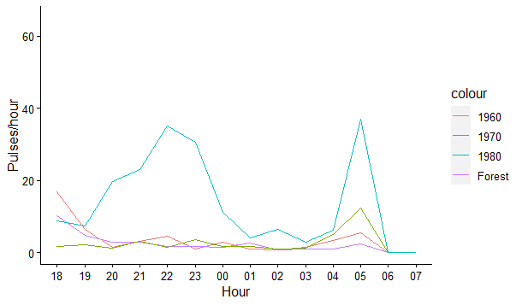
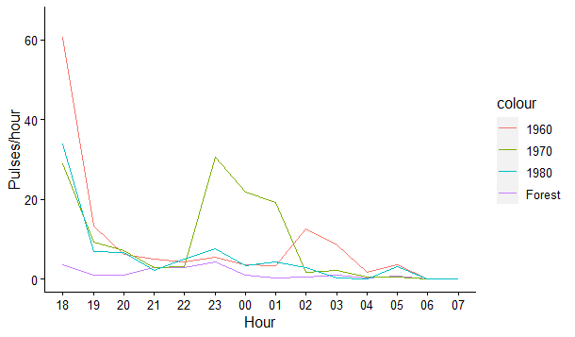

Field Type

Figure S1. Average nocturnal activity (x̄ bat passes/hour) for corrected (identified bat passes) audio data during Autumn (A) and Spring (B) across former fields (abandoned in the 1960s, 1970s and 1980s) and forest fragments in the Willowvale area, Eastern Cape, South Africa.
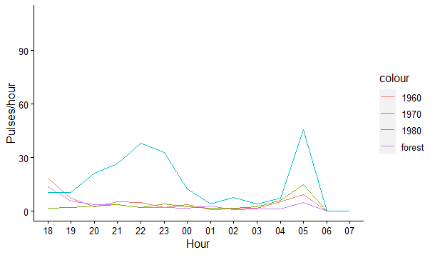
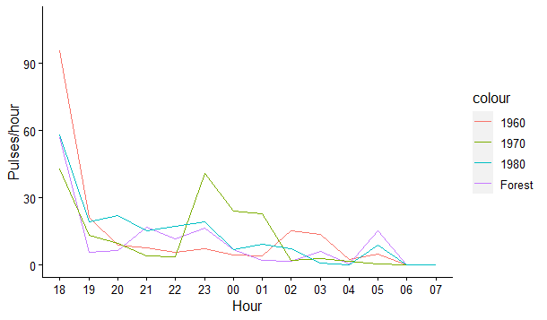
A
B
Field Type

Figure S2: Realised nocturnal activity (x̄ bat passes/hour) for uncorrected (includes unidentified bat passes) audio data during Autumn (A) and Spring (B) across former agricultural fields (since the 1960s, 1970s and 1980s) and forest fragments in the Willovale area, Eastern Cape, South Africa.

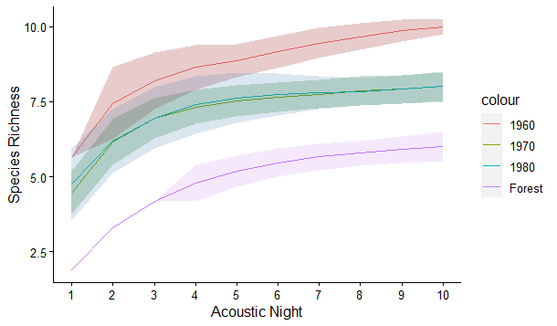
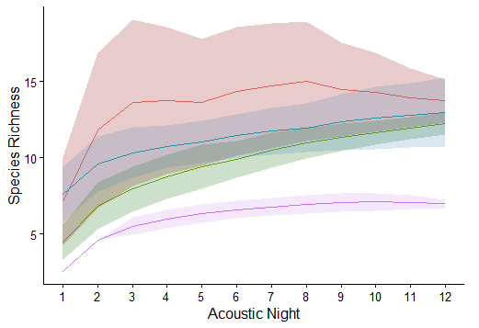
A
B

Figure S3. Species richness estimates and calculated in EstimateS (Colwell 2013) per former field type and forest fragments per acoustic (A; Autumn; B, Spring). Standard deviation is indicated by the shaded area around the respective line graphs. The species accumulation curve extrapolated for the 1960s category falls behind the curve extrapolated for 1970s.

