Supplementary Material
Predator control reduces colony size fluctuations and enhances recolonization of Caspian terns breeding in the Baltic sea
Julia Gómez-Catasús^{1,2,3,4*}, Antti Below⁵, Heikki Lokki⁶, Torsten Stjernberg⁶, Ulrik Lötberg⁷, Patrik Byholm^{1,8}
¹ Novia University of Applied Sciences, FI‑10600 Ekenäs, Finland
² University of Jyväskylä, Jyväskylä, Finland
³ Terrestrial Ecology Group (TEG-UAM), Department of Ecology, Autonomous University of Madrid, Madrid, Spain.
⁴ Centro de Investigación en Biodiversidad y Cambio Global (CIBC-UAM), Department of Ecology, Autonomous University of Madrid, Madrid, Spain.
⁵ Metsähallitus, Nature and Heritage, FI-01301 Vantaa, Finland
⁶ Finnish Museum of Natural History LUOMUS, FI-00014 University of Helsinki, Finland
⁷ BirdLife Sweden, Stenhusa Gård, 386 62 Mörbylånga, Sweden
⁸ Organismal & Evolutionary Biology, University of Helsinki, FI-00014, Helsinki, Finland
*Correspondence author: julia.gomez@uam.es

Appendix A. Expansion of white-tailed eagle population in Finland and relationship with Caspian tern instability
The white-tailed eagle (Haliaeetus albicilla) has undergone an important recovery in Finland since 1990s due to the application of different conservation measures and the ban of DDT and other pesticides. In this appendix we present the information on all the monitored white-tailed eagle nests in Finland within 10 km from the Baltic shoreline during 1985-2019 collected by members of the white-tailed eagle working group, World Wildlife Fund (WWF) Finland. This raw data show that the number of white-tailed eagle nests has increased from 42 in 1984 up to 399 in 2019, highlighting the significant increase undergone by the white-tailed eagle in Finland (ca. 850% in 35 years; Fig. A1).
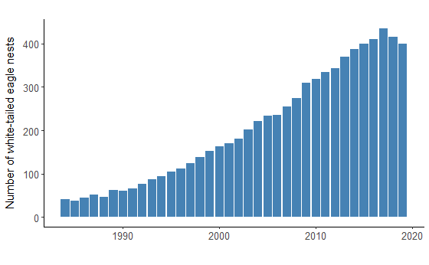
Figure A1. Number of white-tailed eagle nests in Finland within 10 km from the Baltic shoreline from 1984 to 2019.
Table A1. Posterior mean estimates (β), standard deviations (SD) and 95% credibility intervals (95% BCI) from the Zero-Altered Gamma (ZAG) INLA model fitted to the fluctuation in Caspian tern colony size from 1984 to 2019 in 55 Finnish colonies. White-tailed eagle KDE: Kernel values used as proxy of space-use by the white-tailed eagle. Predictors with an important effect are highlighted in bold.
 | Parameters | β | SD | 95% BCI
Bernoulli | Intercept | -0.818 | 0.158 | [-1.131; -0.509]
Bernoulli | Year | 0.076 | 0.054 | [-0.030; 0.181]
Bernoulli | White-tailed eagle KDE | -0.096 | 0.067 | [-0.228: 0.034]
Gamma | Intercept | 0.126 | 0.057 | [0.017; 0.239]
Gamma | Year | 0.321 | 0.038 | [0.246; 0.395]
Gamma | Caspian tern abundance | -0.418 | 0.037 | [-0.491; -0.345]
Gamma | White-tailed eagle KDE | -0.123 | 0.042 | [-0.202; -0.037]

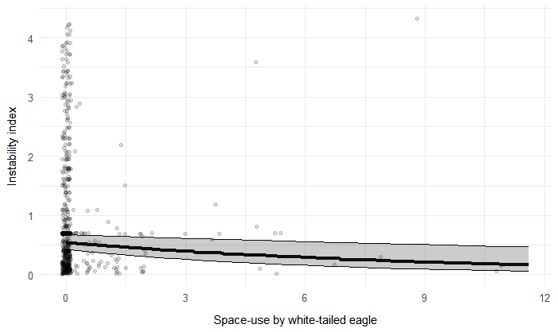
Figure A2. Relationship between the fluctuation in Caspian tern colony size (y-axis) and space-use by white-tailed eagle (i.e., KDE values). Observed values for the Finnish colonies (n = 55; black dots), are depicted. Mean (thick line) and 95% Bayesian Credible Interval (grey surface) of the values predicted by the Gamma model (see Table 2), are represented.

Appendix B. Photographs
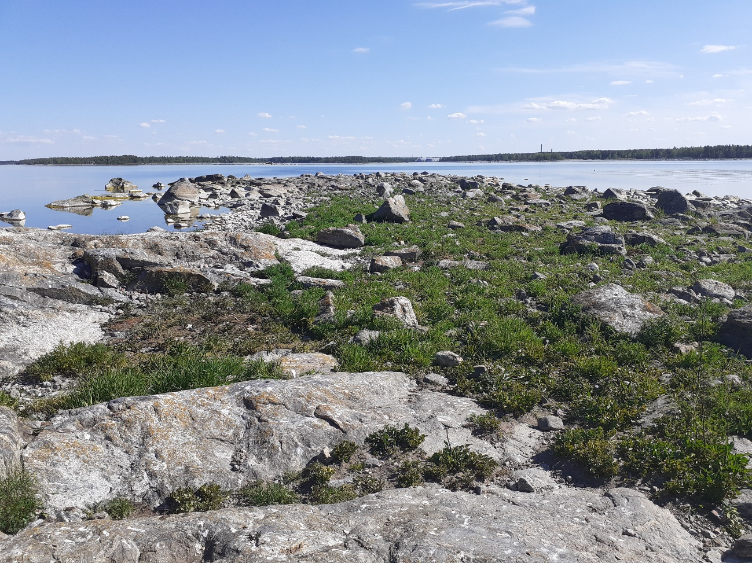
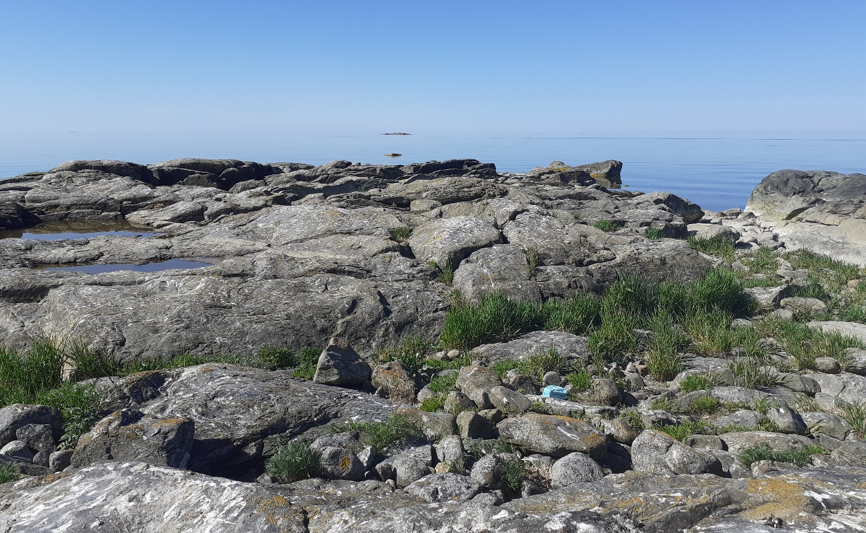
Figure B1. Typical breeding islands of Caspian terns. Colonies are usually located at low rocky islands with flat slabs or gravel banks, which normally lack trees and with low herbaceous cover, located off the coast in the outermost part of the archipelago being exposed to wind and waves. Photos: Patrik Byholm.
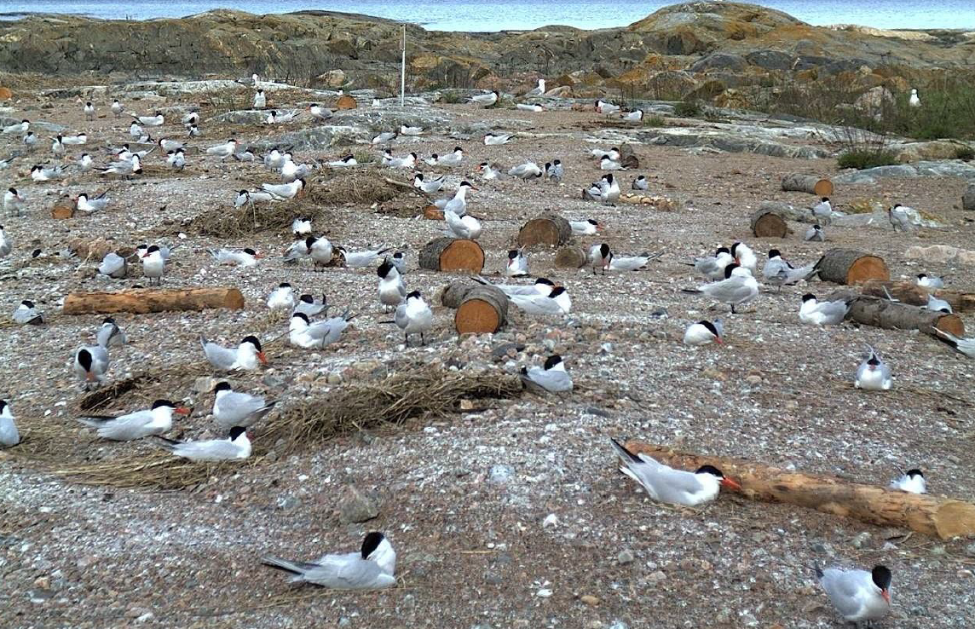
Figure B2. Caspian tern colony. Photo: webcamera.

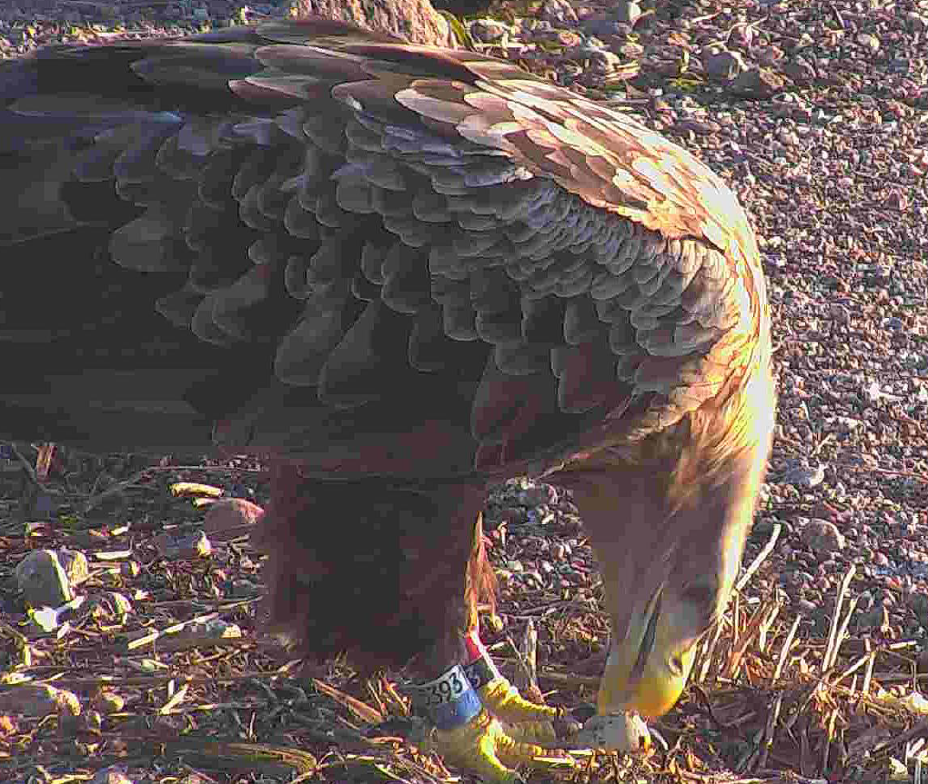
Figure B3. A white-tailed eagle preying on a Caspian tern egg. Photo: webcamera.
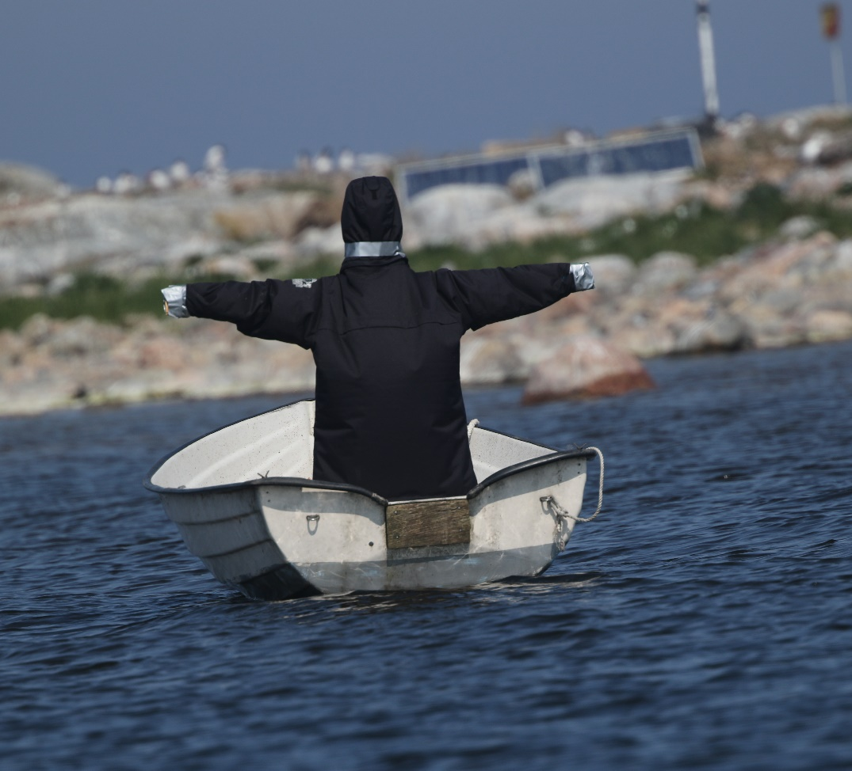
Figure B4. The "Eagle Scarecrow". Photo: Ulrik Lötberg.

Appendix C. Predator control actions
Table C1. Predator control actions conducted at treatment colonies during 1997-2021.
Colony cluster¹ | Colony | Gull nests destroyed | Days with eagle-scarecrow | Killed minks² | Mink traps²
Blekinge  (N= 5; 3-C, 2-T) | Båtaskär | 10 Herring gull nests during 2009-2010 | - | Yes³, during 2008-2021 | 5-10/year
Blekinge  (N= 5; 3-C, 2-T) | Gylvan-Gylvebådan | - | - | Yes³, during 2008-2021 | 5-10/year
Norrbotten  (N= 2; 1-C, 1-T) | Rödkallen | No, but two adult ravens in 2015 | - | No, but two badgers in 2021 | -
Östergötland  (N= 5; 3-C, 2-T) | Röskären | 5 Herring gull nests and 1 Greater-black backed gull nest during 2013-2021 | 90 days a year during 2021 | - | -
Östergötland  (N= 5; 3-C, 2-T) | Yttre Benskären | - | 90 days a year during2021 | 51 during 2008-2021⁴ | 5-10/year
Småland  (N= 4; 2-C, 2-T) | Furö-Örbåden | 2 Greater-black backed gull nests during 2012-2021 | - | - | -
Småland  (N= 4; 2-C, 2-T) | Skorvan | - | 90 days a year during 2021 | - | -
Södermanland  (N= 9; 7-C, 2-T) | Hållen-Långa Hållet | - | 90 days a year during 2020-2021 | 51 during 2008-2021⁴ | 5-10/year
Södermanland  (N= 9; 7-C, 2-T) | Risskären | - | 90 days a year during 2020-2021 | 51 during 2008-2021⁴ | 5-10/year
Uppland  (N= 6; 4-C, 2-T) | Stenarna norra | 15 Herring gull nests during 2010-2021 | 90 days a year during 2019-2021 | 251 during 1997-2021 | 5-10/year
Uppland  (N= 6; 4-C, 2-T) | Tisslan | 1 Greater-black backed gull nest in 2017 | 90 days a year during 2021 | 2 during 2015-2021 | 5-10/year

¹ We indicate between brackets the total number of islands per colony cluster, discerning between control (C) and treatment (T) colonies
² Statistics on killed minks and trap number refers not only to the colony island, but minks were hunted also in other on adjacent island within the archipelago.
³ Exact numbers missing.
⁴ The number of hunted minks reported for Hållen-Långa Hållen, Risskären and Yttre-Benskären referes to pooled information for all islands as reported by the County Administrative Board of Östergötland.

APPENDIX D. Model selection
Table D1. Watanabe-Akaike Information Criterion (wAIC) for all plausible models, with the model displaying the lowest wAIC value (highlighted in bold) identified as the best fit. "BA" represents the factor "Before-After," while "CI" denotes "Control-Impact”.
 | Model description | wAIC
Fluctuations in colony size | ~ 1 + IslandSize | 784.29
Fluctuations in colony size | ~ 1 + BA | 816.40
Fluctuations in colony size | ~ 1 + CI | 824.34
Fluctuations in colony size | ~ 1 + BA + CI | 817.02
Fluctuations in colony size | ~ 1 + IslandSize + CI | 786.9
Fluctuations in colony size | ~ 1 + IslandSize + BA | 773.36
Fluctuations in colony size | ~ 1 + IslandSize + BA + CI | 806.76
Fluctuations in colony size | ~ 1 + BA + CI + BA:CI | 773.07
Fluctuations in colony size | ~ 1 + IslandSize + BA + CI + BA:CI | 771.75
Abundance and Occurrence | ~ 1 + IslandSize | 15,351.69
Abundance and Occurrence | ~ 1 + BA | 15,893.45
Abundance and Occurrence | ~ 1 + CI | 15,330.65
Abundance and Occurrence | ~ 1 + BA + CI | 15,900.38
Abundance and Occurrence | ~ 1 + IslandSize + CI | 15,332.18
Abundance and Occurrence | ~ 1 + IslandSize + BA | 15,895.47
Abundance and Occurrence | ~ 1 + IslandSize + BA + CI | 15,901.96
Abundance and Occurrence | ~ 1 + BA + CI + BA:CI | 13,235.14
Abundance and Occurrence | ~ 1 + IslandSize + BA + CI + BA:CI | 13,234.72
Breeding success | ~ 1 + IslandSize | 3,316.65
Breeding success | ~ 1 + BA | 11,104.39
Breeding success | ~ 1 + CI | 11,385.46
Breeding success | ~ 1 + BA + CI | 11,042.76
Breeding success | ~ 1 + IslandSize + CI | 3,323.41
Breeding success | ~ 1 + IslandSize + BA | 3,267.33
Breeding success | ~ 1 + IslandSize + BA + CI | 3,263.99
Breeding success | ~ 1 + BA + CI + BA:CI | 11,601.7
Breeding success | ~ 1 + IslandSize + BA + CI + BA:CI | 3,243.46

