Biodiversity and Conservation
Linking environmental uniqueness, local physicochemical variables, and human disturbance to zooplankton functional uniqueness in tropical ponds and streams
Larissa Araújo dos Santos¹, Thaísa Sala Michelan¹, Francieli de Fátima Bomfim¹*
¹ Laboratório de Ecologia de Produtores Primários (ECOPRO), Programa de Pós-graduação em Ecologia, Instituto de Ciências Biológicas, Universidade Federal do Pará, Belém, PA, Brazil
* Corresponding author: larissaarj.17@gmail.com

Larissa Araújo dos Santos ORCID: 0000-0002-6046-0282
Thaisa S. Michelan ORCID: 0000-0001-9416-0758
Francieli F. Bomfim ORCID: 0000-0003-4630-3587

Functional traits description and body size measurements

The body shape trait was classified into the following categories: fusiform (including conical, elongated fusiform, and fusiform), elongated (including elongated cuboid, elongated, elongated oval, spoon-shaped, and vase-shaped), oval (including globular, irregular oval, oblong, oblong oval, oval, rectangular oval, ovoid, rhombic, rounded, semicircular, spherical, subcylindrical, and elongated sub-ovoid), and rectangular (including rectangular, subquadrangular, and sub-rectangular). The buoyancy trait was classified based on body structures, including spines (spines, spicules, spinules, and cusps), cilia (cilia and setae), setae, and the absence of such structures.
The body structure trait was classified as loricate or illoricate for rotifers, with the presence or absence of a lorica related to organismal adaptation, habitat type, and life-history strategies, as this structure provides protection, structural support, and affects mobility (Segers and Yule, 2004; Yin et al., 2017). For cladocerans and copepods, the trait was categorized as chitinous. The buoyancy and body shape traits were selected to help understand how zooplankton respond to water flow in the different environments studied (ponds and streams).
For body size, 30 individuals of each species were measured from randomly selected samples. If fewer than 30 individuals were available, all individuals were measured. For cladocerans, body size was measured from the top of the head to the base of the carapace, excluding spines. For rotifers, measurements were taken along the main body axis, excluding spines. For copepods, body size was measured from the top of the head to the base of the furca, excluding caudal setae.

Table S1. Functional traits are classified into: Variable type, categories, and importance.
Functional trait | Variable type | Category | Importance
Body size | Continuous | Medium length (μm) | This trait is related to dispersal, foraging efficiency, competition, and predation (De Bie et al., 2012; Dias et al., 2016).
Habitat type | Categorical | Littoral  Pelagic | It influences the acquisition of food resources and habitat (Burks et al., 2002). Littoral habitats may offer more variable conditions with greater nutrient availability, whereas pelagic habitats require specific adaptive strategies (Burks et al., 2002; Cardoso et al., 2019).
Feeding type | Categorical | Filter_R  Suctor_R  Predator_R  Filter_Cop  Raptorial_Cop  Filter_Clad  Scraper_Clad | It represents the morpho-functional variability for food acquisition and is related to productivity and nutrient cycling (Litchman et al., 2013).
Lifespan | Categorical | Short  Long | It represents the energetic investment in reproduction and growth (Litchman et al., 2013).
Predator scape | Categorical | None  Low  Medium  Efficient | Used as an indicator of predation pressure and survival capacity (Diniz et al., 2021).
Body shape | Categorical | Elongated  Fusiform  Oval  Rectangular | Indicates resistance to water flow (Molloy and Cowling, 1999).
Body structure | Categorical | Loricate  Iloricate  Chitinous | Influences mobility and responses to water conditions (Kiørboe, 2013).
Floatability | Categorical | Setae  Spines  Cilia  Absent | Indicates increased resistance to water (Molloy and Cowling, 1999), mobility, and responses to water conditions.

Table S2. Environment uniqueness and functional uniqueness values in Amazonian ponds and streams.

Points | Region | Environment | Environment uniqueness | Functional uniqueness (abundance) | Functional uniqueness (presence and absence)
ST22_01 | Paragominas | Stream | 0.0198 | 0.0260 | 0.0217
ST22_02 | Paragominas | Stream | 0.0224 | 0.0327 | 0.0225
ST222_06 | Paragominas | Stream | 0.0461 | 0.0311 | 0.0147
ST22_07 | Paragominas | Stream | 0.0040 | 0.0169 | 0.0100
ST22_09 | Paragominas | Stream | 0.0256 | 0.0362 | 0.0207
ST22_14 | Paragominas | Stream | 0.0059 | 0.0130 | 0.0125
ST22_16 | Paragominas | Stream | 0.0071 | 0.0155 | 0.0154
ST22_17 | Paragominas | Stream | 0.0021 | 0.0269 | 0.0384
ST22_18 | Paragominas | Stream | 0.0082 | 0.0327 | 0.0384
ST22_21 | Paragominas | Stream | 0.0005 | 0.0174 | 0.0118
ST22_22 | Paragominas | Stream | 0.1527 | 0.0408 | 0.0195
ST22_23 | Paragominas | Stream | 0.0006 | 0.0148 | 0.0076
ST22_25 | Paragominas | Stream | 0.0158 | 0.0234 | 0.0233
ST22_29 | Paragominas | Stream | 0.0188 | 0.0237 | 0.0169
ST22_31 | Paragominas | Stream | 0.0020 | 0.0336 | 0.0432
ST22_34 | Paragominas | Stream | 0.0039 | 0.0327 | 0.0384
ST22_36 | Paragominas | Stream | 0.0067 | 0.0364 | 0.0525
A01 | Barcarena | Stream | 0.0039 | 0.0147 | 0.0254
F03 | Barcarena | Stream | 0.0093 | 0.0150 | 0.0139
G03 | Barcarena | Stream | 0.0135 | 0.0126 | 0.0174
J02 | Barcarena | Stream | 0.0484 | 0.0389 | 0.0348
J03 | Barcarena | Stream | 0.0159 | 0.0126 | 0.0086
L03 | Barcarena | Stream | 0.0087 | 0.0152 | 0.0050
M03 | Barcarena | Stream | 0.0142 | 0.0114 | 0.0158
P03 | Barcarena | Stream | 0.0026 | 0.0286 | 0.0387
PB02 | Barcarena | Stream | 0.0107 | 0.0112 | 0.0150
PB05 | Barcarena | Stream | 0.0884 | 0.0167 | 0.0363
PB06 | Barcarena | Stream | 0.0179 | 0.0168 | 0.0420
PB08 | Barcarena | Stream | 0.0015 | 0.0309 | 0.0262
PB18 | Barcarena | Stream | 0.0082 | 0.0248 | 0.0080
PB20 | Barcarena | Stream | 0.0026 | 0.0200 | 0.0075
PB22 | Barcarena | Stream | 0.0127 | 0.0334 | 0.0297
PB27 | Barcarena | Stream | 0.0422 | 0.0201 | 0.0158
PB32 | Barcarena | Stream | 0.0080 | 0.0134 | 0.0053
PC06 | Barcarena | Stream | 0.0073 | 0.0103 | 0.0075
PFM14 | Barcarena | Stream | 0.0024 | 0.0157 | 0.0297
PM02 | Barcarena | Stream | 0.2218 | 0.0272 | 0.0158
PM32 | Barcarena | Stream | 0.0139 | 0.0127 | 0.0053
PM33 | Barcarena | Stream | 0.0201 | 0.0181 | 0.0325
PM35 | Barcarena | Stream | 0.0036 | 0.0140 | 0.0108
PM36 | Barcarena | Stream | 0.0326 | 0.0385 | 0.0339
RQ3 | Barcarena | Stream | 0.0013 | 0.0151 | 0.0168
T03 | Barcarena | Stream | 0.0005 | 0.0128 | 0.0150
U03 | Barcarena | Stream | 0.0311 | 0.0257 | 0.0121
Z01 | Barcarena | Stream | 0.0146 | 0.0199 | 0.0514
ST22_03 | Paragominas | Pond | 0.0432 | 0.0264 | 0.0189
ST22_04 | Paragominas | Pond | 0.0432 | 0.0200 | 0.0118
ST22_05 | Paragominas | Pond | 0.0452 | 0.0420 | 0.0398
ST22_08 | Paragominas | Pond | 0.0433 | 0.0323 | 0.0304
ST22_10 | Paragominas | Pond | 0.0432 | 0.0248 | 0.0230
ST22_11 | Paragominas | Pond | 0.0451 | 0.0519 | 0.0625
ST22_13 | Paragominas | Pond | 0.0432 | 0.0238 | 0.0328
ST22_15 | Paragominas | Pond | 0.0452 | 0.0465 | 0.0223
ST22_20 | Paragominas | Pond | 0.0432 | 0.0423 | 0.0854
ST22_24 | Paragominas | Pond | 0.0432 | 0.0658 | 0.0602
ST22_26 | Paragominas | Pond | 0.0453 | 0.0489 | 0.0258
ST22_28 | Paragominas | Pond | 0.0432 | 0.0265 | 0.0329
ST22_35 | Paragominas | Pond | 0.1207 | 0.0647 | 0.0485
ST22_37 | Paragominas | Pond | 0.0432 | 0.0353 | 0.0184
ST22_38 | Paragominas | Pond | 0.0453 | 0.0380 | 0.0590
ST22_40 | Paragominas | Pond | 0.0432 | 0.0345 | 0.0288
MA02 | Barcarena | Pond | 0.0003 | 0.0188 | 0.0075
MA03 | Barcarena | Pond | 0.0075 | 0.0305 | 0.0254
MA04 | Barcarena | Pond | 0.0453 | 0.0258 | 0.0196
MA06 | Barcarena | Pond | 0.0331 | 0.0602 | 0.0301
MA07 | Barcarena | Pond | 0.0452 | 0.0367 | 0.0884
MA12 | Barcarena | Pond | 0.0108 | 0.0565 | 0.0857
MA14 | Barcarena | Pond | 0.0319 | 0.0248 | 0.0277
MA17 | Barcarena | Pond | 0.0015 | 0.0423 | 0.0385
MA18 | Barcarena | Pond | 0.0017 | 0.0510 | 0.0112
MA19 | Barcarena | Pond | 0.0440 | 0.0298 | 0.0654

Table S3. List of zooplankton taxa with their frequency of occurrence in Amazonian ponds and streams.
Taxa | Frequency of occurrence (%) in streams | Frequency of occurrence (%) in ponds
ROTIFERA
Bdelloidea | 34.78 | 15.38
Rotifer sp. | 2.17 | 0
BRACHIONIDAE Ehrenberg, 1838
Brachionus calyciflorus Pallas, 1766 | 0 | 3.85
Brachionus caudatus f. personatus Ahlstrom, 1940 | 2.17 | 0
Brachionus falcatus Zacharias, 1898 | 8.70 | 0
Brachionus mirus Daday, 1905 | 4.35 | 3.85
Brachionus urceolaris Müller, 1773 | 2.17 | 0
Brachionus zahniseri Ahlstrom, 1934 | 13.04 | 15.38
Keratella americana Carlin, 1943 | 2.17 | 3.85
Keratella cochlearis (Gosse, 1851) | 15.22 | 15.38
Keratella lenzi Hauer, 1953 | 4.35 | 3.85
Plationus patulus (Müller, 1786) | 0 | 7.69
Plationus patulus macrachantus (Daday, 1905) | 0 | 15.38
Platyias quadricornis (Ehrenberg, 1832) | 15.22 | 38.46
DICRANOPHORIDAE Harring, 1831
Dicranophorus epicharis Harring & Myers, 1928 | 0 | 3.85
Dicranophorus prionacis Harring & Myers, 1928 | 0 | 3.85
Dicranophorus sp. | 0 | 3.85
EUCHLANIDAE Ehrenberg, 1838
Dipleuchlanis propatula (Gosse, 1886) | 15.22 | 38.46
Euchlanis dilatata Ehrenberg, 1832 | 4.35 | 0
HEXARTHRIDAE Bartos, 1959
Hexarthra mira (Hudson, 1871) | 0 | 3.85
LECANIDAE Remane, 1933
Lecane aculeata (Jakubski, 1912) | 2.17 | 0
Lecane amazonica (Murray, 1913) | 4.35 | 0
Lecane bulla (Gosse, 1851) | 67.39 | 61.54
Lecane cf. deridderae | 6.52 | 3.85
Lecane cf. pertica | 17.39 | 15.38
Lecane cf. signifera | 0 | 3.85
Lecane closterocerca (Schmarda, 1859) | 2.17 | 0
Lecane cornuta (Müller, 1786) | 6.52 | 11.54
Lecane curvicornis (Murray, 1913) | 8.70 | 19.23
Lecane doryssa Harring, 1914 | 8.70 | 3.85
Lecane elongata Harring & Myers, 1926 | 2.17 | 3.85
Lecane elsa Hauer, 1931 | 2.17 | 26.92
Lecane furcata (Murray, 1913) | 6.52 | 0
Lecane haliclysta Harring & Myers, 1926 | 2.17 | 3.85
Lecane hornemanni (Ehrenberg, 1834) | 8.70 | 3.85
Lecane leontina (Turner, 1892) | 32.61 | 73.08
Lecane ludwigii (Eckstein, 1883) | 4.35 | 11.54
Lecane ludwigii f. ecordes Harring, 1914 | 2.17 | 0
Lecane luna (Müller, 1776) | 0 | 11.54
Lecane lunaris (Ehrenberg, 1832) | 65.22 | 42.31
Lecane lunaris crenata (Harring, 1913) | 0 | 7.69
Lecane monostyla (Daday, 1897) | 4.35 | 0
Lecane obtusa (Murray, 1913) | 2.17 | 0
Lecane papuana (Murray, 1913) | 10.87 | 42.31
Lecane pertica Harring & Myers, 1926 | 0 | 7.69
Lecane proiecta Hauer, 1956 | 2.17 | 3.85
Lecane pyriformis (Daday, 1905) | 10.87 | 11.54
Lecane quadridentata (Ehrenberg, 1830) | 30.43 | 30.77
Lecane signifera (Jennings, 1896) | 50 | 46.15
Lecane sp. | 6.52 | 0
Lecane stichaea Harring, 1913 | 8.70 | 0
Lecane thienemanni (Hauer, 1938) | 17.39 | 7.69
Lecane ungulata (Gosse, 1887) | 2.17 | 0
LEPADELLIDAE Harring, 1913
Colurella sp. | 2.17 | 0
Lepadella patella (Müller, 1773) | 15.22 | 11.54
Lepadella sp. | 10.87 | 3.85
Lepadella triptera (Ehrenberg, 1830) | 8.70 | 11.54
Paracolurella sp. | 4.35 | 0
MYTILINIDAE Harring, 1913
Mytilina bisulcata (Lucks, 1912) | 0 | 3.85
Mytilina macrocera (Jennings, 1894) | 0 | 3.85
Mytilina mucronata (Müller, 1773) | 2.17 | 3.85
NOTOMMATIDAE Hudson & Gosse, 1886
Cephalodella gibba (Ehrenberg, 1830) | 2.17 | 0
Cephalodella mucronata Myers, 1924 | 4.35 | 0
Cephalodella sp. | 2.17 | 0
Monommata actices Myers, 1930 | 2.17 | 3.85
Monommata caeca Myers, 1930 | 0 | 3.85
Monommata sp. | 2.17 | 0
Notommata pachyura (Gosse, 1886) | 2.17 | 0
PROALIDAE Harring & Myers, 1924
Proales sp. | 2.17 | 0
SYNCHAETIDAE Hudson & Gosse, 1886
Polyarthra dolichoptera Idelson, 1925 | 2.17 | 7.69
TESTUDINELLIDAE Harring, 1913
Testudinella mucronata (Gosse, 1886) | 2.17 | 19.23
Testudinella ohlei Koste, 1972 | 19.57 | 11.54
Testudinella patina (Hermann, 1783) | 8.70 | 15.38
Testudinella sp. | 4.35 | 0
TRICHOCERCIDAE Harring, 1913
Trichocerca bicristata (Gosse, 1887) | 0 | 3.85
Trichocerca capucina (Wierzejski & Zacharias, 1893) | 0 | 7.69
Trichocerca elongata (Gosse, 1886) | 4.35 | 0
Trichocerca gracilis (Tessin, 1890) | 2.17 | 0
Trichocerca heterodactyla (Tschugunoff, 1921) | 2.17 | 0
Trichocerca macera (Gosse, 1886) | 2.17 | 0
Trichocerca myersi (Hauer, 1931) | 2.17 | 0
Trichocerca rattus (Müller, 1776) | 2.17 | 0
Trichocerca sp. | 6.52 | 0
TRICHOTRIIDAE Harring, 1913
Macrochaetus collinsii (Gosse, 1867) | 4.35 | 15.38
Macrochaetus sericus (Thorpe, 1893) | 4.35 | 7.69
Trichotria tetractis (Ehrenberg, 1830) | 15.22 | 15.38
TROCHOSPHAERIDAE Harring, 1913
Filinia limnetica (Zacharias, 1893) | 0 | 3.85
Filinia terminalis (Plate, 1886) | 2.17 | 0
CLADOCERA
Cladocera sp. | 13.04 | 7.69
Cladocera sp. 2 | 2.17 | 0
Chydoridae sp. | 4.35 | 7.69
BOSMINIDAE Sars, 1865
Bosmina longirostris (O. F. Müller, 1776) | 2.17 | 0
Bosminopsis deitersi Richard, 1895 | 13.04 | 23.08
Bosminopsis sp. | 2.17 | 0
CHYDORIDAE Stebbing, 1902
Alona isabellae Sousa, Elmoor-Loureiro & Santos, 2016 | 0 | 3.85
Alona sp. | 2.17 | 0
Alonella clathratula Sars, 1896 | 4.35 | 11.54
Alonella dadayi Birge, 1910 | 54.35 | 65.38
Anthalona verrucosa (Sars, 1901) | 15.22 | 42.31
Biapertura ossiani (Sinev, 1998) | 21.74 | 42.31
Camptocercus australis Sars, 1896 | 0 | 3.85
Chydorus nitidulus (Sars, 1901) | 0 | 3.85
Chydorus parvireticulatus Frey, 1987 | 0 | 7.69
Chydorus pubescens Sars, 1901 | 13.04 | 19.23
Chydorus sp. | 0 | 3.85
Coronatella monacantha (Sars, 1901) | 4.35 | 11.54
Coronatella undata Sousa, Elmoor-Loureiro & Santos, 2015 | 0 | 3.85
Disparalona lucianae Sousa, Elmoor-Loureiro, Mugnai, Panarelli & Paggi, 2018 | 10.87 | 15.38
Disparalona sp. | 0 | 7.69
Disparalona tenuispina Sousa, Elmoor-Loureiro, Mugnai, Panarelli & Paggi, 2018 | 15.22 | 11.54
Dunhevedia odontoplax Sars, 1901 | 2.17 | 3.85
Ephemeroporus hybridus (Daday, 1905) | 0 | 3.85
Ephemeroporus tridentatus (Bergamin, 1931) | 0 | 3.85
Flavalona iheringula (Kotov & Sinev, 2004) | 0 | 3.85
Graptoleberis occidentalis Sars, 1901 | 4.35 | 0
Karualona muelleri (Richard, 1897) | 0 | 3.85
Monospilus brachyspinus Sousa, Elmoor-Loureiro & Panarelli, 2017 | 2.17 | 0
Nicsmirnovius paggii Sousa & Elmoor-Loureiro, 2017 | 10.87 | 11.54
Ovalona glabra (Sars, 1901) | 6.52 | 0
Oxyurella ciliata Bergamin, 1939 | 0 | 3.85
Oxyurella longicaudis (Birge, 1910) | 0 | 3.85
Prendalona cf. julietae | 0 | 3.85
Prendalona julietae Sousa, Elmoor-Loureiro & Santos, 2023 | 8.70 | 23.08
DAPHNIIDAE Straus, 1820
Ceriodaphnia laticaudata Müller, 1867 | 0 | 3.85
Ceriodaphnia sp. | 0 | 3.85
ILYOCRYPTIDAE Smirnov, 1992
Ilyocryptus sp. | 4.35 | 0
Ilyocryptus spinifer Herrick, 1882 | 10.87 | 23.08
MACROTHRICIDAE Norman & Brady, 1867
Macrothrix laticornis (Jurine, 1820) | 2.17 | 3.85
Macrothrix sp. | 2.17 | 3.85
Macrothrix squamosa Sars, 1901 | 17.39 | 42.31
SIDIDAE Baird, 1850
Diaphanosoma birgei Korinek, 1981 | 6.52 | 0
Diaphanosoma brevireme Sars, 1901 | 2.17 | 0
Diaphanosoma sp. | 2.17 | 3.85
Diaphanosoma spinulosum Herbst, 1975 | 0 | 3.85
COPEPODA
Calanoida sp. | 2.17 | 0
Cyclopoida sp. | 6.52 | 11.54
Harpacticoida sp. | 2.17 | 7.69
CYCLOPIDAE Rafinesque, 1815
Acanthocyclops robustus (Sars, 1863) | 0 | 11.54
Ectocyclops rubescens Brady, 1904 | 2.17 | 0
Eucyclops elegans (Herrick, 1884) | 2.17 | 0
Mesocyclops longisetus (Thiébaud, 1912) | 0 | 3.85
Mesocyclops meridianus (Kiefer, 1926) | 2.17 | 0
Mesocyclops ogunnus (Onabamiro, 1957) | 0 | 3.85
Mesocyclops sp. | 0 | 3.85
Microcyclops alius (Kiefer, 1935) | 2.17 | 3.85
Microcyclops ceibaensis (Marsh, 1919) | 19.57 | 15.38
Microcyclops sp. | 0 | 7.69
Tropocyclops sp. | 2.17 | 3.85
DIAPTOMIDAE Baird, 1950
Argyrodiaptomus sp. | 0 | 3.85

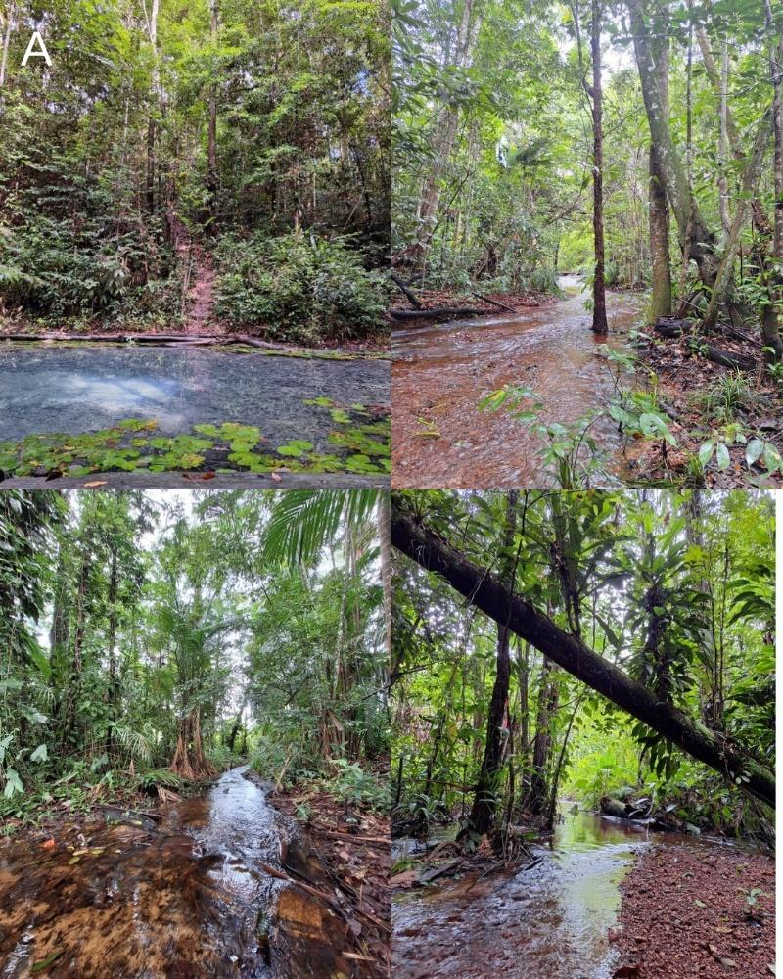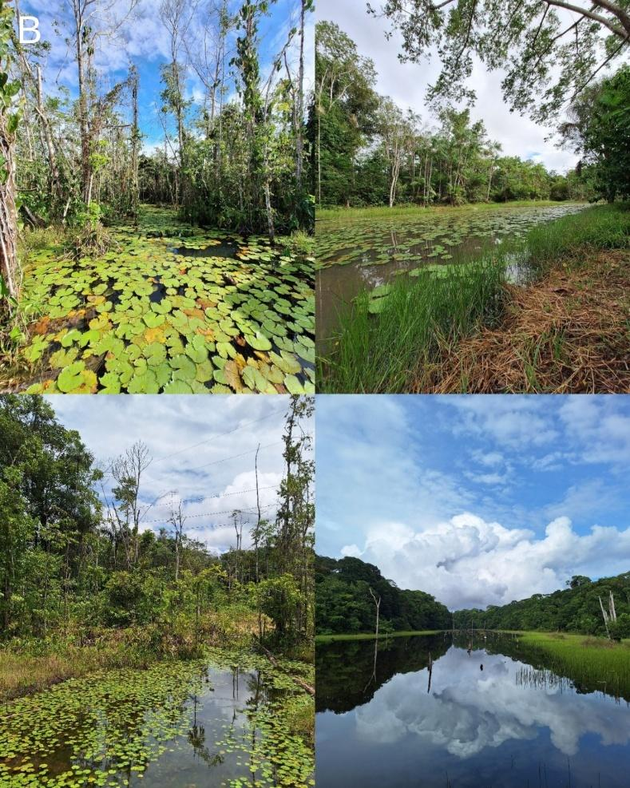
Fig. S1. Characterization of the physiognomy of the sampled water bodies: (A) streams and (B) ponds.
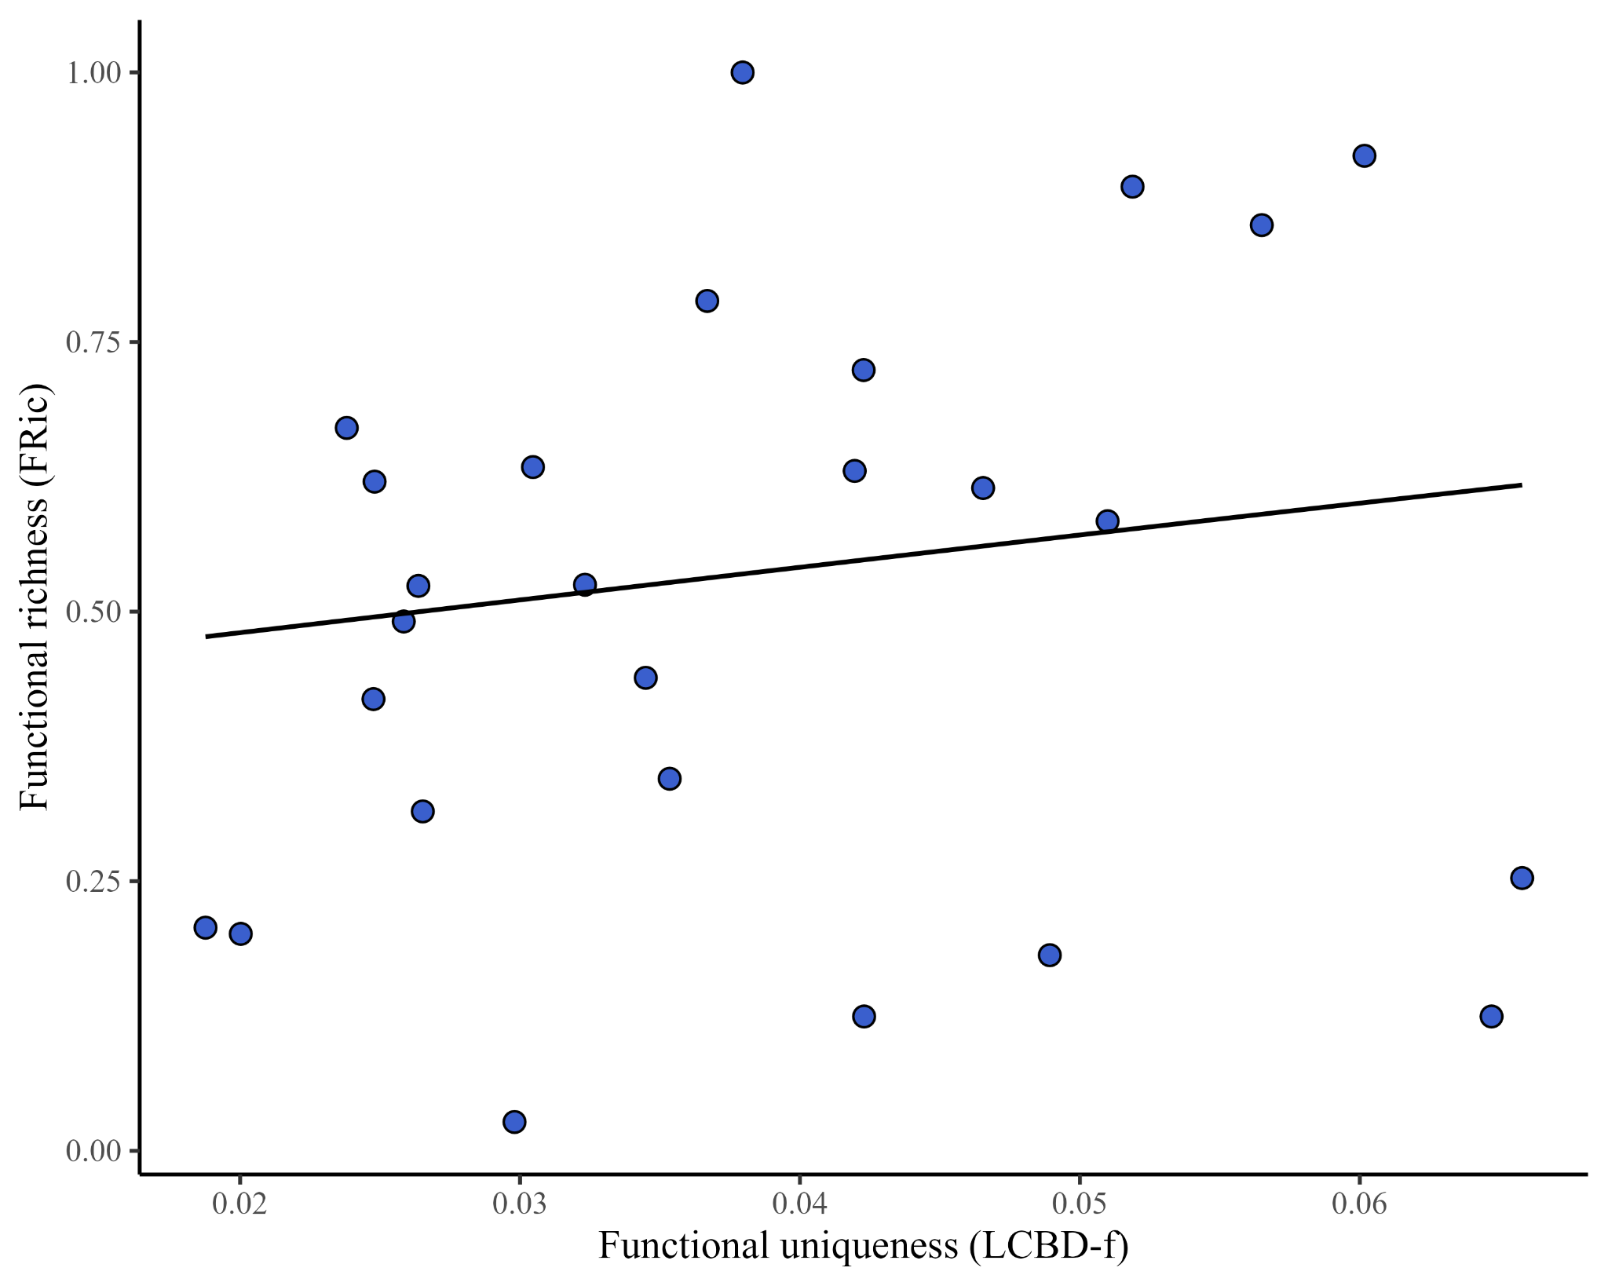

Fig. S2. Relationship between functional richness (FRic) and functional uniqueness (LCBD-f) of zooplankton communities (based on abundance data) in ponds in the state of Pará, Brazil.

