Supplementary Information 2

Assessing the impact of linear infrastructure on landscape connectivity: a worked example from South Sudan and Uganda
Fonda Federica^{1,*}, Bullegas Fabrizio^{1,2}, Petruzzellis Francesco^{1,3}, Bacaro Giovanni¹
¹ Department of Life Science, University of Trieste, via L. Giorgieri 10, 34127 Trieste, Italy
² Department of Life and Environmental Sciences, University of Cagliari, viale S. Ignazio da Laconi 13, 09123 Cagliari, Italy
³ Department of Biology, University of Padova, viale Colombo 3, 35131 Padova, Italy
* Corresponding author: Federica Fonda, federica.fonda@gmail.com

Supplementary Information 2 – Results
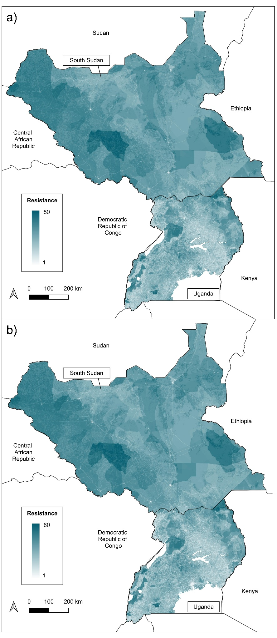
Figure S2.1 – Resistance surfaces of the present scenario (a) and future scenario (b).
Indicator used to create resistance surfaces:
- Linear infrastructure density (LI): values are 10 for 92.60% of the study area (Figure S2.2). The distribution of values across the study area shows greater environmental permeability in South Sudan, which has a lower density of linear infrastructure than Uganda. Only spatial data on planned power lines were available in the open access database, while data on roads, railways and other linear infrastructure were not freely available. The total length of planned power lines is 6865 km, of which 2885 km in South Sudan and 3980 km in Uganda (Figure S2.3).
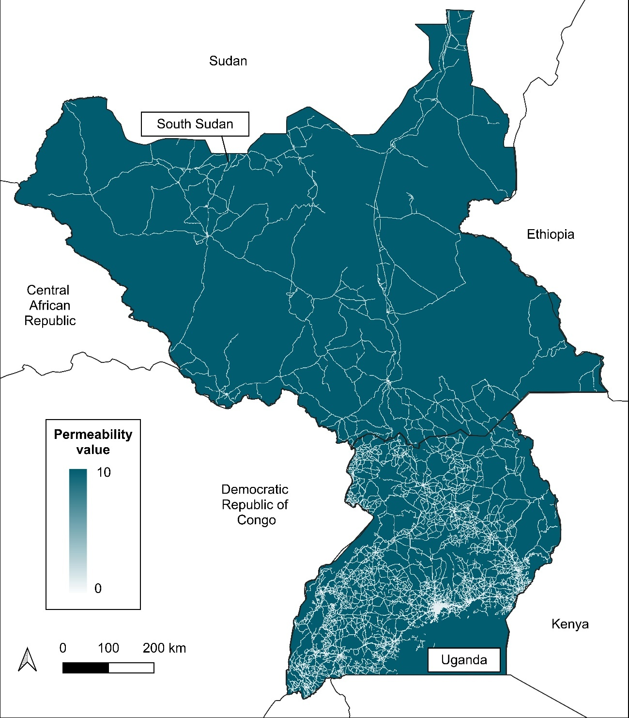
Figure S2.2 - Values of permeability obtained for the linear infrastructure density (LI) indicator used in the present scenario.
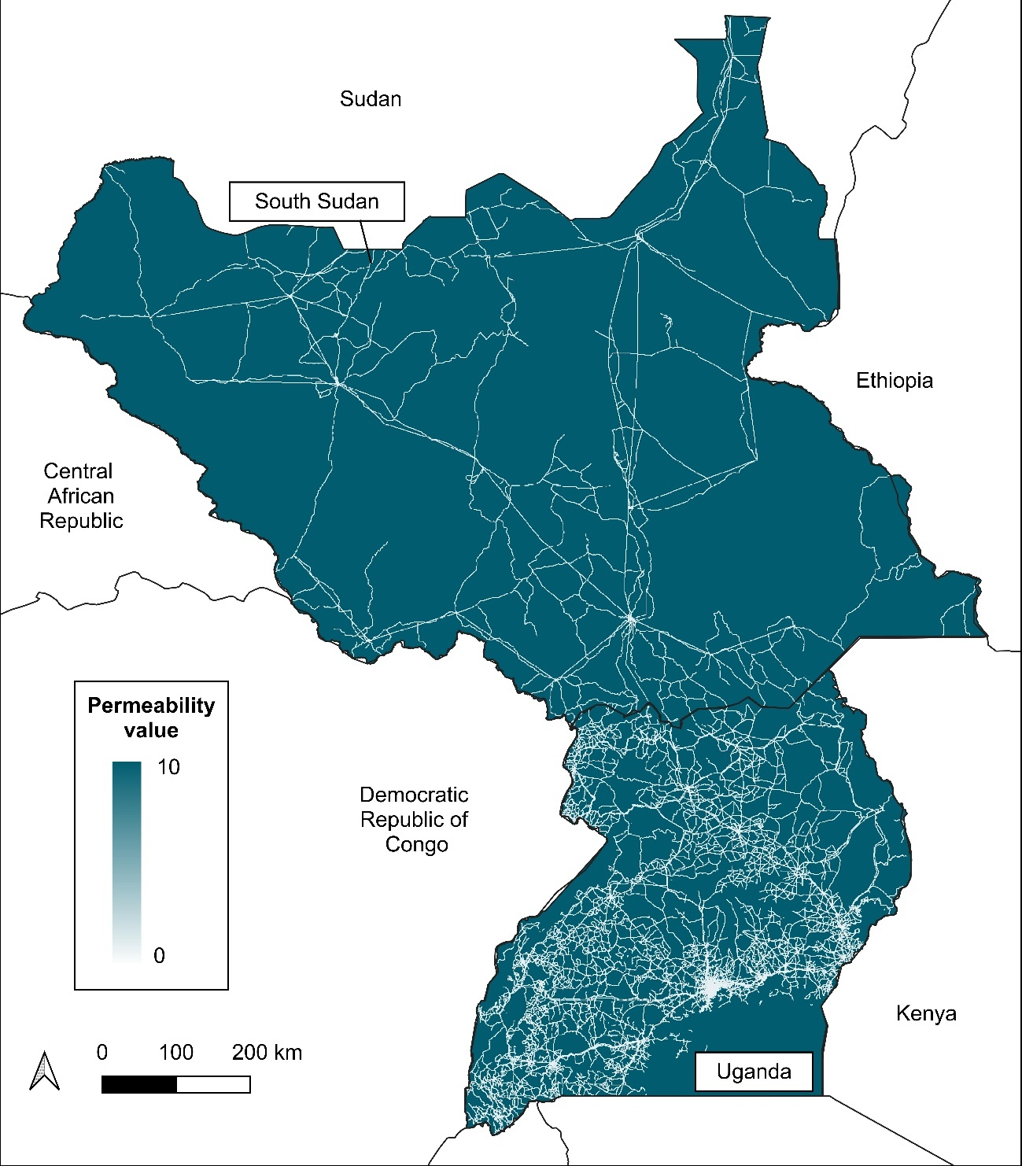
Figure S2.3 - Values of permeability obtained for the linear infrastructure density (LI) indicator used in the future scenario.

- Species conservation (CONS): The areas of habitat used to calculate the CONS indicator (Figure S2.4) included a total of 2,143 species, of which 1,064 were birds (49.64% of the total), 324 mammals (15.12%), 194 reptiles (9.05%), 79 amphibians (3.69%), 304 arthropods (14.19%) and 178 plants (8.31%). The number of threatened species was 106, of which 57 were vulnerable (VU), 41 endangered (EN) and 8 critically endangered (CR). Of these, 40 are birds, 33 mammals, 10 reptiles, 1 amphibian, 12 arthropods and 10 plants.
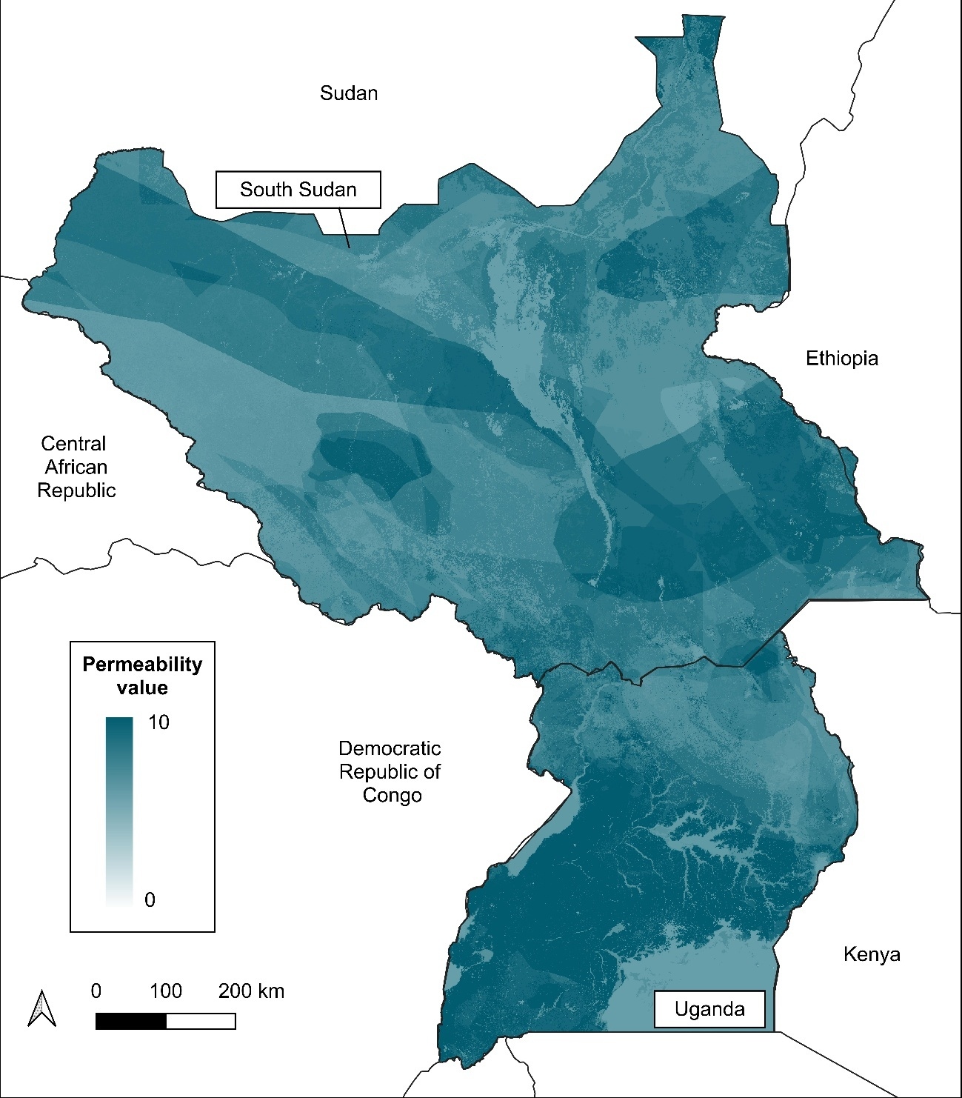
Figure S2.4 – Values of permeability obtained for the species conservation (CONS) indicator.

- Land cover (LAN): The land cover of the study area is represented by forest (35.24%), followed by herbaceous vegetation (25.06%), shrubland (23.69%), cropland (7,81%), permanent water bodies (4.17%), herbaceous wetland (3.79%), urban areas (0.22%), bare soil/sparse vegetation (0.0085%) and ice and snow areas (0.0001%). Thus, most of the study area has permeability values greater than 5 (Figure S2.5).
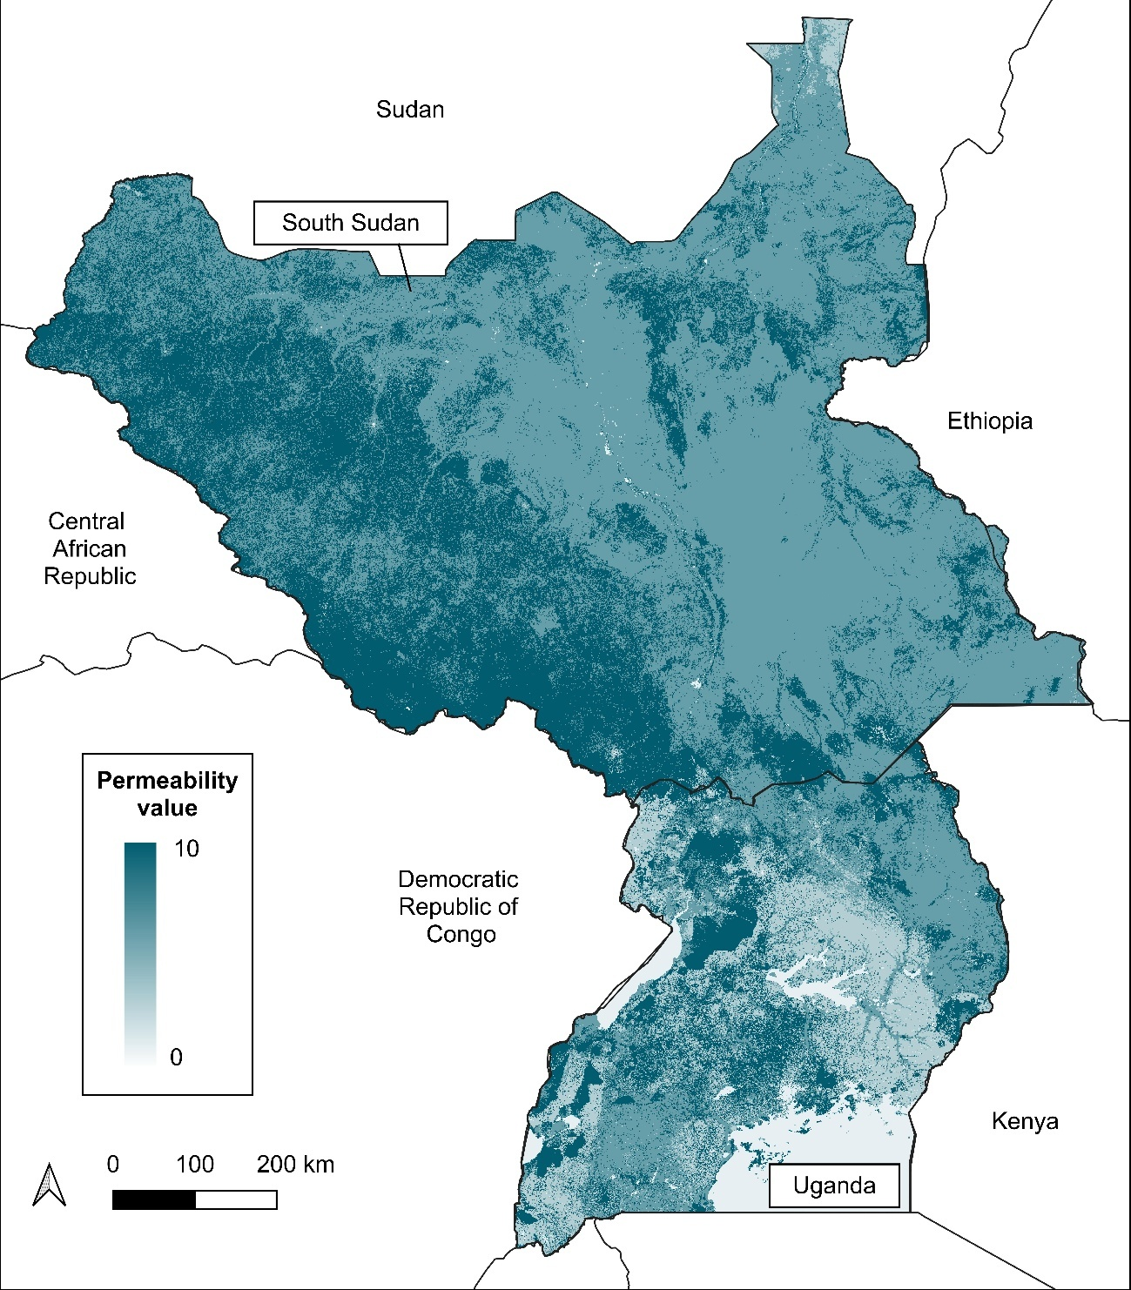
Figure S2.5 – Values of permeability obtained for land cover (LAN) indicator.

- Human population (POP): Population pressure is much higher in Uganda, where there are more densely populated areas, than in South Sudan, where it is low, except in a few major cities (Figure S2.6).

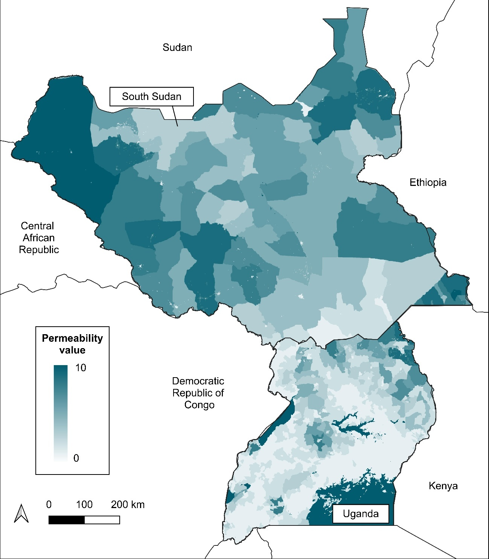
Figure S2.6 - Values of permeability obtained for the human population (POP) indicator.

- Environmental protection (ENV): There are a total of 738 protected areas in the study area, 27 from South Sudan and 711 from Uganda (Figure S2.7). The total area of protected areas is 133,294 km² (16% of the total area), of which 97,714 km² (12%) are in South Sudan and 35,580 km² in Uganda (4%). The remaining 84% of the area has a zero value and represents areas without any level of protection.
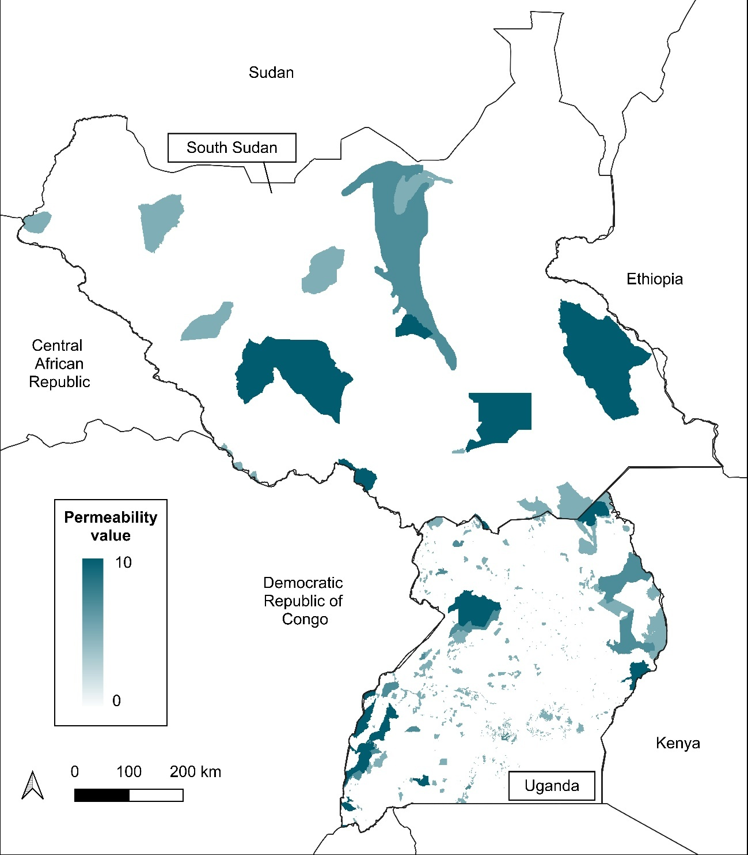
Figure S2.7 - Values of permeability obtained for the environmental protection (ENV) indicator.

- Topography (TOP): The values are mostly 10 (Figure S2.8) and mainly reflect the contribution of low slope values, which are less than 30° for 94.62% of the study area. Most of the lowest values are 5 and represent mountainous areas with altitudes up to 5,000 metres and slopes up to 40°.

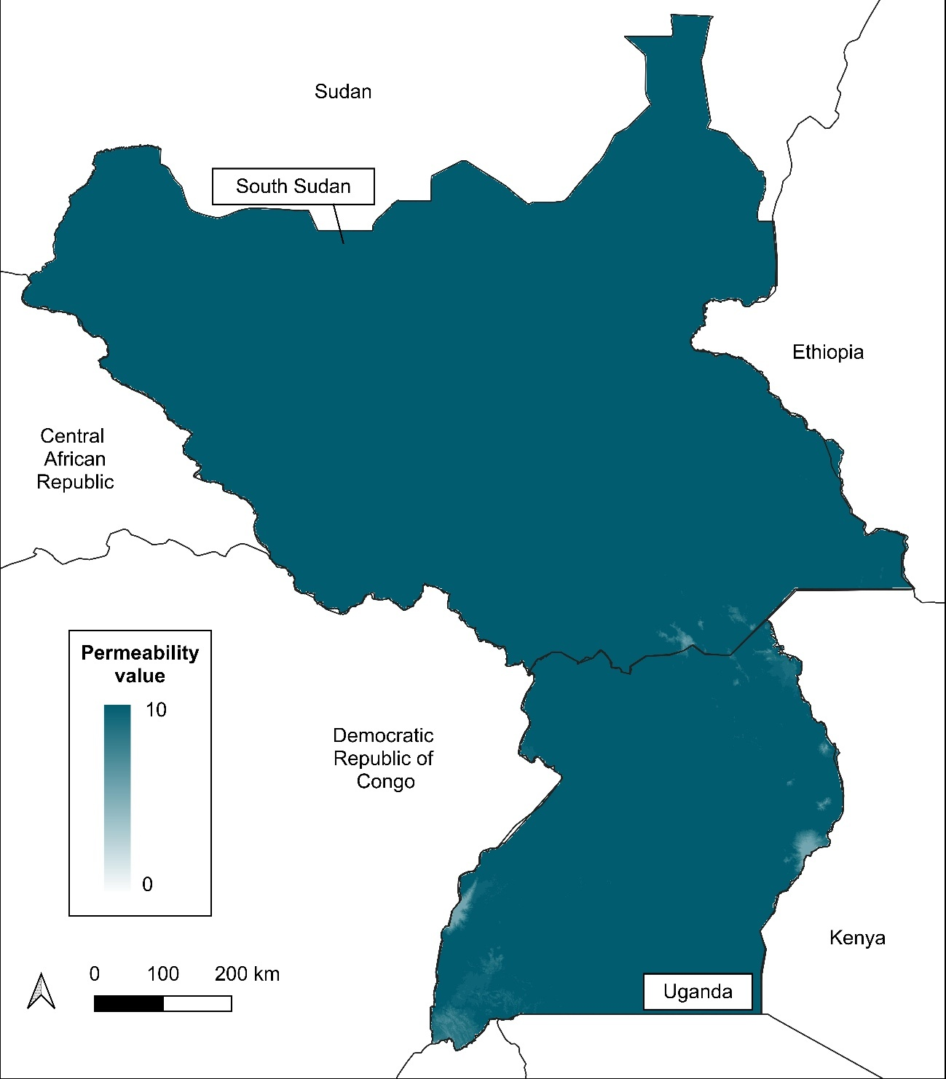
Figure S2.8 - Values of permeability obtained for the Topography (TOP) indicator.

Table S2.1 - Resistance and permeability values of the indicators under the present and future scenarios in South Sudan and Uganda.
 | South Sudan  (mean ± standard deviation) | Uganda  (mean ± standard deviation)
Resistance - present scenario | 29.62 (8.87) | 42.96 (11.34)
Resistance - future scenario | 29.69 (8.95) | 43.07 (11.55)
LI - present scenario | 9.75 (1.11) | 8.39 (2.65)
LI - future scenario | 9.69 (1.39) | 8.32 (3.04)
CONS | 7.8 (1.07) | 8.41 (1.53)
LAN | 7.49 (1.64) | 5.53 (2.79)
POP | 6.25 (2.35) | 3.52 (3.08)
ENV | 1.25 (3.04) | 1.05 (2.65)
TOP | 9.99 (0.09) | 9.91 (0.42)

Core areas in present and future scenarios:
Table S2.2 – Comparison between present and future scenarios of changes in the extent of priority conservation areas. The table reports the absolute and relative changes in area for each priority conservation area under both scenarios. Priority conservation areas that directly intersect planned linear infrastructures are highlighted in bold.
Country | Present |  | Future |  | Area change | Change (%)
Country | ID | Area (km²) | ID | Area (km²) | Area change | Change (%)
South Sudan | core1 | 58 | core1 | 58 | 0 | 0.0
South Sudan | core2 | 16 | core2 | 16 | 0 | 0.0
South Sudan | core3 | 71 | core3 | 71 | 0 | 0.0
South Sudan | core4 | 16 | core4 | 16 | 0 | 0.0
South Sudan | core5 | 291 | core5 | 296 | 5 | 1.7
South Sudan | core6 | 25 | core6 | 25 | 0 | 0.0
South Sudan | core7 | 11 | core7 | 11 | 0 | 0.0
South Sudan | core8 | 14 | core8 | 14 | 0 | 0.0
South Sudan | core9 | 31 | core9 | 31 | 0 | 0.0
South Sudan | core10 | 24 | core10 | 24 | 0 | 0.0
South Sudan | core11 | 19 | core11 | 19 | 0 | 0.0
South Sudan | core12 | 78 | core13a | 44336 | -40 | -0.1
South Sudan | core13 | 45464
South Sudan | core13 | 45464 | core13b | 42 | -40 | -0.1
South Sudan | core13 | 45464 | core13c | 1125 | -40 | -0.1
South Sudan | core14 | 70 | core14 | 70 | 0 | 0.0
South Sudan | core15 | 17 | core15 | 17 | 0 | 0.0
South Sudan | core16 | 12 | core16 | 12 | 0 | 0.0
South Sudan | core17 | 35 | core17 | 36 | 1 | 2.8
South Sudan | core18 | 11 | core18 | 11 | 0 | 0.0
South Sudan | core19 | 13 | core19 | 12 | -1 | -7.7
South Sudan | core20 | 15 | core20 | 15 | 0 | 0.0
South Sudan | core21 | 21 | core21 | 21 | 0 | 0.0
South Sudan | core22 | 12 | core22 | 12 | 0 | 0.0
South Sudan | core23 | 42 | core23 | 41 | -1 | -2.4
South Sudan | core24 | 80 | core24 | 79 | -1 | -1.2
South Sudan | core25 | 11 | core25 | 11 | 0 | 0.0
South Sudan | core26 | 13 | core26 | 13 | 0 | 0.0
South Sudan | core27 | 36 | core27 | 36 | 0 | 0.0
South Sudan | core28 | 24 | core28 | 24 | 0 | 0.0
South Sudan | core29 | 26 | core29 | 26 | 0 | 0.0
South Sudan | core30 | 26 | core30 | 26 | 0 | 0.0
South Sudan | core31 | 13 | core31 | 13 | 0 | 0.0
South Sudan | core32 | 16 | core32 | 16 | 0 | 0.0
South Sudan | core33 | 17 | core33 | 17 | 0 | 0.0
South Sudan | core34 | 218 | core34 | 218 | 0 | 0.0
South Sudan | core35 | 18 | core35 | 18 | 0 | 0.0
South Sudan | core36 | 10 | core36 | 10 | 0 | 0.0
South Sudan | core37 | 20 | core37 | 12 | -8 | -40.0
South Sudan | core38 | 25 | core38 | 25 | 0 | 0.0
South Sudan | core39 | 17 | core39 | 17 | 0 | 0.0
South Sudan | core40 | 17 | core40 | 17 | 0 | 0.0
South Sudan | core41 | 38 | core41 | 38 | 0 | 0.0
South Sudan | core42 | 43 | core42 | 43 | 0 | 0.0
South Sudan | core43 | 589 | core43 | 589 | 0 | 0.0
South Sudan | core44 | 44 | core44 | 44 | 0 | 0.0
South Sudan | core45 | 18 | core45 | 18 | 0 | 0.0
South Sudan | core46 | 16 | core46 | 16 | 0 | 0.0
South Sudan | core47 | 15 | core47 | 15 | 0 | 0.0
South Sudan | core48 | 17 | core48 | 17 | 0 | 0.0
South Sudan | core49 | 11 | core49 | 11 | 0 | 0.0
South Sudan | core50 | 170 | core50 | 169 | -1 | -0.6
South Sudan | core51 | 71 | core51 | 71 | 0 | 0.0
South Sudan | core52 | 12 | core52 | 12 | 0 | 0.0
South Sudan | core53 | 17 | core53 | 17 | 0 | 0.0
South Sudan | core54 | 12 | core54 | 12 | 0 | 0.0
South Sudan | core55 | 41 | core55 | 41 | 0 | 0.0
South Sudan | core56 | 48 | core56 | 49 | 1 | 2.1
South Sudan | core57 | 18 | core57 | 18 | 0 | 0.0
South Sudan | core58 | 26 | core58 | 26 | 0 | 0.0
South Sudan | core59 | 10 | core59 | 10 | 0 | 0.0
South Sudan | core60 | 13 | core60 | 13 | 0 | 0.0
South Sudan | core61 | 22 | core61 | 22 | 0 | 0.0
South Sudan | core62 | 31 | core62 | 31 | 0 | 0.0
South Sudan | core63 | 51 | core63 | 51 | 0 | 0.0
South Sudan | core64 | 33 |  |  | -33 | -100.0
South Sudan | core65 | 16 | core65 | 16 | 0 | 0.0
South Sudan | core66 | 13 | core66 | 13 | 0 | 0.0
South Sudan | core67 | 29 | core67 | 29 | 0 | 0.0
South Sudan | core68 | 20 | core68 | 22 | 2 | 6.9
South Sudan | core69 | 433 | core69 | 433 | 0 | 0.0
South Sudan | core70 | 22 | core70 | 22 | 0 | 0.0
South Sudan | core71 | 100 | core71 | 100 | 0 | 0.0
South Sudan | core72 | 39 | core72 | 39 | 0 | 0.0
South Sudan | core73 | 167 | core73a | 11 | -19 | -11.4
South Sudan | core73 | 167 | core73b | 137 | -19 | -11.4
South Sudan | core74 | 30 | core74 | 30 | 0 | 0.0
South Sudan | core75 | 12 | core75 | 12 | 0 | 0.0
South Sudan | core76 | 13 | core76 | 13 | 0 | 0.0
South Sudan | core77 | 205 | core77 | 205 | 0 | 0.0
South Sudan | core78 | 25 | core78 | 25 | 0 | 0.0
South Sudan | core79 | 11 | core79 | 11 | 0 | 0.0
South Sudan | core80 | 13 | core80 | 13 | 0 | 0.0
South Sudan | core81 | 88 | core81 | 88 | 0 | 0.0
South Sudan | core82 | 11 | core82 | 11 | 0 | 0.0
South Sudan | core83 | 13 | core83 | 13 | 0 | 0.0
South Sudan | core84 | 13 | core84 | 13 | 0 | 0.0
South Sudan | core85 | 189 | core85 | 189 | 0 | 0.0
South Sudan | core86 | 163 | core86 | 160 | -3 | -1.8
South Sudan | core87 | 17 | core87 | 17 | 0 | 0.0
South Sudan | core88 | 15 | core88 | 15 | 0 | 0.0
South Sudan | core89 | 25 | core89 | 30 | 5 | 20.0
South Sudan | core90 | 19 | core90 | 16 | -3 | -15.8
South Sudan | core91 | 26 | core91 | 32 | 6 | 23.1
South Sudan | core92 | 1812 | core92 | 1812 | 0 | 0.0
South Sudan | core93 | 24 | core93 | 23 | -1 | -4.2
South Sudan | core94 | 37 | core94 | 22 | -15 | -40.5
South Sudan | core95 | 22 | core95 | 22 | 0 | 0.0
South Sudan | core96 | 36 | core96 | 37 | 1 | 2.8
South Sudan | core97 | 28 | core97 | 28 | 0 | 0.0
South Sudan | core98 | 14 | core98 | 14 | 0 | 0.0
South Sudan | core99 | 12 | core99 | 12 | 0 | 0.0
South Sudan | core100 | 13 | core100 | 13 | 0 | 0.0
South Sudan | core101 | 25 | core101 | 25 | 0 | 0.0
South Sudan | core102 | 34 | core102 | 34 | 0 | 0.0
South Sudan | core103 | 28 | core103 | 28 | 0 | 0.0
South Sudan | core104 | 18 | core104 | 18 | 0 | 0.0
South Sudan | core105 | 37 | core105 | 38 | 1 | 2.7
South Sudan | core106 | 12 | core106 | 12 | 0 | 0.0
South Sudan | core107 | 17 | core107 | 17 | 0 | 0.0
South Sudan | core108 | 21 | core108 | 21 | 0 | 0.0
South Sudan | core109 | 23 | core109 | 23 | 0 | 0.0
South Sudan | core110 | 140 | core110 | 158 | 18 | 12.8
South Sudan | core111 | 57 | core111 | 69 | 12 | 20.7
South Sudan | core112 | 4230 | core112a | 242 | -53 | -1.3
South Sudan | core112 | 4230 | core112b | 95 | -53 | -1.3
South Sudan | core112 | 4230 | core112c | 32 | -53 | -1.3
South Sudan | core112 | 4230 | core112d | 3807 | -53 | -1.3
South Sudan | core113 | 88 | core113 | 68 | -20 | -22.5
South Sudan | core114 | 15 | core114 | 17 | 2 | 13.3
South Sudan | core115 | 16 | core115 | 27 | 11 | 68.7
South Sudan | core116 | 11 | core116 | 11 | 0 | 0.0
South Sudan | core117 | 12 |  |  |  | -100.0
South Sudan | core118 | 14 | core118 | 14 | 0 | 0.0
South Sudan | core119 | 203 | core119 | 221 | 19 | 9.3
South Sudan | core120 | 12 | core120 | 12 | 0 | 0.0
South Sudan | core121 | 34 | core121 | 18 | -16 | -47.1
South Sudan | core122 | 21 | core122 | 21 | 0 | 0.0
South Sudan | core123 | 16 | core123 | 16 | 0 | 0.0
South Sudan | core124 | 33 | core124 | 33 | 0 | 0.0
South Sudan | core125 | 17734 | core125 | 17731 | -3 | 0.0
South Sudan | core126 | 65 | core126 | 65 | 0 | 0.0
South Sudan | core127 | 10 | core127 | 10 | 0 | 0.0
South Sudan | core128 | 654 | core128a | 217 | -3 | -0.5
South Sudan | core128 | 654 | core128b | 434 | -3 | -0.5
South Sudan | core129 | 18 | core129 | 18 | 0 | 0.0
South Sudan | core130 | 13 | core130 | 13 | 0 | 0.0
South Sudan | core131 | 64 | core131 | 64 | 0 | 0.0
South Sudan | core132 | 20 | core132 | 20 | 0 | 0.0
South Sudan | core133 | 24878 | core133a | 24873 | 15 | 0.1
South Sudan | core133 | 24878 | core133b | 20 | 15 | 0.1
South Sudan | core134 | 38 | core134 | 38 | 0 | 0.0
South Sudan | core135 | 529 | core135 | 552 | 23 | 4.3
South Sudan | core136 | 22 | core136 | 22 | 0 | 0.0
South Sudan | core137 | 16 | core137 | 16 | 0 | 0.0
South Sudan | core138 | 33 | core138 | 33 | 0 | 0.0
South Sudan | core139 | 24 | core139 | 24 | 0 | 0.0
South Sudan | core140 | 19 | core140 | 16 | -3 | -15.8
South Sudan | core141 | 19 | core141 | 19 | 0 | 0.0
South Sudan | core142 | 16 | core142 | 16 | 0 | 0.0
South Sudan | core143 | 20 | core143 | 20 | 0 | 0.0
South Sudan | core144 | 18 | core144 | 18 | 0 | 0.0
South Sudan | core145 | 31 | core145 | 31 | 0 | 0.0
South Sudan | core146 | 20 | core146 | 20 | 0 | 0.0
South Sudan | core147 | 30 | core147 | 30 | 0 | 0.0
South Sudan | core148 | 17 | core148 | 17 | 0 | 0.0
South Sudan | core149 | 18 | core149 | 18 | 0 | 0.0
South Sudan | core150 | 19 | core150 | 19 | 0 | 0.0
South Sudan | core151 | 12 | core151 | 12 | 0 | 0.0
South Sudan | core152 | 13 | core152 | 13 | 0 | 0.0
South Sudan | core153 | 20 | core153 | 19 | -1 | -5.0
South Sudan | core154 | 11 | core154 | 11 | 0 | 0.0
South Sudan | core155 | 17 | core155 | 17 | 0 | 0.0
South Sudan | core156 | 25 | core156 | 25 | 0 | 0.0
South Sudan | core157 | 34 | core157 | 34 | 0 | 0.0
South Sudan | core158 | 42 | core158 | 42 | 0 | 0.0
South Sudan | core159 | 79 | core159 | 79 | 0 | 0.0
South Sudan | core160 | 59 | core160 | 46 | -13 | -22.0
South Sudan | core161 | 59 | core161 | 64 | 5 | 8.5
South Sudan | core162 | 11 | core162 | 11 | 0 | 0.0
South Sudan | core163 | 82 | core163 | 82 | 0 | 0.0
South Sudan | core164 | 18 | core164 | 18 | 0 | 0.0
South Sudan | core165 | 36 | core165 | 36 | 0 | 0.0
South Sudan | core166 | 16 | core166 | 16 | 0 | 0.0
South Sudan | core167 | 17 | core167 | 17 | 0 | 0.0
South Sudan | core168 | 12 | core168 | 12 | 0 | 0.0
South Sudan | core169 | 14 | core169 | 14 | 0 | 0.0
South Sudan | core170 | 20 | core170 | 20 | 0 | 0.0
South Sudan | core171 | 16 | core171 | 16 | 0 | 0.0
South Sudan | core172 | 13 | core172 | 15 | 2 | 15.4
South Sudan | core173 | 20 | core173 | 24 | 4 | 20.0
South Sudan | core174 | 16 | core174 | 16 | 0 | 0.0
South Sudan | core175 | 20 | core175 | 20 | 0 | 0.0
South Sudan | core176 | 12 | core176 | 12 | 0 | 0.0
South Sudan | core177 | 114 | core177 | 112 | -2 | -1.8
South Sudan | core178 | 36 | core178 | 36 | 0 | 0.0
South Sudan | core179 | 13 | core179 | 13 | 0 | 0.0
South Sudan | core180 | 76 | core180 | 76 | 0 | 0.0
South Sudan | core181 | 23 | core181 | 23 | 0 | 0.0
South Sudan | core182 | 24 | core182 | 26 | 2 | 8.3
South Sudan | core183 | 22 | core183 | 22 | 0 | 0.0
South Sudan | core184 | 57 | core184 | 57 | 0 | 0.0
South Sudan | core185 | 83 | core185 | 83 | 0 | 0.0
South Sudan | core186 | 13 | core186 | 13 | 0 | 0.0
South Sudan | core187 | 206 | core187 | 206 | 0 | 0.0
South Sudan | core188 | 49 | core188 | 56 | 7 | 14.3
South Sudan | core189 | 33 | core189 | 33 | 0 | 0.0
South Sudan | core190 | 19 | core190 | 23 | 4 | 21.1
South Sudan | core191 | 18 | core191 | 18 | 0 | 0.0
South Sudan | core192 | 13 | core192 | 13 | 0 | 0.0
South Sudan | core193 | 29 | core193 | 31 | 2 | 6.9
South Sudan | core194 | 14 | core194 | 14 | 0 | 0.0
South Sudan | core195 | 27 | core195 | 27 | 0 | 0.0
South Sudan | core196 | 131 | core196 | 140 | 9 | 6.9
South Sudan | core197 | 13 | core197 | 18 | 5 | 38.5
South Sudan | core198 | 12 | core198 | 12 | 0 | 0.0
South Sudan | core199 | 14 | core199 | 14 | 0 | 0.0
South Sudan | core200 | 25 | core200 | 25 | 0 | 0.0
South Sudan | core201 | 13 | core201 | 13 | 0 | 0.0
South Sudan | core202 | 14 | core202 | 14 | 0 | 0.0
South Sudan | core203 | 30 | core203 | 38 | 8 | 26.7
South Sudan | core204 | 13 | core204 | 13 | 0 | 0.0
South Sudan | core205 | 19 | core205 | 19 | 0 | 0.0
South Sudan | core206 | 128 | core206 | 129 | 1 | 0.8
South Sudan | core207 | 19 | core207 | 19 | 0 | 0.0
South Sudan | core208 | 18 | core208 | 18 | 0 | 0.0
South Sudan | core209 | 45 | core209a | 22 | -11 | -24.4
South Sudan | core209 | 45 | core209b | 12 | -11 | -24.4
South Sudan | core210 | 29 | core210 | 38 | 9 | 31.0
South Sudan | core211 | 67 | core211 | 69 | 2 | 3.0
South Sudan | core212 | 89 | core212 | 80 | -9 | -10.1
South Sudan | core213 | 498 | core213 | 518 | 20 | 4.0
South Sudan | core214 | 30 | core214 | 30 | 0 | 0.0
South Sudan | core215 | 175 | core215 | 175 | 0 | 0.0
South Sudan | core216 | 12 | core216 | 12 | 0 | 0.0
South Sudan | core217 | 15 | core217 | 14 | -1 | -6.7
South Sudan | core218 | 104 | core218 | 104 | 0 | 0.0
South Sudan | core219 | 1768 | core219 | 1725 | -43 | -2.4
South Sudan | core220 | 123 | core220 | 126 | 3 | 2.4
South Sudan | core221 | 249 | core221a | 29 | -11 | -4.4
South Sudan | core221 | 249 | core221b | 209 | -11 | -4.4
South Sudan | core222 | 1306 | core222a | 1189 | -58 | -4.4
South Sudan | core222 | 1306 | core222b | 59 | -58 | -4.4
South Sudan | core223 | 34 | core223 | 29 | -5 | -14.7
South Sudan | core224 | 173 | core224 | 173 | 0 | 0.0
South Sudan | core225 | 119 | core225 | 119 | 0 | 0.0
South Sudan | core226 | 2069 | core226 | 2053 | -16 | -0.8
South Sudan |  |  | core266 | 11 | 11 | 100.0
South Sudan |  |  | core267 | 12 | 12 | 100.0
South Sudan |  |  | core268 | 11 | 11 | 100.0
Uganda | core227 | 16 | core227 | 16 | 0 | 0.0
Uganda | core228 | 17 | core228 | 17 | 0 | 0.0
Uganda | core229 | 153 | core229 | 153 | 0 | 0.0
Uganda | core230 | 251 | core230 | 252 | 1 | 0.4
Uganda | core231 | 12 | core231 | 12 | 0 | 0.0
Uganda | core232 | 34 | core232a | 74 | 10 | 15.6
Uganda | core233 | 30
Uganda | core234 | 27 | core234 | 27 | 0 | 0.0
Uganda | core235 | 66 | core235 | 66 | 0 | 0.0
Uganda | core236 | 14 | core236 | 14 | 0 | 0.0
Uganda | core237 | 14 | core237 | 14 | 0 | 0.0
Uganda | core238 | 23 | core238 | 23 | 0 | 0.0
Uganda | core239 | 13 |  |  |  | -100.0
Uganda | core240 | 25 | core240 | 21 | -4 | -16.0
Uganda | core241 | 12 | core241 | 12 | 0 | 0.0
Uganda | core242 | 1682 | core242a | 2353 | 5 | 0.2
Uganda | core243 | 294
Uganda | core244 | 372
Uganda | core245 | 68 | core245 | 73 | 5 | 7.4
Uganda | core246 | 22 | core246 | 24 | 2 | 9.1
Uganda | core247 | 37 | core247 | 35 | -2 | -5.4
Uganda | core248 | 10 | core248 | 11 | 1 | 10.0
Uganda | core249 | 101 | core249a | 43 | -3 | -3.0
Uganda | core249 | 101 | core249b | 55 | -3 | -3.0
Uganda | core250 | 20 | core250 | 20 | 0 | 0.0
Uganda | core251 | 390 | core251 | 386 | -5 | -1.3
Uganda | core252 | 64 | core252 | 77 | 13 | 20.3
Uganda | core253 | 278 | core253 | 281 | 3 | 1.1
Uganda | core254 | 69 | core254 | 81 | 12 | 17.4
Uganda | core255 | 136 | core255 | 108 | -28 | -20.6
Uganda | core256 | 110 | core256 | 120 | 10 | 9.1
Uganda | core257 | 32 | core257 | 29 | -3 | -9.4
Uganda | core258 | 80 | core258 | 78 | -2 | -2.5
Uganda | core259 | 18 | core259 | 16 | -2 | -11.1
Uganda | core260 | 502 | core260a | 562 | 4 | 0.7
Uganda | core261 | 56
Uganda | core262 | 32 | core262 | 37 | 5 | 15.6
Uganda | core263 | 337 | core263 | 336 | -1 | -0.3
Uganda | core264 | 21 | core264 | 21 | 0 | 0.0
Uganda | core265 | 113 | core265 | 112 | -1 | -0.9
Total |  | 115958 |  | 115798 | -160 | -0.1

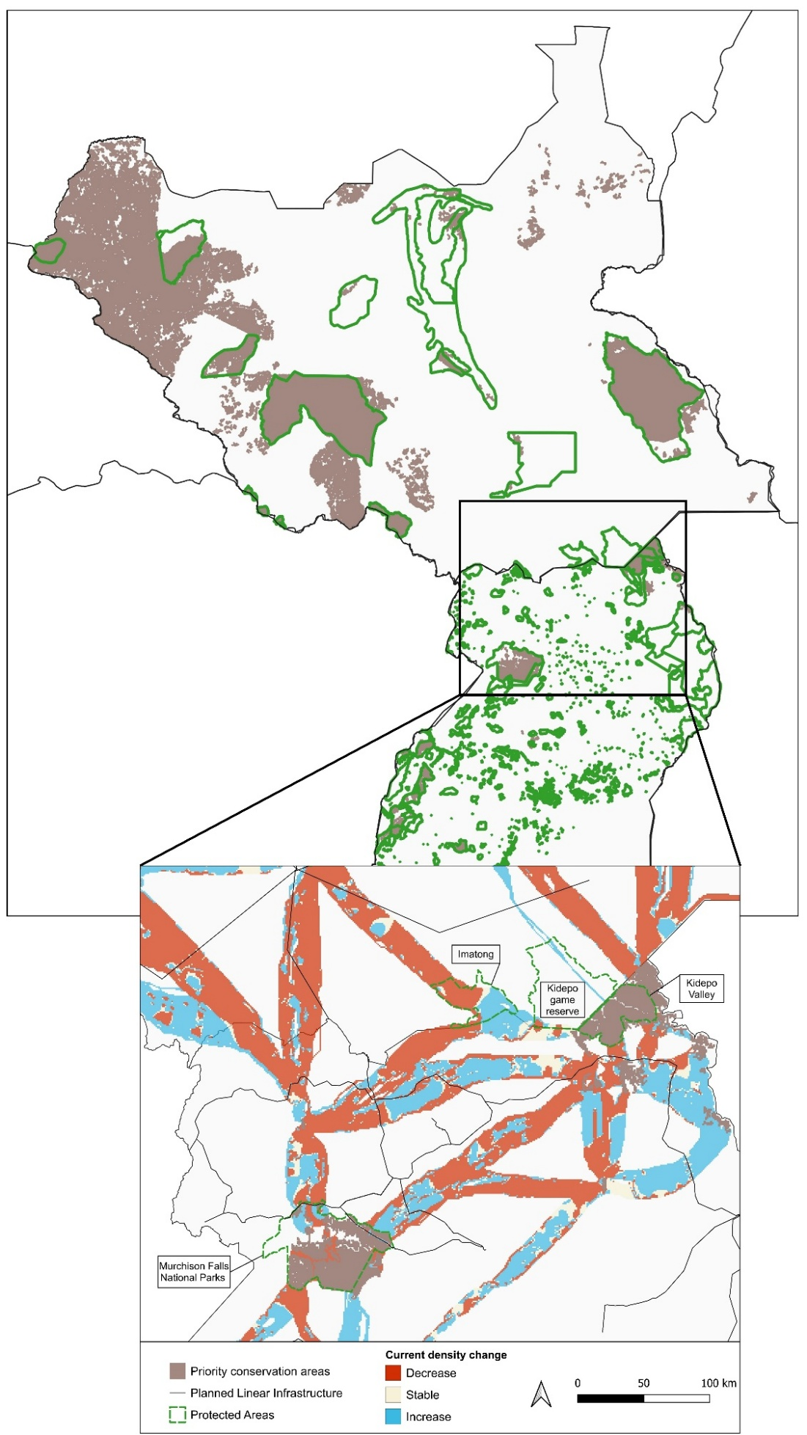
Figure S2.9 – Distribution of priority conservation areas in the present scenario and location of protected areas in South Sudan and Uganda. The inset shows a zoomed-in view of the transboundary region between the two countries, indicating the locations of Imatong Forest Reserve and Kidepo Game Reserve in South Sudan, and Kidepo Valley and Murchison Falls National Parks in Uganda. Current density changes of corridors in the transboundary region are shown in the inset.
Macro-regional ecological network in the present and future scenarios:
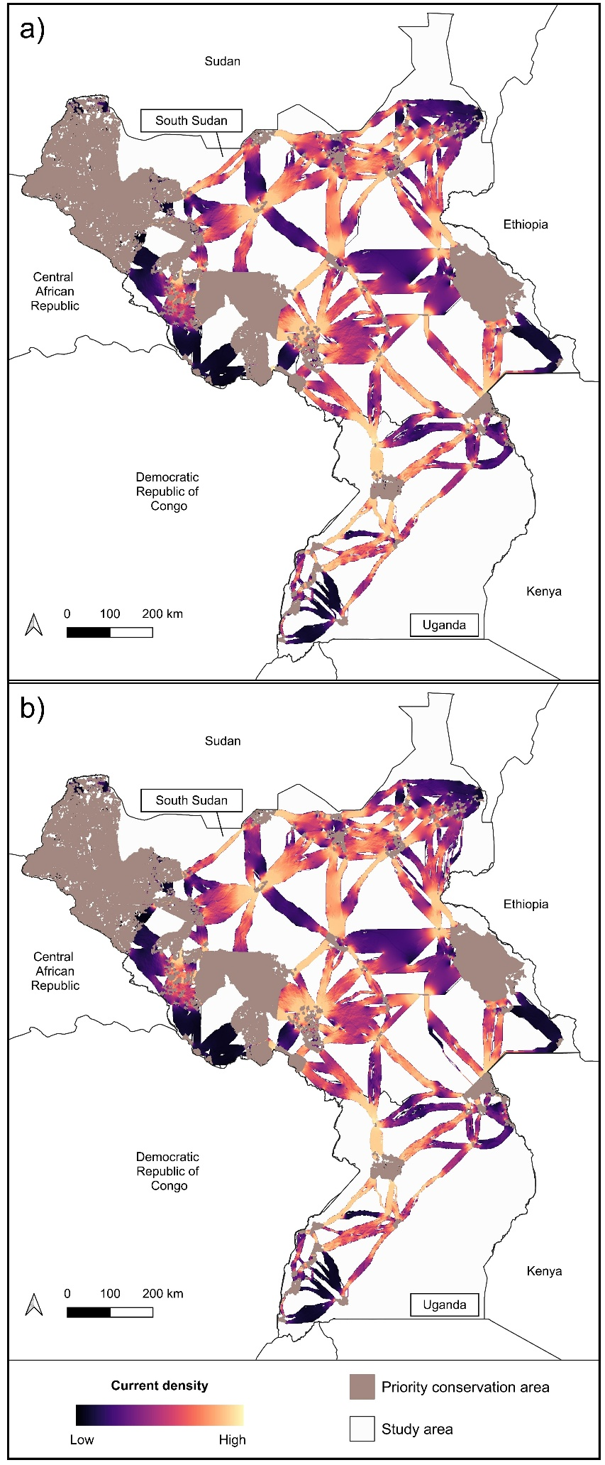
Figure S2.10 – Macro-regional ecological networks in the present (a) and future (b) scenarios.
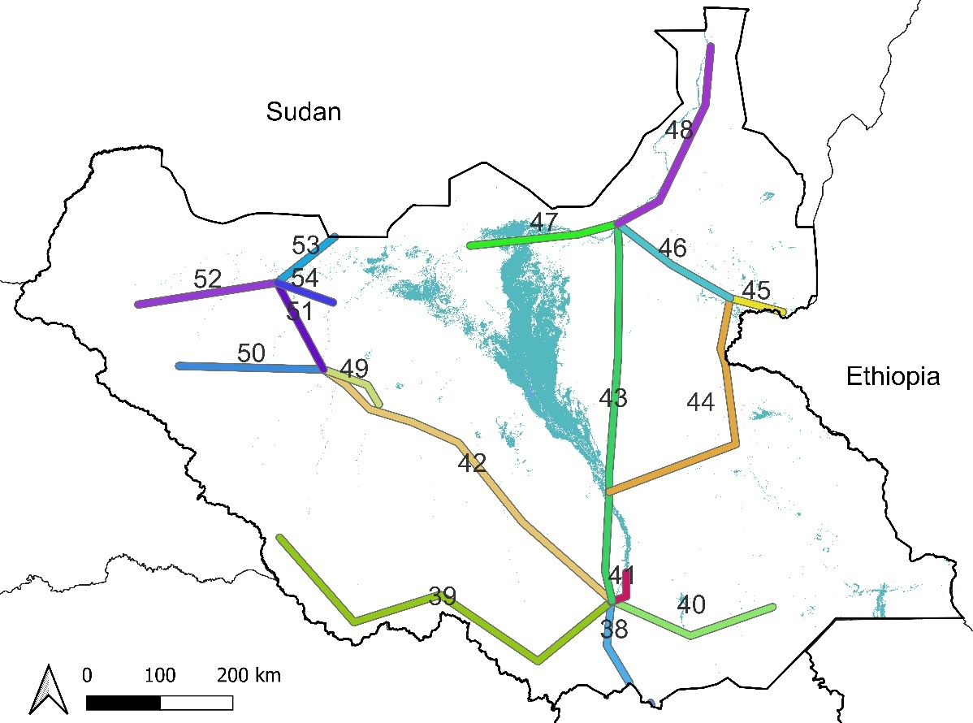
Figure S2.11 – Planned linear infrastructure in South Sudan.

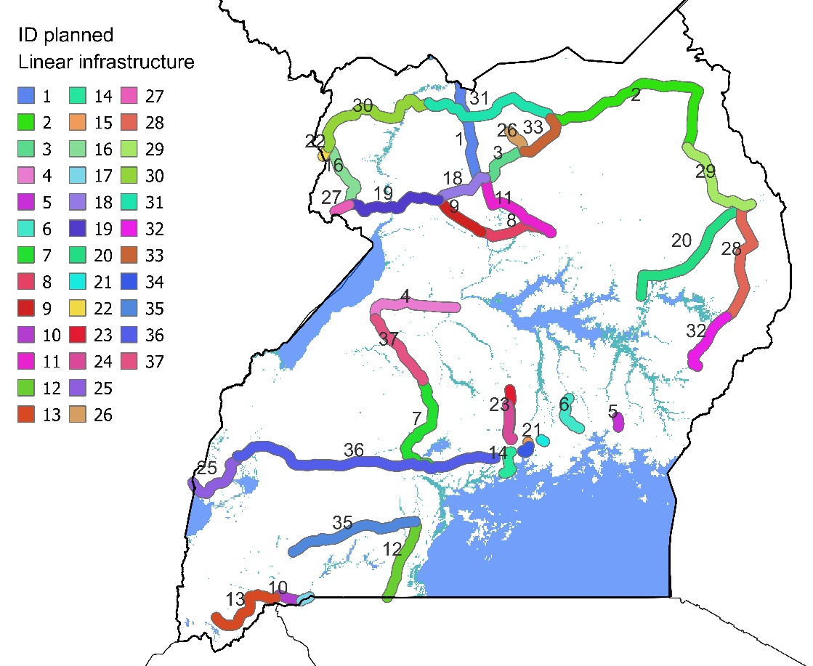
Figure S2.12 – Planned linear infrastructure in Uganda.

Table S2.3 – Details of the 54 planned linear infrastructures analysed in this study and comparison of ecological network characteristics in the present and future scenarios within the 5 km radius buffer around them. The number and length of LCPs refer to the Least-Cost Paths identified by the Linkage mapper pathway tool that intersect the 5 km buffer of each planned linear infrastructure; the current density refers to the Circuitscape outputs and the pinch points area refers to all areas with current densities above the 95th quantile of the present scenario.
ID | Country | Voltage (kV) | Linear infrastructure length (km) | Number of LCPs |  | Length of LCP (km) |  |  | Current density |  |  | Pinch points area (km²)
 |  |  |  | Present | Future | Present | Future | Change (%) | Present | Future | Change (%) | Present | Future | Change (%)
1 | Uganda | 400 | 149 | 2 | 2 | 23.04 | 23.04 | 0.00 | 26611.70 | 25007.67 | -6.03 | 0.00 | 0.00 | -
2 | Uganda | 132 | 216 | 8 | 8 | 90.45 | 88.47 | -2.19 | 122193.21 | 112923.78 | -7.59 | 86.83 | 53.30 | -38.61
3 | Uganda | 132 | 53 | 0 | 0 | 0.00 | 0.00 | - | 603.80 | 228.18 | -62.21 | 0.00 | 0.00 | -
4 | Uganda | 220 | 92 | 4 | 3 | 43.59 | 31.67 | -27.36 | 79868.91 | 74231.36 | -7.06 | 177.36 | 171.59 | -3.25
5 | Uganda | 132 | 10 | 0 | 0 | 0.00 | 0.00 | - | 0.00 | 0.00 | - | 0.00 | 0.00 | -
6 | Uganda | 132 | 40 | 0 | 0 | 0.00 | 0.00 | - | 0.00 | 0.00 | - | 0.00 | 0.00 | -
7 | Uganda | 132 | 122 | 3 | 3 | 30.40 | 31.69 | 4.26 | 50098.66 | 48320.36 | -3.55 | 0.00 | 0.00 | -
8 | Uganda | 132 | 76 | 0 | 0 | 0.00 | 0.00 | - | 574.14 | 601.66 | 4.79 | 0.00 | 0.00 | -
9 | Uganda | 400 | 54 | 2 | 1 | 2.04 | 2.00 | -2.10 | 8623.48 | 7400.06 | -14.19 | 0.00 | 0.00 | -
10 | Uganda | 132 | 27 | 0 | 0 | 0.00 | 0.00 | - | 549.17 | 645.75 | 17.59 | 0.00 | 0.00 | -
11 | Uganda | 132 | 96 | 3 | 2 | 32.86 | 27.03 | -17.73 | 54044.86 | 48211.92 | -10.79 | 0.00 | 0.00 | -
12 | Uganda | 220 | 82 | 0 | 0 | 0.00 | 0.00 | - | 0.00 | 0.00 | - | 0.00 | 0.00 | -
13 | Uganda | 132 | 85 | 1 | 1 | 22.29 | 20.65 | -7.37 | 6803.99 | 6778.91 | -0.37 | 0.00 | 0.00 | -
14 | Uganda | 132 | 31 | 0 | 0 | 0.00 | 0.00 | - | 0.00 | 0.00 | - | 0.00 | 0.00 | -
15 | Uganda | 132 | 5 | 0 | 0 | 0.00 | 0.00 | - | 0.00 | 0.00 | - | 0.00 | 0.00 | -
16 | Uganda | 132 | 69 | 0 | 0 | 0.00 | 0.00 | - | 0.00 | 0.00 | - | 0.00 | 0.00 | -
17 | Uganda | 132 | 9 | 0 | 0 | 0.00 | 0.00 | - | 0.00 | 0.00 | - | 0.00 | 0.00 | -
18 | Uganda | 132 | 55 | 0 | 0 | 0.00 | 0.00 | - | 0.00 | 0.00 | - | 0.00 | 0.00 | -
19 | Uganda | 132 | 101 | 7 | 4 | 34.90 | 19.74 | -43.42 | 88083.78 | 93887.54 | 6.59 | 207.39 | 233.57 | 12.62
20 | Uganda | 132 | 158 | 0 | 0 | 0.00 | 0.00 | - | 0.00 | 0.00 | - | 0.00 | 0.00 | -
21 | Uganda | 220 | 4 | 0 | 0 | 0.00 | 0.00 | - | 0.00 | 0.00 | - | 0.00 | 0.00 | -
22 | Uganda | 132 | 10 | 0 | 0 | 0.00 | 0.00 | - | 0.00 | 0.00 | - | 0.00 | 0.00 | -
23 | Uganda | 132 | 53 | 0 | 0 | 0.00 | 0.00 | - | 0.00 | 0.00 | - | 0.00 | 0.00 | -
24 | Uganda | 220 | 38 | 0 | 0 | 0.00 | 0.00 | - | 0.00 | 0.00 | - | 0.00 | 0.00 | -
25 | Uganda | 220 | 72 | 3 | 3 | 36.46 | 36.87 | 1.14 | 26374.29 | 23789.07 | -9.80 | 9.00 | 3.00 | -66.67
26 | Uganda | 132 | 28 | 0 | 0 | 0.00 | 0.00 | - | 0.00 | 0.00 | - | 0.00 | 0.00 | -
27 | Uganda | 132 | 15 | 0 | 0 | 0.00 | 0.00 | - | 0.00 | 0.00 | - | 0.00 | 0.00 | -
28 | Uganda | 132 | 133 | 0 | 0 | 0.00 | 0.00 | - | 0.00 | 0.00 | - | 0.00 | 0.00 | -
29 | Uganda | 132 | 99 | 2 | 2 | 22.07 | 22.07 | 0.00 | 13204.24 | 13414.69 | 1.59 | 0.00 | 0.00 | -
30 | Uganda | 132 | 145 | 3 | 3 | 39.08 | 46.53 | 19.05 | 118034.64 | 112173.58 | -4.97 | 258.61 | 251.48 | -2.76
31 | Uganda | 132 | 142 | 2 | 2 | 23.12 | 23.12 | 0.00 | 56396.60 | 53298.23 | -5.49 | 0.00 | 0.00 | -
32 | Uganda | 132 | 67 | 0 | 0 | 0.00 | 0.00 | - | 0.00 | 0.00 | - | 0.00 | 0.00 | -
33 | Uganda | 132 | 52 | 0 | 0 | 0.00 | 0.00 | - | 2687.56 | 1684.18 | -37.33 | 0.00 | 0.00 | -
34 | Uganda | 132 | 14 | 0 | 0 | 0.00 | 0.00 | - | 0.00 | 0.00 | - | 0.00 | 0.00 | -
35 | Uganda | 220 | 131 | 6 | 6 | 66.04 | 64.04 | -3.04 | 27210.76 | 25134.97 | -7.63 | 1.00 | 1.00 | 0.00
36 | Uganda | 220 | 271 | 5 | 5 | 42.06 | 41.96 | -0.22 | 38594.53 | 40788.52 | 5.68 | 20.00 | 22.00 | 10.00
37 | Uganda | 132 | 81 | 3 | 3 | 44.01 | 38.06 | -13.52 | 45037.35 | 40227.19 | -10.68 | 1.00 | 0.00 | -100.00
38 | South Sudan | 220 | 120 | 1 | 1 | 19.35 | 14.99 | -22.51 | 80587.68 | 71548.65 | -11.22 | 0.00 | 0.00 | -
39 | South Sudan | 220 | 573 | 16 | 21 | 156.32 | 200.68 | 28.37 | 182299.06 | 204389.68 | 12.12 | 0.30 | 8.00 | 2540.26
40 | South Sudan | 220 | 238 | 4 | 4 | 89.81 | 79.74 | -11.21 | 138717.74 | 129062.84 | -6.96 | 36.18 | 10.90 | -69.88
41 | South Sudan | 220 | 55 | 5 | 5 | 45.12 | 49.63 | 10.01 | 85642.29 | 81699.01 | -4.60 | 77.27 | 48.45 | -37.30
42 | South Sudan | 220 | 519 | 17 | 17 | 262.63 | 310.06 | 18.06 | 366549.31 | 392165.75 | 6.99 | 134.82 | 139.07 | 3.15
43 | South Sudan | 220 | 521 | 25 | 24 | 273.97 | 267.89 | -2.22 | 407369.71 | 403287.91 | -1.00 | 126.88 | 103.32 | -18.57
44 | South Sudan | 220 | 391 | 11 | 11 | 410.79 | 400.43 | -2.52 | 385270.94 | 372554.02 | -3.30 | 227.24 | 263.10 | 15.78
45 | South Sudan | 220 | 75 | 0 | 0 | 0.00 | 0.00 | - | 3754.98 | 13136.49 | 249.84 | 0.00 | 2.00 | 100.00
46 | South Sudan | 220 | 186 | 10 | 14 | 92.45 | 125.42 | 35.66 | 174037.43 | 175778.33 | 1.00 | 180.21 | 181.75 | 0.86
47 | South Sudan | 220 | 206 | 21 | 16 | 243.19 | 210.59 | -13.40 | 168734.27 | 161363.54 | -4.37 | 68.20 | 16.74 | -75.46
48 | South Sudan | 220 | 293 | 14 | 15 | 109.97 | 121.33 | 10.33 | 83484.65 | 93065.35 | 11.48 | 15.48 | 10.60 | -31.52
49 | South Sudan | 220 | 95 | 3 | 4 | 51.34 | 66.25 | 29.03 | 68023.10 | 77806.91 | 14.38 | 0.00 | 0.00 | -
50 | South Sudan | 220 | 198 | 6 | 16 | 39.28 | 80.99 | 106.22 | 41732.66 | 82407.60 | 97.47 | 51.66 | 75.53 | 46.21
51 | South Sudan | 220 | 135 | 5 | 4 | 47.39 | 43.83 | -7.51 | 71039.74 | 72602.66 | 2.20 | 6.00 | 0.00 | -100.00
52 | South Sudan | 220 | 192 | 7 | 5 | 15.98 | 7.55 | -52.77 | 5950.40 | 5121.97 | -13.92 | 0.00 | 0.00 | -
53 | South Sudan | 220 | 101 | 0 | 0 | 0.00 | 0.00 | - | 0.00 | 0.00 | - | 0.00 | 0.00 | -
54 | South Sudan | 220 | 82 | 3 | 2 | 40.79 | 27.20 | -33.33 | 50134.66 | 28137.32 | -43.88 | 0.00 | 0.00 | -

Table S2.4 – Comparison of corridor centrality and impact across planned linear infrastructures (ID) in present and future scenarios.
ID planned linear infrastructure | Present |  |  | Future |  |  | Type of impact
ID planned linear infrastructure | From | To | Centrality class | From | To | Centrality class | Type of impact
1 | core226 | core236 | Medium | core226 | core236 | Medium
1 | core232 | core236 | Medium | core232a | core236 | Medium
2 | core226 | core230 | High | core226 | core230 | High
2 | core226 | core232 | High | core226 | core232a | High
2 | core228 | core230 | Low | core228 | core230 | Low
2 | core229 | core230 | Low | core229 | core230 | Low
2 | core230 | core231 | Low | core230 | core231 | Low
2 | core230 | core234 | Low | core230 | core234 | Low
2 | core230 | core237 | Low | core230 | core237 | Low
2 | core232 | core236 | Medium | core232a | core236 | Medium
4 | core242 | core248 | Medium | core242a | core248 | High
4 | core242 | core249 | Medium | core242a | core249a | High
4 | core242 | core250 | Medium | core242a | core250 | High
4 | core244 | core248 | Medium |  |  |  | LCP lost
7 | core249 | core251 | Low | core251 | core249b | Low
7 | core249 | core253 | Medium | core249b | core253 | Low | Lower centrality
7 | core249 | core263 | Low | core249b | core263 | Low
9 | core238 | core242 | Medium |  |  |  | LCP lost
9 | core242 | core245 | High | core242a | core245 | High
11 | core232 | core245 | High | core232a | core245 | High
11 | core238 | core242 | Medium |  |  |  | LCP lost
11 | core238 | core245 | Medium | core238 | core245 | High | Higher centrality
13 | core263 | core265 | Low | core263 | core265 | Low
19 | core236 | core239 | High |  |  |  | LCP lost
19 | core236 | core240 | High | core236 | core240 | High
19 | core239 | core240 | Low |  |  |  | LCP lost
19 | core239 | core241 | Medium |  |  |  | LCP lost
19 | core239 | core242 | High |  |  |  | LCP lost
19 |  |  |  | core236 | core242a | High | New LCP
19 | core240 | core241 | High | core240 | core241 | High
19 |  |  |  | core240 | core242a | Medium | New LCP
19 | core240 | core243 | Medium |  |  |  | LCP lost
25 | core252 | core257 | Low | core252 | core257 | Low
25 | core252 | core258 | Low | core252 | core258 | Low
25 | core257 | core258 | Medium | core257 | core258 | Medium
29 | core235 | core238 | Low | core235 | core238 | Low
29 | core237 | core238 | Low | core237 | core238 | Low
30 | core217 | core236 | High | core217 | core236 | High
30 | core222 | core236 | High | core222a | core236 | High
30 | core223 | core236 | High | core223 | core236 | High
31 | core226 | core236 | Medium | core226 | core236 | Medium
31 | core232 | core236 | Medium | core232a | core236 | Medium
35 | core249 | core263 | Low | core249b | core263 | Low
35 | core253 | core263 | Low | core253 | core263 | Low
35 | core255 | core263 | Low | core255 | core263 | Low
35 | core256 | core263 | Low | core256 | core263 | Low
35 | core259 | core263 | Low | core259 | core263 | Low
35 | core260 | core263 | Low | core260a | core263 | Low
36 | core249 | core263 | Low | core249b | core263 | Low
36 | core252 | core257 | Low | core252 | core257 | Low
36 | core253 | core263 | Low | core253 | core263 | Low
36 | core254 | core255 | High | core254 | core255 | High
36 | core254 | core256 | Low | core254 | core256 | Low
37 | core248 | core251 | Low | core248 | core251 | Low
37 | core248 | core253 | Medium | core248 | core253 | Medium
37 | core249 | core251 | Low | core251 | core249b | Low
38 | core217 | core236 | High | core217 | core236 | High
39 | core133 | core219 | High | core133a | core219 | High
39 | core133 | core221 | High | core133a | core221a | High
39 |  |  |  | core133a | core222a | High | New LCP
39 | core133 | core224 | Low | core133a | core224 | Low
39 | core133 | core225 | Low | core133a | core225 | Low
39 | core182 | core183 | Low | core182 | core183 | Low
39 | core182 | core192 | Low | core182 | core192 | Low
39 | core182 | core215 | Low | core182 | core215 | Low
39 | core192 | core215 | Low | core192 | core215 | Low
39 | core194 | core215 | Low | core194 | core215 | Low
39 | core194 | core224 | Low | core194 | core224 | Low
39 | core204 | core222 | Low | core204 | core222a | Medium | Higher centrality
39 | core207 | core222 | Medium | core207 | core222a | Medium
39 | core210 | core222 | Medium | core210 | core222a | Medium
39 | core213 | core222 | High | core213 | core222b | High
39 |  |  |  | core219 | core221a | Medium | New LCP
39 |  |  |  | core221a | core221b | High | New LCP
39 |  |  |  | core221a | core225 | Low | New LCP
39 | core222 | core236 | High |  |  |  | LCP lost
39 | core223 | core236 | High | core223 | core236 | High
39 |  |  |  | core222a | core222b | High | New LCP
39 |  |  |  | core221b | core225 | Low | New LCP
40 | core178 | core226 | Medium | core178 | core226 | Medium
40 | core214 | core226 | High | core214 | core226 | Medium | Lower centrality
40 | core217 | core226 | High | core217 | core226 | Medium | Lower centrality
40 | core217 | core236 | High | core217 | core236 | High
41 | core178 | core214 | Medium | core178 | core214 | Medium
41 | core185 | core214 | High | core185 | core214 | High
41 | core214 | core226 | High | core214 | core226 | Medium | Lower centrality
41 | core217 | core226 | High | core217 | core226 | Medium | Lower centrality
41 | core217 | core236 | High | core217 | core236 | High
42 | core103 | core133 | High |  |  |  | LCP lost
42 | core105 | core133 | High | core105 | core133a | High
42 | core107 | core110 | High | core107 | core110 | High
42 |  |  |  | core107 | core114 | High | New LCP
42 | core107 | core117 | High |  |  |  | LCP lost
42 |  |  |  | core107 | core119 | High | New LCP
42 | core107 | core121 | High | core107 | core121 | High
42 | core107 | core133 | High | core107 | core133a | High
42 | core128 | core150 | High | core128a | core150 | High
42 | core128 | core190 | High | core128b | core190 | High
42 |  |  |  | core128b | core150 | High | New LCP
42 | core151 | core190 | High | core151 | core190 | High
42 |  |  |  | core151 | core267 | High | New LCP
42 | core151 | core193 | High |  |  |  | LCP lost
42 | core177 | core193 | Medium |  |  |  | LCP lost
42 |  |  |  | core177 | core267 | Medium | New LCP
42 | core185 | core193 | Medium |  |  |  | LCP lost
42 |  |  |  | core185 | core267 | Medium | New LCP
42 | core193 | core214 | Medium |  |  |  | LCP lost
42 | core209 | core214 | Medium |  |  |  | LCP lost
42 | core209 | core217 | Medium | core209a | core217 | Medium
42 | core214 | core220 | Medium |  |  |  | LCP lost
42 |  |  |  | core267 | core214 | Medium | New LCP
42 |  |  |  | core267 | core217 | Medium | New LCP
42 | core217 | core220 | Medium | core217 | core220 | High | Higher centrality
43 | core46 | core50 | Medium | core46 | core50 | Medium
43 | core46 | core69 | High | core46 | core69 | Medium | Lower centrality
43 | core55 | core69 | High | core55 | core69 | Medium | Lower centrality
43 | core69 | core73 | Medium | core69 | core73b | Medium
43 | core69 | core79 | Medium | core69 | core79 | Medium
43 | core79 | core81 | Medium | core79 | core81 | Medium
43 | core81 | core84 | Medium | core81 | core84 | Medium
43 | core81 | core85 | Medium | core81 | core85 | Medium
43 | core85 | core87 | Medium | core85 | core87 | Medium
43 | core85 | core130 | Medium | core85 | core130 | Medium
43 | core127 | core128 | Low | core127 | core128b | Low
43 | core127 | core130 | Low | core127 | core130 | Low
43 | core127 | core142 | Low | core127 | core142 | Low
43 | core127 | core146 | Low | core127 | core146 | Low
43 | core127 | core148 | Low | core127 | core148 | Low
43 | core139 | core148 | Medium | core139 | core148 | Medium
43 | core148 | core177 | Medium | core148 | core177 | Medium
43 | core151 | core177 | Medium | core151 | core177 | Medium
43 | core177 | core193 | Medium |  |  |  | LCP lost
43 |  |  |  | core177 | core267 | Medium | New LCP
43 | core185 | core193 | Medium |  |  |  | LCP lost
43 |  |  |  | core185 | core267 | Medium | New LCP
43 |  |  |  | core267 | core214 | Medium | New LCP
43 |  |  |  | core267 | core217 | Medium | New LCP
43 | core193 | core214 | Medium |  |  |  | LCP lost
43 | core209 | core214 | Medium |  |  |  | LCP lost
43 | core209 | core217 | Medium | core209a | core217 | Medium
43 | core214 | core220 | Medium |  |  |  | LCP lost
43 | core217 | core220 | Medium | core217 | core220 | High | Lower centrality
44 | core57 | core125 | High | core57 | core125 | High
44 | core58 | core125 | High | core58 | core125 | High
44 | core62 | core125 | High | core62 | core125 | High
44 | core77 | core125 | High | core77 | core125 | High
44 | core77 | core127 | High | core77 | core127 | High
44 | core125 | core127 | High | core125 | core127 | High
44 | core127 | core139 | Medium | core127 | core139 | Medium
44 | core127 | core178 | Low | core127 | core178 | Low
44 | core139 | core148 | Medium | core139 | core148 | Medium
44 | core148 | core177 | Medium | core148 | core177 | Medium
44 | core151 | core177 | Medium | core151 | core177 | Medium
46 | core46 | core50 | Medium | core46 | core50 | Medium
46 | core46 | core69 | High | core46 | core69 | Medium | Lower centrality
46 | core51 | core77 | High | core51 | core77 | High
46 | core55 | core69 | High | core55 | core69 | Medium | Lower centrality
46 | core57 | core125 | High | core57 | core125 | High
46 | core58 | core125 | High | core58 | core125 | High
46 | core62 | core77 | High | core62 | core77 | High
46 | core62 | core125 | High | core62 | core125 | High
46 | core68 | core73 | High | core68 | core73a | High
46 |  |  |  | core68 | core79 | Medium | New LCP
46 |  |  |  | core73a | core73b | High | New LCP
46 |  |  |  | core73a | core76 | Low | New LCP
46 |  |  |  | core73a | core77 | Low | New LCP
46 | core76 | core77 | Medium | core76 | core77 | Medium
47 | core44 | core72 | Low | core44 | core72 | Low
47 | core46 | core50 | Medium | core46 | core50 | Medium
47 | core46 | core69 | High | core46 | core69 | Medium | Lower centrality
47 | core50 | core64 | Low |  |  |  | LCP lost
47 | core50 | core67 | Low | core50 | core67 | Low
47 | core50 | core70 | Low | core50 | core70 | Low
47 |  |  |  | core50 | core71 | Low | New LCP
47 | core53 | core67 | Medium |  |  |  | LCP lost
47 | core53 | core70 | Low | core53 | core70 | Medium | Higher centrality
47 | core53 | core72 | Low | core53 | core72 | Low
47 | core53 | core75 | Low | core53 | core75 | Low
47 | core55 | core69 | High | core55 | core69 | Medium | Lower centrality
47 | core56 | core64 | Low |  |  |  | LCP lost
47 | core56 | core66 | Low | core56 | core66 | Low
47 |  |  |  | core56 | core71 | Low | New LCP
47 | core63 | core72 | High | core63 | core72 | High
47 | core63 | core100 | Medium | core63 | core100 | Medium
47 | core64 | core66 | Low |  |  |  | LCP lost
47 | core64 | core67 | Low |  |  |  | LCP lost
47 | core64 | core71 | Low |  |  |  | LCP lost
47 | core66 | core69 | High | core66 | core69 | Medium | Lower centrality
47 | core66 | core71 | Low | core66 | core71 | Low
47 | core69 | core73 | Medium |  |  |  | LCP lost
48 | core7 | core15 | Low | core7 | core15 | Low
48 | core7 | core20 | Low | core7 | core20 | Low
48 | core7 | core37 | Low | core7 | core37 | Low
48 | core9 | core15 | Low | core9 | core15 | Low
48 | core9 | core19 | High | core9 | core19 | High
48 | core9 | core20 | Low | core9 | core20 | Low
48 | core9 | core38 | Low | core9 | core38 | Low
48 | core19 | core24 | High | core19 | core24 | High
48 | core24 | core37 | High | core24 | core37 | High
48 | core37 | core40 | Medium | core37 | core40 | Medium
48 | core37 | core46 | High | core37 | core46 | High
48 | core37 | core49 | Medium | core37 | core49 | Medium
48 |  |  |  | core37 | core50 | Medium | New LCP
48 | core46 | core50 | Medium | core46 | core50 | Medium
48 | core46 | core69 | High | core46 | core69 | Medium | Lower centrality
49 | core107 | core110 | High | core107 | core110 | High
49 | core107 | core117 | High |  |  |  | LCP lost
49 |  |  |  | core107 | core114 | High | New LCP
49 |  |  |  | core107 | core119 | High | New LCP
49 | core107 | core121 | High | core107 | core121 | High
50 |  |  |  | core13a | core112b | Medium | New LCP
50 |  |  |  | core13a | core112d | High | New LCP
50 | core13 | core112 | High | core13c | core112b | High
50 | core107 | core110 | High | core107 | core110 | High
50 |  |  |  | core110 | core112c | Medium | New LCP
50 | core110 | core113 | Medium | core110 | core113 | Medium
50 | core110 | core114 | Low | core110 | core114 | Low
50 |  |  |  | core112a | core112b | Medium | New LCP
50 |  |  |  | core112a | core112c | High | New LCP
50 |  |  |  | core112a | core112d | High | New LCP
50 |  |  |  | core112b | core112d | High | New LCP
50 |  |  |  | core112c | core112d | High | New LCP
50 | core112 | core113 | Medium | core112c | core113 | Low | Lower centrality
50 |  |  |  | core112d | core113 | Medium | New LCP
50 |  |  |  | core112d | core116 | Low | New LCP
50 |  |  |  | core112d | core124 | Low | LCP lost
50 | core113 | core114 | Low |  |  |  | Lower centrality
51 | core92 | core94 | High |  |  |  | LCP lost
51 | core94 | core96 | High | core94 | core96 | High
51 | core95 | core96 | High | core95 | core96 | High
51 | core95 | core110 | Low | core95 | core110 | Low
51 | core107 | core110 | High | core107 | core110 | High
52 | core13 | core88 | Low | core13a | core88 | Low
52 | core86 | core88 | Low | core86 | core88 | Low
52 | core86 | core90 | Low | core86 | core90 | Low
52 | core86 | core12 | Low |  |  |  | LCP lost
52 | core88 | core12 | Low |  |  |  | LCP lost
52 | core89 | core91 | Low | core89 | core91 | Low
52 | core90 | core91 | Low | core90 | core91 | Low
54 | core60 | core94 | Medium | core60 | core94 | Medium
54 | core60 | core95 | Medium | core60 | core95 | Medium
54 | core61 | core95 | Medium |  |  |  | LCP lost

