Supplementary Material

Fig. S1 Species accumulation curve showing the relationship between species richness and sampling effort (number of sampling units).
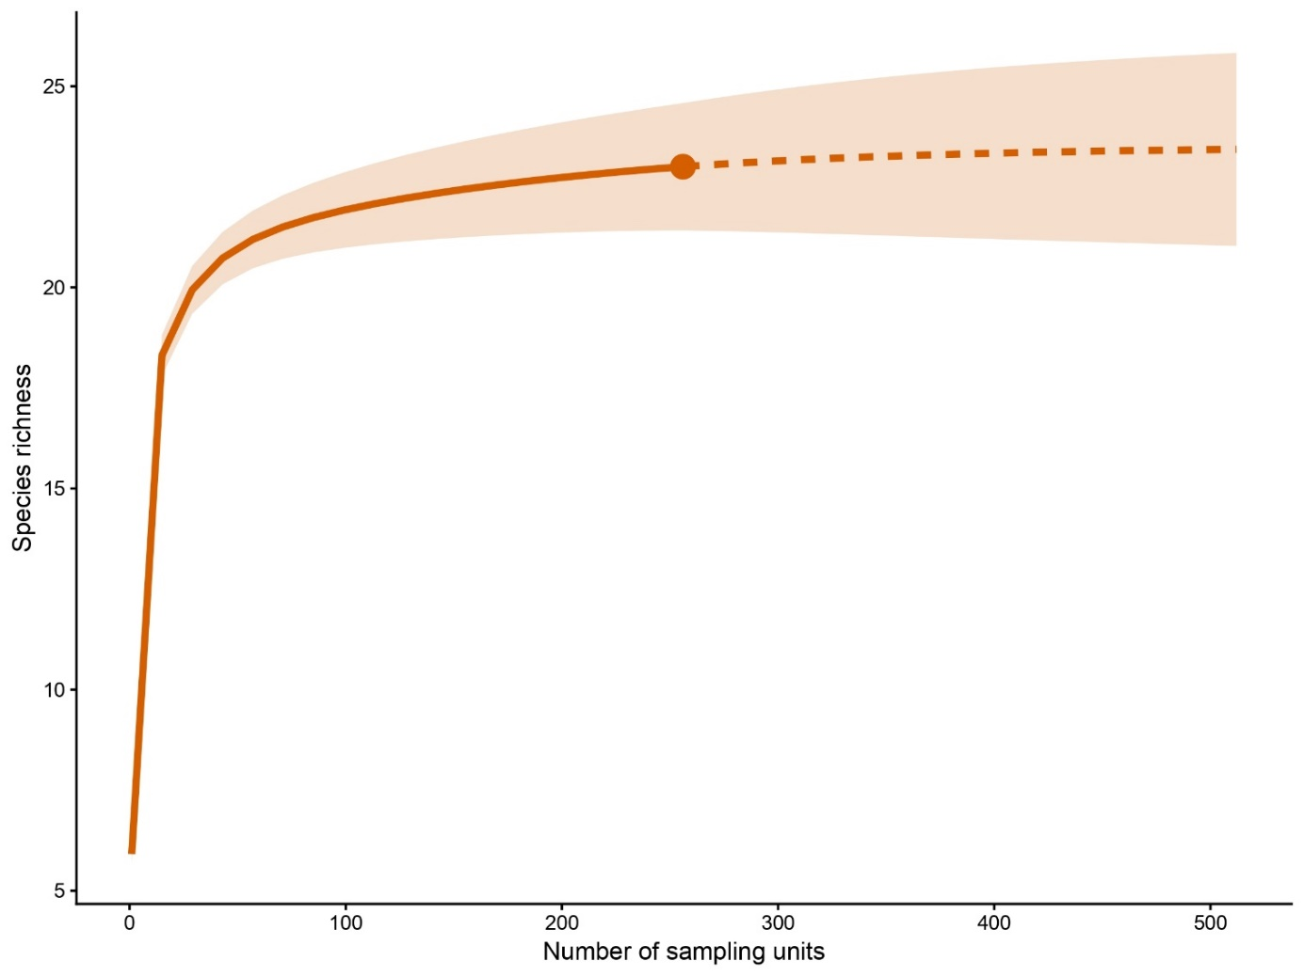

Fig. S2. Coverage-based rarefaction and extrapolation curve for medium- and large-bodied mammals derived from camera-trap data.
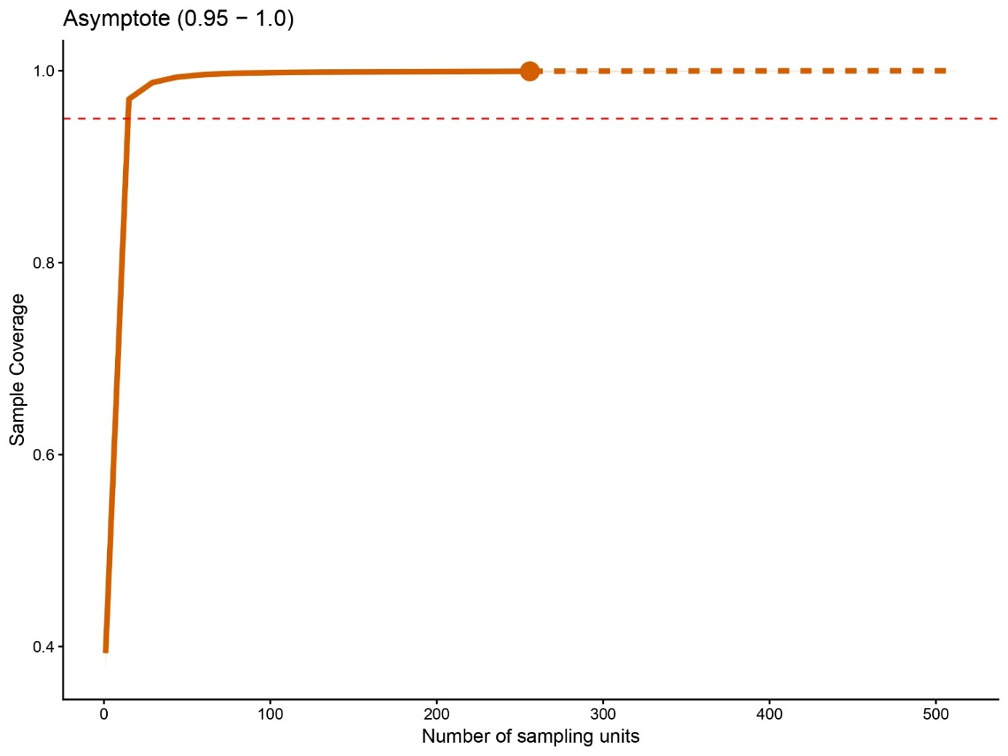

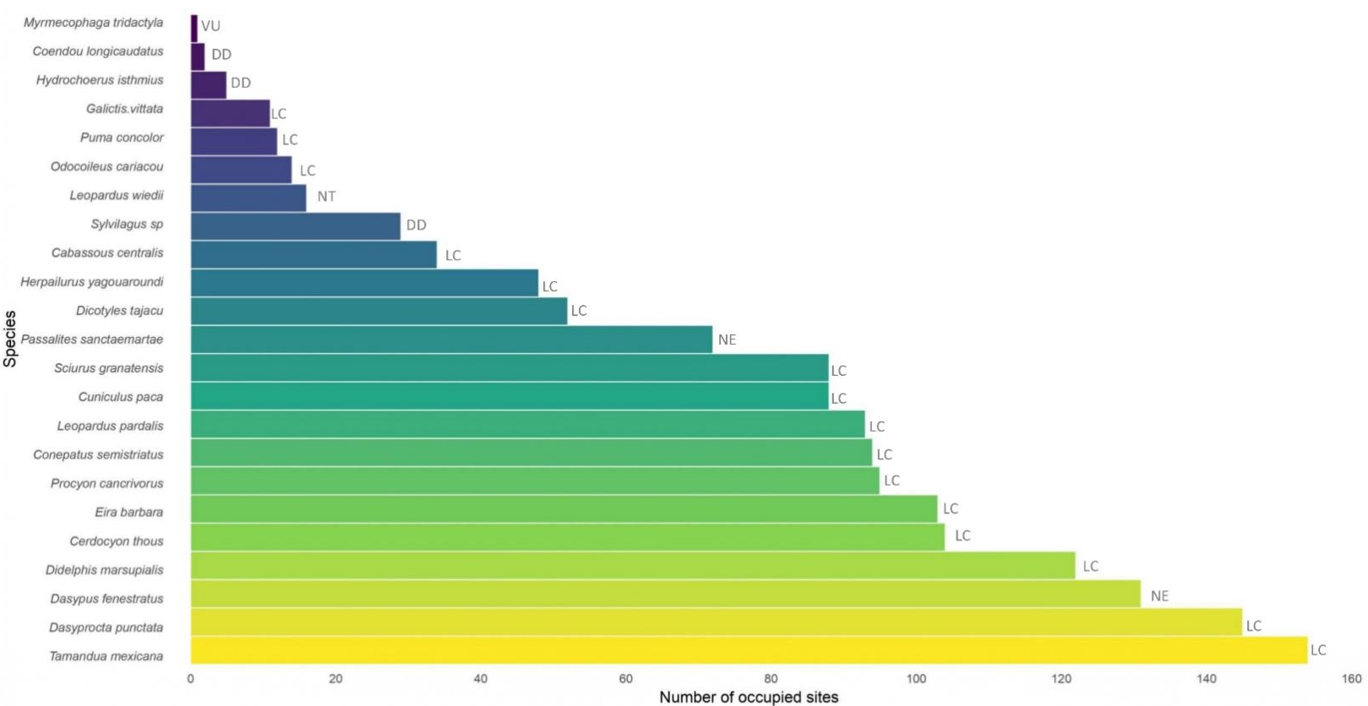
Fig. S3. Occurrence of 23 medium- to large-bodied mammals in 256 tropical dry forest (TDF) sites in the Colombian Caribbean. Species/genus names are ordered from bottom to top, from least to most frequent across all sites. including the IUCN Red List category (https://www.iucn.org/) for each species (IUCN): Data Deficient (DD), Least Concern (LC), Near Threatened (NT), Vulnerable (VU), Not Evaluated (NE).
Table S1. Mean Absolute Deviation (MAD) values for functional spaces defined by different numbers of principal components (PCOA). Low MAD values indicate a better representation of the functional space. According to the MAD index, the functional space defined by three dimensions (PC1-PC3) showed good performance.

PCoA | MAD
PC1 | 0.22
PC2 | 0.108
PC3 | 0.071
PC4 | 0.067
PC5 | 0.081
PC6 | 0.098
PC7 | 0.108
PC8 | 0.11
PC9 | 0.111
PC10 | 0.115

Table S2. Summary of the relationships between species functional traits and the axes of the functional space derived from the principal component analysis (PCA). Categorical traits (Trophic guild, Activity patterns, and Forest dependence) were evaluated using Kruskal–Wallis tests, with effect sizes expressed as eta squared (η²). Continuous traits (Body mass and Home range) were assessed using linear models, with the coefficient of determination (R²) used as a measure of explained variance.

Trait | Axis | Test | Stat | Value | p-value
Trophic guild | PC2 | Kruskal-Wallis | η² | 0.536 | 0.004
Trophic guild | PC3 | Kruskal-Wallis | η² | 0.422 | 0.012
Activity patterns | PC2 | Kruskal-Wallis | η² | 0.445 | 0.004
Activity patterns | PC3 | Kruskal-Wallis | η² | 0.295 | 0.019
Body mass | PC1 | Linear Model | r2 | 0.416 | 0.001
Body mass | PC2 | Linear Model | r2 | 0.177 | 0.046
Home Range | PC1 | Linear Model | r2 | 0.484 | <0.001
Forest dependency | PC1 | Kruskal-Wallis | η² | 0.590 | <0.001
Forest dependency | PC2 | Kruskal-Wallis | η² | 0.231 | 0.016

Table S3. Akaike Information Criteria (AIC) of the variables forest cover (FC), number of patches (NP), and edge density (ED) analyzed in relation to species richness, forest-dependent species richness, non-forest-dependent species richness and standardized effect sizes (SES) functional richness of medium- to large-bodied mammals in the Colombian Caribbean. In bold, the lowest AIC values and the selected scale are highlighted.

 |  | Species richness | Forest-dependent | Non-forest-dependent | (SES) Functional richness
Variable | Scale (km) | AIC | AIC | AIC | AIC
 | 0.5 | 1294.765 | 1016.597 | 1012.158 | 481.976
 | 1 | 1295.082 | 1005.465 | 1004.397 | 480.996
FC | 2 | 1296.522 | 1012.353 | 999.572 | 482.651
 | 4 | 1296.828 | 1018.037 | 999.040 | 482.307
 | 6 | 1296.848 | 1020.430 | 997.490 | 479.786
 | 0.5 | 1296.660 | 1037.438 | 1012.797 | 481.074
 | 1 | 1296.749 | 1027.653 | 1004.751 | 482.204
NP | 2 | 1295.002 | 1013.219 | 1011.020 | 484.177
 | 4 | 1293.859 | 1009.732 | 1012.107 | 484.091
 | 6 | 1294.570 | 1011.108 | 1011.092 | 482.209
 | 0.5 | 1288.078 | 1042.746 | 999.671 | 484.017
 | 1 | 1280.575 | 1042.544 | 994.783 | 483.451
ED | 2 | 1276.785 | 1040.579 | 997.526 | 482.676
 | 4 | 1283.347 | 1039.837 | 1008.794 | 485.299
 | 6 | 1285.971 | 1036.346 | 1016.276 | 485.614

Table S4. Variance Inflation Factor (VIF) of the analyzed response variables (species richness, forest-dependent species richness, non-forest-dependent species richness, and standardized effect sizes (SES) functional richness). Predictor variables include forest cover (FC), number of patches (NP), edge density (ED) and sampling effort (Effort). The numeric suffix (e.g., _0.5, _0.1 _2, _4, _6) indicates the selected scale of effect (in km) at which each variable best explained variation in the response variable.

Species richness
Variable | VIF
FC_0.5 | 1.5606
NP_4 | 1.6500
ED_2 | 1.4296
Effort | 1.1027
Forest-dependent
 | VIF
FC_1 | 1.8943
NP_4 | 2.3243
ED_6 | 1.2759
Effort | 1.1177
Non-forest-dependent
 | VIF
FC_6 | 1.5340
NP_1 | 2.1673
ED_1 | 1.7318
Effort | 1.1317
(SES) Functional Richness
 | VIF
FC_6 | 1.2409
NP_0.5 | 1.3744
ED_2 | 1.3045
Effort | 1.0867

Table S5. Results of Moran’s I spatial autocorrelation tests for the analyzed response variables. For each variable, the table shows the observed Moran’s I value, the expected value under spatial randomness, and the associated p-value. Significant positive Moran’s I value (p ≤ 0.05) indicate the presence of spatial autocorrelation in species richness, forest-dependent species richness, non-forest-dependent species richness, and standardized effect sizes (SES) functional richness.

Variable | Moran´s I  (p-value) | Moran´s I index observed | Moran´s I index expected
Richness species | <0.0001 | 0.2946 | -0.0039
Forest-dependent | <0.0001 | 0.3516 | -0.0039
Non-forest-dependent | <0.0001 | 0.2708 | -0.0039
(SES) Functional richness | <0.0001 | 0.1893 | -0.0052

Table S6. Models of the four possible combinations of explanatory variables plus one null model and the corresponding AIC values: (FC) forest cover, (NP) number of patches, (ED) edge density, sampling effort (Effort) and autocov. The numeric suffix (e.g., _0.5, _0.1 _2, _4, _6) indicates the selected scale of effect (in km) at which each variable best explained variation in the response variable.

Model
Species richness | (Intercept) | FC | NP | ED | Effort | autocov | df | logLik | AICc | ΔAIC | ωi
FC_0.5+NP_4+ED_2+Effort+autocov | 1.7261 | 0.0615 | -0.0975 | 0.1097 | 0.1532 | 0.1908 | 6.0000 | 570.8774 | 1154.0921 | 0.0000 | 0.9234
FC_0.5+ ED_2+Effort+autocov | 1.7276 | 0.0968 | - | 0.0840 | 0.1329 | 0.2157 | 5.0000 | 574.6438 | 1159.5276 | 5.4355 | 0.0610
FC_0.5+ NP_4+Effort+autocov | 1.7293 | 0.0248 | -0.0655 | - | 0.1493 | 0.2279 | 5.0000 | 576.3771 | 1162.9943 | 8.9022 | 0.0108
FC_0.5+Effort+autocov | 1.7301 | 0.0563 | - | - | 0.1347 | 0.2389 | 4.0000 | 578.2040 | 1164.5675 | 10.4754 | 0.0049
Null | 1.7767 | - | - | - | - | - | 1.0000 | 646.4311 | 1294.8780 | 140.7859 | 0
Forest Dependent
FC_1+ NP_4+ED_6+Effort+autocov | 0.9868 | 0.1468 | -0.1273 | 0.0911 | 0.1521 | 0.3073 | 6.0000 | 445.9250 | 904.1874 | 0.0000 | 0.3454
FC_1+Effort+autocov | 0.9903 | 0.1944 | - | - | 0.1375 | 0.3548 | 4.0000 | 448.2176 | 904.5945 | 0.4071 | 0.2818
FC_1+ED_6+Effort+autocov | 0.9900 | 0.2082 | - | 0.0494 | 0.1396 | 0.3375 | 5.0000 | 447.5882 | 905.4164 | 1.2290 | 0.1868
FC_1+ NP_4+Effort+autocov | 0.9885 | 0.1549 | -0.0698 | - | 0.1439 | 0.3464 | 5.0000 | 447.5923 | 905.4245 | 1.2371 | 0.1861
Null | 1.0881 | - | - | - | - | - | 1.0000 | -519.4572 | 1040.9301 | 136.7427 | 0
Non-forest dependent
FC_6+ED_1+Effort+autocov | 1.0143 | -0.0169 | - | 0.1089 | 0.1874 | 0.1571 | 5.0000 | -458.3574 | 926.9547 | 0.0000 | 0.6774
FC_6+NP_1+ED_1+Effort+autocov | 1.0142 | -0.0190 | -0.0049 | 0.1119 | 0.1875 | 0.1564 | 6.0000 | -458.3523 | 929.0419 | 2.0872 | 0.2386
FC_6+NP_1+Effort+autocov | 1.0187 | -0.0029 | 0.0623 | - | 0.1821 | 0.1810 | 5.0000 | -461.0024 | 932.2449 | 5.2902 | 0.0481
FC_6+Effort+autocov | 1.0205 | -0.0355 | - | - | 0.1829 | 0.1808 | 4.0000 | -462.3359 | 932.8311 | 5.8764 | 0.0359
Null | 1.0789 | - | - | - | - | - | 1.0000 | -508.3497 | 1018.7152 | 91.7605 | 0
Standardized effect sizes (SES) Functional Richness
FC_6+NP_0.5+Effort+autocov | -0.6983 | 0.0050 | -0.1437 | - | 0.0599 | 0.3027 | 6.0000 | 221.8875 | 456.2242 | 0.0000 | 0.6239
FC_6+NP_0.5+ED_2+Effort+autocov | -0.6968 | 0.0043 | -0.1374 | -0.0154 | 0.0593 | 0.3002 | 7.0000 | 221.8616 | 458.3254 | 2.1012 | 0.2182
FC_6+Effort+autocov | -0.7012 | 0.0610 | - | - | 0.0599 | 0.2917 | 5.0000 | 224.8837 | 460.0866 | 3.8624 | 0.0904
FC_6+ ED_2+Effort+autocov | -0.6929 | 0.0454 | - | -0.0770 | 0.0570 | 0.2817 | 6.0000 | 224.1116 | 460.6725 | 4.4483 | 0.0675
Null | -0.7132 | - | - | - | - | - | 2.0000 | 241.6215 | 487.3058 | 31.0816 | 0

Table S7. Coefficients of the models: (FC) forest cover, (NP) number of patches, (ED) edge density, sampling effort (Effort) and autocov. The numeric suffix indicates the selected scale of effect (in km) at which each variable best explained variation in the response variable.

Models | Average model coefficients | Standard error | Confidence intervals
Models | Average model coefficients | Standard error | 2.5% | 97.5%
Species richness
(Intercept) | 1.7262 | 0.0270 | 1.6730 | 1.7794
FC_0.5 | 0.0633 | 0.0349 | -0.0055 | 0.1320
NP_4 | -0.0907 | 0.0425 | -0.1743 | -0.0072
ED_2 | 0.1065 | 0.0360 | 0.0355 | 0.1774
Effort | 0.1519 | 0.0262 | 0.1002 | 0.2035
autocov | 0.1929 | 0.0337 | 0.1265 | 0.2593
Forest Dependent
(Intercept) | 0.9887 | 0.0400 | 0.9100 | 1.0674
FC_1 | 0.1732 | 0.0571 | 0.0609 | 0.2855
NP_4 | -0.0570 | 0.0757 | -0.2056 | 0.0917
ED_6 | 0.0407 | 0.0538 | -0.0650 | 0.1464
Effort | 0.1441 | 0.0365 | 0.0722 | 0.2160
autocov | 0.3336 | 0.0464 | 0.2423 | 0.4250
Non-forest dependent
(Intercept) | 1.0147 | 0.0387 | 0.9384 | 1.0909
FC_6 | -0.0174 | 0.0403 | -0.0968 | 0.0620
NP_1 | 0.0018 | 0.0286 | -0.0544 | 0.0580
ED_1 | 0.1005 | 0.0499 | 0.0024 | 0.1986
Effort | 0.1870 | 0.0369 | 0.1143 | 0.2597
autocov | 0.1589 | 0.0448 | 0.0707 | 0.2472
Standardized effect sizes (SES) Functional richness
(Intercept) | -0.6979 | 0.0562 | -0.8087 | -0.5871
FC_6 | 0.0126 | 0.0689 | -0.1233 | 0.1485
NP_0.5 | -0.1196 | 0.0761 | -0.2693 | 0.0301
ED_2 | -0.0085 | 0.0409 | -0.0891 | 0.0720
Effort | -0.0595 | 0.0556 | -0.1693 | 0.0502
autocov | 0.2997 | 0.0604 | 0.1805 | 0.4189

